**Debriefing**

+ Style Guide

**Concept**

The pinball machine will be just as regular pinball machines. Points are awarded for doing certain things and hitting certain objects.

**Theme**

The pinball machine will support a “Medieval” theme. Which means towers and castle walls will be a thing. The lighting will be (if possible) done by torches, giving it that extra medieval touch.

The theme fits me well because I am fairly interested in history. The medieval time-period is one of my favorites. It also fits because I am a great fan of medieval-fantasy games, so making a medieval themed game is just right for me.

**Style**

The 3D-models will be reasonably low-polygon models, so not everything will be perfectly smooth. The textures will be 1080p / high-resolution while still supporting the style of low-polygon models. I took the liberty of already making some concept-art for the pinball machine.

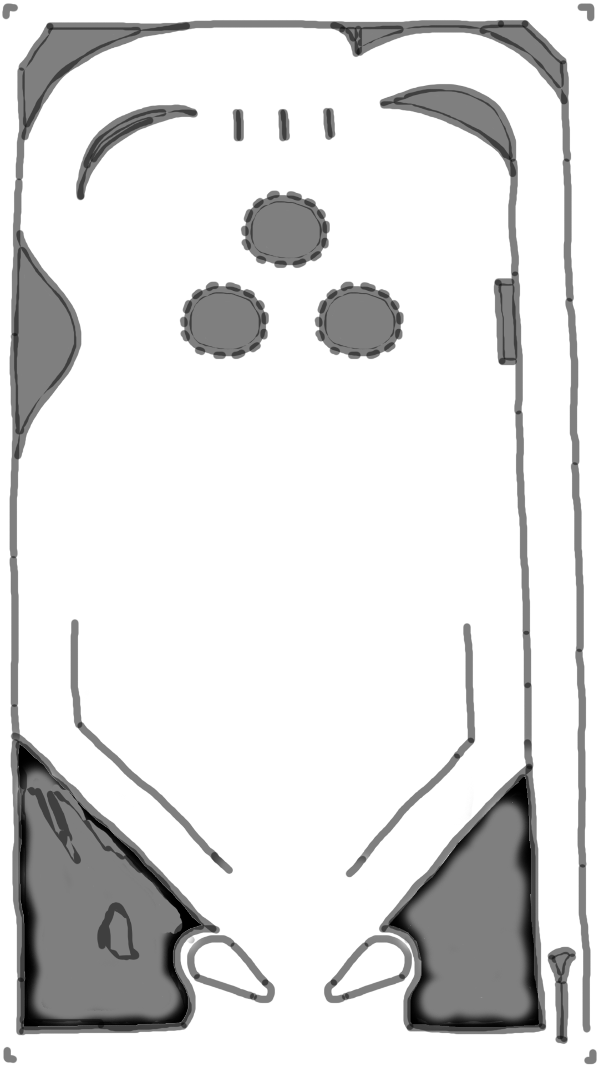

The image on the left   
is a rough concept   
of the pinball machine.

The image on the right   
is the background   
of the playfield.