Q：服务器IP？
A：测试环境：182.150.21.90；正式环境：39.104.108.95

Q：有余额查询接口吗？
A：没有余额查询接口哈，不过在提单接口会返回账户余额。

Q：请求超时
A：检查提单程序的时间与服务器时间是否一致。

Q：一直没有货源下载订单
A：开启充值外挂、回调程序（密码：000000）

测试账号：TestApi
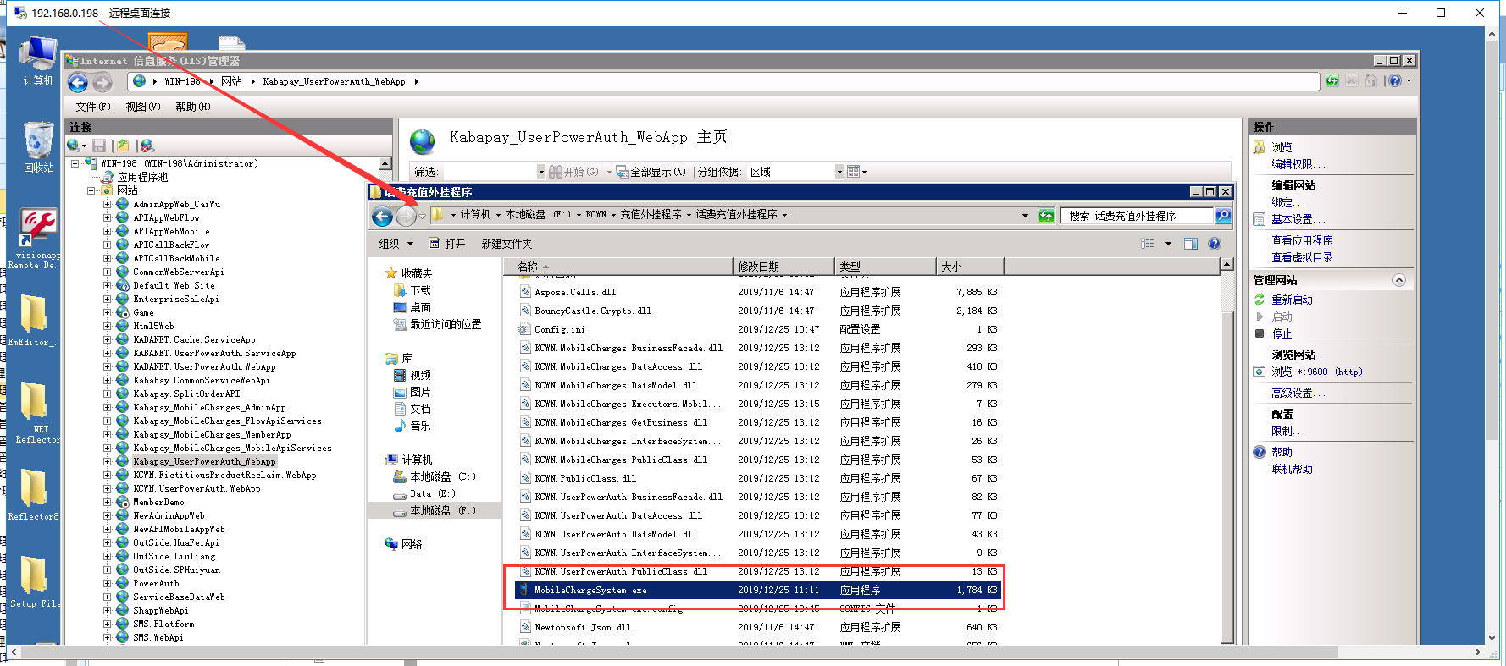
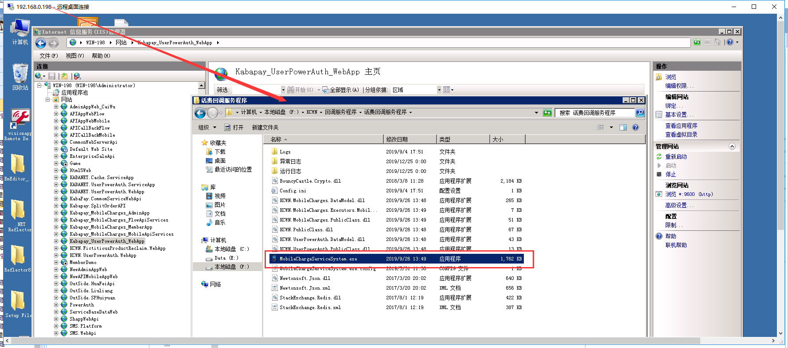

Q：给会员的提单、查询、回调日志？
A：见截图
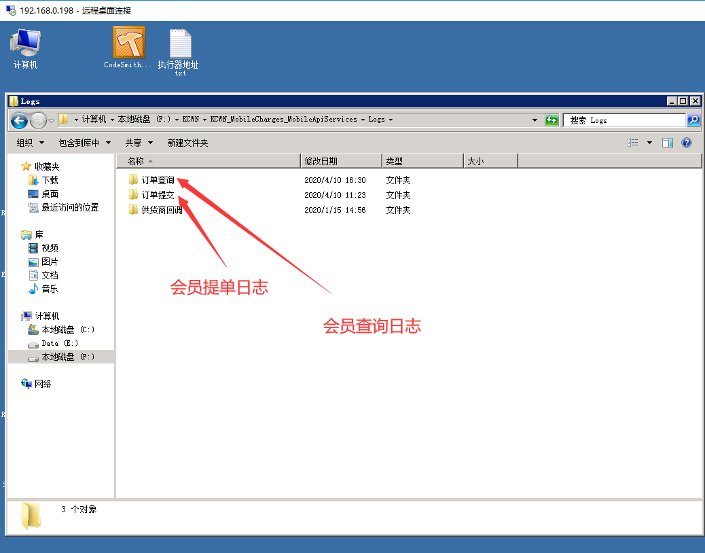
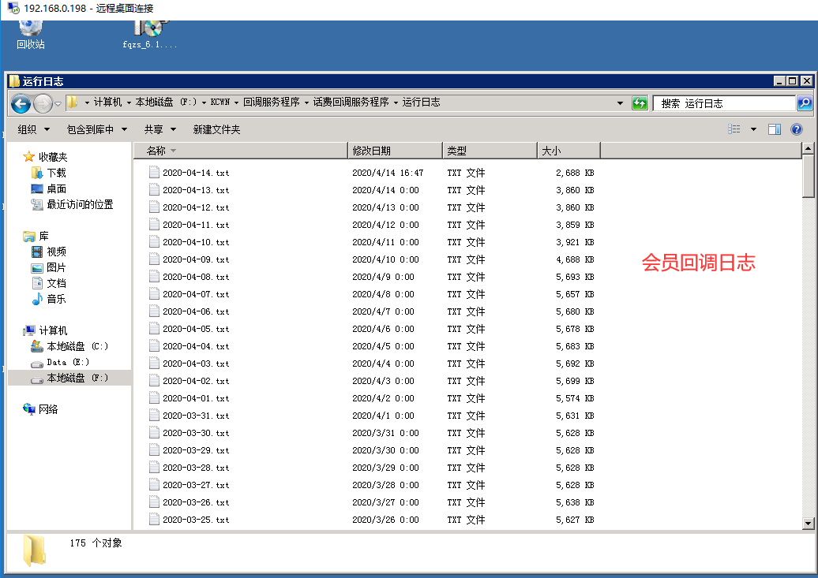

2020-11-11 10:51:24
接收请求数据：{"ApiAccount":"TestApi","MOrderID":"1605063068460","ProductCode":"SCC_YD_01_001000_0001","ChargeNum":"18888888888","ParValue":null,"ProductType":null,"Quantity":1,"TimesTamp":"20201111105108","CustomIP":null,"CallbackUrl":null,"Sign":"B1C94F1B172F8510CD28329B70D8303D","ApiRequestIP":"118.112.58.79"}

2020-11-11 10:51:24
提交订单服务端响应：{"ResponseStatus":true,"ResponseCode":"000000","ResponseMessage":"提交成功","ExceptionMessage":"","ResponseObject":{"CapitalAccountID":"1000000000000001","CreditAmount":0.0000,"AccountBalance":863185314.3740,"AvailableBalance":863185314.3740,"OrderID":"20201111000000016049","Quantity":1,"SellPrice":10.0000,"SellAmounts":10.0000},"ResponseData":null}

2020-11-11 10:51:24
提交订单客户端响应：{"Request":{"ApiAccount":"TestApi","MOrderID":"1605063068460","ProductCode":"SCC_YD_01_001000_0001","ChargeNum":"18888888888","ParValue":null,"ProductType":null,"Quantity":1,"TimesTamp":"20201111105108","CustomIP":null,"CallbackUrl":null,"Sign":"B1C94F1B172F8510CD28329B70D8303D","ApiRequestIP":"118.112.58.79"},"Response":{"ResponseCode":"000000","ResponseMessage":"提交成功","ResponseData":{"CapitalAccountID":"1000000000000001","CreditAmount":0.0,"AccountBalance":863185314.374,"AvailableBalance":863185314.374,"OrderID":"20201111000000016049","Quantity":1,"SellPrice":10.0,"SellAmounts":10.0}}}

