appId、appSecret供应商提供

执行器类型名:KCWN.MultiBussiness.SupplierExecutor.HBRP

执行器dll：KCWN.MultiBussiness.SupplierExecutor.HBRP

充值结果类型：回调

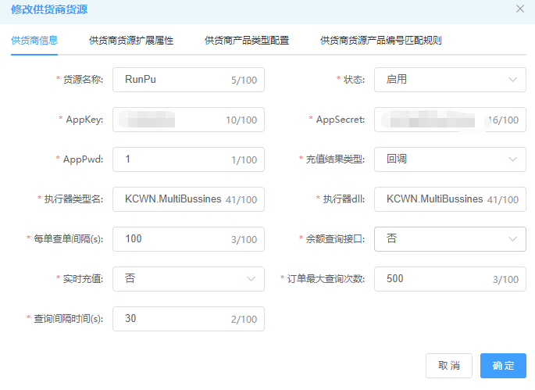

-----------------------------------------------------------------------------------------------------------------

扩展属性

ZCSubmitOrderUrl http://120.79.190.232:8911/api/order/submit 直充充值接口

KQSubmitOrderUrl http://120.79.190.232:8911/api/card/get 卡券充值接口

QueryOrderUrl http://120.79.190.232:8911/api/order/query 查询接口

CallBackUrl http://video.notify.sctongqian.com/CallBack/HBRP 回调接口

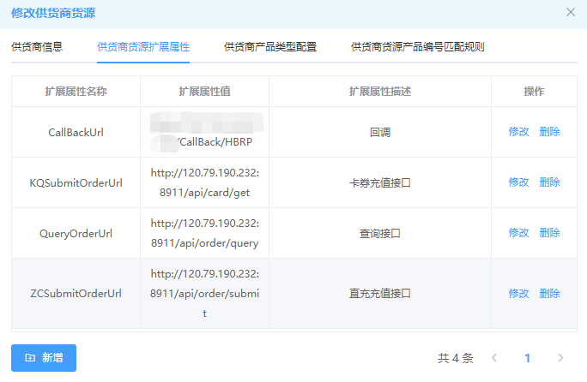

跑直充，只用填写产品编码

跑卡密时，除了填写产品编码，扩展参数还要填写 {"supplyMode":"1"}

