客户名称

京东

类型

KCWN.CollectMemberOrderService.Collectors.JingDongCollector

扩展属性:

Jd_CustomerId 11433401 京东商家编号

CallBackUrl http://video.collect.sctongqian.com/CallBack/NewKCWN 收单回调

MemberZCCallBackUrl http://card.jd.com/api/gameApi.action 会员直充回调url

MemberKMCallBackUrl http://card.jd.com/api/cardApi.action 会员卡密回调url

Jd_PrivateKey 07368ca345e9bbc855d9b82f3ca5cc17 京东接口Key

AppKey 视频会员Key

AppSecret 视频会员Secret

PrivateRSAKey 视频会员私钥

PublicRSAKey 视频会员公钥

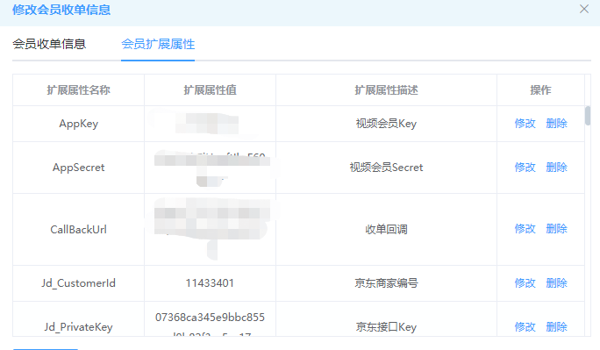

以下内容需提供给京东

直充收单地址

http://video.collect.sctongqian.com/CollectOrder/JingDong_ZCCollectOrder

卡密收单地址

http://video.collect.sctongqian.com/CollectOrder/JingDong_KMCollectOrder

直充查单地址

http://video.collect.sctongqian.com/CollectOrder/JingDong_ZCQueryOrder

卡密查单地址

http://video.collect.sctongqian.com/CollectOrder/JingDong_KMQueryOrder