appKey:M00146

appSercet:jCzLQjicbgBjw72Xm7ogSqfjYQE4s81K

执行器dll:

KCWN.MultiBussiness.SupplierExecutor.SZKBH

充值结果类型：回调

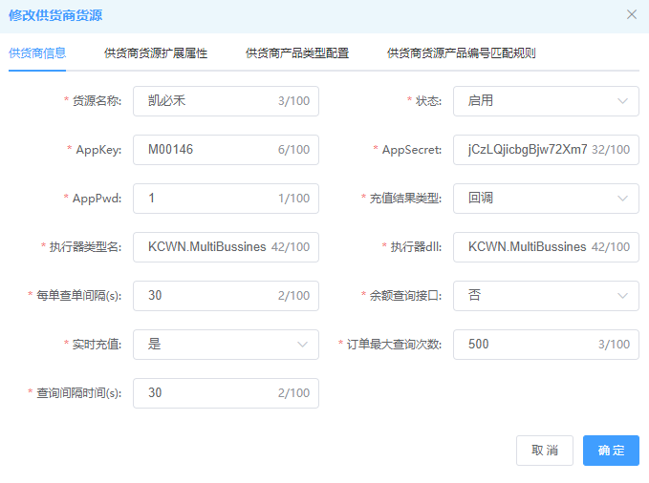

扩展属性：

SubmitUrl:http://121.43.252.14:8080/api/libao/makeOrder 订单提交地址

QueryUrl:http://121.43.252.14:8080/api/queryOrder 订单查询地址

CallBackUrl:http://182.150.21.90:9063/CallBack/SZKB 回调接口

