We receive POS (also called “Sales Out”) and Inventory from our distributers in 2 ways:

One way, is an EDI transmission from the Distributers system directly to Panasonics SAP.  It is stored in a custom SAP table called ZED117.

The *other way* (for Distributers who are not capable of sending EDI transmissions) is to send us an Excel file with the information.

Part of Mike’s role is to compile this data into reports on every Monday and then every day from the 20th until the end of the month.  Attached below is the communication and output for our Security business (there are others.)

Gather the Jenne every week before the 20th per month, even though Jenne comes everyday, but not so rush before 20th, so can besides the ANIXER do together.

POS -> POS feedout(Zyme) -> Service POS

POS Report:

Get the POS data from several ways.

History comm (Steve lenard) ToughBook

History SAP(have EDI) -BroadCast, Protector, Arbitrator, Display, Food Service

History Non-SAP(no EDI) BTS/SIP/DOC/Scanner/Security(SSG/VIG)

This project only deal with those four.

People:

|  |
| --- |
| ANIXTER #non-sap ( send weekly, but the report contain whole month, need extract out )  tania bolina anixer team box |
| JENNE #non-sap (send her POS everyday and weekly) (delete her file in SAP too) |
| SCANSOURCE #sap (everyday)(gather specific values from sap) |
| SYNNEX #sap (everyday)(same as up) |

Inventory: Weekly deal with.

Procedure:

## For ANIXER part: (every Monday)

1. From the team box -> Tania Bolina get weekly data, they are from ANIXER(Panasonic Sec Weekly COGS US-OCT) . Create the same format as the template.
2. From the template, use Pnana.Material column to correct the model number, use the POSMODEL to store the original values.
3. use the filter to select targeted date. (to the specific day).
4. Use the replace to trim the Pana.Material Column. (comes per week, so include every day in a week) (replace space to nothing. Because there always a space in front of Model Number)
5. Then, copy to the TOOL’s file POS.
6. Down the function to Pana.Material(O), Material Group(R), Week(Z), follow the formula.
7. Change all name to ANXIER.
8. Make sure there no N/A in model in template.

## For JENNE part:(Daily and Weekly)

1. Coz Jenne comes every day, first open PHSG POS, find the [reports@jenne.com](mailto:reports@jenne.com) PHSG POS Report-Daily. Or name is Panasonic Customer Sales
2. The date is one day after the real file. 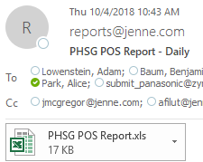. Here should be 10/3/2018 file. Gather them all every week as the ANIXTER does before 20th per month. Add after the template.
3. From Jenne file, Special Bid => Quote Number InvCost => Cost Ext_Cost => total
4. Make sure there no N/A in model in template.
5. Deal With O R Z columns
6. **Combine 5(daily) +1(weekly)**

**For the JENNE ‘week file.**

1. **Once a week ,from the JENNE, fill the POS data in the tools**
2. **Monday once a week.**
3. **Name = Jenne_POS_Video_Insight_VI2018-10-08-08-30-25**

For

1. ANIXTER, comes from every week, but his file contains the whole month, extract that day’s data in big file. ANIXTER has the space in the model number, use the replace function in excel to change all space into the null.
2. Then for the SAP side, coz Jenne also send file to SAP, we need delete them in SAP, make sure every Partner Name is right. Get all SAP data from SAP, put into the big file.
3. After finished all four parts, create a new POS file to do, paste pivot table.

Tips:

1. H column in Mike’s tool is original wrong model number. I Column is the right one to use (to do reference)
2. ANIXTER has the space in the model number, use the replace function in excel to change all space into the null.
3. 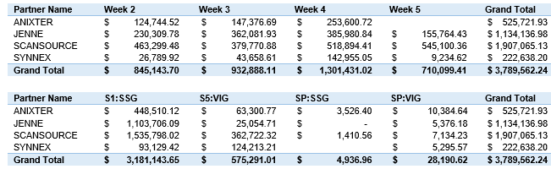

## For SAP:

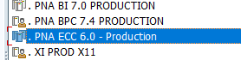

Include weekend 6/10-16/10/2018



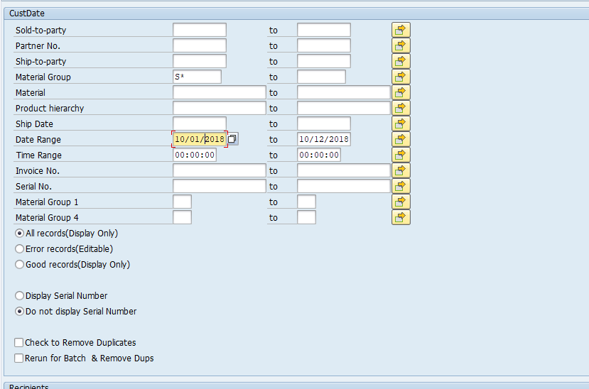

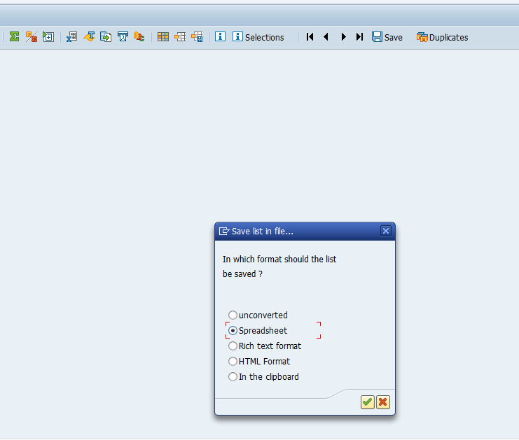

**Delete those material groups HOS\ WAS\ BLANK from the excel data**

**Delete all useless ship_date, only the 10/01- 10/05. Check the ship_Date in SAP against Received date-1 if the ship date is missing**

**Correct the name in column A , delete the JENNE, change the SCANSOURCE name and SYNNEX**

## For the INV Part :

**SAP_INV_ per week:**

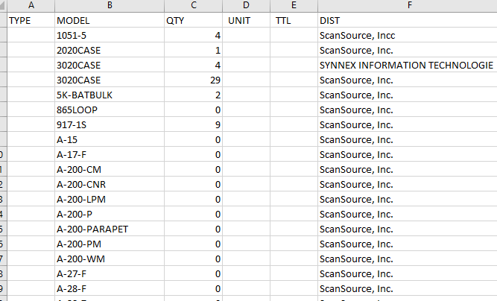

**Combine the 3+1 those inventory file. (zed119)**

**3 comes from SAP**

**1 comes from ANIXTER FILE.**



**The date should be that day 22/10**

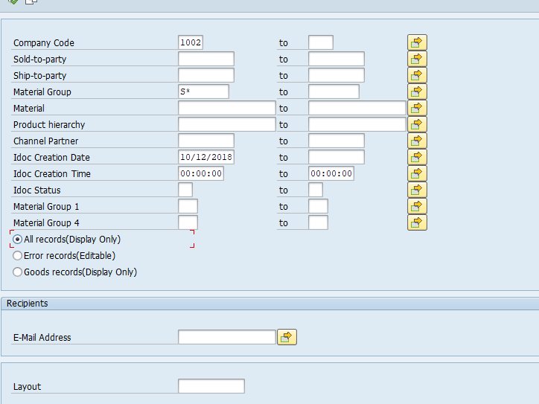

**Make sure change the format to excel.**

**Step 1: deal with three dis except the annixter. (SAP Only)**

**Change the model in right way from tools, then grasp the material group against the tools material group and right model.**

**Columns B and C and E**

**Channel Partner Name\ Pana. Material\** **Qty in hand**

**Unit is the Ps Price in TOOLS.**

**TYPE is the material group in TOOLS.**

**TTL is UNIT * QTY**

**In INV**

**Step 2 :**

**In Annxiter file , grasp the Panasonic Sec Inventory - OCT 2018.xlsx**

**Add after the inv file**

**The Anixter had the blank space in the model.**

**Delete all the N/A in INV**

**Column B and I**

**VNDR_ITEM_I\** **SumOfONHAND_Q**

**These are all a part of columns, The SAP file only get 3, the Anixter only get 2.**

**The rest of should be made base on tools.**

**Don’t send at Friday, just do it and keep until next Monday**

**Delete the receipt:**

[Otake, Hajime (hajime.ootake@us.panasonic.com)](mailto:hajime.ootake@us.panasonic.com)