First project:

1.material master

-> cost, sales projections, sales organization, pos data(v) , material hierarchy, material family.

mission:

profitability project

forcasted + actual sales, two different tables

### Stage 1: Data Preparation

To build the data module, the data we need feed in is PSSNA Pipeline Forecast, Pscna Zyme Pos History, Pssna Mobility Sales Org, Prod Hierarchy Mobility Xlsx and several dataset related with W Material.

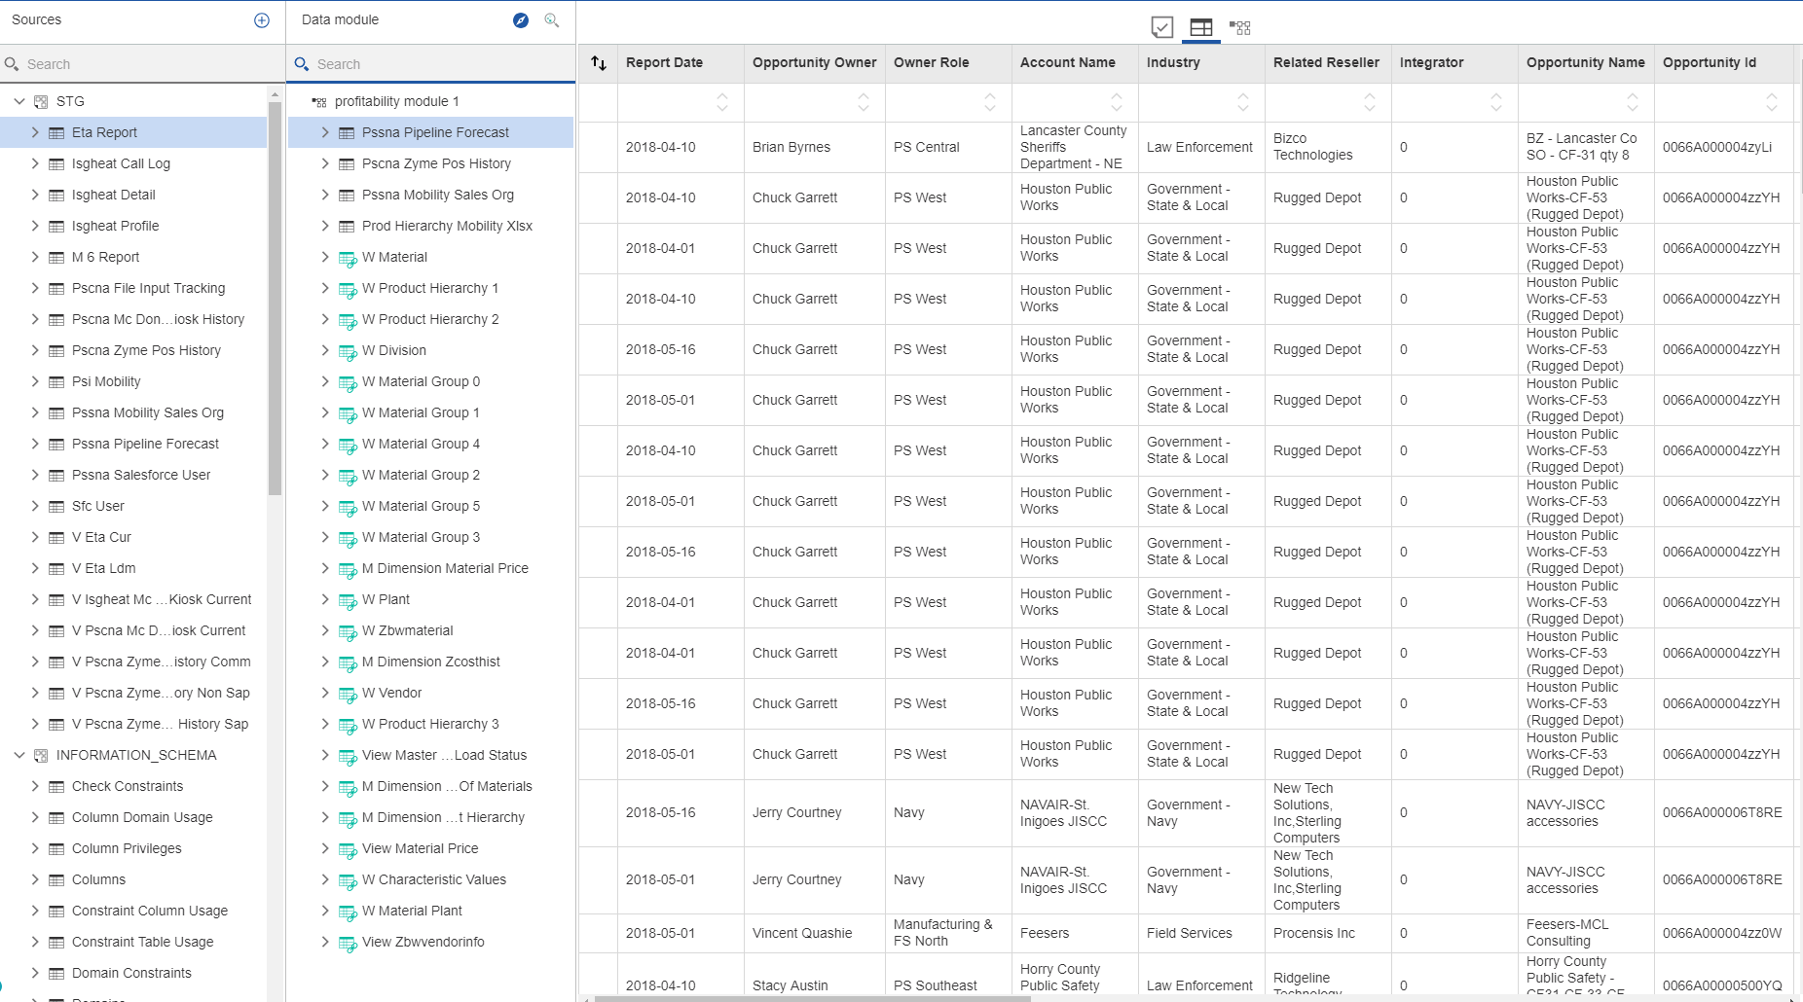

### Stage 2: Data Connection and Model Building

You can use data modeling in IBM® Cognos® Analytics to fuse together many sources of data, including relational databases, Hadoop-based technologies, Microsoft Excel spreadsheets, text files, and so on. Using these sources, a data module is created that can then be used in reporting and dashboarding.

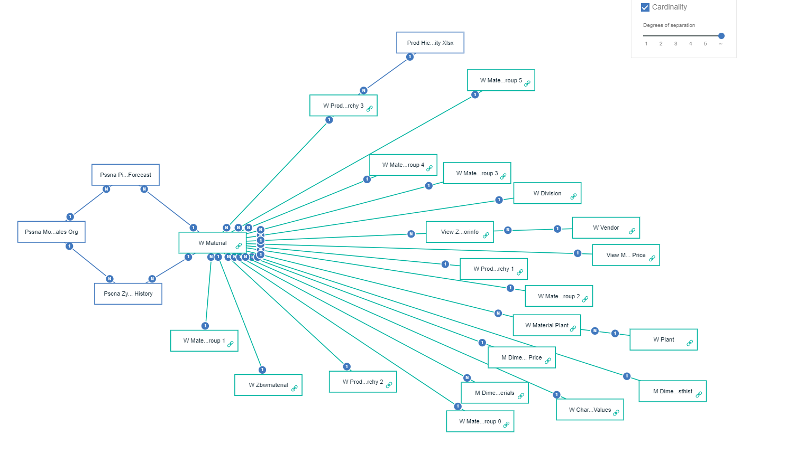

Relationship table:

Created followed by the values in the book.

### Stage 3: Query Creating

From the report, create a list in a new report

From the Toolbox to create the query

We need create the following data items:

1. The Landed Cost is made by Landed Cost multiply the Quantity
2. Then calculate the profit , we need do the subtraction of Revenue and Landed Cost.

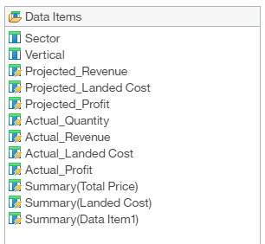

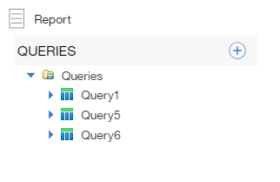

In this stage 3 , we got the wrong answer, even though the dataset is right, the landed cost is wrong because the relationship or connection wrong.

We need do the data validation in the stage 4 to cross check every answer from data module with the real data to find out the connection problem.

### Stage 4: Data Validation

After the following stage, the landed cost is wrong in most of cases, so that we cannot get a right value of profit.

In this stage, we need to validate the landed cost values, to cross validation of different tables, to figure out why the cost is wrong.

Excel Trick:

### <https://www.ablebits.com/office-addins-blog/2014/07/29/vlookup-formula-examples/>

### How to get all occurrences of lookup value (duplicates)

As mentioned above, the Excel VLOOKUP function cannot get duplicate instances of the lookup value. To do this, you would need a far more complex array formula consisting of several Excel functions such as INDEX, SMALL and ROW.

For instance, the below formula finds all instances of the value in cell F2 in the lookup range B2:B16, and returns values from column C in the same rows:

{=IFERROR(INDEX($C$2:$C$16, SMALL(IF($F$2=B2:B16, ROW(C2:C16)-1,""), ROW()-3)),"")}

Copy the below formula to several adjacent cells, e.g. cells F4:F8 as demonstrated in the screenshot below. The number of cells where you copy the formula should be equal to or larger than the maximum number of possible duplicate entries. Also, remember to press Ctrl + Shift + Enter to enter an array formula correctly.

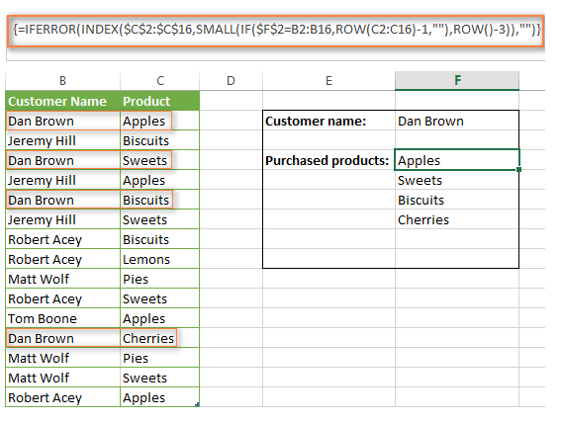

Projected:

Revenue: [C].[profitability_module_1].[PSSNA_Pipeline_Forecast].[Total_Price]

Landed Cost: [C].[profitability_module_1].[VIEW_MATERIAL_PRICE].[LANDED_COST] * [C].[profitability_module_1].[PSSNA_Pipeline_Forecast].[Quantity]

Actual:

Revenue: [C].[profitability_module_1].[PSCNA_Zyme_POS_History].[Total_]

Quantity: [C].[profitability_module_1].[PSCNA_Zyme_POS_History].[Quantity]

Landed Cost: [C].[profitability_module_1].[VIEW_MATERIAL_PRICE].[LANDED_COST] * [Actual_Quantity]

Also actual revenue\POS Sales Report Total Price: [C].[profitability_module_1].[PSCNA_Zyme_POS_History].[Total_]

Ship date

Product name /line

Stage

Forecast Category

Opportunity id\ owner\name’

Report date

Task:

1. Identify data to be validated and how to validate it
   1. Projected Sales by group/month/amount Validate vs Sales Force Data (forecast_sale) sets Total Price+ Qty(quantity) #finished 6/12 (2 part)
   2. Landed Cost compare Validate vs  M6 Landed Cost #finished 6/11 (1part)
   3. Sales POS by group/month/amount  Validate vs POS (actual)Sales Report Total Price+ Qty (3 part) (history part)

a. Projected Sales by group/month/amount Validate vs Sales Force Data sets Total Price+ Qty(quantity)

To test the forecast data.

create the report_1_sales based on the profitability module 1, here

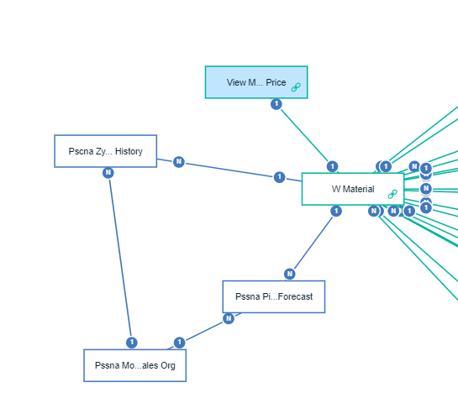

Combined all the data table except the History, the history should be tested by the task c below.

Here, according to the organization data table, we test the forecasting total price on task a is right.

b. Landed Cost compare Validate vs  M6 Landed Cost

1.

W Material and View Material Price table are 1:1 connection by SURROGATE_KEY, test that relationship,

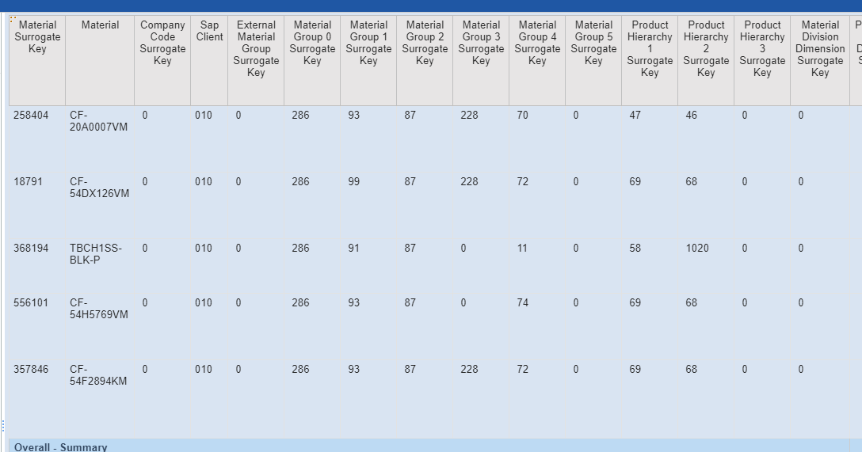

To the Material- Landed cost, the value is right.

2.

Then , connect the W Material + View Material Price + Pssna Pipeline Forecast.

The landed cost is right.

c. Sales POS by group/month/amount  Validate vs POS Sales Report Total Price+ Qty

here, we need based on the data module on the team content called model_2 to create the new report, because the data model has changed, based on that and add all other data table with the history datatable too, to test the historical total price. Against with Pos Test baseline (only have April data)