**Standard Report Format**



Name: Joey Kosseifi

ID: 230 906

Supervisor Name:

DR. Khouloud Samrouth

# **Abstract:**

Many young adults, in Lebanon, particularly those between the ages of 18 and 25, struggle to find work that can help cover their expenses and university tuition fees, as they often cannot work in their chosen fields until after graduation. The hospitality and service industries present accessible opportunities for these individuals, yet both job seekers and employers face difficulties in connecting efficiently. “JobLink” aims to address this by creating a centralized platform specifically designed to link employers and young adult job seekers within these industries and restaurants.

“JobLink” enables Lebanese companies to post detailed job openings and simplifies the recruitment process, while job seekers can search for local positions using location-based services like Google Maps. With options to view job details and submit CVs directly from their home, “JobLink” enhances the hiring process, making it easier for young adults to find employment opportunities that support their financial needs during their studies.

# **Acknowledgements:**

In this part, I would like to convey my gratitude to Dr. Khouloud Samrouth who has played a major role of helping me to organize my report in an organized manner. On top of that, I acknowledge that my family and my friends also have supported me to complete the first part of my project.

Table of Contents

**Abstract:** ii

**Acknowledgements:** iii

Table of Figures: v

**I.** **Chapter 1: Introduction:** 1

**1.1-** **Problem:** 1

**1.2-** **Solution:** 1

**1.3-** **Aims and scope:** 1

**1.4-** **Schedule:** 2

**II.** **Chapter 2: Literature Review:** 2

**2.1.** **Introduction:** 2

**2.2.** **Similar applications:** 2

**2.2.1.** **Indeed:** 2

**2.2.2.** **Instawork:** 4

**2.2.3. Sirvo platform:** 6

**2.3.** **Conclusion:** 8

**III.** **Chapter 3: Requirements:** 8

**3.1. Introduction:** 8

**3.2. Stackholders:** 9

**3.3. Requirements:** 9

**3.3.1. Functional Requirements:** 9

**3.3.2. Non-Functional Requirements:** 10

**IV.** **Chapter 4: UML Diagrams:** 10

**4.1. Introduction:** 10

**4.2. Design:** 11

**4.2.1. Use case diagram:** 11

**4.2.2. Activity diagram:** 12

**4.2.3.** **Class diagram:** 13

**V.** **References:** 14

# Table of Figures:

Figure 1-Indeed-Home-page/Job-Search. 3

Figure 2-Indeed/Job-Search-Result. 4

Figure 3-Instawork-Create-Employer-Account. 5

Figure 4-Instawork/Job-Opportunities. 6

Figure 5-Sirvo /Home page. 7

Figure 6-Sirvo /Job Search. 7

Figure 7-JobLink-Use case Diagram. 11

Figure 8 JobLink-Activity Diagram. 12

Figure 9-JobLink-Class Diagram. 13

# **Chapter 1: Introduction:**

## **Problem:**

The global job market, especially in hospitality and services industries, is often fragmented and inefficient. Employers struggle to find qualified and reliable candidates quickly, while job seekers face challenges in finding job opportunities that match their skills and their location preferences. For job seekers, the inability to easy find local opportunities or to apply quickly and conveniently can lead to delays and missed opportunities. Moreover, the lack of transparency and verification mechanisms in many job platforms can erode trust between employers and job seekers.

## **Solution:**

In order to solve these challenges and issues, we have decided to develop a digital centralized platform designed to streamline the recruitment process for both employers and job seekers. In where businesses can post job availability, and job seekers can easily find nearby positions using advanced filtering and location based services. Real-time updates on job availability ensure that users are always aware of the most current opportunities. Furthermore, the platform features a simple and efficient application process, allowing candidates to submit their CV directly and employers to manage applications, and communicate seamlessly.

## **Aims and scope:**

The primary aim of this platform is to revolutionize the recruitment process in the hospitality and service industries by offering an easy-to-use, efficient, and transparent system for both employers and job seekers. The scope of this application includes providing businesses with tools to post job openings, track application, and manage candidate interactions in one place.

Moreover, university students, particularly those in the age range of 18-24, often face financial challenges that make it difficult to cover their tuition fees and other living expenses. As a result, many students are forced to take on part-time jobs in fields unrelated to their studies. This is where this platform can make a significant difference, by connecting students with flexible job opportunities. [1]

## **Schedule:**

Regarding the approaches and methods employed in our system, it is crucial to emphasize the importance of having the project manager create a detailed schedule for our primary task. This schedule ensures we stay on track and avoid delays in the delivery of the project [2]. The schedule can be structured on a daily or weekly basis, and it is outlined in the table below.

|  |  |
| --- | --- |
| **Week** | **Tasks** |
| 1, 2 | 1. Writing our schedule. 2. Writing our proposal. 3. Submitting our proposal form. |
| 3, 4 | 1. Writing our aim and scope. 2. Writing the description of our system. |
| 5, 6 | 1. Writing our literature review. |
| 7, 8 | 1. Writing our system requirements. |
| 9, 10 | 1. Drawing our diagrams. |
| 11, 12 | 1. Writing our references. 2. Submitting our report. |
| 13, 14 | 1. Writing our presentation. 2. Submitting our presentation. |

# **Chapter 2: Literature Review:**

## **Introduction:**

In this part of our report, we are going to do some simple research in order to know more about previous websites and applications that are sort of related to our graduation project. Speaking of which, the most important thing we are going to mention is their advantages and disadvantages and their features, in order to analyse them for better prepare for our implementation.

## **Similar applications:**

### **Indeed:**

#### **Description:**

Indeed, is the #1 job site in the world1and a global job matching and hiring platform. More people get hired on Indeed than any other site because we put job seekers first, giving them access to search for jobs, post resumes, research companies and more. With AI-powered technology, Indeed, is transforming job matching and hiring. Every day, we connect millions of people to new opportunities. [3]

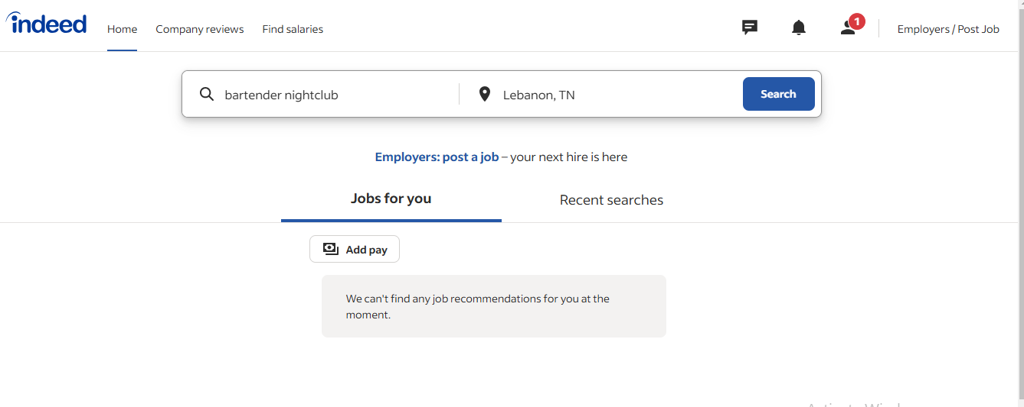

Figure 1-Indeed-Home-page/Job-Search.

#### **Functionalities:**

Indeed, is a job search platform connecting job seekers with employers. It offers job search filters, resume uploads, direct applications, company reviews, salary insights, and job alerts. Employers can post jobs, review applications, and manage recruitment. Users also access career resources like resume tips and interview guides.

#### **Limitations:**

**-Job Quality Variance**: Listings can include low-quality or outdated postings, making it harder to find suitable opportunities.

**-Paywall for Employers**: Features like candidate insights or job visibility enhancements often require paid access, limiting accessibility for smaller companies.

#### **Advantages:**

**-Friendly User Interface**: The platform is easy to navigate, with intuitive search and filtering options.

**-Employer Reviews**: Job seekers can read reviews and ratings of companies to make informed decisions.

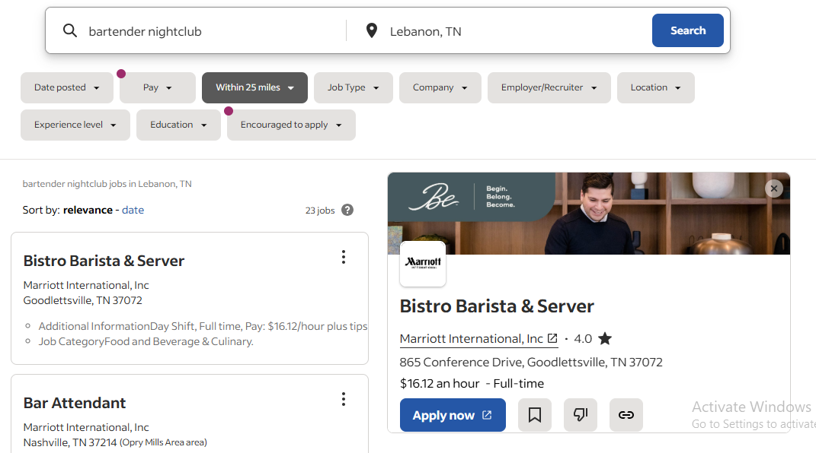

Figure 2-Indeed/Job-Search-Result.

### **Instawork:**

#### **Description:**

**Instawork** connects businesses with hourly workers, specializing in industries like hospitality, logistics, and food service. Workers can find flexible gigs that match their skills and schedule, while businesses can quickly fill shifts with pre-vetted professionals. [4]

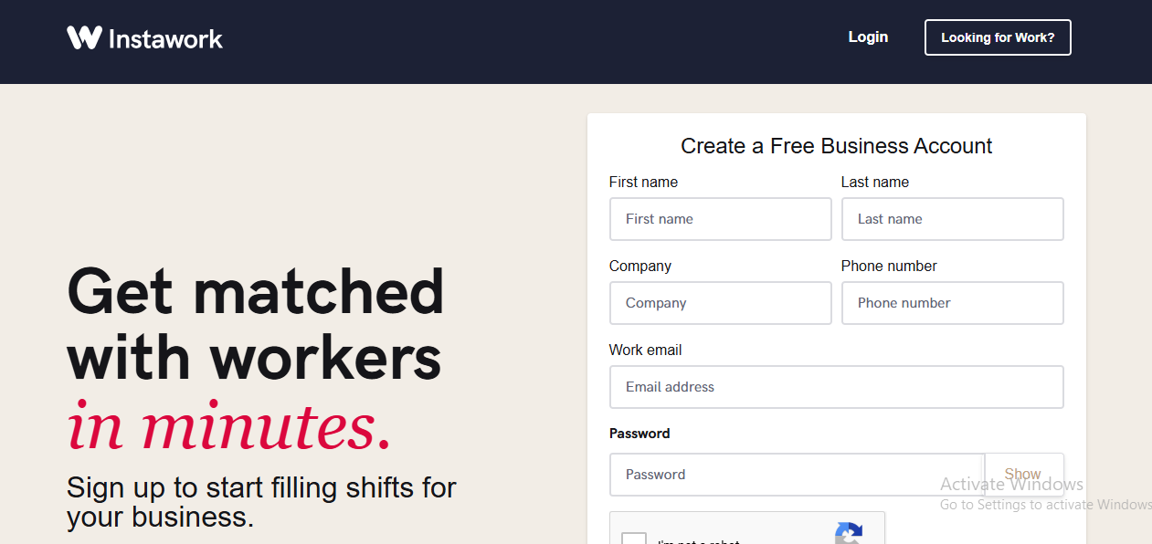

Figure 3-Instawork-Create-Employer-Account.

#### **Functionalities:**

##### **For Workers:**

Workers can create a detailed profile showcasing their skills, experience, and availability. The platform offers the ability to select shifts that match their schedules, providing freedom and control over work hours. Additionally, workers can build their professional reputation by earning ratings and reviews from employers. Payments are processed securely and delivered directly through the app.

##### **For Businesses:**

Employers can post job opportunities and access a pool of pre-vetted, skilled professionals. The platform simplifies shift management with a user-friendly dashboard, allowing businesses to organize and track schedules with ease. Employers can review worker profiles and ratings to ensure they select the right candidates for their needs. Instawork’s flexibility also enables businesses to adjust staffing levels based on demand, eliminating the need for long-term commitments.

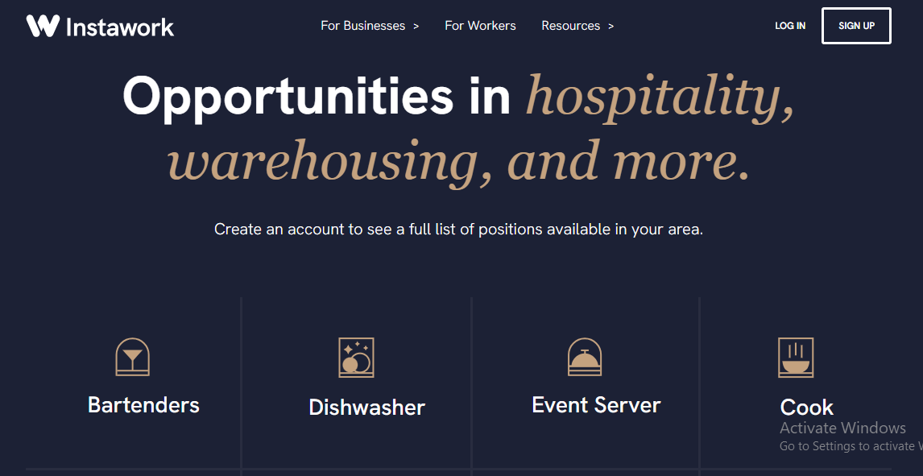

Figure 4-Instawork/Job-Opportunities.

#### **Limitations:**

- The platform is not available in all cities or regions, limiting access for some users.

- Businesses may find it challenging to ensure worker quality, as they rely on pre-screened profiles and reviews.

#### **Advantages:**

-Businesses can review worker profiles and ratings to find the right fit.

-Instawork offers flexible scheduling, allowing workers to choose gigs that fit their lifestyle.

### **2.2.3. Sirvo platform:**

#### **Description:**

Sirvo offers tools for hiring in the restaurant, retail, and hospitality industries. It allows for unlimited job postings, application tracking, and talent search through its database. Employers can create customized career pages, sync job listings with social media platforms, and distribute jobs across partner networks. It also includes features like multi-admin access and customizable job forms​. [5]



Figure 5-Sirvo /Home page.

#### **Functionalities:**

Sirvo offers tools for hiring in the restaurant, retail, and hospitality industries. It allows for unlimited job postings, application tracking, and talent search through its database. Employers can create customized career pages, sync job listings with social media platforms, and distribute jobs across partner networks. It also includes features like multi-admin access and customizable job forms​.

#### **Limitations:**

**-Limited Global Reach**: It appears to cater mainly to the U.S. market, which could limit its usefulness for international companies or those hiring globally.

**-No Free Trial**: Sirvo doesn't provide a free trial, which might deter businesses wanting to test its features before committing.

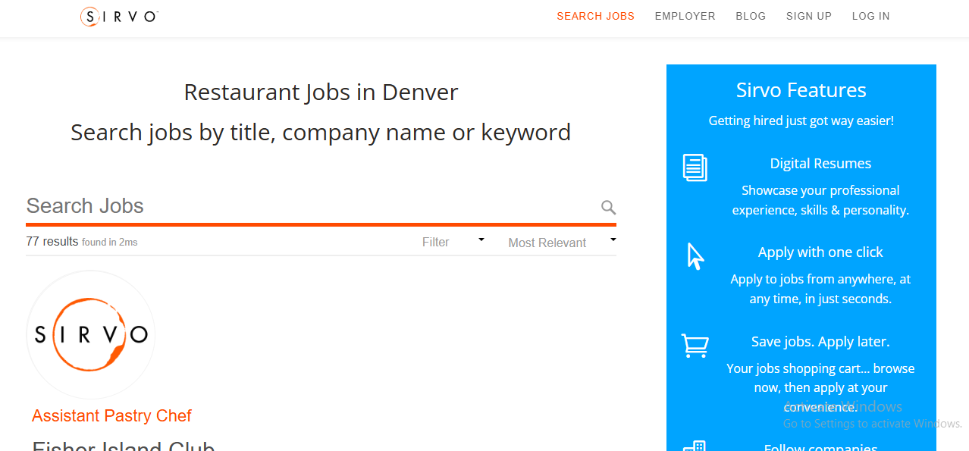

Figure 6-Sirvo /Job Search.

#### **Advantages:**

**Ease of Use**: User-friendly tools like an intuitive applicant tracking system (ATS) simplify managing applications and coordinating hiring efforts.

**On-Demand Talent Access**: Employers can search a library of candidate profiles, filtering by keywords and skills.

## **Conclusion:**

Briefly, in this section we analyzed three applications **Indeed**, **Instawork**, and **Sirvo** to understand their features, advantages, and limitations. While **Indeed** excels in global reach and user-friendliness. However, it struggles with job quality and paid features. In other hand, **Instawork** offers flexibility for hourly workers but is regionally limited. Last but not Least, **Sirvo** provides robust hiring tools for the hospitality sector but lacks global reach and a free trial. These insights will help us design a more efficient **JobLink** platform that addresses existing gaps and improves user experience for jobseekers and employers.

# **Chapter 3: Requirements:**

## **3.1. Introduction:**

In this chapter, and once we have finished analyzing and searching for some existing application that are same as JobLink, we will begin by collecting the different requirements of JobLink platform.

In particular, we will start in section 1 by stating the different stackholders, then in section 2 we will describe the functional requirements, in section 3 the non-functional requirements. [6]

## **3.2. Stackholders:**

The main users of this platform can be grouped by three stackholders:

1. Firstly, the Job Seekers (young adults), where they search for a part-time or full-time jobs and in where they benefit from easy access to job opportunities.
2. Secondly, the Employers (or businesses), in the hospitality industries that are looking to hire staff, and they use the platform to post jobs and communicate with candidates.
3. Thirdly, the developers or the administrators that are responsible of managing the backend of the platform and ensure smooth operations for users and support them.

## **3.3. Requirements:**

It is very important to write requirements to our platform before starting the implementation since it shows us some features and functions of our system.

### **3.3.1. Functional Requirements:**

In this section we will provide different functional requirements for our platform:

* User can choose between a job seeker or employer.
* User can create an account or login to an account if it exists and reset their password.
* Job seeker can create their special profile and edit it.
* Job seekers can search for jobs and view job details.
* Job seeker can search and filter nearby opportunities using google maps and their locations.
* Job seeker can apply to jobs.
* Job seekers can receive jobs alert.
* Businesses can create a company profile and edit it.
* Businesses can post jobs, edit jobs or delete them.
* Businesses can view job seekers applications, and filter them.
* Businesses can receive notifications when new applications are submitted.
* Businesses can delete or edit their account.

### **3.3.2. Non-Functional Requirements:**

In this section we will provide the non-functional requirements for our platform:

* Our platform must have a maximum response time of 2 seconds for most user actions (performance requirements).
* Our platform must implement secure login mechanism (Security requirement)
* Our platform should have an intuitive and easy-to-navigate interface for both job seeker and employers. (Usability requirement)
* Our platform should be developed in an easy manner so it will be easy to update, allowing the addition of new features, and fixing bugs. (Maintainability requirement)
* Our System should not violate any Lebanese law. (Legal requirement)

# **Chapter 4: UML Diagrams:**

## **4.1. Introduction:**

Drawing some diagrams before starting doing our implementation part is very crucial, since it shows all the stakeholders a broader view about the main functionalities of our system [7]. Therefore, in this part of our graduation project, we decided to draw the use-case diagram, the activity diagram, and the class diagram.

## **4.2. Design:**

### **4.2.1. Use case diagram:**

In order to show you the use cases of our project, we drew our use-case diagram that shows us the use cases that every type of user can do while using our system. kindly, Check our below diagram.

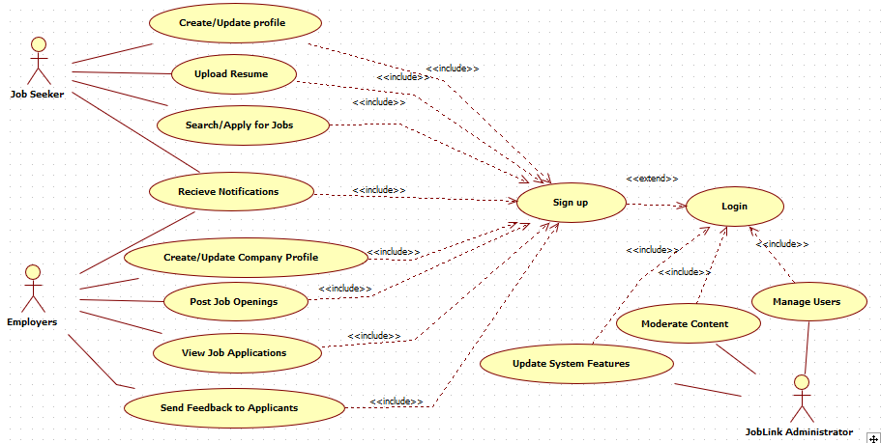

Figure 7-JobLink-Use case Diagram.

In JobLink Use-case diagram, we can see the use-case of each type of user in our system. Speaking of which, the job seeker can create and update profile, upload his CV or his resume, search or apply for jobs, and receive notifications. In other hand, employer can create and update a company profile, can post job openings, view job applications, send feedback to applicants, and receive notifications provided that both employer and job seeker already registered in our system and they logged in afterwards. However, JobLink administrator can manage users, moderate the content of the platform, and update the features of the system. However, we have to note that the admins can do all of the above by logging in by typing their usernames and passwords that they got from their managers.

### **4.2.2. Activity diagram:**

In order to show you some activities of our project before starting our implementation part, we drew our activity diagram that describe how system activities are connected one to another. kindly, Check our below diagram.

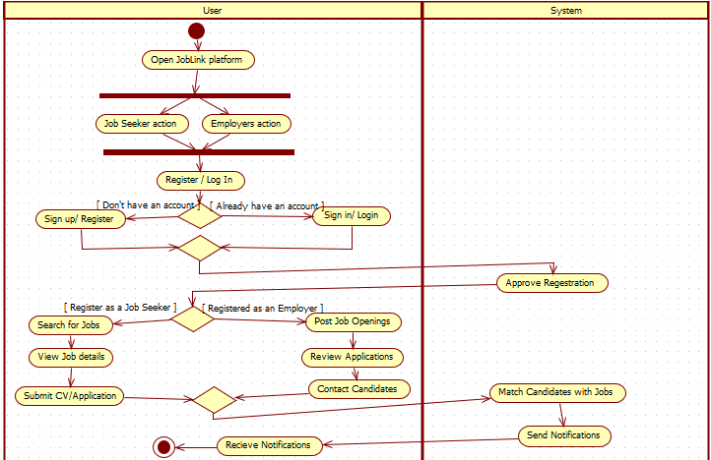

Figure 8 JobLink-Activity Diagram.

In this diagram, we can see the steps of our system and how it works. our system began by entering to the website, where a user has the choice to choose the action needed to login to our website either as a job seeker or as an employer. Then, user must sign up to our website in order for them to login afterwards if they are not already registered.

After that, user will receive registration approval message. If the user register as a jobseeker, he can search for jobs, view jobs details, and submit CV. However, if he registers as an employer, user can post jobs, review applications, and contact candidates. our System Match the candidates with jobs and send notifications for user in order to receive it.

### **Class diagram:**

It is very important to draw a class diagram for our system before starting our implementation part of the system. Kindly check it.

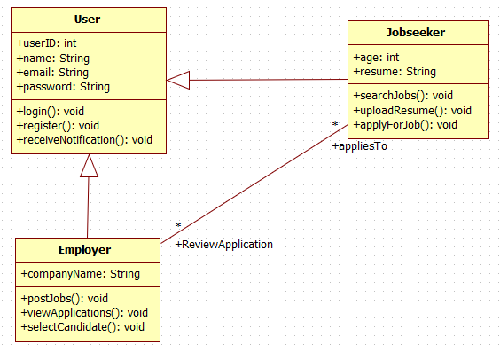

Figure 9-JobLink-Class Diagram.

Based on the JobLink class diagram in Figure 9:

The User class serves as the base class for both Jobseeker and Employer. It contains four attributes: userID (int), name (String), email (String), and password (String). The class also defines 3 methods: login (), register (), and receiveNotification(), where these 3 methods return void.

The **Jobseeker** class inherits from the User class, extending its functionality. It includes two additional attributes: age (int) and resume (String), which are specific to jobseekers. The class provides three methods: uploadResume(), searchJobs(), and applyForJob().

The **Employer** class also inherits from the User class. It has one unique attribute, companyName (string). The class defines three methods: postJob(), viewApplications(), and selectCandidate().

In this class diagram there are two direct associations with their multiplicities added where multiple **Jobseeker** can apply for jobs posted by Employers, and Employers can review multiple applications from Jobseekers.

# **Chapter 5: Used Technology and Software Tools:**

## **Solution Overview**

The "JobLink" platform is designed to streamline the recruitment process for both job seekers and employers in the hospitality and service industries. The platform leverages modern technologies to provide a user-friendly interface, real-time job updates, and efficient communication between stakeholders. The development process follows a structured methodology to ensure that all requirements are met, and the system is robust, scalable, and easy to maintain.

## **Development Methodology (Design Approach)**

The development of the "JobLink" platform follows the **Waterfall methodology**, a linear and sequential approach that ensures each phase of the project is completed before moving on to the next. This methodology is particularly suitable for projects with well-defined requirements, such as "JobLink," where the functional and non-functional requirements have been clearly outlined in Chapter 3.

### **Phases of the Waterfall Methodology:**

1. **Requirements Gathering:**
   * The requirements for the platform were gathered and documented in Chapter 3, including both functional and non-functional requirements.
2. **System Design:**
   * The system design phase involved creating UML diagrams (use-case, activity, and class diagrams) to visualize the system's structure and interactions. These diagrams were presented in Chapter 4 of the report.
3. **Implementation:**
   * The implementation phase involves coding the platform using the selected development tools and technologies. This phase is guided by the design documents and requirements.
4. **Testing:**
   * The testing phase ensures that the platform meets all functional and non-functional requirements. Various testing methods, such as unit testing, integration testing, and user acceptance testing, will be conducted.
5. **Deployment:**
   * Once testing is complete, the platform will be deployed for use by job seekers and employers.
6. **Maintenance:**
   * Post-deployment, the platform will be maintained to fix bugs, add new features, and ensure smooth operation.

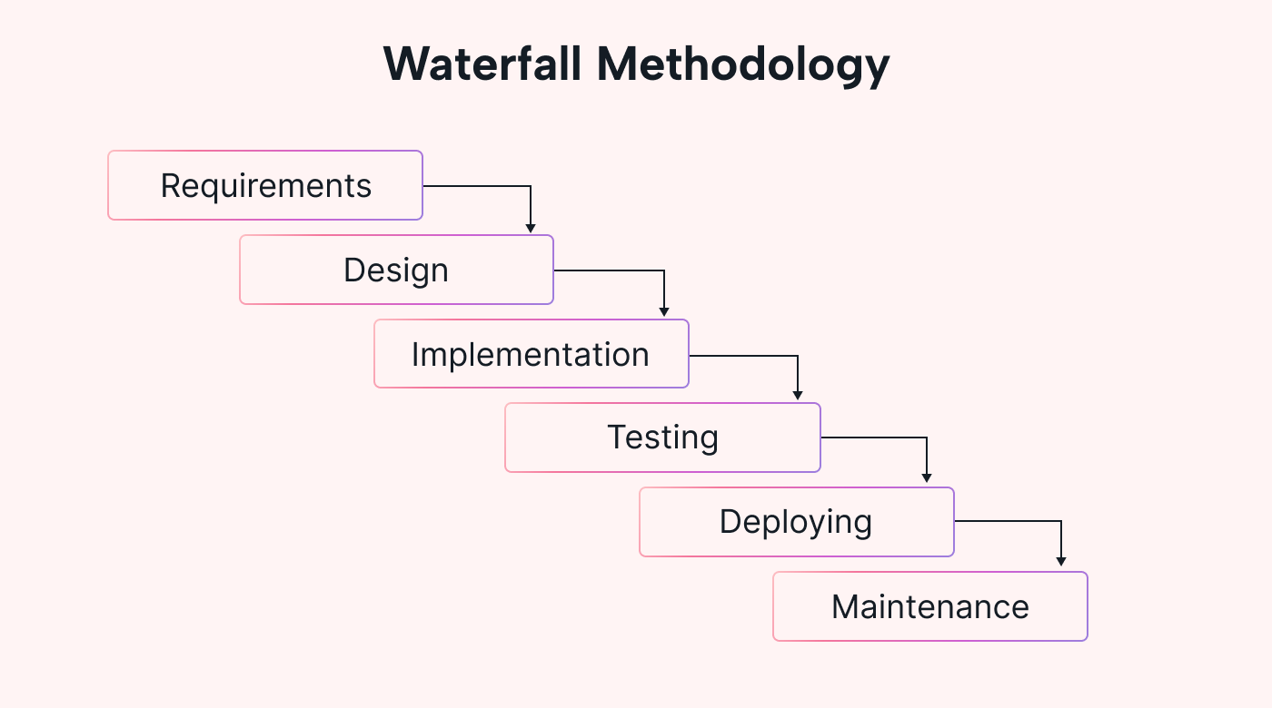

## **Development Environment (Development Tools)**

The "JobLink" platform is developed using a combination of modern tools and technologies that ensure efficiency, scalability, and ease of use. Below is an overview of the development

## **Implementation**

The implementation phase involves translating the design documents into a functional platform. The following steps were taken during implementation:

1. **Frontend Development:**
   * The frontend of the platform was developed using Flutter, ensuring a responsive and user-friendly interface for both job seekers and employers. The UI components were designed based on the use-case and activity diagrams.
2. **Backend Development:**
   * The backend was implemented using Firebase for real-time data storage and authentication. MySQL was used for managing structured data, such as job postings and user profiles.
3. **Integration:**
   * The frontend and backend were integrated to ensure seamless communication between the user interface and the database. APIs were developed to facilitate data exchange between Flutter and Firebase/MySQL.
4. **Testing:**
   * The platform was tested at various stages of development to ensure that all functional and non-functional requirements were met. Unit tests were conducted for individual components, while integration tests ensured that the system worked as a whole.

## **Testing**

Testing is a critical phase in the development of the "JobLink" platform. The following testing methods were employed:

1. **Unit Testing:**
   * Individual components of the platform, such as the job search functionality and user authentication, were tested to ensure they worked as expected.
2. **Integration Testing:**
   * The integration between the frontend and backend was tested to ensure that data was correctly exchanged and displayed to users.
3. **User Acceptance Testing (UAT):**
   * A group of potential users (job seekers and employers) were invited to test the platform and provide feedback. This feedback was used to make final adjustments before deployment.

## **Conclusion**

The design, implementation, and testing of the "JobLink" platform were carried out using a structured and methodical approach. The use of modern tools like Flutter and Firebase ensured that the platform is efficient, scalable, and user-friendly. The Waterfall methodology provided a clear roadmap for development, ensuring that all requirements were met and the platform was delivered on time.

# **References**

|  |  |
| --- | --- |
| [1] | "North Eastern Graduate Program," 18 May 2022. [Online]. Available: https://graduate.northeastern.edu/. [Accessed 18 December 2024]. |
| [2] | "Project Manager," 2022. [Online]. Available: https://www.projectmanager.com/guides/project-scheduling. [Accessed 18 December 2024]. |
| [3] | "Indeed," November 2024. [Online]. Available: https://www.indeed.com/. [Accessed 18 December 2024]. |
| [4] | "InstaWork," 2015. [Online]. Available: https://www.instawork.com/. [Accessed 18 December 2024]. |
| [5] | "Sirvo," 2020. [Online]. Available: https://sirvo.com/. [Accessed 18 December 2024]. |
| [6] | "iiba," 2003. [Online]. Available: https://www.iiba.org/special-pages/global-standard-for-business-analysis-membership/. [Accessed 18 December 2024]. |
| [7] | "White star UML," 2011. [Online]. Available: https://sourceforge.net/projects/whitestaruml/. [Accessed 18 December 2024]. |