Course Project week 5

Table output

Joey Muzzo

Braxton Snyder

12/1/18

DeVry University

CUSTOMER

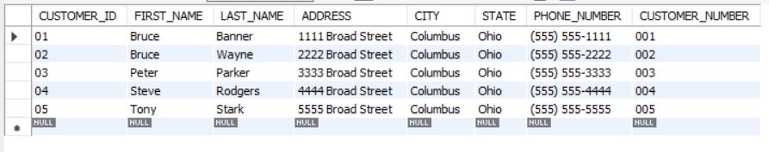

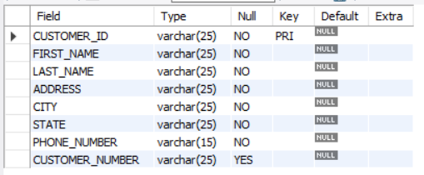

TECHNICIAN

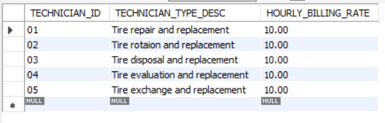

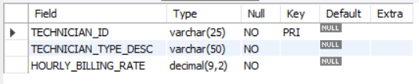

GARAGE

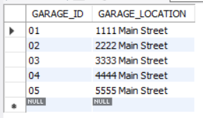

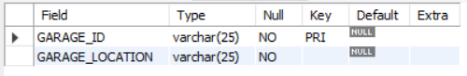

GARAGE_LOG

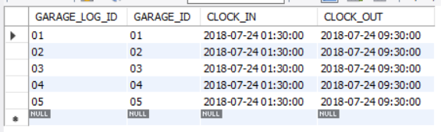

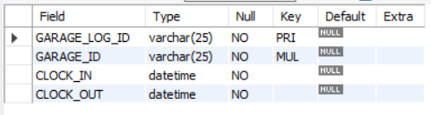

EMPLOYEE

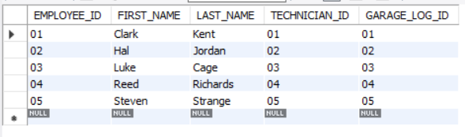

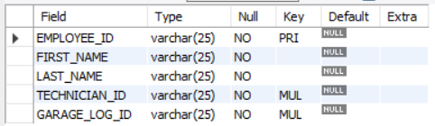

VEHICLE

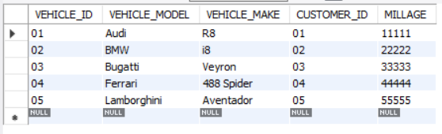

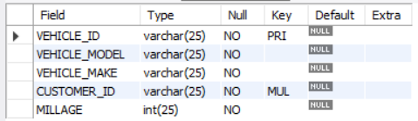

INVOICE

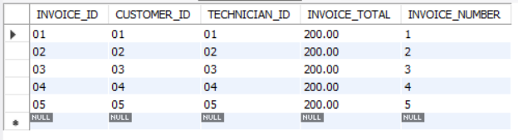

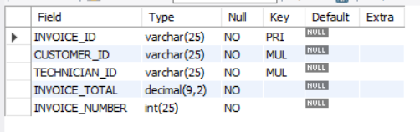

PRODUCT

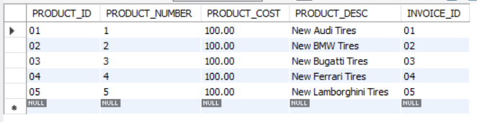

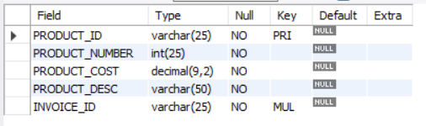

SERVICE

