Joey Muzzo

Braxton Snyder

Course project Week 7

Task 3 and lessons learned

CIS-336

12/7/18

UPDATE

For my update requirement I chose to update the hourly billing rate for technician 05 and to update the price of all invoice totals to $250. Technician 05 received a raise and the price of all work increased slightly raising the price of each invoice total to $250.

UPDATE QUERY

UPDATE TECHNICIAN T, INVOICE I

SET T.HOURLY_BILLING_RATE = 15, I.INVOICE_TOTAL = 250

WHERE T.TECHNICIAN_ID IN

(SELECT TID

FROM

(SELECT TECHNICIAN_ID AS TID

FROM INVOICE I

WHERE I.TECHNICIAN_ID = 05 ) AS C);

OLD TECHNICIAN TABLE

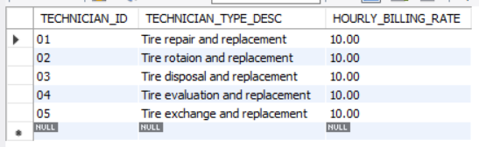

OLD INVOICE TABLE

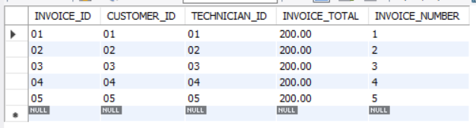

UPDATED TECHNICIAN TABLE RESULTS

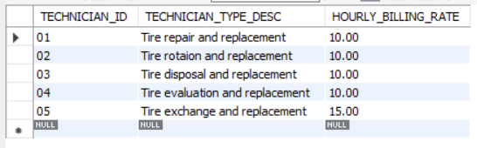

UPDATED INVOICE TABLE RESULTS

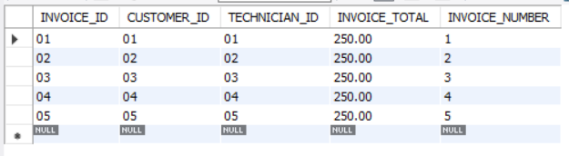

OR 2ND POSSIBLE UPDATE

I wasn’t totally sure how to interpret the first task, so I made a 2nd possible update. For this update I chose to update the hourly billing rate for technician 05. The business requirements for this update are that technician 05 received a promotion and his hourly billing rate increased.

2ND UPDATE QUERY

UPDATE TECHNICIAN

SET HOURLY_BILLING_RATE = 15

WHERE TECHNICIAN_ID =

(SELECT TECHNICIAN_ID

FROM INVOICE

WHERE TECHNICIAN_ID = 05);

2ND UPDATE RESULTS

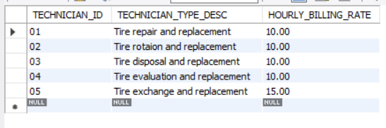

REPORT 1

For my first report I chose to make a customer view which shows all the customers for my business. The business requirement for this report is to provide information about the customers of the business. The report provides the customer id, the customers first and last name as one field named customer, the customers address, city, phone number, and customer number.

REPORT 1 QUERY

CREATE OR REPLACE VIEW CUSTOMER_NEW AS

SELECT CUSTOMER_ID AS "CUSTOMER ID", CONCAT(last_name,', ',first_name) AS Customer, ADDRESS, CITY, STATE, PHONE_NUMBER AS "PHONE NUMBER", CUSTOMER_NUMBER AS "CUSTOMER NUMBER"

FROM CUSTOMER;

SELECT * FROM CUSTOMER_NEW;

REPORT 1 RESULTS

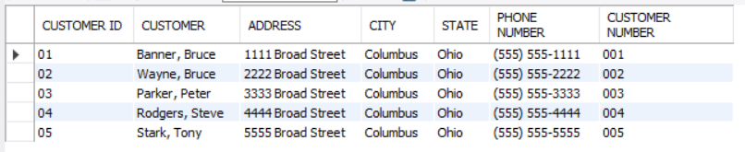

REPORT 2 USING A JOIN

For my second report, I chose to create a customer invoice report which shows a summary of every customer and their invoice total. The business requirement for this report is to show the invoice total for each customer in one table. This helps to track the customers and the total they owe. This report provides the customer id, the customers first and last name as one field named customer, the customer number, the invoice id, invoice total, and invoice table in one view.

REPORT 2 QUERY

CREATE OR REPLACE VIEW CUSTOMER_INVOICES AS

SELECT C.CUSTOMER_ID AS "CUSTOMER ID", CONCAT(C.last_name,', ',C.first_name) AS CUSTOMER, C.CUSTOMER_NUMBER AS "CUSTOMER NUMBER", I.INVOICE_ID AS "INVOICE ID", I.INVOICE_TOTAL AS "INVOICE TOTAL", I.INVOICE_NUMBER AS "INVOICE NUMBER"

FROM CUSTOMER C JOIN INVOICE I ON

C.CUSTOMER_ID = I.CUSTOMER_ID;

SELECT * FROM CUSTOMER_INVOICES;

REPORT 2 RESULTS

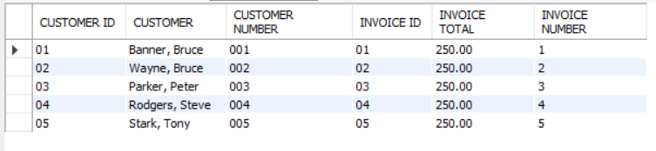

REPORT 3 _USING A SUBQUERY

For this report I chose to create a customer invoices 1 report that shows the customer id, the customer’s first and last name combined into one field, the customers state and city combined into one field, and the customers phone number. The business requirement for this report is to show customers identifying information in one table without duplicates. This helps to track the customers of the business.

REPORT 3 QUERY

CREATE OR REPLACE VIEW CUSTOMER_INVOICES1 AS

SELECT C.CUSTOMER_ID AS "CUSTOMER ID", CONCAT(C.last_name,', ',C.first_name) AS CUSTOMER, CONCAT(C.CITY, ', ',C.STATE) AS LOCATION, C.PHONE_NUMBER

FROM CUSTOMER C

WHERE CUSTOMER_ID IN (SELECT distinct CUSTOMER_ID FROM INVOICE);

SELECT * FROM CUSTOMER_INVOICES1;

REPORT 3 RESULTS

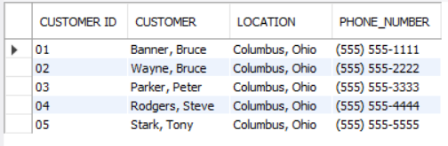

REPORT 4 USING AN AGGREGATE FUNCTION

For this report I chose to create an invoice sum report that shows the sum of all the invoice totals for the business. The business requirement for this report is show the calculated sum of all the invoice totals for the business. This is helpful for calculating the total earned by the business for its services. This report provides the calculated sum of all the invoice totals for the business.

REPORT 4 QUERY

CREATE OR REPLACE VIEW INVOICE_SUM AS

SELECT SUM(INVOICE_TOTAL) AS "INVOICE SUM"

FROM INVOICE

WHERE INVOICE_ID >= 1

ORDER BY INVOICE_ID;

SELECT * FROM INVOICE_SUM;

REPORT 4 RESULTS

