Pre-Requisite:

1. install Zabbix Server:

I found a very good tutorial at having step by step guide to install Zabbix on CentOS 7:

<https://www.digitalocean.com/community/tutorials/how-to-install-and-configure-zabbix-to-securely-monitor-remote-servers-on-centos-7>

  Here is one of portal having detailed steps for installation : <https://www.howtogeek.com/197947/how-to-install-python-on-windows/>

Steps:

1 Setting-up Zabbix Server:

1.1 Configure PaperCut in Zabbix Server:

~~(~~[~~https://www.papercut.com/kb/Main/SimpleMonitorZabbix~~](https://www.papercut.com/kb/Main/SimpleMonitorZabbix)~~)~~

1.2.1 Log in to the Zabbix administration page at:- http://<server ip or hostname>/Zabbix

Use the administrator Zabbix server login and password created set at time in installation (i.e. step 1.1 1)

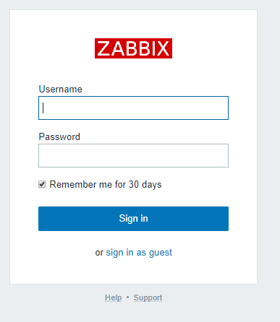

1.2.2 Create Host Group:

* Select **‘Configuration > Hosts Groups**’.
* Click **‘Create Host group**’.

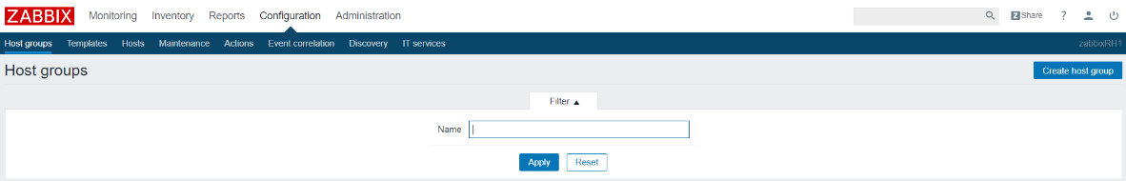

* Define Group name as wthat ever you want and relevant for latter reference and click ‘Add’:

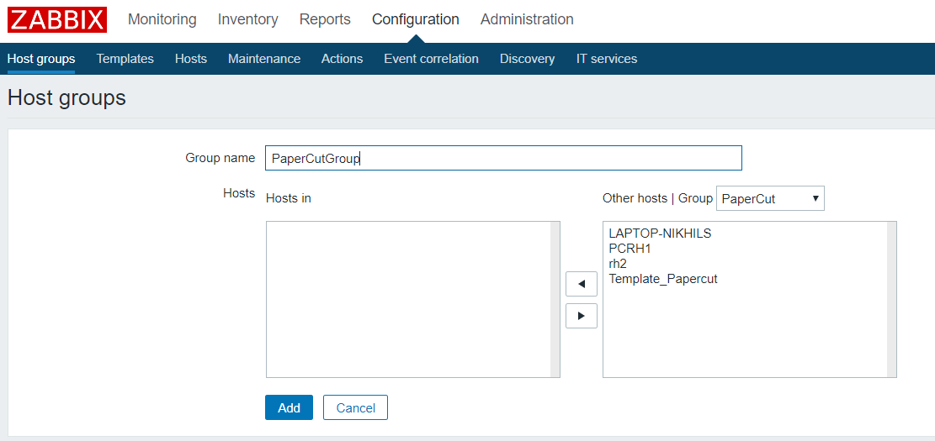

1.2.4 Add PaperCut Server in Zabbix as Host­­­­­

* Select **‘Configuration > Hosts**’.
* Click **‘Create Host**’.



* Create the host that corresponds to your PaperCut Application Server.
  + Host name: Set is as exact hostname (do not include the FQDN) if your papercut server
  + Visible Name : Keep it simple that help you easily identify the server.
  + Select the Group we created for PaperCut in Step 1.2.2 above.
  + Change the IP and set it as the IP-address of your PaperCut Application Server.
  + Change the Port to 9191.
  + Leave ever thing else as default and click on “Add”

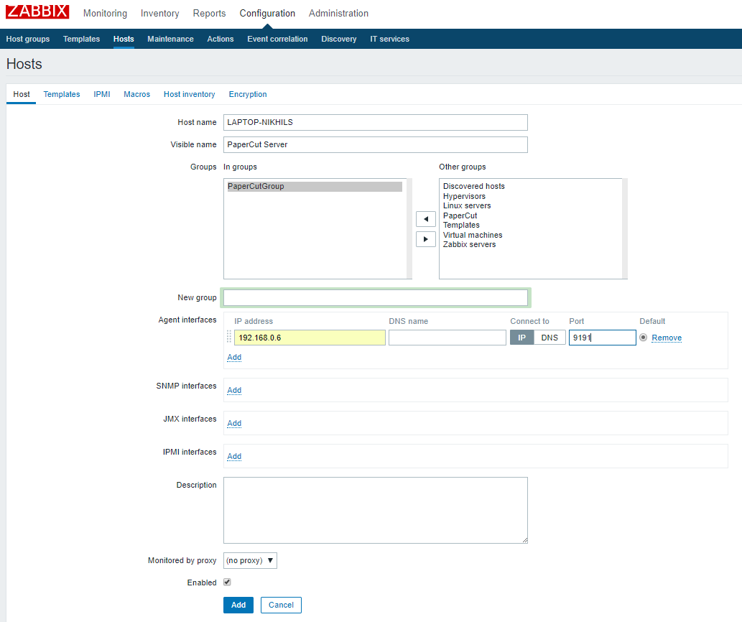

The New PaperCut Server is showing now:

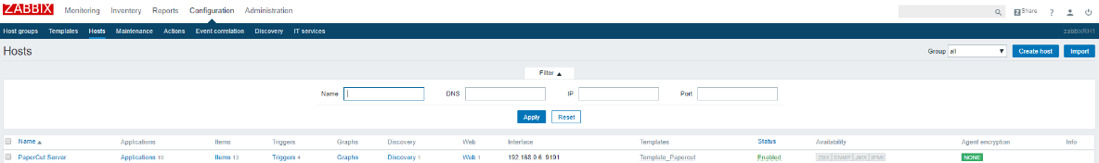

* + 1. Import template in Zabbix for PaperCut:

1.2.3.1 Download “**zabbix_papercut_template.xml**” file from <https://github.com/Open-Future-Belgium/zabbix-papercut/tree/master/template>

By right clicking on “Zabbix_papercut_template.xml” and select “save as”.

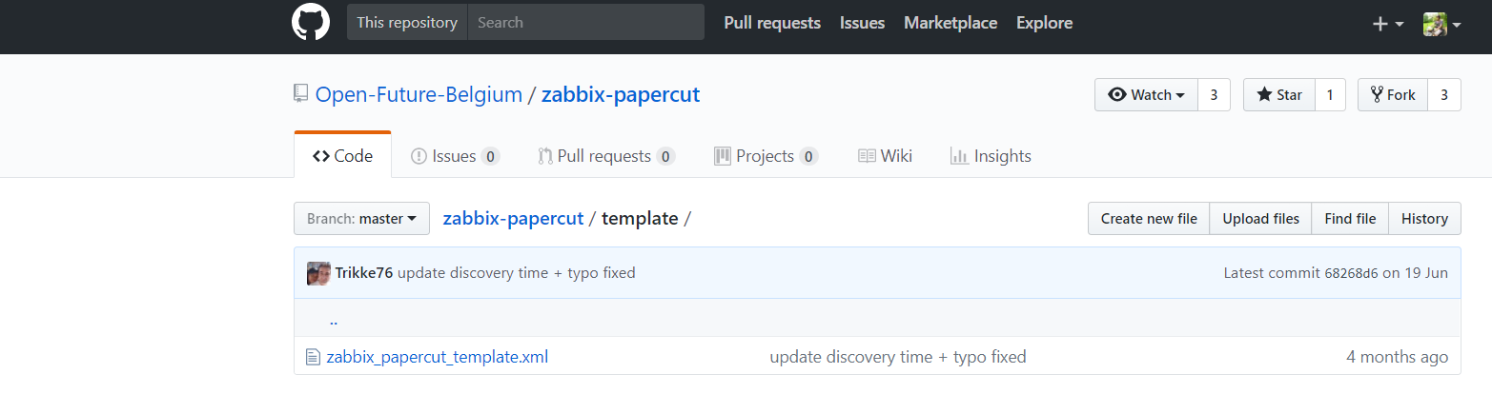

1.2.3.2 On Zabbix Server web-admin page:

* Select **‘Configuration > Templates**’.
* Click **‘Import**’.



The new page will appear. Click on “Choose file”

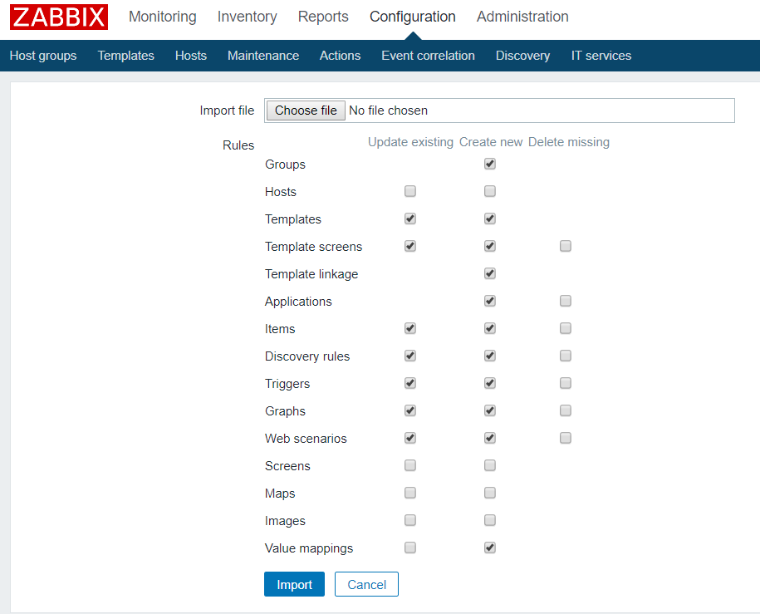

Navigate to location where you have saved the Zabbix_papercut_template.xml. Select “Zabbix_papercut_template” and click on open.

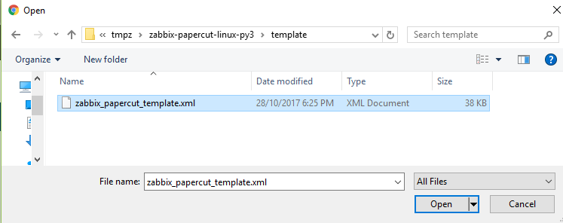

Click on Import with default option:

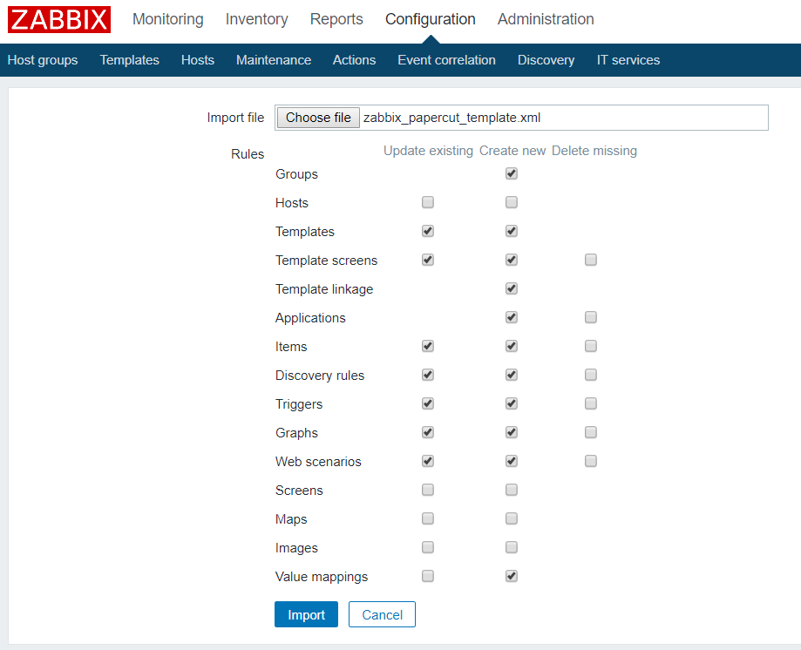

This will create PaperCut Template.

Tip: If you have trouble in finding it due to long list of templates; search with string ‘Papercut’ as Name in filter.

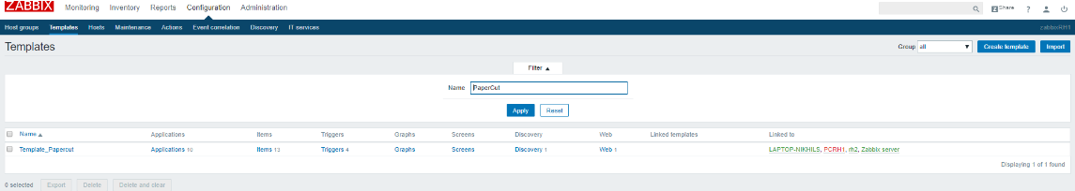

Open the template to add PaperCut Host in Template.

## Edit the Template:

In Groups: Add PaperCut Groups created above

Hosts / Templated: In “Other | Groups” drop down: select PaperCurt Groups created above. This will start showing PaperCut Server name. Select it to left window (i.e.In)

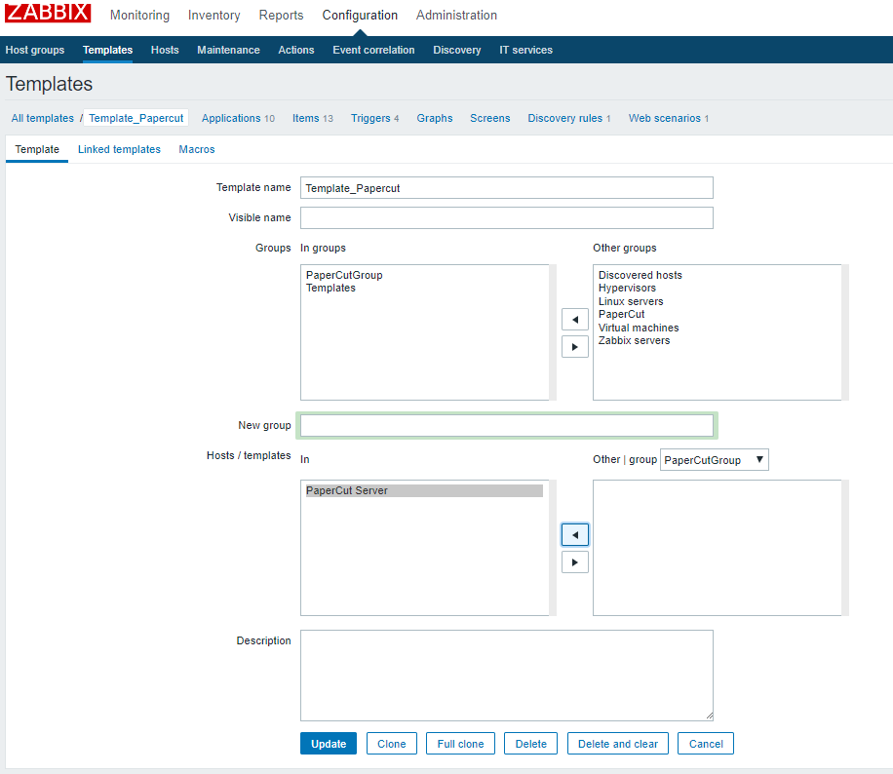

## Configure host Macros:

Navigate to Configuration → Hosts → Select PaperCut Host :

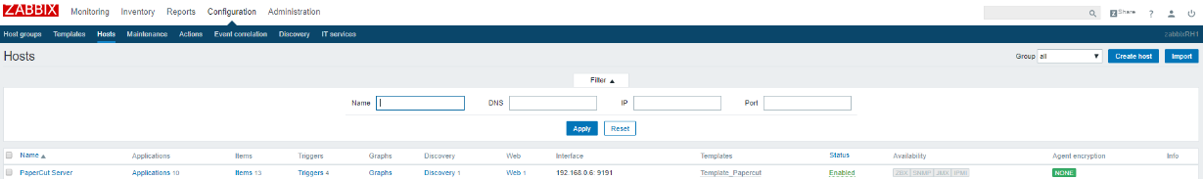

Go to Macros → Inherited and host macros → Click for” change” for Macro “{$AUTHORIZATION}” and {$PAPERCUTIP}.

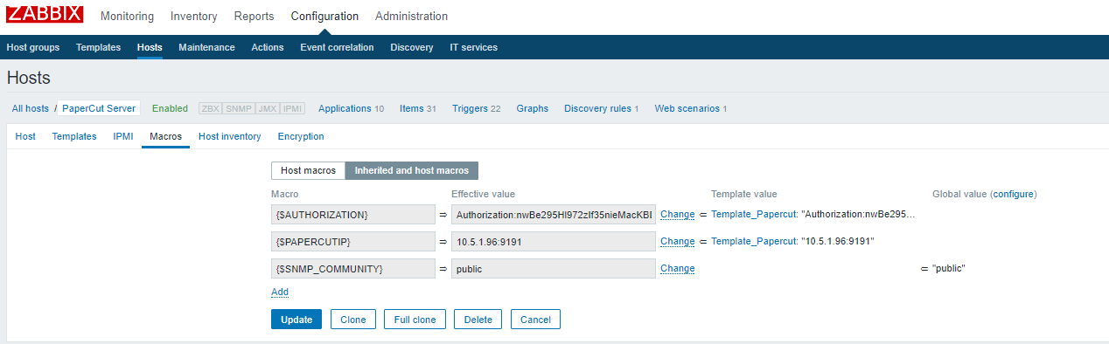

Afterwards click on Host macros . Check if both the Macro value now should be visible in “Host macros” section. Click on “Host macros” and update is same as you have specified in **#PCIP&Auth**:

* 1. populate the {$PAPERCUTURL} with the correct ip of your papercut server
  2. Populate the {$AUTHORIZATION} macro with your authorization key from papercut

It should look something like this:

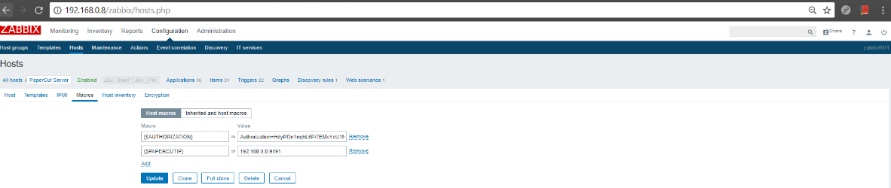

## **Install the Zabbix agent on the papercut server on Linux:**

1. Update Zabbix repository and Install the Zabbix agent on the papercut server:

Run below commands from Linux Shell:

# Add Zabbix repository

rpm -Uvh http://repo.zabbix.com/zabbix/3.4/rhel/7/x86_64/zabbix-release-3.4-1.el7.centos.noarch.rpm

# Install Zabbix agent

yum install zabbix-agent -y

# start Zabbix agent

systemctl start zabbix-agent.service

# confirm Zabbix agent is started

systemctl status zabbix-agent.service

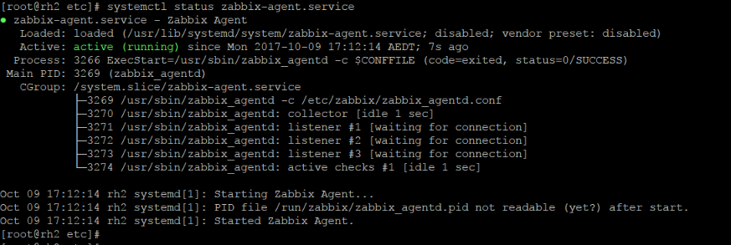

# Setup Zabbix agent to start at startup by default.

systemctl enable zabbix-agent.service



1. Download all code from : <https://github.com/Open-Future-Belgium/zabbix-papercut>
   1. Download all code (zabbix-papercut-linux-py3.zip) from : **#TBD**

By Clicking on “Clone or download” >> “Download ZIP

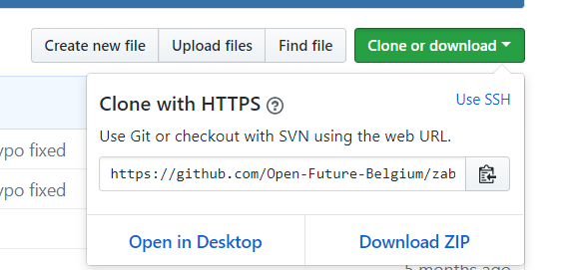

1. Copy all files to the folder /etc/zabbix on PaperCut Server.
2. On PaperCut Server, edit the “/etc/zabbix/papercut.conf” file add the correct Authorization token and papercut server ip.

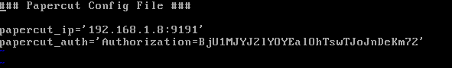

## Add comment:

Access PaperCut paperCut web-admin page: http://<PaperCut-Server-IP>:9191/admin.

Navigate to Optipns >> Advanced .

In the Advanced Page Scroll to Authorization. Copy the string after “=” in GET query parameter window, as highlited in the screen shot below:

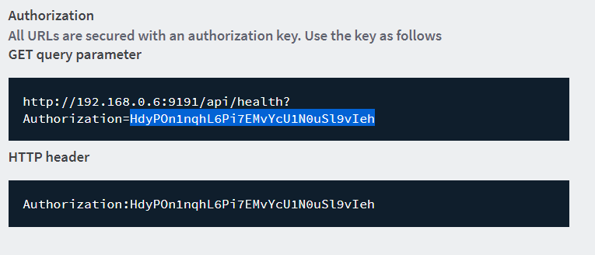

1. Go to “/etc/zabbix/Zabbix-agentd.conf” file and
   * 1. “Server=127.0.0.1” to “**Server=<Zabbix Sevrer IP address>”**
     2. “ServerActive=127.0.0.1” to “**ServerActive=<Zabbix Sevrer IP address>”**
     3. “Hostname=” to “**Hostname=<PaperCut-Server-Hostname>**”
     4. Add “UnsafeUserparameters=1” at last of the file to enable support for UnsafeUser parameters (we need this as there are “/” in the printer names)

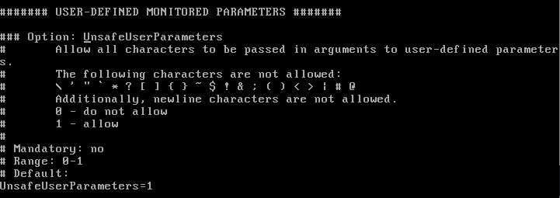

1. Restart the Zabbix-Agent on PaperCut Server, so that it picks up the new configuration files. The command is:

systemctl restart zabbix-agent.service

**##Final Test:**

All Done! Lets Check:

1. Check the latest data page to run the query to see if latest data feed from PaperCut Server:
   1. login to Web-admin page of Zabbix Server, navigate to Monitoring --> Latest date. Add PaperCut Server in Hosts parameter, and click on apply.
   2. You should be able to see latest data like:

Navigate to Monitoring 🡪 Latest Data :

Click on “Select” button for Host. The new window will pop-up.

On top right of windows select the PaperCut group Created Above ; afterwards it will start showing PaperCut Server Name. Check the box before Sever Name and click on select.

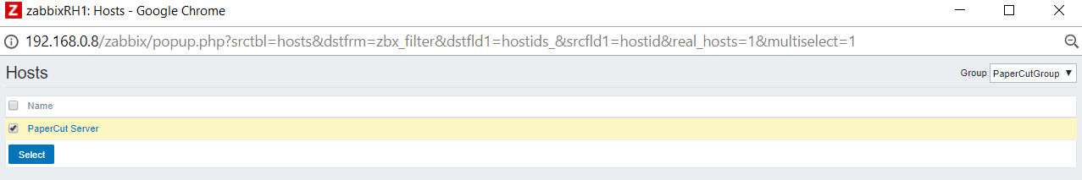

Now Enjoy the report. If it’s shoing date even for any and all priners name , that’s means it working. Give ot some time. Itshould starting showing all.

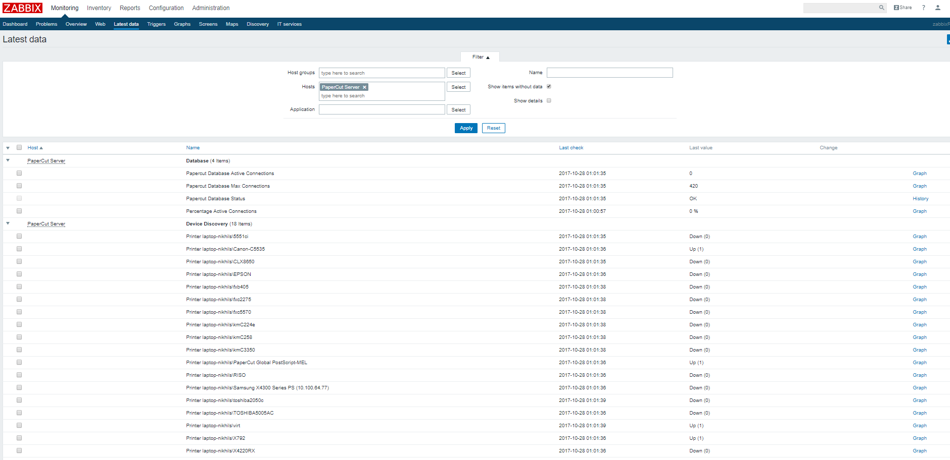

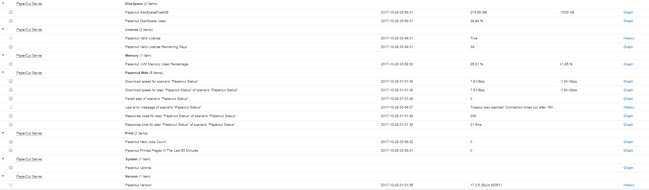

Troubleshooting:

* If no data pops up check if the hostname in the Zabbix server matches with the hostname in the agent.
* Try from the Zabbix Server, if you can telnet to port 9191 Zabbix server.
* Avoid DNS if possible as a broken DNS server can give you faulty information in Zabbix.
* To get a deeper understanding of Zabbix go to [www.zabbix.com](http://www.zabbix.com/) and find a certified partner to follow a training