Pre-Requsite:

1. Python 2.x or 3.x installed on PaoerCut server. Please download python from : <https://www.python.org/downloads/>

  Here is one of portal having detailed steps for installation : <https://www.howtogeek.com/197947/how-to-install-python-on-windows/>

Steps:

1 Installation and Setting-up Zabbix Server:

1.1 install Zabbix Server:

I found a very good tutorial at having step by step guide to install Zabbix on CentOS 7:

<https://www.digitalocean.com/community/tutorials/how-to-install-and-configure-zabbix-to-securely-monitor-remote-servers-on-centos-7>

1.2 When done, Configure PaperCut in Zabbix Server:

~~(~~[~~https://www.papercut.com/kb/Main/SimpleMonitorZabbix~~](https://www.papercut.com/kb/Main/SimpleMonitorZabbix)~~)~~

1.2.1 Log in to the Zabbix administration page at:- http://<server ip or hostname>/Zabbix

Use the administrator Zabbix server login and password created set at time in installation (i.e. step 1.1 1)

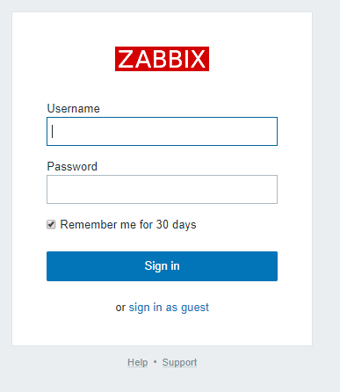

1.2.2 Create Host Group:

* Select **‘Configuration > Hosts Groups**’.
* Click **‘Create Host group**’.

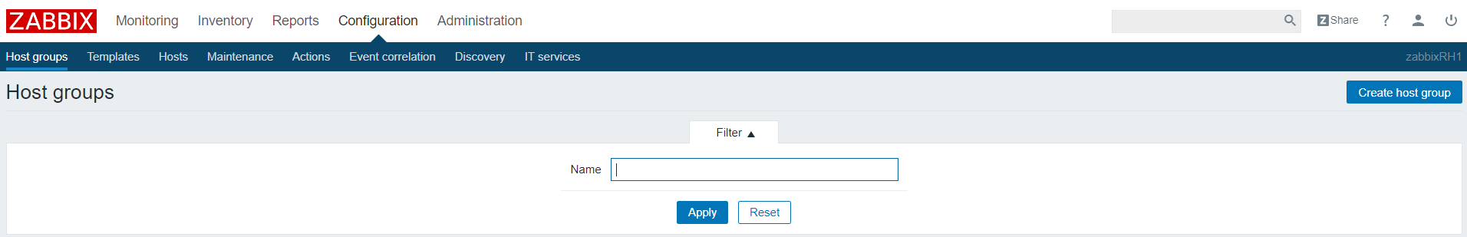

* Define Group name as wthat ever you want and relevant for latter reference and click ‘Add’:

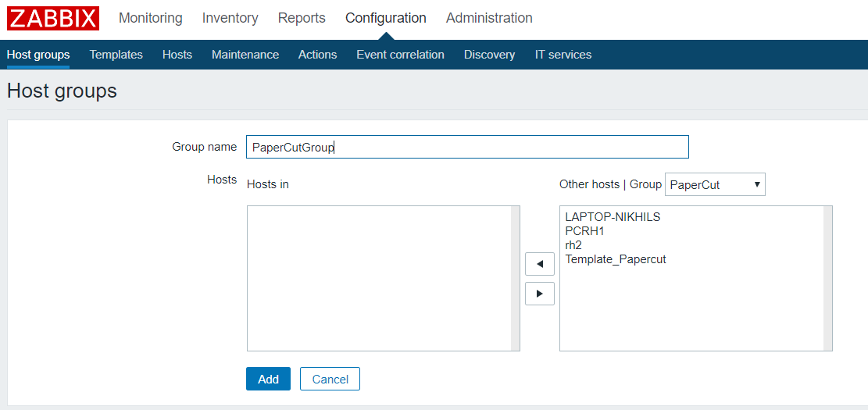

1.2.4 Add PaperCut Server in Zabbix as Host

* Select **‘Configuration > Hosts**’.
* Click **‘Create Host**’.



* Create the host that corresponds to your PaperCut Application Server.
  + Host name: Set is as exact hostname (do not include the FQDN) if your papercut server
  + Visible Name : Keep it simple that help you you easily identify the server.
  + Select the Group we created for PaperCut in Step 1.2.2 above.
  + Change the IP and set it as the IP-address of your PaperCut Application Server.
  + Change the Port to 9191.
  + Leave ever thing else as default and click on “Add”

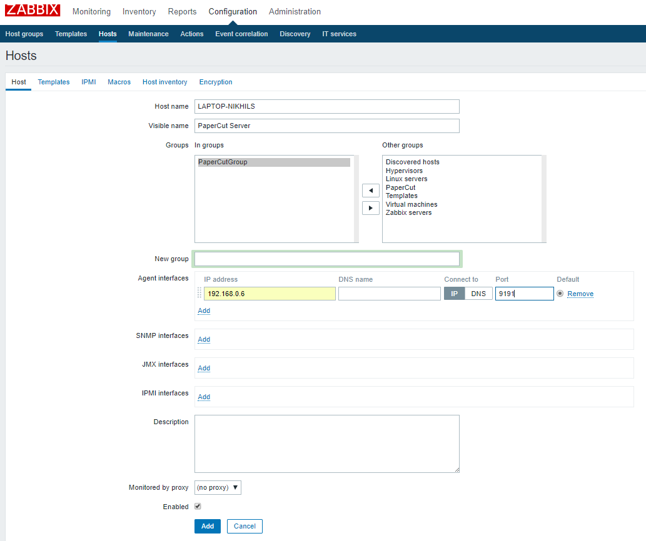

The New PaperCut Server is showing now:

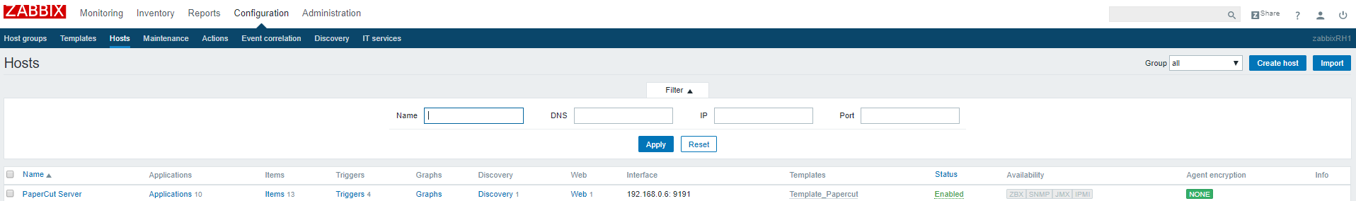

* + 1. Import template in Zabbix for PaperCut :

1.2.3.1 Download “**zabbix_papercut_template.xml**” file from <https://github.com/Open-Future-Belgium/zabbix-papercut/tree/master/template>

By right clicking on “Zabbix_papercut_template.xml” and select “save as”.

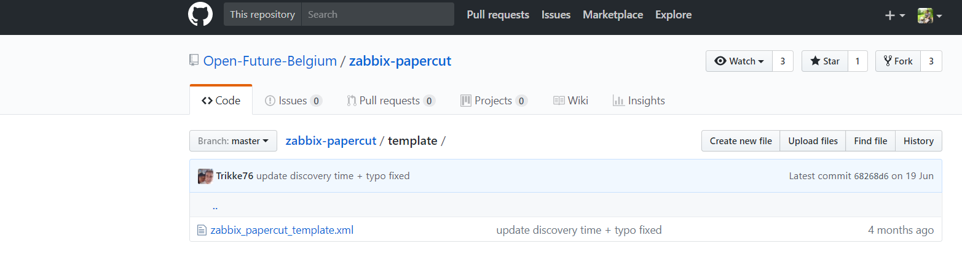

1.2.3.2 On Zabbix Server web-admin page:

* Select **‘Configuration > Templates**’.
* Click **‘Import**’.



The new page will appear. Click on “Choose file”

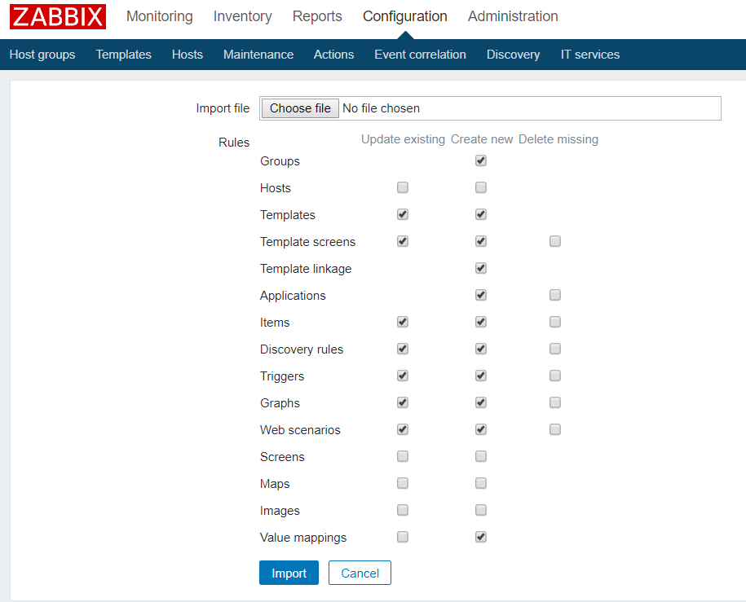

Navigate to location where you have saved the Zabbix_papercut_template.xml. Select “Zabbix_papercut_template” and click on open.

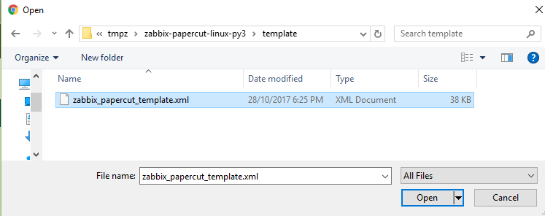

Click on Import with default option:

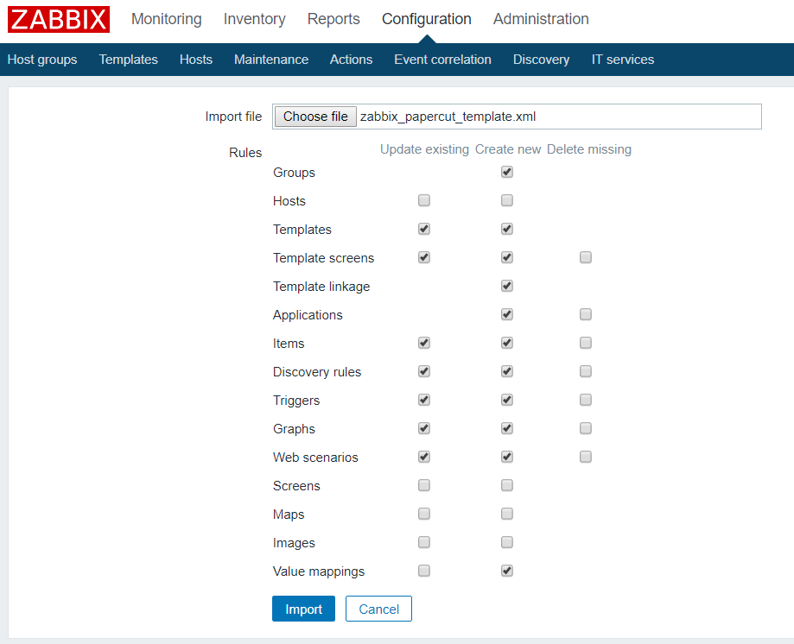

This will create PaperCut Template.

If you have trouble in finding it due to long list of templates; search with string ‘Papercut’ as Name in filter.

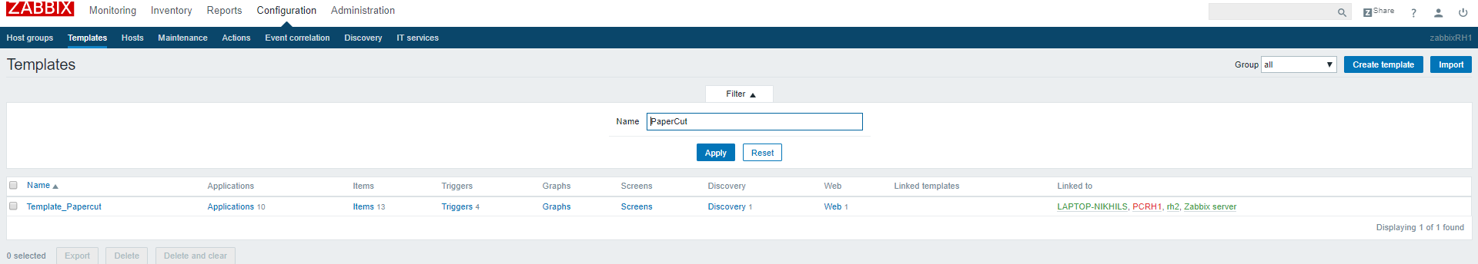

Open the template to add PaperCut Host in Template.

In Groups: Add PaperCut Groups created above

Hosts / Templated: In “Other | Groups” drop down: select PaperCurt Groups created above. This will start showing PaperCut Server name. Select it to left window (i.e.In)

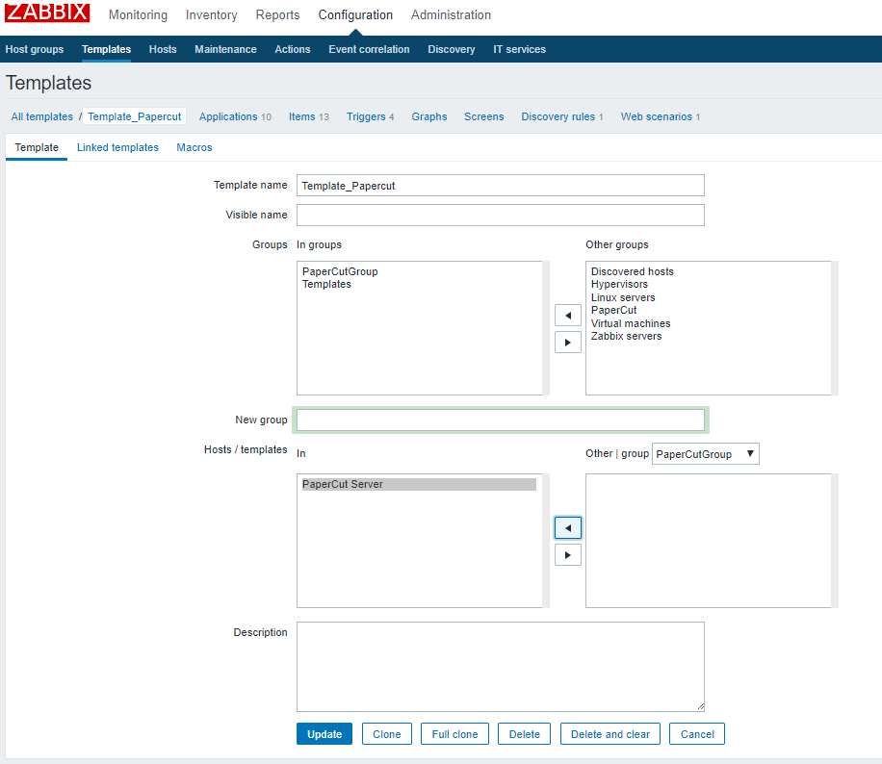

Configure host Macros:

Navigate to Configuration → Hosts → Select PaperCut Host :



Go to Macros → Inherited and host macros → Click for” change” for Macro “{$AUTHORIZATION}” and {$PAPERCUTIP}.

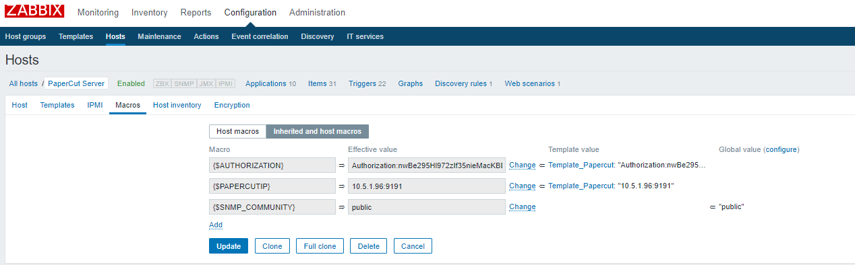

Afterwards click on Host macros . Check if both the Macro value now should be visible in “Host macros” section. Click on “Host macros” and update is same as you have specified in step 12 above:

* 1. populate the {$PAPERCUTURL} with the correct ip of your papercut server
  2. Populate the {$AUTHORIZATION} macro with your authorization key from papercut

It should look something like this:

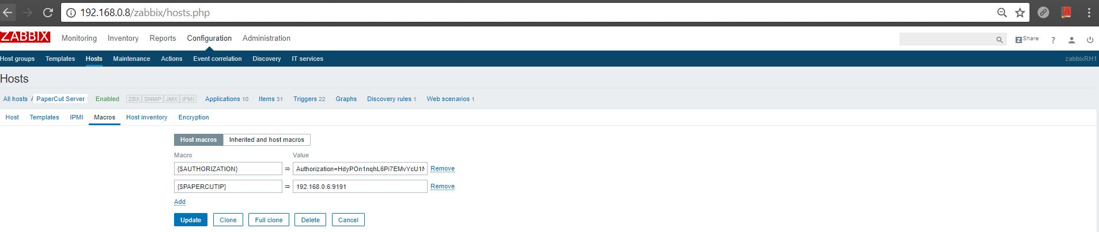

## **Install the Zabbix agent on the papercut server:**

* 1. I created “c:\zabbix” folder.
  2. Download latest Zabbix Source file from “Zabbix Source section” of link:  <https://www.zabbix.com/download>

Download 3.4.3 release.

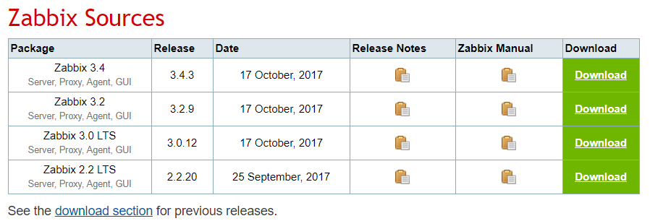

* 1. Copy the downloaded zabbix-3.4.3.tar.gz to “c:\zabbix” folder.
  2. Download all code (zabbix-papercut-linux-py3.zip) from : **#TBD**

By Clicking on “Clone or download” >> “Download ZIP

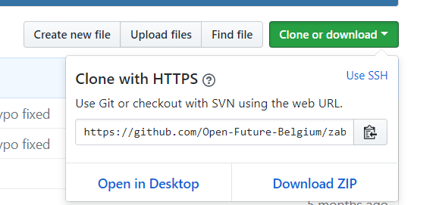

* 1. Copy the downloaded file (i.e.“ zabbix-papercut-linux-py3.zip.zip”) in “c:\zabbix” folder.

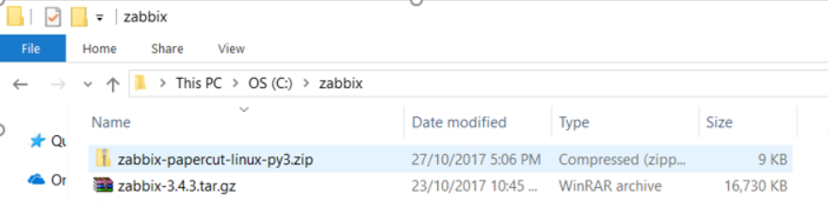

6. Modify the downlaod files and run the installation (Use 6.1 or 6.2):

6.1 Copy “InstallZabbixAgent.py” in c:\zabbix:

Form where #TBD

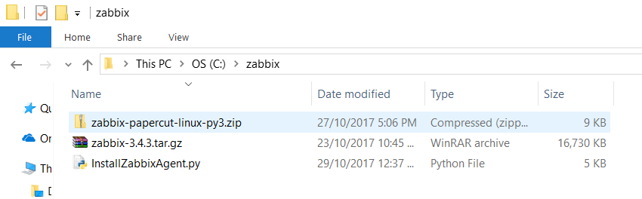

Login to windows command prompt as administrator. Run below steps of command.

6.1.1 Change directory to “c:\zabbix” with command: **cd c:\zabbix**

6.1.2 Run the Zabbix agent installation Script: **Python InstallZabbixAgent.py**

Answer the question of asked prompt.

**Enter PaperCut System Health Monitoring URL:**

Access PaperCut paperCut web-admin page: http://<PaperCut-Server-IP>:9191/admin.

Navigate to Optipns >> Advanced .

In the Advanced Page Scroll to Authorization. Copy the whole URL in GET query parameter window, as highlighted in the screen shot below:

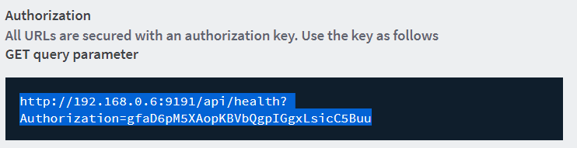

**Enter Zabbix Server IP address [127.0.0.1] :**

Enter the ip address of Zabbix Server.

**Enter Zabbix active Server IP address [] :**

In case of multiple Zabbix server eneter the active Server IP Else, if you have only one Zabbix server enter the same ip address of Zabbix server as entered in last question.

If all goes well Zabbix will be installed and running.

If list three line end will successfully; most likely the Zabbix agent installation is successful.

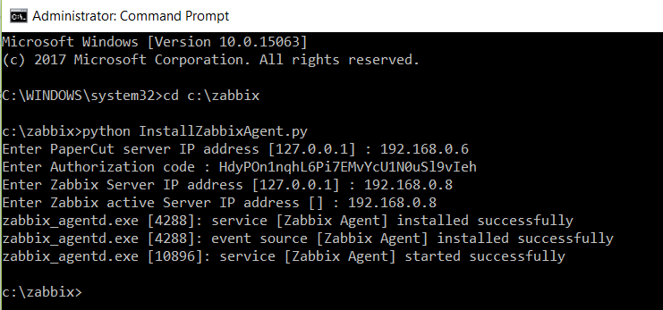

6.2 Manually edit the installation file and start Zabbix server.

6.2.1 From “zabbix-papercut-linux-py3.zip.zip” extract and copy papercut.conf, and all python scripts (i.e. .py) fin in “c:\zabbix” folder.

6.2.2 Right click on “zabbix-3.4.3.tar.gz” and click on “Extract Here”.

* + 1. In c:\zabbix directory, open all Python files with “.py” extension (i.e. Python scripts).

Replace “**/etc/zabbix/papercut.conf**” with “**C:\\zabbix\\papercut.conf**”

* + 1. Copy “zabbix_agentd.win.conf” from “C:\zabbix\zabbix-3.4.1\conf” to “C:\zabbix”.
    2. Go to “C:\zabbix”;rename “zabbix_agentd.win.conf” to “zabbix_agentd.conf”
    3. In “C:\zabbix”, open “zabbix_agentd.conf” on your favorite text editor :
       1. to uncomment (by removing # at start of line) and update following attributes value:

**Server**=<Zabbix_server_IP_address>

**ServerActive**=<Zabbix_server_IP_address>

**Hostname**=<PaperCut_Server_Hostname>

Update following **UserParameters**:

Copy the below lines however replace python with full path on python.exe on PaperCut Server. You can get the full path with below steps on PaperCut Server:

Login on windows command prompt as administrator :

Login to python command mode with command: **python**

Run command: **import sys; sys.executable**

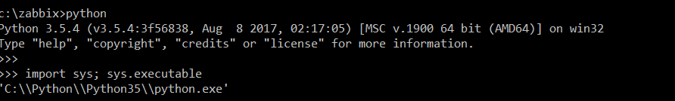

UserParameter=papercut[*],**python** C:\zabbix\papercut.py "$1"

UserParameter=device.discovery,**python** C:\zabbix\discovery-device.py

UserParameter=device.status[*],**python** C:\zabbix\discovery-devicestatus.py "$1"

UserParameter=printer.discovery,**python** C:\zabbix\discovery-printer.py

UserParameter=printer.status[*],**python** C:\zabbix\discovery-printerstatus.py "$1"

* + 1. Edit the papercut.conf file at c:\zabbix and add the correct Authorization token and papercut server IP. Here are steps to get it:

Access PaperCut paperCut web-admin page: http://<PaperCut-Server-IP>:9191/admin.

Navigate to Optipns >> Advanced .

In the Advanced Page Scroll to Authorization. Copy the string after “=” in GET query parameter window, as highlited in the screen shot below:

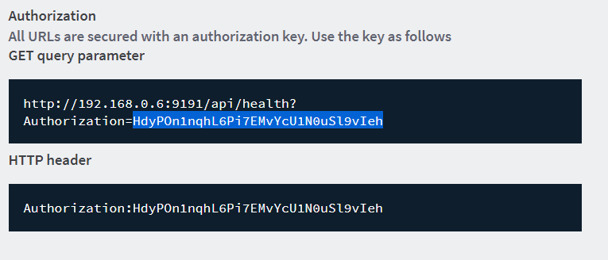

The Updated value in papaercut.conf file should look like:  
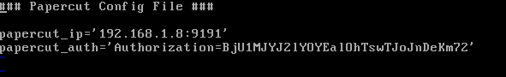

* + - 1. In the Zabbix-Agent configuration file (“zabbix_agentd.conf”) enable support for UnsafeUser parameters (we need this as there are “/” in the printer names)

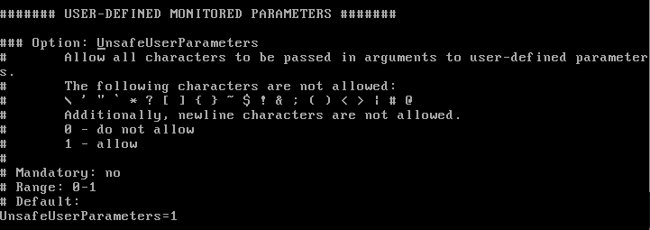

Save the changes in “zabbix_agentd.conf”.

1. Run the following command to start Zabbix on windows:
2. C:\zabbix\zabbix-3.4.1\bin\win64\zabbix_agentd.exe -c C:\zabbix\zabbix_agentd.conf --install

1. C:\zabbix\zabbix-3.4.1\bin\win64\zabbix_agentd.exe --start

**##Final Test:**

All Done! Lets Check:

1. Check the latest data page to run the query to see if latest data feed from PaperCut Server:
   1. login to Web-admin page of Zabbix Server, navigate to Monitoring --> Latest date. Add PaperCut Server in Hosts parameter, and click on apply.
   2. You should be able to see latest data like:

Nevigate to Monitoring → Latest Data :

Click on “Select” button for Host. The new window will pop-up.

On top right of windows select the PaperCut group Created Above ; afterwards it will start showing PaperCut Server Name. Check the box before Sever Name and click on select.

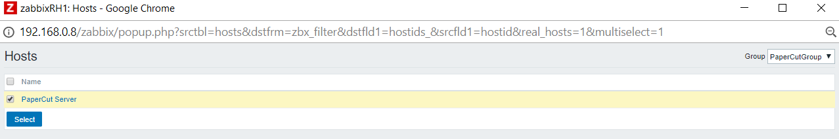

Now Enjoy the report. If it’s shoing date even for any and all priners name , that’s means it working. Give ot some time. Itshould starting showing all.

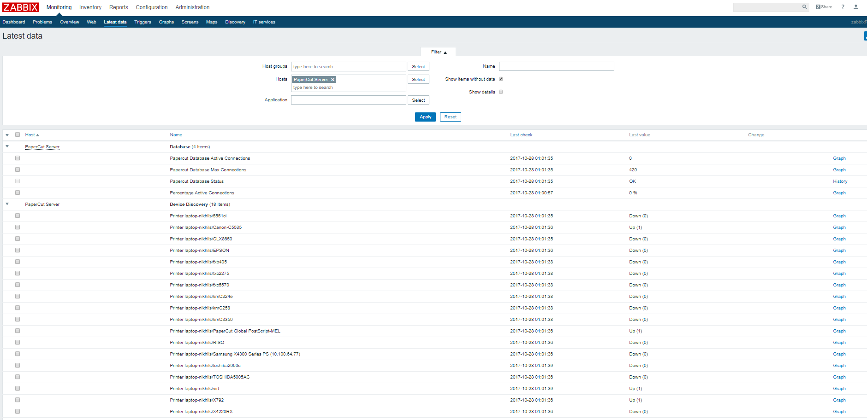

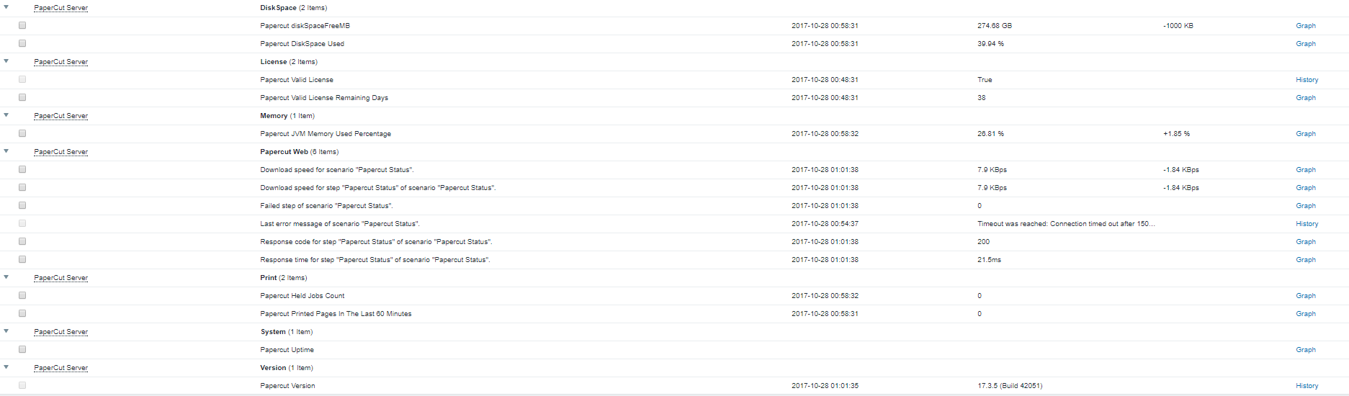

Troubleshooting:

* Go to latest data page in Zabbix (Monitoring – Latest – Data) and see after a few minutes if it popluates with data.
* If no data pops up check if the hostname in the Zabbix server matches with the hostname in the agent.
* Try from the Zabbix agent if you can telnet to port 10051 of the Zabbix server.
* Avoid DNS if possible as a broken DNS server can give you faulty information in Zabbix.
* To get a deeper understanding of Zabbix go to [www.zabbix.com](http://www.zabbix.com/) and find a certified partner to follow a training