**//Buy and sell**

What it can look like when the battery charges/buy (green curve negative) and when the battery sell (green curve positive). The black curve is from import and export to grid. (Picture taken in December when the panels did not not produce much)

**//README**

**Remember to read all prerequisites, preparations that you need in the README file!**

**//Set up the flows**

The following flow is not part of the automation, but can be used to force the settings back to auto. That is no charging and no discharging. Back to what you have configured as default in the portal (Self Consumption, Peak Shaving, etc.)

The following flow is not part of the automation but can be used to force battery to charge.

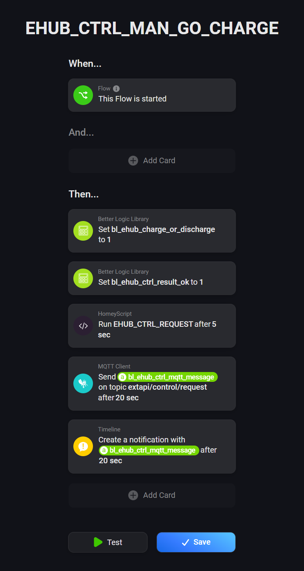

The following flow is not part of the automation but can be used to force battery to charge.

The following flow is part of the automation and is used to send the request to EHUB to start or end charging, or going back to default (auto).

The following flows are part of the automation and is used to read the response and result coming back from EHUB after the request has been sent.

The following flows are not part of the automation but can be used to debug the flows.

The following flows are part of the automation and is used to catch the MQTT messages from the different parts of the EHUB system

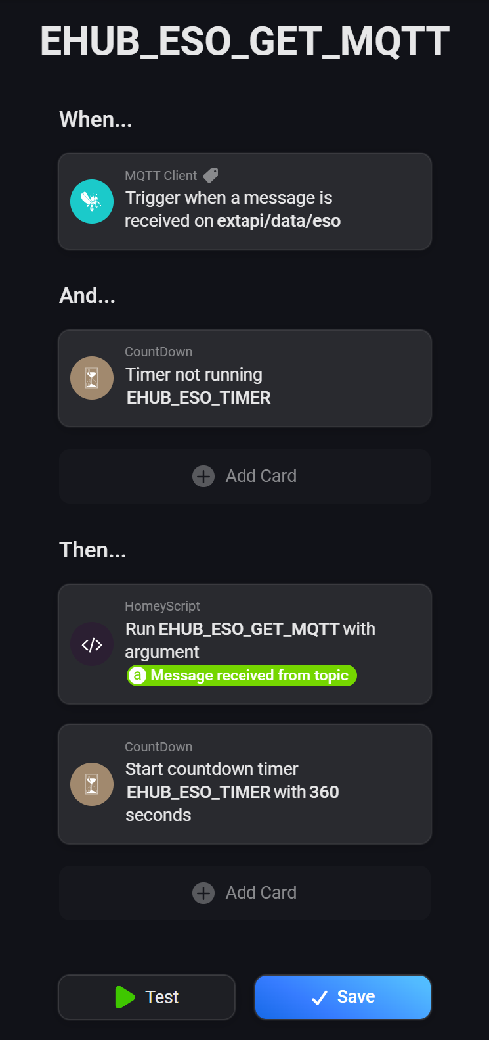

The following flow is part of the automation and is used to get the prices from the electricity market using the Power By The Hour app

The following flow is part of the automation and is used to get the values to evaluate if the battery is going to make it to the morning without extra charging.

The following flow is not part of the automation but can be used to set variables to default values.

Run this when you have setup the variables in the Better Logic Library app.

Here you alse specify what price gap that you are comfortable with in buying and selling. Below set to 0.90 SEK, which means if the price is 0.9 lower than in the coming X hours it will start buying and sell it off later.

The following flow is the heart logic of the automation. This flows start the EHUB_TRADE_DECISION script and all the logic that is within.

The following flow is part of the automation and is used to get the new electricity prices every hour

**//Power by the Hour settings**

Find settings: In left pane select ‘Devices’. Select the app icon below. Select settings.

= Settings

Initially set zero (0) on all fields. These values are setup by values from flows and in the Better Logic Library app.

**The Better Logic Library app**

Make sure to set up all the variables in the Better Logic Library app that are used in all the scripts.

If a script uses the following variables

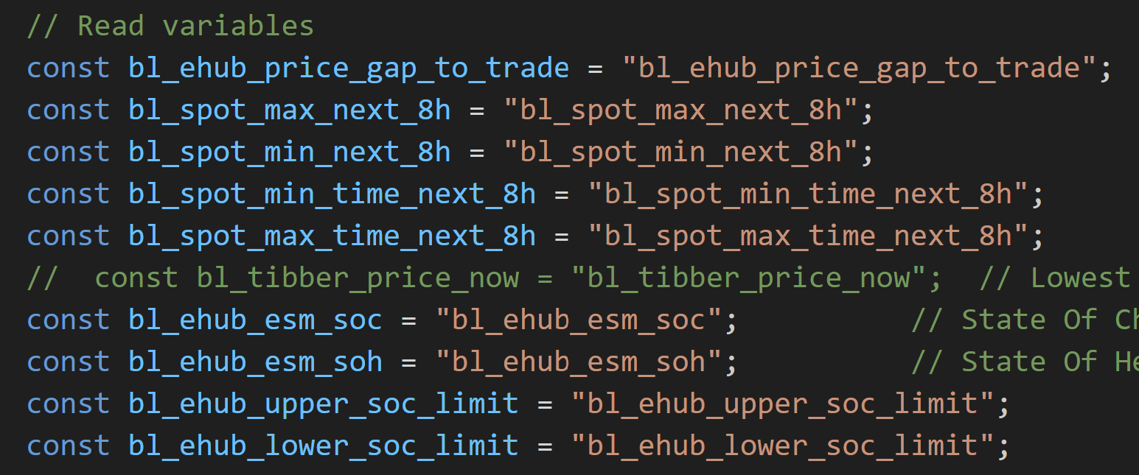 Add them in the app manually or import the variables as stated below:

1. In Homey settings goto the app The Better Logic Library
2. Select Configure
3. Select Variables -> Add Variable -> Import
   1. A screenshot of a computer

      Description automatically generated
4. Copy the remainder of this file and paste into the import field in the app
5. There might be variables in here that are not necessary. I have them in here as I use them to also control the car charging (sorry for that).
6. Done! Have fun!

[

{

"name": "bl_sensor_ehub_pbat",

"value": 225.503,

"type": "number",

"remove": false,

"lastChanged": "2024-11-24T18:39:42.345Z"

},

{

"name": "bl_sensor_ehub_pload_tot",

"value": 2734.8849999999998,

"type": "number",

"remove": false,

"lastChanged": "2024-11-24T18:39:42.222Z"

},

{

"name": "bl_sensor_ehub_pext_tot",

"value": 2629.213,

"type": "number",

"remove": false,

"lastChanged": "2024-11-24T18:39:42.096Z"

},

{

"name": "bl_sensor_ehub_sext",

"value": 3433.739,

"type": "number",

"remove": false,

"lastChanged": "2024-11-24T18:39:41.759Z"

},

{

"name": "bl_sensor_ehub_ppv",

"value": 0,

"type": "number",

"remove": false,

"lastChanged": "2024-11-24T18:39:41.639Z"

},

{

"name": "bl_ehub_eso_temp",

"value": 16.927,

"type": "number",

"remove": false,

"lastChanged": "2024-11-24T18:38:18.536Z"

},

{

"name": "bl_ehub_esm_soh",

"value": 98,

"type": "number",

"remove": false,

"lastChanged": "2024-11-24T18:35:29.050Z"

},

{

"name": "bl_ehub_esm_soc",

"value": 36,

"type": "number",

"remove": false,

"lastChanged": "2024-11-24T18:35:28.781Z"

},

{

"name": "bl_sunset",

"value": "15:00 ",

"type": "string",

"remove": false,

"lastChanged": "2024-11-24T18:30:00.140Z"

},

{

"name": "bl_sunrise",

"value": "09:32",

"type": "string",

"remove": false,

"lastChanged": "2024-11-24T18:30:00.072Z"

},

{

"name": "bl_time",

"value": "19:30",

"type": "string",

"remove": false,

"lastChanged": "2024-11-24T18:30:00.049Z"

},

{

"name": "bl_ehub_ctrl_result_ok",

"value": 1,

"type": "number",

"remove": false,

"lastChanged": "2024-11-24T18:04:22.117Z"

},

{

"name": "bl_ehub_ctrl_result_transId",

"value": 827,

"type": "number",

"remove": false,

"lastChanged": "2024-11-24T18:04:21.975Z"

},

{

"name": "bl_ehub_ctrl_result_msg",

"value": "all ESOs have changed setting",

"type": "string",

"remove": false,

"lastChanged": "2024-11-24T18:04:21.791Z"

},

{

"name": "bl_ehub_ctrl_result_status",

"value": "ack",

"type": "string",

"remove": false,

"lastChanged": "2024-11-24T18:04:21.730Z"

},

{

"name": "bl_ehub_ctrl_resp_ok",

"value": 1,

"type": "number",

"remove": false,

"lastChanged": "2024-11-24T18:04:11.944Z"

},

{

"name": "bl_ehub_ctrl_resp_transId",

"value": 827,

"type": "number",

"remove": false,

"lastChanged": "2024-11-24T18:04:11.830Z"

},

{

"name": "bl_ehub_ctrl_resp_msg",

"value": "sending cmd to ESOs",

"type": "string",

"remove": false,

"lastChanged": "2024-11-24T18:04:11.759Z"

},

{

"name": "bl_ehub_ctrl_resp_status",

"value": "ack",

"type": "string",

"remove": false,

"lastChanged": "2024-11-24T18:04:11.698Z"

},

{

"name": "bl_ehub_ctrl_last_transId",

"value": 827,

"type": "number",

"remove": false,

"lastChanged": "2024-11-24T18:04:01.828Z"

},

{

"name": "bl_ehub_ctrl_mqtt_message",

"value": "{\"transId\": \"827\", \"cmd\": {\"name\":\"auto\"}}",

"type": "string",

"remove": false,

"lastChanged": "2024-11-24T18:04:01.728Z"

},

{

"name": "bl_adj_sell_price",

"value": 0.77,

"type": "number",

"remove": false,

"lastChanged": "2024-11-24T18:03:53.072Z"

},

{

"name": "bl_adj_buy_price",

"value": 0.23,

"type": "number",

"remove": false,

"lastChanged": "2024-11-24T18:03:52.956Z"

},

{

"name": "bl_ehub_debug_message",

"value": "spot_1h: 0.06\nspot_2h: 0.04\nDEBUG: soc lunch37. lower_soc_limit: 20. average_burn_rate: 6\nDEBUG: : Evening. 14h to sunrise. 2.833h in battery\n timeToNextPossibleBuy: 100\nadjSellPriceNow_loc: 0.77\nGapToTrade_loc: 0.8\nadj_buy_spot_1h_loc: 0.17\nadj_buy_spot_2h_loc: 0.15\nadj_buy_spot_3h_loc: 0.14\nadj_buy_spot_4h_loc: 0.10\nadj_buy_spot_5h_loc: 0.10\nadj_buy_spot_6h_loc: 0.10\nadj_buy_spot_7h_loc: 0.10\nNo buy. Better buy within hours..\n adj_buy_spot_1h_loc: 0.17\n adj_buy_spot_2h_loc: 0.15",

"type": "string",

"remove": false,

"lastChanged": "2024-11-24T18:03:52.868Z"

},

{

"name": "bl_ehub_message_to_user",

"value": "19:03\nM8 Decision: No trading time. \n SOC: 37\n Panels: 0.000\n ESO temp: 16.719\n Spot: 0.1\n\n BestBuyTimeNow: false\n BestSellTimeNow: false\n WillMakeItToNextBuy: false\n WillMakeTheNight: false\n\n hours in battery: 2.833\n hours to next possible buy: 100\n hours to next sunrise: 14\n\n Real buy price: 0.23\n coming max 0.77 kr at19\n last max 2.48 kr (old)\n\n Real sell price: 0.77\n coming min 0.10 kr at 1\n last min 0.15 kr at 14\n\n forw buy: 0.540\n backw buy: 0.000\n forw sell: 0.670\n backw sell: 0.620\n\n addGapToTrade: 0.8",

"type": "string",

"remove": false,

"lastChanged": "2024-11-24T18:03:52.784Z"

},

{

"name": "bl_ehub_charge_or_discharge",

"value": 0,

"type": "number",

"remove": false,

"lastChanged": "2024-11-24T18:03:52.692Z"

},

{

"name": "bl_spot_max_time_next_8h",

"value": 19,

"type": "number",

"remove": false,

"lastChanged": "2024-11-24T18:03:01.033Z"

},

{

"name": "bl_spot_min_time_next_8h",

"value": 1,

"type": "number",

"remove": false,

"lastChanged": "2024-11-24T18:03:00.965Z"

},

{

"name": "bl_spot_max_next_8h",

"value": 0.1,

"type": "number",

"remove": false,

"lastChanged": "2024-11-24T18:03:00.921Z"

},

{

"name": "bl_spot_min_next_8h",

"value": -0.02,

"type": "number",

"remove": false,

"lastChanged": "2024-11-24T18:03:00.871Z"

},

{

"name": "bl_spot_7h",

"value": -0.01,

"type": "number",

"remove": false,

"lastChanged": "2024-11-24T18:03:00.852Z"

},

{

"name": "bl_spot_6h",

"value": -0.02,

"type": "number",

"remove": false,

"lastChanged": "2024-11-24T18:03:00.821Z"

},

{

"name": "bl_spot_5h",

"value": -0.01,

"type": "number",

"remove": false,

"lastChanged": "2024-11-24T18:03:00.778Z"

},

{

"name": "bl_spot_4h",

"value": 0,

"type": "number",

"remove": false,

"lastChanged": "2024-11-24T18:03:00.756Z"

},

{

"name": "bl_spot_3h",

"value": 0.03,

"type": "number",

"remove": false,

"lastChanged": "2024-11-24T18:03:00.722Z"

},

{

"name": "bl_spot_2h",

"value": 0.04,

"type": "number",

"remove": false,

"lastChanged": "2024-11-24T18:03:00.692Z"

},

{

"name": "bl_spot_1h",

"value": 0.06,

"type": "number",

"remove": false,

"lastChanged": "2024-11-24T18:03:00.648Z"

},

{

"name": "bl_spot",

"value": 0.1,

"type": "number",

"remove": false,

"lastChanged": "2024-11-24T18:03:00.627Z"

},

{

"name": "bl_tibber_min_price_today",

"value": 0.09,

"type": "number",

"remove": false,

"lastChanged": "2024-11-24T18:00:51.482Z"

},

{

"name": "bl_tibber_max_price_today",

"value": 0.2488,

"type": "number",

"remove": false,

"lastChanged": "2024-11-24T18:00:51.269Z"

},

{

"name": "bl_tibber_price_now",

"value": 0.21,

"type": "number",

"remove": false,

"lastChanged": "2024-11-24T18:00:51.148Z"

},

{

"name": "bl_last_buy_price_adj",

"value": 0.15,

"type": "number",

"remove": false,

"lastChanged": "2024-11-24T13:03:53.225Z"

},

{

"name": "bl_last_buy_price",

"value": 0.04,

"type": "number",

"remove": false,

"lastChanged": "2024-11-24T13:03:53.129Z"

},

{

"name": "bl_last_buy_time",

"value": 14,

"type": "number",

"remove": false,

"lastChanged": "2024-11-24T13:03:53.011Z"

},

{

"name": "bl_last_sell_time",

"value": 40,

"type": "number",

"remove": false,

"lastChanged": "2024-11-22T18:03:53.074Z"

},

{

"name": "bl_last_sell_price_adj",

"value": 2.48,

"type": "number",

"remove": false,

"lastChanged": "2024-11-22T08:03:53.650Z"

},

{

"name": "bl_last_sell_price",

"value": 1.81,

"type": "number",

"remove": false,

"lastChanged": "2024-11-22T08:03:53.543Z"

},

{

"name": "bl_ehub_ppv_on_timelog",

"value": 0,

"type": "number",

"remove": false,

"lastChanged": "2024-11-19T15:10:00.306Z"

},

{

"name": "bl_tesla_message_to_user",

"value": "3. Tesla needs NO charging! Actual car SOC: 89. Car needs: 90. pext:0.0377",

"type": "string",

"remove": false,

"lastChanged": "2024-10-03T15:30:11.725Z"

},

{

"name": "bl_tesla_hours_to_fill_up_car",

"value": 0,

"type": "number",

"remove": false,

"lastChanged": "2024-10-03T15:30:11.626Z"

},

{

"name": "bl_tesla_charge_current",

"value": 16,

"type": "number",

"remove": false,

"lastChanged": "2024-10-03T15:30:11.413Z"

},

{

"name": "bl_tesla_charge_on",

"value": 0,

"type": "number",

"remove": false,

"lastChanged": "2024-10-03T15:30:11.254Z"

},

{

"name": "bl_tesla_soc",

"value": 89,

"type": "number",

"remove": false,

"lastChanged": "2024-10-03T15:30:00.753Z"

},

{

"name": "bl_tesla_charge_level",

"value": 90,

"type": "number",

"remove": false,

"lastChanged": "2024-10-03T15:30:00.572Z"

},

{

"name": "bl_tesla_best_charge_hour_now",

"value": 0,

"type": "number",

"remove": false,

"lastChanged": "2024-10-03T02:57:14.509Z"

},

{

"name": "bl_ehub_lower_soc_limit",

"value": 20,

"type": "number",

"remove": false,

"lastChanged": "2024-05-16T17:15:33.977Z"

},

{

"name": "bl_ehub_variable_markup_sell",

"value": 1,

"type": "number",

"remove": false,

"lastChanged": "2024-05-16T17:15:33.932Z"

},

{

"name": "bl_ehub_fixed_markup_sell",

"value": 0.67,

"type": "number",

"remove": false,

"lastChanged": "2024-05-16T17:15:33.830Z"

},

{

"name": "bl_ehub_variable_markup_buy",

"value": 1.25,

"type": "number",

"remove": false,

"lastChanged": "2024-05-16T17:15:33.782Z"

},

{

"name": "bl_ehub_fixed_markup_buy",

"value": 0.1,

"type": "number",

"remove": false,

"lastChanged": "2024-05-16T17:15:33.729Z"

},

{

"name": "bl_ehub_price_gap_to_trade",

"value": 0.8,

"type": "number",

"remove": false,

"lastChanged": "2024-05-16T17:15:33.692Z"

},

{

"name": "bl_ehub_best_charge_hour_now",

"value": 0,

"type": "number",

"remove": false,

"lastChanged": "2024-05-07T03:00:18.639Z"

},

{

"name": "bl_ehub_upper_soc_limit",

"value": 80,

"type": "number",

"remove": false,

"lastChanged": "2024-05-01T06:25:57.061Z"

},

{

"name": "bl_tesla_hour_fully_charged",

"value": 10,

"type": "number",

"remove": false,

"lastChanged": "2024-03-07T03:49:27.691Z"

},

{

"name": "bl_ehub_off_season",

"value": 1,

"type": "number",

"remove": false,

"lastChanged": "2023-10-21T20:37:27.950Z"

},

{

"name": "bl_ehub_highLimitToStartDischarge",

"value": 0.58,

"type": "number",

"remove": false,

"lastChanged": "2023-07-18T11:00:44.598Z"

},

{

"name": "bl_ehub_lowerLimitToStartCharge",

"value": -0.03,

"type": "number",

"remove": false,

"lastChanged": "2023-07-18T11:00:44.384Z"

},

{

"name": "bl_ehub_debug_on",

"value": false,

"type": "boolean",

"remove": false,

"lastChanged": "2023-07-05T13:01:54.992Z"

},

{

"name": "bl_ehub_trade_or_not",

"value": 0,

"type": "number",

"remove": false,

"lastChanged": "2023-07-05T12:02:56.704Z"

},

{

"name": "bl_dec_time_period_2_starts",

"value": 6,

"type": "number",

"remove": false,

"lastChanged": "2023-06-25T13:58:30.044Z"

},

{

"name": "bl_dec_time_period_3_starts",

"value": 18,

"type": "number",

"remove": false,

"lastChanged": "2023-06-16T17:22:10.758Z"

},

{

"name": "bl_dec_time_period_1_starts",

"value": 0,

"type": "number",

"remove": false,

"lastChanged": "2023-06-11T16:26:42.782Z"

},

{

"name": "bl_ehub_ctrl_charge_power",

"value": 4300,

"type": "number",

"remove": false,

"lastChanged": "2023-06-01T11:28:35.507Z"

},

{

"name": "bl_ehub_ctrl_discharge_power",

"value": 4400,

"type": "number",

"remove": false,

"lastChanged": "2023-06-01T11:28:13.612Z"

},

{

"name": "DayOfYear",

"value": 129,

"type": "number",

"remove": false,

"lastChanged": "2023-05-09T12:18:03.551Z"

},

{

"name": "SSOTopic",

"value": "extapi/data/sso",

"type": "string",

"remove": false,

"lastChanged": "2023-05-03T07:18:36.289Z"

},

{

"name": "EnergyHubTopic",

"value": "extapi/data/ehub",

"type": "string",

"remove": false,

"lastChanged": "2023-05-03T07:17:42.264Z"

}

]

(Edit: 2024-11-24)