Wayne's Clinic Baltimore - Advanced Database Systems

Portfolio 3 — Transactions and Concurrency
Organisation: Wayne's Clinic Baltimore · Engine: PostgreSQL 16 (MVCC, Serializable Snapshot Isolation)
A hospital database is written by many people at once. Receptionists book, doctors diagnose, pharmacists dispense and the lab files results. This portfolio shows, on a real server, what transactions guarantee, what goes wrong without the right isolation or locking, and which mechanism fixes each problem. Every demonstration opens genuine concurrent sessions, each a separate PostgreSQL backend process, and interleaves their statements in a fixed order so the outcome is reproducible.
Deliverable | Where
Commit, rollback, savepoint, atomicity on error | §2 · sql/01_commit_rollback_savepoint.sql
Isolation levels (dirty / non-repeatable / phantom reads) | §3 · C1–C3
Concurrency problems and control mechanisms | §4 · C4–C7 (lost update, write skew, double booking, deadlock)
MVCC and durability | §5 · C8, C9
Screenshots / output evidence | evidence/: a .txt log with millisecond timestamps and a two-column timeline .png per demo

1. Transactions in one paragraph
A transaction is a unit of work that the database treats as indivisible. ACID names its guarantees. Atomicity: all of its changes happen or none do. Consistency: it moves the database from one state that satisfies every constraint to another. Isolation: concurrent transactions do not see each other's half-finished work, to a degree set by the isolation level. Durability: once COMMIT returns, the change survives a crash. PostgreSQL implements isolation with multi-version concurrency control (MVCC): an update writes a new row version instead of overwriting, and each transaction reads from a snapshot. Readers therefore never block writers and writers never block readers. Only writers competing for the same row wait for each other.

2. Commit, rollback and savepoints (single session)
Full output: evidence/01_commit_rollback_savepoint_output.txt.
Demo | Scenario | What it proves
T1 COMMIT | A walk-in patient is registered and booked in one transaction. After COMMIT, a brand-new connection sees both rows, stamped with the creating transaction id (xmin). | Committed work is visible to everyone and permanent
T2 ROLLBACK | A pharmacist removes 100 insulin pens instead of 10 and also writes an audit row, then cancels. | ROLLBACK undoes every statement in the transaction, the audit row included
T3 Atomicity on error | James Holloway walks into the Emergency Department on a Sunday. The doctor stores a diagnosis, then prescribes penicillin, to which he is allergic. The trigger raises WC001. The transaction enters the aborted state; even SELECT is refused (25P02) and COMMIT becomes ROLLBACK. | The diagnosis written before the error is discarded too: all or nothing
T4 SAVEPOINT | Same consultation with SAVEPOINT before_line_1. After the allergy error, ROLLBACK TO SAVEPOINT undoes only the bad line; azithromycin is prescribed instead and the transaction commits. | Partial rollback keeps valid work inside a long transaction
T5 Sequences | An appointment insert is rolled back but the identity sequence still advances. | Sequences are deliberately non-transactional, so ids have gaps and must never be used as counts
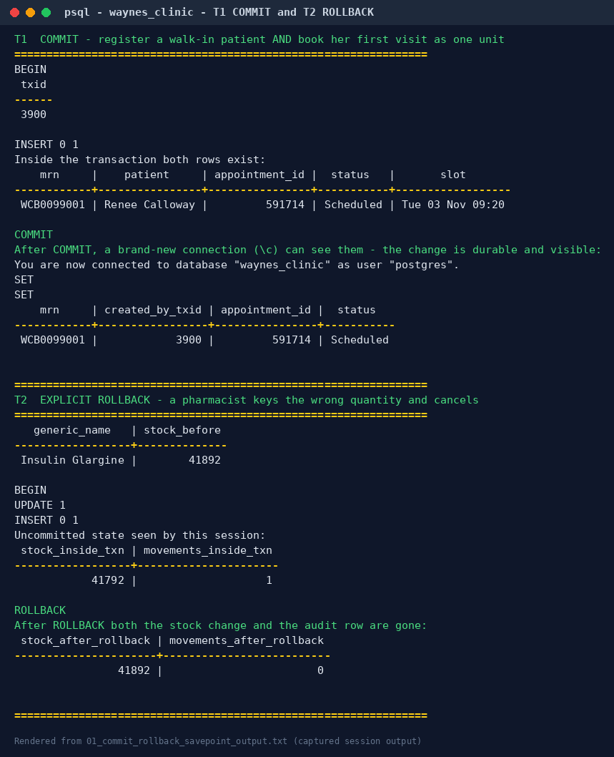
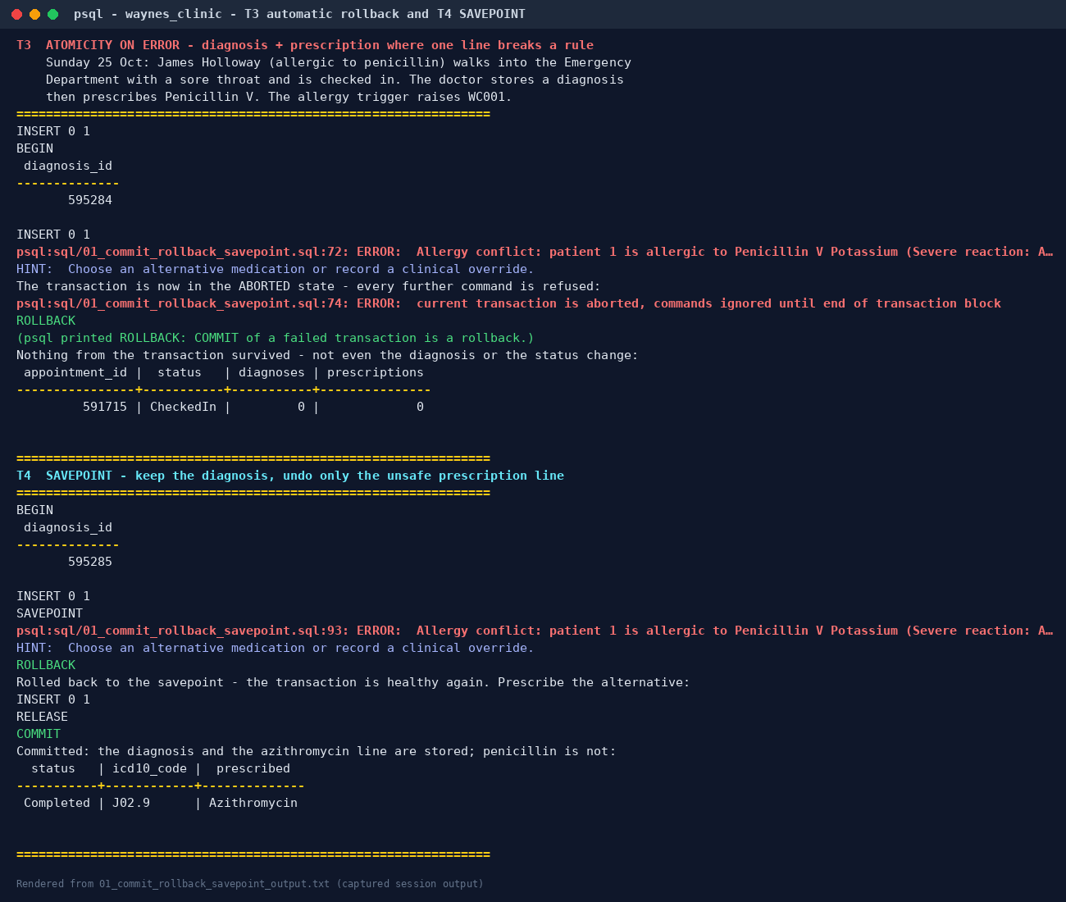

3. Isolation levels and read anomalies
The SQL standard defines four isolation levels by the anomalies each permits. PostgreSQL implements three distinct behaviours, and these demos test each claim.

C1 — Dirty read (READ UNCOMMITTED)
The lab scientist (A) changes a potassium result to 6.9 but does not commit. The doctor (B), at READ UNCOMMITTED, reads the result and sees 3.3, the committed value. PostgreSQL treats READ UNCOMMITTED as READ COMMITTED, so dirty reads are impossible at every level.

C2 — Non-repeatable read
Doctor A reads Tyrone Jackson's INR twice in one transaction while the lab (B) corrects it from 2.1 to 3.6 and commits.
Isolation | A's 1st read | A's 2nd read | Anomaly
READ COMMITTED | 2.1 | 3.6 | Yes: a new snapshot is taken for every statement
REPEATABLE READ | 2.1 | 2.1 | No: one snapshot for the whole transaction
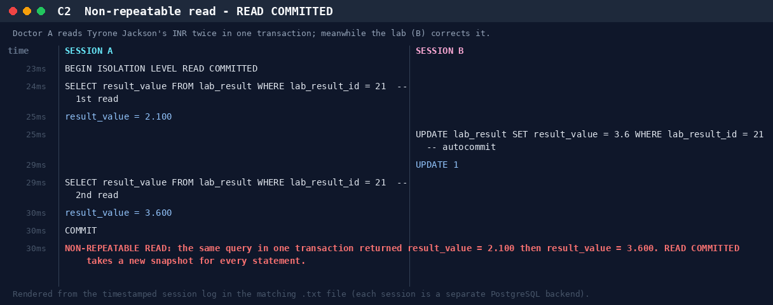

C3 — Phantom read
A manager counts Dr Raman's bookings for a day twice while a receptionist books a new slot.
Isolation | 1st count | 2nd count | Anomaly
READ COMMITTED | n | n + 1 | Yes: a new row appeared
REPEATABLE READ | n | n | No: PostgreSQL's repeatable read is snapshot isolation, which also stops phantoms (stricter than the standard requires)

4. Concurrency problems and control mechanisms

C4 — Lost update: two pharmacists dispense the same drug
Insulin stock is 10. Pharmacist A dispenses 3 and B dispenses 4, so the correct final stock is 3.
Variant | Mechanism | Final stock | Evidence
C4a read value → compute in app → write back (READ COMMITTED) | none | 6 — LOST UPDATE | log
C4b SELECT … FOR UPDATE | pessimistic row lock: B waited 410 ms until A committed, then read 7 | 3 | log
C4c UPDATE … SET stock = stock - n | atomic update: B queued on A's row lock, then re-evaluated against the new version | 3 | log
C4d same code at REPEATABLE READ | first-updater-wins: B got 40001 could not serialize access due to concurrent update, retried and succeeded | 3 | log
C4e compare-and-set UPDATE … WHERE stock_on_hand = <value read> | optimistic: B's update matched 0 rows, so it re-read and retried; no locks held while the user thinks | 3 | log
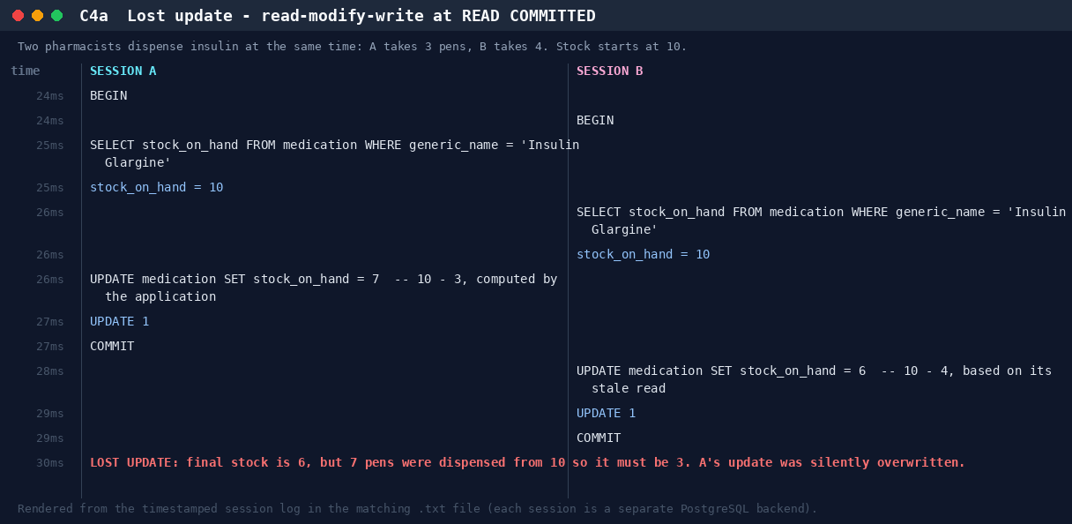
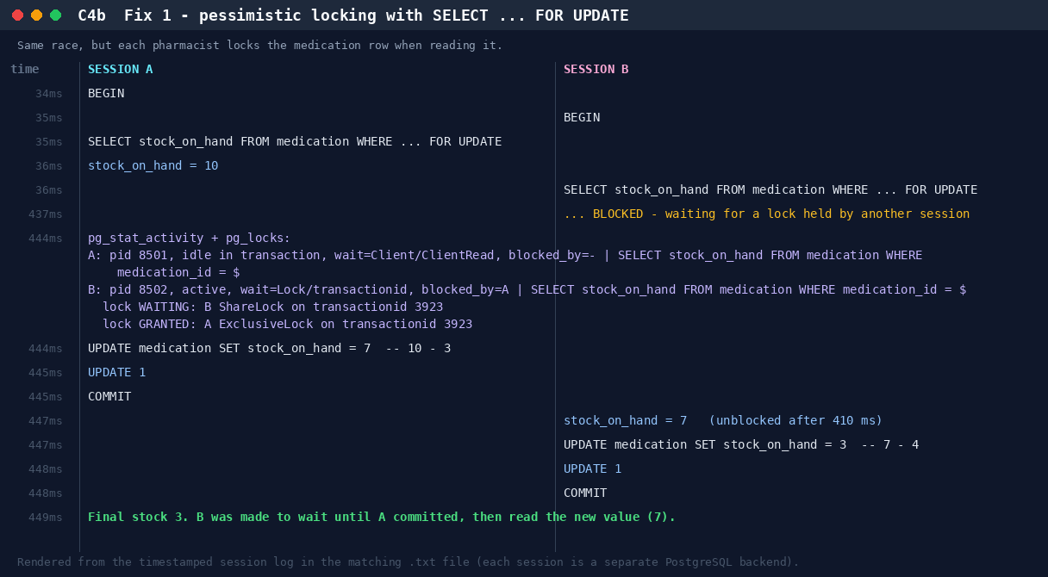
The monitor session in C4b reads pg_stat_activity and pg_locks while B is blocked. It shows B waiting on Lock/transactionid, blocked_by = A: the lock is visible inside the server, not just inferred from timing.
Which fix should the clinic use? The atomic UPDATE (C4c) is simplest when the new value can be computed in SQL. dispense_prescription() uses SELECT … FOR UPDATE (C4b) because it must check stock before deciding to dispense. Optimistic control (C4e) suits web screens where a user may hold a form open for minutes.

C5 — Write skew: the on-call rule
Rule: at least one doctor must stay on call. Dr Fairbanks (A) and Dr Whitfield (B) each check that 2 doctors are on call, and each then signs themselves off. The two transactions update different rows, so there is no write-write conflict for row locks to catch.
Isolation | Outcome
REPEATABLE READ | Both commit. 0 doctors on call: the invariant is broken (write skew is allowed by snapshot isolation)
SERIALIZABLE | B fails with 40001 could not serialize access due to read/write dependencies among transactions. On retry B sees only 1 doctor on call and is refused. 1 doctor remains on call.
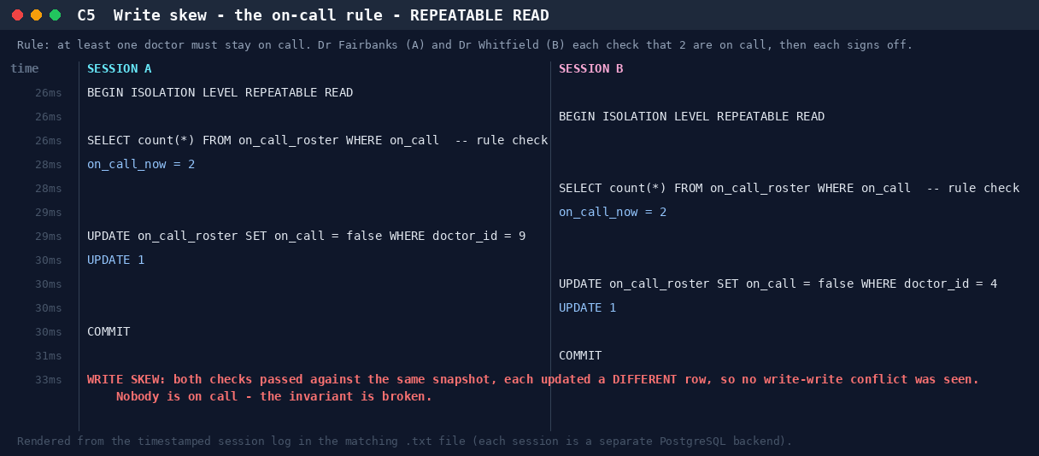
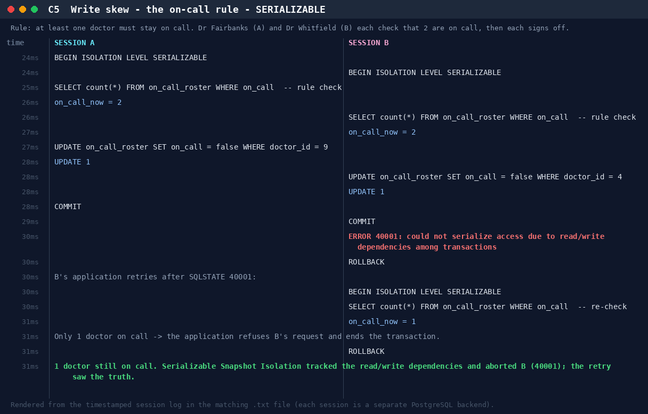
PostgreSQL's SERIALIZABLE level uses Serializable Snapshot Isolation (SSI). It records which rows each transaction read (predicate locks) and aborts one transaction when a dangerous cycle of read/write dependencies appears. The application must be ready to retry on 40001. That is the price of a guarantee no CHECK constraint can express.

C6 — Double booking: application check vs database constraint
Variant | Outcome
C6a "Is the slot free? Then insert" on a table with no constraint | Both receptionists see 0 clashes and both insert: 2 patients in one slot
C6b book_appointment() on the real table (EXCLUDE constraint) | B blocks (it cannot know if the slot is taken until A finishes). A commits, and B immediately gets 23P01 Slot taken
C6c Same, but A rolls back | B's booking succeeds once A's tentative row disappears
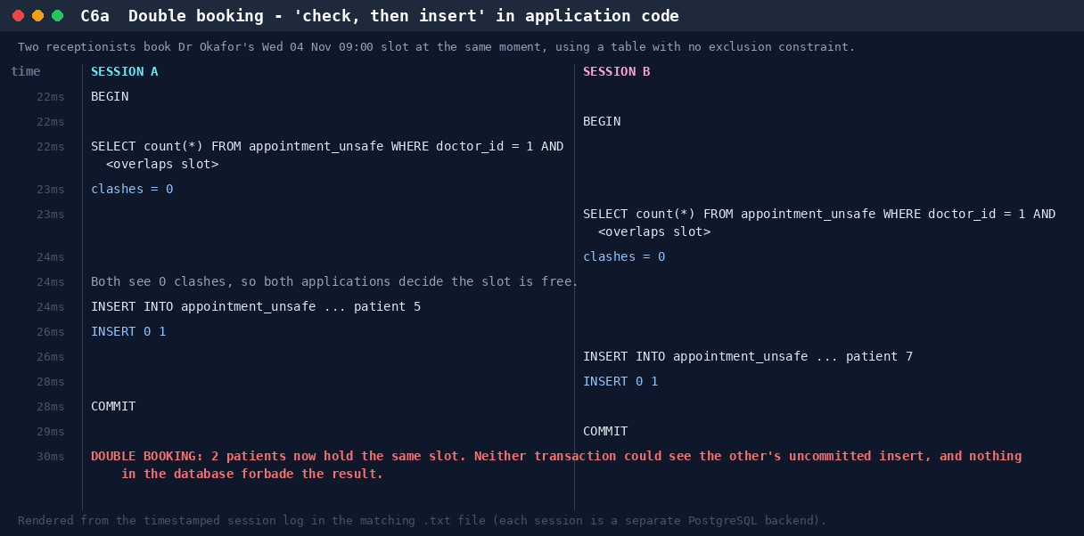
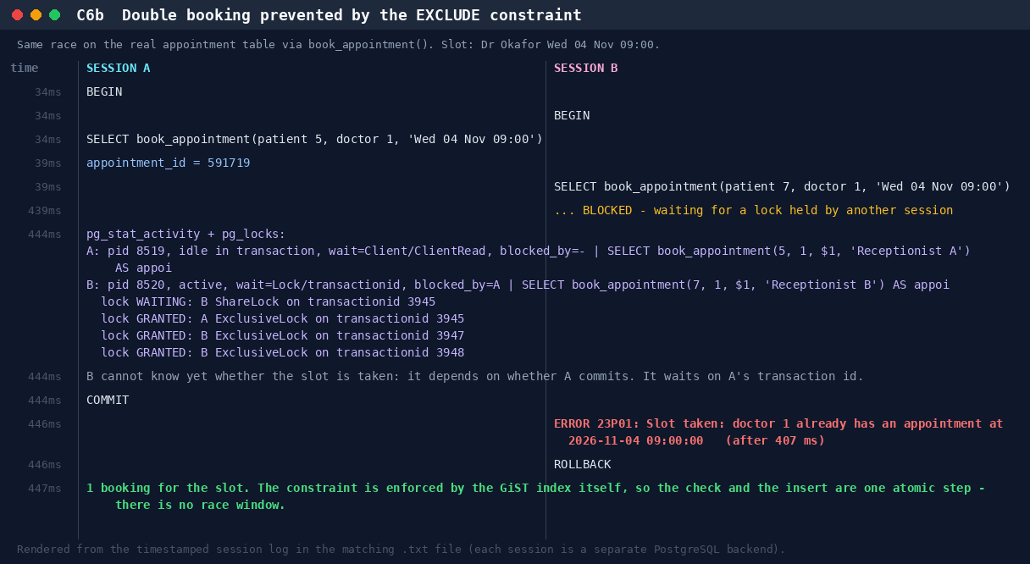
This is the strongest argument for declaring rules in the schema (Portfolio 1). The exclusion constraint makes "check" and "insert" one atomic step inside the index, so there is no race window. Waiting instead of failing fast (C6c) is also correct: the conflicting row might never commit.

C7 — Deadlock: detection and prevention
A moves stock insulin → albuterol while B moves albuterol → insulin. Each locks its first row, then waits for the other's: a cycle.
- C7a. After deadlock_timeout (1 s), PostgreSQL's deadlock detector found the cycle and aborted A with 40P01 deadlock detected; B completed. The server log records both processes and the lock each was waiting for (included in the evidence).
- C7b. Prevention. Both transfers first lock both rows with ORDER BY medication_id FOR UPDATE. A consistent global lock order turns the cycle into a queue: B waited about 400 ms and both committed. dispense_prescription() applies the same rule.
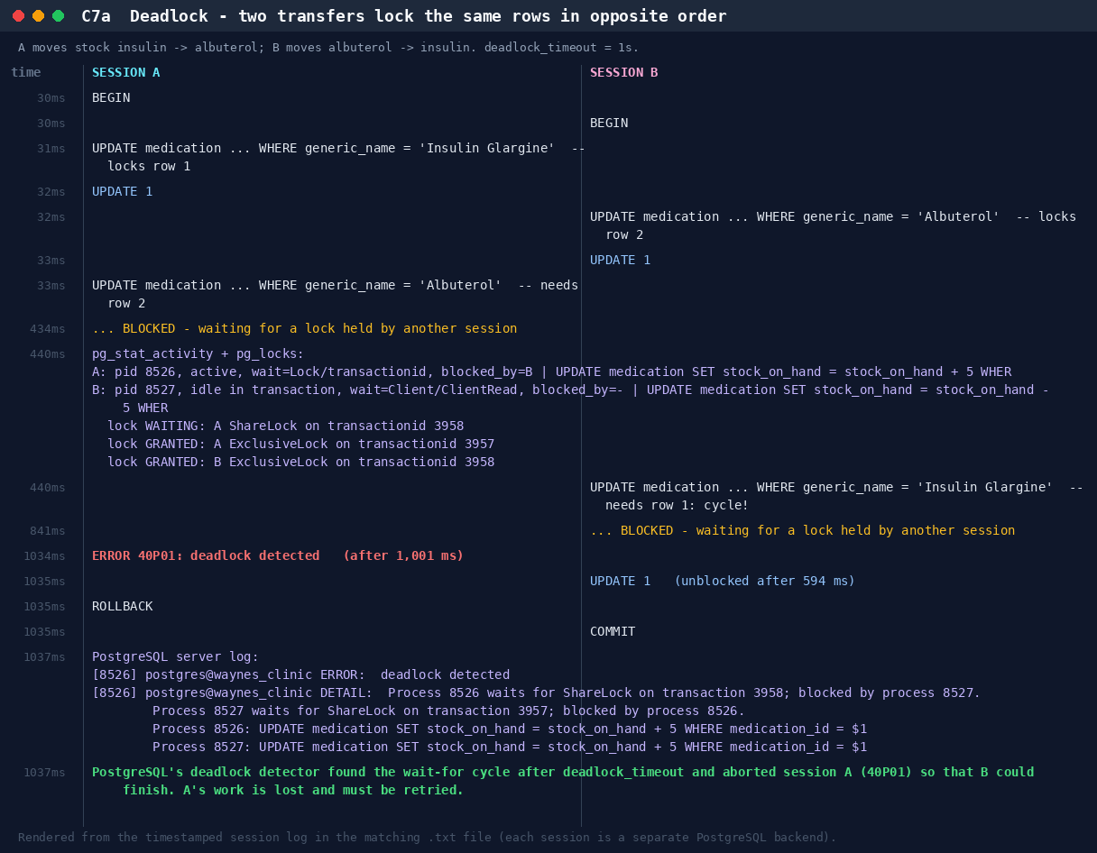

5. MVCC and durability
C8 — Row versions. A opens a REPEATABLE READ snapshot and reads insulin stock 10 at physical location ctid (0,72), created by transaction 3961. B updates the stock to 99 without waiting and creates a new version at (0,73). The old version's xmax is now B's transaction id, yet A, inside its snapshot, still reads 10 from (0,72), and a fresh session C sees 99 at (0,73). Two versions of one row coexist until VACUUM removes the dead one.
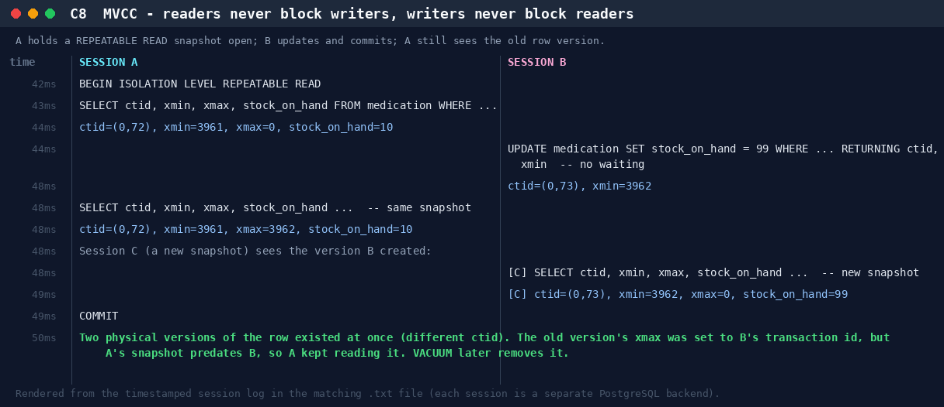
C9 — Durability: a real crash test. Session A commits a stock movement; session B inserts another row but never commits. The server is then killed with pg_ctl stop -m immediate (no checkpoint, equivalent to a power cut) and restarted. The server log shows "database system was not properly shut down; automatic recovery in progress … redo starts … redo done". Afterwards only the committed row exists. COMMIT returned only after the commit record was flushed to the write-ahead log (synchronous_commit = on), so WAL replay restored it. B's transaction never committed, so its row is invisible.
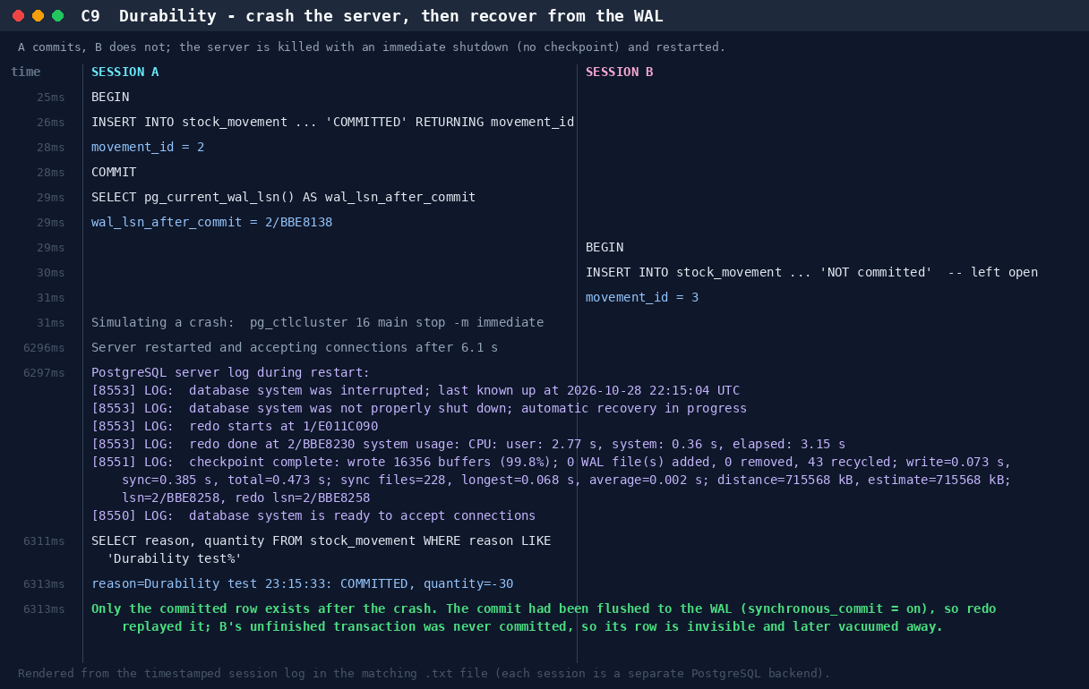

6. Results matrix
What was observed on PostgreSQL 16 (evidence/concurrency_summary.md):
Anomaly | READ COMMITTED (default) | REPEATABLE READ | SERIALIZABLE
Dirty read | prevented (C1) | prevented | prevented
Non-repeatable read | occurs (C2) | prevented (C2) | prevented
Phantom read | occurs (C3) | prevented (C3) | prevented
Lost update (read-modify-write) | occurs (C4a) | detected → 40001 (C4d) | detected → 40001
Write skew | occurs | occurs (C5) | detected → 40001 (C5)
Recommendations for Wayne's Clinic.
- Keep READ COMMITTED as the default for its throughput, and make every multi-row read-modify-write either an atomic UPDATE or a SELECT … FOR UPDATE.
- Use SERIALIZABLE, with automatic retry on 40001, for the few transactions that protect a cross-row invariant: the on-call roster, bed allocation and controlled-drug registers.
- Enforce booking rules with constraints, not application checks.
- Lock rows in a fixed order to avoid deadlocks, and treat 40P01 as retryable.
- Keep synchronous_commit = on for clinical data.

7. Reproduce
./run_portfolio3.sh # needs Portfolio 1 loaded; Portfolio 2 data optional
SKIP_CRASH_TEST=1 ./run_portfolio3.sh # skip the server restart on shared machines
scripts/session_lab.py is a small harness: each Session is its own connection, .start() sends a statement expected to block in a background thread, and Monitor.snapshot() reads pg_stat_activity/pg_locks while it waits. The timelines are drawn from the same timestamped events as the .txt logs.

