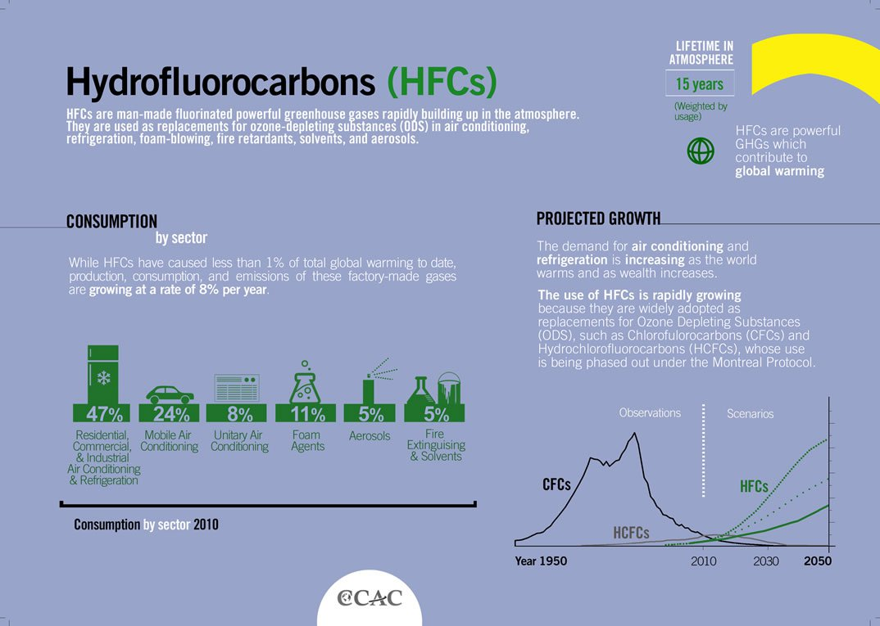

**Hydrofluorocarbons (HFC)**

Hydrofluorocarbons (HFCs) are a group of industrial chemicals primarily used for cooling and refrigeration. HFCs were developed to replace stratospheric ozone-depleting substances that are currently being phased out under the Montreal Protocol on Substances that Deplete the Ozone Layer.

Many HFCs are very powerful greenhouse gases and a substantial number are short-lived climate pollutants with a lifetime of between 15 and 29 years in the atmosphere.

Though HFCs currently represent around 1% of total greenhouse gases, their impact on global warming can be hundreds to thousands of times greater than that of carbon dioxide per unit of mass. Assuming no new regulation, HFC consumption is projected to double by 2020, and emissions could contribute substantially to radiative forcing in the atmosphere by the middle of the century.

**KEY FIGURES**

|  |  |  |  |
| --- | --- | --- | --- |
| **1,430x** | **10-15%** | **29 years** | **5.6 billion** |
| The most abundant HFC is 1,430 times more damaging to the climate than carbon dioxide per unit of mass | Emissions of HFCs are growing at a rate of 10-15% per year | HFCs remain in the atmosphere for up to 29 years | The global stock of air conditioners in buildings will grow to 5.6 billion by 2050,  which amounts to 10 new units sold every second for the next 30 years |

**PRIMARY HFC SOURCES**

HFCs are entirely man-made. They are primarily produced for use in refrigeration, air-conditioning, insulating foams and aerosol propellants, with minor uses as solvents and for fire protection. Most HFCs are contained within equipment, so emissions are the result of wear, faulty maintenance, or leakage at the end of a product’s lifetime.

HFCs have only been commercialized since the early 1990s, and their abundance in the atmosphere is currently small. They are, however, among the fastest growing greenhouse gases, largely as a result of increasing demand for refrigeration and air-conditioning, particularly in developing countries. Emissions of these gases are growing at a rate of 10-15% per year, which will cause a [doubling every five to seven years](http://science.sciencemag.org/content/335/6071/922.summary?sid=59449fa3-6f4c-48f6-8a5d-57c6b1ebcf11).

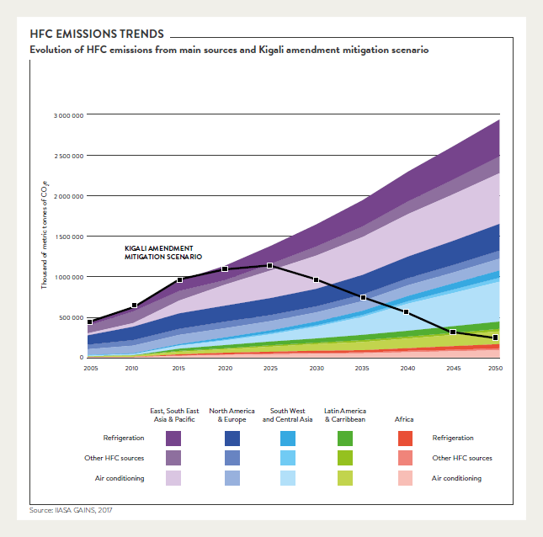

HFCs can be most effectively controlled through a phase down of their production and consumption.

In addition to the direct climate benefits from HFC mitigation, a global HFC phase down could also provide [indirect benefits](https://ccacoalition.org/en/resources/low-gwp-alternatives-commercial-refrigeration-propane-co2-and-hfo-case-studies) through improvements in the energy efficiency of the refrigerators, air conditioners, and other products and equipment that use these chemicals. These efficiency gains could also lead to reduced emissions of CO2 and other air pollutants.

* [**Methane (CH4)**](https://www.epa.gov/ghgemissions/overview-greenhouse-gases#methane): Methane is emitted during the production and transport of coal, natural gas, and oil. Methane emissions also result from livestock and other agricultural practices and by the decay of organic waste in municipal solid waste landfills.
* [**Nitrous oxide (N2O)**](https://www.epa.gov/ghgemissions/overview-greenhouse-gases#nitrous-oxide): Nitrous oxide is emitted during agricultural and industrial activities, combustion of fossil fuels and solid waste, as well as during treatment of wastewater.
* [**Fluorinated gases**](https://www.epa.gov/ghgemissions/overview-greenhouse-gases#f-gases): Hydrofluorocarbons, perfluorocarbons, sulfur hexafluoride, and nitrogen trifluoride are synthetic, powerful greenhouse gases that are emitted from a variety of industrial processes. Fluorinated gases are sometimes used as substitutes for stratospheric [ozone-depleting substances](https://www.epa.gov/ozone-layer-protection) (e.g., chlorofluorocarbons, hydrochlorofluorocarbons, and halons). These gases are typically emitted in smaller quantities, but because they are potent greenhouse gases, they are sometimes referred to as High [Global Warming Potential](https://www.epa.gov/ghgemissions/understanding-global-warming-potentials) gases ("High GWP gases").