PORTFOLIO ENGLISH A2 - TASK 5 TO 8

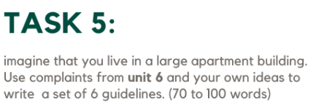
- Please keep the noise down after 10 PM. Don’t play music late at night.
- Park your car only in your space. Do not use a space if that is not yours.
- Do not smoke in the common areas, like the stairs or the lobby.
- Remember to lock the main door when you enter or leave the building.
- Keep pets on a leash when you are in the lobby.
- Take out your trash frequently.

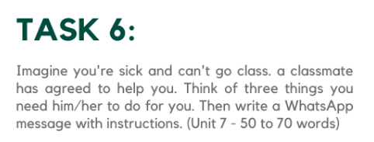
To my best friend fredy
I need three favors from you.
- Please tell the teacher that I'm sick and I'll bring my excuse soon.
- Can you take notes or photos of everything they do in class today, please?
- Also, tell Sofia that we have to finish the project another day.

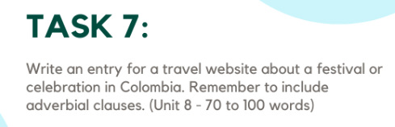
The Day of the Little Candles is a beautiful Colombian tradition celebrated every December 7th. On this day, families or friends gather to light candles and lanterns in the streets, parks, and their homes, creating a warm and colorful atmosphere at night. It marks the beginning of the Christmas season in Colombia. People also enjoy traditional Colombian Christmas foods, music, and joyful moments together, celebrating love, hope, and unity in a magical and festive way.

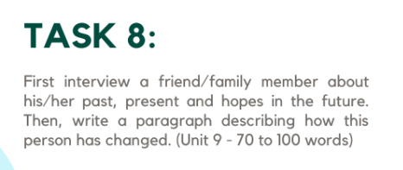

The person I interviewed used to have a countryside life with all their siblings. They spent happy moments together and experienced many things, but also suffered from bullying problems. However, they managed to move on by moving to the city. Nowadays, they have a wonderful family that supports them and a very good job. In the future, they hope to achieve great things and watch their child grow up to be a successful person.

