Publish Your Own Orienteering Map Archive
A complete beginner’s guide — no coding or GitHub experience needed
This guide takes you from a single file called index.html to a live, public map archive on the internet. The page shows all your maps as markers on a map of Europe, and it reads everything from one Google Sheet. Once set up, adding a new map is as easy as typing a new row in that sheet.
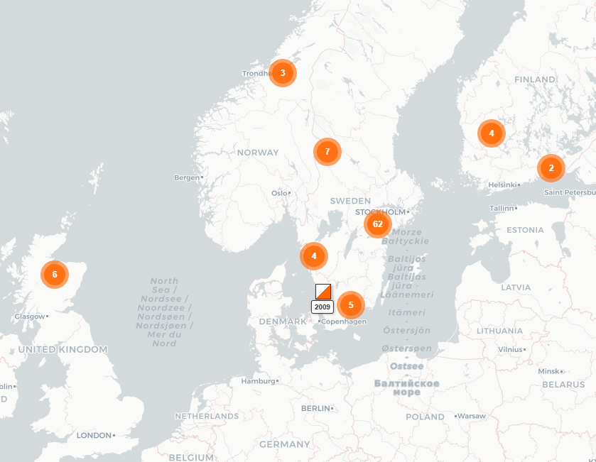

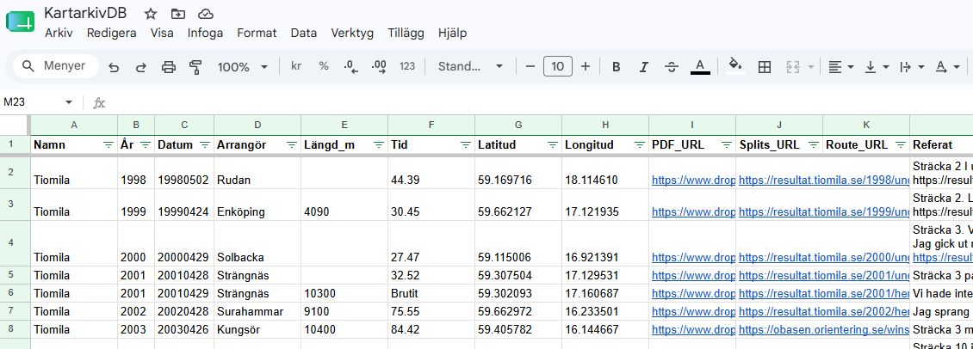
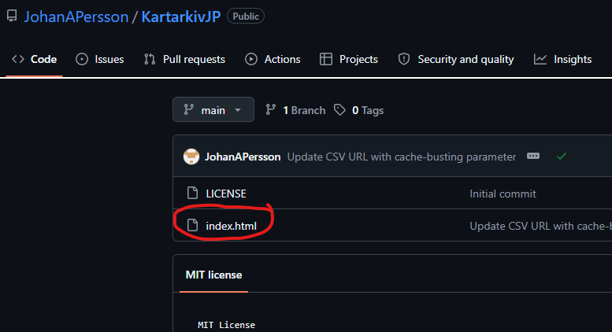

1. What You’ll Need Before Starting
You need two free accounts and your file. Nothing costs anything.
- A GitHub account. Go to the GitHub website, click “Sign up” in the top-right corner, and follow the instructions. You will be asked to verify your email address.
- A Google account. If you already use Gmail, you have one. If not, go to the Google Account sign-up page and create one.
- Your index.html file saved somewhere easy to find, for example on your Desktop.

2. Creating a GitHub Repository and Uploading index.html
A “repository” (often shortened to “repo”) is simply a folder on GitHub that stores your files.
- Sign in to GitHub.
- Click the “+” icon in the very top-right corner of the page, then click “New repository”.
- In the “Repository name” box, type a short name with no spaces, for example: map-archive
- Make sure “Public” is selected. (Free GitHub Pages hosting requires a public repository.)
- Tick the box “Add a README file”. This small extra file makes the next steps simpler.
- Click the green “Create repository” button at the bottom.
- On the page that opens, click the “Add file” button (next to the green “Code” button), then click “Upload files”.
- Drag your index.html file into the large upload box, or click “choose your files” and select it.
- Scroll down and click the green “Commit changes” button. Your file is now stored on GitHub.

3. Turning On GitHub Pages and Finding Your Live Address
GitHub Pages is the free hosting service that turns your repository into a real website.
- While viewing your repository, click the “Settings” tab near the top of the page (it is the right-most tab).
- In the menu on the left-hand side, click “Pages”.
- Under “Build and deployment”, find the dropdown labelled “Branch” that currently says “None”. Click it and choose “main”.
- Leave the folder dropdown next to it as “/ (root)” and click “Save”.
- Wait one or two minutes, then reload the page. A box appears at the top saying “Your site is live at …” followed by an address like https://yourusername.github.io/map-archive/
- Click “Visit site” (or copy the address into a new browser tab). Because your file is named index.html, it opens automatically. You should see the background map of Sweden — but no markers yet. That is expected; the data comes in the next steps.

4. Creating Your Google Sheet
The Google Sheet is your archive’s database: every row becomes one marker on the map. The column headers in row 1 must match exactly — including capital letters, the Swedish characters, and the underscores.
- Go to Google Sheets in your browser and sign in with your Google account.
- Click “Blank spreadsheet” (the big plus tile) to create a new sheet.
- Click the text “Untitled spreadsheet” in the top-left corner and give it a name, for example “Map archive data”.
- Type these eleven headers into row 1, one per cell, from cell A1 to cell K1, in this exact order and spelling: Namn, År, Arrangör, Längd_m, Tid, Latitud, Longitud, Referat, PDF_URL, Winsplits_URL, Livelox_URL
- Double-check every header carefully. A single typo — for example “Ar” instead of “År”, or a stray space — will make the page show nothing at all.

5. Publishing the Sheet to the Web as a CSV
Publishing gives your sheet a public link that the web page can read.
- In your Google Sheet, click the “File” menu in the top-left corner.
- Hover over “Share”, then click “Publish to web”.
- A window opens. Leave the first dropdown as “Entire Document”. In the second dropdown, change “Web page” to “Comma-separated values (.csv)”.
- Click the green “Publish” button and confirm with “OK”.
- A long web link appears. Click it once to select it, then copy it (Ctrl+C on Windows, Cmd+C on Mac).
- Paste the link into a notepad or empty document for safekeeping — you need it in the next section.
Note: “Publish to web” means anyone who has the link can read the sheet’s contents, so don’t put private information in it.

6. Pointing index.html at Your Own Sheet
Your copy of index.html currently points at someone else’s sheet. You will now change exactly one line so it points at yours.
- Go back to your GitHub repository (click the “Code” tab if you are still in Settings).
- In the file list, click the file name index.html.
- Click the pencil icon (“Edit this file”) near the top-right of the file view.
- Press Ctrl+F (Windows) or Cmd+F (Mac) and search for csvUrl to jump to the right line.
- The line looks like this: const csvUrl = 'https://docs.google.com/…output=csv';
- Replace only the text between the two quote marks with your own published CSV link from section 5. Leave the quote marks, and everything else on the line, exactly as they are.

7. Saving the Change So the Live Site Updates
- Click the green “Commit changes…” button in the top-right corner of the editor.
- A small box appears. You can type a short description such as “Use my own sheet”, or simply keep the suggested text.
- Click the green “Commit changes” button in that box.
- GitHub Pages republishes your site automatically. This usually takes one to two minutes — no further action needed.

8. Adding Your First Test Row
- Go back to your Google Sheet.
- In row 2, fill in a test map. For example: Namn: Testkarta — År: 2026 — Arrangör: your club’s name — Längd_m: 5000 — Tid: can be left empty — Latitud: 59.19 — Longitud: 17.63 — Referat: any short sentence. The three URL columns can be left empty for now.
- Latitud and Longitud must be decimal coordinates. Both writing styles work: 59.19 and 59,19 are equally fine.
- You do not need to publish the sheet again — a published sheet updates automatically, though it can take a few minutes.
- Open your live site and do a hard refresh (Ctrl+Shift+R on Windows, Cmd+Shift+R on Mac). An orange-and-white square marker should appear. Click it to see the popup with the name, year, buttons and summary text.

9. Ongoing Maintenance: Adding New Maps Later
From now on, your daily routine never touches GitHub — only the sheet.
- Open your Google Sheet and add a new row with the map’s details.
- Wait a few minutes, then refresh the live site. The new marker appears automatically.
- Handy tip for coordinates: click the desired spot on your live map — the small box in the bottom-left corner shows the latitude and longitude, ready to copy into the sheet.
- You only need to edit index.html on GitHub again if you ever want to change the page itself.

10. Troubleshooting
The page shows no markers at all:
- Check the column headers in row 1 of the sheet. They must match the list in section 4 exactly — same capital letters, same Swedish characters, same underscores, no extra spaces before or after.
- Check that Latitud and Longitud contain valid decimal numbers (either a period or a comma as decimal separator is fine). A cell containing text, or an empty coordinate cell, means that row is skipped.
- Check that the sheet was published as “Comma-separated values (.csv)” in section 5, and that the link you pasted into index.html ends with output=csv.
Your changes are not appearing on the live site:
- Do a hard refresh: Ctrl+Shift+R on Windows, Cmd+Shift+R on Mac. Your browser often shows an old cached copy of the page.
- Be patient for a minute or two. After you commit a change on GitHub, Pages needs a short moment to redeploy. Sheet changes can also take a few minutes to reach the published CSV.
- If it is still stale, open the site in a private/incognito browser window — that bypasses the cache completely.

