* [](http://www.myfma.net/group/bedford-arnis-uk)

[Bedford Arnis UK](http://www.myfma.net/group/bedford-arnis-uk)

1 memberLatest Activity: Aug 5, 2012We teach and promote Diwang Panlaban Arnis UK.  
  
Ingat & God Bless

* [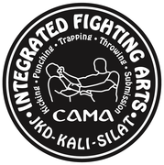](http://www.myfma.net/group/cambridge-academy-of-martial-arts)

[Cambridge Academy of Martial Arts®](http://www.myfma.net/group/cambridge-academy-of-martial-arts)

1 memberLatest Activity: Jul 20, 2012

Founded in July 1989 by Senior Instructor Ollie Batts and his most Senior Student at that time, Dr. Julie Gabriel.

Multi-cultural,…

* [](http://www.myfma.net/group/sandata-ng-arnis)

[Sandata Ng Arnis](http://www.myfma.net/group/sandata-ng-arnis)

1 memberLatest Activity: Jul 18, 2012

This very eclectic system comes from the old Manila region which is now the Isabella Province. It was founded by Guro Christopher Taubert and his…

* [Abenir Kali](http://www.myfma.net/group/ak)

[Abenir Kali](http://www.myfma.net/group/ak)

1 memberLatest Activity: Jul 18, 2012

Abenir Kali System is primarily a blade based martial art which derives its bulk of techniques and fighting principles in the arts of Kalis…

* [](http://www.myfma.net/group/kapisanag-mandirigma-institute)

[Kapisanag Mandirigma Institute](http://www.myfma.net/group/kapisanag-mandirigma-institute)

1 memberLatest Activity: Jul 12, 2012

The Kapisanang Mandirigma Institute is the Warrior Arts Training Department of Kapisanang Mandirigma.

The Kapisanang Mandirigma Institute…

* [](http://www.myfma.net/group/west-coast-fight-lab)

[West Coast Fight Lab](http://www.myfma.net/group/west-coast-fight-lab)

1 memberLatest Activity: Jul 9, 2012

* [](http://www.myfma.net/group/united-states-philippine-jendo-association)

[United States Philippine Jendo association](http://www.myfma.net/group/united-states-philippine-jendo-association)

1 memberLatest Activity: May 2, 2012

The United States Philippine Jendo Association (USA-JPA) was founded in 1996 by USA-JPA President…

* [](http://www.myfma.net/group/okotokseskrimadors)

[Okotoks Eskrimadors](http://www.myfma.net/group/okotokseskrimadors)

3 membersLatest Activity: Apr 18, 2012

Filipino Knife/Stick/Empty-hand training... Always evolving.

* [](http://www.myfma.net/group/tres-armas-kali)

[Tres Armas Kali](http://www.myfma.net/group/tres-armas-kali)

1 memberLatest Activity: Mar 23, 2012

We are based out of the Chicago Area practicing a blend of Kali with a heavy emphasis on Villa Eskrima.

* [](http://www.myfma.net/group/kali-serpent-concepts)

[KALI SERPENT CONCEPTS](http://www.myfma.net/group/kali-serpent-concepts)

1 memberLatest Activity: Mar 25, 2012

This training program is the result of experience in practice our instructor Alejandro Carreño P in the style Lucay Lucay Kali, …

* [](http://www.myfma.net/group/bayani-warrior-group)

[Bayani Warrior Group](http://www.myfma.net/group/bayani-warrior-group)

1 memberLatest Activity: Feb 9, 2012

Bayani Warrior is a group that seeks to develop people physically, mentally, and spiritually by teaching them an expression of what the…

* [](http://www.myfma.net/group/casasai)

[CASASAI](http://www.myfma.net/group/casasai)

1 memberLatest Activity: Dec 20, 2011

CASASAI (Combative and Sportive Arnis System Association Incorporated) is an organization that promotes CASAS. CASAS stands for Combative and…

* [](http://www.myfma.net/group/concrete-kali-system)

[Concrete Kali system](http://www.myfma.net/group/concrete-kali-system)

1 memberLatest Activity: Dec 12, 2011

    Hawaiian Kali Kempo,ie, Concrete Kali System. A blen of Kaju Kenbo and Villabrille Kali…

* [](http://www.myfma.net/group/kaliwali-arnis-arts)

[Kaliwali Arnis Arts](http://www.myfma.net/group/kaliwali-arnis-arts)

1 memberLatest Activity: Dec 14, 2011

* [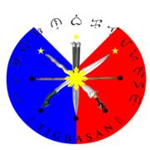](http://www.myfma.net/group/tigbasanarniskalieskrima)

[Tigbasan Arnis Kali Eskrima](http://www.myfma.net/group/tigbasanarniskalieskrima)

1 memberLatest Activity: Jul 24, 2011

Bicol-Visayan Blade Concept Arnis System with strong influence of Lameco-Sulite stlyle, Laolan Doce Henerales style & Arnes-arnes Tirigbasan…

* [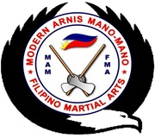](http://www.myfma.net/group/modernarnismanomanofilipinomartialarts)

[Modern Arnis Mano-Mano Filipino Martial Arts](http://www.myfma.net/group/modernarnismanomanofilipinomartialarts)

2 membersLatest Activity: Jun 21, 2011

* [](http://www.myfma.net/group/payanarnisdemano)

[Payan Arnis De Mano](http://www.myfma.net/group/payanarnisdemano)

1 memberLatest Activity: Jun 12, 2011

Payan Arnis De Mano is an eclectic Filipino Martial Art style comprised of various Filipino concepts, ideas and techniques.   for info on classes…

* [](http://www.myfma.net/group/k3lightning)

['K3-Lightning"](http://www.myfma.net/group/k3lightning)

1 memberLatest Activity: Jul 8, 2010

                     ' K3-Lightning '

method of imparting the principles and theories of practice of  one of the most impressive Filipino…

Top of Form

 [Search Groups](http://www.myfma.net/groups?page=8)

Bottom of Form

Sort by:                 

* [](http://www.myfma.net/group/gurusifujohn)

[Dragon Flower Boxing](http://www.myfma.net/group/gurusifujohn)

24 membersLatest Activity: May 18, 2010The Dragon Flower Boxing system,is my collective oriental martial arts experience and innovations.From Silat and Kuntao(Kung Fu).This system focus on…

* [](http://www.myfma.net/group/fixed-armour-filipino-martial-arts-club)

[Fixed Armour Filipino Martial arts club](http://www.myfma.net/group/fixed-armour-filipino-martial-arts-club)

1 memberLatest Activity: Mar 14, 2017

kali/ arnis/ escrima/ emptyhand dumog and knife fighting

* [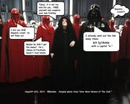](http://www.myfma.net/group/sayonatchi)

[Sayonatchi](http://www.myfma.net/group/sayonatchi)

1 memberLatest Activity: Nov 7, 2016

* [](http://www.myfma.net/group/practical-defensive-tactics)

[Practical Defensive Tactics](http://www.myfma.net/group/practical-defensive-tactics)

1 memberLatest Activity: Oct 20, 2015

FMA as taught by PDT founder Guro Mike Keller thru the Inosanto, Lucaylucay and Sulite lineage.

* [](http://www.myfma.net/group/armado-fma-deftac-int-l-philippines)

[Armado FMA Deftac Int'l Philippines](http://www.myfma.net/group/armado-fma-deftac-int-l-philippines)

1 memberLatest Activity: Apr 1, 2015

Armado FMA Deftac Int'l Academy  
****************************************  
Arnis ,Kali and Eskrima :…

* [](http://www.myfma.net/group/survival-awareness-concepts)

[Survival Awareness Concepts](http://www.myfma.net/group/survival-awareness-concepts)

1 memberLatest Activity: Feb 22, 2015Inspired by schools of thought such as, Bruce Lee’s Jeet Kun Do, Survival Awareness Concepts. is geared up to more of a martial training concept than…

* [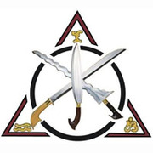](http://www.myfma.net/group/ki-survival-concepts)

[KI Survival Concepts](http://www.myfma.net/group/ki-survival-concepts)

1 memberLatest Activity: Feb 14, 2015

Inspired by schools of thought such as, Bruce Lee’s Jeet Kun Do, KI Survival Concepts. is geared up to more of a martial training…

* [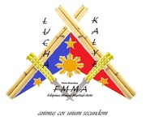](http://www.myfma.net/group/lucha-kalye-filipino-mixed-martial-arts)

[LUCHA KALYE - Filipino Mixed Martial Arts](http://www.myfma.net/group/lucha-kalye-filipino-mixed-martial-arts)

1 memberLatest Activity: Aug 17, 2014

Focusing mostly on Dirty Street Fighting with bases on Filipino Panuntukan and Filipino Dumog.Developed mainly for Street Tactics,Street Strategy…

* [](http://www.myfma.net/group/groveland-balintawak)

[Groveland Balintawak](http://www.myfma.net/group/groveland-balintawak)

1 memberLatest Activity: Jun 26, 2014

Balintawak is a Filipino martial art where the focus is on close quarters stick, knife and empty hand combat.The primary training tool used…

* [](http://www.myfma.net/group/pekiti-tirsia-kali-manila)

[Pekiti Tirsia Kali Manila](http://www.myfma.net/group/pekiti-tirsia-kali-manila)

1 memberLatest Activity: May 30, 2014

PTK Manila is the oldest civilian PTK club in Manila.

* [](http://www.myfma.net/group/te-combat-kuntao-jiu-jitsu)

[Te Combat Kuntao Jiu Jitsu](http://www.myfma.net/group/te-combat-kuntao-jiu-jitsu)

3 membersLatest Activity: Nov 29, 2013

|  |
| --- |
| Te Combat Kuntao Ju Jitsu welcomes all martial… |

* [](http://www.myfma.net/group/wotbag)

[WOTBAG](http://www.myfma.net/group/wotbag)

1 memberLatest Activity: Aug 3, 2013

World Original Teovels Balintawak Arnis Group  (WOTBAG)

* [](http://www.myfma.net/group/ang-mga-eskrimadoras-at-eskrimadors-ng-new-mexico)

[Ang mga Eskrimadoras at Eskrimadors ng New Mexico](http://www.myfma.net/group/ang-mga-eskrimadoras-at-eskrimadors-ng-new-mexico)

1 memberLatest Activity: Jul 2, 2013

* [](http://www.myfma.net/group/pekiti-tirsia-kali-sicas-famosus-dubai-uae)

[Pekiti-Tirsia Kali - Sicas Famosus Dubai / UAE](http://www.myfma.net/group/pekiti-tirsia-kali-sicas-famosus-dubai-uae)

1 memberLatest Activity: May 31, 2013

* [](http://www.myfma.net/group/kuma-goshin-jitsu-de-escrima)

[Kuma Goshin-jitsu de Escrima](http://www.myfma.net/group/kuma-goshin-jitsu-de-escrima)

1 memberLatest Activity: Apr 19, 2013

Kuma Goshin-jitsu de Escrima is a warrior training program inside of Okii Kuma Ryu Tamanegi Budo and is currently my main warrior training…

* [](http://www.myfma.net/group/the-official-visayan-style-corto-kadena-larga-mano)

[The Official Visayan Style Corto Kadena Larga Mano Eskrima (VSCK)](http://www.myfma.net/group/the-official-visayan-style-corto-kadena-larga-mano)

1 memberLatest Activity: Mar 19, 2013

This is the Official Visayan Corto Kadena group also known as Visayan Style Corto Kadena Larga Mano Eskrima that is based from the teachings of…

* [](http://www.myfma.net/group/lapunti-arnis-de-abanico-international)

[Lapunti Arnis de Abanico International](http://www.myfma.net/group/lapunti-arnis-de-abanico-international)

1 memberLatest Activity: Feb 21, 2013

Lapunti Arnis de Abanico, otherwise referred simply as 'Lapunti', is a style of arnis or eskrima that originated from Cebu,…

* [](http://www.myfma.net/group/bahad-zu-bu-filipino-fighting-arts-eskrima-kali-ar)

[Bahad Zu'bu Filipino Fighting Arts, Eskrima,Kali,Arnis](http://www.myfma.net/group/bahad-zu-bu-filipino-fighting-arts-eskrima-kali-ar)

1 memberLatest Activity: Oct 9, 2012

Bahad Zu'bu Eskrima, Arnis, Kali. Founded by Dakilang Guro Epifanio "Yuli" Romo. Classes are held at the Tanny Martial Arts Academy in Aurora,…

* [](http://www.myfma.net/group/villabrille-largusa-kali)

[Kali Association of America](http://www.myfma.net/group/villabrille-largusa-kali)

1 memberLatest Activity: Oct 4, 2012

Villabrille Largusa Kali System

* [](http://www.myfma.net/group/ochokantoskali)

[Ocho Kantos Kali](http://www.myfma.net/group/ochokantoskali)

5 membersLatest Activity: Aug 9, 2012

Mindanao based system of Kali merged with IKTHOF Knife and Axe Throwing and Parkour.

Top of Form

 [Search Groups](http://www.myfma.net/groups?page=7)

Bottom of Form

Sort by:                 

* [](http://www.myfma.net/group/arnisramosbatanguena)

[ARNIS RAMOS BATANGUEÑA](http://www.myfma.net/group/arnisramosbatanguena)

2 membersLatest Activity: Sep 1, 2010Arnis Ramos Batangueña is an a traditional style from the Ramos family of Cumba Lian Batangas

* [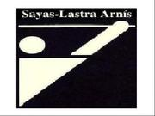](http://www.myfma.net/group/sayaslastrabrotherhood)

[Sayas-Lastra Brotherhood](http://www.myfma.net/group/sayaslastrabrotherhood)

29 membersLatest Activity: Jul 11, 2019The purpose of this group is to bring together those that have trained in the Sayas-Lastra System of Arnis and to honor our elders and teachers.

* [](http://www.myfma.net/group/kalipagano)

[Kali Pagano](http://www.myfma.net/group/kalipagano)

4 membersLatest Activity: Sep 1, 2010Kali Pagano is not a traditional FMA. We're a hybrid style that concentrates on a unique form of Stick Grappling with emphasis in single stick and…

* [](http://www.myfma.net/group/LoongFuPaiMartialArtsAcademy)

[Loong Fu Pai Martial Arts Academy](http://www.myfma.net/group/LoongFuPaiMartialArtsAcademy)

2 membersLatest Activity: Jan 30, 2010Kung Fu, Karate, Muay Thai, Aikido, Escrima/Kali/Arnis. Welcome to Loong Fu Pai Martial Arts Academy. Our club was founded by Master Kancho Terry…

* [](http://www.myfma.net/group/filipinocombatinstitute)

[Filipino Tactical Systems](http://www.myfma.net/group/filipinocombatinstitute)

9 membersLatest Activity: Sep 5, 2013

* [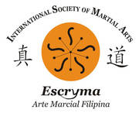](http://www.myfma.net/group/ismaescryma)

[ISMA ESCRYMA](http://www.myfma.net/group/ismaescryma)

5 membersLatest Activity: Sep 1, 2010

* [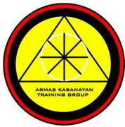](http://www.myfma.net/group/AKTG)

[Armas Kasanayan Training Group](http://www.myfma.net/group/AKTG)

10 membersLatest Activity: Sep 1, 2010A training group with a passion for Southeast Asian Martial Arts. We currently train in Dog Brothers Martial Arts, Kabaroan, Serrada, Balicki…

* [](http://www.myfma.net/group/houstonstickfightingassociation)

[Houston Stick Fighting Association](http://www.myfma.net/group/houstonstickfightingassociation)

12 membersLatest Activity: Aug 12, 2014The Houston Stick Fighting Association ("HSFA") is an association of like-minded martial artists that engage in simulated combat to to test and…

* [](http://www.myfma.net/group/arnistendencia)

[A.R.N.I.S. TENDENCIA](http://www.myfma.net/group/arnistendencia)

8 membersLatest Activity: Aug 31, 2010The training techniques stress development of key fundamental footwork, “live” check hand, essential distancing and timing in order to develop the…

* [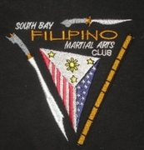](http://www.myfma.net/group/SouthBayFMAClub)

[South Bay FMA Club](http://www.myfma.net/group/SouthBayFMAClub)

31 membersLatest Activity: Nov 3, 2013

Mountain Visayan style fighting with single stick, knife or bolo, empty hands with kick and punch, and stick grapling. We train with all kinds of…

* [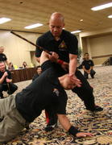](http://www.myfma.net/group/hufanatraditionalarnisinternational)

[Hufana Traditional Arnis International](http://www.myfma.net/group/hufanatraditionalarnisinternational)

5 membersLatest Activity: Sep 1, 2010Punong Guro Myrlino P. Hufana is the founder and grandmaster of the Hufana Traditional Arnis fighting system. The development of HTAI dates back to…

* [](http://www.myfma.net/group/bugnobaraw)

[Bugno Baraw](http://www.myfma.net/group/bugnobaraw)

4 membersLatest Activity: Sep 1, 2010+ BUGNO BARAW + is a Filipino based Close Quarter Bladefighting System, incorporating long- and shortblades, as well as empty hand…

* [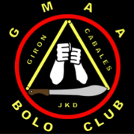](http://www.myfma.net/group/GMAA)

[GMAA](http://www.myfma.net/group/GMAA)

23 membersLatest Activity: Aug 31, 2010

* [](http://www.myfma.net/group/mfa)

[Motta Fighting Arts](http://www.myfma.net/group/mfa)

24 membersLatest Activity: Sep 24, 2012

San Francisco Bay Area club conducting regular classes in Giron Escrima, Kickboxing and Supportive Arts.

* [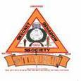](http://www.myfma.net/group/worldsimatukinunion)

[WORLD SIMATUKIN UNION](http://www.myfma.net/group/worldsimatukinunion)

5 membersLatest Activity: Aug 31, 2010ANGULAR SYSTEM BASES ITS COMBATIVE SUCCESS AND VICTORY ON THE POSITION, ATTACK, DEFENSES, COUNTER ATTACKS AND TRANSITION OF MOVEMENTS OF ITS OPPONENT…

* [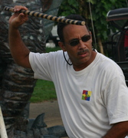](http://www.myfma.net/group/crossmartialarts)

[Cross Martial Arts](http://www.myfma.net/group/crossmartialarts)

8 membersLatest Activity: May 18, 2010JKD, FMA, Western Boxing, Grappling Arts, Chinese Kung Fu Wu-SU

* [](http://www.myfma.net/group/escrimadeceballos)

[Escrima de Ceballos](http://www.myfma.net/group/escrimadeceballos)

3 membersLatest Activity: Apr 27, 2010Escrima de Ceballos is the escrima art of Michael J. Ceballos. It is a combination of his families warrior arts, it's knowledge and warrior training…

* [](http://www.myfma.net/group/AgahonPassiIloiloCityPhilippines)

[PIKA - Philippines International Kickboxing Association](http://www.myfma.net/group/AgahonPassiIloiloCityPhilippines)

4 membersLatest Activity: Aug 31, 2010Philippines International Kickboxing Association... Founder Master Romy P. Aguilar

* [](http://www.myfma.net/group/eskabodaan)

[ESKABO Daan](http://www.myfma.net/group/eskabodaan)

17 membersLatest Activity: Sep 1, 2010

* [](http://www.myfma.net/group/americanmaharlikakuntawassociation)

[American Maharlika Kuntaw Association](http://www.myfma.net/group/americanmaharlikakuntawassociation)

14 membersLatest Activity: Dec 1, 2011Formed in 1974 to promote and propagate the Philippine art of Maharlika Kuntaw

* [](http://www.myfma.net/group/danielarolamartialartsgroupinc)

[DAMAG-INC Kali-Combatives](http://www.myfma.net/group/danielarolamartialartsgroupinc)

27 membersLatest Activity: Jun 22, 2013

DAMAG-INC is the acronym to Daniel Arola Martial Arts Group-Inc. We're a small group based out of Houston, Texas that is known primarily as a…

* [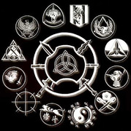](http://www.myfma.net/group/inosantolacosteacademy)

[inosanto lacoste academy](http://www.myfma.net/group/inosantolacosteacademy)

53 membersLatest Activity: Aug 28, 2017kali eskrima silat inosanto lacoste academy

* [](http://www.myfma.net/group/inosantolacoste)

[inosanto lacoste](http://www.myfma.net/group/inosantolacoste)

23 membersLatest Activity: Aug 28, 2017kali eskrima silat "inosanto lacoste" by guro Salem Assli

* [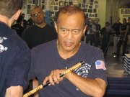](http://www.myfma.net/group/inosantolacostemethodoffilipinomartialarts)

[Inosanto/Lacoste Method of Filipino Martial Arts](http://www.myfma.net/group/inosantolacostemethodoffilipinomartialarts)

124 membersLatest Activity: Aug 28, 2017

* [](http://www.myfma.net/group/Kalisilatbrazil)

[KALI SILAT FEDERATION](http://www.myfma.net/group/Kalisilatbrazil)

36 membersLatest Activity: Jun 10, 2012Kali Silat Sina Tirsia Wali Brazil Branch

* [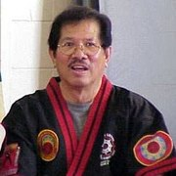](http://www.myfma.net/group/modernarnis)

[Modern Arnis](http://www.myfma.net/group/modernarnis)

68 membersLatest Activity: Apr 20, 2016

* [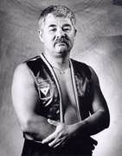](http://www.myfma.net/group/inayaneskrima)

[Inayan Eskrima](http://www.myfma.net/group/inayaneskrima)

34 membersLatest Activity: Jan 13, 2013A place to share Inayan Eskrima ideas

* [](http://www.myfma.net/group/academyofjeetkunedofightingtechnology)

[Academy Of Jeet Kune Do Fighting Technology](http://www.myfma.net/group/academyofjeetkunedofightingtechnology)

41 membersLatest Activity: Feb 16, 2015Academy in Athens, Greece teaching Jeet Kune Do and Inosanto/LaCoste Kali

* [](http://www.myfma.net/group/pambuanarnis)

[Pambuan Arnis](http://www.myfma.net/group/pambuanarnis)

31 membersLatest Activity: Mar 22, 2014Pambuan Arnis is a the family art of Ama Guro Raffy Pambuan, from Santa Cruz, Laguana, Philipines. it is a combination of the arts of his…

* [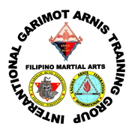](http://www.myfma.net/group/garimotarnistraininggroupinternational)

[GARIMOT ARNIS TRAINING GROUP](http://www.myfma.net/group/garimotarnistraininggroupinternational)

83 membersLatest Activity: Nov 29, 2019Filipino Martial Arts group originated from Paete, Laguna (Philippines) founded and head by Gat Puno Abon "Garimot" Baet

* [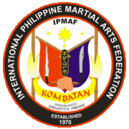](http://www.myfma.net/group/ipmaf)

[IPMAF - Kombatan](http://www.myfma.net/group/ipmaf)

310 membersLatest Activity: Aug 28, 2017Kombatan was developed by Grandmaster Ernesto Presas of Negros Occidental Province in the Visayas. Kombatan is a composite of various classical and…

* [](http://www.myfma.net/group/buot-balintawak)

[Buot Balintawak](http://www.myfma.net/group/buot-balintawak)

1 memberLatest Activity: Apr 20, 2016

* [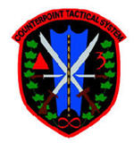](http://www.myfma.net/group/counterpoint-tactical-systems)

[Zach Whitson's Counterpoint Tactical Systems](http://www.myfma.net/group/counterpoint-tactical-systems)

6 membersLatest Activity: Feb 21, 2015

The Counterpoint Tactical System, also known by the acronym CTS, is a weapon-based integrated martial art designed…

* [](http://www.myfma.net/group/eskrima-carin)

[Eskrima Carin](http://www.myfma.net/group/eskrima-carin)

1 memberLatest Activity: Jun 26, 2012

just visit the website

eskrimacarin.org

for more info and history about

our style

* [](http://www.myfma.net/group/maharlika)

[Arnis Kali Maharlika / Inocalla System](http://www.myfma.net/group/maharlika)

1 memberLatest Activity: Apr 16, 2012

Grupo sobre a escola Arnis Maharlika / Inocalla System. A group about Arnis Kali Maharlika - Inocalla System.

* [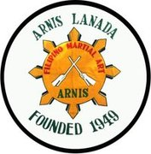](http://www.myfma.net/group/arnis-lanada)

[Arnis Lanada](http://www.myfma.net/group/arnis-lanada)

4 membersLatest Activity: Feb 16, 2012

Grand Master Porfirio Lanada

Arnis Lanada

 …

* [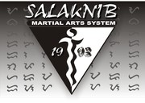](http://www.myfma.net/group/salaknib-martial-arts-system)

[SALAKNIB MARTIAL ARTS SYSTEM](http://www.myfma.net/group/salaknib-martial-arts-system)

1 memberLatest Activity: Mar 6, 2012

* [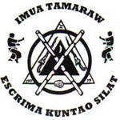](http://www.myfma.net/group/imuatamaraw)

[Imua Tamaraw](http://www.myfma.net/group/imuatamaraw)

2 membersLatest Activity: Aug 22, 2011Imua Tamaraw uses the 9 Gates methods as well as the 9 Points of Balance and the 5 Levels of Anatomical Targets as a means of teaching drills,…

* [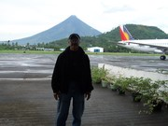](http://www.myfma.net/group/group-deleted)

[group deleted](http://www.myfma.net/group/group-deleted)

1 memberLatest Activity: Apr 30, 2011

* [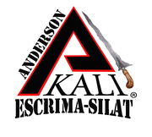](http://www.myfma.net/group/Andersonkali)

[Anderson-Kali](http://www.myfma.net/group/Andersonkali)

5 membersLatest Activity: Aug 31, 2010Anderson-Kali teaches Bugeido-Lihok, comprised of various forms of martial arts from Filipino styles to Kempo, Boxing, and others. We know that no…

* [](http://www.myfma.net/group/advancedcombativetacticsnow)

[Advanced Combative Tactics Now (ACT Now)](http://www.myfma.net/group/advancedcombativetacticsnow)

5 membersLatest Activity: May 7, 2010A culmination of 20 years of intensive study in traditional and what might be considered "non-traditional" Martial systems.

* [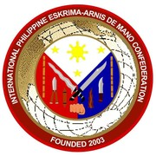](http://www.myfma.net/group/internationalphilippineeskrimaarnisdemanoconfedera)

[International Philippine Eskrima Arnis-De Mano Confederation](http://www.myfma.net/group/internationalphilippineeskrimaarnisdemanoconfedera)

9 membersLatest Activity: Apr 8, 2011OPEN to all Martial Arts Styles

* [](http://www.myfma.net/group/sistemabirada)

[SISTEMA BIRADA](http://www.myfma.net/group/sistemabirada)

10 membersLatest Activity: Jan 17, 2011Filipino Martial Arts

* [](http://www.myfma.net/group/usharimawbunofederation)

[US HARIMAW BUNO FEDERATION](http://www.myfma.net/group/usharimawbunofederation)

55 membersLatest Activity: Jul 26, 2014Authentic Filipino Wrestling Grappling Arts from Luzon, Philippines taught by Gat Puno Abon "Garimot" Baet

* [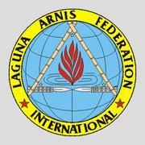](http://www.myfma.net/group/lagunaarnisfederationinternational)

[LAGUNA ARNIS FEDERATION INTERNATIONAL](http://www.myfma.net/group/lagunaarnisfederationinternational)

42 membersLatest Activity: Sep 13, 2011FMA martial arts group pratitioner and supporter from Laguna, Philippines.

* [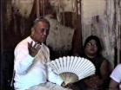](http://www.myfma.net/group/stocktonmultistyleescrima)

[Stockton Multi-Style Escrima](http://www.myfma.net/group/stocktonmultistyleescrima)

159 membersLatest Activity: Aug 28, 2017

The Stockton Multi-Style Escrima School is comprised of the top instructors and graduates of the Original Bahala Na Club#1 under Grandmaster Leo…

* [](http://www.myfma.net/group/lescima)

[Llanera Fighting Systems (LFS)](http://www.myfma.net/group/lescima)

5 membersLatest Activity: Feb 14, 2014Llanera Fighting Systems: Llanera Escrima and SayKan Kombat. Founded by Grand Master Modesto (Ding) Llanera.

* [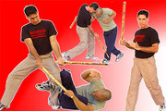](http://www.myfma.net/group/battlefieldkali)

[Burton "Lucky Dog" Richardson's Battlefield Kali](http://www.myfma.net/group/battlefieldkali)

38 membersLatest Activity: Jun 7, 2014This program is a certification course based on sparring to ensure that EVERYTHING trained is functionalized by the individual. If you want to be a…

* [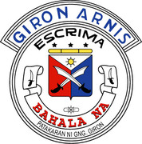](http://www.myfma.net/group/bahalanafilipinomartialartsassociationgironescrima)

[Bahala Na Filipino Martial Arts Association/Giron Escrima Arnis](http://www.myfma.net/group/bahalanafilipinomartialartsassociationgironescrima)

53 membersLatest Activity: Sep 7, 2015Bahala Na is dedicated to the purity of the late Grand Master Leovigildo Migel Giron's original teachings, philosophies and traditions. Celebrating…

* [](http://www.myfma.net/group/internationaleskrimaserradainternational)

[International Eskrima / Serrada International](http://www.myfma.net/group/internationaleskrimaserradainternational)

4 membersLatest Activity: Sep 23, 2010

* [](http://www.myfma.net/group/classiceskrima)

[Classic Eskrima](http://www.myfma.net/group/classiceskrima)

11 membersLatest Activity: Mar 7, 2013Filipino Martial Arts

* [](http://www.myfma.net/group/cacoydocepareseskrima)

[Cacoy Doce Pares Eskrima](http://www.myfma.net/group/cacoydocepareseskrima)

40 membersLatest Activity: Jul 1, 2013The Doce Pares style of Supreme Gradmaster Ciriaco 'Cacoy' Canete (12th Degree Black Belt).

* [](http://www.myfma.net/group/visayanlegacyassociation)

[Visayan Legacy Association • Doce Pares](http://www.myfma.net/group/visayanlegacyassociation)

13 membersLatest Activity: Mar 15, 2015In general terms, Visayan Legacy is a martial arts school and has produced champions at both the National and International levels but its purpose…

* [](http://www.myfma.net/group/abc)

[Please Delete This Group](http://www.myfma.net/group/abc)

2 membersLatest Activity: Apr 30, 2012

* [](http://www.myfma.net/group/dobleterapilon)

[Doblete Rapilon](http://www.myfma.net/group/dobleterapilon)

24 membersLatest Activity: Jun 30, 2016"Doblete Rapilon Arnis is the style of my father and of our forefathers. It is the soul of our island Ilo-Ilo and the heart of our nation, The…

* [](http://www.myfma.net/group/vitalkali)

[Vital Kali](http://www.myfma.net/group/vitalkali)

7 membersLatest Activity: Sep 5, 2013A minimalistic system of combat covering all fighting aspects.

* [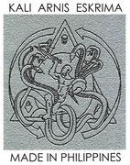](http://www.myfma.net/group/headhuntersports)

[Headhunter Sports](http://www.myfma.net/group/headhuntersports)

15 membersLatest Activity: Dec 20, 2010It's a nice friendly group where we train a hybrid of FMA concepts based on the classical and modern principles of developing self-discipline,…

* [](http://www.myfma.net/group/seamoktacticalsolutions)

[SEAMOK Tactical Solutions](http://www.myfma.net/group/seamoktacticalsolutions)

76 membersLatest Activity: Feb 8, 2015SEAMOK Tactical Solutions  
S - Simple  
E- Effective  
A- Aggressive  
M- Methods  
O- Of  
K- Kombate

* [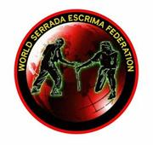](http://www.myfma.net/group/worldserradaescrimafederation)

[World Serrada Escrima Federation](http://www.myfma.net/group/worldserradaescrimafederation)

66 membersLatest Activity: Jan 19, 2018The (WSEF) is an international escrima federation that was founded in 2003, by Grandmaster Anthony Davis and Prof. Leo T. Fong.

* [](http://www.myfma.net/group/eskrimalabaniego)

[Eskrima Labaniego](http://www.myfma.net/group/eskrimalabaniego)

9 membersLatest Activity: Feb 19, 2012Eskrima Labaniego is a Filipino Martial Art that practices the deadly style of "espada y daga eskrima" under the lineage and tutelage of Grandmaster…

* [](http://www.myfma.net/group/Senkotiros)

[Senkotiros](http://www.myfma.net/group/Senkotiros)

14 membersLatest Activity: Feb 23, 2013Senkotiros means "five strikes" and is based on angles of attack, defensive shielding, minimizing movements, and sensitivity. The practitioner…

* [](http://www.myfma.net/group/armaskalikaishinkskmartialart)

[Armas-Kali & Kai-Shin / KSK Martial Arts](http://www.myfma.net/group/armaskalikaishinkskmartialart)

32 membersLatest Activity: Jul 9, 2015This group is for anyone interested in K.S.K. Martial Arts, Sensei-Guro T. Kent Nelson's teachings, Armas-Kali & Kai-Shin. We teach the Principles &…

* [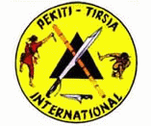](http://www.myfma.net/group/pekititersiainternational)

[Pekiti Tersia International Study Group](http://www.myfma.net/group/pekititersiainternational)

39 membersLatest Activity: Jun 10, 2014Pekiti-Tirsia is a Filipino Martial Art developed by the Tortal family of Negros, an island in the central Visayan region of the Philippines and…

* [](http://www.myfma.net/group/marppio)

[MARPPIO](http://www.myfma.net/group/marppio)

25 membersLatest Activity: May 19, 2014This is the group for MAPPIO (Modern Arnis Remy P. Presas International Organization) led by Dr. Remy P. Presas Jr. and maintained by the Presas…

* [](http://www.myfma.net/group/Bacolod)

[MantasDaga Int'l](http://www.myfma.net/group/Bacolod)

10 membersLatest Activity: Jan 2, 2012A Filipino Indigenous Knife Fighting Tactics

* [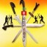](http://www.myfma.net/group/siratalsayfmuslimmartialartsystem)

[SIRAT AS SAYF MUSLIM MARTIAL ART SYSTEM](http://www.myfma.net/group/siratalsayfmuslimmartialartsystem)

9 membersLatest Activity: Oct 8, 2012Sirat As Sayf MMA is an eclectic fighting art. Developed for the sole purpose to allow Muslims to practice martial arts in an Islamic manner without…

* [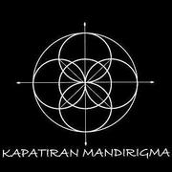](http://www.myfma.net/group/kapatiranmandirigma)

[Kapatiran Mandirigma](http://www.myfma.net/group/kapatiranmandirigma)

37 membersLatest Activity: Apr 20, 2016Kapatiran Mandirigma is a union teaching Kombatan Arnis, Kadena Kruzada Eskrima, Kuntao Silat deThouars, Combate Eskrima Orehenal, Inti Ombak Pencak…

* [](http://www.myfma.net/group/kuntawkali)

[FMA FIGHTERS](http://www.myfma.net/group/kuntawkali)

14 membersLatest Activity: Jun 24, 2011I am a direct student and a full instructor under Maestro Rico & Datu Rich Acosta. We are a small group but keep expanding!My group and I represent…

* [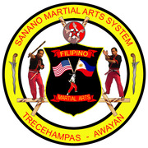](http://www.myfma.net/group/sananoarnis)

[Sanano Arnis](http://www.myfma.net/group/sananoarnis)

7 membersLatest Activity: Jul 16, 2012

* [](http://www.myfma.net/group/lightningscientificarnisinternational)

[Lightning Scientific Arnis International](http://www.myfma.net/group/lightningscientificarnisinternational)

31 membersLatest Activity: Jun 13, 2013A System founded in 1937 by the late Grandmaster Benjamin Luna Lema composed of Tercia, Serrada, Cadenilla and Espada y Daga styles. It is know for…

* [](http://www.myfma.net/group/unitedstateswanchuandoassn)

[United States Wan Chuan Do Association](http://www.myfma.net/group/unitedstateswanchuandoassn)

14 membersLatest Activity: Feb 15, 2013

Circa 1975 Inosanto JKD/Kali with heavy influence on off-line movements, angling and rapid destructions.

* [](http://www.myfma.net/group/defensormethod)

[Defensor Method](http://www.myfma.net/group/defensormethod)

41 membersLatest Activity: Aug 28, 2017The Defensor Method of Filipino-Indonesian Martial Arts headed by Maha Guro Nate Defensor based in Chicago, IL. It is a complete system that enables…

* [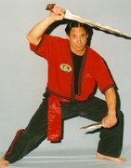](http://www.myfma.net/group/miraradaescrimaweeblycom)

[MiraRada Escrima (Knights of Escrima)](http://www.myfma.net/group/miraradaescrimaweeblycom)

14 membersLatest Activity: Jan 6, 2013MiraRada Escrima was started by Master Art Miraflor in 1968 to promote the Filipino martial Arts. We specialize in custom padded sticks. 209-405-3189.

* [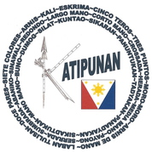](http://www.myfma.net/group/katipunanfmaflorida)

[Katipunan_FMA Brotherhood](http://www.myfma.net/group/katipunanfmaflorida)

51 membersLatest Activity: Feb 19, 2012FILIPINO MARTIAL ARTS BROTHERHOOD

* [](http://www.myfma.net/group/bakbakaninternationalkaliilustrisimo)

[Bakbakan Kali-Ilustrisimo/Sibukan Kali](http://www.myfma.net/group/bakbakaninternationalkaliilustrisimo)

33 membersLatest Activity: Aug 20, 2012This is for all practitioners of the Warrior Arts of the Philippines (aka Filipino Martial Arts). A place to share your stories, discuss techniques,…

* [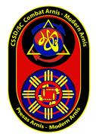](http://www.myfma.net/group/cssdconceptualmodernarnispresasarnis)

[CSSD Conceptual Modern Arnis/Presas Arnis](http://www.myfma.net/group/cssdconceptualmodernarnispresasarnis)

14 membersLatest Activity: May 19, 2014The Concepts of Modern Arnis and Presas Arnis as expressed through the use of the Blade such as the Bolo and the Tactical applications called…

* [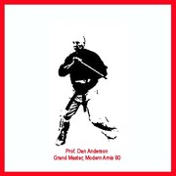](http://www.myfma.net/group/MA80)

[MA-80](http://www.myfma.net/group/MA80)

21 membersLatest Activity: May 19, 2014MA-80 (Modern Arnis 80) is Dan Anderson's curriculum of FMA.

* [](http://www.myfma.net/group/cadenillaeskimagroup)

[Cadenilla Eskrima Group](http://www.myfma.net/group/cadenillaeskimagroup)

7 membersLatest Activity: Jan 1, 2012Modern Arnis, Cinco Teros - Kasilagan, Lightning Scientific Arnis (Tersia Serrada Cadenilla y Espada y Daga) and CSSD/SC Modular Knife

* [](http://www.myfma.net/group/sagupaanstrategyandtacticsteamintl)

[SAGUPAAN STRATEGY AND TACTICS TEAM INT'L.](http://www.myfma.net/group/sagupaanstrategyandtacticsteamintl)

3 membersLatest Activity: Apr 10, 2010STREET CONFRONTATION, TACTICAL ART AND SURVIVAL ART.STANDING AND GROUND FIGHTHING. CLASSIC FMA BASED WITH A TOUCH OF DIFFERENT CONCEPTS TYPE OF ART.

* [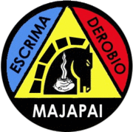](http://www.myfma.net/group/majapaiderobioescrima)

[Majapai Derobio Escrima](http://www.myfma.net/group/majapaiderobioescrima)

47 membersLatest Activity: Jun 17, 2016Majapai Derobio Escrima is a style with its foundation in Derobio Escrima, with influances from Arnis 63 Generals from Cotabato,Arnis…

Top of Form

 [Search Groups](http://www.myfma.net/groups?page=3)

Bottom of Form

Sort by:                 

* [](http://www.myfma.net/group/olaanaloeskrimajunglestyle)

[Ola'a-nalo Eskrima Jungle Style](http://www.myfma.net/group/olaanaloeskrimajunglestyle)

8 membersLatest Activity: Jul 29, 2011

Ola'a-nalo Eskrima is a weapons based martial art drawing influences from Derobio Escrima and other various armed and unarmed fighting arts of the…

* [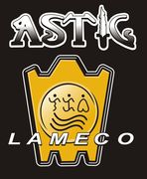](http://www.myfma.net/group/astigcombativescanada)

[ASTIG COMBATIVES CANADA](http://www.myfma.net/group/astigcombativescanada)

19 membersLatest Activity: May 30, 2012ASTIG Combatives Canada----Guro Roger Agbulos.

* [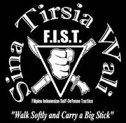](http://www.myfma.net/group/sinatirsiawalikali)

[SinaTirsiaWali Kali](http://www.myfma.net/group/sinatirsiawalikali)

14 membersLatest Activity: Nov 12, 2018The SinaTirsiaWali Kali Self-Protection System is based upon the 64 attacks, various siniwalli, footwork, body mechanics, and how to strike, and is…

* [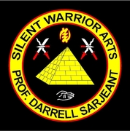](http://www.myfma.net/group/silentwarriorarts)

[Tahimik Mandirigma Kali Silat](http://www.myfma.net/group/silentwarriorarts)

14 membersLatest Activity: Apr 5, 2011

The official group of Tahimik Mandirigma Kali Silak

* [](http://www.myfma.net/group/Docepares1989)

[Doce Pares Scotland](http://www.myfma.net/group/Docepares1989)

4 membersLatest Activity: Feb 7, 2017

* [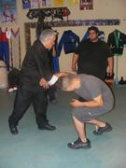](http://www.myfma.net/group/saturnomodernserrada)

[Saturno Modern Serrada](http://www.myfma.net/group/saturnomodernserrada)

47 membersLatest Activity: Aug 28, 2017Dedicated to the the advancement of Serrada Escrima of the late great Manong Cabales

* [](http://www.myfma.net/group/hertfordshiremartialarts)

[Hertfordshire Martial Arts (CFS/MKG)](http://www.myfma.net/group/hertfordshiremartialarts)

2 membersLatest Activity: Apr 26, 2010A group for all who train at HMA & all of our friends around the world with an interest in martial arts. At HMA we mainly train in the following…

* [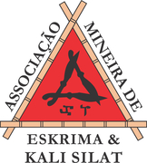](http://www.myfma.net/group/amksassociaomineiradekalisilat)

[AMEKS- ASSOCIAÇÃO MINEIRA DE ESKRIMA e KALI SILAT](http://www.myfma.net/group/amksassociaomineiradekalisilat)

9 membersLatest Activity: Jun 29, 2015

Associação Mineira de Eskrima Kali Silat e - Sina Tirsia wali - Minas Gerais Brasil. 'Tuhon Greg Alland, Punog Guru Paulo…

* [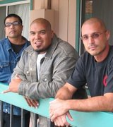](http://www.myfma.net/group/kadaananeskrima)

[Kada Anan Eskrima](http://www.myfma.net/group/kadaananeskrima)

11 membersLatest Activity: Dec 2, 2012

An Arizona chapter of the Fierce Tigers Martial Arts Association (FTMA), based in Salinas, California and the Arizona chapter of the buffalo black…

* [](http://www.myfma.net/group/dekittirsiasiradas)

[Dekiti Tirsia Siradas](http://www.myfma.net/group/dekittirsiasiradas)

17 membersLatest Activity: Apr 29, 2012Dekiti-Tirsia Siradas is a blade oriented system heavily emphasizing footwork, enabling the practitioner to rapidly close the distance and finish the…

* [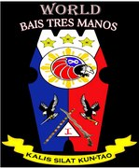](http://www.myfma.net/group/kalissilatkuntaofma)

[World Bais3Manos/Kalis Silat Kun-Tao FMA Heritage Network](http://www.myfma.net/group/kalissilatkuntaofma)

13 membersLatest Activity: Jun 22, 2013

World Bais3Manos/KALIS SILAT KUN-TAO FMA network.

An Ancient Elite Combat Arts and Adapted to Modern Sports. World B3M/KSK FMA Heritage…

* [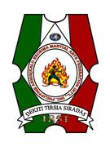](http://www.myfma.net/group/dekititersiaseradaskali)

[Dekiti Tersia Seradas (kali)](http://www.myfma.net/group/dekititersiaseradaskali)

13 membersLatest Activity: Feb 4, 2012DEKITI-TIRSIA-SIRADAS The Filipino Indigenous Legendary Family System From the Island of Negros, Occidental Philippines

* [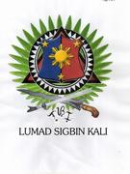](http://www.myfma.net/group/lumadsigbinkali)

[Lumad Sigbin Kali](http://www.myfma.net/group/lumadsigbinkali)

11 membersLatest Activity: Feb 15, 2011Cebu- Visayan WEDO close quarter

* [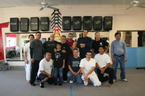](http://www.myfma.net/group/kemscrimadohassociation)

[Kemscrima Doh Association](http://www.myfma.net/group/kemscrimadohassociation)

10 membersLatest Activity: Apr 2, 2012Chinese Indonesian Filipino influenced Self Defense Art created by Glenn Abrescy Sr. Over 50 years of learning, teaching, and evolving is reflected…

* [](http://www.myfma.net/group/originalgironescrima)

[Original Giron Escrima](http://www.myfma.net/group/originalgironescrima)

35 membersLatest Activity: Jun 22, 2013

* [](http://www.myfma.net/group/shinkaliacademy)

[ShinKali Academy](http://www.myfma.net/group/shinkaliacademy)

22 membersLatest Activity: Jan 30, 2011

ShinKali Academy is a Blade & Impact Weapons Training System that has a wide variety of Training Methods aimed at developing a well rounded…

* [](http://www.myfma.net/group/hilotgarimotfilipinohealingarts)

[HILOT GARIMOT {Filipino Healing Arts}](http://www.myfma.net/group/hilotgarimotfilipinohealingarts)

26 membersLatest Activity: Feb 29This page for the group of Hilot Garimot (Therapeutic Healing Arts of the Philippines) Disccussion Topic: History, Threrapeutic Massage, Herbs,…

* [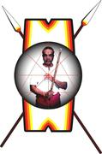](http://www.myfma.net/group/3124box)

[Senkotiros Arnis Tribe](http://www.myfma.net/group/3124box)

22 membersLatest Activity: May 19

Senkotiros Arnis, Philippine Martial Art, Arnis, Kali, Eskrima

* [](http://www.myfma.net/group/unitedfilipinomartialartscouncilufmac)

[Unified Filipino Martial Arts Council "UFMAC"](http://www.myfma.net/group/unitedfilipinomartialartscouncilufmac)

118 membersLatest Activity: May 3Our mission is to provide an open forum for the preservation, promotion, and the unification of the Filipino Martial Arts Community. Membership is…

* [](http://www.myfma.net/group/paclibarbicolarnis)

[Paclibar Bicol Arnis](http://www.myfma.net/group/paclibarbicolarnis)

7 membersLatest Activity: Apr 30, 2012

Top of Form

 [Search Groups](http://www.myfma.net/groups?page=2)

Bottom of Form

Sort by:                 

* [](http://www.myfma.net/group/i)

[International Rutano Estokada Federation](http://www.myfma.net/group/i)

5 membersLatest Activity: Jan 25, 2015

This group is dedicated to preserving and promoting the original Filipino martial art of Founder and Punong Tagapagturo Daniel G.…

* [](http://www.myfma.net/group/bahad-zubu-irl)

[Bahad ZuBu IRL](http://www.myfma.net/group/bahad-zubu-irl)

5 membersLatest Activity: May 18, 2013

It is unique Filipinos Art of Fighting System founded by GM Epifanio “Yul” Romo. This system does not use straight attacks and raw force, instead…

* [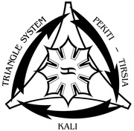](http://www.myfma.net/group/pekiti-tirsia)

[Pekiti-Tirsia Kali](http://www.myfma.net/group/pekiti-tirsia)

26 membersLatest Activity: Aug 13, 2014

Pekiti-Tirsia Kali is a close quarters bladefighting system that employs edged and impact…

* [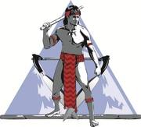](http://www.myfma.net/group/rmkg)

[Rocky Mountain Kali Group](http://www.myfma.net/group/rmkg)

5 membersLatest Activity: Dec 31, 2018

Currently Colorado's only Dogbrother Martial Arts training group.  Training involves development of functional skill sets in real contact stick…

* [](http://www.myfma.net/group/nickelstick-balintawak-usa)

[Nickelstick Balintawak USA](http://www.myfma.net/group/nickelstick-balintawak-usa)

18 membersLatest Activity: Feb 29

Nickelstick Balintawak was established on the 27th of April 2003 by GM Nick Elizar after representing Teovels Balintawak White Chapter for more…

* [](http://www.myfma.net/group/progressive-american-combatives-escrima-ju-jutsu)

[Progressive American Combatives Escrima Ju-Jutsu](http://www.myfma.net/group/progressive-american-combatives-escrima-ju-jutsu)

3 membersLatest Activity: May 30, 2012

* [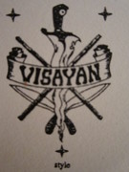](http://www.myfma.net/group/visayan-oakland-style-corto-kadena-larga-mano-eskr)

[Visayan - Oakland Style (Corto Kadena & Larga Mano Eskrima)](http://www.myfma.net/group/visayan-oakland-style-corto-kadena-larga-mano-eskr)

5 membersLatest Activity: Mar 5, 2013

* [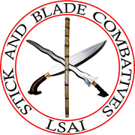](http://www.myfma.net/group/stick-and-blade-combatives-l-s-a-i)

[Stick and Blade Combatives (L.S.A.I.)](http://www.myfma.net/group/stick-and-blade-combatives-l-s-a-i)

4 membersLatest Activity: Oct 7, 2011

* [](http://www.myfma.net/group/escrimagoldengateclub)

[Escrima Golden Gate Club](http://www.myfma.net/group/escrimagoldengateclub)

3 membersLatest Activity: Sep 20, 2011

Escrima Golden Gate Club is a martial arts group that preserves the traditions of the Maylay Arts.…

* [](http://www.myfma.net/group/wekafusawekafinternational)

[WEKAF USA ( WEKAF INTERNATIONAL )](http://www.myfma.net/group/wekafusawekafinternational)

17 membersLatest Activity: Nov 30, 2012Unifying FMA

* [](http://www.myfma.net/group/InayanTrainingOrganization)

[Inayan Training Organization (ITO)](http://www.myfma.net/group/InayanTrainingOrganization)

11 membersLatest Activity: Jul 29, 2014

The Inayan Training Organization (ITO) is an association of individuals and schools interested in broadening their martial arts and self-defense…

* [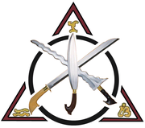](http://www.myfma.net/group/liahonawarriora)

[Liahona Warrior Arts International](http://www.myfma.net/group/liahonawarriora)

3 membersLatest Activity: Nov 27, 2011

* [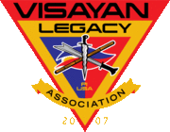](http://www.myfma.net/group/VLA)

[Visayan Legacy Association](http://www.myfma.net/group/VLA)

3 membersLatest Activity: Feb 13, 2012Visayan Legacy Association, one of the premiere Filipino Martial Arts schools in the world, has been producing champions for over a decade.

* [](http://www.myfma.net/group/FMASCHOOL)

[FMASCHOOL.com](http://www.myfma.net/group/FMASCHOOL)

4 membersLatest Activity: Mar 15, 2015Filipino Martial Arts School (FMASCHOOL) is a branch of VISAYAN LEGACY Association with schools in Perris & Los Angeles California.

* [](http://www.myfma.net/group/sitbatankalisilat)

[Sitbatan Kali Silat](http://www.myfma.net/group/sitbatankalisilat)

3 membersLatest Activity: Mar 22, 2011Founded by Guro Rohnee Tiong Gumpal aka Brother Mujahid

* [](http://www.myfma.net/group/seamokpensacola)

[SEAMOK Tactical Solutions; Pensacola Florida Chapter](http://www.myfma.net/group/seamokpensacola)

12 membersLatest Activity: Nov 19, 2013Spreading the art forged in Texas by Amo Guro Michael Blackgrave. No nonsense. Just getting it done so we can get home.

* [](http://www.myfma.net/group/jkj_balintawak)

[JKJ-Balintawak](http://www.myfma.net/group/jkj_balintawak)

4 membersLatest Activity: Jan 4, 2011JKJ-Balintawak is a mix of Balintawak, The Dacayana Eskrima System and parts from Bujinkan (Ninjutsu) and Sports Ju-Jutsu... The style is aimed at…

* [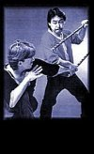](http://www.myfma.net/group/skdtacticalweaponry)

[SKD Tactical Weaponry](http://www.myfma.net/group/skdtacticalweaponry)

4 membersLatest Activity: Mar 5, 2013FMA as taught by Guro Mark Stewart thru the Ted Lucaylucay Lineage. Sungkite Kali Derecho (SKD) is a Modern Filipino method with a strong…

* [](http://www.myfma.net/group/villasinbalintawakarnisacademy)

[Villasin Balintawak Arnis Academy](http://www.myfma.net/group/villasinbalintawakarnisacademy)

5 membersLatest Activity: Sep 1, 2015Balintawak Arnis taught by Grand Master Ver Villasin. Training takes place at the Bayanihan Center at Seafood City in Vallejo, CA. This close range,…

* [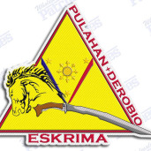](http://www.myfma.net/group/pulahanderobioeskrima)

[Pulahan - DEROBIO EsKrima](http://www.myfma.net/group/pulahanderobioeskrima)

23 membersLatest Activity: Apr 5, 2016Pulahan-Derobio Eskrima Founded by the Siangco Collective: Grand Tuhon Chris Siangco, Tuhon Chaz Siangco and Tuhon Christian Siangco. The Siangco…

* [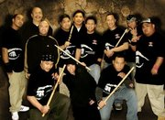](http://www.myfma.net/group/tabiminabalintawakusa)

[Tabimina Balintawak](http://www.myfma.net/group/tabiminabalintawakusa)

11 membersLatest Activity: Dec 6, 2011

Tabimina Balintawak is a stickfighting art that preserves the teachings of the the GGM Venancion "Anciong" Bacon as taught to Bob Tabimina. Is a…

* [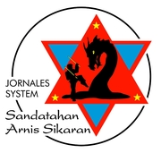](http://www.myfma.net/group/jornales-system-sandatahan-arnis-sikaran)

[Jornales System SANDATAHAN Arnis-Sikaran](http://www.myfma.net/group/jornales-system-sandatahan-arnis-sikaran)

3 membersLatest Activity: Oct 10, 2011

* [](http://www.myfma.net/group/sinatirsiawali)

[Sina Tirsia Wali](http://www.myfma.net/group/sinatirsiawali)

25 membersLatest Activity: Apr 17Filipino Indonesian Self-Defense Tactics, other wise known as FIST, was established in 2003 and had been responsible for providing outstanding…

* [](http://www.myfma.net/group/international-real-arnis-federation)

[International Real Arnis Federation](http://www.myfma.net/group/international-real-arnis-federation)

2 membersLatest Activity: Feb 11, 2013

Real Arnis contain all my knowledge which I learn in 35 years. (30 years in many differant Escrima, Arnis and Kali,Silat Styles) and 20 years of…

* [](http://www.myfma.net/group/philippine-warrior-arts-society)

[Philippine Warrior Arts Society](http://www.myfma.net/group/philippine-warrior-arts-society)

13 membersLatest Activity: Jul 8, 2014

The Philippine Warrior Arts Society is hereby brought forth into…

* [](http://www.myfma.net/group/unique-martial-arts-academy-nz-presents-henderson-)

[Unique Martial Arts Academy NZ - Presents Henderson's Diamondback Eskrima](http://www.myfma.net/group/unique-martial-arts-academy-nz-presents-henderson-)

4 membersLatest Activity: Jun 19, 2012

* [](http://www.myfma.net/group/edmonton-filipino-martial-arts-club)

[Edmonton Filipino Martial Arts Club](http://www.myfma.net/group/edmonton-filipino-martial-arts-club)

9 membersLatest Activity: Oct 24, 2012

The Edmonton Filipino Martial Arts Club is dedicated to preserving and promoting authentic and original Filipino martial arts.

* [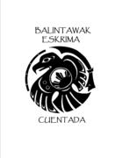](http://www.myfma.net/group/balintawak-cuentada-seattle)

[Puget Sound Eskrima](http://www.myfma.net/group/balintawak-cuentada-seattle)

13 membersLatest Activity: Nov 26, 2013

Balintawak is considered a close quarter style, the Cuentada system prepares the  
practitioner for the varying ranges of combat - employing…

* [](http://www.myfma.net/group/internationalkuntawfederation)

[International Kuntaw Federation](http://www.myfma.net/group/internationalkuntawfederation)

7 membersLatest Activity: Mar 5, 2012Modern sport style of Kuntaw and Arnis. Grandmaster Carlito A Lanada,SR Founder & Chief Executive Director KUNTAW NG PILIPINAS INTERNATIONAL…

* [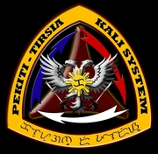](http://www.myfma.net/group/pekiti)

[Pekiti Tirsia Kali DC/MD/VA](http://www.myfma.net/group/pekiti)

2 membersLatest Activity: Nov 12, 2018

**Pekiti Tirsia Kali Training Schedule…**

* [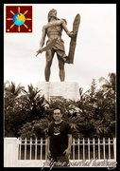](http://www.myfma.net/group/filipino-martial-heritage-atlanta)

[Filipino Martial Heritage, Atlanta](http://www.myfma.net/group/filipino-martial-heritage-atlanta)

2 membersLatest Activity: Apr 7, 2015

We are the Atlanta wing of Guro Victor Gendrano Jr.'s Filipino Martial Heritage.  We have been under the guidance and tutelage of Guro Victor…

* [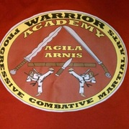](http://www.myfma.net/group/agila-arnis)

[Agila arnis](http://www.myfma.net/group/agila-arnis)

2 membersLatest Activity: Feb 2, 2015A combination of several Philippine styles as well as other influences. Very focused on the historical aspects of arts but progressive to modern…

* [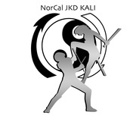](http://www.myfma.net/group/norcal-jkd-kali-academy)

[NORCAL JKD KALI ACADEMY](http://www.myfma.net/group/norcal-jkd-kali-academy)

3 membersLatest Activity: Dec 29, 2013

Official Guro Dan Inosanto Academy

Jeet Kune Do and Filipino Martial Arts

Affiliated with Sensei Erik Paulson

Combat…

* [](http://www.myfma.net/group/urban-defense-tactics)

[Urban Defense Tactics](http://www.myfma.net/group/urban-defense-tactics)

2 membersLatest Activity: Jan 9, 2015

Urban Defense Tactics focuses on enhancing the survivability of the individual while engaged in urban environments, using both spiritual and…

* [](http://www.myfma.net/group/modern-arnis-mfa-method)

[MODERN ARNIS - MFA METHOD](http://www.myfma.net/group/modern-arnis-mfa-method)

10 membersLatest Activity: Aug 28, 2017

Headed by Guro Andrew "Tattoo"Filardo. Personal student of the late GM Remy Presas. MFA Method emphasis is on the "Combat" rather than the "Art".…

* [](http://www.myfma.net/group/houston-martial-arts-acacdemy)

[Houston Martial Arts Acacdemy](http://www.myfma.net/group/houston-martial-arts-acacdemy)

4 membersLatest Activity: Jan 3, 2014

HMAA brings together and shares the systems of Bahala Na Martial Arts/Giron Arnis Escrima, Galleon Clan Escrima and Chung Do Kwan TKD.

* [](http://www.myfma.net/group/balintawak-arnis-cuentada)

[Balintawak Arnis Cuentada](http://www.myfma.net/group/balintawak-arnis-cuentada)

8 membersLatest Activity: Feb 6, 2017

Balintawak Arnis Cuentada is a stickfighting art as taught by GM Bobby Taboada, and originally creaded by GGM Venancion "Anciong"…

* [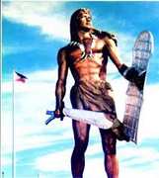](http://www.myfma.net/group/atlanta-filipino-martial-arts)

[Atlanta Filipino Martial Arts](http://www.myfma.net/group/atlanta-filipino-martial-arts)

3 membersLatest Activity: Aug 2, 2013

Traditional Filipino Martial Arts Training in Escrima Kali Arnis & Silat. We offer a comprehensive training curriculum which covers all the…

* [](http://www.myfma.net/group/isidro-modern-arnis)

[Isidro Modern Arnis](http://www.myfma.net/group/isidro-modern-arnis)

12 membersLatest Activity: Oct 11, 2013

Modern Arnis techniques with Visadario and Arkido (Arnis and Hapkido). The FMA School of Modern Arnis that teaches both …

* [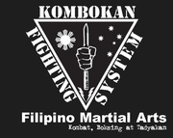](http://www.myfma.net/group/kombokan)

[KOMBOKAN](http://www.myfma.net/group/kombokan)

3 membersLatest Activity: Sep 8, 2014

KOMBOKAN (KOMBAT, BOKSING at TADYAKAN) is a non-competitive reality-based freestyle self-defense fighting concept and system that is purely based…