

CENTENNIAL COLLEGE PROGRESS CAMPUS

COURSE COMP125 Winter 2022

ASSIGNMENT #1

Basal Metabolic Rate (BMR) Calculator

Create an HTMLdocument called **assignment1.html** that implements a calorie intake calculator based on the Harris-Benedict equation used by nutritionists and health professionals to determine the daily energy needs based on age, sex, height, weight and level of physical activity.

Follow these guidelines to implement your assignment:

1. Research the formula on wiki:

<https://en.wikipedia.org/wiki/Harris%E2%80%93Benedict_equation>

1. Build a form to accept all the required input from the visitors.
2. Create a JavaScript file called assignment1.js and write the code for a function that calculates the calorie intake based on the user input.
3. Invoke the function every time the visitor presses a Calculate button on the form.
4. Display the results (BMR and daily calories intake) on the page.
5. (**10% of the grade**) Use HTML5 controls that limit/validate the user input.
6. (**10% of the grade**) Use good web design practices to enhance visually your html page.
7. (**10% of the grade**) Extend the calculator to accept metric measurements.

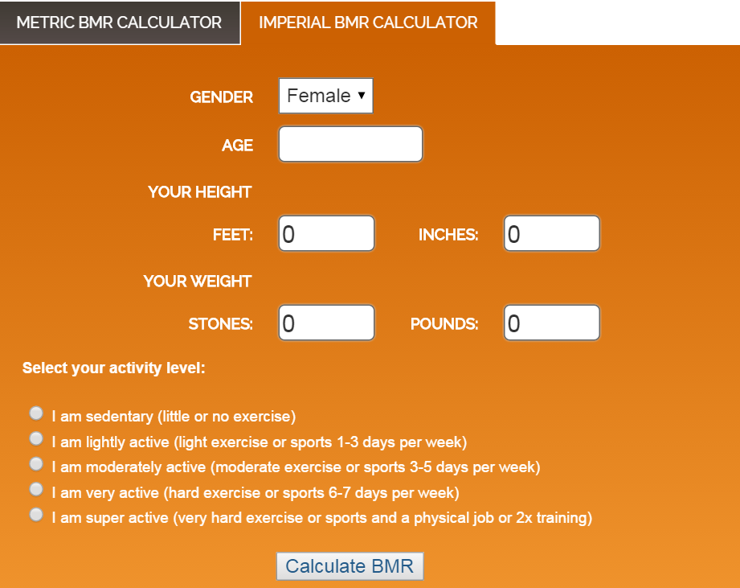

(The screenshot above is provided only as guidance to familiarize you with the functionality of a BMR calculator).

This assignment is **due on Fri. Jan 28th at 11:00 pm**. **Late assignments are accepted two more days after the due date and they are marked out of 80%**. Submit your assignment to Assignment 1 drop box.