FLUCTUS.NET · CONCEPT NOTE
Earn global, live local
Industrial reconversion with AI infrastructure as the lever — and what that means on the ground at the Glaverbel site in Sambreville
From | Johan Konings — Fluctus.net, Kortrijk, Belgium
Date | 29 August 2026
For | Authorities, landowners, grid operator, partners and neighbours
Subject | Why we are doing what we are doing on the Glaverbel site, and why this is not a conventional data centre project

Why this note
When people hear that a data centre is coming to an old industrial site, they usually think the same thing: a large box that takes land and power, employs few people, and sends its returns elsewhere. That reflex is not unfounded — plenty of projects work exactly like that.
This note explains why the Sambreville project is set up differently. Not because we are more virtuous, but because the structure itself is different: the data centre is not the goal, it is the instrument. It uses a fraction of the land and the grid capacity that is already there, and it brings in the capital needed to make the rest of the site usable again. Part I sets out the reasoning. Part II shows how it works out on one concrete site, with the cadastral reality alongside.
PART I The strategy

1 The problem: sites with everything except a starter
A disused industrial site usually has everything a developer looks for — industrial zoning, access, a historic grid connection of tens of MVA, often cooling water and sometimes a rail siding — and still the redevelopment does not start. The reason is always the same: there is no first paying user large enough to carry remediation, access works and site preparation. Public reconversion funding rarely suffices, and fragmented small-scale occupancy does not cover the fixed costs of the site.
At the same time, one good is scarce on the energy market today: grid connection capacity. Waiting times for new or upgraded connections run into years. An existing, paid-for and permitted connection is therefore not a leftover from the past but the most valuable asset on the site.

2 Why AI infrastructure is the lever
Few activities convert a large amount of power into economic value on very little land, with a flat and predictable consumption profile. An AI data centre is one of them. That makes it suitable as the starter for a reconversion:
- High power density. A few tens of MW fit into one or two halls. The rest of the site remains.
- Flat base load. Steady consumption year-round is exactly what makes local energy investment bankable.
- Capital strength. Demand for compute comes from international players whose financing does not have to come from the local economy.
- Continuous heat. No seasonal peak, no shutdown — the best conceivable profile for a heat network.
Equally important is what kind of data centre this is. Training clusters, where models are built, aim for hundreds of megawatts and are largely location-independent as long as there is power. This file is about inference: running existing models for customers and users who expect an answer now.
For inference, proximity counts. Every kilometre between user and machine costs time, and for applications embedded in a conversation, a production line or a service, that delay is the difference between usable and unusable. Data that does not need to leave also stays inside the company and inside Europe. Twenty megawatts close to the users is therefore a better machine for inference than two hundred megawatts five hundred kilometres away — and that is precisely why the existing connection of an old factory is enough.
In this strategy the data centre is therefore not a goal but an anchor: the first tenant that makes it possible to finance everything that follows. That is also the standard by which the project may be measured. If nothing follows the data centre, the strategy has failed.

3 The cascade
The diagram below shows the structure. The data centre sits at the top as the source and feeds two arms: grid capacity on the right, expertise on the left. Both converge on new local business activity.
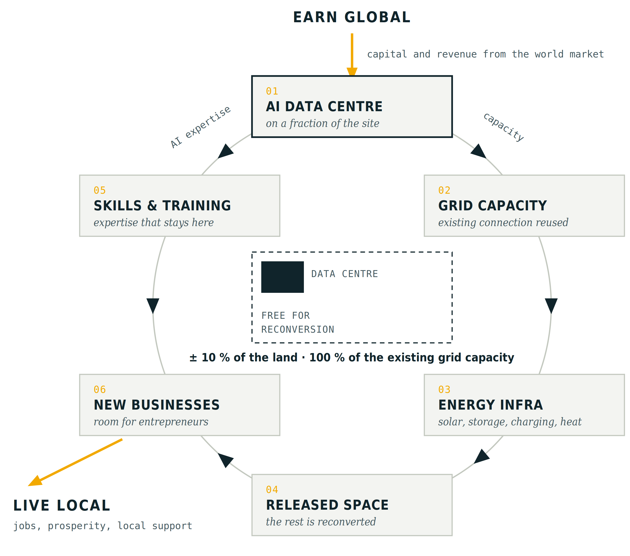
The cascade: the data centre feeds two arms — capacity on the right, expertise on the left — converging on new local business.
01 — An AI data centre on a fraction of the site. One building, a limited footprint, a long-term tenant. Land value and remediation planning start moving because there is a concrete customer with a concrete payment profile on the other side.
02 — The existing grid capacity is put back to work. The historic connection is reused rather than handed back. That avoids years of waiting, saves grid investment and keeps capacity in the region instead of having it surface somewhere else.
03 — Local energy infrastructure becomes viable. Behind the same connection an energy community grows: PV on roofs and residual land, battery storage for peak shaving and flexibility, charging capacity for trucks and corporate fleets, and a heat network fed by the heat the data centre rejects. The large consumer provides the scale; smaller users get energy costs they would never reach on their own.
04 — The released space becomes supply. What the data centre does not occupy comes to market as serviced land with power, heat, connectivity and operational site management already present. That is a fundamentally different product from a bare brownfield.
05 — Skills and training keep the value local. The AI expertise that arrives with the operator and its suppliers is translated into training on the site, together with education and training partners. Without this step the data centre remains a transit port for capital; with it, it becomes the basis of a cluster.
06 — New businesses settle. Whoever masters the new skills can start a business on one of the released plots. The site moves from a single-purpose activity to a mixed business park with several employers, which lowers the risk profile of the whole reconversion.
Both arms converge on new local business activity. That is the point at which the whole structure may be judged: if nothing arises there, the data centre has only served itself.

4 What each party gains
Party | Interest
Site owner | Value from land that yields nothing today, and a funded start to the reconversion rather than a remediation bill with nothing in return.
Municipality and residents | Restart of a heat network project with a reliable source, local employment and a broader tax base.
Businesses on the site | Access to power and energy on terms not achievable individually, plus charging infrastructure for their fleet.
Grid operator | Reuse of existing capacity instead of a new connection elsewhere, with a flexible consumer that contributes to grid stability.
Investor and operator | A permittable site with power and a short time-to-power — today the decisive factor in siting.
PART II Sambreville — the strategy on one site

5 The site
This concerns the former Glaceries de la Sambre / Glaverbel glass production complex in Auvelais, municipality of Sambreville, set in a bend of the river Sambre. Cadastrally these are contiguous parcels totalling roughly 40 hectares, with one main parcel of over 40 ha. Much of the area is already hardstanding, the industrial zoning is historic, and there is an old private rail siding towards the Sambreville and Auvelais yards.
The location is exceptional for what we want to do there: junction 14 Velaine-Sambreville of the E42 — the Autoroute de Wallonie, part of the TEN-T core network — is about a kilometre away. Charleroi is 24 km, Namur 25 km. A 150 kV line also runs north of the site, leaving room for higher capacity in the longer term should the market justify it.

6 Grid capacity: the scarce good
A connection study is under way with Elia for 20 MVA on a 30 kV line, with capacity reserved in the project’s name. That is the core of the file. In the Belgian context, medium- and high-voltage capacity requests are blocked at hundreds of locations by grid congestion, with waiting times typically of four to eight years. Here the procedure is already running.
That capacity is not there by chance. It is there because glass was once made here. The question is not whether it will be used, but by whom and to what effect for the surrounding area.

7 What the data centre actually occupies
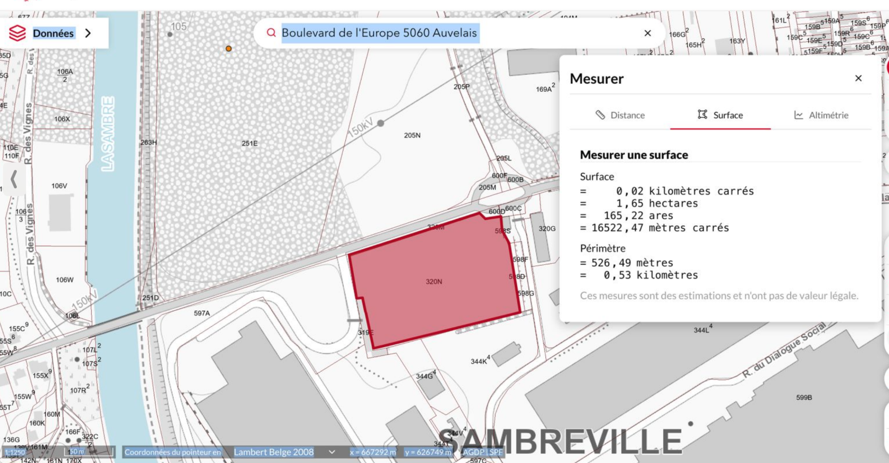
Parcel 320N along Boulevard de l’Europe: 1.65 ha, perimeter 526 m. Source: Géoportail de la Wallonie.
The measurement above gives the order of magnitude of the footprint: 1.65 hectares, or 16,522 m². Set against the roughly 40 hectares of the site, that comes to about four per cent of the area. On those four per cent, virtually all of the available grid capacity is put to use.
The data centre also goes on the existing car park of the old factory. No hall that could still have a second life is demolished, and no undeveloped ground is broken. A conventional industrial reoccupation wanting to use 20 MVA would need ten to twenty times more land — and that reoccupation has not arrived in twenty years.

8 What remains — and is already subdivided
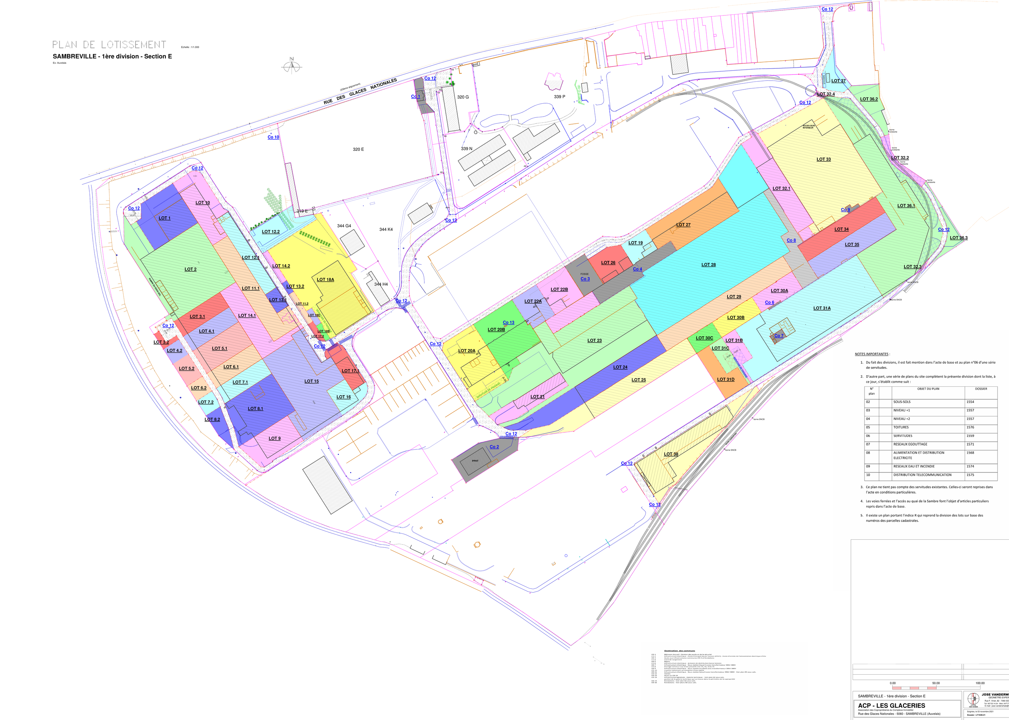
Subdivision plan ACP Les Glaceries, Sambreville 1st division section E (2021): the site is already divided into dozens of plots, with roads, utilities and easements.
This plan is the strongest argument in the file, and it did not come from us. The site is already divided into dozens of plots, with roads, connections and easements drawn. The reconversion is therefore not an idea still to be conceived: the plan exists, the structure is there.
What is missing is a first user large enough to set the whole thing in motion. Until that user appears, those plots remain what they are today: colours on paper. The data centre takes one place in that plan — and makes the rest sellable and lettable, with power, heat and management already present.

9 The energy layer around the data centre
Around the data centre we build the layer that serves the site and the region:
- Solar. Around 20 MWp on hardstanding and residual land, good for something in the order of 17 GWh a year, actively dispatched rather than passively sold. What the site does not use goes to the data centre rather than to the grid.
- Battery storage. 20 MW / 40 MWh, for peak shaving, spot market arbitrage and imbalance management.
- Charging site. A hundred 22 kW AC points for staff, visitors and municipal vehicles, and thirty 300 kW fast chargers, MCS-capable, for heavy transport on the E42 corridor.
That last component is not a luxury. Under the AFIR regulation (EU) 2023/1804, by the end of 2030 the TEN-T core network must have a charging pool of at least 3,600 kW every 60 km. Sambreville lies between two urban nodes, on exactly such a corridor. Anyone wanting to meet that obligation needs grid capacity — and grid capacity is what is lacking elsewhere.
Technically, the battery is the key to coexistence. A single 20 MVA connection cannot carry the simultaneous peak of the data centre, the charging site and the site users. The battery decouples those peaks from one another, and the solar installation lowers daytime draw from the grid. The precise split between users is a matter for the technical design and for the legal framework for energy sharing — in Wallonia a réseau fermé professionnel supervised by the CWaPE. That design is exactly what turns one connection into shared rather than exclusive infrastructure.
Investment in this energy layer is in the order of 23.5 million euro. It stands or falls with the presence of a large, stable consumer on the same connection.

10 What the site and the region get back
What | Concretely in Sambreville
Heat | Continuous heat from the data centre as the source for the municipal heat network project, with industry on the site, public buildings and the CHRSM — site Sambre hospital in Auvelais as first candidate customers.
Energy costs | Businesses behind the same connection buy on terms they cannot reach alone, with on-site generation and storage rather than the market price alone.
Charging | Fleets of the Sambre valley industry within 30 km, municipal vehicles, and heavy transport on the E42.
Space | The already subdivided plots become usable supply, with power and heat on site.
Work | Construction and installation through local contractors and partners, then operation of the energy hub and the businesses that settle.
Training | A training strand around AI and energy skills on the site itself, with education and training partners.
Grid | Reuse of existing capacity instead of a new request elsewhere, with a battery that returns flexibility to the grid.

11 Why this is not an extractive data centre project
The criticism of data centres is well known and, for many projects, justified. It deserves an answer point by point, not reassurance.
The common criticism | How this file is set up
They swallow land | 1.65 ha out of roughly 40 ha, on existing hardstanding. The rest is already subdivided for other users and is made usable by this project rather than blocked by it.
Data centres just keep getting bigger | That is true of training clusters, which want to be as large as possible and for which location barely matters. This is an inference site: running models for nearby users. There, proximity counts for more than scale, and twenty megawatts on an existing connection is enough.
They take scarce grid capacity | This is the historic connection of a closed factory, not capacity taken from someone else. The battery also returns flexibility to the grid.
The heat is wasted | Not here. The heat is a programme item with named customers: the businesses on the site, public buildings, and the Auvelais hospital. It is the source that lets the municipal heat network project restart.
They create hardly any jobs | The data centre itself, indeed, few. That is precisely why the released plots and the training strand are part of the same project rather than a later phase.
The profits leave the region | The data centre profit goes to the investor — that is the price of capital we are not raising here ourselves. What stays local is the construction flow, the energy infrastructure, land and rental value, the heat and the training. The model does not promise that no money leaves; it makes sure that structure stays behind.
There is one test that makes this distinction verifiable, and we propose it ourselves: put the obligations on heat supply, energy sharing and training into the agreements with the operator, not into a letter of intent. A reconversion project that fails that test is indeed just a data centre.

12 Status and next steps
- Grid capacity. Confirmation of the 20 MVA reservation and agreement with the grid operator on timing and connection costs.
- Land. Security over the land with the owners, including the municipality, before the investment phase closes.
- Soil. Soil survey in line with Walloon regulation, with costs provided for in the project buffer.
- Heat. Inventory of heat demand within reach: route, distances, temperature levels and consumption profiles of candidate customers.
- Permits. Planning permit and class 1 environmental permit, with the screening required for the battery installation.
- Legal framework. Development of the framework for energy sharing behind the connection — in Wallonia a réseau fermé professionnel supervised by the CWaPE.
- Delivery. Jacops as contractor for preparatory works and civil infrastructure, E+Drive for the charging architecture.
- Financing. A first letter of intent has been received from the investor side; structuring is under way.
What we are trying to demonstrate in Sambreville is simple. Demand for compute is moving capital around the world today. That flow can put a Walloon industrial site back to work — not as compensation after the fact, but as the design itself. Our knowledge, your power.
Fluctus.net — cooperative with a social purpose — BE 0757 494 180 — Kortrijk, Belgium

