SRILANKA

7Days & 6 Nights

**KANDY- NUWARA ELIYA – BENTOTA-COLOMBO**

**Day 1: Arrival**

Meet & Assist on arrival by One Above staff & transfer from Airport to Kandy on route visit Pinnawala Elephant Orphanage.

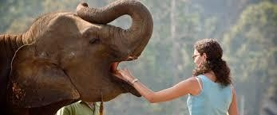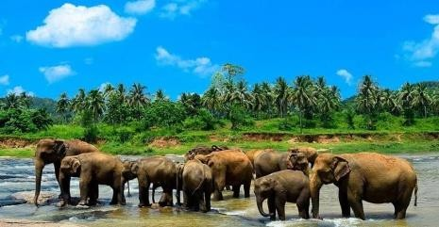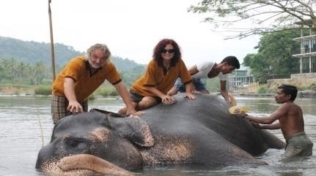

**Pinnawala Elephant Orphanage -** App. 55 miles from Colombo, off the Colombo - Kandy road is Pinnawela, where an orphanage was started in 1975 to house the abandoned and the wounded elephants. The number of elephants has increased to more than 65 now; including Baby Elephants brought from various parts, as well as the 23 babies born, as a result of the captive breeding programme. The best time to visit is the feeding time from 0930-1000 hrs and 1330-1400 hrs and the bathing time from 1000-1030 hrs and 1400-1430 hrs when all the elephants are taken to the river close by.

**Overnight stay at Hotel, Kandy**

**Day 2: Kandy Breakfast at hotel**

Enjoy the city tour in Kandy

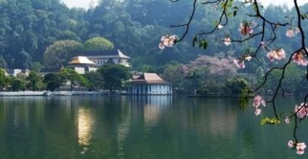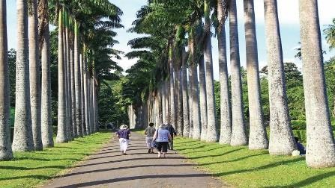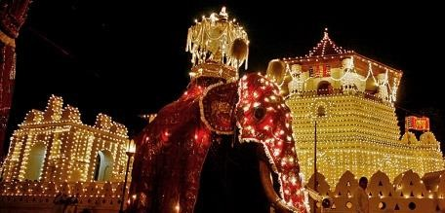

Kandy, nestled amidst lush hills, captivates with cultural and natural wonders. Visit the sacred Temple of the Tooth Relic, stroll around the picturesque Kandy Lake, and explore the diverse flora at Peradeniya Botanical Gardens. Immerse in traditional Kandyan dance, creating an unforgettable blend of spirituality, history, and scenic beauty.

* Kandy, a cultural gem in Sri Lanka, boasts several key tourist attractions: Kandy's cultural richness and scenic beauty make it a captivating destination for travelers.
* **Temple of the Tooth Relic (Sri Dalada Maligawa**): A sacred Buddhist site housing the tooth relic of Buddha.
* **Peradeniya Botanical Gardens**: A vast and beautiful garden with diverse plant species.
* **Kandy Lake:** A picturesque artificial lake in the heart of the city.
* **Royal Botanical Gardens:** Stunning gardens with exotic plants, located in Peradeniya.
* **Kandy Royal Palace:** Former residence of the Kandyan monarchs, now a museum.
* **Bahirawakanda Vihara Buddha Statue:** A large seated Buddha statue offering panoramic views of Kandy.

**Overnight stay at Hotel, Kandy**

**Day 3: Kandy to Nuwara Eliya Breakfast at hotel**

Transfer from Kandy to Nuwara Eliya

On route visit Tea Plantation & Hanumanji Temple

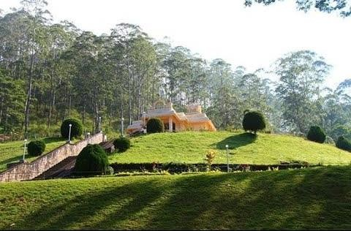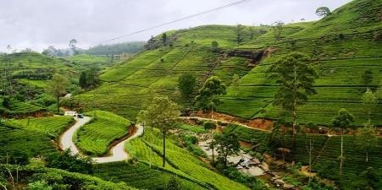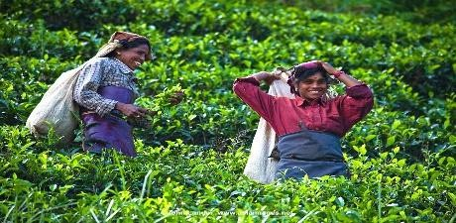

**Tea Plantation** - Tea was first planted in Sri Lanka in 1824 at the Botanical Gardens at Peradeniya, when a few plants were brought from China. More were introduced from Assam in 1839. In 1867, a Scottish Planter named **James Taylor** planted tea seedlings in an 8 hectares of forest land, in the **Loolkondura Estate.** In 1873, the tea export industry of Sri Lanka began with a modest 23 lbs. being shipped to London. Tea will grow only on rolling terrain and is classified by elevation into low grown, medium grown and high grown into 3 main groups. Today more than 200,000 hectares in highlands and other areas are under Tea and around 300 million Kilograms, with a 25% of world tea exports are done by Sri Lanka as the World’s largest Tea exporter.

**Shri Bhakta Hanuman Temple Ramboda Sri Lanka**

Sri Bhakta Hanuman Temple is one of the important Hanuman Temples in Sri Lanka located on summit of the very beautiful picturesque mountain in Ramboda 30 KM north to Nuwara Eliya, the gateway to the tea country hill station of Sri Lanka. This Hanuman Temple in Ramboda was constructed by Chinmaya

Mission of Sri Lanka. Shri Bhakta Hanuman temple is dedicated to the God Hanuman and this is one of important sites of [Ramayana Tour in Sri Lanka](https://www.ceylonexpeditions.com/ramayana-tour-in-sri-lanka). Visitors can witness the 18 feet Hanuman statue which is the tallest Hanuman statue in Sri Lanka established inside the Shri Bhakta Hanuman Temple in Ramboda.

On completion proceed to Nuwara Eliya

**Overnight stay at Hotel, Nuwara Eliya**

**Day 4: Nuwara Eliya Breakfast at hotel**

Enjoy the city tour in Nuwara Eliya

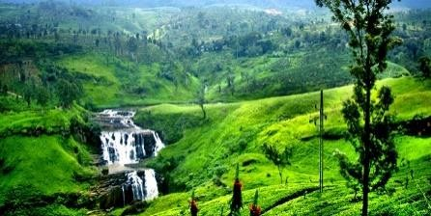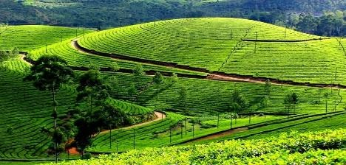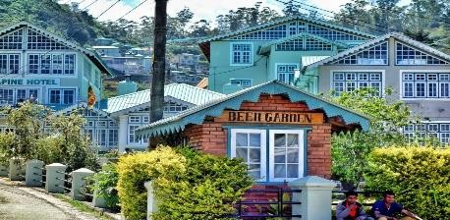

Nuwara Eliya, Sri Lanka's "Little England," enchants with its colonial charm and natural beauty. Surrounded by lush tea plantations, the town offers stunning landscapes, cool climates, and architectural remnants of British influence. Explore the picturesque Gregory Lake, visit tea estates, and experience a tranquil escape in this hill country gem.

Nuwara Eliya, a scenic town in the central highlands of Sri Lanka, offers several tourist attractions:

* **Gregory Lake:** A picturesque reservoir for boat rides and lakeside strolls.
* **Hakgala Botanical Garden (Ashok Vatika):** Associated with the Ramayana, and Hakgala Gardens in Nuwara Eliya, Sri Lanka, offer a cultural and natural experience. Explore historic sites and lush gardens amid scenic landscapes.**Tea Plantations:** Explore lush estates like Pedro Tea Estate.
* **Adma Agro Strawberry Farm:** Experience strawberry picking and indulge in fresh produce.
* **Lover's Leap Waterfall:** A scenic waterfall with a romantic legend.

**Overnight stay at Hotel, Nuwara Eliya**

**Day 5: Nuwara Eliya to Bentota Breakfast at hotel**

Transfer from Nuwara Eliy to Bentota

Upon reaching to Bentota (if Time Permits) Visit Madu river boat ride and Turtle Hatchery.

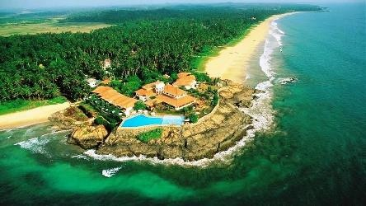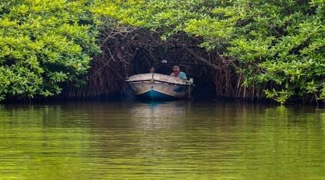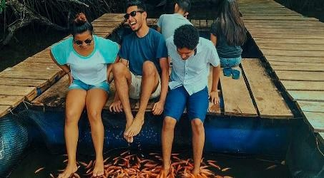

Bentota is a popular tourist destination in Sri Lanka, known for its beautiful beaches, water activities, and cultural attractions. Here are some tourist places and activities you can explore in and around Bentota:

* **Turtle Hatchery:** Visit a turtle hatchery to see and learn about the conservation efforts for sea turtles.
* **Madu River Boat Safari:** Take a boat safari on the Madu River, known for its mangrove forests, islands, and diverse wildlife.
* **Water Sports at Bentota River:** Enjoy water activities in Bentota river.

**Overnight stay at Hotel, Bentota**

**Day 6: Bentota to Colombo Breakfast at hotel**

Transfer from Bentota to Colombo

Visit city tour and shopping.

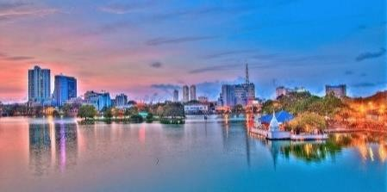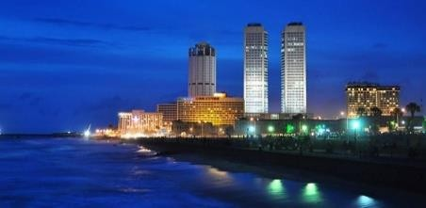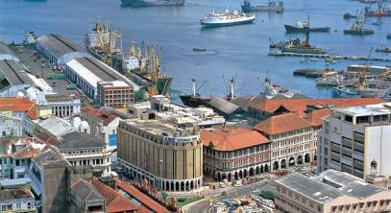

Colombo, the capital city of Sri Lanka, is a vibrant and bustling destination with a mix of modern and historical attractions. Here are some popular tourist places in Colombo:

* **Galle Face Green:** A beautiful promenade along the coast, Galle Face Green is a popular spot for locals and tourists alike. It's a great place to enjoy a leisurely stroll, fly kites, or sample street food.
* **Gangaramaya Temple:** This Buddhist temple is a significant religious and cultural landmark in Colombo. It features a mix of Sri Lankan, Thai, Indian, and Chinese architecture and houses a museum and a library.
* **Independence Memorial Hall:** Built to commemorate Sri Lanka's independence from British rule, this iconic structure and surrounding Independence Square offer a peaceful setting for visitors.
* **Viharamahadevi Park:** Located near the National Museum, this public park is a popular place for locals and tourists to relax and enjoy greenery in the heart of the city.
* **Old Parliament Building:** A colonial-era building with impressive architecture, it is now the Presidential Secretariat. While you can't enter the building, its exterior is worth admiring.
* **Dutch Hospital Shopping Precinct:** A historic building that has been transformed into a shopping and dining complex, offering a mix of local and international brands and restaurants.
* **Colombo Fort:** This area is a mix of old and new, with colonial-era buildings alongside modern structures. It's a commercial hub with offices, shopping centers, and hotels.

**Overnight stay at Hotel, Colombo**

**Day 7: Colombo to Airport Breakfast at hotel**

Transfer from Colombo to Airport for the departure

**END OF TOUR**

# INCLUDES

* + Accommodation on **Half board basis** at hotels specified or at hotels in similar standard.
  + Service of **an English-Speaking Chauffer.**
  + Transportation by Luxury an **Air – Conditioned CAR.**
  + **All the transfers on private basis only.**
  + All the government taxes.
  + Sightseeing – As per the attached day wise tour itinerary.
  + Road/interstate taxes, fuel surcharges.
  + The price includes petrol, tolls, road taxes, a driver bata and his accommodation and meals.
  + First Aid On-board.
  + Value added tax.

## Value Added Services

* Honeymoon freebies in the room for honeymooners
* Tea plantation visit + Tea plucking experience & demonstration + Free Tea Tasting + tea factory visit & demonstration + tea factory old machineries museum visit.
* Ceylon Gem Museum visit & demonstration (Free Guided Tour).
* Ceylon Batik clothing factory visit (Free Guided Tour).

# EXCLUDES

* + Entry Visa Fees, please visit [www.eta.gov.sl](http://www.eta.gov.sl/) for more details.
  + **Lunch on tour.**

# 5% GST

* + **TCS as applicable**
  + **Early check-in & late check-out.**
  + Usage of vehicle beyond the given route (As per the day wise tour itinerary) drives after

# 07.00 PM,(DEPEND ON THE SIGHTSEEING & OUTISDE DINNER IN RESTAURANT OR

**ANY HOTEL)** usage of guide beyond the mentioned timings or anything beyond the itinerary is chargeable.

* + Expenses of personal nature such as laundry, mini bar charges, beverages, liquor, telephone charges, etc.
  + Any other services not specified in above itinerary.
  + Video and camera permit at sites.
  + Tips & portage.
  + Any compulsory room / Peak period supplements during the tour.
  + **All the Entrance Fees at sightseeing.**

**For more details MANOHARAN.A**

## (Director)

+919585603000

+91 9514903000