*EUROPEHOLIDAY- Switzerland*

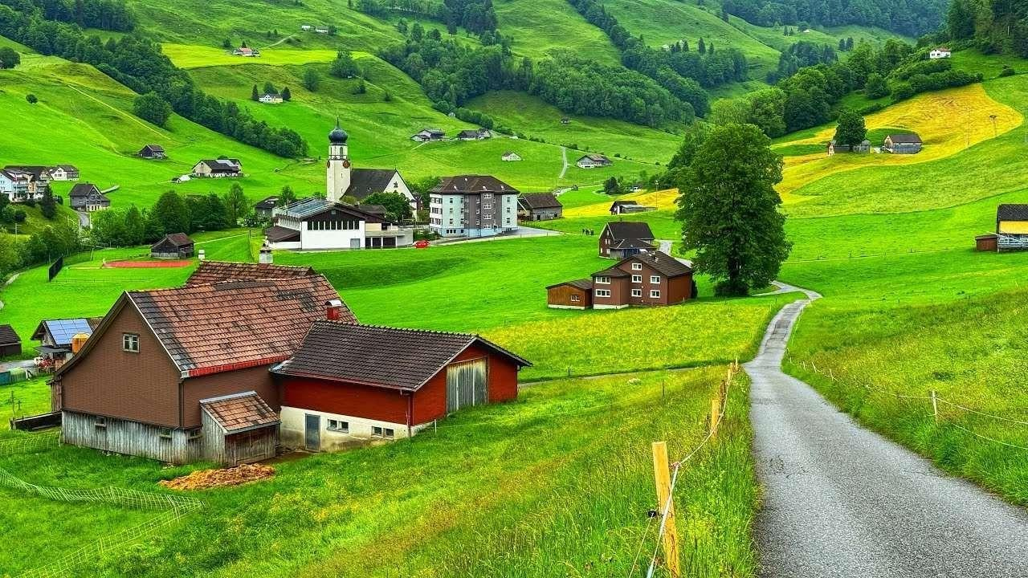

TravelDate:8th August 2025 No. of Pax: 02

Cities: Montreux, Interlaken, Zermatt, Lucerne, Zurich

Duration: 8Nights / 9Days

## *Hotels Envisaged:*

|  |  |  |  |  |
| --- | --- | --- | --- | --- |
| **City** | **Hotel** | **Nights** | **In** | **Out** |
| Montreux | Hotel Mona Montreux (3 Star) Standard or similar room | 2 | 8-Aug | 10-Aug |
| Interlaken | Hotel Beausite (3 Star) Standard or similar room | 2 | 10-Aug | 12-Aug |
| Zermatt | Hotel Mirbeau (4 Star) Standard or similar room | 1 | 12-Aug | 13-Aug |
| Lucerne | Hotel Alpina(3 Star) Standard or similar room | 2 | 13-Aug | 15-Aug |
| Zurich | Hotel Novotel Zurich Airport Messe(4 Star) Standard or similar room | 1 | 15- Aug | 16- Aug |

Cost of the package includes:-

* 02 nights accommodation at Hotel Mona Montreux at Montreux
* 02 nights accommodation at Hotel Beausite at Interlaken
* 01 night accommodation at Hotel Mirbeau at Zermatt
* 02 nights accommodation at Hotel Alpina at Lucerne
* 01 night accommodation at Hotel Novotel Zurich Airport Messe at Zurich
* Daily breakfast
* 02nd Class Swiss rail pass for 08 consecutive days
* Excursion to Glacier 3000
* Excursion to Jungfraujoch
* Excursion to Matterhorn Glacier Paradise
* Excursion to Titlis
* Entrance to Lindt Museum

# ITINERARY:

## *Detailed Day Wise Inclusions:*

|  |  |  |  |
| --- | --- | --- | --- |
| **Days** | **Date** | **Sector** | **Program** |
| Day 1 | 08-Aug | Montreux Switzerland | Arrive Zurich and further connect to Montreux. Arrive Montreux and Transfer to Accommodation, Check-in at hotel chosen and rest of the day is free for leisure and overnight at  Montreux |
| Day 2 | 09- Aug |  | Excursion to Glacier 3000 |
| Day 3 | 10-Aug | Interlaken | Check-out and Transfer from Montreux - Interlaken. Arrive Interlaken and transfer to Accommodation. Check-in at hotel chosen and rest of the day is free for leisure and overnight at  Interlaken |
| Day 4 | 11-Aug |  | Excursion to Jungfraujoch |
| Day 5 | 12-Aug | Zermatt Switzerland | Check-out and Transfer from Interlaken - Zermatt. Arrive Zermatt and transfer to Accommodation. Check-in at hotel chosen and proceed for Matterhorn Glacier Paradise and  overnight at Zermatt |
| Day 6 | 13-Aug | Lucerne | Check-out and Transfer to from Zermatt - Lucerne. Arrive Lucerne and Transfer to Accommodation. Check-in at hotel chosen and rest of the day is free for leisure and overnight at  Lucerne |
| Day 7 | 14-Aug |  | Excursion to Titlis |
| Day 8 | 15-Aug | Zurich | Check-out and Transfer to Zurich. Arrive Zurich and Transfer to Accommodation. Check-in at hotel chosen and rest of the day is free for leisure and proceed for Rhine Falls and Lindt Museum  and overnight |
| Day 9 | 16-Aug |  | Check-out and Transfer to Zurich Airport for flight back home |

Note :

* The above rates are Nett & Non-Commissionable to you.
* This is just a quote; no Rooms or Services have been blocked and the same are subject to availability.
* Above rates are valid for Indian National only
* Rates & Availability is subject to change without any prior Notice
* At most Hotels Standard check in time will be 1500hrs & checkout will be 1100 hrs .
* Early check is subject to availability & can incur additional charges.
* Please check all inclusions as any additions will occur in extra charges.
* Station / Airport transfers are not included unless mentioned.
* If your Travel period falls during a fair or Event period, A supplement cost will be applicable if any.
* A note about City Tax/Tourist tax and Bank Fees and Tips:

Many cities in Europe have introduced a local "City Tax/Tourist tax". This tax is collected by the hotels directly from clients and it is not included in our offers. The City tax/Tourist tax commonly varies between €1-4 per person per night depending on the hotel standard. Please also note that bank fees are not included in our offers. We request that bank fees and credit card fees are borne by the payer. For Van tours Tips are mandatory – 2 EUR/GBP per person per day.

Swiss hotels may charge CHF 2.– to CHF 7.– local city taxes per person/night

Transfers :

Transfers has schedule timings if the transfers are odd hours supplement will be applicable All transfers quote are for no of pax mentioned if the pax no changes rates will differ

Supplements for night transfers, luggage trailers, extra kilometres, extra waiting time and other fees will be advised at time of booking.

Child car seats and boosters are not included unless specified in your booking and can carry an extra cost. Should you need to book them,

Transfers are only point to point transfers no additional service will be provided maximum waiting time at Airport is 60 Mins & Train Station / Hotel is 15 mins exceed in waiting time charges will be applicable

Sightseeing:

Suppliers reserve the right to modify or cancel the tour itinerary without prior notice due to force majeure reasons. SIC tours has fixed timings request you to kindly reconfirm the services at least 24 hrs. prior to departure

SIC Tour pick up is not from the hotel , clients has to make their own arrangement for transfers to & fro to the pickup point exact pick up point will come to know once booking is confirmed

# COSTING:

|  |  |
| --- | --- |
| **DETAILS** | **COST PER PERSON IN INR** |
| LAND+ACCOMMODATION | 2,27,304 |
| 5%TCSand5%GST | 22730.4 |
| **TOTALCOSTWITHTAXES** | **250034.4** |

**Exclusions**

* + Personal Expenses
  + International tickets
  + Driver and Guide tip
  + VISA
  + Drinks during meals
  + Tips to the local guide and driver
  + Anything other than mentioned in the itinerary / inclusions