Band Tracker Design Document
Udacity iOS NanoDegree – Project 5

 | Author | Johan Smet
 | Revision | v0.1
 | Last modified | 2015-09-10
 | Number of pages | 24

Table of Contents
1. Revision History 2
2. Introduction 2
3. Server architecture 3
3.1. Overview 3
3.2. Functionality 3
3.3. Database design 3
3.4. API reference 6
4. iOS App 10
4.1. Philosophy and points of interest 10
4.2. Screen flow 11
4.3. Implementation details 12
5. Development cycle and milestones 12
6. Appendix – external resources 13
6.1. Development tools 13
6.2. Server 13
6.3. App 13

Revision History
Revision | Date | Comments
v0.1 | 2015-09-02 | Initial draft

Introduction
After a few years of frequenting music festival it gets difficult to remember which bands you've seen and whether you liked them or not. This apps allows you to keep track of the performances you've seen and what you thought of the show. Additionally it will assist you in choosing which bands to see when going to an event.

Server architecture

Overview
The server is a Node.js webservice that handles client-requests through a rest-like API. The service written in TypeScript using Express and has a MongoDB database as the storage back-end.

The server provides basic information to the application. At the moment only an administrator can add or update data, the database is read-only to the clients. In the future this will change when more social network related function are implemented.

Database design
A NoSQL document database, specifically MongoDB, was chosen to implement the server back-end. This has influenced the design of the data structures. Please refer to Illustration 1: Database Schema (page 3) for a schematic overview.

Illustration 1: Database Schema

Datatypes
- number : signed integer or decimal number (decimal separator = point)
- string : UTF-8 encoded string
- localized string : string in multiple languages (dictionary of language-code + value)
- date : using ISO 8601 format (yyyy-mm-dd'T'hh:mm:ss.sss)
- boolean : true / false

Band
{
MBID : <string>, // MusicBrainz ID
name : <string>, // Name of the band
genre : <string>, // genre of music
imageUrl : <string>, // url of an image of the band
biography : <localized-string>, // Short biography of the band
source : string // Reference to data source
}

TourDate
{
bandId : <string>, // MusicBrainz ID
startDate : <date>,
endDate : <date>,
stage : <string>, // optional
venue : <string>, // optional
city : <string>, // optional
countryCode : <string>,
supportAct : <boolean> // was this gig as a support act
}

Event
{
description : <string>,
startDate : <date>,
endDate : <date>,
venue : <string>, // optional
city : <string>, // optional
countryCode : <string>,
performances :
{
<date> : // day
{
<string> : // stage
[
{ // gig
bandId : <string>,
startTime : <date>,
endTime : <date>
},
...
],
...
},
<date> :
{
...
}
...
}
}

Venue
{
name : <string>,
city : <string>,
countryCode : <string>
}

City
{
city : <string>,
countryCode : <string>
}

Country
{
code : <string>,
name : <localized string>
}

API reference

Bands
/bands |  |  | GET
Action | Retrieves a list of all known bands
Permission | Blessed application
Parameters | - | -
Response-body | list | List of band records

/bands/{id} |  |  | GET
Action | Retrieve information about a particular band
Permission | Blessed application
Parameters | id | The MBID of the band to retrieve.
Response-body | record | The current contents of the BAND-record with the specified ID.

/bands/{id} |  |  | POST
Action | Add a new band or update an existing band. The server retrieves extra information about the band from external services and returns it to the client.
Permission | ADMIN
Parameters | id | The MBID of the band to add or update
Response-body | record | The current contents of the BAND-record with the specified ID.

/bands/find-by-name?name={pattern} |  |  | GET
Action | Search for bands matching a particular name.
Permission | Blessed application
Parameters | pattern | The name or pattern to search by
Response-body | list | List of BAND-records that match the query. Only a subset of available fields are returned.

TourDate
/tourdate |  |  | POST
Action | Add a new tourdate or update an existing record.
Permission | ADMIN
Request-body | record | The tourdate to be added/updated
Response-body | record | Current information of the TourDate

/tourdate/find?band={MBID}&start={date}&end={date}&location={location} |  |  | GET
Action | Search for tourdates
Permission | Blessed application
Parameters | band | The band playing the gig
Parameters | start | (optional) Starting date of the interval to look for tourdates
Parameters | end | (optional) Ending date of the interval to look for tourdates
Parameters | location | (optional) Location of the gig (venue, city or country)
Response-body | list | List of TOURDATE-records that match the query.

Event
/event |  |  | POST
Action | Add a new event or update an existing record.
Permission | ADMIN
Request-body | record | The event to be added/updated
Response-body | record | Current information of the Event

/event/{id} |  |  | GET
Action | Retrieve details of a specific event
Permission | Blessed application
Parameters | Id | Id of the EVENT-record to get more details about
Response-body | record | Current information of the Event

/event/find?event={pattern}&start={date}&end={date}&location={location} |  |  | GET
Action | Search for events
Permission | Blessed application
Parameters | name | Pattern to match the name of the event
Parameters | start | (optional) Starting date of the interval to look for events
Parameters | end | (optional) Ending date of the interval to look for events
Parameters | location | (optional) Location of the event (venue, city or country)
Response-body | list | List of partial EVENT-records that match the query.

Venue
/venue |  |  | POST
Action | Add a new venue or update an existing record.
Permission | ADMIN
Request-body | record | The venue to be added/updated
Response-body | record | Current information of the Venue

/venue/find?pattern={pattern}&city={city}&country={country} |  |  | GET
Action | Search for venues
Permission | Blessed application
Parameters | pattern | Pattern to match the name of the venue
Parameters | city | (optional) The city of the venue
Parameters | country | (optional) The country of the venue
Response-body | list | List of VENUE-records that match the query

City
/city |  |  | POST
Action | Add a new city or update an existing record.
Permission | ADMIN
Request-body | record | The city to be added/updated
Response-body | record | Current information of the city

/city/find?pattern={pattern}&country={country} |  |  | GET
Action | Search for city
Permission | Blessed application
Parameters | pattern | Pattern to match the name of the city
Parameters | country | (optional) The country of the city
Response-body | list | List of CITY-records that match the query

Country
/country |  |  | POST
Action | Add a new country or update an existing record.
Permission | ADMIN
Request-body | record | The country to be added/updated
Response-body | record | Current information of the country

/country/sync?current={hash} |  |  | POST
Action | Retrieve a list of the countries if the specified hash does not match the current hash of the countries on the server
Permission | Blessed application
Parameter | hash | Hash of the last synced country list
Response-body | updated | Boolean to indicate if the list has changed
Response-body | hash | (if updated) hash of the new list
Response-body | list | (if updated) list of COUNTRY-records

iOS App

Screen flow

The band overview
The band-screen shows an overview of the bands you've seen, sorted by average rating. Tap on a row to see more details. Tap the plus at the top to add a new band.
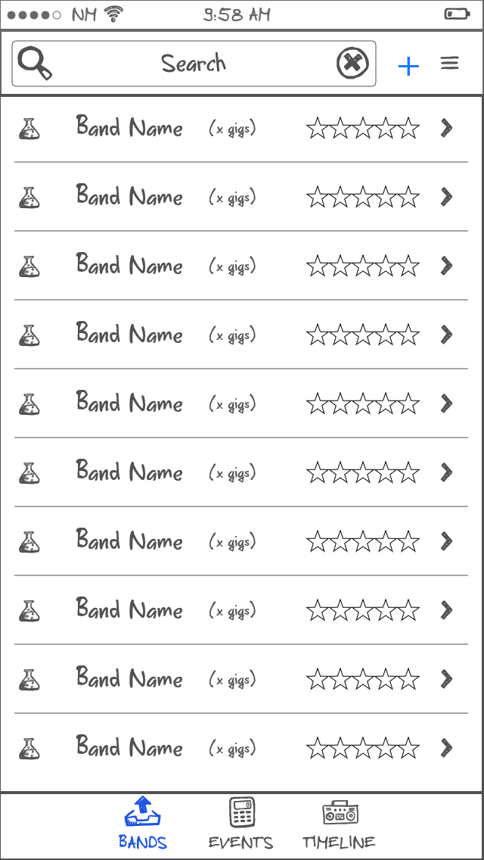Illustration 2: Band Overview

Band details
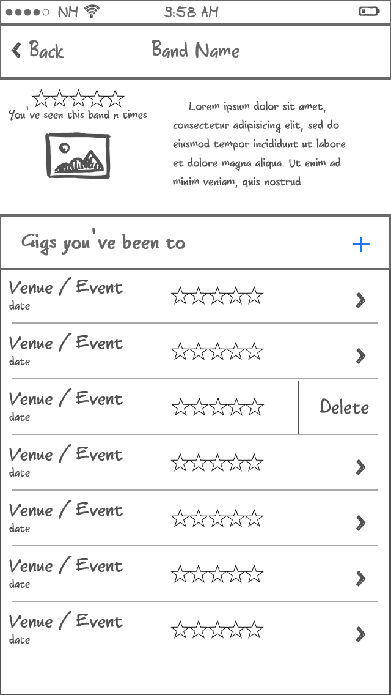Illustration 3: Band details
The band-details shows some background information of the band and the list of gig's you've them play. Tap a row to see more details of the gig or swipe to delete. Tap the plus to add a new gig.

Guided creation of a gig
When adding a gig to an artist you're first presented with a screen that allows you to search for known gigs on the server. Specify a few parameters and select the wanted gig from the list. If the gig isn't found you can still add it by typing in the details manually.

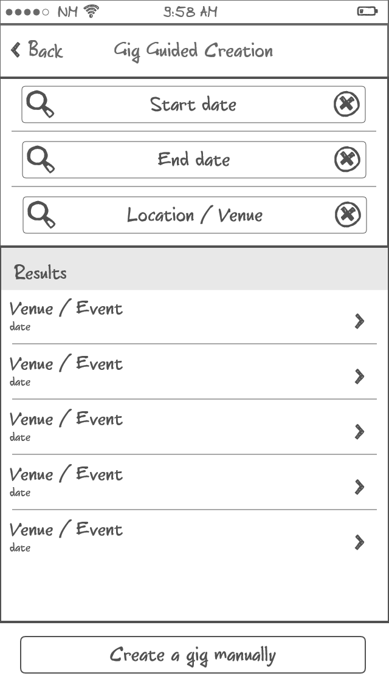Illustration 4: Guided creating of a gig

Details of a gig
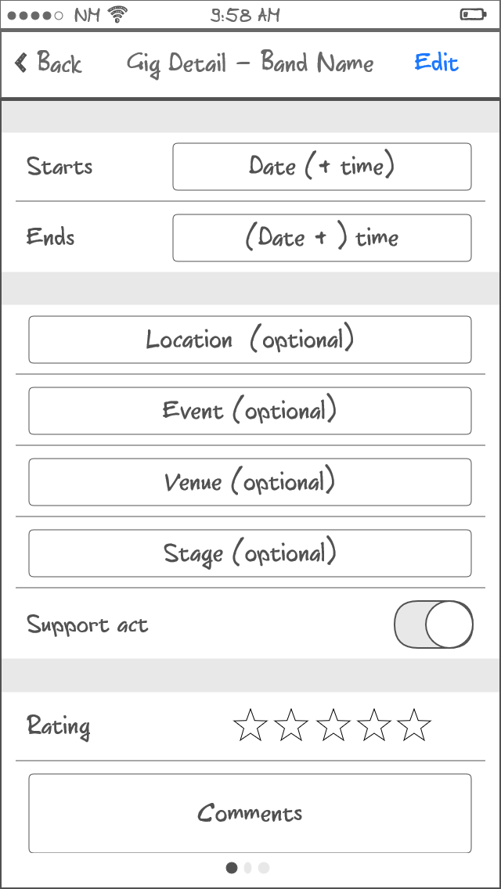Illustration 5: Details of a gig (1/3)
This screen is used to display details of gig but also to create a new gig. The fields should be self-explanatory. Tap the edit button to change an existing gig. To two following screen are only available when view not creating/editing.

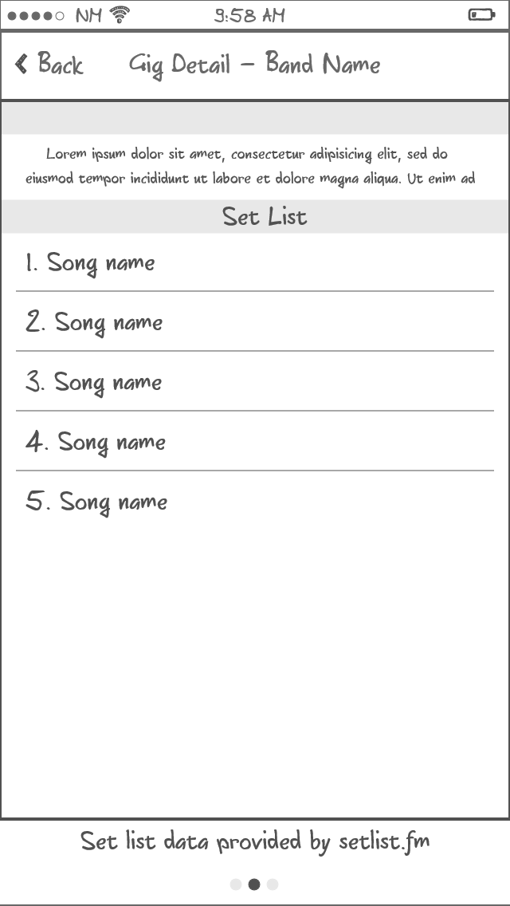Illustration 6: Details of a gig (2/3)
This screen shows the set list of the gig by fetching the relevant data from setlist.fm.
The third screen lists the top-rated videos of the gig that it finds on YouTube. It either searches for the entire gig or a specific song when the screen is reached by tapping on a song in the set list.

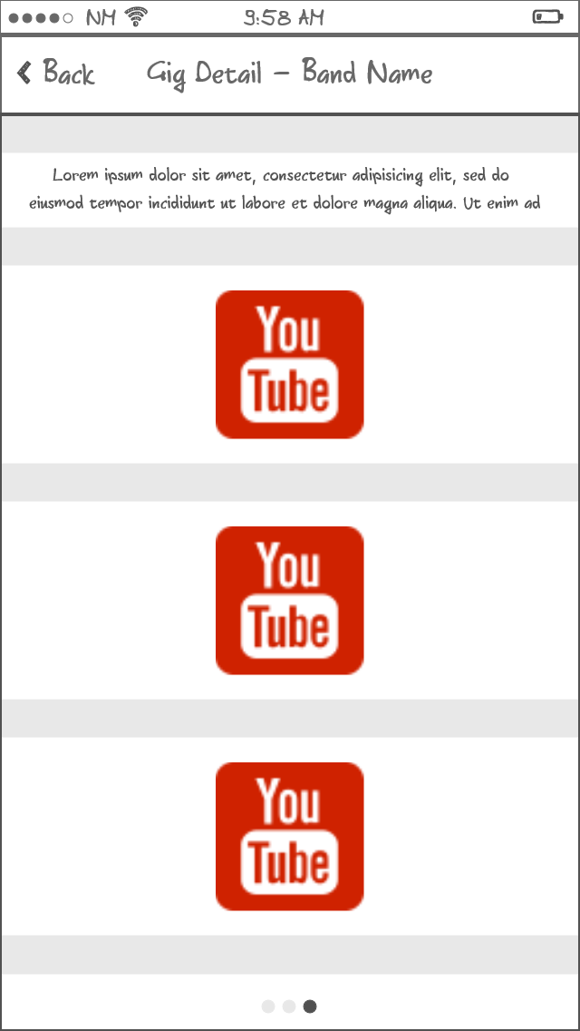Illustration 7: Details of a gig (3/3)

The event-overview
The event overview shows all the events (festivals or other multi-band events) you've been to.
Tap on an event to see more details. Tap on the plus to add a new event.
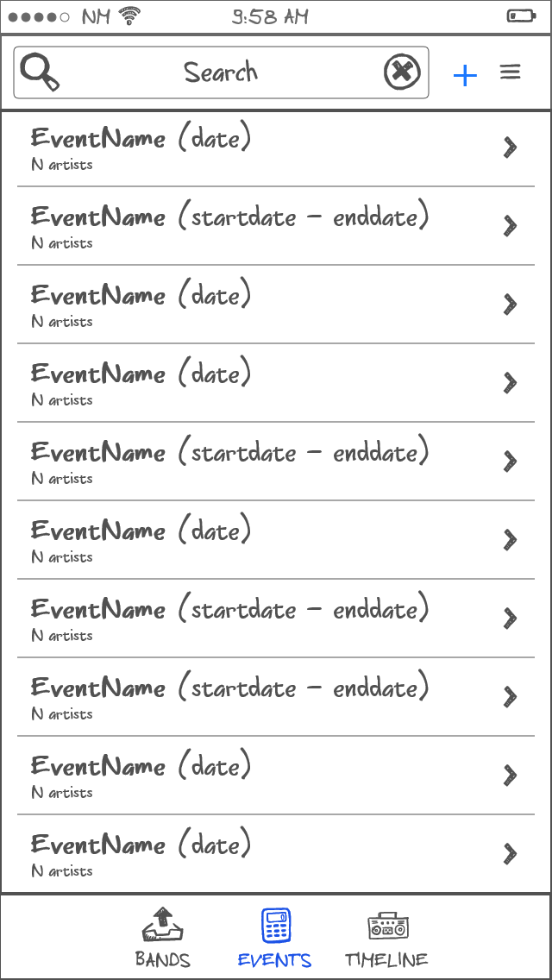Illustration 8: Event overview

Creating a new event
The user is first given the opportunity to select a predefined from the server. Enter a few parameters and select the wanted event from the list. When no event matches the one the user is looking for, tapping the “Create an event manually” can be used to create the event by entering all the relevant information.

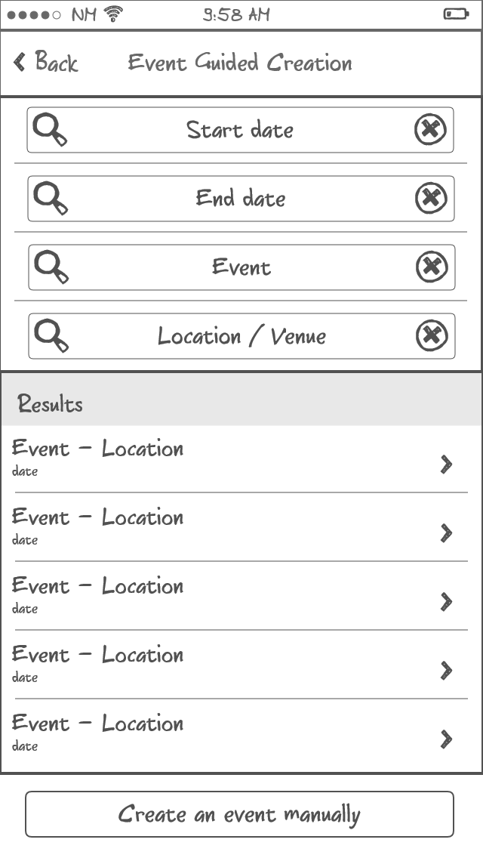Illustration 9: Guided event creation

Event details
The first screen shows general information about the event. The same screen is used to edit or create an event.
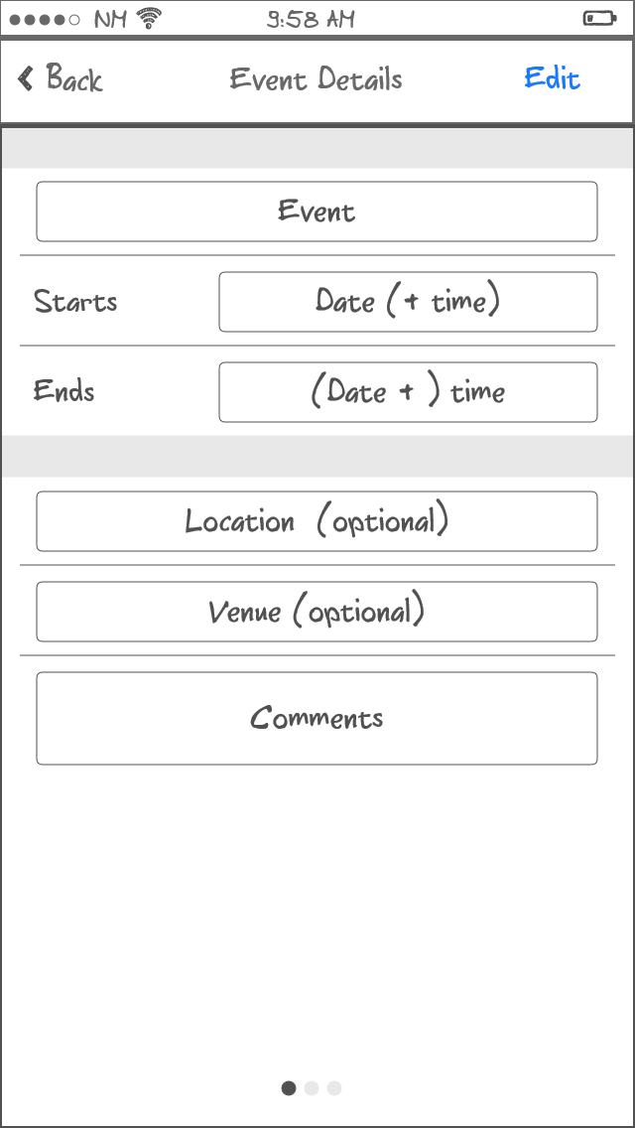Illustration 10: Details of an event (1/3)
The second screen show the participating bands and allows the user to edit this information.

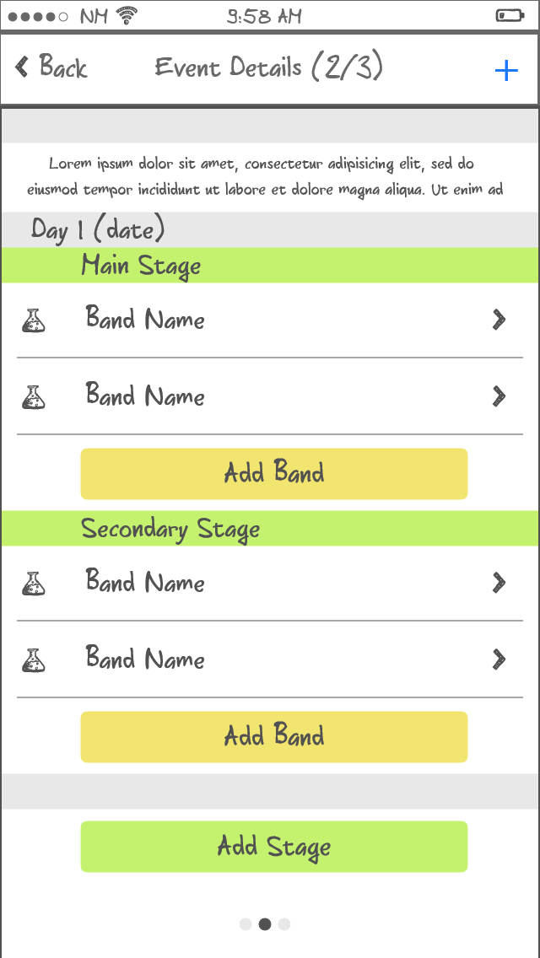Illustration 11: Details of an event (2/3)
The third screen (not pictured here) shows highest rated YouTube videos of the event.

To add a band to the event the app-standard screen is used. To add a stage a popup windows will be used.
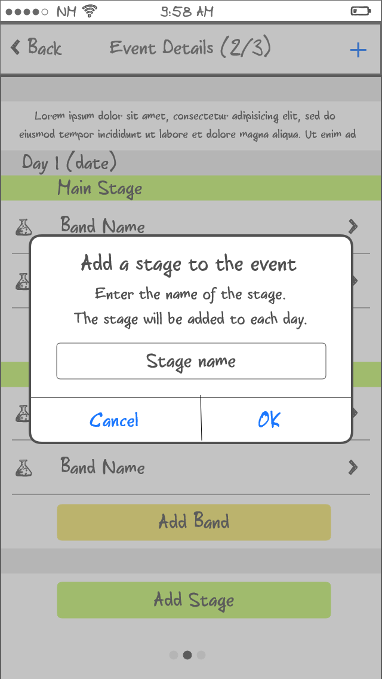Illustration 12: Adding a stage to an event
The exact flow of adding/editing an event has not been worked out. Sufficient room is left to experiment during implementation to achieve a comfortable work-flow.

Timeline
The last major screen of the app shows a time-line of events and artists you've seen. The list is split into section by month and can be searched.
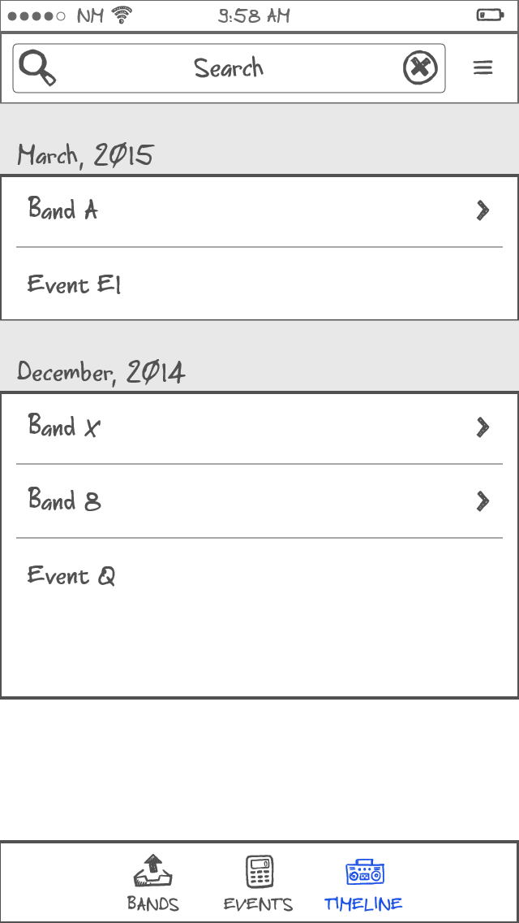Illustration 13: Timeline

Local database

Implementation details

Accessing setlist.fm
See http://api.setlist.fm for more information. Use the http://api.setlist.fm/rest/0.1/search/setlists endpoint with artistMbid and date parameters and parse the results.

Accessing Youtube
See https://developers.google.com/youtube/v3/docs/search/list for more information.

Development cycle and milestones

Server |  | Implement API's to serve information about artists from manually created dataset. (see chapter 3.3.1)
Client |  | Search for artists on the server and add them to local database (see chapter 4.1.1 and 4.1.2)
Milestone-1 |  | List of artists (no gigs, ratings)
Server |  | Add token-based authentication to all request
Client |  | Add token-based authentication to all request
Milestone-2 |  | Authenticated requests
Server |  | Implement API's to serve information about venues, cities and countries.
Client |  | Manually create gigs
Milestone-3 |  | Basic functionality in bands view (add bands / gigs)
Client |  | Add set-list and YouTube videos to gig detail
Milestone-4 |  | Full functionality in bands detail view
Server |  | Implement API's to serve information about tourdates
Client |  | Add guided creation of gigs
Milestone-5 |  | Full functionality in bands detail view
Server |  | Implement API's to serve information about events
Client |  | Add guided creation of events
Milestone-6 |  | Basic functionality of events view
Client |  | Add manual creation of events
Client |  | Add timeline view
Milestone-7 |  | Complete functionality for submission to Udacity
Client |  | Polish general UX – UI for rotated views
CodeReview |  | Submission to Udacity

Potential extra features before submission to Apple:
- tablet specific lay-outs
- social features (see ratings etc. of facebook friends)

Appendix – external resources

Development tools
XCode | For development of the iOS app | -
Visual Studio 2013 | For development of the server component. | Community Edition
NinjaMock | For the screen mockups | Non-commercial use.
OpenOffice | Documentation | Apache License 2.0

Server
Node.JS | JavaScript runtime | ICU License
Express | Web framework for Node.js | MIT License
MongoDB | Database backend | GNU AGPL
Mongoose | MongoDB object modeling for Node.js | MIT License
Cheerio | core jQuery implementation for Node.js | MIT License

IOS App
SwiftyJSON | JSON parser for Swift | MIT License

