Mutibo Design Document
A Coursera Android Capstone project

 | Author | Redacted for peer review
 | Revision | v0.1
 | Last modified | 2014-10-25
 | Number of pages | 29

Table of Contents
1. Revision History 2
2. Introduction 2
3. Server architecture 3
3.1. Overview 3
3.2. Functionality 3
3.3. Database design 4
3.4. API reference 6
4. Android App 13
4.1. Philosophy and points of interest 13
4.2. Screen flow 14
4.3. Implementation details 25
5. Development cycle and milestones 25
6. Mid-Point Peer Assessment Rubric 26
6.1. Basic 26
6.2. Functional 27
6.3. Bonus 28
7. Appendix – external resources 29
7.1. Development tools 29
7.2. Server 29
7.3. App 29

Revision History
Revision | Date | Comments
v0.1 | 2014-10-19 | Initial draft

Introduction
This document describes the design for the Mutibo project of the Android Capstone Project on Coursera. For more information about this project and its requirements please visit the project homepage at https://class.coursera.org/androidcapstone-001/wiki/Mutibo.
Please do not feel daunted by the size of this document. A large portion is taken up by API-references and screen mockups and are quickly read.
Chapter 3 describes the architecture of the server back-end. The fourth chapter delves into the design of the android application. In the fifth chapter we discuss the implementation time line and the various milestones we want to deliver. For your convenience the sixth chapter provides direct answers to the assessment rubric for the mid-term evaluation of this document.
The appendix lists the external resources that will be used to implement all the parts of this project.

Server architecture

Overview
The server will be a Java web-server that handles client-requests through a rest-like API. The service is implemented using Spring with a MongoDB database as a storage back-end.

As an extension to the requirements of the Mutibo project we introduce the concept of a “deck”. A deck is a grouping of Mutibo-sets that are managed as a single entity. This allows us to simplify the release cycle of new sets and manage updates to previously released sets.

Functionality
The server will provide these functions :
- User management and authentication
- Management of game information
- Data-synchronization with client applications
- Game results and leaderboards
- A limited lobby for multiplayer games

User management and authentication
Users can create accounts from the android application and need to authenticate before using any functionality of the server. The server defines two user roles : ADMIN and PLAYER. A user with the PLAYER-role is allowed to play games can not modify movies or sets. A user with the ADMIN-role can define and edit movies and sets.

At first only rudimentary user name / password authentication will be implemented. Later on in the project this will be replaced by social media authentication (Facebook and/or Google+).

Management of game information
The server exposes several API-functions to manage decks, sets and the movies contained therein.

These functions will also encapsulate the use of external API's to retrieve information about the movies (e.g. posters). This allows us to transparently change these details during the course of the applications' lifetime without affecting the client. Also this insulates the client visible portions of the application to failure of services not under our control.

A relatively simple web-application will be developed to allow easy management of decks, sets and movies during the course of the project.

Data-synchronization with client applications
To keep the number of required client-requests to a minimum most information will be transferred for a whole deck at a time. The decks are relatively small so the tradeoff with respect to required bandwidth is justified.
The client application is expected to cache information locally to further reduce bandwidth requirements and delays at application start-up. An API to quickly determine if cached information is out of date and should be replaced is provided.

Game results and leaderboards
The results of each played game are reported back to the server with an optional user provided rating of the quality of the set. Rating information is visualized in the management interface.

The game scores are used to build leaderboards which can be consulted by the client application in various ways.

Important events (e.g. a friend beating your score) will be pushed to the client application using Google Cloud Messaging for Android.

A limited lobby for multiplayer games
As a bonus feature a simple multiplayer lobby system will be implemented. This lobby will provide two ways of starting a multiplayer game.

- When the user was authenticated through a social media service, like Facebook, the user will be able to challenge his friends of the social media to a Mutibo match. If the challenged user is also a known Mutibo-player the challenge will be send through Google Cloud Messaging for Android. If the challenged player is not a Mutibo player a message will be sent on the social network with information on how to obtain Mutibo.
- A user can elect to challenge a random online user. A multiplayer game will be started against another user who has also challenged a random online user. If no waiting players are available the user will be asked to wait until a player becomes available.

Communication between players engaged in a multiplayer Mutibo battle will be handled by the server.

Database design
A NoSQL document database, specifically MongoDB, was chosen to implement the server back-end. This has influenced the design of the data structures. Easy synchronization with clients was another major consideration. Please refer to Illustration 1: Database Schema on page 5 for a schematic overview.

A DECK is a grouping of SETs that are processed simultaneously for certain actions. This includes marking a DECK for release and transferring information to the client. A hash of all the information sent to the client of the deck is stored and can be used to quickly determine if a locally cached set must be refreshed.

A SET contains links to the movies and the information required to play one game. The user-ratings are tallied up regularly and cached in the set. The ratings aren't displayed by the client application so they are not included in the synchronization hash.

The identification of the movie on IMDB is used as the primary key of a MOVIE as this is also used in multiple online movie database. All information required about a movie is retrieved from external services (or entered by an admin-user) and then served to clients. Posters for movies are stored in a separate collection.

The GAME collection contains information pertaining to the results of a single played set and a SESSION has the results of one play-through of a game. The “isCumulated” field is used by a server background procedure to update the sumation-fields in SET and USER.
Illustration 1: Database Schema

A USER has a fixed user-id to make it simple to change a nickname of a player although this functionality is not surfaced at moment. The password is not stored as plain text. During the course of the implementation other fields will be added to support login through social media.
Additionally a USER-record also store information to construct the leaderboards.

The MATCH collection contains information about currently running multiplayer matches.

API reference

User management and authentication
/user/login?nickname={nickname}&password={password} |  |  | POST
Action | Authenticate a user. Returns an access-token if successful or an error code at failure.
Permission | Anonymous
Parameters | nickname | The nickname of the player that wants to login
Parameters | password_hash | The password of the player that wants to login
Response-body | status | “OK” : user login successful  “FAIL” : login failed
Response-body | token | Authentication token to be used in subsequent requests

/user/logout |  |  | POST
Action | Logout the currently authenticated user
Permission | Authenticated
Parameters | - | -
Response-body | status | “OK” : logout successful  “FAIL” : logout failed

/user/add_player?nickname={nickname}&password={password} |  |  | POST
Action | Create a user with the PLAYER-role. This function is also used when a player authenticates through social-media for the first time in which the password isn't used.
Permission | ADMIN
Parameters | nickname | The nickname of the new player
Parameters | password_hash | (optional) The password of the new player
Response-body | status | “OK” : user created successfully  “DUPLICATE” : a user with same nickname already exists  “INVALID-PASSWORD” : the requested password is not valid

/user/login_facebook?nickname={nickname}&fb_id={id} |  |  | POST
Action | Authenticate a user using their facebook account. Preliminary specification pending further research of the facebook API.
Permission | Anonymous
Parameters | nickname | The nickname of the player that wants to login
Parameters | id | The facebook-id of the player that wants to login
Response-body | status | “OK” : user login successful  “MISMATCH” : nickname and id don't match  “NEW” : first time this player logged in. More info requested.
Response-body | token | Authentication token to be used in subsequent requests

Movies
/movie?id={id} |  |  | GET
Action | Retrieve information about a particular movie.
Permission | ADMIN
Parameters | id | The IMDB-id of the movie to retrieve.
Response-body | record | The current contents of the MOVIE-record with the specified ID.

/movie?id={id} |  |  | POST
Action | Add a new movie or update an existing movie. The server retrieves extra information about the movie from external services and returns it to the client.
Permission | ADMIN
Parameters | id | The IMDB-id of the movie to add.
Response-body | record | The current contents of the MOVIE-record with the specified ID.

/movie/poster?id={id}&resolution={resolution} |  |  | GET
Action | Retrieve the poster of the specified movie in the specified resolution
Permission | PLAYER
Parameters | id | The IMDB-id of the movie poster to retrieve
Parameters | resolution | Indication of the resolution to retrieve (low/medium/high...)
Response-body | image | image/jpeg data

/movie/poster?id={id}&resolution={resolution} |  |  | POST
Action | Update the poster of the movie with the specified IMDB-id
Permission | PLAYER
Parameters | id | The IMDB-id of the movie poster to retrieve
Parameters | resolution | Indication of the resolution to retrieve (low/medium/high...)
R-body | image | image/jpeg data

Decks
/deck/list-released |  |  | GET
Action | Retrieve a list of all the released decks and their content-hashes
Permission | PLAYER / ADMIN
Parameters | - | -
Response-body | decks | List of DECK-records.

/deck?id={id} |  |  | GET
Action | Retrieve the information of a single deck
Permission | PLAYER / ADMIN
Parameters | id | The id of the deck to be retrieved.
Response-body | record | DECK-record with the current information of the requested id.

/deck |  |  | POST
Action | Adds or updates a deck.
Permission | ADMIN
Request-body | record | DECK-record to be added/updated.
Response-body | record | Current information of the deck.

/deck/release?id={id} |  |  | POST
Action | Release the specified deck. Basically a shorthand method.
Permission | ADMIN
Parameters | id | The id of the deck to be released.
Response-body | record | Current information of the deck.

Sets
/set?id={id} |  |  | GET
Action | Retrieve the information of a specific set
Permission | ADMIN
Parameters | id | The id of the set to be retrieved
Response-body | record | Current information of the set.

/set |  |  | POST
Action | Add or update a set
Permission | ADMIN
Request-body | record | Record containing the information of the set to add or update.
Response-body | record | Current information of the set.

Data-synchronization
/set?id={id}&hash={hash} |  |  | GET
Action | Retrieve all the required information to play all the sets in the specified deck. The hash is included in the URI to easily force a client to ignore a cached version of the deck.
Permission | PLAYER / ADMIN
Parameters | id | The id of the deck to be retrieved
Parameters | hash | The contentHash of the deck to be retrieved
Response-body | record | Information about the requested deck augmented with two lists :
Response-body | + movies | A list of all the MOVIE-records used in the deck.
Response-body | + sets | A list of all SET-records included in the deck.

Games
/game/results |  |  | POST
Action | Store the results of a game-session.
Permission | PLAYER
Request-body | startTime | UTC time when the game-session was started
Request-body | endTime | UTC time when the game-session ended
Request-body | set-results | List of records with the results of each played set :  - setId  - timePlayed : UTC time when the game was played  - score : the obtained score by the player for this game  - rating : user rating (0 – 5)
Response-body | id | The id of the stored game-session

Leaderboard
/leaderboard?from={from}&count={count} |  |  | GET
Action | Retrieve a part of the leaderboard
Permission | PLAYER
Parameters | from | The starting position of the portion of the leaderboard to retrieve.
Parameters | count | The number of entries to return
Response-body | entries | List of leaderboard entries. Empty if the requested indices lie beyond the available range.  - ranking : position in the leaderboard  - nickname : player's nickname  - bestScore : the highest registered score of this player  - playedGames : the amount of games played by this player.

/leaderboard/player?id={id}&count={count} |  |  | GET
Action | Retrieve a part of the leaderboard centered around the specified player
Permission | PLAYER
Parameters | id | Id of the player to center the return leaderboard portion around.
Parameters | count | The number of entries to return
Response-body | entries | List of leaderboard entries (see previous entry).

mutliplayer
/multiplayer/challenge_random |  |  | POST
Action | Challenge a random player to a multiplayer match. If no opponent is currently available, place this player in the wait queue.
Permission | PLAYER
Parameters | - | -
Response-body | multiplayerId | Id of this multiplayer-session to use in subsequent requests.
Response-body | ready | Is an opponent available or not (0/1)
Response-body | opponentName | (optional) name of the opponent
Response-body | setId | Id of the first set to play

/multiplayer/challenge_friend |  |  | POST
Action | Challenge a particular friend to a multiplayer match. If the user is not a known Mutibo-player a message will be sent on the socia network
Permission | PLAYER
Parameters | friend-id | Id of the friend to challenge
Response-body | mutibo | Is the challenged friend a known Mutibo-player (0/1) ?
Response-body | sessionId | (optional) id of this multiplayer-session to use in subsequent requests. Only if the challenged friend is a known Mutibo-player

/multiplayer/game |  |  | POST
Action | Post the results playing a set in a multiplayer match
Permission | PLAYER
Parameters | multiplayerId | Id of the multiplayer-session you are engaged in.
Parameters | setId | Id of the played set
Parameters | score | Result of the played set
Response-body | setId | Id of the next set to play

/multiplayer/ping |  |  | POST
Action | Notify the server that your still active in the multiplayer game.
Permission | PLAYER
Parameters | multiplayerId | Id of the multiplayer-session you are engaged in.
Response-body | - | -

Information and events about the opposing player are sent through Google Cloud Messaging for Android. The contents of these messages is in a JSON-format with a fixed format :

{
'type' : <type>
'params' : [
<type specific params>
]
}

A list of the defined messages :

Type | Explanation and parameters
OPPONENT_READY | An opponent is ready to join your multiplayer game  - nickname : name of the opponent
OPPONENT_QUIT | The opponent exited the multiplayer-session before the end
OPPONENT_SCORE | Current score of your opponent  - nickname : name of the opponent  - totalScore : current total score  - lives : remaining number of lives
SCORE | Your current score according to the server.  - totalScore : current total score  - lives : remaining number of lives
NEWS | Information about an event to be displayed in the app's news ticker .

Social network features

/social/friends?&mutibo-only={1/0} |  |  | GET
Action | Request a list of friends from the social network used to login the current player.
Permission | PLAYER
Parameters | mutibo-only | Boolean : only return friends with a Mutibo account or all of them
Response-body | list | List of friend records with fields :  - friend-id  - name  - mutibo

Android App

Philosophy and points of interest

Dialog with the player
To avoid having the app feel as an exam and not a game we'll try to adopt a more informal tone when communicating with the player. This is reflected in some of the screen mockups presented later but will be refined later on in the project.

Authentication
Authentication solely through social networks has been chosen for this project. Mostly to take advantage of the friends lists of those networks for multiplayer games but also to to avoid forcing players to manage yet another account.

Google+ is supported for obvious reasons as most android users can be expected to have one for the Google Play Store. Facebook support also seems worthwhile because it's arguably still the most popular network.

Offline play
Given the relatively short development time to implement the project it was decided not to implement full offline play functionality, at first.

The player will have to be online when finishing a game to post the results to the leaderboards.
Efforts to cache results will only be undertaken when sufficient time remains at the end of the development cycle.

However the application will do its best to fetch the information required to play the games only once and caches it locally.

Multiplayer
The player will be able to challenge his friends from a social network to a Mutibo match. A basic multiplayer lobby will also be implemented to allow random strangers to play each other.

During a multiplayer game both players will receive the same questions. The game continues until a player answers three questions wrong. The player with the highest score wins the game. When both players have the same amount of points no tie breaker will be implemented.

The score of the opponent will be shown alongside the score of the player.

Set selection
The game selects the next set to be played in manner to appear random to the player. Beneath the hood though certain factors are used to skew the random selection. Sets with lower rating will have a lower chance to be chosen.

Screen flow

The login screen

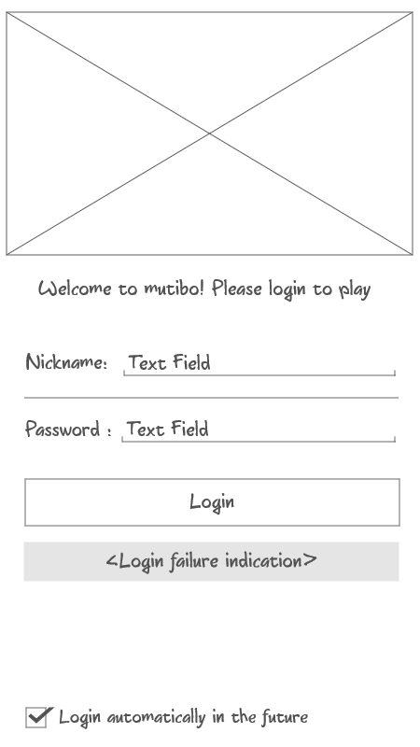Illustration 2: Preliminary login screen
In the first stage of the implementation only a basic user name/password login screen will be implemented. Once the basis functionality of the app is complete this basic login procedure will be replaced with a login procedure using a social network account of the user.
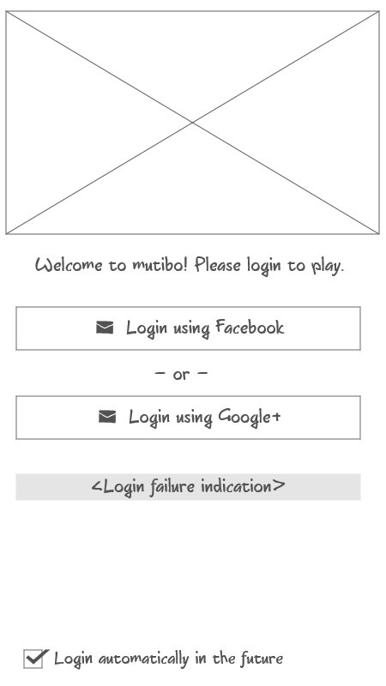Illustration 3: Final login screen

When a user logs in for the first time, he/she will be prompted for additional information. Currently the user is able to change the nickname to be used on the leaderboards. The name of the user on the social network is used a default.

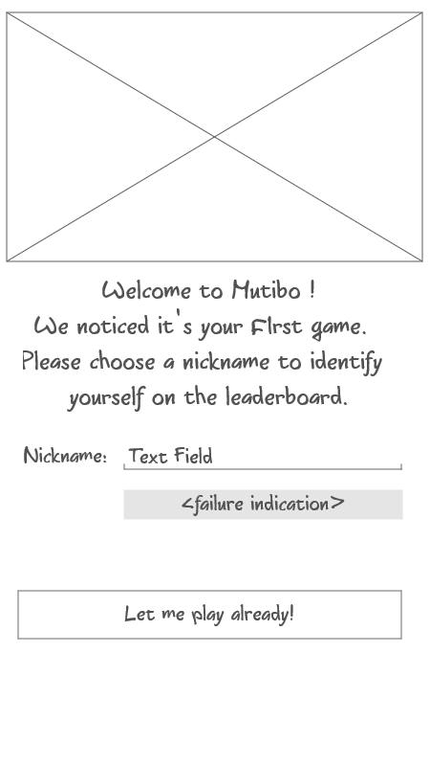Illustration 4: First login of a user

Menu
After login the user is presented with a menu screen.
A news ticker displays information about events that could be important to the player. Besides choosing to play a game or looking up the ranking a player can peruse a help screen and an screen providing more information about this project and its background.
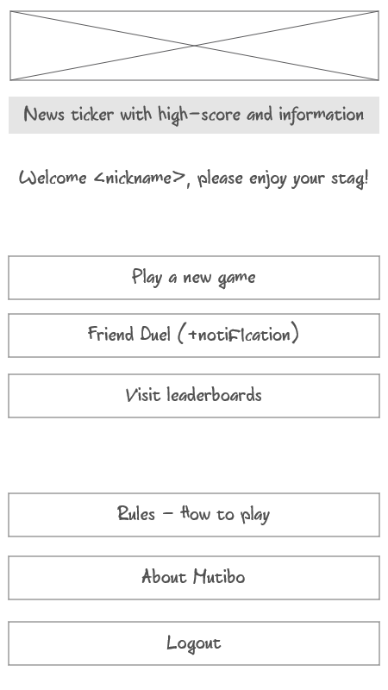Illustration 5: Menu

Playing a game
Choosing “Play a new game” starts a new single-player game.
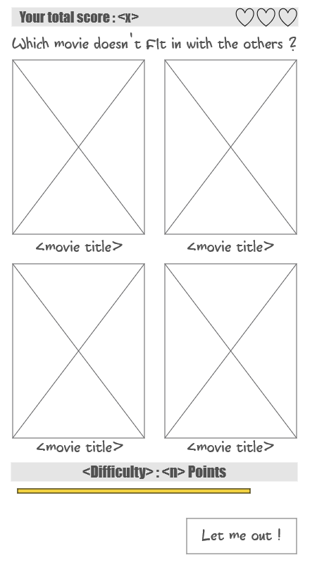Illustration 6: Game screen
Posters for four movies are shown along with the movie-title. An animated progress bar indicates the time that is left for the player to make his/her choice.
The difficulty of the question and the associated number points to earn are listed at the bottom of the screen along with a button to preliminary end the game. At the top of the screen the current score and the remaining 'lives' are displayed.
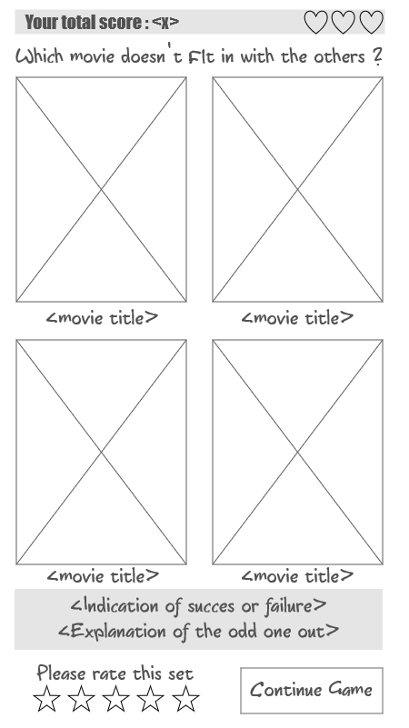Illustration 7: Game results
The selected movie is emphasized using a neutral colored frame. The color of the frame will change to a color indicating success or failure and a appropriate sound will be played. All this information will also be displayed as a text message.

The player can, optionally, rate this set and then move on to the next question.

Slightly alternative layouts for landscape-mode are also implemented.
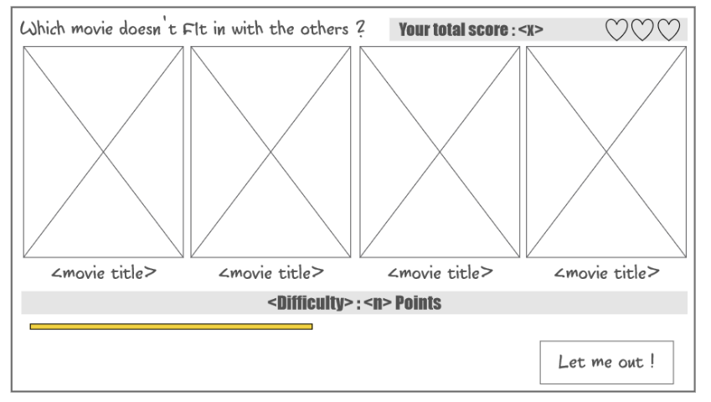Illustration 8: Landscape game
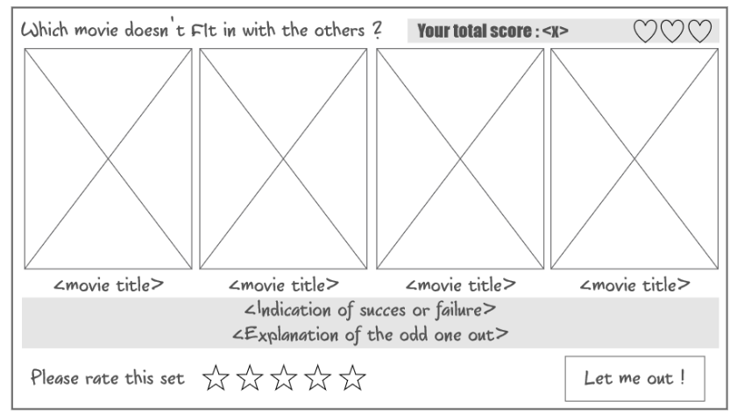Illustration 9: Landscape set results
The game finishes when a player answers three sets wrong. But the game also ends when the player has exhausted all available sets before getting three wrong.
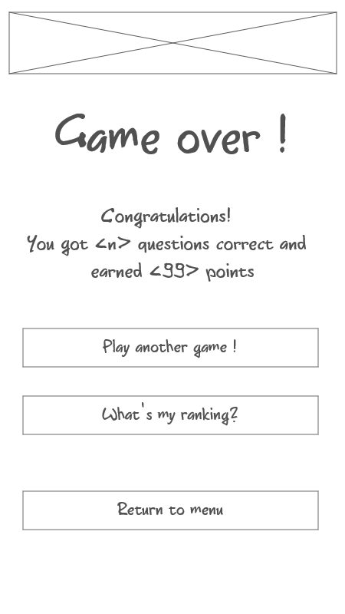Illustration 10: End of game

Leaderboards
The leaderboard screen displays the ranking of the people who have played Mutibo. By default the screen show the ranking of the authenticated player and provides several options to quickly display the top ten and the relative ranking of your friends. The list can be scrolled to view more players.
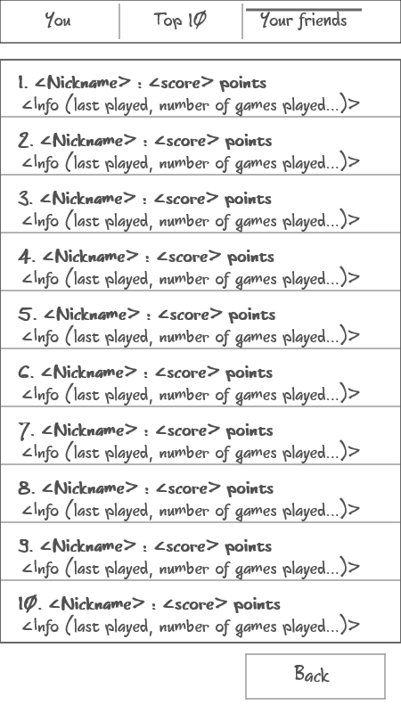Illustration 11: Leaderboards

Multiplayer
On the multiplayer screen the player can challenge other players to a multiplayer duel. The player can opt to player a random opponent or choose to challenge a friend. The friend list indicates which players were online recently and can also be filtered.
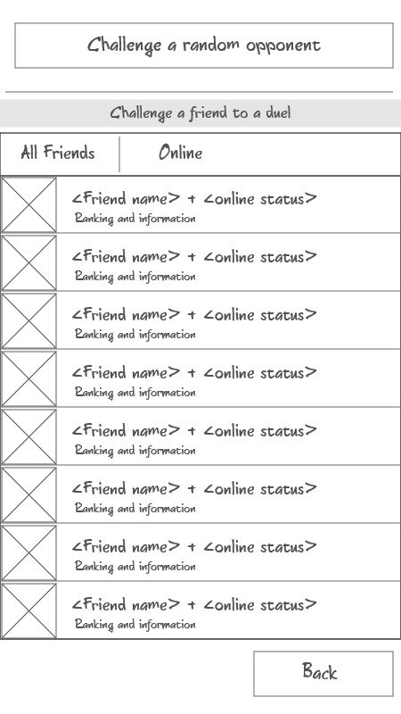Illustration 12: Multiplayer challenge
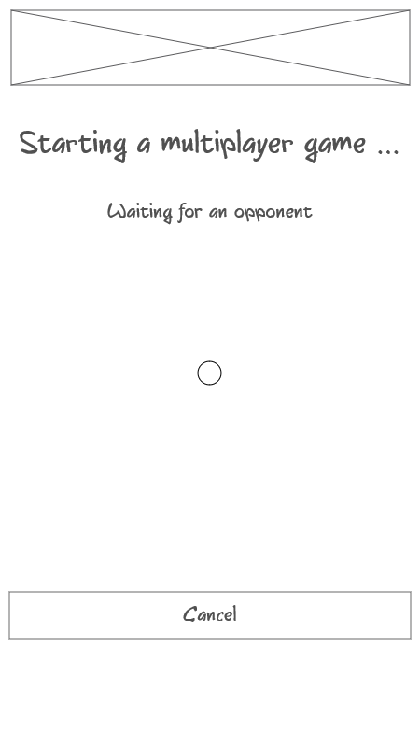Illustration 13: Waiting for a multiplayer opponent
When a challenge is made the app proceeds to show a screen waiting for the challenged player to respond. The player can elect to rescind the challenge if the other party doesn't respond in a timely manner. If the challenged player does not have a known Mutibo account the player is asked if a message should be sent to the other player detailling how he/she can obtain Mutibo.

Implementation details
Retrofit will be used as the REST-client together with OkHttp as the network layer. OkHttp will be configured to cache as much information as possible.

Google Cloud Message for Android will be used to send messages to the client when events occur that the server needs to make clients aware of as soon as possible, mostly during multiplayer matches.

We don't intend to use a local database. The potential benefits seem limited and do not warrant the increased complexity of keep the client up-to-date with the server. The required data will be loaded at application start up and kept in memory. In most cases the data will be loaded from a local cache without requiring contacting the server.

Game logic will be implemented in a separate class from the android activities.

Development cycle and milestones
Server | Implement API's to serve information about movies, sets and decks  (see chapters 3.4.2, 3.4.3, 3.4.4 and 3.4.5)
Client | Implement the game logic and the required activities to play a game of multiple sets. (see chapter 4.2.3)
Milestone - 1 | Able to play a single-player game without sending data back to the server
Server | Basic authentication (see chapter 3.4.1)
Client | Basic login screen and menu (see chapters 4.2.1 and 4.2.2)
Milestone-2 | Able to login and play a single-player game.
Server | Implement API's to receive results of a played game. (see chapter 3.4.6)
Client | Sent results of a play game back to the server and show the leaderboard.  (see chapter 4.2.4)
Milestone-3 | Able to login and consult the leaderboards
Server | Login using Google+
Client | Login using Google+
Milestone-4 | Able to login using an existing Google+ account
Server | Multiplayer games (see chapter 3.4.8)
Client | Multiplayer games (see chapter 4.2.5)
Milestone-5 | Able challenge someone to a match and play a multiplayer game.
Server | Deploy to cloud platform
Client | UI/UX polishing and advanced features (e.g. filtering the leaderboard)
Milestone-6 | Application in a releasable state
Bonus | Server/Client : Login using facebook.

Mid-Point Peer Assessment Rubric

Basic
1. Basic Project Requirement:
App supports multiple users via individual user accounts
Yes, see chapters 3.2.1,3.4.1 and 4.1.2

2. Basic Project Requirement:
App contains at least one user facing function available only to authenticated users
Yes, users have to login to use the app. Most API-functions exposed by the server (chapter 3.4) are only available to authenticated users.

3. Basic Project Requirement:
App comprises at least 1 instance of each of at least 2 of the following 4 fundamental Android components.
- Activity Yes : multiple activities (see chapter 4.2)
- BroadcastReceiver No
- Service Yes : all communication with the server
- ContentProvider No

4. Basic Project Requirement:
App interacts with at least one remotely-hosted Java Spring-based service
Yes, please see chapter 3.4 for an API reference.

5. Basic Project Requirement:
App interacts over the network via HTTP
Yes, using OkHttp and Retrofit (see chapter 4.3)

6. Basic Project Requirement:
App allows users to navigate between 3 or more user interface screens at runtime
Yes, the app has multiple interface screens (see chapter 4.2)

7. Basic Project Requirement:
App uses at least one advanced capability or API from the following list (covered in the MoCCA Specialization): multimedia capture, multimedia playback, touch gestures, sensors, animation.**
Yes, the app plays sounds to indicate a correct or a wrong answer. After answering a set the app animates the game screen to visualize the chosen movie and the correctness of the response.

8. Basic Project Requirement:
App supports at least one operation that is performed off the UI Thread in one or more background Threads of Thread pool.
Yes, all communication with the server is performed in a background thread.

Functional
1. Functional Description and App Requirement:
A Set is a unit of data that contains four movie titles, optional associated images for each movie, information identifying the one movie that is not like the other three, and accompanying text, explaining the relationship between the three related movies.
Please see chapter 3.3.

2. Functional Description and App Requirement:
A User should be able to log into the game using an authenticated user account.
Yes, please see chapters 3.2.1 or 4.1.2.

3. Functional Description and App Requirement:
A single game presents a series of Sets and guesses, until the User has made three Incorrect Guesses.
Please see page 21.

4a. Functional Description and App Requirement:
After viewing a Set, a User will be able to rate a Set based on the explanation of the link between the movies.
Please see page 19.

4b. Functional Description and App Requirement:
If a Set receives a large number of poor ratings, it can be removed from the game.
Sets with poor ratings will have a lower chance of being chosen by the app to be played. An admin-user can choose to remove a set with a poor rating but this will not happen automatically.

5. Functional Description and App Requirement:
For each successfully completed Set, the user will get Points.
Yes, the points that can be earned and the current score are shown on the game screen.

6. Functional Description and App Requirement:
All data (questions, answers, points, etc.) are stored to and retrieved from a web-based service accessible in the cloud.
Yes, please see chapter 3.4.

Bonus

1. Bonus* Functional Description and App Component:
Users could be allowed to challenge a friend to a sudden death playoff. For example, friends could answer questions turn by turn, and the first person to make a mistake loses.
Multiplayer will be implemented (see chapters 3.2.5, 3.4.8, 4.1.4 or 4.2.5). Although currently this is not designed as a sudden death playoff.

2. Bonus* Functional Description and App Component:
Users could be given progressively difficult questions (e.g., based on other users' previous success with each Set).
Sets have a fixed difficulty. The set selection procedure can take this into account.

3. Bonus* Functional Description and App Component:
Users could be given special "power ups" such as the ability to pass a Set, or to get help from a friend them when they are stuck.
No plans to implement this at the moment.

4. Bonus* Functional Description and App Component:
Users could be allowed to challenge Facebook friends to do various things such as to beat their high score, to help answer a question they are stuck on, etc.
Yes, players will be able to challenge friends from a social network.

5. Bonus* Functional Description and App Component:
The app could be optimized for the Amazon Appstore and could leverage Amazon’s GameCircle API to incorporate leaderboards.
No plans at the moment but if enough time remains at the end of the project implementation this might be considered as a bonus features.

Appendix – external resources

Development tools
Android Studio | For development of the android app | -
Netbeans IDE | For development of the server component. | CDDL
NinjaMock | For the screen mockups | Non-commercial use.
OpenOffice | Documentation | Apache License 2.0

Server
MongoDB | Database backend | GNU AGPL
Spring IO | For the REST service | Apache License 2.0
TMDb | Queried for movie information | Non-commercial use.

App
Retrofit | REST-client | Apache License 2.0
OkHttp | HTTP client library | Apache License 2.0

