**COMP 3133 – Full Stack Development II**

**Lab 08 – Angular Data Binding & Directives**

**Topics:**

* Angular Data Binding & Directives
* Building Custom Pipes & Directives

**Developer Note:**When working on your exercises, please use the same Angular project from previous labs. This way you way you won’t have to re-generate a new Angular application every lab.

Only submit the files components, typescript files that you have created and not the entire application.

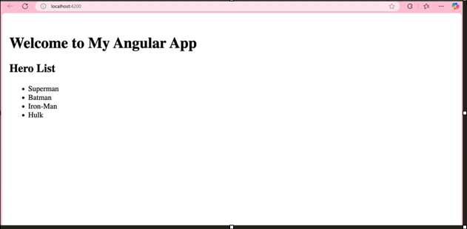

Removed -

