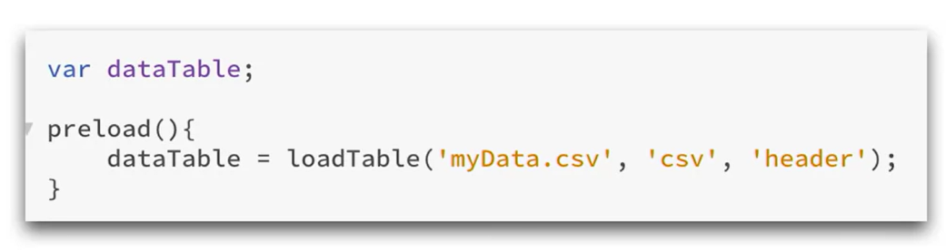

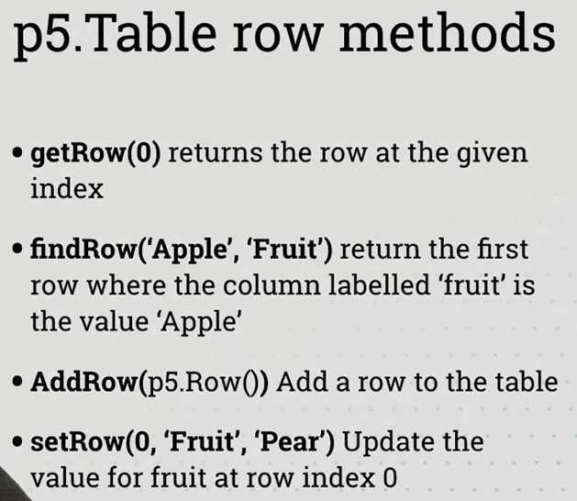

The following snippet means that there’s a div with id “app” in the index.html file. We create a canvas and then we put that canvas inside that #app div.

