**1. Splash Screen:**

**Functional Requirements:**

* Display the app logo or a relevant visual element.
* Auto-redirect to the Home Screen after a set time or when the user interacts with it (e.g., tapping the screen).

**Non-Functional Requirements:**

* Load quickly to provide a seamless user experience.
* The splash screen image should be optimized for various screen sizes and resolutions.
* Should work in both portrait and landscape orientations.

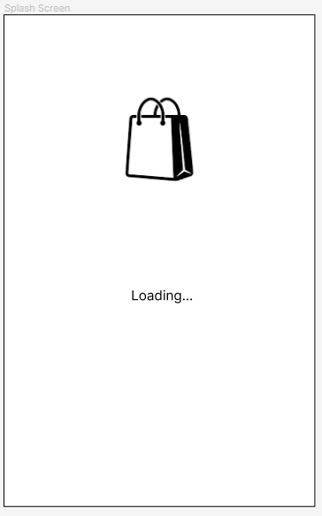

**2. Home Screen:**

**Functional Requirements:**

* Display featured products or collections.
* Provide navigation options for categories, search, and menu.
* Allow users to tap on featured items to view details.

**Non-Functional Requirements:**

* Load product images efficiently to reduce loading times.
* Provide responsive design for different devices and screen sizes.
* Ensure smooth scrolling and transitions between sections.

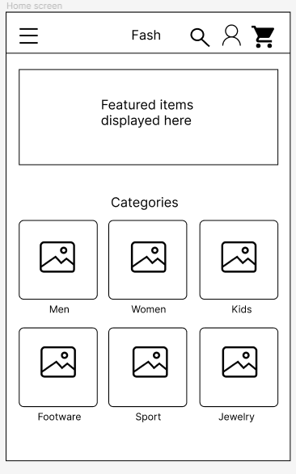

**3. Product Listing Screen:**

**Functional Requirements:**

* Display a list of products based on selected categories or search queries.
* Show product information (name, price, rating) for each item.
* Allow users to apply filters and sorting options.
* Enable users to click on a product to view details.

**Non-Functional Requirements:**

* Load product data quickly, even when there are a large number of items.
* Implement effective search algorithms for fast and accurate results.
* Support offline access to previously viewed listings when connectivity is lost.

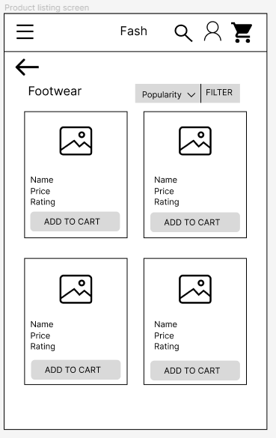

**4. Product Detail Screen:**

**Functional Requirements:**

* Display detailed product information, including images, descriptions, sizes, and colours.
* Allow users to add items to their shopping cart.
* Provide a section for user reviews and ratings.
* Offer social sharing options.

**Non-Functional Requirements:**

* Load high-resolution product images quickly and efficiently.
* Ensure that user reviews and ratings are up-to-date.
* Implement a smooth and responsive user interface for interactions like zooming in on product images.

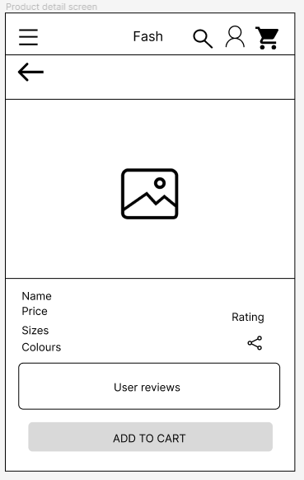

**5. Shopping Cart Screen:**

**Functional Requirements:**

* Show a list of items added to the shopping cart.
* Allow users to adjust quantities or remove items.
* Calculate and display the total order amount.
* Provide a "Checkout" option.

**Non-Functional Requirements:**

* Update cart contents in real-time as users make changes.
* Ensure that cart data is stored securely and can be retrieved across sessions.
* Optimize the checkout process for a smooth user experience.

