1. jgrasp installation instructions
2. <http://www.jgrasp.org/>
3. Click Download

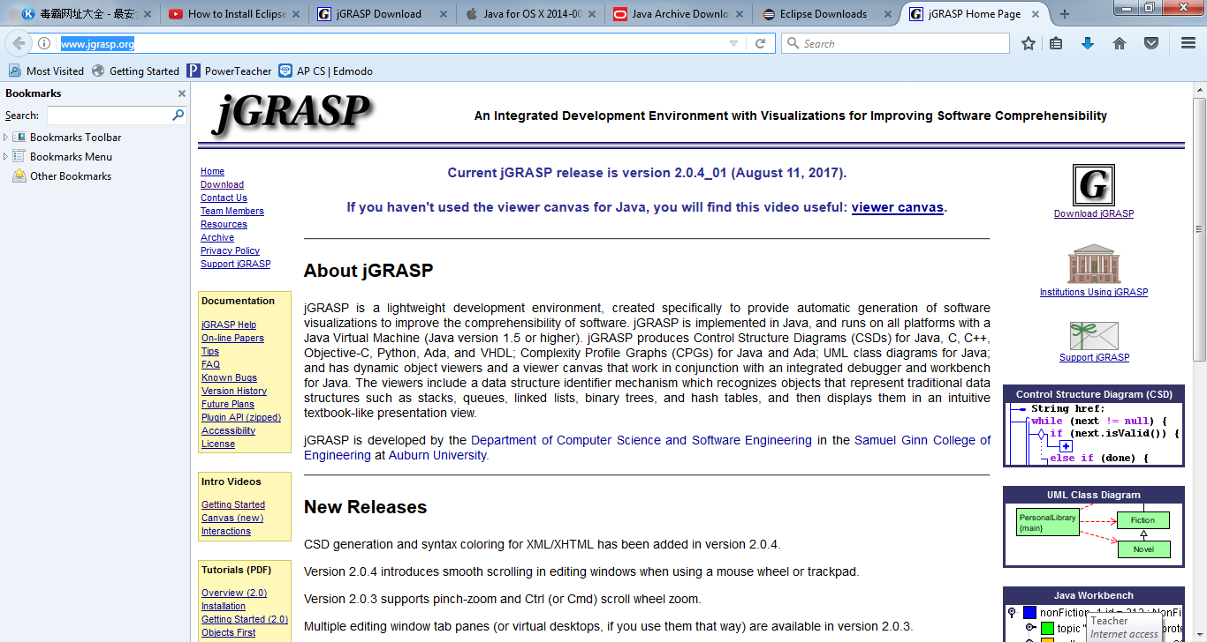

1. Scroll down the page
2. 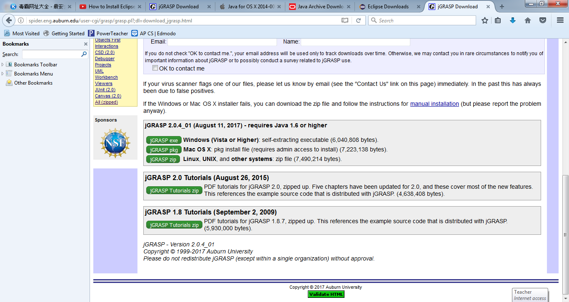
3. Select JGRASP exe for window
4. Select JGRASP pkg for Mac OS x
5. Eclipse installation Instructions:
6. go to <https://www.eclipse.org>
7. Click download package under the DOWNLOAD button, <https://www.eclipse.org/downloads/eclipse-packages/>
8. 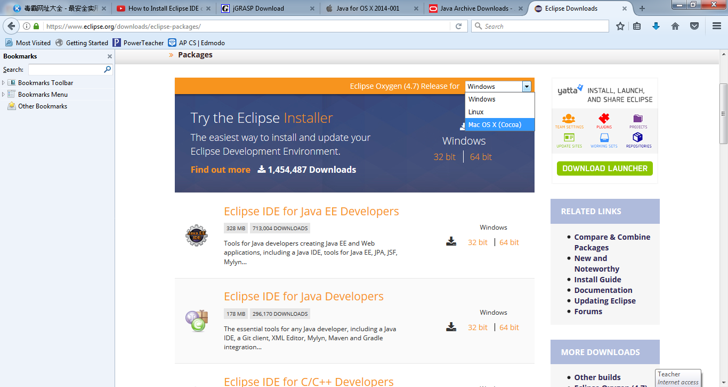
9. For window operating PC, Make sure you select Windows for window operating system
10. 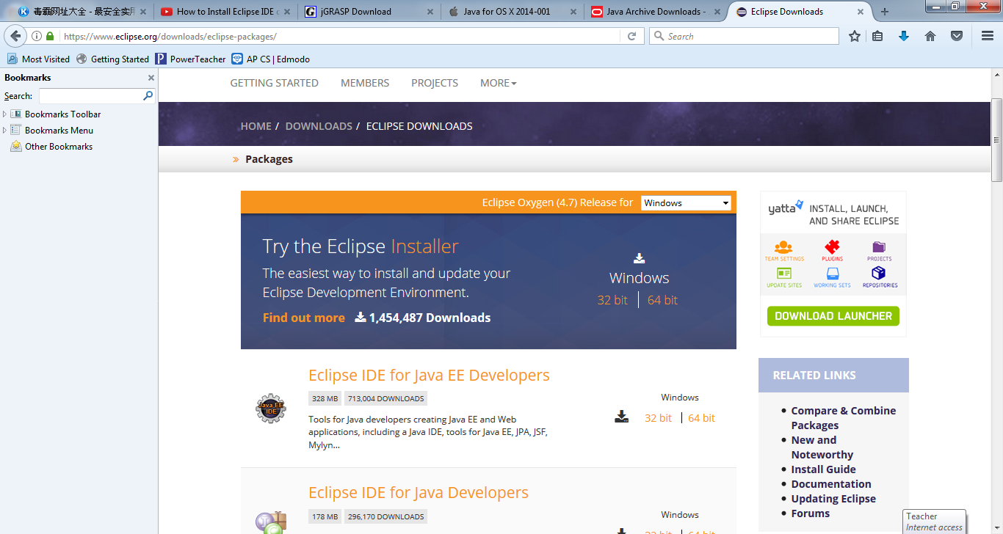

Eclipse on MAC, Make sure you select Mac OS for mac operating system, see below

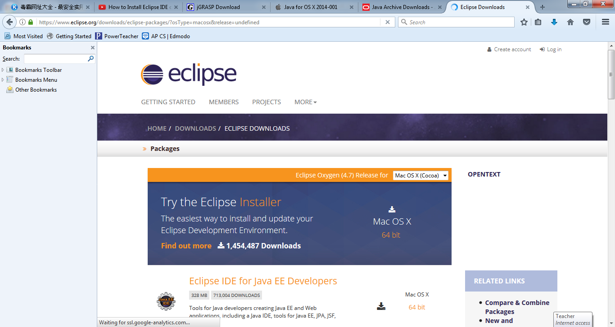

Then click download.