Project Tweets
********************************************
Johanna Riquelme
student 2023094
CCT College
Dublin,Irereland
2023094@student.cct.ie

CCT College Dublin

Assessment Cover Page
To be provided separately as a word doc for students to include with every submission

Module Title: | Advanced Data Analytics  Big Data Storage and Processing
Assessment Title: | MSC_DA_BD_ADAv5
Lecturer Name: | David McQuaid  Muhammad Iqbal
Student Full Name: | Johanna Riquelme A.
Student Number: | 2023094
GitHub repository | https://github.com/Johanna23cct/Integrated-CA2-MSc-2023094.git
Assessment Due Date: | 13/10/2023
Date of Submission: | 10/11/2023

Declaration

By submitting this assessment, I confirm that I have read the CCT policy on Academic Misconduct and understand the implications of submitting work that is not my own or does not appropriately reference material taken from a third party or other source. I declare it to be my own work and that all material from third parties has been appropriately referenced. I further confirm that this work has not previously been submitted for assessment by myself or someone else in CCT College Dublin or any other higher education institution.

Abstract—This electronic document is a “live” template and already defines the components of your paper [title, text, heads, etc.] in its style sheet. *CRITICAL: Do Not Use Symbols, Special Characters, Footnotes, or Math in Paper Title or Abstract. (Abstract)
Keywords—BigData, Hadoop, MapReduce, spark, database, dataset, programming tools (R,Python, SQL, Scala, and Julia) , key tooling categories, Big Data (Hadoop, HTFS, Spark, MapReduce, abd DataBricks) Visualization (Tableau, Palantir, SAS, Pentalto and Teradata) Exabyte (EB=1024 PB) parallel and linear processing,graphs-Charts-Maps, Open source, Types of big data (structured, unstructured Semi-Structured, fault tolerance, action-transformation- prediction, implementation-Evaluation, Architecture, Gartner Glossary

PROLOGUE: What is big data.
First start my project, I must to research more and put my ideas in order, because when I started I had some terminology confusion and concepts not understood. To understand quickly I looking for in all moodle and internet tutorial to create a visualization to help me understand, What is Big Data.
I would like to bring part of the history looking in the past time when all company working in smaller server with reduced memory and in the IT field, work was conducted using termninals that lackered memory at the user stations, and all coworker said to each other, Let me go with the dataset, because only one could work at a time. Well that was the best form to explain what is a small Data, with its characteristics, smaller, slowly, mosly located in storage systems within Enterprises or data centers and fragile to partial or total data loss due to disk errors or fireware failures or absence of these.
I love Big Data is the best plataform to interconect everything and everiwere with the management in huge volumens and could be structured, semistructured, or unstructured dataset. With speed and precision from multiple sources, recognition diferent formatting of data including image, record and more, and the more fantastic like angelical, the cloud. By the way, it is a meme so fany abouth what hapen when something is wrong in the cloud.
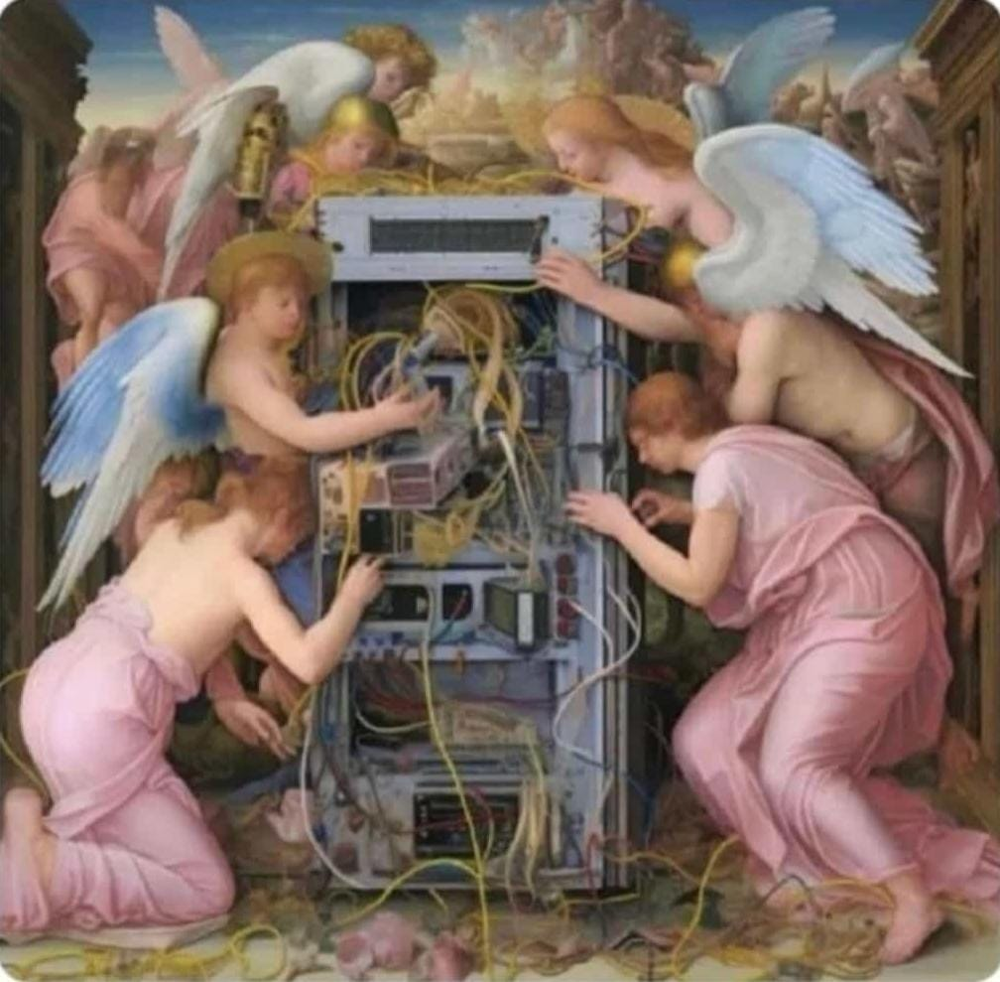

[1]. Like a Big data definition we can find in Gartner Glossary : Big Data is Higt-Volume, High-Velocity and/or High-Variety information assest that demand cost-effective, innovative forms of information processing that enable enhanced insight, decision making, and pross automation. __Gartner
Is good put on the table all the information and here you are all abpouth Bit, Bytes and more:
Bits | = | 0 or 1
8 Bits | = | 1Byte
1024 Bytes | = | 1 Kilobyte (KB)
1024 KB | = | 1 Megabyte (MG)
1024 MB | = | 1 Gigabite (GB)
1024 GB | = | 1 Terabyte (TB)
1024 TB | = | 1 Petabyte (PB)
1024 PB | = | 1 Exabyte (EB)
1024 EB | = | 1 Zettabyte (ZB)
1024 ZB | = | 1 Yottabyte (YB)

Well if we go to talk about Big Data, we need to mention the four V’s of Big Data: Velocity: is the speed, Volume is huge big data, Variety is the divesity quality of data and Veracity is the certainty of data, the presicion.
Is important considerate in the real live the impact of big data companies like Amazon, Netflix Spotify and the people how use virtual personal assistants like alexia or Siri on Apple devices, everyones use Big Data to dvise answers to the infinite number of questions inclusive to help with some simple task like turn on or tur off the ligth. That is frecuently in IoT – Internet of think , an internet- enabled connected network off smart devices such as sensors, processors, embedded devices and comunication hardware for example, a security camera could continually upload footage, and a cloud-based big data algorithm may alert the user if any activity is detected.

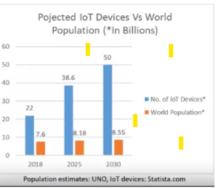
Next I would like to address the topic of Parallel processing and scalability, in linear processing le ogig go step by step following the instruction and when there are an Error mut to back the beging but in parallel processing the instructions are then distribuited to multiple execution nodes of equal processing power and are executed in parallel. If there are an error it can be fixed independent of other instructions in fact this stile of work reduced the processing time and loss data information and can processing big quantity of data.
Is necesary talk abouth what is data scaling in big data This simple meand adding additional nodes with the same capacity , the individual note arranged in thi way are called a computer cluster, like this the multiple computation must coordinate with one another. This disminue the fault problem because the informatios is distribuite across differebt nodes thus achieving a Fault tolerance enable a system to continue operating properly in the event of the failure of some of its components.
I want to mention what i learned a lot with this resourse, like for exaple the six categories of Big Data tooling ,
Big Data Ecosystem
Data Technologies: Key tecnilogies include Hadoop, HDFS, Spark, MapReduce, Cloudera, and Databricks
Analytics & Visualization: Popular analytics tools available are Tableau, Palantir, SAS, Pentaho, and Teradata
Busines Intelligence: Examples include Cognos, Oracle, PowerBI, Business Objecte, and Hyperion.
cloud server provider: Shared resources including computing, starage, networking, and analytical software.
NoSQL Databases: Examples include MongoDB, CouchDB, Cassandra, Redis.
Programming tools: R, Python, SQL, Scala, and Julia are common programing tools.
In this last point we ne to mention the Open source software, are free source code is open, open source license in Open source platforms, we have: The Apache Software Foundation, Linux Foundation, and Cloud Native Computing Foundation.
The big gest componet of Big Data Open source is Hadoop and it plays a major role in this area, Hadoop MapReduce, Hadoop File System (HDFS) yet Another Resurse Negotiator (YARN) Open source has big data tools like Apache Hive and Apache Spark.
Where does Big data come from?
Social Data, Machine data, Transactional data.
What thypes of Data Base there are?
Structured, Unstrucured, and Semi-structured.

Introduction
To introduct to my proyect first i made a thohusand question expernal to why I am here and internal about this proyect. Well i will jump the fisrt question and i will focus in the important, I am learning in gib steps and the spedst form than I have never had before.
Honestly, some time i file so alone ich time que my Lecturers said Any question, I go to outer space and see as question like star the are in the univers but for one hand I haven the clear idea to make a question and for the other hand i feel embarrassed to ask a question not at the level of my classmates. Then I fell like i can’t bother the professors and when I ask for technical suppot they ask me to make an appoinment and so I feel witout adequate support to facilitate my learning. All i have to this point is thank God, sure the ninety percent of a reserch with tears and a lot of effort that I only hope will result in a clearer understanding of where I am and consequently the path towrdas continuous improvement, which though the personal experimentation, I know, the technologies do not stop. And I want to be at the center of the big data ecosytem to teach others who like e today feel on the threshold of something big without enough tools to cross the threshold.
By the way, I recived one email with the great iniciative to create a Student Mentor Team. Well that is what I mean. Well, I congratutale that initiative and I would have liked to have had it when I joined CCT College last semester.
Back to th topic, the real question in this point, what is the best wait to develop this project. And the best anwer is follow the instructions that the professors have provided in CA2 for the tasts and report. So well, here i go.
Only i would like anticipate some thing, like my following big step to follow:
- Selecting the Database and storage
- Data preparation and Data Wrangling
- Comparative analysis of Databases
- Sentimenr Analysis and Tiem-Series Forecasting
- Results and Visualization
- Dasboard creation
- Conclusion and future work
- Reference and citations
- Profreading
As we can see, it is hard work. There is no time to waste.
Let’s go!

Big data storage and Processing

1. like we will see in Figure 1 on the next page, the data provided for this project has five columns and for this assignment, the most important is the Columns number two. And from my point of view it is dirty, Due to my lack of experience, I did a cleanup and separated it into two new variable, one called Date and the other Time. Fromy point of view, experimentation enriches our knowledge. But the idea of seleccting directy from that column the fieds that interest me, which are the Month, Day and Year, is spinning in my head.
Fig 1. From Hadoop pyspark
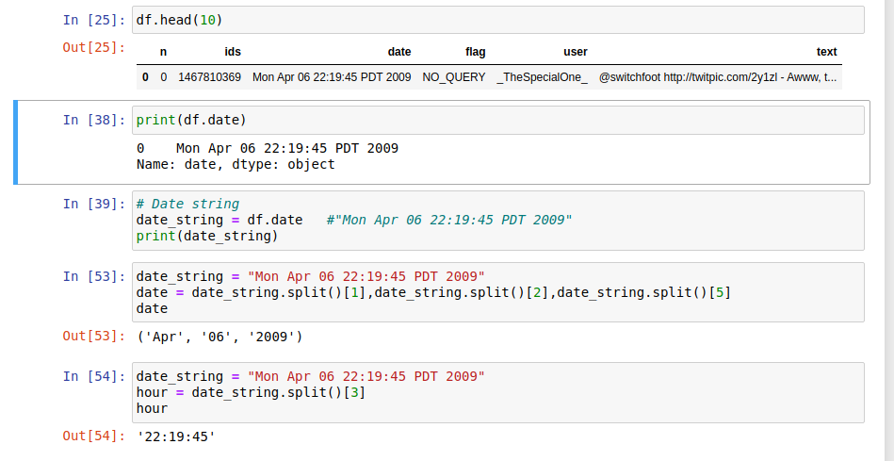
By the way, the name of our dataset is “ProjectTweets.csv” and is a large data set, like we can see,
Fig 2. Dataset’s Name and Size
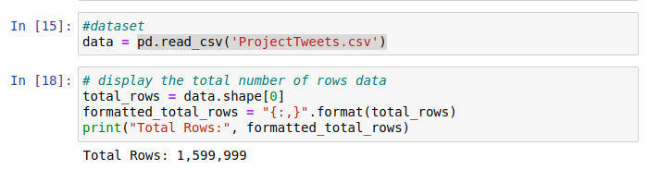
we can see in the follow fig, our dataset was put in Hadoop enviroment with the following commmand
Using Hadoop start scripts, well running ‘start-dfs’ and, ‘sh, start-yarn.sh’ Start the HDFS and yarn components of Hadoop, Whith are required for distributed storage and processing.
After starting Hadoop services, i can run JPS command to check the list of java process and verify that the Hadoop components are running.
Starting Pyspark after Hadoop service are runnin enables i can take advantage of a fully funtional Hadoop cluster for distributed data processing this is the recommnended aproach for production use.
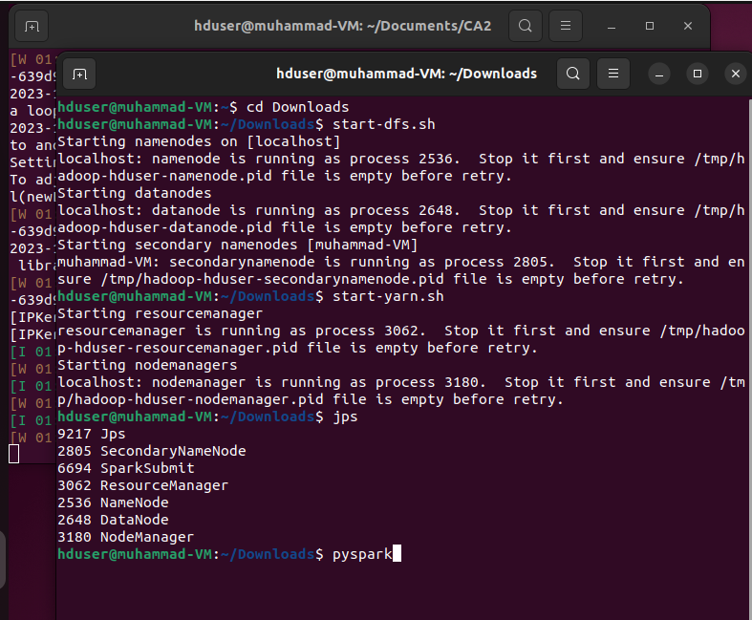
With the followiong command I copy the dataset from my server to Hadoop by the way only in this moment i could see the Big data store process. And stay ready to use the 5V.
$ hadoop fs -put ./ProjectTweets.csv /user1
$ hadoop fs -ls /user1
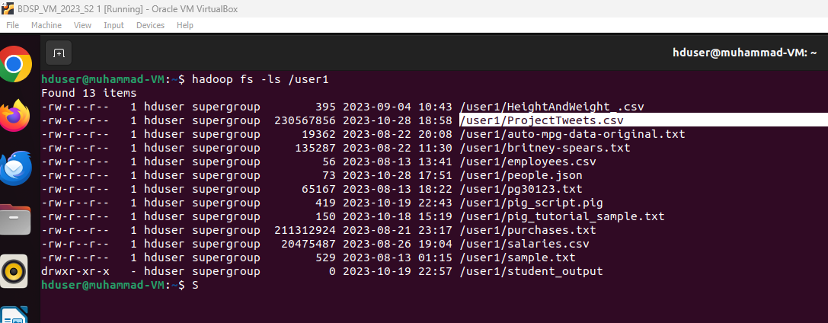
finally I read the dataset from Hadoop enviroment, folowiong you can see the two way to load the dataset, I will use direct from the path, to have one of five V' (Velocity)
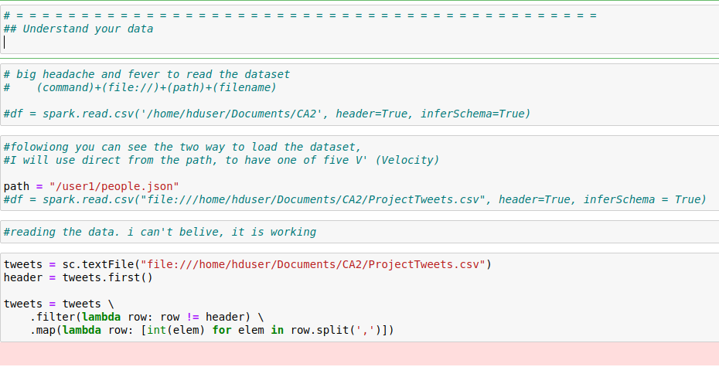
with those step we can see the dataset Utilization of Hadoop ans spark to distributed data processing enviroment
stored in Hadoop tool
Extra: Something strange has happened, my Python files were corrupt and with the nerves I had I made a backup copy of my Word’s file without reviewing it, because I knew I had not modified it, so from Hadoop I sent it to GitHub, but strangely this file It was trampled by other information and when doing the backup my repository was trampled. I made no edits four days ago and was able to recover my Python codes and Word report. It's good that you learned how to use GitHub.
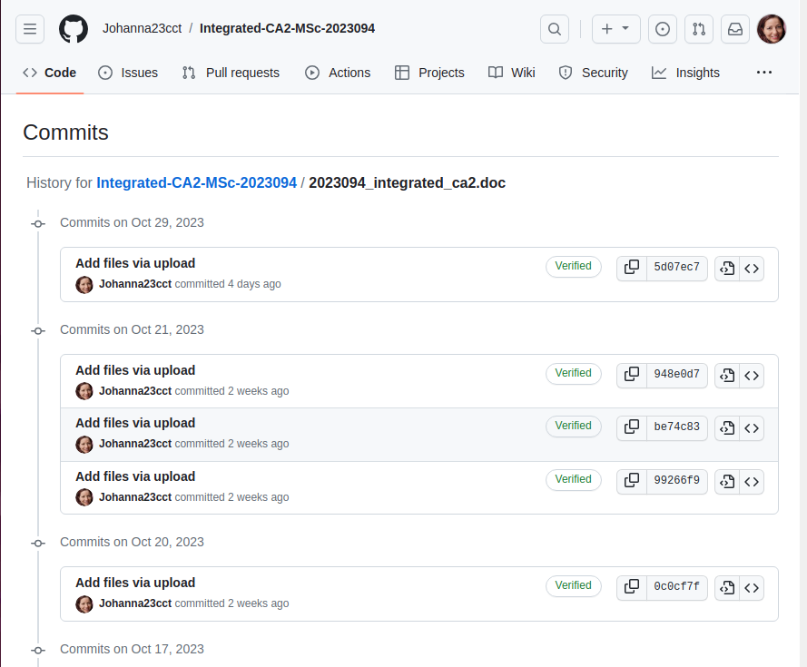
2. Well, After coming back from my state of shock and panic attack, i would like to following with the instruction, like a second topy I hope to explain my justifications:
in retalion to data processing and storage:
Rationale: Whereas data processing and storage options depend on the volume, variety, and velocity the best option for me is Hadoop. It was so dificul to learn but with all my sforce it is a interestin plataform to proccess and storage my data, abouth the choice of programming language I am not expert but Python it so frienship and I found a lot information in my moodle to improve my knoledge, by the way. Data wrangling was so dificul because like you can see in my code, i made a lot mistake tray to clean an call some libraries which gave me a degrre of complication.
At the moment I can not talk abouth manchine learning models because the algorithms do not work for me either. But I am doing my best to make this work, I hope to have a result as soon as possible. [0-40]
3. Comparative analysis for at least two databases using any benchmarking tool. By the way, I am expectant to learn Mongo and compare this database with SQL because I think that is more near to the pass and the future and only wait to have enouth time to made a comparative analysis with this two mentioned databases using YCSB.[0-10]

The Gross Work

4. Your analysis of any change sentiment that occurs over the time period that you have selected. Let’s talk about feelings with the heart and the hand, because before doing this I had only achieved my feeling of frustration. Going through the process that you can see in the following image was not easy at all.[0-10]
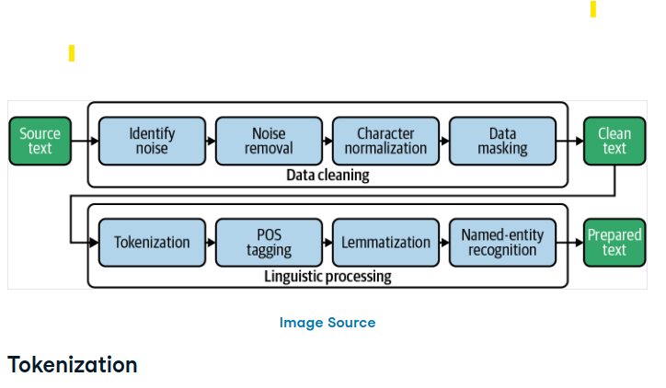

5. Your forecast of the sentiment at 1 week, 1 month and 3 months going forward[0-10]

6. Presentation of results by making appropriate use of figures along with caption, tables, etc and your dashboard for your forecast.[0-10]reviations and Acronyms
HDFS: Hadoop Distributed file System
YARN:
BI: Business Intelligence
IoT: Internet of Think

Units
- Use either SI (MKS) or CGS as primary units. (SI units are encouraged.) English units may be used as secondary units (in parentheses). An exception would be the use of English units as identifiers in trade, such as “3.5-inch disk drive”.
- Avoid combining SI and CGS units, such as current in amperes and magnetic field in oersteds. This often leads to confusion because equations do not balance dimensionally. If you must use mixed units, clearly state the units for each quantity that you use in an equation.
- Do not mix complete spellings and abbreviations of units: “Wb/m2” or “webers per square meter”, not “webers/m2”. Spell out units when they appear in text: “. . . a few henries”, not “. . . a few H”.
- Use a zero before decimal points: “0.25”, not “.25”. Use “cm3”, not “cc”. (bullet list)
Identify applicable funding agency here. If none, delete this text box.

Equations
The equations are an exception to the prescribed specifications of this template. You will need to determine whether or not your equation should be typed using either the Times New Roman or the Symbol font (please no other font). To create multileveled equations, it may be necessary to treat the equation as a graphic and insert it into the text after your paper is styled.
Number equations consecutively. Equation numbers, within parentheses, are to position flush right, as in (1), using a right tab stop. To make your equations more compact, you may use the solidus ( / ), the exp function, or appropriate exponents. Italicize Roman symbols for quantities and variables, but not Greek symbols. Use a long dash rather than a hyphen for a minus sign. Punctuate equations with commas or periods when they are part of a sentence, as in:
a  b    
Note that the equation is centered using a center tab stop. Be sure that the symbols in your equation have been defined before or immediately following the equation. Use “(1)”, not “Eq. (1)” or “equation (1)”, except at the beginning of a sentence: “Equation (1) is . . .”

Some Common Mistakes
- The word “data” is plural, not singular.
- The subscript for the permeability of vacuum μ₀, and other common scientific constants, is zero with subscript formatting, not a lowercase letter “o”.
- In American English, commas, semicolons, periods, question and exclamation marks are located within quotation marks only when a complete thought or name is cited, such as a title or full quotation. When quotation marks are used, instead of a bold or italic typeface, to highlight a word or phrase, punctuation should appear outside of the quotation marks. A parenthetical phrase or statement at the end of a sentence is punctuated outside of the closing parenthesis (like this). (A parenthetical sentence is punctuated within the parentheses.)
- A graph within a graph is an “inset”, not an “insert”. The word alternatively is preferred to the word “alternately” (unless you really mean something that alternates).
- Do not use the word “essentially” to mean “approximately” or “effectively”.
- In your paper title, if the words “that uses” can accurately replace the word “using”, capitalize the “u”; if not, keep using lower-cased.
- Be aware of the different meanings of the homophones “affect” and “effect”, “complement” and “compliment”, “discreet” and “discrete”, “principal” and “principle”.
- Do not confuse “imply” and “infer”.
- The prefix “non” is not a word; it should be joined to the word it modifies, usually without a hyphen.
- There is no period after the “et” in the Latin abbreviation “et al.”.
- The abbreviation “i.e.” means “that is”, and the abbreviation “e.g.” means “for example”.
An excellent style manual for science writers is [7].

Using the Template
After the text edit has been completed, the paper is ready for the template. Duplicate the template file by using the Save As command, and use the naming convention prescribed by your conference for the name of your paper. In this newly created file, highlight all of the contents and import your prepared text file. You are now ready to style your paper; use the scroll down window on the left of the MS Word Formatting toolbar.

Authors and Affiliations
The template is designed for, but not limited to, six authors. A minimum of one author is required for all conference articles. Author names should be listed starting from left to right and then moving down to the next line. This is the author sequence that will be used in future citations and by indexing services. Names should not be listed in columns nor group by affiliation. Please keep your affiliations as succinct as possible (for example, do not differentiate among departments of the same organization).

For papers with more than six authors: Add author names horizontally, moving to a third row if needed for more than 8 authors.

For papers with less than six authors: To change the default, adjust the template as follows.

Selection: Highlight all author and affiliation lines.

Change number of columns: Select the Columns icon from the MS Word Standard toolbar and then select the correct number of columns from the selection palette.

Deletion: Delete the author and affiliation lines for the extra authors.

Identify the Headings
Headings, or heads, are organizational devices that guide the reader through your paper. There are two types: component heads and text heads.
Component heads identify the different components of your paper and are not topically subordinate to each other. Examples include Acknowledgments and References and, for these, the correct style to use is “Heading 5”. Use “figure caption” for your Figure captions, and “table head” for your table title. Run-in heads, such as “Abstract”, will require you to apply a style (in this case, italic) in addition to the style provided by the drop down menu to differentiate the head from the text.
Text heads organize the topics on a relational, hierarchical basis. For example, the paper title is the primary text head because all subsequent material relates and elaborates on this one topic. If there are two or more sub-topics, the next level head (uppercase Roman numerals) should be used and, conversely, if there are not at least two sub-topics, then no subheads should be introduced. Styles named “Heading 1”, “Heading 2”, “Heading 3”, and “Heading 4” are prescribed.

Figures and Tables

Positioning Figures and Tables: Place figures and tables at the top and bottom of columns. Avoid placing them in the middle of columns. Large figures and tables may span across both columns. Figure captions should be below the figures; table heads should appear above the tables. Insert figures and tables after they are cited in the text. Use the abbreviation “Fig. 1”, even at the beginning of a sentence.
- Table Type Styles
Table Head | Table Column Head
Table Head | Table column subhead | Subhead | Subhead
copy | More table copyª
- Sample of a Table footnote. (Table footnote)
- Example of a figure caption. (figure caption)
Figure Labels: Use 8 point Times New Roman for Figure labels. Use words rather than symbols or abbreviations when writing Figure axis labels to avoid confusing the reader. As an example, write the quantity “Magnetization”, or “Magnetization, M”, not just “M”. If including units in the label, present them within parentheses. Do not label axes only with units. In the example, write “Magnetization (A/m)” or “Magnetization {A[m(1)]}”, not just “A/m”. Do not label axes with a ratio of quantities and units. For example, write “Temperature (K)”, not “Temperature/K”.

Acknowledgment (Heading 5)
The preferred spelling of the word “acknowledgment” in America is without an “e” after the “g”. Avoid the stilted expression “one of us (R. B. G.) thanks ...”. Instead, try “R. B. G. thanks...”. Put sponsor acknowledgments in the unnumbered footnote on the first page.

References

[1].( Gartner Glossary)
file:///home/hduser/Downloads/cloud.jpeg
https://www.datacamp.com/tutorial/text-analytics-beginners-nltk

