CSCD 429 – Project Model

* Create a Decision tree
  + Can create inside of RapidMiner, however we aren’t sure which DecisionTree to use and how we will weigh our attributes
  + Don’t have an order preference for now on what attributes would be selected first
* Problems with the Decision Tree
  + Too big for us to manage
  + Too many brands and sub branches
  + The model gets too big for us to even finish visualizing
  + Too many branches and is very tedious to do

Find other potential models that we could use

* Random Forest – essentially what we are ending up with as each brand is representing its separate trees in our dataset and the random forest is using multiple trees results in order to make a prediction
  + This is the closest to what we had wanted , as we are using the stats of the laptop to predict what price range it should fall into

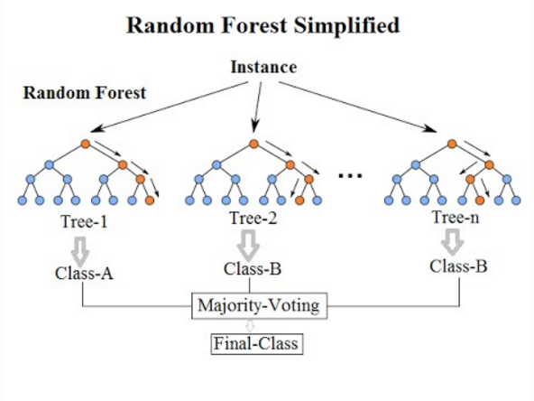

* SVM model – linear/non-linear model used for classification and regression
  + Doesn’t really fit what we need here

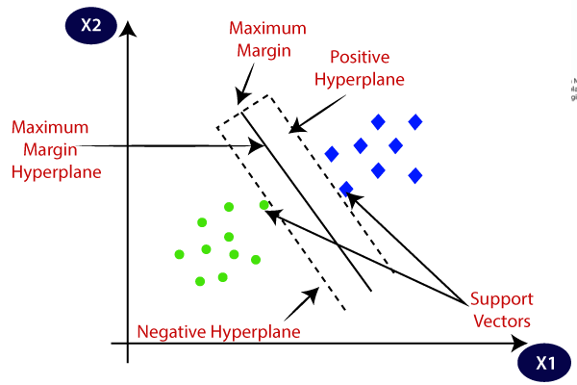

* Neural Network Model –
  + Could work but I need to look into it more as it seems like a slightly different Random Forest

