**Udacity Self-Driving Car Nanodegree**

**Project 5- Vehicle Detection and Tracking**

**Author: Johannes Betz**

**Date: 08/16/2017**

Table of Contents

1. Introduction and goals 3

1. Loading Data und Plot Example 3

2. Histrogram of Oriented Gradients (HOG) 4

3. Sliding Window Search 8

4. Pipeline on a video Stream 14

5. Discussion 16

# Introduction and goals

The following writeup includes the code and the descriptionfor project 5, vehicle detection and tracking.The goals / steps of this project are the following:

* Perform a Histogram of Oriented Gradients (HOG) feature extraction on a labeled training set of images and train a classifier Linear SVM classifier
* Optionally, you can also apply a color transform and append binned color features, as well as histograms of color, to your HOG feature vector.
* Note: for those first two steps don't forget to normalize your features and randomize a selection for training and testing.
* Implement a sliding-window technique and use your trained classifier to search for vehicles in images.
* Run your pipeline on a video stream (start with the test_video.mp4 and later implement on full project_video.mp4) and create a heat map of recurring detections frame by frame to reject outliers and follow detected vehicles.
* Estimate a bounding box for vehicles detected.

Every section provides one part of the project rubics. The whole code can be found in the file “project5.py”

# Loading Data und Plot Example

In the first step, the data , provided as different pictures (vehicle and non-vehicle) are loaded. All training data provided by Udacity (i.e. GTI, KITTI and project video extracts) have been used for this project. Because the vehicle and non-vehicle data sets contain roughly the same number of images it was deemed unnecessary to ceate additional training images for one of the data set. In Addition an example plot is provided. The code looks as following:

# Training images paths  
TRAINING_PATH_VEHICLES = "data/vehicles"  
TRAINING_PATH_NON_VEHICLES = "data/non-vehicles"  
TRAINING_PATH_TRAINED_MODEL = "models"  
  
vehicles = []  
non_vehicles = []  
  
# Vehicle images names  
print("Loading training image names...")  
**for** image **in** glob.glob(TRAINING_PATH_VEHICLES + '/**/*.png', recursive=**True**):  
 vehicles.append(image)  
  
# Non-vehicle images names  
**for** image **in** glob.glob(TRAINING_PATH_NON_VEHICLES + '/**/*.png', recursive=**True**):  
 non_vehicles.append(image)  
  
print(' # of vehicle images: {}'.format(len(vehicles)))  
print('# of non-vehicle images: {}'.format(len(non_vehicles)))  
  
##################################################################################  
############### PLOT TEST EXAMPLE ####################  
##################################################################################  
  
plt.figure(figsize=(15,8))  
  
**for** i **in** range(5):  
 car_ind = np.random.randint(0, len(vehicles))  
 notcar_ind = np.random.randint(0, len(non_vehicles))  
  
 # Read in car / not-car images  
 car_image = mpimg.imread(vehicles[car_ind])  
 notcar_image = mpimg.imread(non_vehicles[notcar_ind])  
  
  
 plt.subplot(2,5,i+1)  
 plt.imshow(car_image)  
 plt.title('Car Image ' + str(car_ind))  
 plt.subplot(2,5,5+i+1)  
 plt.imshow(notcar_image)  
 plt.title('Non-car Image ' + str(notcar_ind))  
  
plt.show()

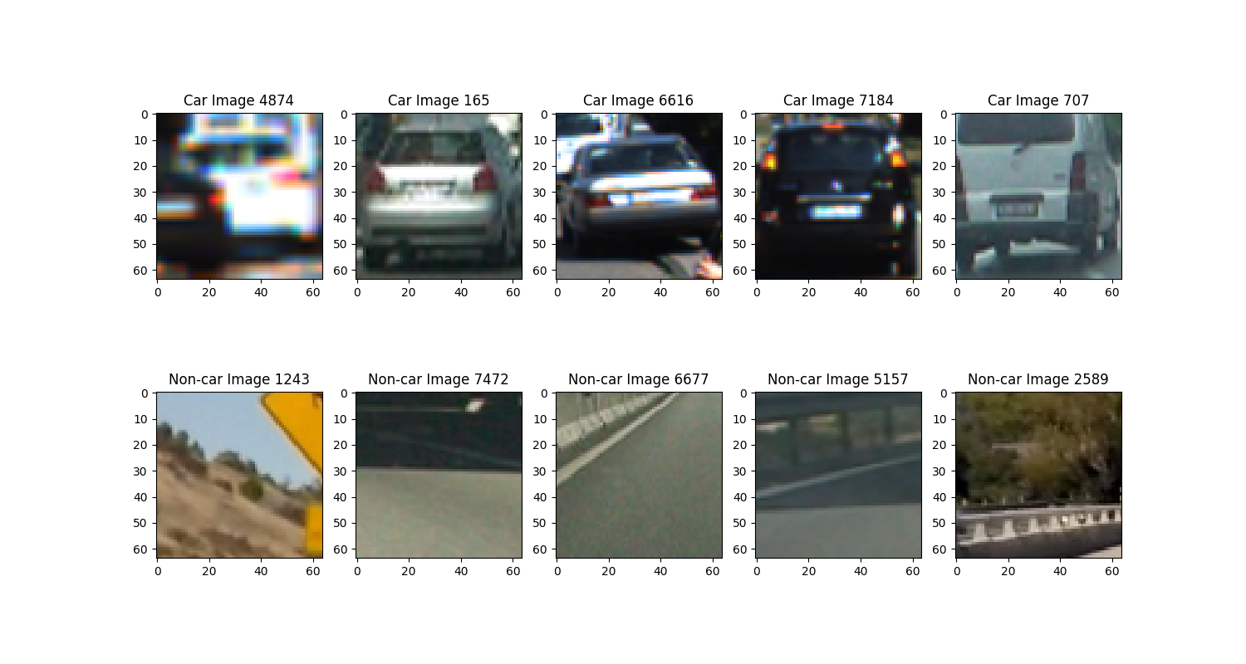

# Histrogram of Oriented Gradients (HOG)

Explain how (and identify where in your code) you extracted HOG features from the training images. Explain how you settled on your final choice of HOG parametersSliding Window Search:

In the second step, the feautres are extracted. The code looks like the following:

# Feature extraction parameters  
colorspace = 'YUV' # Can be RGB, HSV, LUV, HLS, YUV, YCrCb  
orient = 11  
pix_per_cell = 16  
cell_per_block = 2  
hog_channel = 'ALL' # Can be 0, 1, 2, or "ALL"  
  
t = time.time()  
car_features = extract_features(vehicles, cspace=colorspace, orient=orient,  
 pix_per_cell=pix_per_cell, cell_per_block=cell_per_block,  
 hog_channel=hog_channel)  
notcar_features = extract_features(non_vehicles, cspace=colorspace, orient=orient,  
 pix_per_cell=pix_per_cell, cell_per_block=cell_per_block,  
 hog_channel=hog_channel)  
t2 = time.time()  
print(round(t2-t, 2), 'Seconds to extract HOG features...')  
# Create an array stack of feature vectors  
X = np.vstack((car_features, notcar_features)).astype(np.float64)

y = np.hstack((np.ones(len(car_features)), np.zeros(len(notcar_features))))  
  
  
# Split up data into randomized training and test sets  
rand_state = np.random.randint(0, 100)  
X_train, X_test, y_train, y_test = train_test_split(  
 X, y, test_size=0.2, random_state=rand_state)  
  
print('Using:',orient,'orientations',pix_per_cell,  
 'pixels per cell and', cell_per_block,'cells per block')  
print('Feature vector length:', len(X_train[0]))

It combines a number of features into one long one-dimensional feature vector for each training image:

1. **Histogram of Oriented Gradient (HOG)**: HOG features are extracted in function __get_hog_features and returned as a one-dimensional feature vector
2. **Spatial binning of color**: function __bin_spatial returns a scaled down version of an image as a one-dimensional feature vector
3. **Histograms of color**: function __color_hist returns the histograms of all three color channels as a single one-dimensional feature vector.

The Code looks like the following:

**def convert_color**(img, conv='RGB2YCrCb'):  
 **if** conv == 'RGB2YCrCb':  
 **return** cv2.cvtColor(img, cv2.COLOR_RGB2YCrCb)  
 **if** conv == 'BGR2YCrCb':  
 **return** cv2.cvtColor(img, cv2.COLOR_BGR2YCrCb)  
 **if** conv == 'RGB2LUV':  
 **return** cv2.cvtColor(img, cv2.COLOR_RGB2LUV)  
  
**def bin_spatial**(img, size=(32, 32)):  
 color1 = cv2.resize(img[:,:,0], size).ravel()  
 color2 = cv2.resize(img[:,:,1], size).ravel()  
 color3 = cv2.resize(img[:,:,2], size).ravel()  
 **return** np.hstack((color1, color2, color3))  
  
**def color_hist**(img, nbins=32): #bins_range=(0, 256)  
 # Compute the histogram of the color channels separately  
 channel1_hist = np.histogram(img[:,:,0], bins=nbins)  
 channel2_hist = np.histogram(img[:,:,1], bins=nbins)  
 channel3_hist = np.histogram(img[:,:,2], bins=nbins)  
 # Concatenate the histograms into a single feature vector  
 hist_features = np.concatenate((channel1_hist[0], channel2_hist[0], channel3_hist[0]))  
 # Return the individual histograms, bin_centers and feature vector  
 **return** hist_features  
  
**def get_hog_features**(img, orient, pix_per_cell, cell_per_block,  
 vis=**False**, feature_vec=**True**):  
 # Call with two outputs if vis==True  
 **if** vis == **True**:  
 features, hog_image = hog(img, orientations=orient,  
 pixels_per_cell=(pix_per_cell, pix_per_cell),  
 cells_per_block=(cell_per_block, cell_per_block),  
 transform_sqrt=**False**,  
 visualise=vis, feature_vector=feature_vec)  
 **return** features, hog_image  
 # Otherwise call with one output  
 **else**:  
 features = hog(img, orientations=orient,  
 pixels_per_cell=(pix_per_cell, pix_per_cell),  
 cells_per_block=(cell_per_block, cell_per_block),  
 transform_sqrt=**False**,  
 visualise=vis, feature_vector=feature_vec)  
 **return** features  
  
  
# Define a function to extract features from a list of image locations  
# This function could also be used to call bin_spatial() and color_hist() (as in the lessons) to extract  
# flattened spatial color features and color histogram features and combine them all (making use of StandardScaler)  
# to be used together for classification  
**def extract_features**(imgs, cspace='RGB', orient=9,  
 pix_per_cell=8, cell_per_block=2, hog_channel=0):  
 # Create a list to append feature vectors to  
 features = []  
 # Iterate through the list of images  
 **for** file **in** imgs:  
 # Read in each one by one  
 image = mpimg.imread(file)  
 # apply color conversion if other than 'RGB'  
 **if** cspace != 'RGB':  
 **if** cspace == 'HSV':  
 feature_image = cv2.cvtColor(image, cv2.COLOR_RGB2HSV)  
 **elif** cspace == 'LUV':  
 feature_image = cv2.cvtColor(image, cv2.COLOR_RGB2LUV)  
 **elif** cspace == 'HLS':  
 feature_image = cv2.cvtColor(image, cv2.COLOR_RGB2HLS)  
 **elif** cspace == 'YUV':  
 feature_image = cv2.cvtColor(image, cv2.COLOR_RGB2YUV)  
 **elif** cspace == 'YCrCb':  
 feature_image = cv2.cvtColor(image, cv2.COLOR_RGB2YCrCb)  
 **else**: feature_image = np.copy(image)  
  
 # Call get_hog_features() with vis=False, feature_vec=True  
 **if** hog_channel == 'ALL':  
 hog_features = []  
 **for** channel **in** range(feature_image.shape[2]):  
 hog_features.append(get_hog_features(feature_image[:,:,channel],  
 orient, pix_per_cell, cell_per_block,  
 vis=**False**, feature_vec=**True**))  
 hog_features = np.ravel(hog_features)  
 **else**:  
 hog_features = get_hog_features(feature_image[:,:,hog_channel], orient,  
 pix_per_cell, cell_per_block, vis=**False**, feature_vec=**True**)  
 # Append the new feature vector to the features list  
 features.append(hog_features)  
 # Return list of feature vectors  
 **return** features

Describe how (and identify where in your code) you trained a classifier using your selected HOG features (and color features if you used them):

A linear Support Vector Machine is used as the classifier. It is trained as “LinearSVC”. Before training commences the training data is split into a large training set (90%) and a small test set (10%).

**1.44 Seconds to train SVC...**

**Test Accuracy of SVC = 0.9848**

**My SVC predicts: [ 0. 0. 0. 0. 0. 0. 0. 0. 1. 0.]**

**For these 10 labels: [ 0. 0. 0. 0. 0. 0. 0. 0. 1. 0.]**

**0.001 Seconds to predict 10 labels with SVC**

Classifier accuracy on the test set is 98.48%. Changing hyperparameters and/or using a different classifier was considered but not implemented because performance seems adequate with just the default parameters. After training, both the classifier and feature scaler are saved. This means a trained model can be used repeatedly without having to train the model from scratch as the pipeline is developed further.

train =1  
**if** train == 1:  
 # Use a linear SVC  
 svc = LinearSVC()  
 # Check the training time for the SVC  
 t = time.time()  
 svc.fit(X_train, y_train)  
 t2 = time.time()  
 print(round(t2-t, 2), 'Seconds to train SVC...')  
  
 joblib.dump(svc, 'model/Test_model.pkl')  
 # Check the score of the SVC  
 print('Test Accuracy of SVC = ', round(svc.score(X_test, y_test), 4))  
 # Check the prediction time for a single sample  
 t=time.time()  
 n_predict = 10  
 print('My SVC predicts: ', svc.predict(X_test[0:n_predict]))  
 print('For these',n_predict, 'labels: ', y_test[0:n_predict])  
 t2 = time.time()  
 print(round(t2-t, 5), 'Seconds to predict', n_predict,'labels with SVC')  
**else**:  
 svc=joblib.load('model/Test_model.pkl')

# Sliding Window Search

Describe how (and identify where in your code) you implemented a sliding window search. How did you decide what scales to search and how much to overlap windows?

Do find cars in a example picture, a pipeline is provided. The code pipeline for all test images looks like this:

test_images = glob.glob('./test_images/test*.jpg')  
  
fig, axs = plt.subplots(3, 2, figsize=(16,14))  
fig.subplots_adjust(hspace = .004, wspace=.002)  
axs = axs.ravel()  
  
**for** i, im **in** enumerate(test_images):  
 axs[i].imshow(process_frame(mpimg.imread(im)))  
 axs[i].axis('off')  
  
plt.show()

This pipeline consists of the “process_frame” function, which looks like this:

**def process_frame**(img):  
 rectangles = []  
  
 colorspace = 'YUV' # Can be RGB, HSV, LUV, HLS, YUV, YCrCb  
 orient = 11  
 pix_per_cell = 16  
 cell_per_block = 2  
 hog_channel = 'ALL' # Can be 0, 1, 2, or "ALL"  
  
 ystart = 400  
 ystop = 464  
 scale = 1.0  
 rectangles.append(find_cars(img, ystart, ystop, scale, colorspace, hog_channel, svc, **None**,  
 orient, pix_per_cell, cell_per_block, **None**, **None**))  
 ystart = 416  
 ystop = 480  
 scale = 1.0  
 rectangles.append(find_cars(img, ystart, ystop, scale, colorspace, hog_channel, svc, **None**,  
 orient, pix_per_cell, cell_per_block, **None**, **None**))  
 ystart = 400  
 ystop = 496  
 scale = 1.5  
 rectangles.append(find_cars(img, ystart, ystop, scale, colorspace, hog_channel, svc, **None**,  
 orient, pix_per_cell, cell_per_block, **None**, **None**))  
 ystart = 432  
 ystop = 528  
 scale = 1.5  
 rectangles.append(find_cars(img, ystart, ystop, scale, colorspace, hog_channel, svc, **None**,  
 orient, pix_per_cell, cell_per_block, **None**, **None**))  
 ystart = 400  
 ystop = 528  
 scale = 2.0  
 rectangles.append(find_cars(img, ystart, ystop, scale, colorspace, hog_channel, svc, **None**,  
 orient, pix_per_cell, cell_per_block, **None**, **None**))  
 ystart = 432  
 ystop = 560  
 scale = 2.0  
 rectangles.append(find_cars(img, ystart, ystop, scale, colorspace, hog_channel, svc, **None**,  
 orient, pix_per_cell, cell_per_block, **None**, **None**))  
 ystart = 400  
 ystop = 596  
 scale = 3.5  
 rectangles.append(find_cars(img, ystart, ystop, scale, colorspace, hog_channel, svc, **None**,  
 orient, pix_per_cell, cell_per_block, **None**, **None**))  
 ystart = 464  
 ystop = 660  
 scale = 3.5  
 rectangles.append(find_cars(img, ystart, ystop, scale, colorspace, hog_channel, svc, **None**,  
 orient, pix_per_cell, cell_per_block, **None**, **None**))  
  
 rectangles = [item **for** sublist **in** rectangles **for** item **in** sublist]  
  
 heatmap_img = np.zeros_like(img[:, :, 0])  
 heatmap_img = add_heat(heatmap_img, rectangles)  
 heatmap_img = apply_threshold(heatmap_img, 1)  
 labels = label(heatmap_img)  
 draw_img, rects = draw_labeled_bboxes(np.copy(img), labels)  
 **return** draw_img

This function provides a various sliding window search. Due to the size and position of cars in the image will be different depending on their distance from the camera, find_cars will have to be called a few times with different ystart, ystop, and scale values. For each searching window the function “find_cars” is called. This function provides a HOG Sub-sampling window search and gives back the rectangles for each car. The function consinsts of the following code:

# Define a single function that can extract features using hog sub-sampling and make predictions  
**def find_cars**(img, ystart, ystop, scale, cspace, hog_channel, svc, X_scaler, orient,  
 pix_per_cell, cell_per_block, spatial_size, hist_bins, show_all_rectangles=**False**):  
 # array of rectangles where cars were detected  
 rectangles = []  
  
 img = img.astype(np.float32) / 255  
  
 img_tosearch = img[ystart:ystop, :, :]  
  
 # apply color conversion if other than 'RGB'  
 **if** cspace != 'RGB':  
 **if** cspace == 'HSV':  
 ctrans_tosearch = cv2.cvtColor(img_tosearch, cv2.COLOR_RGB2HSV)  
 **elif** cspace == 'LUV':  
 ctrans_tosearch = cv2.cvtColor(img_tosearch, cv2.COLOR_RGB2LUV)  
 **elif** cspace == 'HLS':  
 ctrans_tosearch = cv2.cvtColor(img_tosearch, cv2.COLOR_RGB2HLS)  
 **elif** cspace == 'YUV':  
 ctrans_tosearch = cv2.cvtColor(img_tosearch, cv2.COLOR_RGB2YUV)  
 **elif** cspace == 'YCrCb':  
 ctrans_tosearch = cv2.cvtColor(img_tosearch, cv2.COLOR_RGB2YCrCb)  
 **else**:  
 ctrans_tosearch = np.copy(image)  
  
 # rescale image if other than 1.0 scale  
 **if** scale != 1:  
 imshape = ctrans_tosearch.shape  
 ctrans_tosearch = cv2.resize(ctrans_tosearch, (np.int(imshape[1] / scale), np.int(imshape[0] / scale)))  
  
 # select colorspace channel for HOG  
 **if** hog_channel == 'ALL':  
 ch1 = ctrans_tosearch[:, :, 0]  
 ch2 = ctrans_tosearch[:, :, 1]  
 ch3 = ctrans_tosearch[:, :, 2]  
 **else**:  
 ch1 = ctrans_tosearch[:, :, hog_channel]  
  
 # Define blocks and steps as above  
 nxblocks = (ch1.shape[1] // pix_per_cell) + 1 # -1  
 nyblocks = (ch1.shape[0] // pix_per_cell) + 1 # -1  
 nfeat_per_block = orient * cell_per_block ** 2  
 # 64 was the orginal sampling rate, with 8 cells and 8 pix per cell  
 window = 64  
 nblocks_per_window = (window // pix_per_cell) - 1  
 cells_per_step = 2 # Instead of overlap, define how many cells to step  
 nxsteps = (nxblocks - nblocks_per_window) // cells_per_step  
 nysteps = (nyblocks - nblocks_per_window) // cells_per_step  
  
 # Compute individual channel HOG features for the entire image  
 hog1 = get_hog_features(ch1, orient, pix_per_cell, cell_per_block, feature_vec=**False**)  
 **if** hog_channel == 'ALL':  
 hog2 = get_hog_features(ch2, orient, pix_per_cell, cell_per_block, feature_vec=**False**)  
 hog3 = get_hog_features(ch3, orient, pix_per_cell, cell_per_block, feature_vec=**False**)  
  
 **for** xb **in** range(nxsteps):  
 **for** yb **in** range(nysteps):  
 ypos = yb * cells_per_step  
 xpos = xb * cells_per_step  
 # Extract HOG for this patch  
 hog_feat1 = hog1[ypos:ypos + nblocks_per_window, xpos:xpos + nblocks_per_window].ravel()  
 **if** hog_channel == 'ALL':  
 hog_feat2 = hog2[ypos:ypos + nblocks_per_window, xpos:xpos + nblocks_per_window].ravel()  
 hog_feat3 = hog3[ypos:ypos + nblocks_per_window, xpos:xpos + nblocks_per_window].ravel()  
 hog_features = np.hstack((hog_feat1, hog_feat2, hog_feat3))  
 **else**:  
 hog_features = hog_feat1  
  
 xleft = xpos * pix_per_cell  
 ytop = ypos * pix_per_cell  
  
 ################ ONLY FOR BIN_SPATIAL AND COLOR_HIST ################  
  
 # Extract the image patch  
 # subimg = cv2.resize(ctrans_tosearch[ytop:ytop+window, xleft:xleft+window], (64,64))  
  
 # Get color features  
 # spatial_features = bin_spatial(subimg, size=spatial_size)  
 # hist_features = color_hist(subimg, nbins=hist_bins)  
  
 # Scale features and make a prediction  
 # test_features = X_scaler.transform(np.hstack((spatial_features, hist_features, hog_features)).reshape(1, -1))  
 # test_features = X_scaler.transform(np.hstack((shape_feat, hist_feat)).reshape(1, -1))  
 # test_prediction = svc.predict(test_features)  
  
 ######################################################################  
  
 test_prediction = svc.predict(hog_features)  
  
 **if** test_prediction == 1 **or** show_all_rectangles:  
 xbox_left = np.int(xleft * scale)  
 ytop_draw = np.int(ytop * scale)  
 win_draw = np.int(window * scale)  
 rectangles.append(  
 ((xbox_left, ytop_draw + ystart), (xbox_left + win_draw, ytop_draw + win_draw + ystart)))  
  
 **return** rectangles

After the rectangles are found, the picture looks like this:

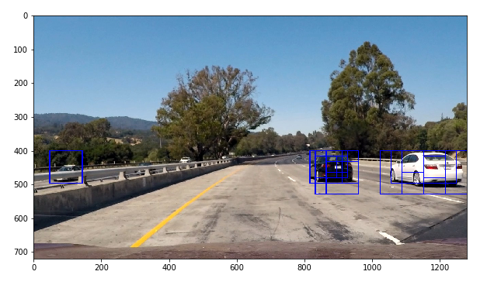

It can be seen that there are overlapping detections exists. In addition there is a false detection on the left side of the picture on the other side of the road. The remove the false positives, the following functions are applied to the picture:

1. Incorporate heatmap
2. Apply threshold to heatmap

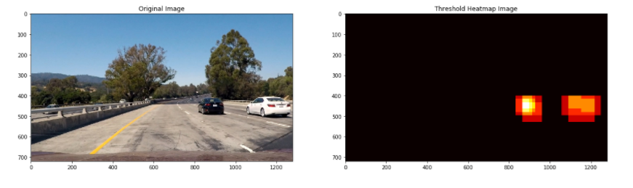

1. Apply SciPy Labels to heatmap

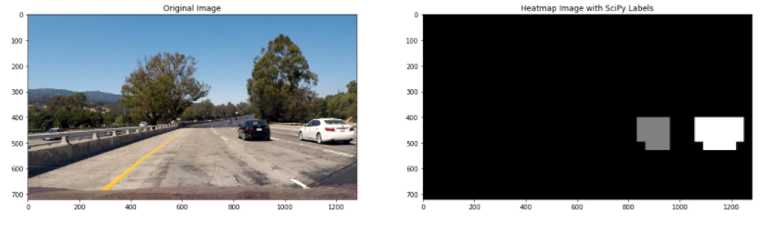

1. Apply bounding boxes around the labeled regions

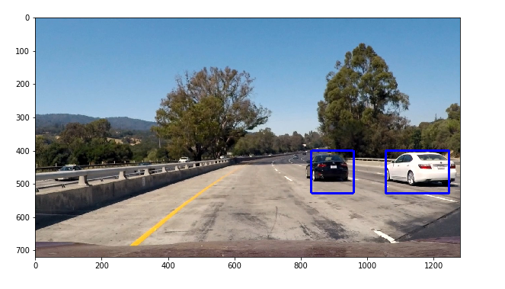

This pipeline for processing an test image is now applied to all images and is shown below:

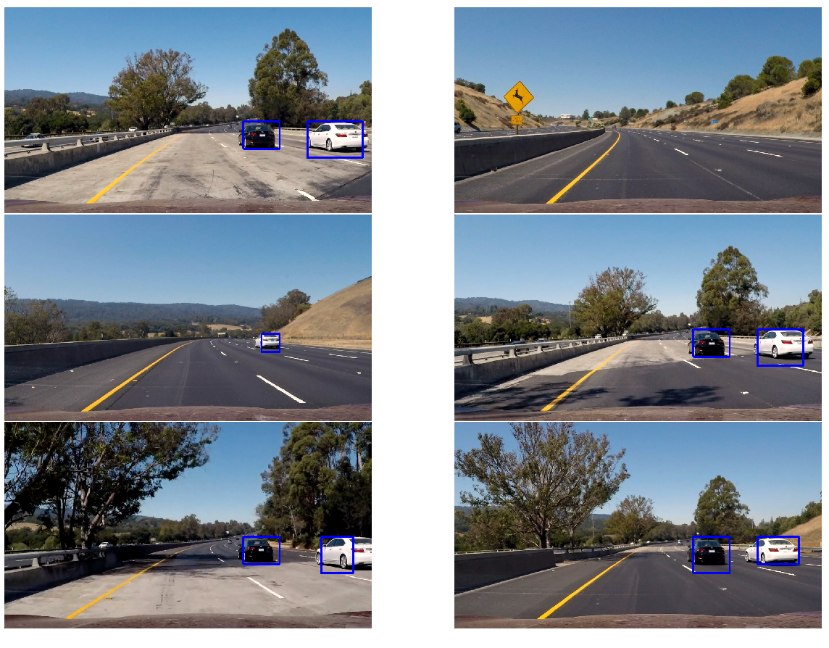

# Pipeline on a video Stream

Provide a link to your final video output. Your pipeline should perform reasonably well on the entire project video (somewhat wobbly or unstable bounding boxes are ok as long as you are identifying the vehicles most of the time with minimal false positives.)

To make a smooth video a similar pipeline as before is used but now we'll also consider previous frames when calculating next localion of frame.

In order to do this the code provides the folliwng

1. Define a class to store data from vehicle detections
2. Create a pipeline that processes images by also adding previous frame detections to the history

##################################################################################  
############### Video Piepline ##################  
##################################################################################  
  
# Define a class to store data from video  
**class Vehicle_Detect**():  
 **def** __init__(self):  
 # history of rectangles previous n frames  
 self.prev_rects = []  
  
 **def add_rects**(self, rects):  
 self.prev_rects.append(rects)  
 **if** len(self.prev_rects) > 15:  
 # throw out oldest rectangle set(s)  
 self.prev_rects = self.prev_rects[len(self.prev_rects) - 15:]  
  
  
**def process_frame_for_video**(img):  
 rectangles = []  
  
 colorspace = 'YUV' # Can be RGB, HSV, LUV, HLS, YUV, YCrCb  
 orient = 11  
 pix_per_cell = 16  
 cell_per_block = 2  
 hog_channel = 'ALL' # Can be 0, 1, 2, or "ALL"  
  
 ystart = 400  
 ystop = 464  
 scale = 1.0  
 rectangles.append(find_cars(img, ystart, ystop, scale, colorspace, hog_channel, svc, **None**,  
 orient, pix_per_cell, cell_per_block, **None**, **None**))  
 ystart = 416  
 ystop = 480  
 scale = 1.0  
 rectangles.append(find_cars(img, ystart, ystop, scale, colorspace, hog_channel, svc, **None**,  
 orient, pix_per_cell, cell_per_block, **None**, **None**))  
 ystart = 400  
 ystop = 496  
 scale = 1.5  
 rectangles.append(find_cars(img, ystart, ystop, scale, colorspace, hog_channel, svc, **None**,  
 orient, pix_per_cell, cell_per_block, **None**, **None**))  
 ystart = 432  
 ystop = 528  
 scale = 1.5  
 rectangles.append(find_cars(img, ystart, ystop, scale, colorspace, hog_channel, svc, **None**,  
 orient, pix_per_cell, cell_per_block, **None**, **None**))  
 ystart = 400  
 ystop = 528  
 scale = 2.0  
 rectangles.append(find_cars(img, ystart, ystop, scale, colorspace, hog_channel, svc, **None**,  
 orient, pix_per_cell, cell_per_block, **None**, **None**))  
 ystart = 432  
 ystop = 560  
 scale = 2.0  
 rectangles.append(find_cars(img, ystart, ystop, scale, colorspace, hog_channel, svc, **None**,  
 orient, pix_per_cell, cell_per_block, **None**, **None**))  
 ystart = 400  
 ystop = 596  
 scale = 3.5  
 rectangles.append(find_cars(img, ystart, ystop, scale, colorspace, hog_channel, svc, **None**,  
 orient, pix_per_cell, cell_per_block, **None**, **None**))  
 ystart = 464  
 ystop = 660  
 scale = 3.5  
 rectangles.append(find_cars(img, ystart, ystop, scale, colorspace, hog_channel, svc, **None**,  
 orient, pix_per_cell, cell_per_block, **None**, **None**))  
  
 rectangles = [item **for** sublist **in** rectangles **for** item **in** sublist]  
  
 # add detections to the history  
 **if** len(rectangles) > 0:  
 det.add_rects(rectangles)  
  
 heatmap_img = np.zeros_like(img[:, :, 0])  
 **for** rect_set **in** det.prev_rects:  
 heatmap_img = add_heat(heatmap_img, rect_set)  
 heatmap_img = apply_threshold(heatmap_img, 1 + len(det.prev_rects) // 2)  
  
 labels = label(heatmap_img)  
 draw_img, rect = draw_labeled_bboxes(np.copy(img), labels)  
 **return** draw_img  
  
det = Vehicle_Detect()  
  
test_out_file2 = 'project_video_out.mp4'  
clip_test2 = VideoFileClip('project_video.mp4')  
clip_test_out2 = clip_test2.fl_image(process_frame_for_video)  
clip_test_out2.write_videofile(test_out_file2, audio=**False**)

The result contains a handful of false positives. The rectangles that identify vehicles also tend to be a bit jittery. Frame-to-frame 'smoothing' of the heatmaps was attempted, but abandoned due to time constraints. To assist with this a diagnostic view was developed, showing detection results at the top. Along the bottom are shown the:

* current frame's heatmap
* thresholded version of the heatmap
* heatmap for the current and previoud frame's heatmap
* tresholded version of the heatmap

The link for the project video is provided here: <https://youtu.be/4LcXEkC3xwY>

# Discussion

Briefly discuss any problems / issues you faced in your implementation of this project. Where will your pipeline likely fail? What could you do to make it more robust?

1. Paramter Tuning: it was hard for me to get the right parameters for the HOG extraction and training the classifier. It needs a lot of know-how or experience to get the right paramters very quickly.
2. Real Time Processing: To process my video it takes quite a while with this pipeline. Right now, I have no idea how to make it in real time or to apply it to a real car.
3. Additional feature extraction is possible.
4. More Data is needed: Although the classifier is good, I think 8000 pictures are not enough.
5. Improve generalization
6. Another Approach: Training a neuronal network for classifying the cars.