Inhalt
1. Model Weight Changes 2
1.1. ROC Model 2
1.2. CLOZE Model 3
1.3. Mixed Model 4
2. Test Metrics 5
2.1. Cloze Test (Unmodified) 5
2.2. Hypothesis-Only 7
1.3. Noise Induced Stories 9
2.4. Negated Stories 11
2.5. Stories Containing Trigger Words 13
2.6. Stories Containing Trigger Words – Triggers Removed 15
2.7. Stories Containing Trigger Words – Trigger Synonymized 17
2.8. Stories Translated 19
2.9. Super Hard Test Set 23
2.10. Cloze-Test (Unmodified), Short 25
3. Salience Maps 27
3.1. Inducing Noise 27
3.1.1 Sample 1 27
3.1.2 Sample 2 28
3.1.3 Sample 3 29
3.1.4 Sample 4 30
3.1.5 Sample 5 31
3.2. Trigger Words 33
3.2.1. ROC model 33
3.2.2. CLOZE model 38
3.2.3. MIXED model 43
3.3 More Samples 48
4. Paraphrasing Scores Mixed Using All Pipelines Available 60

1. Model Weight Changes

1.1. ROC Model

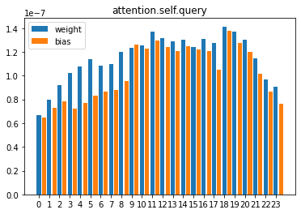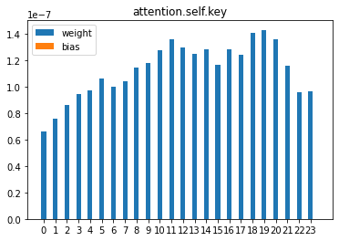

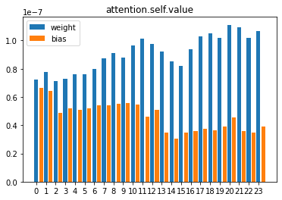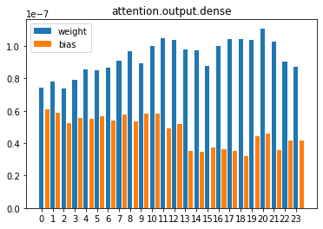

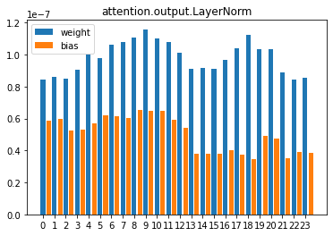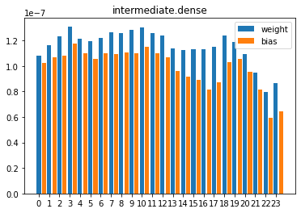

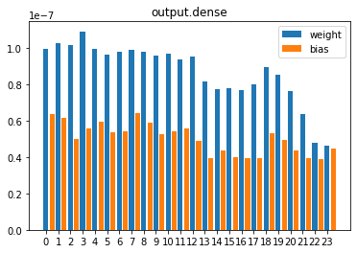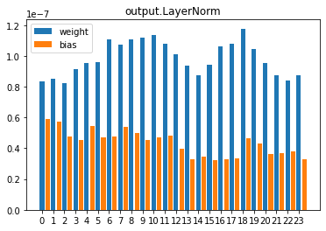

1.2. CLOZE Model

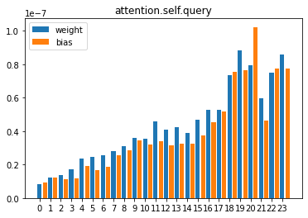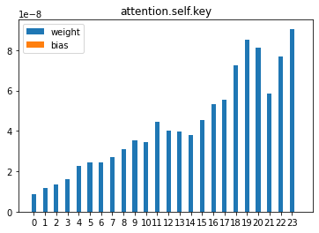
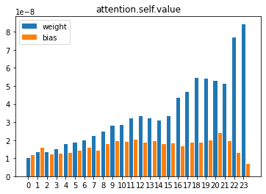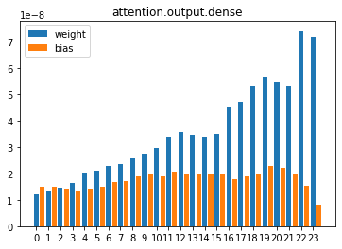
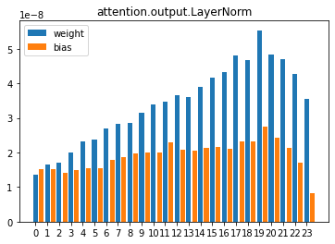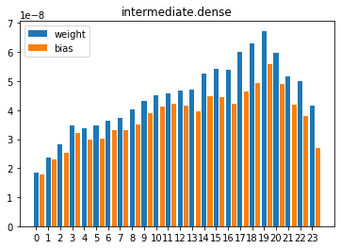

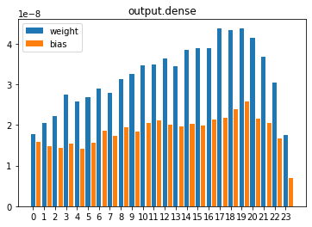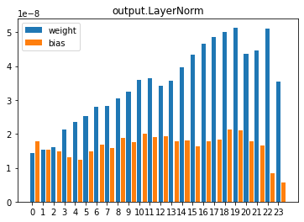

1.3. Mixed Model

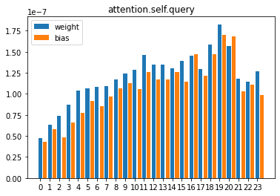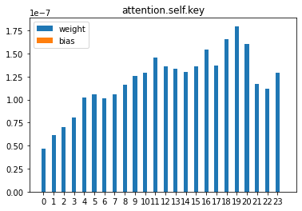

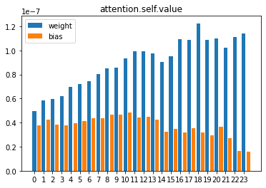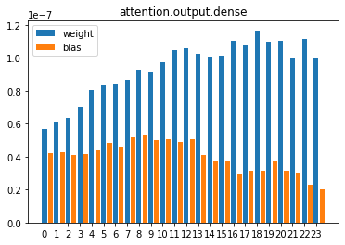

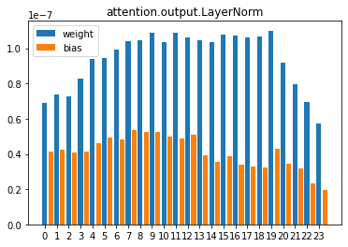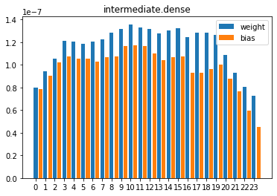

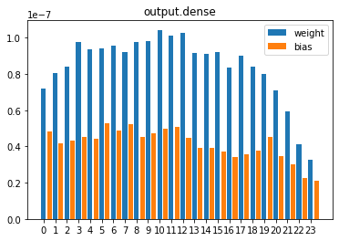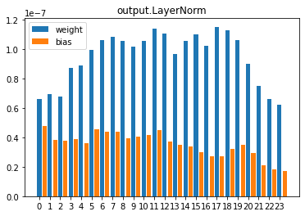

2. Test Metrics
DISCLAIMER: The classes 0 and 1 refer to the index of the logits in the logit-pair put out by the model. 0 refers therefore to TRUE. 1 refers to FALSE.

2.1. Cloze Test (Unmodified)

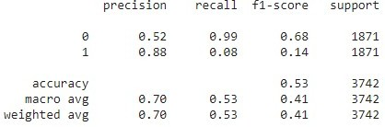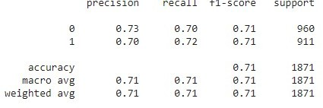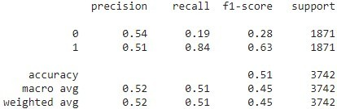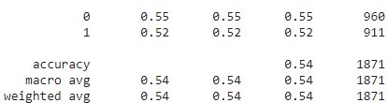
Model
Mode
Default
Choice
BERT
Binary
Choice
RocOnly
Binary

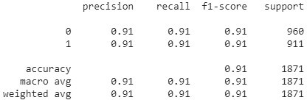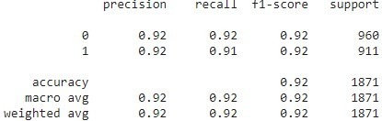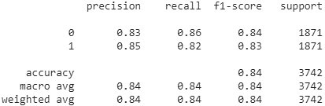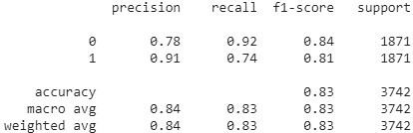
Model
Mode
Default
Choice
ClozeOnly
Binary
Choice
Cloze+5000Roc
Binary

2.2. Hypothesis-Only

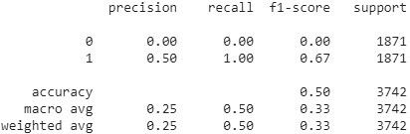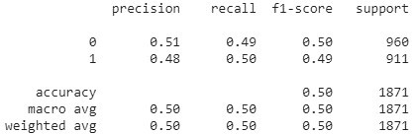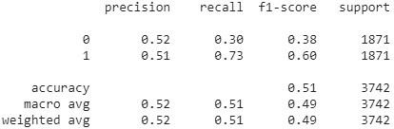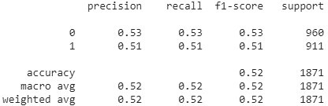
Model
Mode
Hypothesis-Only
Choice
BERT
Binary
Choice
RocOnly
Binary

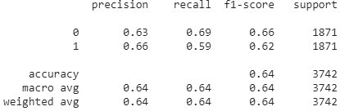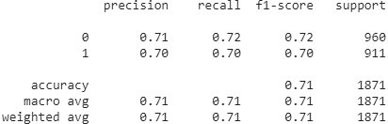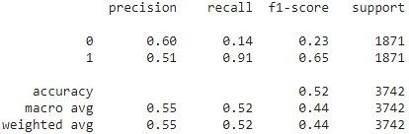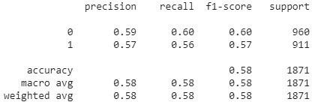
Model
Mode
Hypothesis-Only
Choice
ClozeOnly
Binary
Choice
Cloze+5000Roc
Binary

1.3. Noise Induced Stories

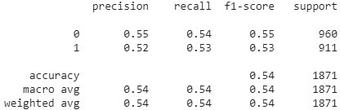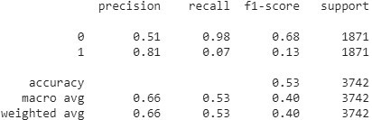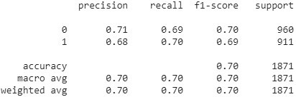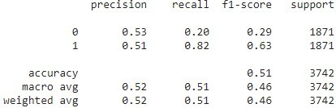
Model
Mode
NoiseInduced
Choice
BERT
Binary
Choice
RocOnly
Binary

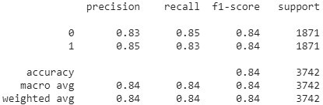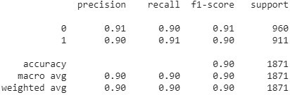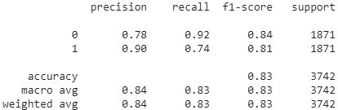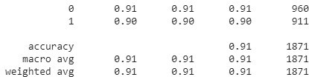
Model
Mode
NoiseInduced
Choice
ClozeOnly
Binary
Choice
Cloze+5000Roc
Binary

2.4. Negated Stories

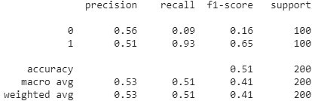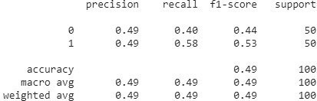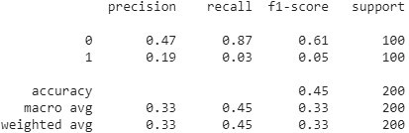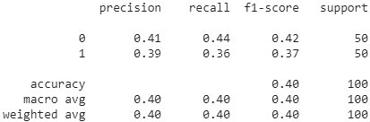
Model
Mode
Negated
Choice
BERT
Binary
Choice
RocOnly
Binary

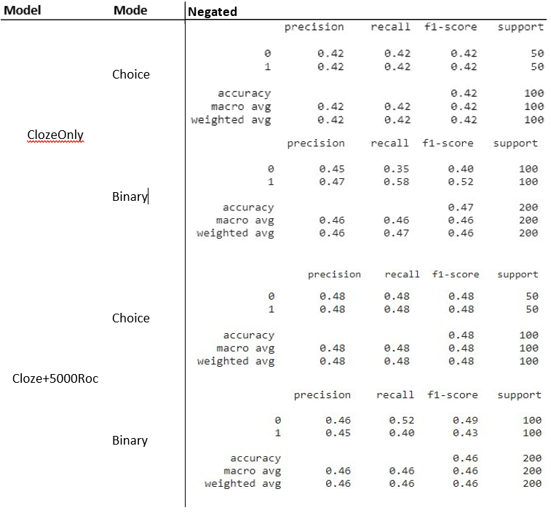

2.5. Stories Containing Trigger Words

Model Mode | TriggerOnly
 |  | precision | recall | f1-score | support
 | 0 | 0.62 | 0.55 | 0.58 | 96
Choice | 1 | 0.51 | 0.58 | 0.54 | 78
 | accuracy |  |  | 0.56 | 174
 | macro avg | 0.56 | 0.56 | 0.56 | 174
BERT | weighted avg | 0.57 | 0.56 | 0.56 | 174
 |  | precision | recall | f1-score | support
 | 0 | 0.53 | 0.16 | 0.24 | 174
Binary | 1 | 0.51 | 0.86 | 0.64 | 174
 | accuracy |  |  | 0.51 | 348
 | macro avg | 0.52 | 0.51 | 0.44 | 348
 | weighted avg | 0.52 | 0.51 | 0.44 | 348
 |  | precision | recall | f1-score | support
 | 0 | 0.80 | 0.70 | 0.74 | 96
Choice | 1 | 0.68 | 0.78 | 0.73 | 78
 | accuracy |  |  | 0.74 | 174
 | macro avg | 0.74 | 0.74 | 0.74 | 174
RocOnly | weighted avg | 0.74 | 0.74 | 0.74 | 174
 |  | precision | recall | f1-score | support
 | 0 | 0.53 | 0.99 | 0.69 | 174
Binary | 1 | 0.95 | 0.12 | 0.21 | 174
 | accuracy |  |  | 0.56 | 348
 | macro avg | 0.74 | 0.56 | 0.45 | 348
 | weighted avg | 0.74 | 0.56 | 0.45 | 348

Model Mode | TriggerOnly
 |  | precision | recall | f1-score | support
 | 0 | 0.94 | 0.94 | 0.94 | 96
Choice | 1 | 0.92 | 0.92 | 0.92 | 78
 | accuracy |  |  | 0.93 | 174
 | macro avg | 0.93 | 0.93 | 0.93 | 174
ClozeOnly | weighted avg | 0.93 | 0.93 | 0.93 | 174
 |  | precision | recall | f1-score | support
 | 0 | 0.80 | 0.89 | 0.84 | 174
Binary | 1 | 0.88 | 0.78 | 0.82 | 174
 | accuracy |  |  | 0.83 | 348
 | macro avg | 0.84 | 0.83 | 0.83 | 348
 | weighted avg | 0.84 | 0.83 | 0.83 | 348
 |  | precision | recall | f1-score | support
 | 0 | 0.96 | 0.95 | 0.95 | 96
Choice | 1 | 0.94 | 0.95 | 0.94 | 78
 | accuracy |  |  | 0.95 | 174
 | macro avg | 0.95 | 0.95 | 0.95 | 174
Cloze+5000Roc | weighted avg | 0.95 | 0.95 | 0.95 | 174
 |  | precision | recall | f1-score | support
 | 0 | 0.78 | 0.93 | 0.85 | 174
Binary | 1 | 0.91 | 0.74 | 0.81 | 174
 | accuracy |  |  | 0.83 | 348
 | macro avg | 0.84 | 0.83 | 0.83 | 348
 | weighted avg | 0.84 | 0.83 | 0.83 | 348

2.6. Stories Containing Trigger Words – Triggers Removed

Mode | TriggerRemoved
 |  | precision | recall | f1-score | support
 | 0 | 0.64 | 0.60 | 0.62 | 96
Choice | 1 | 0.54 | 0.58 | 0.56 | 78
 | accuracy |  |  | 0.59 | 174
 | macro avg | 0.59 | 0.59 | 0.59 | 174
 | weighted avg | 0.59 | 0.59 | 0.59 | 174
 |  | precision | recall | f1-score | support
 | 0 | 0.61 | 0.17 | 0.27 | 174
Binary | 1 | 0.52 | 0.89 | 0.66 | 174
 | accuracy |  |  | 0.53 | 348
 | macro avg | 0.57 | 0.53 | 0.46 | 348
 | weighted avg | 0.57 | 0.53 | 0.46 | 348
 |  | precision | recall | f1-score | support
 | 0 | 0.79 | 0.71 | 0.75 | 96
Choice | 1 | 0.68 | 0.77 | 0.72 | 78
 | accuracy |  |  | 0.74 | 174
 | macro avg | 0.74 | 0.74 | 0.74 | 174
 | weighted avg | 0.74 | 0.74 | 0.74 | 174
 |  | precision | recall | f1-score | support
 | 0 | 0.53 | 0.99 | 0.69 | 174
Binary | 1 | 0.91 | 0.11 | 0.20 | 174
 | accuracy |  |  | 0.55 | 348
 | macro avg | 0.72 | 0.55 | 0.45 | 348
 | weighted avg | 0.72 | 0.55 | 0.45 | 348

BERT

RocOnly

Mode | TriggerRemoved
 |  | precision | recall | f1-score | support
 | 0 | 0.94 | 0.92 | 0.93 | 96
Choice | 1 | 0.90 | 0.92 | 0.91 | 78
 | accuracy |  |  | 0.92 | 174
 | macro avg | 0.92 | 0.92 | 0.92 | 174
 | weighted avg | 0.92 | 0.92 | 0.92 | 174
 |  | precision | recall | f1-score | support
 | 0 | 0.79 | 0.82 | 0.81 | 174
Binary | 1 | 0.82 | 0.79 | 0.80 | 174
 | accuracy |  |  | 0.80 | 348
 | macro avg | 0.80 | 0.80 | 0.80 | 348
 | weighted avg | 0.80 | 0.80 | 0.80 | 348
 |  | precision | recall | f1-score | support
 | 0 | 0.96 | 0.90 | 0.92 | 96
Choice | 1 | 0.88 | 0.95 | 0.91 | 78
 | accuracy |  |  | 0.92 | 174
 | macro avg | 0.92 | 0.92 | 0.92 | 174
 | weighted avg | 0.92 | 0.92 | 0.92 | 174
 |  | precision | recall | f1-score | support
 | 0 | 0.80 | 0.90 | 0.85 | 174
Binary | 1 | 0.88 | 0.78 | 0.83 | 174
 | accuracy |  |  | 0.84 | 348
 | macro avg | 0.84 | 0.84 | 0.84 | 348
 | weighted avg | 0.84 | 0.84 | 0.84 | 348

Model

ClozeOnly

Cloze+5000Roc

2.7. Stories Containing Trigger Words – Trigger Synonymized

Model
Mode | TriggerSynonymized
 |  | precision | recall | f1-score | support
 | 0 | 0.63 | 0.56 | 0.59 | 96
Choice | 1 | 0.52 | 0.59 | 0.55 | 78
 | accuracy |  |  | 0.57 | 174
 | macro avg | 0.58 | 0.58 | 0.57 | 174
 | weighted avg | 0.58 | 0.57 | 0.58 | 174
 |  | precision | recall | f1-score | support
 | 0 | 0.57 | 0.16 | 0.24 | 174
Binary | 1 | 0.51 | 0.89 | 0.65 | 174
 | accuracy |  |  | 0.52 | 348
 | macro avg | 0.54 | 0.52 | 0.45 | 348
 | weighted avg | 0.54 | 0.52 | 0.45 | 348
 |  | precision | recall | f1-score | support
 | 0 | 0.79 | 0.72 | 0.75 | 96
Choice | 1 | 0.69 | 0.77 | 0.73 | 78
 | accuracy |  |  | 0.74 | 174
 | macro avg | 0.74 | 0.74 | 0.74 | 174
 | weighted avg | 0.75 | 0.74 | 0.74 | 174
 |  | precision | recall | f1-score | support
 | 0 | 0.53 | 0.99 | 0.69 | 174
Binary | 1 | 0.95 | 0.12 | 0.21 | 174
 | accuracy |  |  | 0.56 | 348
 | macro avg | 0.74 | 0.56 | 0.45 | 348
 | weighted avg | 0.74 | 0.56 | 0.45 | 348

BERT

RocOnly

Model
Mode | TriggerSynonymized
 |  | precision | recall | f1-score | support
 | 0 | 0.94 | 0.93 | 0.93 | 96
Choice | 1 | 0.91 | 0.92 | 0.92 | 78
 | accuracy |  |  | 0.93 | 174
 | macro avg | 0.92 | 0.93 | 0.92 | 174
 | weighted avg | 0.93 | 0.93 | 0.93 | 174
 |  | precision | recall | f1-score | support
 | 0 | 0.80 | 0.87 | 0.83 | 174
Binary | 1 | 0.86 | 0.79 | 0.82 | 174
 | accuracy |  |  | 0.83 | 348
 | macro avg | 0.83 | 0.83 | 0.83 | 348
 | weighted avg | 0.83 | 0.83 | 0.83 | 348
 |  | precision | recall | f1-score | support
 | 0 | 0.97 | 0.93 | 0.95 | 96
Choice | 1 | 0.91 | 0.96 | 0.94 | 78
 | accuracy |  |  | 0.94 | 174
 | macro avg | 0.94 | 0.94 | 0.94 | 174
 | weighted avg | 0.94 | 0.94 | 0.94 | 174
 |  | precision | recall | f1-score | support
 | 0 | 0.78 | 0.93 | 0.85 | 174
Binary | 1 | 0.91 | 0.74 | 0.81 | 174
 | accuracy |  |  | 0.83 | 348
 | macro avg | 0.84 | 0.83 | 0.83 | 348
 | weighted avg | 0.84 | 0.83 | 0.83 | 348

ClozeOnly

Cloze+5000Roc

2.8. Stories Translated

2.8.1 English - Hungarian - Slovenian - English.

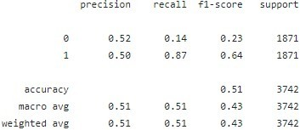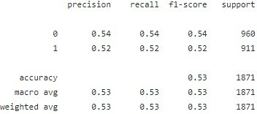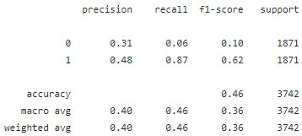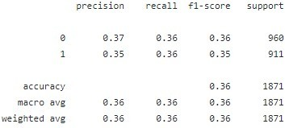
precision recall f1-score support

0 0.52 0.95 0.67 1871
1 0.71 0.12 0.21 1871

accuracy 0.54 3742
macro avg 0.61 0.54 0.44 3742
weighted avg 0.61 0.54 0.44 3742
precision recall f1-score support

0 0.68 0.66 0.67 960
1 0.66 0.67 0.66 911

accuracy 0.67 1871
macro avg 0.67 0.67 0.67 1871
weighted avg 0.67 0.67 0.67 1871

Model
Mode
Translated
Choice
BERT
Binary
Choice
RocOnly
Binary

2.8.1 English - Hungarian - Slovenian - English.

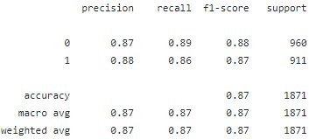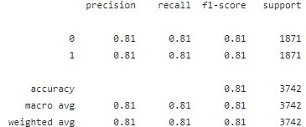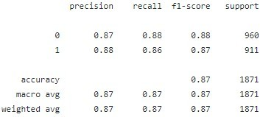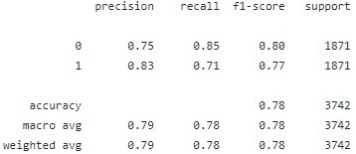
Model
Mode
Translated
Choice
ClozeOnly
Binary
Choice
Cloze+5000Roc
Binary

2.8.1 Mixed Paraphrased

precision recall f1-score support

0 0.52 0.89 0.66 1871
1 0.61 0.17 0.26 1871

accuracy 0.53 3742
macro avg 0.56 0.53 0.46 3742
weighted avg 0.56 0.53 0.46 3742
precision recall f1-score support

0 0.65 0.64 0.64 960
1 0.63 0.63 0.63 911

accuracy 0.64 1871
macro avg 0.64 0.64 0.64 1871
weighted avg 0.64 0.64 0.64 1871
precision recall f1-score support

0 0.50 0.11 0.18 1871
1 0.50 0.89 0.64 1871

accuracy 0.50 3742
macro avg 0.50 0.50 0.41 3742
weighted avg 0.50 0.50 0.41 3742
precision recall f1-score support

0 0.53 0.51 0.52 960
1 0.50 0.52 0.51 911

accuracy 0.51 1871
macro avg 0.51 0.51 0.51 1871
weighted avg 0.51 0.51 0.51 1871
Model
Mode
Translated
Choice
BERT
Binary
Choice
RocOnly
Binary

precision recall f1-score support

0 0.73 0.78 0.76 1871
1 0.77 0.71 0.74 1871

accuracy 0.75 3742
macro avg 0.75 0.75 0.75 3742
weighted avg 0.75 0.75 0.75 3742
precision recall f1-score support

0 0.82 0.85 0.84 960
1 0.83 0.81 0.82 911

accuracy 0.83 1871
macro avg 0.83 0.83 0.83 1871
weighted avg 0.83 0.83 0.83 1871

precision recall f1-score support

0 0.79 0.74 0.76 1871
1 0.75 0.81 0.78 1871

accuracy 0.77 3742
macro avg 0.77 0.77 0.77 3742
weighted avg 0.77 0.77 0.77 3742

precision recall f1-score support

0 0.84 0.87 0.85 960
1 0.85 0.83 0.84 911

accuracy 0.85 1871
macro avg 0.85 0.85 0.85 1871
weighted avg 0.85 0.85 0.85 1871
Model
Mode
Translated
Choice
ClozeOnly
Binary
Choice
Cloze+5000Roc
Binary

2.9. Super Hard Test Set

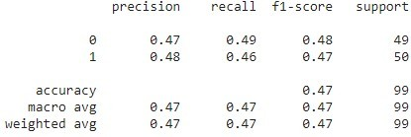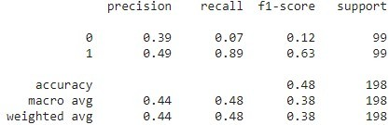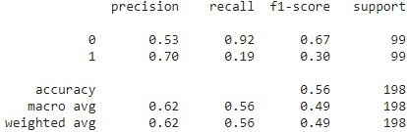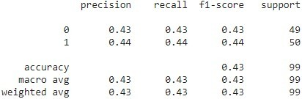
Model
Mode
Super Hard Testset
Choice
BERT
Binary
Choice
RocOnly
Binary

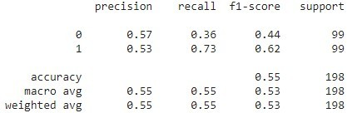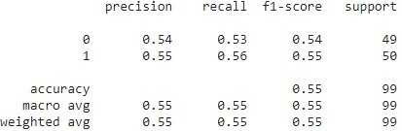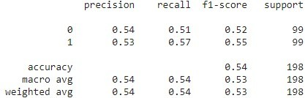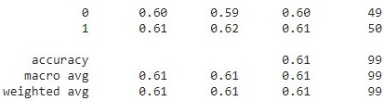
Model
Mode
Super Hard Testset
Choice
ClozeOnly
Binary
Choice
Cloze+5000Roc
Binary

2.10. Cloze-Test (Unmodified), Short

This test set comprises the same stories as the negated test set and the super hard test set.

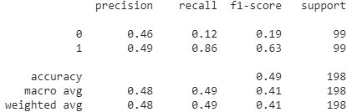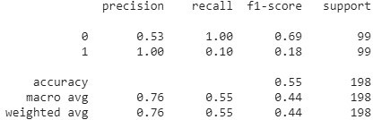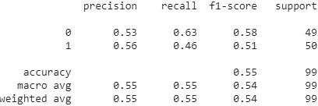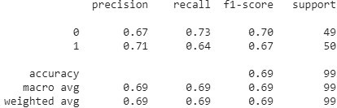
Model
Mode
Default (first 100 stories only)
Choice
BERT
Binary
Choice
RocOnly
Binary

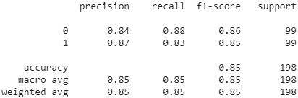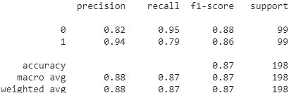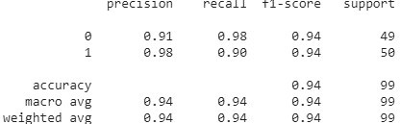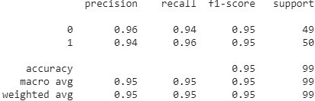
Model
Mode
Default (first 100 stories only)
Choice
ClozeOnly
Binary
Choice
Cloze+5000Roc
Binary

3. Salience Maps
DISCLAIMER: The stories listed for each point are either exhaustive or sampled randomly. All saliency maps are based on the loss calculated in the binary test setup. The tokens marked red indicate “contribution” to the predicted class, the tokens marked blue indicate “contribution” to the not predicted class.

3.1. Inducing Noise
Each randomly sampled story shows the saliencies assigned to it by BERT, ROC model, CLOZE model, and MIXED model. For each model, two stories are shown: The first is the default story, the second one the story induced with noise.

3.1.1 Sample 1

BERT:
Predicted Label: 1
[CLS] my sister in law dropped off some baked chicken. the dish looked very appealing. my wife heated the dish up. we ate the chicken but found it to be very bland. [SEP] we agreed that it was the best meal we had ever eaten. [SEP]
True Label: 1
Predicted Label: 1
[CLS] my sister in law dropped off some baked chicken. last wednesday the dish looked very appealing. furthermore, my wife heated the dish up. indeed, we ate the chicken but found it to be very bland. [SEP] we agreed that it was the best meal we had ever eaten. [SEP]
ROC Model:
True Label: 1
Predicted Label: 0
[CLS] my sister in law dropped off some baked chicken. the dish looked very appealing. my wife heated the dish up. we ate the chicken but found it to be very bland. [SEP] we agreed that it was the best meal we had ever eaten. [SEP]
True Label: 1
Predicted Label: 0
[CLS] my sister in law dropped off some baked chicken. last wednesday the dish looked very appealing. furthermore, my wife heated the dish up. indeed, we ate the chicken but found it to be very bland. [SEP] we agreed that it was the best meal we had ever eaten. [SEP]
CLOZE Model:
True Label: 1
Predicted Label: 1
[CLS] my sister in law dropped off some baked chicken. the dish looked very appealing. my wife heated the dish up. we ate the chicken but found it to be very bland. [SEP] we agreed that it was the best meal we had ever eaten. [SEP]
True Label: 1
Predicted Label: 1
[CLS] my sister in law dropped off some baked chicken. last wednesday the dish looked very appealing. furthermore, my wife heated the dish up. indeed, we ate the chicken but found it to be very bland. [SEP] we agreed that it was the best meal we had ever eaten. [SEP]
MIXED Model:
True Label: 1
Predicted Label: 1
[CLS] my sister in law dropped off some baked chicken. the dish looked very appealing. my wife heated the dish up. we ate the chicken but found it to be very bland. [SEP] we agreed that it was the best meal we had ever eaten. [SEP]
True Label: 1
Predicted Label: 1
[CLS] my sister in law dropped off some baked chicken. last wednesday the dish looked very appealing. furthermore, my wife heated the dish up. indeed, we ate the chicken but found it to be very bland. [SEP] we agreed that it was the best meal we had ever eaten. [SEP]

3.1.2 Sample 2

BERT:
True Label: 0
Predicted Label: 1
[CLS] amy awoke in her dark room. she had fallen asleep waiting on dinner. that was 4 hours ago. she went to see if her family had eaten. [SEP] amy found out that dinner had been finished for hours. [SEP]
True Label: 0
Predicted Label: 1
[CLS] last winter amy awoke in her dark room. in ettenstatt, she had fallen asleep waiting on dinner. however, that was 4 hours ago. hence she went to see if her family had eaten. [SEP] amy found out that dinner had been finished for hours. [SEP]
ROC Model:
True Label: 0
Predicted Label: 0
[CLS] amy awoke in her dark room. she had fallen asleep waiting on dinner. that was 4 hours ago. she went to see if her family had eaten. [SEP] amy found out that dinner had been finished for hours. [SEP]
True Label: 0
Predicted Label: 0
[CLS] last winter amy awoke in her dark room. in ettenstatt, she had fallen asleep waiting on dinner. however, that was 4 hours ago. hence she went to see if her family had eaten. [SEP] amy found out that dinner had been finished for hours. [SEP]
CLOZE Model:
True Label: 0
Predicted Label: 0
[CLS] amy awoke in her dark room. she had fallen asleep waiting on dinner. that was 4 hours ago. she went to see if her family had eaten. [SEP] amy found out that dinner had been finished for hours. [SEP]
True Label: 0
Predicted Label: 1
[CLS] last winter amy awoke in her dark room. in ettenstatt, she had fallen asleep waiting on dinner. however, that was 4 hours ago. hence she went to see if her family had eaten. [SEP] amy found out that dinner had been finished for hours. [SEP]
MIXED Model:
True Label: 0
Predicted Label: 0
[CLS] amy awoke in her dark room. she had fallen asleep waiting on dinner. that was 4 hours ago. she went to see if her family had eaten. [SEP] amy found out that dinner had been finished for hours. [SEP]
True Label: 0
Predicted Label: 1
[CLS] last winter amy awoke in her dark room. in ettenstatt, she had fallen asleep waiting on dinner. however, that was 4 hours ago. hence she went to see if her family had eaten. [SEP] amy found out that dinner had been finished for hours. [SEP]

3.1.3 Sample 3

BERT:
True Label: 0
Predicted Label: 1
[CLS] georgia was carving a pumpkin. first she put it on the table, on top of some newspaper. then, she cut the top off and scraped out all of the seeds. finally, she used a large knife to carve a face in the pumpkin. [SEP] georgia made a great looking pumpkin when she finished. [SEP]
True Label: 0
Predicted Label: 1
[CLS] last summer georgia was carving a pumpkin. anyway, first she put it on the table, on top of some newspaper. in santopadre, then, she cut the top off and scraped out all of the seeds. finally, finally, she used a large knife to carve a face in the pumpkin. [SEP] georgia made a great looking pumpkin when she finished. [SEP]
ROC Model:
True Label: 0
Predicted Label: 0
[CLS] georgia was carving a pumpkin. first she put it on the table, on top of some newspaper. then, she cut the top off and scraped out all of the seeds. finally, she used a large knife to carve a face in the pumpkin. [SEP] georgia made a great looking pumpkin when she finished. [SEP]
True Label: 0
Predicted Label: 0
[CLS] last summer georgia was carving a pumpkin. anyway, first she put it on the table, on top of some newspaper. in santopadre, then, she cut the top off and scraped out all of the seeds. finally, finally, she used a large knife to carve a face in the pumpkin. [SEP] georgia made a great looking pumpkin when she finished. [SEP]
CLOZE Model:
True Label: 0
Predicted Label: 0
[CLS] georgia was carving a pumpkin. first she put it on the table, on top of some newspaper. then, she cut the top off and scraped out all of the seeds. finally, she used a large knife to carve a face in the pumpkin. [SEP] georgia made a great looking pumpkin when she finished. [SEP]
True Label: 0
Predicted Label: 0
[CLS] last summer georgia was carving a pumpkin. anyway, first she put it on the table, on top of some newspaper. in santopadre, then, she cut the top off and scraped out all of the seeds. finally, finally, she used a large knife to carve a face in the pumpkin. [SEP] georgia made a great looking pumpkin when she finished. [SEP]
MIXED Model:
True Label: 0
Predicted Label: 0
[CLS] georgia was carving a pumpkin. first she put it on the table, on top of some newspaper. then, she cut the top off and scraped out all of the seeds. finally, she used a large knife to carve a face in the pumpkin. [SEP] georgia made a great looking pumpkin when she finished. [SEP]
True Label: 0
Predicted Label: 0
[CLS] last summer georgia was carving a pumpkin. anyway, first she put it on the table, on top of some newspaper. in santopadre, then, she cut the top off and scraped out all of the seeds. finally, finally, she used a large knife to carve a face in the pumpkin. [SEP] georgia made a great looking pumpkin when she finished. [SEP]

3.1.4 Sample 4

BERT:
True Label: 1
Predicted Label: 1
[CLS] bev was cleaning out her childhood bedroom. her parents were moving after 25 years in the same house. she came across her diary from 7th grade. she smiled as she read the thoughts of her younger self. [SEP] bev was upset her parents threw away her diary. [SEP]
True Label: 1
Predicted Label: 0
[CLS] in xingping, bev was cleaning out her childhood bedroom. indeed, her parents were moving after 25 years in the same house. thus, she came across her diary from 7th grade. well, she smiled as she read the thoughts of her younger self. [SEP] bev was upset her parents threw away her diary. [SEP]
ROC Model:
True Label: 1
Predicted Label: 0
[CLS] bev was cleaning out her childhood bedroom. her parents were moving after 25 years in the same house. she came across her diary from 7th grade. she smiled as she read the thoughts of her younger self. [SEP] bev was upset her parents threw away her diary. [SEP]
True Label: 1
Predicted Label: 0
[CLS] in xingping, bev was cleaning out her childhood bedroom. indeed, her parents were moving after 25 years in the same house. thus, she came across her diary from 7th grade. well, she smiled as she read the thoughts of her younger self. [SEP] bev was upset her parents threw away her diary. [SEP]
CLOZE Model:
True Label: 1
Predicted Label: 1
[CLS] bev was cleaning out her childhood bedroom. her parents were moving after 25 years in the same house. she came across her diary from 7th grade. she smiled as she read the thoughts of her younger self. [SEP] bev was upset her parents threw away her diary. [SEP]
True Label: 1
Predicted Label: 1
[CLS] in xingping, bev was cleaning out her childhood bedroom. indeed, her parents were moving after 25 years in the same house. thus, she came across her diary from 7th grade. well, she smiled as she read the thoughts of her younger self. [SEP] bev was upset her parents threw away her diary. [SEP]
MIXED Model:
True Label: 1
Predicted Label: 1
[CLS] bev was cleaning out her childhood bedroom. her parents were moving after 25 years in the same house. she came across her diary from 7th grade. she smiled as she read the thoughts of her younger self. [SEP] bev was upset her parents threw away her diary. [SEP]
True Label: 1
Predicted Label: 1
[CLS] in xingping, bev was cleaning out her childhood bedroom. indeed, her parents were moving after 25 years in the same house. thus, she came across her diary from 7th grade. well, she smiled as she read the thoughts of her younger self. [SEP] bev was upset her parents threw away her diary. [SEP]

3.1.5 Sample 5

BERT:
True Label: 0
Predicted Label: 0
[CLS] sam was an exceptional ice skater. one day, sam decided to try hockey. he and his friend practiced together every chance they could. they went to tryouts and did their best. [SEP] sam and his friend scored a goal. [SEP]
True Label: 0
Predicted Label: 0
[CLS] last winter sam was an exceptional ice skater. in fairview shores, one day, sam decided to try hockey. now, he and his friend practiced together every chance they could. thereafter, they went to tryouts and did their best. [SEP] sam and his friend scored a goal. [SEP]
ROC Model:
True Label: 0
Predicted Label: 0
[CLS] sam was an exceptional ice skater. one day, sam decided to try hockey. he and his friend practiced together every chance they could. they went to tryouts and did their best. [SEP] sam and his friend scored a goal. [SEP]
True Label: 0
Predicted Label: 0
[CLS] last winter sam was an exceptional ice skater. in fairview shores, one day, sam decided to try hockey. now, he and his friend practiced together every chance they could. thereafter, they went to tryouts and did their best. [SEP] sam and his friend scored a goal. [SEP]
CLOZE Model:
True Label: 0
Predicted Label: 0
[CLS] sam was an exceptional ice skater. one day, sam decided to try hockey. he and his friend practiced together every chance they could. they went to tryouts and did their best. [SEP] sam and his friend scored a goal. [SEP]
True Label: 0
Predicted Label: 0
[CLS] last winter sam was an exceptional ice skater. in fairview shores, one day, sam decided to try hockey. now, he and his friend practiced together every chance they could. thereafter, they went to tryouts and did their best. [SEP] sam and his friend scored a goal. [SEP]
MIXED Model:
True Label: 0
Predicted Label: 0
[CLS] sam was an exceptional ice skater. one day, sam decided to try hockey. he and his friend practiced together every chance they could. they went to tryouts and did their best. [SEP] sam and his friend scored a goal. [SEP]
True Label: 0
Predicted Label: 0
[CLS] last winter sam was an exceptional ice skater. in fairview shores, one day, sam decided to try hockey. now, he and his friend practiced together every chance they could. thereafter, they went to tryouts and did their best. [SEP] sam and his friend scored a goal. [SEP]

3.2. Trigger Words

In the following document, saliency mappings of tokens for one sentence for each trigger word is shown. For each trained model, the mapping for each trigger word is done for the original sentence (with triggers), the sentence with triggers removed and the sentence with triggers changed to a synonym (triggers synonymized). Additionally, the actual label (label) and the label predicted by the model (prediction) is shown. The labelling for Huggingface transformers is used. As a result, “0” means the ending is true and “1” means the ending is false.

3.2.1. ROC model
sentences with instead:
with triggers label:0 prediction:0 [CLS] aaron ' s girlfriend asked him to come over for dinner . she said she was making his favorite , chicken alfredo . aaron was very excited she wanted to cook , but he hated alfredo . she must have mixed up his words when he told her his least favorite . [SEP] aaron suggested he help her cook another meal instead . [SEP]
triggers removed label:0 prediction:0 [CLS] aaron ' s girlfriend asked him to come over for dinner . she said she was making his favorite , chicken alfredo . aaron was very excited she wanted to cook , but he hated alfredo . she must have mixed up his words when he told her his least favorite . [SEP] aaron suggested he help her cook another meal . [SEP]
triggers synonymized label:0 prediction:0 [CLS] aaron ' s girlfriend asked him to come over for dinner . she said she was making his favorite , chicken alfredo . aaron was very excited she wanted to cook , but he hated alfredo . she must have mixed up his words when he told her his least favorite . [SEP] aaron suggested he help her cook another meal alternatively . [SEP]
sentences with ever:
with triggers label:1 prediction:0 [CLS] ed wanted to make homemade juice for his family . he bought a bag of orange ##s and juice ##d them . then he chilled the juice overnight . in the morning , he served it to his family . [SEP] it was the best apple juice that they had ever had . [SEP]
triggers removed label:1 prediction:0 [CLS] ed wanted to make homemade juice for his family . he bought a bag of orange ##s and juice ##d them . then he chilled the juice overnight . in the morning , he served it to his family . [SEP] it was the best apple juice that they had had . [SEP]
triggers synonymized label:1 prediction:0 [CLS] ed wanted to make homemade juice for his family . he bought a bag of orange ##s and juice ##d them . then he chilled the juice overnight . in the morning , he served it to his family . [SEP] it was the best apple juice that they had at any point had . [SEP]
sentences with anymore:
with triggers label:1 prediction:0 [CLS] pam was in love with josh but she didn ' t know how to get his attention . she talked to her friends , and she talked to her parents . they all offered advice that didn ' t quite work for her . finally , she just went up to him and told him her feelings . [SEP] pam ' s friends won ' t talk to her anymore . [SEP]
triggers removed label:1 prediction:0 [CLS] pam was in love with josh but she didn ' t know how to get his attention . she talked to her friends , and she talked to her parents . they all offered advice that didn ' t quite work for her . finally , she just went up to him and told him her feelings . [SEP] pam ' s friends won ' t talk to her . [SEP]
triggers synonymized label:1 prediction:0 [CLS] pam was in love with josh but she didn ' t know how to get his attention . she talked to her friends , and she talked to her parents . they all offered advice that didn ' t quite work for her . finally , she just went up to him and told him her feelings . [SEP] pam ' s friends won ' t talk to her any further . [SEP]
sentences with too:
with triggers label:0 prediction:0 [CLS] jeff just got engaged to his girlfriend ashley ! they are very happy and started planning the wedding right away . within hours they realized how expensive everything is going to be . jeff decided to get a part time job to pay for all of this . [SEP] ashley got a part time job too . [SEP]
triggers removed label:0 prediction:0 [CLS] jeff just got engaged to his girlfriend ashley ! they are very happy and started planning the wedding right away . within hours they realized how expensive everything is going to be . jeff decided to get a part time job to pay for all of this . [SEP] ashley got a part time job . [SEP]
triggers synonymized label:0 prediction:0 [CLS] jeff just got engaged to his girlfriend ashley ! they are very happy and started planning the wedding right away . within hours they realized how expensive everything is going to be . jeff decided to get a part time job to pay for all of this . [SEP] ashley got a part time job as well . [SEP]
sentences with eventually:
with triggers label:0 prediction:0 [CLS] my friend got me a plant ##er as a house ##war ##ming gift . it ' s small and cute and fits in nicely with my decor . but i ' m still not sure where to put it . i hope he doesn ' t get sad . [SEP] i ' m sure i ' ll figure out a place for it eventually . [SEP]
triggers removed label:0 prediction:0 [CLS] my friend got me a plant ##er as a house ##war ##ming gift . it ' s small and cute and fits in nicely with my decor . but i ' m still not sure where to put it . i hope he doesn ' t get sad . [SEP] i ' m sure i ' ll figure out a place for it . [SEP]
triggers synonymized label:0 prediction:0 [CLS] my friend got me a plant ##er as a house ##war ##ming gift . it ' s small and cute and fits in nicely with my decor . but i ' m still not sure where to put it . i hope he doesn ' t get sad . [SEP] i ' m sure i ' ll figure out a place for it ultimately . [SEP]
sentences with immediately:
with triggers label:1 prediction:0 [CLS] a company came to give a quote on windows . they walked around and measured all the windows . they then sat us down and went over their products . all the options looked great . [SEP] we were so angry we sent them away immediately . [SEP]
triggers removed label:1 prediction:0 [CLS] a company came to give a quote on windows . they walked around and measured all the windows . they then sat us down and went over their products . all the options looked great . [SEP] we were so angry we sent them away . [SEP]
triggers synonymized label:1 prediction:0 [CLS] a company came to give a quote on windows . they walked around and measured all the windows . they then sat us down and went over their products . all the options looked great . [SEP] we were so angry we sent them away instantly . [SEP]
sentences with anyway:
with triggers label:0 prediction:0 [CLS] my roommate is from germany . he is a very good cook . one day , he made some sausage for me that he ate back home in germany . the sausage turned out poorly , according to him . [SEP] i loved them anyway . [SEP]
triggers removed label:0 prediction:0 [CLS] my roommate is from germany . he is a very good cook . one day , he made some sausage for me that he ate back home in germany . the sausage turned out poorly , according to him . [SEP] i loved them . [SEP]
triggers synonymized label:0 prediction:0 [CLS] my roommate is from germany . he is a very good cook . one day , he made some sausage for me that he ate back home in germany . the sausage turned out poorly , according to him . [SEP] i loved them any ##how . [SEP]
sentences with soon:
with triggers label:0 prediction:0 [CLS] jean was delighted to receive a pet an ##ole for her birthday . this was the first pet her mother had ever let her have . the next day , there was a white egg in the cage ! jean waited with anticipation , hoping the egg would hatch . [SEP] soon , jean had two pet an ##oles . [SEP]
triggers removed label:0 prediction:0 [CLS] jean was delighted to receive a pet an ##ole for her birthday . this was the first pet her mother had ever let her have . the next day , there was a white egg in the cage ! jean waited with anticipation , hoping the egg would hatch . [SEP] jean had two pet an ##oles . [SEP]
triggers synonymized label:0 prediction:0 [CLS] jean was delighted to receive a pet an ##ole for her birthday . this was the first pet her mother had ever let her have . the next day , there was a white egg in the cage ! jean waited with anticipation , hoping the egg would hatch . [SEP] shortly , jean had two pet an ##oles . [SEP]
sentences with later:
with triggers label:0 prediction:0 [CLS] james woke up and was in a bad mood immediately . he went too fix breakfast and burnt his toast . then went to get dressed and couldn ' t find any socks . james decided it was a bad day and he was going back to bed . [SEP] james woke up later and felt much better . [SEP]
triggers removed label:0 prediction:0 [CLS] james woke up and was in a bad mood immediately . he went too fix breakfast and burnt his toast . then went to get dressed and couldn ' t find any socks . james decided it was a bad day and he was going back to bed . [SEP] james woke up and felt much better . [SEP]
triggers synonymized label:0 prediction:0 [CLS] james woke up and was in a bad mood immediately . he went too fix breakfast and burnt his toast . then went to get dressed and couldn ' t find any socks . james decided it was a bad day and he was going back to bed . [SEP] james woke up afterwards and felt much better . [SEP]
sentences with now:
with triggers label:0 prediction:0 [CLS] samantha had recently purchased a used car . she loved everything about the car except for the color . she took her car to her local paint shop . she got it painted a bright pink color . [SEP] samantha likes the color of her car now . [SEP]
triggers removed label:0 prediction:0 [CLS] samantha had recently purchased a used car . she loved everything about the car except for the color . she took her car to her local paint shop . she got it painted a bright pink color . [SEP] samantha likes the color of her car . [SEP]
triggers synonymized label:0 prediction:0 [CLS] samantha had recently purchased a used car . she loved everything about the car except for the color . she took her car to her local paint shop . she got it painted a bright pink color . [SEP] samantha likes the color of her car currently . [SEP]
sentences with finally:
with triggers label:0 prediction:0 [CLS] kelly was playing her new mario game . she had been playing it for weeks . she was playing for so long without beating the level . finally she beat the last level . [SEP] kelly was so happy to finally beat it . [SEP]
triggers removed label:0 prediction:0 [CLS] kelly was playing her new mario game . she had been playing it for weeks . she was playing for so long without beating the level . finally she beat the last level . [SEP] kelly was so happy to beat it . [SEP]
triggers synonymized label:0 prediction:0 [CLS] kelly was playing her new mario game . she had been playing it for weeks . she was playing for so long without beating the level . finally she beat the last level . [SEP] kelly was so happy to at last beat it . [SEP]

3.2.2. CLOZE model
sentences with instead:
with triggers label:0 prediction:0 [CLS] aaron ' s girlfriend asked him to come over for dinner . she said she was making his favorite , chicken alfredo . aaron was very excited she wanted to cook , but he hated alfredo . she must have mixed up his words when he told her his least favorite . [SEP] aaron suggested he help her cook another meal instead . [SEP]
triggers removed label:0 prediction:0 [CLS] aaron ' s girlfriend asked him to come over for dinner . she said she was making his favorite , chicken alfredo . aaron was very excited she wanted to cook , but he hated alfredo . she must have mixed up his words when he told her his least favorite . [SEP] aaron suggested he help her cook another meal . [SEP]
triggers synonymized label:0 prediction:0 [CLS] aaron ' s girlfriend asked him to come over for dinner . she said she was making his favorite , chicken alfredo . aaron was very excited she wanted to cook , but he hated alfredo . she must have mixed up his words when he told her his least favorite . [SEP] aaron suggested he help her cook another meal alternatively . [SEP]
sentences with ever:
with triggers label:1 prediction:1 [CLS] ed wanted to make homemade juice for his family . he bought a bag of orange ##s and juice ##d them . then he chilled the juice overnight . in the morning , he served it to his family . [SEP] it was the best apple juice that they had ever had . [SEP]
triggers removed label:1 prediction:1 [CLS] ed wanted to make homemade juice for his family . he bought a bag of orange ##s and juice ##d them . then he chilled the juice overnight . in the morning , he served it to his family . [SEP] it was the best apple juice that they had had . [SEP]
triggers synonymized label:1 prediction:1 [CLS] ed wanted to make homemade juice for his family . he bought a bag of orange ##s and juice ##d them . then he chilled the juice overnight . in the morning , he served it to his family . [SEP] it was the best apple juice that they had at any point had . [SEP]
sentences with anymore:
with triggers label:1 prediction:1 [CLS] pam was in love with josh but she didn ' t know how to get his attention . she talked to her friends , and she talked to her parents . they all offered advice that didn ' t quite work for her . finally , she just went up to him and told him her feelings . [SEP] pam ' s friends won ' t talk to her anymore . [SEP]
triggers removed label:1 prediction:1 [CLS] pam was in love with josh but she didn ' t know how to get his attention . she talked to her friends , and she talked to her parents . they all offered advice that didn ' t quite work for her . finally , she just went up to him and told him her feelings . [SEP] pam ' s friends won ' t talk to her . [SEP]
triggers synonymized label:1 prediction:1 [CLS] pam was in love with josh but she didn ' t know how to get his attention . she talked to her friends , and she talked to her parents . they all offered advice that didn ' t quite work for her . finally , she just went up to him and told him her feelings . [SEP] pam ' s friends won ' t talk to her any further . [SEP]
sentences with too:
with triggers label:0 prediction:0 [CLS] jeff just got engaged to his girlfriend ashley ! they are very happy and started planning the wedding right away . within hours they realized how expensive everything is going to be . jeff decided to get a part time job to pay for all of this . [SEP] ashley got a part time job too . [SEP]
triggers removed label:0 prediction:0 [CLS] jeff just got engaged to his girlfriend ashley ! they are very happy and started planning the wedding right away . within hours they realized how expensive everything is going to be . jeff decided to get a part time job to pay for all of this . [SEP] ashley got a part time job . [SEP]
triggers synonymized label:0 prediction:0 [CLS] jeff just got engaged to his girlfriend ashley ! they are very happy and started planning the wedding right away . within hours they realized how expensive everything is going to be . jeff decided to get a part time job to pay for all of this . [SEP] ashley got a part time job as well . [SEP]
sentences with eventually:
with triggers label:0 prediction:0 [CLS] my friend got me a plant ##er as a house ##war ##ming gift . it ' s small and cute and fits in nicely with my decor . but i ' m still not sure where to put it . i hope he doesn ' t get sad . [SEP] i ' m sure i ' ll figure out a place for it eventually . [SEP]
triggers removed label:0 prediction:0 [CLS] my friend got me a plant ##er as a house ##war ##ming gift . it ' s small and cute and fits in nicely with my decor . but i ' m still not sure where to put it . i hope he doesn ' t get sad . [SEP] i ' m sure i ' ll figure out a place for it . [SEP]
triggers synonymized label:0 prediction:0 [CLS] my friend got me a plant ##er as a house ##war ##ming gift . it ' s small and cute and fits in nicely with my decor . but i ' m still not sure where to put it . i hope he doesn ' t get sad . [SEP] i ' m sure i ' ll figure out a place for it ultimately . [SEP]
sentences with immediately:
with triggers label:1 prediction:1 [CLS] a company came to give a quote on windows . they walked around and measured all the windows . they then sat us down and went over their products . all the options looked great . [SEP] we were so angry we sent them away immediately . [SEP]
triggers removed label:1 prediction:1 [CLS] a company came to give a quote on windows . they walked around and measured all the windows . they then sat us down and went over their products . all the options looked great . [SEP] we were so angry we sent them away . [SEP]
triggers synonymized label:1 prediction:1 [CLS] a company came to give a quote on windows . they walked around and measured all the windows . they then sat us down and went over their products . all the options looked great . [SEP] we were so angry we sent them away instantly . [SEP]
sentences with anyway:
with triggers label:0 prediction:1 [CLS] my roommate is from germany . he is a very good cook . one day , he made some sausage for me that he ate back home in germany . the sausage turned out poorly , according to him . [SEP] i loved them anyway . [SEP]
triggers removed label:0 prediction:1 [CLS] my roommate is from germany . he is a very good cook . one day , he made some sausage for me that he ate back home in germany . the sausage turned out poorly , according to him . [SEP] i loved them . [SEP]
triggers synonymized label:0 prediction:1 [CLS] my roommate is from germany . he is a very good cook . one day , he made some sausage for me that he ate back home in germany . the sausage turned out poorly , according to him . [SEP] i loved them any ##how . [SEP]
sentences with soon:
with triggers label:0 prediction:0 [CLS] jean was delighted to receive a pet an ##ole for her birthday . this was the first pet her mother had ever let her have . the next day , there was a white egg in the cage ! jean waited with anticipation , hoping the egg would hatch . [SEP] soon , jean had two pet an ##oles . [SEP]
triggers removed label:0 prediction:0 [CLS] jean was delighted to receive a pet an ##ole for her birthday . this was the first pet her mother had ever let her have . the next day , there was a white egg in the cage ! jean waited with anticipation , hoping the egg would hatch . [SEP] jean had two pet an ##oles . [SEP]
triggers synonymized label:0 prediction:0 [CLS] jean was delighted to receive a pet an ##ole for her birthday . this was the first pet her mother had ever let her have . the next day , there was a white egg in the cage ! jean waited with anticipation , hoping the egg would hatch . [SEP] shortly , jean had two pet an ##oles . [SEP]
sentences with later:
with triggers label:0 prediction:0 [CLS] james woke up and was in a bad mood immediately . he went too fix breakfast and burnt his toast . then went to get dressed and couldn ' t find any socks . james decided it was a bad day and he was going back to bed . [SEP] james woke up later and felt much better . [SEP]
triggers removed label:0 prediction:0 [CLS] james woke up and was in a bad mood immediately . he went too fix breakfast and burnt his toast . then went to get dressed and couldn ' t find any socks . james decided it was a bad day and he was going back to bed . [SEP] james woke up and felt much better . [SEP]
triggers synonymized label:0 prediction:0 [CLS] james woke up and was in a bad mood immediately . he went too fix breakfast and burnt his toast . then went to get dressed and couldn ' t find any socks . james decided it was a bad day and he was going back to bed . [SEP] james woke up afterwards and felt much better . [SEP]
sentences with now:
with triggers label:0 prediction:0 [CLS] samantha had recently purchased a used car . she loved everything about the car except for the color . she took her car to her local paint shop . she got it painted a bright pink color . [SEP] samantha likes the color of her car now . [SEP]
triggers removed label:0 prediction:0 [CLS] samantha had recently purchased a used car . she loved everything about the car except for the color . she took her car to her local paint shop . she got it painted a bright pink color . [SEP] samantha likes the color of her car . [SEP]
triggers synonymized label:0 prediction:0 [CLS] samantha had recently purchased a used car . she loved everything about the car except for the color . she took her car to her local paint shop . she got it painted a bright pink color . [SEP] samantha likes the color of her car currently . [SEP]
sentences with finally:
with triggers label:0 prediction:0 [CLS] kelly was playing her new mario game . she had been playing it for weeks . she was playing for so long without beating the level . finally she beat the last level . [SEP] kelly was so happy to finally beat it . [SEP]
triggers removed label:0 prediction:0 [CLS] kelly was playing her new mario game . she had been playing it for weeks . she was playing for so long without beating the level . finally she beat the last level . [SEP] kelly was so happy to beat it . [SEP]
triggers synonymized label:0 prediction:0 [CLS] kelly was playing her new mario game . she had been playing it for weeks . she was playing for so long without beating the level . finally she beat the last level . [SEP] kelly was so happy to at last beat it . [SEP]

3.2.3. MIXED model
sentences with instead:
with triggers label:0 prediction:0 [CLS] aaron ' s girlfriend asked him to come over for dinner . she said she was making his favorite , chicken alfredo . aaron was very excited she wanted to cook , but he hated alfredo . she must have mixed up his words when he told her his least favorite . [SEP] aaron suggested he help her cook another meal instead . [SEP]
triggers removed label:0 prediction:0 [CLS] aaron ' s girlfriend asked him to come over for dinner . she said she was making his favorite , chicken alfredo . aaron was very excited she wanted to cook , but he hated alfredo . she must have mixed up his words when he told her his least favorite . [SEP] aaron suggested he help her cook another meal . [SEP]
triggers synonymized label:0 prediction:0 [CLS] aaron ' s girlfriend asked him to come over for dinner . she said she was making his favorite , chicken alfredo . aaron was very excited she wanted to cook , but he hated alfredo . she must have mixed up his words when he told her his least favorite . [SEP] aaron suggested he help her cook another meal alternatively . [SEP]
sentences with ever:
with triggers label:1 prediction:1 [CLS] ed wanted to make homemade juice for his family . he bought a bag of orange ##s and juice ##d them . then he chilled the juice overnight . in the morning , he served it to his family . [SEP] it was the best apple juice that they had ever had . [SEP]
triggers removed label:1 prediction:1 [CLS] ed wanted to make homemade juice for his family . he bought a bag of orange ##s and juice ##d them . then he chilled the juice overnight . in the morning , he served it to his family . [SEP] it was the best apple juice that they had had . [SEP]
triggers synonymized label:1 prediction:1 [CLS] ed wanted to make homemade juice for his family . he bought a bag of orange ##s and juice ##d them . then he chilled the juice overnight . in the morning , he served it to his family . [SEP] it was the best apple juice that they had at any point had . [SEP]
sentences with anymore:
with triggers label:1 prediction:1 [CLS] pam was in love with josh but she didn ' t know how to get his attention . she talked to her friends , and she talked to her parents . they all offered advice that didn ' t quite work for her . finally , she just went up to him and told him her feelings . [SEP] pam ' s friends won ' t talk to her anymore . [SEP]
triggers removed label:1 prediction:1 [CLS] pam was in love with josh but she didn ' t know how to get his attention . she talked to her friends , and she talked to her parents . they all offered advice that didn ' t quite work for her . finally , she just went up to him and told him her feelings . [SEP] pam ' s friends won ' t talk to her . [SEP]
triggers synonymized label:1 prediction:1 [CLS] pam was in love with josh but she didn ' t know how to get his attention . she talked to her friends , and she talked to her parents . they all offered advice that didn ' t quite work for her . finally , she just went up to him and told him her feelings . [SEP] pam ' s friends won ' t talk to her any further . [SEP]
sentences with too:
with triggers label:0 prediction:0 [CLS] jeff just got engaged to his girlfriend ashley ! they are very happy and started planning the wedding right away . within hours they realized how expensive everything is going to be . jeff decided to get a part time job to pay for all of this . [SEP] ashley got a part time job too . [SEP]
triggers removed label:0 prediction:0 [CLS] jeff just got engaged to his girlfriend ashley ! they are very happy and started planning the wedding right away . within hours they realized how expensive everything is going to be . jeff decided to get a part time job to pay for all of this . [SEP] ashley got a part time job . [SEP]
triggers synonymized label:0 prediction:0 [CLS] jeff just got engaged to his girlfriend ashley ! they are very happy and started planning the wedding right away . within hours they realized how expensive everything is going to be . jeff decided to get a part time job to pay for all of this . [SEP] ashley got a part time job as well . [SEP]
sentences with eventually:
with triggers label:0 prediction:0 [CLS] my friend got me a plant ##er as a house ##war ##ming gift . it ' s small and cute and fits in nicely with my decor . but i ' m still not sure where to put it . i hope he doesn ' t get sad . [SEP] i ' m sure i ' ll figure out a place for it eventually . [SEP]
triggers removed label:0 prediction:0 [CLS] my friend got me a plant ##er as a house ##war ##ming gift . it ' s small and cute and fits in nicely with my decor . but i ' m still not sure where to put it . i hope he doesn ' t get sad . [SEP] i ' m sure i ' ll figure out a place for it . [SEP]
triggers synonymized label:0 prediction:0 [CLS] my friend got me a plant ##er as a house ##war ##ming gift . it ' s small and cute and fits in nicely with my decor . but i ' m still not sure where to put it . i hope he doesn ' t get sad . [SEP] i ' m sure i ' ll figure out a place for it ultimately . [SEP]
sentences with immediately:
with triggers label:1 prediction:1 [CLS] a company came to give a quote on windows . they walked around and measured all the windows . they then sat us down and went over their products . all the options looked great . [SEP] we were so angry we sent them away immediately . [SEP]
triggers removed label:1 prediction:1 [CLS] a company came to give a quote on windows . they walked around and measured all the windows . they then sat us down and went over their products . all the options looked great . [SEP] we were so angry we sent them away . [SEP]
triggers synonymized label:1 prediction:1 [CLS] a company came to give a quote on windows . they walked around and measured all the windows . they then sat us down and went over their products . all the options looked great . [SEP] we were so angry we sent them away instantly . [SEP]
sentences with anyway:
with triggers label:0 prediction:1 [CLS] my roommate is from germany . he is a very good cook . one day , he made some sausage for me that he ate back home in germany . the sausage turned out poorly , according to him . [SEP] i loved them anyway . [SEP]
triggers removed label:0 prediction:1 [CLS] my roommate is from germany . he is a very good cook . one day , he made some sausage for me that he ate back home in germany . the sausage turned out poorly , according to him . [SEP] i loved them . [SEP]
triggers synonymized label:0 prediction:1 [CLS] my roommate is from germany . he is a very good cook . one day , he made some sausage for me that he ate back home in germany . the sausage turned out poorly , according to him . [SEP] i loved them any ##how . [SEP]
sentences with soon:
with triggers label:0 prediction:0 [CLS] jean was delighted to receive a pet an ##ole for her birthday . this was the first pet her mother had ever let her have . the next day , there was a white egg in the cage ! jean waited with anticipation , hoping the egg would hatch . [SEP] soon , jean had two pet an ##oles . [SEP]
triggers removed label:0 prediction:0 [CLS] jean was delighted to receive a pet an ##ole for her birthday . this was the first pet her mother had ever let her have . the next day , there was a white egg in the cage ! jean waited with anticipation , hoping the egg would hatch . [SEP] jean had two pet an ##oles . [SEP]
triggers synonymized label:0 prediction:0 [CLS] jean was delighted to receive a pet an ##ole for her birthday . this was the first pet her mother had ever let her have . the next day , there was a white egg in the cage ! jean waited with anticipation , hoping the egg would hatch . [SEP] shortly , jean had two pet an ##oles . [SEP]
sentences with later:
with triggers label:0 prediction:0 [CLS] james woke up and was in a bad mood immediately . he went too fix breakfast and burnt his toast . then went to get dressed and couldn ' t find any socks . james decided it was a bad day and he was going back to bed . [SEP] james woke up later and felt much better . [SEP]
triggers removed label:0 prediction:0 [CLS] james woke up and was in a bad mood immediately . he went too fix breakfast and burnt his toast . then went to get dressed and couldn ' t find any socks . james decided it was a bad day and he was going back to bed . [SEP] james woke up and felt much better . [SEP]
triggers synonymized label:0 prediction:0 [CLS] james woke up and was in a bad mood immediately . he went too fix breakfast and burnt his toast . then went to get dressed and couldn ' t find any socks . james decided it was a bad day and he was going back to bed . [SEP] james woke up afterwards and felt much better . [SEP]
sentences with now:
with triggers label:0 prediction:0 [CLS] samantha had recently purchased a used car . she loved everything about the car except for the color . she took her car to her local paint shop . she got it painted a bright pink color . [SEP] samantha likes the color of her car now . [SEP]
triggers removed label:0 prediction:0 [CLS] samantha had recently purchased a used car . she loved everything about the car except for the color . she took her car to her local paint shop . she got it painted a bright pink color . [SEP] samantha likes the color of her car . [SEP]
triggers synonymized label:0 prediction:0 [CLS] samantha had recently purchased a used car . she loved everything about the car except for the color . she took her car to her local paint shop . she got it painted a bright pink color . [SEP] samantha likes the color of her car currently . [SEP]
sentences with finally:
with triggers label:0 prediction:0 [CLS] kelly was playing her new mario game . she had been playing it for weeks . she was playing for so long without beating the level . finally she beat the last level . [SEP] kelly was so happy to finally beat it . [SEP]
triggers removed label:0 prediction:0 [CLS] kelly was playing her new mario game . she had been playing it for weeks . she was playing for so long without beating the level . finally she beat the last level . [SEP] kelly was so happy to beat it . [SEP]
triggers synonymized label:0 prediction:0 [CLS] kelly was playing her new mario game . she had been playing it for weeks . she was playing for so long without beating the level . finally she beat the last level . [SEP] kelly was so happy to at last beat it . [SEP]

3.3 More Samples

Every story’s salience map is shown four times, once for each model, in following order: 1. BERT, 2. ROC Model, 3. CLOZE Model, 4. MIXED Model

BERT:
True Label: 1
Predicted Label: 1
[CLS] jerome dribbled the ball quickly. sam tried to grab it from him, but wasn't fast enough. he chased jerome down the court. jerome pushed sam backwards and threw the ball. [SEP] sam grabbed the ball from jerome. [SEP]
ROC Model:
True Label: 1
Predicted Label: 0
[CLS] jerome dribbled the ball quickly. sam tried to grab it from him, but wasn't fast enough. he chased jerome down the court. jerome pushed sam backwards and threw the ball. [SEP] sam grabbed the ball from jerome. [SEP]
CLOZE Model:
True Label: 1
Predicted Label: 0
[CLS] jerome dribbled the ball quickly. sam tried to grab it from him, but wasn't fast enough. he chased jerome down the court. jerome pushed sam backwards and threw the ball. [SEP] sam grabbed the ball from jerome. [SEP]
MIXED Model:
True Label: 1
Predicted Label: 0
[CLS] jerome dribbled the ball quickly. sam tried to grab it from him, but wasn't fast enough. he chased jerome down the court. jerome pushed sam backwards and threw the ball. [SEP] sam grabbed the ball from jerome. [SEP]

BERT:
True Label: 0
Predicted Label: 1
[CLS] kate was interested in taking karate. kate searched the yellow pages for a qualified school. kate found a school that peaked her interest. in visiting the school, kate was excited to join. [SEP] kate practiced often and became great. [SEP]
ROC Model:
True Label: 0
Predicted Label: 0
[CLS] kate was interested in taking karate. kate searched the yellow pages for a qualified school. kate found a school that peaked her interest. in visiting the school, kate was excited to join. [SEP] kate practiced often and became great. [SEP]
CLOZE Model:
True Label: 0
Predicted Label: 0
[CLS] kate was interested in taking karate. kate searched the yellow pages for a qualified school. kate found a school that peaked her interest. in visiting the school, kate was excited to join. [SEP] kate practiced often and became great. [SEP]
MIXED Model:
True Label: 0
Predicted Label: 0
[CLS] kate was interested in taking karate. kate searched the yellow pages for a qualified school. kate found a school that peaked her interest. in visiting the school, kate was excited to join. [SEP] kate practiced often and became great. [SEP]

BERT:
True Label: 0
Predicted Label: 1
[CLS] carol has been looking for a hobby to keep herself busy. she decides to begin collecting baskets. she collects small baskets at first. finally she buys a very big basket, which she is proud of. [SEP] eventually she ran out of room to store them! [SEP]
ROC Model:
True Label: 0
Predicted Label: 1
[CLS] carol has been looking for a hobby to keep herself busy. she decides to begin collecting baskets. she collects small baskets at first. finally she buys a very big basket, which she is proud of. [SEP] eventually she ran out of room to store them! [SEP]
CLOZE Model:
True Label: 0
Predicted Label: 1
[CLS] carol has been looking for a hobby to keep herself busy. she decides to begin collecting baskets. she collects small baskets at first. finally she buys a very big basket, which she is proud of. [SEP] eventually she ran out of room to store them! [SEP]
MIXED Model:
True Label: 0
Predicted Label: 1
[CLS] carol has been looking for a hobby to keep herself busy. she decides to begin collecting baskets. she collects small baskets at first. finally she buys a very big basket, which she is proud of. [SEP] eventually she ran out of room to store them! [SEP]

BERT:
True Label: 1
Predicted Label: 1
[CLS] i just started doing ebay for my sister in law. she lost her husband a few months ago. she wanted to sell things on ebay in order to keep busy. i listed twelve items for her and made $ 120. 00 [SEP] but when she told her husband, he got mad. [SEP]
ROC Model:
True Label: 1
Predicted Label: 0
[CLS] i just started doing ebay for my sister in law. she lost her husband a few months ago. she wanted to sell things on ebay in order to keep busy. i listed twelve items for her and made $ 120. 00 [SEP] but when she told her husband, he got mad. [SEP]
CLOZE Model:
True Label: 1
Predicted Label: 0
[CLS] i just started doing ebay for my sister in law. she lost her husband a few months ago. she wanted to sell things on ebay in order to keep busy. i listed twelve items for her and made $ 120. 00 [SEP] but when she told her husband, he got mad. [SEP]
MIXED Model:
True Label: 1
Predicted Label: 0
[CLS] i just started doing ebay for my sister in law. she lost her husband a few months ago. she wanted to sell things on ebay in order to keep busy. i listed twelve items for her and made $ 120. 00 [SEP] but when she told her husband, he got mad. [SEP]

BERT:
True Label: 0
Predicted Label: 1
[CLS] i bought my girlfriend new gloves for christmas. they are leather and look nice. she loved them and tried them on. unfortunately they didn't fit. [SEP] i took them back to the store and got a different size. [SEP]
ROC Model:
True Label: 0
Predicted Label: 0
[CLS] i bought my girlfriend new gloves for christmas. they are leather and look nice. she loved them and tried them on. unfortunately they didn't fit. [SEP] i took them back to the store and got a different size. [SEP]
CLOZE Model:
True Label: 0
Predicted Label: 0
[CLS] i bought my girlfriend new gloves for christmas. they are leather and look nice. she loved them and tried them on. unfortunately they didn't fit. [SEP] i took them back to the store and got a different size. [SEP]
MIXED Model:
True Label: 0
Predicted Label: 0
[CLS] i bought my girlfriend new gloves for christmas. they are leather and look nice. she loved them and tried them on. unfortunately they didn't fit. [SEP] i took them back to the store and got a different size. [SEP]

BERT:
True Label: 1
Predicted Label: 1
[CLS] i bought my ticket. i waited for wednesday night. the lady was calling the numbers. all of my numbers matched. [SEP] i then had to pay a large bill. [SEP]
ROC Model:
True Label: 1
Predicted Label: 0
[CLS] i bought my ticket. i waited for wednesday night. the lady was calling the numbers. all of my numbers matched. [SEP] i then had to pay a large bill. [SEP]
CLOZE Model:
True Label: 1
Predicted Label: 1
[CLS] i bought my ticket. i waited for wednesday night. the lady was calling the numbers. all of my numbers matched. [SEP] i then had to pay a large bill. [SEP]
MIXED Model:
True Label: 1
Predicted Label: 0
[CLS] i bought my ticket. i waited for wednesday night. the lady was calling the numbers. all of my numbers matched. [SEP] i then had to pay a large bill. [SEP]

BERT:
True Label: 1
Predicted Label: 1
[CLS] gina washed her dad's car. he wasn't satisfied with the job she did. she washed all the missed spots and double checked the car. she had him inspect the car again. [SEP] her dad took the car to the mud races. [SEP]
ROC Model:
True Label: 1
Predicted Label: 0
[CLS] gina washed her dad's car. he wasn't satisfied with the job she did. she washed all the missed spots and double checked the car. she had him inspect the car again. [SEP] her dad took the car to the mud races. [SEP]
CLOZE Model:
True Label: 1
Predicted Label: 1
[CLS] gina washed her dad's car. he wasn't satisfied with the job she did. she washed all the missed spots and double checked the car. she had him inspect the car again. [SEP] her dad took the car to the mud races. [SEP]
MIXED Model:
True Label: 1
Predicted Label: 1
[CLS] gina washed her dad's car. he wasn't satisfied with the job she did. she washed all the missed spots and double checked the car. she had him inspect the car again. [SEP] her dad took the car to the mud races. [SEP]

BERT:
True Label: 0
Predicted Label: 1
[CLS] i wrote a prompt and posted it online. readers of my prompt wanted more. i wrote a short story that expanded on the prompt. my prompt readers grew and they wanted even more. [SEP] i decided to start a blog. [SEP]
ROC Model:
True Label: 0
Predicted Label: 0
[CLS] i wrote a prompt and posted it online. readers of my prompt wanted more. i wrote a short story that expanded on the prompt. my prompt readers grew and they wanted even more. [SEP] i decided to start a blog. [SEP]
CLOZE Model:
True Label: 0
Predicted Label: 1
[CLS] i wrote a prompt and posted it online. readers of my prompt wanted more. i wrote a short story that expanded on the prompt. my prompt readers grew and they wanted even more. [SEP] i decided to start a blog. [SEP]
MIXED Model:
True Label: 0
Predicted Label: 0
[CLS] i wrote a prompt and posted it online. readers of my prompt wanted more. i wrote a short story that expanded on the prompt. my prompt readers grew and they wanted even more. [SEP] i decided to start a blog. [SEP]

BERT:
True Label: 1
Predicted Label: 1
[CLS] holly is pregnant. she's scared because she doesn't know if she is ready to have a child. nine months later her child is born. holly looks at her newborn son and sees how much she loves him. [SEP] holly decided to give the kid up for adoption. [SEP]
ROC Model:
True Label: 1
Predicted Label: 0
[CLS] holly is pregnant. she's scared because she doesn't know if she is ready to have a child. nine months later her child is born. holly looks at her newborn son and sees how much she loves him. [SEP] holly decided to give the kid up for adoption. [SEP]
CLOZE Model:
True Label: 1
Predicted Label: 1
[CLS] holly is pregnant. she's scared because she doesn't know if she is ready to have a child. nine months later her child is born. holly looks at her newborn son and sees how much she loves him. [SEP] holly decided to give the kid up for adoption. [SEP]
MIXED Model:
True Label: 1
Predicted Label: 1
[CLS] holly is pregnant. she's scared because she doesn't know if she is ready to have a child. nine months later her child is born. holly looks at her newborn son and sees how much she loves him. [SEP] holly decided to give the kid up for adoption. [SEP]

BERT:
True Label: 1
Predicted Label: 1
[CLS] zeke was about to go on a date with his girlfriend. but, his parents suddenly pulled into his driveway. they wanted to surprise him by coming to meet him for the weekend. at first, zeke was sad because he wanted to see his girlfriend. [SEP] zeke did not want to see his girlfriend. [SEP]
ROC Model:
True Label: 1
Predicted Label: 0
[CLS] zeke was about to go on a date with his girlfriend. but, his parents suddenly pulled into his driveway. they wanted to surprise him by coming to meet him for the weekend. at first, zeke was sad because he wanted to see his girlfriend. [SEP] zeke did not want to see his girlfriend. [SEP]
CLOZE Model:
True Label: 1
Predicted Label: 1
[CLS] zeke was about to go on a date with his girlfriend. but, his parents suddenly pulled into his driveway. they wanted to surprise him by coming to meet him for the weekend. at first, zeke was sad because he wanted to see his girlfriend. [SEP] zeke did not want to see his girlfriend. [SEP]
MIXED Model:
True Label: 1
Predicted Label: 1
[CLS] zeke was about to go on a date with his girlfriend. but, his parents suddenly pulled into his driveway. they wanted to surprise him by coming to meet him for the weekend. at first, zeke was sad because he wanted to see his girlfriend. [SEP] zeke did not want to see his girlfriend. [SEP]

BERT:
True Label: 1
Predicted Label: 1
[CLS] christie had to complete an art project for school. she decided to complete a self portrait. she bought lots of watercolor paints. she worked for many days on her painting. [SEP] she threw it away, and never painted again. [SEP]
ROC Model:
True Label: 1
Predicted Label: 0
[CLS] christie had to complete an art project for school. she decided to complete a self portrait. she bought lots of watercolor paints. she worked for many days on her painting. [SEP] she threw it away, and never painted again. [SEP]
CLOZE Model:
True Label: 1
Predicted Label: 1
[CLS] christie had to complete an art project for school. she decided to complete a self portrait. she bought lots of watercolor paints. she worked for many days on her painting. [SEP] she threw it away, and never painted again. [SEP]
MIXED Model:
True Label: 1
Predicted Label: 1
[CLS] christie had to complete an art project for school. she decided to complete a self portrait. she bought lots of watercolor paints. she worked for many days on her painting. [SEP] she threw it away, and never painted again. [SEP]

BERT:
True Label: 1
Predicted Label: 1
[CLS] john and bill signed up to participate in a scavenger hunt. the scavenger hunt was at their school. they went from classroom to classroom to search for clues. john and bill found all the clues. [SEP] but they weren't interesting in winning. [SEP]
ROC Model:
True Label: 1
Predicted Label: 0
[CLS] john and bill signed up to participate in a scavenger hunt. the scavenger hunt was at their school. they went from classroom to classroom to search for clues. john and bill found all the clues. [SEP] but they weren't interesting in winning. [SEP]
CLOZE Model:
True Label: 1
Predicted Label: 1
[CLS] john and bill signed up to participate in a scavenger hunt. the scavenger hunt was at their school. they went from classroom to classroom to search for clues. john and bill found all the clues. [SEP] but they weren't interesting in winning. [SEP]
MIXED Model:
True Label: 1
Predicted Label: 0
[CLS] john and bill signed up to participate in a scavenger hunt. the scavenger hunt was at their school. they went from classroom to classroom to search for clues. john and bill found all the clues. [SEP] but they weren't interesting in winning. [SEP]

BERT:
True Label: 0
Predicted Label: 1
[CLS] dave decided one day he wanted to go see a hockey game. he ordered a few tickets. he then invited some of his friends. they all went to the game, and had a good time [SEP] dave was glad he went. [SEP]
ROC Model:
True Label: 0
Predicted Label: 0
[CLS] dave decided one day he wanted to go see a hockey game. he ordered a few tickets. he then invited some of his friends. they all went to the game, and had a good time [SEP] dave was glad he went. [SEP]
CLOZE Model:
True Label: 0
Predicted Label: 0
[CLS] dave decided one day he wanted to go see a hockey game. he ordered a few tickets. he then invited some of his friends. they all went to the game, and had a good time [SEP] dave was glad he went. [SEP]
MIXED Model:
True Label: 0
Predicted Label: 0
[CLS] dave decided one day he wanted to go see a hockey game. he ordered a few tickets. he then invited some of his friends. they all went to the game, and had a good time [SEP] dave was glad he went. [SEP]

BERT:
True Label: 0
Predicted Label: 1
[CLS] i looked in the cabinet for pie flavor. we didn't have any pie flavor. i went to the store but they were out of pie flavor. i made my pie without flavor anyway. [SEP] predictably the pie was not flavorful. [SEP]
ROC Model:
True Label: 0
Predicted Label: 0
[CLS] i looked in the cabinet for pie flavor. we didn't have any pie flavor. i went to the store but they were out of pie flavor. i made my pie without flavor anyway. [SEP] predictably the pie was not flavorful. [SEP]
CLOZE Model:
True Label: 0
Predicted Label: 0
[CLS] i looked in the cabinet for pie flavor. we didn't have any pie flavor. i went to the store but they were out of pie flavor. i made my pie without flavor anyway. [SEP] predictably the pie was not flavorful. [SEP]
MIXED Model:
True Label: 0
Predicted Label: 0
[CLS] i looked in the cabinet for pie flavor. we didn't have any pie flavor. i went to the store but they were out of pie flavor. i made my pie without flavor anyway. [SEP] predictably the pie was not flavorful. [SEP]

BERT:
True Label: 0
Predicted Label: 1
[CLS] aya wanted to be a chef. she decided to test her skills. she cooked her family a huge dinner. then she asked them if they had enjoyed it. [SEP] they all told her that they enjoyed it very much. [SEP]
ROC Model:
True Label: 0
Predicted Label: 0
[CLS] aya wanted to be a chef. she decided to test her skills. she cooked her family a huge dinner. then she asked them if they had enjoyed it. [SEP] they all told her that they enjoyed it very much. [SEP]
CLOZE Model:
True Label: 0
Predicted Label: 0
[CLS] aya wanted to be a chef. she decided to test her skills. she cooked her family a huge dinner. then she asked them if they had enjoyed it. [SEP] they all told her that they enjoyed it very much. [SEP]
MIXED Model:
True Label: 0
Predicted Label: 0
[CLS] aya wanted to be a chef. she decided to test her skills. she cooked her family a huge dinner. then she asked them if they had enjoyed it. [SEP] they all told her that they enjoyed it very much. [SEP]

BERT:
True Label: 1
Predicted Label: 1
[CLS] joe turned on his computer and noticed a problem. there were programs he did not install and he could not delete them. joe went to the store and purchased and antivirus program. joe ran the program on his computer for hours. [SEP] he was very happy that the program took that amount of time. [SEP]
ROC Model:
True Label: 1
Predicted Label: 0
[CLS] joe turned on his computer and noticed a problem. there were programs he did not install and he could not delete them. joe went to the store and purchased and antivirus program. joe ran the program on his computer for hours. [SEP] he was very happy that the program took that amount of time. [SEP]
CLOZE Model:
True Label: 1
Predicted Label: 1
[CLS] joe turned on his computer and noticed a problem. there were programs he did not install and he could not delete them. joe went to the store and purchased and antivirus program. joe ran the program on his computer for hours. [SEP] he was very happy that the program took that amount of time. [SEP]
MIXED Model:
True Label: 1
Predicted Label: 0
[CLS] joe turned on his computer and noticed a problem. there were programs he did not install and he could not delete them. joe went to the store and purchased and antivirus program. joe ran the program on his computer for hours. [SEP] he was very happy that the program took that amount of time. [SEP]

BERT:
True Label: 1
Predicted Label: 1
[CLS] jenny wanted to learn how to dance. she took a class on how to square dance. she then would go to square dances with her friends. one day she met a guy who square dances. [SEP] but jenny thought he wasn't skilled enough. [SEP]
ROC Model:
True Label: 1
Predicted Label: 0
[CLS] jenny wanted to learn how to dance. she took a class on how to square dance. she then would go to square dances with her friends. one day she met a guy who square dances. [SEP] but jenny thought he wasn't skilled enough. [SEP]
CLOZE Model:
True Label: 1
Predicted Label: 0
[CLS] jenny wanted to learn how to dance. she took a class on how to square dance. she then would go to square dances with her friends. one day she met a guy who square dances. [SEP] but jenny thought he wasn't skilled enough. [SEP]
MIXED Model:
True Label: 1
Predicted Label: 0
[CLS] jenny wanted to learn how to dance. she took a class on how to square dance. she then would go to square dances with her friends. one day she met a guy who square dances. [SEP] but jenny thought he wasn't skilled enough. [SEP]

BERT:
True Label: 0
Predicted Label: 1
[CLS] matt wanted to join the army. he submitted an application. they called him in for a physical. matt went in for his checkup. [SEP] matt was in great physical shape and joined the army. [SEP]
ROC Model:
True Label: 0
Predicted Label: 0
[CLS] matt wanted to join the army. he submitted an application. they called him in for a physical. matt went in for his checkup. [SEP] matt was in great physical shape and joined the army. [SEP]
CLOZE Model:
True Label: 0
Predicted Label: 0
[CLS] matt wanted to join the army. he submitted an application. they called him in for a physical. matt went in for his checkup. [SEP] matt was in great physical shape and joined the army. [SEP]
MIXED Model:
True Label: 0
Predicted Label: 0
[CLS] matt wanted to join the army. he submitted an application. they called him in for a physical. matt went in for his checkup. [SEP] matt was in great physical shape and joined the army. [SEP]

BERT:
True Label: 1
Predicted Label: 1
[CLS] kori liked to dress up for comic conventions. she decided to dress up as her favorite character for an upcoming one. she worked very hard for months on her costume. she entered the cosplay contest at the convention. [SEP] she decided to go to the ballet. [SEP]
ROC Model:
True Label: 1
Predicted Label: 1
[CLS] kori liked to dress up for comic conventions. she decided to dress up as her favorite character for an upcoming one. she worked very hard for months on her costume. she entered the cosplay contest at the convention. [SEP] she decided to go to the ballet. [SEP]
CLOZE Model:
True Label: 1
Predicted Label: 1
[CLS] kori liked to dress up for comic conventions. she decided to dress up as her favorite character for an upcoming one. she worked very hard for months on her costume. she entered the cosplay contest at the convention. [SEP] she decided to go to the ballet. [SEP]
MIXED Model:
True Label: 1
Predicted Label: 1
[CLS] kori liked to dress up for comic conventions. she decided to dress up as her favorite character for an upcoming one. she worked very hard for months on her costume. she entered the cosplay contest at the convention. [SEP] she decided to go to the ballet. [SEP]

BERT:
True Label: 0
Predicted Label: 1
[CLS] jon woke up and went to his living room. his dog was still sleeping. jon decided to wake up his dog. his dog refused to wake up. [SEP] jon was very worried. [SEP]
ROC Model:
True Label: 0
Predicted Label: 0
[CLS] jon woke up and went to his living room. his dog was still sleeping. jon decided to wake up his dog. his dog refused to wake up. [SEP] jon was very worried. [SEP]
CLOZE Model:
True Label: 0
Predicted Label: 0
[CLS] jon woke up and went to his living room. his dog was still sleeping. jon decided to wake up his dog. his dog refused to wake up. [SEP] jon was very worried. [SEP]
MIXED Model:
True Label: 0
Predicted Label: 0
[CLS] jon woke up and went to his living room. his dog was still sleeping. jon decided to wake up his dog. his dog refused to wake up. [SEP] jon was very worried. [SEP]

4. Paraphrasing Scores Mixed Using All Pipelines Available
