Inhalt
1. Model Weight Changes 2
1.1. ROC Model 2
1.2. CLOZE Model 3
1.3. Mixed Model 4
2. Test Metrics 5
2.1. Cloze Test (Unmodified) 5
2.2. Hypothesis-Only 7
1.3. Noise Induced Stories 9
2.4. Negated Stories 11
2.5. Stories Containing Trigger Words 13
2.6. Stories Containing Trigger Words – Triggers Removed 15
2.7. Stories Containing Trigger Words – Trigger Synonymized 17
2.8. Stories Translated 19
2.9. Super Hard Test Set 21
2.10. Cloze-Test (Unmodified), Short 23
3. Salience Maps 25
3.1. Inducing Noise 25
3.1.1 Sample 1 25
3.1.2 Sample 2 26
3.1.3 Sample 3 26
3.1.4 Sample 4 27
3.1.5 Sample 5 28
3.2. Trigger Words 30
3.2.1. ROC model 30
3.2.2. CLOZE model 35
3.2.3. MIXED model 40
3.3 More Samples 44

1. Model Weight Changes

1.1. ROC Model

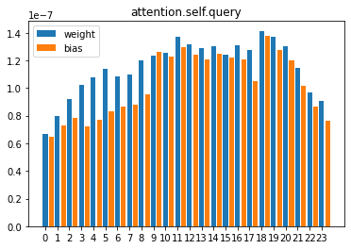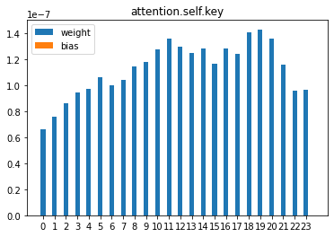

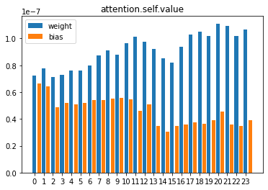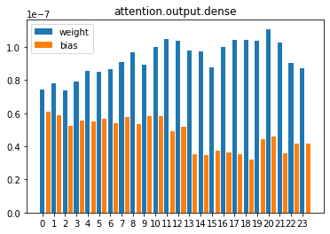

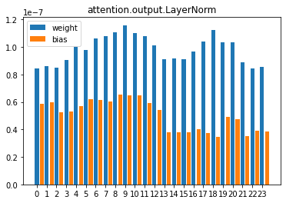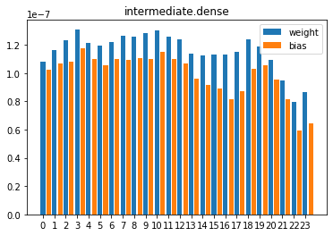

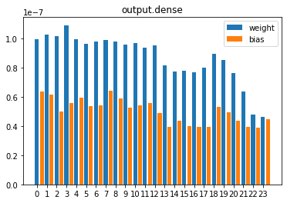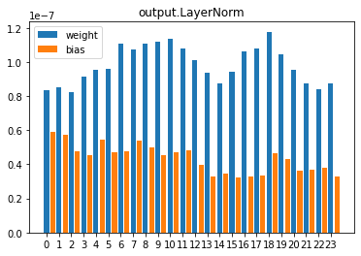

1.2. CLOZE Model

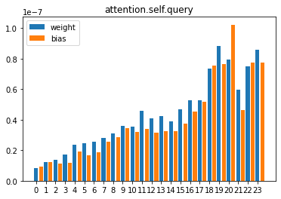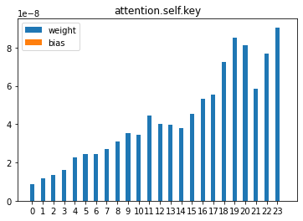
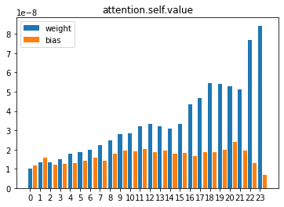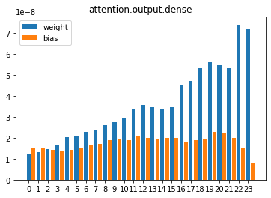
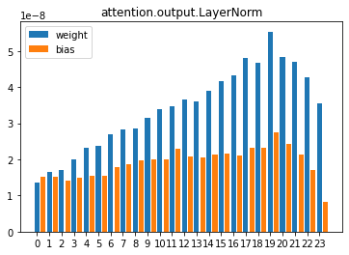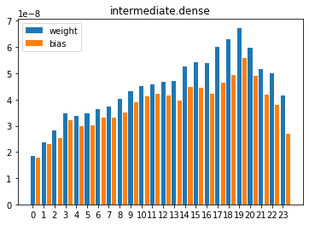

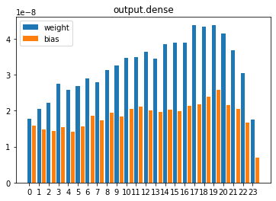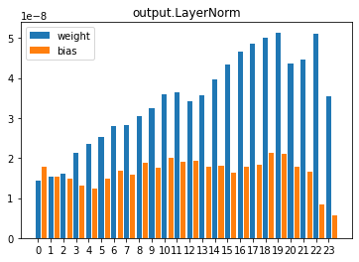

1.3. Mixed Model

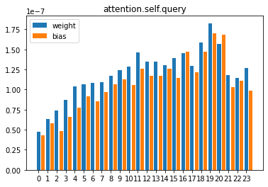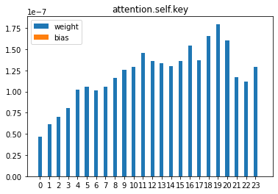

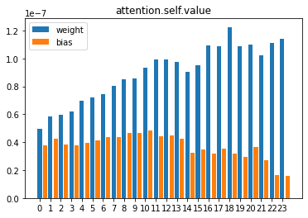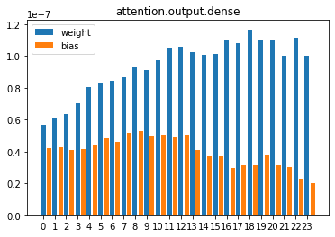

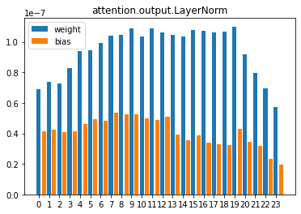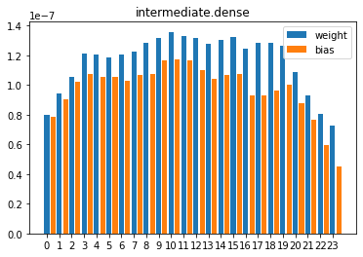

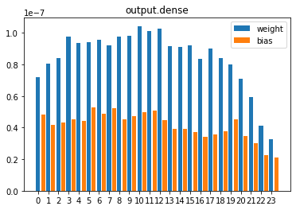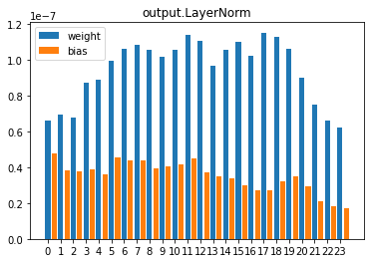

2. Test Metrics

2.1. Cloze Test (Unmodified)

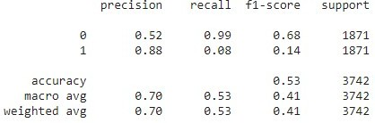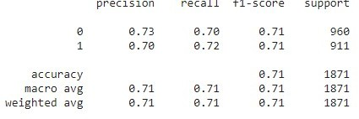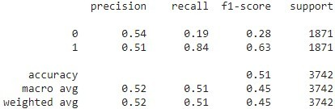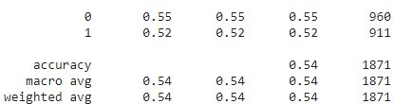
Model
Mode
Default
Choice
BERT
Binary
Choice
RocOnly
Binary

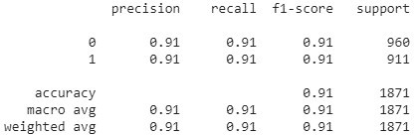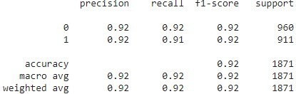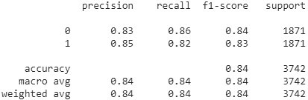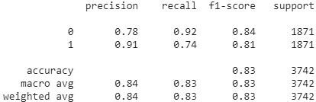
Model
Mode
Default
Choice
ClozeOnly
Binary
Choice
Cloze+5000Roc
Binary

2.2. Hypothesis-Only

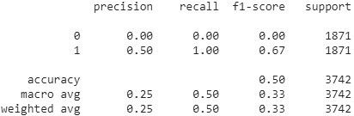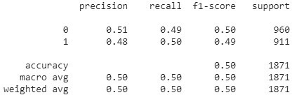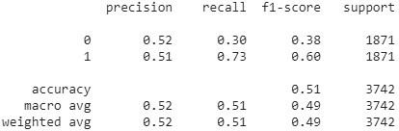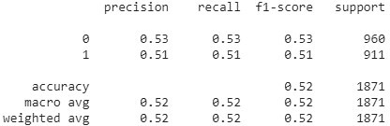
Model
Mode
Hypothesis-Only
Choice
BERT
Binary
Choice
RocOnly
Binary

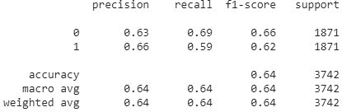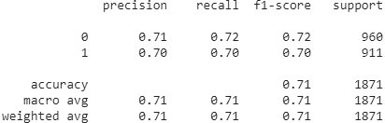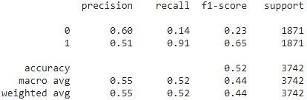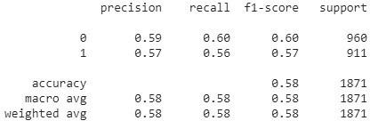
Model
Mode
Hypothesis-Only
Choice
ClozeOnly
Binary
Choice
Cloze+5000Roc
Binary

1.3. Noise Induced Stories

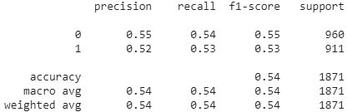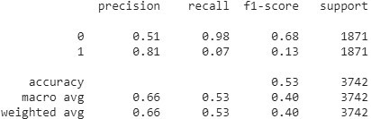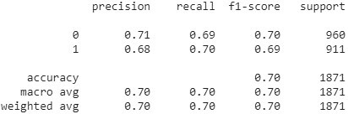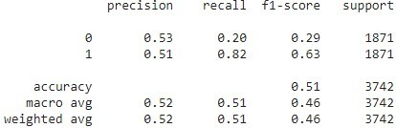
Model
Mode
NoiseInduced
Choice
BERT
Binary
Choice
RocOnly
Binary

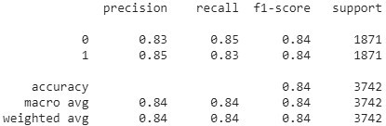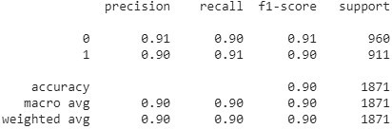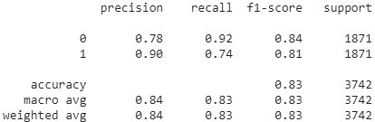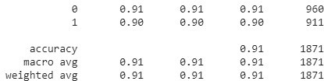
Model
Mode
NoiseInduced
Choice
ClozeOnly
Binary
Choice
Cloze+5000Roc
Binary

2.4. Negated Stories

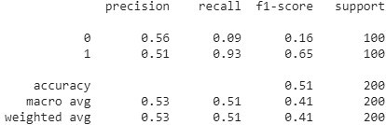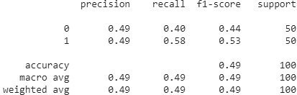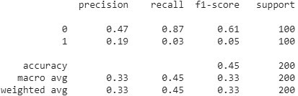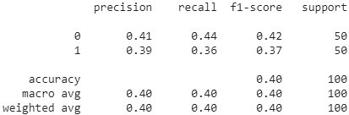
Model
Mode
Negated
Choice
BERT
Binary
Choice
RocOnly
Binary

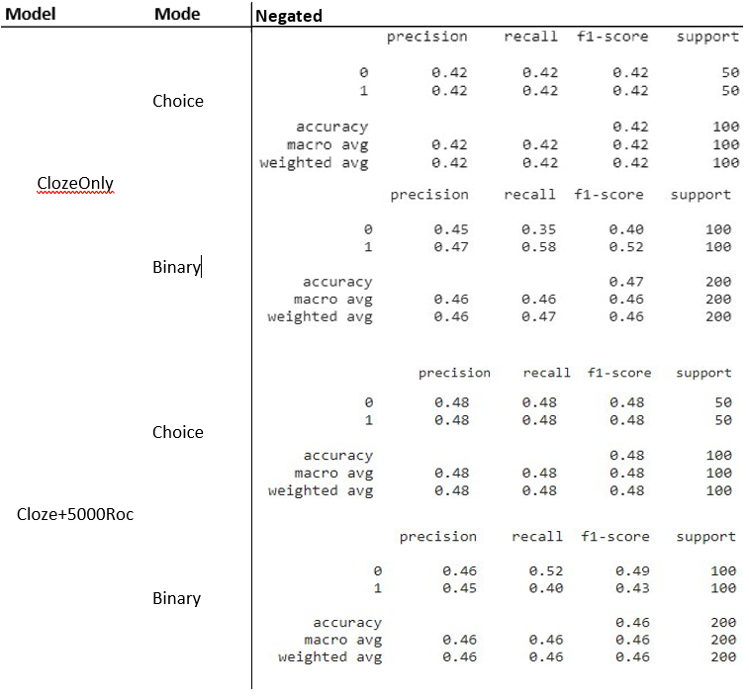

2.5. Stories Containing Trigger Words

Model Mode | TriggerOnly
 |  | precision | recall | f1-score | support
 | 0 | 0.62 | 0.55 | 0.58 | 96
Choice | 1 | 0.51 | 0.58 | 0.54 | 78
 | accuracy |  |  | 0.56 | 174
 | macro avg | 0.56 | 0.56 | 0.56 | 174
BERT | weighted avg | 0.57 | 0.56 | 0.56 | 174
 |  | precision | recall | f1-score | support
 | 0 | 0.53 | 0.16 | 0.24 | 174
Binary | 1 | 0.51 | 0.86 | 0.64 | 174
 | accuracy |  |  | 0.51 | 348
 | macro avg | 0.52 | 0.51 | 0.44 | 348
 | weighted avg | 0.52 | 0.51 | 0.44 | 348
 |  | precision | recall | f1-score | support
 | 0 | 0.80 | 0.70 | 0.74 | 96
Choice | 1 | 0.68 | 0.78 | 0.73 | 78
 | accuracy |  |  | 0.74 | 174
 | macro avg | 0.74 | 0.74 | 0.74 | 174
RocOnly | weighted avg | 0.74 | 0.74 | 0.74 | 174
 |  | precision | recall | f1-score | support
 | 0 | 0.53 | 0.99 | 0.69 | 174
Binary | 1 | 0.95 | 0.12 | 0.21 | 174
 | accuracy |  |  | 0.56 | 348
 | macro avg | 0.74 | 0.56 | 0.45 | 348
 | weighted avg | 0.74 | 0.56 | 0.45 | 348

Model Mode | TriggerOnly
 |  | precision | recall | f1-score | support
 | 0 | 0.94 | 0.94 | 0.94 | 96
Choice | 1 | 0.92 | 0.92 | 0.92 | 78
 | accuracy |  |  | 0.93 | 174
 | macro avg | 0.93 | 0.93 | 0.93 | 174
ClozeOnly | weighted avg | 0.93 | 0.93 | 0.93 | 174
 |  | precision | recall | f1-score | support
 | 0 | 0.80 | 0.89 | 0.84 | 174
Binary | 1 | 0.88 | 0.78 | 0.82 | 174
 | accuracy |  |  | 0.83 | 348
 | macro avg | 0.84 | 0.83 | 0.83 | 348
 | weighted avg | 0.84 | 0.83 | 0.83 | 348
 |  | precision | recall | f1-score | support
 | 0 | 0.96 | 0.95 | 0.95 | 96
Choice | 1 | 0.94 | 0.95 | 0.94 | 78
 | accuracy |  |  | 0.95 | 174
 | macro avg | 0.95 | 0.95 | 0.95 | 174
Cloze+5000Roc | weighted avg | 0.95 | 0.95 | 0.95 | 174
 |  | precision | recall | f1-score | support
 | 0 | 0.78 | 0.93 | 0.85 | 174
Binary | 1 | 0.91 | 0.74 | 0.81 | 174
 | accuracy |  |  | 0.83 | 348
 | macro avg | 0.84 | 0.83 | 0.83 | 348
 | weighted avg | 0.84 | 0.83 | 0.83 | 348

2.6. Stories Containing Trigger Words – Triggers Removed

Mode | TriggerRemoved
 |  | precision | recall | f1-score | support
 | 0 | 0.64 | 0.60 | 0.62 | 96
Choice | 1 | 0.54 | 0.58 | 0.56 | 78
 | accuracy |  |  | 0.59 | 174
 | macro avg | 0.59 | 0.59 | 0.59 | 174
 | weighted avg | 0.59 | 0.59 | 0.59 | 174
 |  | precision | recall | f1-score | support
 | 0 | 0.61 | 0.17 | 0.27 | 174
Binary | 1 | 0.52 | 0.89 | 0.66 | 174
 | accuracy |  |  | 0.53 | 348
 | macro avg | 0.57 | 0.53 | 0.46 | 348
 | weighted avg | 0.57 | 0.53 | 0.46 | 348
 |  | precision | recall | f1-score | support
 | 0 | 0.79 | 0.71 | 0.75 | 96
Choice | 1 | 0.68 | 0.77 | 0.72 | 78
 | accuracy |  |  | 0.74 | 174
 | macro avg | 0.74 | 0.74 | 0.74 | 174
 | weighted avg | 0.74 | 0.74 | 0.74 | 174
 |  | precision | recall | f1-score | support
 | 0 | 0.53 | 0.99 | 0.69 | 174
Binary | 1 | 0.91 | 0.11 | 0.20 | 174
 | accuracy |  |  | 0.55 | 348
 | macro avg | 0.72 | 0.55 | 0.45 | 348
 | weighted avg | 0.72 | 0.55 | 0.45 | 348

BERT

RocOnly

Mode | TriggerRemoved
 |  | precision | recall | f1-score | support
 | 0 | 0.94 | 0.92 | 0.93 | 96
Choice | 1 | 0.90 | 0.92 | 0.91 | 78
 | accuracy |  |  | 0.92 | 174
 | macro avg | 0.92 | 0.92 | 0.92 | 174
 | weighted avg | 0.92 | 0.92 | 0.92 | 174
 |  | precision | recall | f1-score | support
 | 0 | 0.79 | 0.82 | 0.81 | 174
Binary | 1 | 0.82 | 0.79 | 0.80 | 174
 | accuracy |  |  | 0.80 | 348
 | macro avg | 0.80 | 0.80 | 0.80 | 348
 | weighted avg | 0.80 | 0.80 | 0.80 | 348
 |  | precision | recall | f1-score | support
 | 0 | 0.96 | 0.90 | 0.92 | 96
Choice | 1 | 0.88 | 0.95 | 0.91 | 78
 | accuracy |  |  | 0.92 | 174
 | macro avg | 0.92 | 0.92 | 0.92 | 174
 | weighted avg | 0.92 | 0.92 | 0.92 | 174
 |  | precision | recall | f1-score | support
 | 0 | 0.80 | 0.90 | 0.85 | 174
Binary | 1 | 0.88 | 0.78 | 0.83 | 174
 | accuracy |  |  | 0.84 | 348
 | macro avg | 0.84 | 0.84 | 0.84 | 348
 | weighted avg | 0.84 | 0.84 | 0.84 | 348

Model

ClozeOnly

Cloze+5000Roc

2.7. Stories Containing Trigger Words – Trigger Synonymized

Model
Mode | TriggerSynonymized
 |  | precision | recall | f1-score | support
 | 0 | 0.63 | 0.56 | 0.59 | 96
Choice | 1 | 0.52 | 0.59 | 0.55 | 78
 | accuracy |  |  | 0.57 | 174
 | macro avg | 0.58 | 0.58 | 0.57 | 174
 | weighted avg | 0.58 | 0.57 | 0.58 | 174
 |  | precision | recall | f1-score | support
 | 0 | 0.57 | 0.16 | 0.24 | 174
Binary | 1 | 0.51 | 0.89 | 0.65 | 174
 | accuracy |  |  | 0.52 | 348
 | macro avg | 0.54 | 0.52 | 0.45 | 348
 | weighted avg | 0.54 | 0.52 | 0.45 | 348
 |  | precision | recall | f1-score | support
 | 0 | 0.79 | 0.72 | 0.75 | 96
Choice | 1 | 0.69 | 0.77 | 0.73 | 78
 | accuracy |  |  | 0.74 | 174
 | macro avg | 0.74 | 0.74 | 0.74 | 174
 | weighted avg | 0.75 | 0.74 | 0.74 | 174
 |  | precision | recall | f1-score | support
 | 0 | 0.53 | 0.99 | 0.69 | 174
Binary | 1 | 0.95 | 0.12 | 0.21 | 174
 | accuracy |  |  | 0.56 | 348
 | macro avg | 0.74 | 0.56 | 0.45 | 348
 | weighted avg | 0.74 | 0.56 | 0.45 | 348

BERT

RocOnly

Model
Mode | TriggerSynonymized
 |  | precision | recall | f1-score | support
 | 0 | 0.94 | 0.93 | 0.93 | 96
Choice | 1 | 0.91 | 0.92 | 0.92 | 78
 | accuracy |  |  | 0.93 | 174
 | macro avg | 0.92 | 0.93 | 0.92 | 174
 | weighted avg | 0.93 | 0.93 | 0.93 | 174
 |  | precision | recall | f1-score | support
 | 0 | 0.80 | 0.87 | 0.83 | 174
Binary | 1 | 0.86 | 0.79 | 0.82 | 174
 | accuracy |  |  | 0.83 | 348
 | macro avg | 0.83 | 0.83 | 0.83 | 348
 | weighted avg | 0.83 | 0.83 | 0.83 | 348
 |  | precision | recall | f1-score | support
 | 0 | 0.97 | 0.93 | 0.95 | 96
Choice | 1 | 0.91 | 0.96 | 0.94 | 78
 | accuracy |  |  | 0.94 | 174
 | macro avg | 0.94 | 0.94 | 0.94 | 174
 | weighted avg | 0.94 | 0.94 | 0.94 | 174
 |  | precision | recall | f1-score | support
 | 0 | 0.78 | 0.93 | 0.85 | 174
Binary | 1 | 0.91 | 0.74 | 0.81 | 174
 | accuracy |  |  | 0.83 | 348
 | macro avg | 0.84 | 0.83 | 0.83 | 348
 | weighted avg | 0.84 | 0.83 | 0.83 | 348

ClozeOnly

Cloze+5000Roc

2.8. Stories Translated

This test set was translated from English to Hungarian to Slovenian to English.

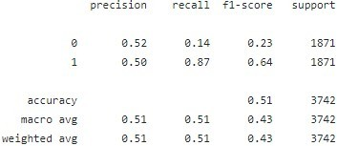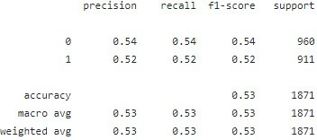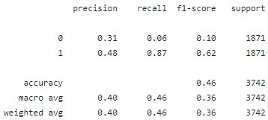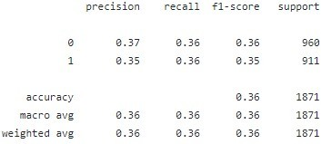
Model
Mode
Translated
Choice
BERT
Binary
Choice
RocOnly
Binary

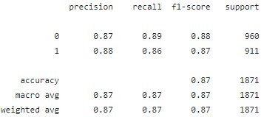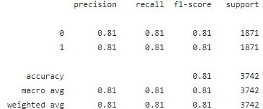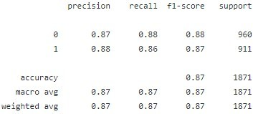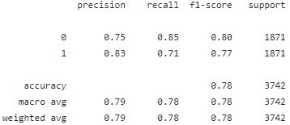
Model
Mode
Translated
Choice
ClozeOnly
Binary
Choice
Cloze+5000Roc
Binary

2.9. Super Hard Test Set

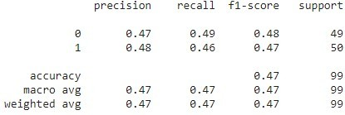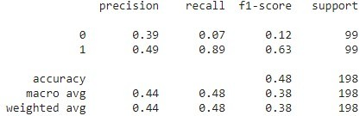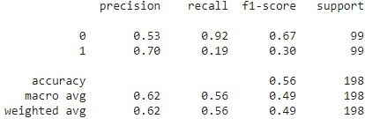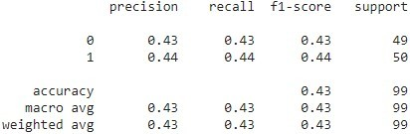
Model
Mode
Super Hard Testset
Choice
BERT
Binary
Choice
RocOnly
Binary

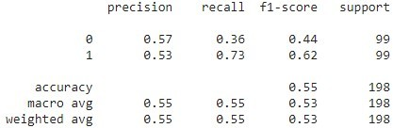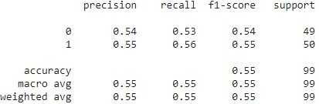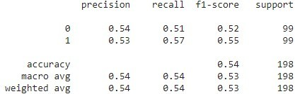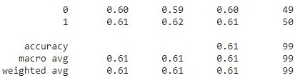
Model
Mode
Super Hard Testset
Choice
ClozeOnly
Binary
Choice
Cloze+5000Roc
Binary

2.10. Cloze-Test (Unmodified), Short

This test set comprises the same stories as the negated test set and the super hard test set.

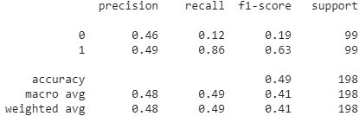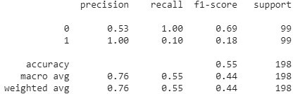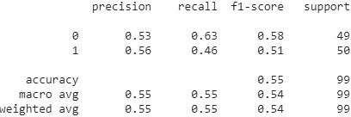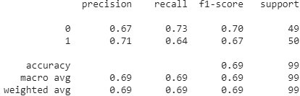
Model
Mode
Default (first 100 stories only)
Choice
BERT
Binary
Choice
RocOnly
Binary

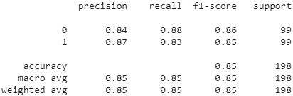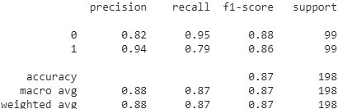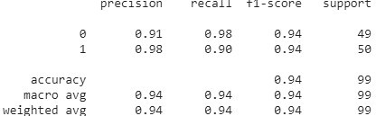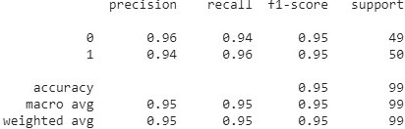
Model
Mode
Default (first 100 stories only)
Choice
ClozeOnly
Binary
Choice
Cloze+5000Roc
Binary

3. Salience Maps
DISCLAIMER: The stories listed for each point are either exhaustive or sampled randomly. All saliency maps are based on the loss calculated in the binary test setup. The tokens marked red indicate “contribution” to the predicted class, the tokens marked blue indicate “contribution” to the not predicted class.

3.1. Inducing Noise
Each randomly sampled story shows the saliencies assigned to it by BERT, ROC model, CLOZE model, and MIXED model. For each model, two stories are shown: The first is the default story, the second one the story induced with noise.

3.1.1 Sample 1
BERT:
[CLS] ned wants a hobby that will get him outside. he decides to plant a vegetable garden in his yard. ned plants tomato, eggplant, and pepper in his garden. he is surprised by how much work it takes. [SEP] ned is proud of his hard work and tasty vegetables. [SEP]

[CLS] ned wants a hobby that will get him outside. last saturday he decides to plant a vegetable garden in his yard. in china, ned plants tomato, eggplant, and pepper in his garden. afterwards, he is surprised by how much work it takes. [SEP] ned is proud of his hard work and tasty vegetables. [SEP]

ROC Model:
[CLS] ned wants a hobby that will get him outside. he decides to plant a vegetable garden in his yard. ned plants tomato, eggplant, and pepper in his garden. he is surprised by how much work it takes. [SEP] ned is proud of his hard work and tasty vegetables. [SEP]

[CLS] ned wants a hobby that will get him outside. last saturday he decides to plant a vegetable garden in his yard. in china, ned plants tomato, eggplant, and pepper in his garden. afterwards, he is surprised by how much work it takes. [SEP] ned is proud of his hard work and tasty vegetables. [SEP]

CLOZE Model:
[CLS] ned wants a hobby that will get him outside. he decides to plant a vegetable garden in his yard. ned plants tomato, eggplant, and pepper in his garden. he is surprised by how much work it takes. [SEP] ned is proud of his hard work and tasty vegetables. [SEP]

[CLS] ned wants a hobby that will get him outside. last saturday he decides to plant a vegetable garden in his yard. in china, ned plants tomato, eggplant, and pepper in his garden. afterwards, he is surprised by how much work it takes. [SEP] ned is proud of his hard work and tasty vegetables. [SEP]

MIXED Model:
[CLS] ned wants a hobby that will get him outside. he decides to plant a vegetable garden in his yard. ned plants tomato, eggplant, and pepper in his garden. he is surprised by how much work it takes. [SEP] ned is proud of his hard work and tasty vegetables. [SEP]

[CLS] ned wants a hobby that will get him outside. last saturday he decides to plant a vegetable garden in his yard. in china, ned plants tomato, eggplant, and pepper in his garden. afterwards, he is surprised by how much work it takes. [SEP] ned is proud of his hard work and tasty vegetables. [SEP]

3.1.2 Sample 2
BERT:
[CLS] today's lab assignment turned out to be a disaster. since my teammates were confused, i had to guide them. this includes showing them how to do every procedure. although we finished after everyone else, i put in a lot of effort. [SEP] the team didn't need me that day. [SEP]
[CLS] today's lab assignment turned out to be a disaster. also, since my teammates were confused, i had to guide them. in bai'e, this includes showing them how to do every procedure. certainly, although we finished after everyone else, i put in a lot of effort. [SEP] the team didn't need me that day. [SEP]

ROC Model:
[CLS] today's lab assignment turned out to be a disaster. since my teammates were confused, i had to guide them. this includes showing them how to do every procedure. although we finished after everyone else, i put in a lot of effort. [SEP] the team didn't need me that day. [SEP]

[CLS] today's lab assignment turned out to be a disaster. also, since my teammates were confused, i had to guide them. in bai'e, this includes showing them how to do every procedure. certainly, although we finished after everyone else, i put in a lot of effort. [SEP] the team didn't need me that day. [SEP]

CLOZE Model:
[CLS] today's lab assignment turned out to be a disaster. since my teammates were confused, i had to guide them. this includes showing them how to do every procedure. although we finished after everyone else, i put in a lot of effort. [SEP] the team didn't need me that day. [SEP]

[CLS] today's lab assignment turned out to be a disaster. also, since my teammates were confused, i had to guide them. in bai'e, this includes showing them how to do every procedure. certainly, although we finished after everyone else, i put in a lot of effort. [SEP] the team didn't need me that day. [SEP]

MIXED Model:
[CLS] today's lab assignment turned out to be a disaster. since my teammates were confused, i had to guide them. this includes showing them how to do every procedure. although we finished after everyone else, i put in a lot of effort. [SEP] the team didn't need me that day. [SEP]

[CLS] today's lab assignment turned out to be a disaster. also, since my teammates were confused, i had to guide them. in bai'e, this includes showing them how to do every procedure. certainly, although we finished after everyone else, i put in a lot of effort. [SEP] the team didn't need me that day. [SEP]

3.1.3 Sample 3

BERT:
[CLS] dennis was walking in the woods. he found a black lab. the lab tried to bite him. dennis showed he was a friend not enemy. [SEP] the rabbit hopped away. [SEP]

[CLS] dennis was walking in the woods. well, he found a black lab. however, the lab tried to bite him. in algodre, dennis showed he was a friend not enemy. [SEP] the rabbit hopped away. [SEP]

ROC Model:
[CLS] dennis was walking in the woods. he found a black lab. the lab tried to bite him. dennis showed he was a friend not enemy. [SEP] the rabbit hopped away. [SEP]

[CLS] dennis was walking in the woods. well, he found a black lab. however, the lab tried to bite him. in algodre, dennis showed he was a friend not enemy. [SEP] the rabbit hopped away. [SEP]

CLOZE Model:
[CLS] dennis was walking in the woods. he found a black lab. the lab tried to bite him. dennis showed he was a friend not enemy. [SEP] the rabbit hopped away. [SEP]

[CLS] dennis was walking in the woods. well, he found a black lab. however, the lab tried to bite him. in algodre, dennis showed he was a friend not enemy. [SEP] the rabbit hopped away. [SEP]

MIXED Model:
[CLS] dennis was walking in the woods. he found a black lab. the lab tried to bite him. dennis showed he was a friend not enemy. [SEP] the rabbit hopped away. [SEP]

[CLS] dennis was walking in the woods. well, he found a black lab. however, the lab tried to bite him. in algodre, dennis showed he was a friend not enemy. [SEP] the rabbit hopped away. [SEP]

3.1.4 Sample 4
BERT:
[CLS] timothy had an urge to eat sweets. he was looking everywhere for something sweet to eat. he found what he was looking for. it was a gigantic cupcake his mom made. [SEP] timothy eat the cupcake in one big bite. [SEP]
[CLS] timothy had an urge to eat sweets. in pouembout, he was looking everywhere for something sweet to eat. what's more, he found what he was looking for. some time ago, it was a gigantic cupcake his mom made. [SEP] timothy eat the cupcake in one big bite. [SEP]

ROC Model:
[CLS] timothy had an urge to eat sweets. he was looking everywhere for something sweet to eat. he found what he was looking for. it was a gigantic cupcake his mom made. [SEP] timothy eat the cupcake in one big bite. [SEP]

[CLS] timothy had an urge to eat sweets. in pouembout, he was looking everywhere for something sweet to eat. what's more, he found what he was looking for. some time ago, it was a gigantic cupcake his mom made. [SEP] timothy eat the cupcake in one big bite. [SEP]

CLOZE Model:
[CLS] timothy had an urge to eat sweets. he was looking everywhere for something sweet to eat. he found what he was looking for. it was a gigantic cupcake his mom made. [SEP] timothy eat the cupcake in one big bite. [SEP]

[CLS] timothy had an urge to eat sweets. in pouembout, he was looking everywhere for something sweet to eat. what's more, he found what he was looking for. some time ago, it was a gigantic cupcake his mom made. [SEP] timothy eat the cupcake in one big bite. [SEP]

MIXED Model:
[CLS] timothy had an urge to eat sweets. he was looking everywhere for something sweet to eat. he found what he was looking for. it was a gigantic cupcake his mom made. [SEP] timothy eat the cupcake in one big bite. [SEP]

[CLS] timothy had an urge to eat sweets. in pouembout, he was looking everywhere for something sweet to eat. what's more, he found what he was looking for. some time ago, it was a gigantic cupcake his mom made. [SEP] timothy eat the cupcake in one big bite. [SEP]

3.1.5 Sample 5
BERT:
[CLS] peter was very hungry. he only had two dollars in his bank account. he decided to go to the grocery store. luckily, noodles were on sale for less than two dollars. [SEP] peter bought noodles. [SEP]
[CLS] last summer peter was very hungry. certainly, he only had two dollars in his bank account. thereafter, he decided to go to the grocery store. anyway, luckily, noodles were on sale for less than two dollars. [SEP] peter bought noodles. [SEP]

ROC Model:
[CLS] peter was very hungry. he only had two dollars in his bank account. he decided to go to the grocery store. luckily, noodles were on sale for less than two dollars. [SEP] peter bought noodles. [SEP]

[CLS] last summer peter was very hungry. certainly, he only had two dollars in his bank account. thereafter, he decided to go to the grocery store. anyway, luckily, noodles were on sale for less than two dollars. [SEP] peter bought noodles. [SEP]

CLOZE Model:
[CLS] peter was very hungry. he only had two dollars in his bank account. he decided to go to the grocery store. luckily, noodles were on sale for less than two dollars. [SEP] peter bought noodles. [SEP]

[CLS] last summer peter was very hungry. certainly, he only had two dollars in his bank account. thereafter, he decided to go to the grocery store. anyway, luckily, noodles were on sale for less than two dollars. [SEP] peter bought noodles. [SEP]

MIXED Model:
[CLS] peter was very hungry. he only had two dollars in his bank account. he decided to go to the grocery store. luckily, noodles were on sale for less than two dollars. [SEP] peter bought noodles. [SEP]

[CLS] last summer peter was very hungry. certainly, he only had two dollars in his bank account. thereafter, he decided to go to the grocery store. anyway, luckily, noodles were on sale for less than two dollars. [SEP] peter bought noodles. [SEP]
BERT:
[CLS] david's parents got him a bike. he didn't want one. but he didn't want his gift to go to waste. after learning how to ride the bike, he was glad he had one. [SEP] david ran away from home. [SEP]

[CLS] david's parents got him a bike. in spain, he didn't want one. thus, but he didn't want his gift to go to waste. however, after learning how to ride the bike, he was glad he had one. [SEP] david ran away from home. [SEP]

ROC Model:
[CLS] david's parents got him a bike. he didn't want one. but he didn't want his gift to go to waste. after learning how to ride the bike, he was glad he had one. [SEP] david ran away from home. [SEP]

[CLS] david's parents got him a bike. in spain, he didn't want one. thus, but he didn't want his gift to go to waste. however, after learning how to ride the bike, he was glad he had one. [SEP] david ran away from home. [SEP]

CLOZE Model:
[CLS] david's parents got him a bike. he didn't want one. but he didn't want his gift to go to waste. after learning how to ride the bike, he was glad he had one. [SEP] david ran away from home. [SEP]

[CLS] david's parents got him a bike. in spain, he didn't want one. thus, but he didn't want his gift to go to waste. however, after learning how to ride the bike, he was glad he had one. [SEP] david ran away from home. [SEP]

MIXED Model:
[CLS] david's parents got him a bike. he didn't want one. but he didn't want his gift to go to waste. after learning how to ride the bike, he was glad he had one. [SEP] david ran away from home. [SEP]

[CLS] david's parents got him a bike. in spain, he didn't want one. thus, but he didn't want his gift to go to waste. however, after learning how to ride the bike, he was glad he had one. [SEP] david ran away from home. [SEP]

3.2. Trigger Words

In the following document, saliency mappings of tokens for one sentence for each trigger word is shown. For each trained model, the mapping for each trigger word is done for the original sentence (with triggers), the sentence with triggers removed and the sentence with triggers changed to a synonym (triggers synonymized). Additionally, the actual label (label) and the label predicted by the model (prediction) is shown. The labelling for Huggingface transformers is used. As a result, “0” means the ending is true and “1” means the ending is false.

3.2.1. ROC model
sentences with instead:
with triggers label:0 prediction:0 [CLS] aaron ' s girlfriend asked him to come over for dinner . she said she was making his favorite , chicken alfredo . aaron was very excited she wanted to cook , but he hated alfredo . she must have mixed up his words when he told her his least favorite . [SEP] aaron suggested he help her cook another meal instead . [SEP]
triggers removed label:0 prediction:0 [CLS] aaron ' s girlfriend asked him to come over for dinner . she said she was making his favorite , chicken alfredo . aaron was very excited she wanted to cook , but he hated alfredo . she must have mixed up his words when he told her his least favorite . [SEP] aaron suggested he help her cook another meal . [SEP]
triggers synonymized label:0 prediction:0 [CLS] aaron ' s girlfriend asked him to come over for dinner . she said she was making his favorite , chicken alfredo . aaron was very excited she wanted to cook , but he hated alfredo . she must have mixed up his words when he told her his least favorite . [SEP] aaron suggested he help her cook another meal alternatively . [SEP]
sentences with ever:
with triggers label:1 prediction:0 [CLS] ed wanted to make homemade juice for his family . he bought a bag of orange ##s and juice ##d them . then he chilled the juice overnight . in the morning , he served it to his family . [SEP] it was the best apple juice that they had ever had . [SEP]
triggers removed label:1 prediction:0 [CLS] ed wanted to make homemade juice for his family . he bought a bag of orange ##s and juice ##d them . then he chilled the juice overnight . in the morning , he served it to his family . [SEP] it was the best apple juice that they had had . [SEP]
triggers synonymized label:1 prediction:0 [CLS] ed wanted to make homemade juice for his family . he bought a bag of orange ##s and juice ##d them . then he chilled the juice overnight . in the morning , he served it to his family . [SEP] it was the best apple juice that they had at any point had . [SEP]
sentences with anymore:
with triggers label:1 prediction:0 [CLS] pam was in love with josh but she didn ' t know how to get his attention . she talked to her friends , and she talked to her parents . they all offered advice that didn ' t quite work for her . finally , she just went up to him and told him her feelings . [SEP] pam ' s friends won ' t talk to her anymore . [SEP]
triggers removed label:1 prediction:0 [CLS] pam was in love with josh but she didn ' t know how to get his attention . she talked to her friends , and she talked to her parents . they all offered advice that didn ' t quite work for her . finally , she just went up to him and told him her feelings . [SEP] pam ' s friends won ' t talk to her . [SEP]
triggers synonymized label:1 prediction:0 [CLS] pam was in love with josh but she didn ' t know how to get his attention . she talked to her friends , and she talked to her parents . they all offered advice that didn ' t quite work for her . finally , she just went up to him and told him her feelings . [SEP] pam ' s friends won ' t talk to her any further . [SEP]
sentences with too:
with triggers label:0 prediction:0 [CLS] jeff just got engaged to his girlfriend ashley ! they are very happy and started planning the wedding right away . within hours they realized how expensive everything is going to be . jeff decided to get a part time job to pay for all of this . [SEP] ashley got a part time job too . [SEP]
triggers removed label:0 prediction:0 [CLS] jeff just got engaged to his girlfriend ashley ! they are very happy and started planning the wedding right away . within hours they realized how expensive everything is going to be . jeff decided to get a part time job to pay for all of this . [SEP] ashley got a part time job . [SEP]
triggers synonymized label:0 prediction:0 [CLS] jeff just got engaged to his girlfriend ashley ! they are very happy and started planning the wedding right away . within hours they realized how expensive everything is going to be . jeff decided to get a part time job to pay for all of this . [SEP] ashley got a part time job as well . [SEP]
sentences with eventually:
with triggers label:0 prediction:0 [CLS] my friend got me a plant ##er as a house ##war ##ming gift . it ' s small and cute and fits in nicely with my decor . but i ' m still not sure where to put it . i hope he doesn ' t get sad . [SEP] i ' m sure i ' ll figure out a place for it eventually . [SEP]
triggers removed label:0 prediction:0 [CLS] my friend got me a plant ##er as a house ##war ##ming gift . it ' s small and cute and fits in nicely with my decor . but i ' m still not sure where to put it . i hope he doesn ' t get sad . [SEP] i ' m sure i ' ll figure out a place for it . [SEP]
triggers synonymized label:0 prediction:0 [CLS] my friend got me a plant ##er as a house ##war ##ming gift . it ' s small and cute and fits in nicely with my decor . but i ' m still not sure where to put it . i hope he doesn ' t get sad . [SEP] i ' m sure i ' ll figure out a place for it ultimately . [SEP]
sentences with immediately:
with triggers label:1 prediction:0 [CLS] a company came to give a quote on windows . they walked around and measured all the windows . they then sat us down and went over their products . all the options looked great . [SEP] we were so angry we sent them away immediately . [SEP]
triggers removed label:1 prediction:0 [CLS] a company came to give a quote on windows . they walked around and measured all the windows . they then sat us down and went over their products . all the options looked great . [SEP] we were so angry we sent them away . [SEP]
triggers synonymized label:1 prediction:0 [CLS] a company came to give a quote on windows . they walked around and measured all the windows . they then sat us down and went over their products . all the options looked great . [SEP] we were so angry we sent them away instantly . [SEP]
sentences with anyway:
with triggers label:0 prediction:0 [CLS] my roommate is from germany . he is a very good cook . one day , he made some sausage for me that he ate back home in germany . the sausage turned out poorly , according to him . [SEP] i loved them anyway . [SEP]
triggers removed label:0 prediction:0 [CLS] my roommate is from germany . he is a very good cook . one day , he made some sausage for me that he ate back home in germany . the sausage turned out poorly , according to him . [SEP] i loved them . [SEP]
triggers synonymized label:0 prediction:0 [CLS] my roommate is from germany . he is a very good cook . one day , he made some sausage for me that he ate back home in germany . the sausage turned out poorly , according to him . [SEP] i loved them any ##how . [SEP]
sentences with soon:
with triggers label:0 prediction:0 [CLS] jean was delighted to receive a pet an ##ole for her birthday . this was the first pet her mother had ever let her have . the next day , there was a white egg in the cage ! jean waited with anticipation , hoping the egg would hatch . [SEP] soon , jean had two pet an ##oles . [SEP]
triggers removed label:0 prediction:0 [CLS] jean was delighted to receive a pet an ##ole for her birthday . this was the first pet her mother had ever let her have . the next day , there was a white egg in the cage ! jean waited with anticipation , hoping the egg would hatch . [SEP] jean had two pet an ##oles . [SEP]
triggers synonymized label:0 prediction:0 [CLS] jean was delighted to receive a pet an ##ole for her birthday . this was the first pet her mother had ever let her have . the next day , there was a white egg in the cage ! jean waited with anticipation , hoping the egg would hatch . [SEP] shortly , jean had two pet an ##oles . [SEP]
sentences with later:
with triggers label:0 prediction:0 [CLS] james woke up and was in a bad mood immediately . he went too fix breakfast and burnt his toast . then went to get dressed and couldn ' t find any socks . james decided it was a bad day and he was going back to bed . [SEP] james woke up later and felt much better . [SEP]
triggers removed label:0 prediction:0 [CLS] james woke up and was in a bad mood immediately . he went too fix breakfast and burnt his toast . then went to get dressed and couldn ' t find any socks . james decided it was a bad day and he was going back to bed . [SEP] james woke up and felt much better . [SEP]
triggers synonymized label:0 prediction:0 [CLS] james woke up and was in a bad mood immediately . he went too fix breakfast and burnt his toast . then went to get dressed and couldn ' t find any socks . james decided it was a bad day and he was going back to bed . [SEP] james woke up afterwards and felt much better . [SEP]
sentences with now:
with triggers label:0 prediction:0 [CLS] samantha had recently purchased a used car . she loved everything about the car except for the color . she took her car to her local paint shop . she got it painted a bright pink color . [SEP] samantha likes the color of her car now . [SEP]
triggers removed label:0 prediction:0 [CLS] samantha had recently purchased a used car . she loved everything about the car except for the color . she took her car to her local paint shop . she got it painted a bright pink color . [SEP] samantha likes the color of her car . [SEP]
triggers synonymized label:0 prediction:0 [CLS] samantha had recently purchased a used car . she loved everything about the car except for the color . she took her car to her local paint shop . she got it painted a bright pink color . [SEP] samantha likes the color of her car currently . [SEP]
sentences with finally:
with triggers label:0 prediction:0 [CLS] kelly was playing her new mario game . she had been playing it for weeks . she was playing for so long without beating the level . finally she beat the last level . [SEP] kelly was so happy to finally beat it . [SEP]
triggers removed label:0 prediction:0 [CLS] kelly was playing her new mario game . she had been playing it for weeks . she was playing for so long without beating the level . finally she beat the last level . [SEP] kelly was so happy to beat it . [SEP]
triggers synonymized label:0 prediction:0 [CLS] kelly was playing her new mario game . she had been playing it for weeks . she was playing for so long without beating the level . finally she beat the last level . [SEP] kelly was so happy to at last beat it . [SEP]

3.2.2. CLOZE model
sentences with instead:
with triggers label:0 prediction:0 [CLS] aaron ' s girlfriend asked him to come over for dinner . she said she was making his favorite , chicken alfredo . aaron was very excited she wanted to cook , but he hated alfredo . she must have mixed up his words when he told her his least favorite . [SEP] aaron suggested he help her cook another meal instead . [SEP]
triggers removed label:0 prediction:0 [CLS] aaron ' s girlfriend asked him to come over for dinner . she said she was making his favorite , chicken alfredo . aaron was very excited she wanted to cook , but he hated alfredo . she must have mixed up his words when he told her his least favorite . [SEP] aaron suggested he help her cook another meal . [SEP]
triggers synonymized label:0 prediction:0 [CLS] aaron ' s girlfriend asked him to come over for dinner . she said she was making his favorite , chicken alfredo . aaron was very excited she wanted to cook , but he hated alfredo . she must have mixed up his words when he told her his least favorite . [SEP] aaron suggested he help her cook another meal alternatively . [SEP]
sentences with ever:
with triggers label:1 prediction:1 [CLS] ed wanted to make homemade juice for his family . he bought a bag of orange ##s and juice ##d them . then he chilled the juice overnight . in the morning , he served it to his family . [SEP] it was the best apple juice that they had ever had . [SEP]
triggers removed label:1 prediction:1 [CLS] ed wanted to make homemade juice for his family . he bought a bag of orange ##s and juice ##d them . then he chilled the juice overnight . in the morning , he served it to his family . [SEP] it was the best apple juice that they had had . [SEP]
triggers synonymized label:1 prediction:1 [CLS] ed wanted to make homemade juice for his family . he bought a bag of orange ##s and juice ##d them . then he chilled the juice overnight . in the morning , he served it to his family . [SEP] it was the best apple juice that they had at any point had . [SEP]
sentences with anymore:
with triggers label:1 prediction:1 [CLS] pam was in love with josh but she didn ' t know how to get his attention . she talked to her friends , and she talked to her parents . they all offered advice that didn ' t quite work for her . finally , she just went up to him and told him her feelings . [SEP] pam ' s friends won ' t talk to her anymore . [SEP]
triggers removed label:1 prediction:1 [CLS] pam was in love with josh but she didn ' t know how to get his attention . she talked to her friends , and she talked to her parents . they all offered advice that didn ' t quite work for her . finally , she just went up to him and told him her feelings . [SEP] pam ' s friends won ' t talk to her . [SEP]
triggers synonymized label:1 prediction:1 [CLS] pam was in love with josh but she didn ' t know how to get his attention . she talked to her friends , and she talked to her parents . they all offered advice that didn ' t quite work for her . finally , she just went up to him and told him her feelings . [SEP] pam ' s friends won ' t talk to her any further . [SEP]
sentences with too:
with triggers label:0 prediction:0 [CLS] jeff just got engaged to his girlfriend ashley ! they are very happy and started planning the wedding right away . within hours they realized how expensive everything is going to be . jeff decided to get a part time job to pay for all of this . [SEP] ashley got a part time job too . [SEP]
triggers removed label:0 prediction:0 [CLS] jeff just got engaged to his girlfriend ashley ! they are very happy and started planning the wedding right away . within hours they realized how expensive everything is going to be . jeff decided to get a part time job to pay for all of this . [SEP] ashley got a part time job . [SEP]
triggers synonymized label:0 prediction:0 [CLS] jeff just got engaged to his girlfriend ashley ! they are very happy and started planning the wedding right away . within hours they realized how expensive everything is going to be . jeff decided to get a part time job to pay for all of this . [SEP] ashley got a part time job as well . [SEP]
sentences with eventually:
with triggers label:0 prediction:0 [CLS] my friend got me a plant ##er as a house ##war ##ming gift . it ' s small and cute and fits in nicely with my decor . but i ' m still not sure where to put it . i hope he doesn ' t get sad . [SEP] i ' m sure i ' ll figure out a place for it eventually . [SEP]
triggers removed label:0 prediction:0 [CLS] my friend got me a plant ##er as a house ##war ##ming gift . it ' s small and cute and fits in nicely with my decor . but i ' m still not sure where to put it . i hope he doesn ' t get sad . [SEP] i ' m sure i ' ll figure out a place for it . [SEP]
triggers synonymized label:0 prediction:0 [CLS] my friend got me a plant ##er as a house ##war ##ming gift . it ' s small and cute and fits in nicely with my decor . but i ' m still not sure where to put it . i hope he doesn ' t get sad . [SEP] i ' m sure i ' ll figure out a place for it ultimately . [SEP]
sentences with immediately:
with triggers label:1 prediction:1 [CLS] a company came to give a quote on windows . they walked around and measured all the windows . they then sat us down and went over their products . all the options looked great . [SEP] we were so angry we sent them away immediately . [SEP]
triggers removed label:1 prediction:1 [CLS] a company came to give a quote on windows . they walked around and measured all the windows . they then sat us down and went over their products . all the options looked great . [SEP] we were so angry we sent them away . [SEP]
triggers synonymized label:1 prediction:1 [CLS] a company came to give a quote on windows . they walked around and measured all the windows . they then sat us down and went over their products . all the options looked great . [SEP] we were so angry we sent them away instantly . [SEP]
sentences with anyway:
with triggers label:0 prediction:1 [CLS] my roommate is from germany . he is a very good cook . one day , he made some sausage for me that he ate back home in germany . the sausage turned out poorly , according to him . [SEP] i loved them anyway . [SEP]
triggers removed label:0 prediction:1 [CLS] my roommate is from germany . he is a very good cook . one day , he made some sausage for me that he ate back home in germany . the sausage turned out poorly , according to him . [SEP] i loved them . [SEP]
triggers synonymized label:0 prediction:1 [CLS] my roommate is from germany . he is a very good cook . one day , he made some sausage for me that he ate back home in germany . the sausage turned out poorly , according to him . [SEP] i loved them any ##how . [SEP]
sentences with soon:
with triggers label:0 prediction:0 [CLS] jean was delighted to receive a pet an ##ole for her birthday . this was the first pet her mother had ever let her have . the next day , there was a white egg in the cage ! jean waited with anticipation , hoping the egg would hatch . [SEP] soon , jean had two pet an ##oles . [SEP]
triggers removed label:0 prediction:0 [CLS] jean was delighted to receive a pet an ##ole for her birthday . this was the first pet her mother had ever let her have . the next day , there was a white egg in the cage ! jean waited with anticipation , hoping the egg would hatch . [SEP] jean had two pet an ##oles . [SEP]
triggers synonymized label:0 prediction:0 [CLS] jean was delighted to receive a pet an ##ole for her birthday . this was the first pet her mother had ever let her have . the next day , there was a white egg in the cage ! jean waited with anticipation , hoping the egg would hatch . [SEP] shortly , jean had two pet an ##oles . [SEP]
sentences with later:
with triggers label:0 prediction:0 [CLS] james woke up and was in a bad mood immediately . he went too fix breakfast and burnt his toast . then went to get dressed and couldn ' t find any socks . james decided it was a bad day and he was going back to bed . [SEP] james woke up later and felt much better . [SEP]
triggers removed label:0 prediction:0 [CLS] james woke up and was in a bad mood immediately . he went too fix breakfast and burnt his toast . then went to get dressed and couldn ' t find any socks . james decided it was a bad day and he was going back to bed . [SEP] james woke up and felt much better . [SEP]
triggers synonymized label:0 prediction:0 [CLS] james woke up and was in a bad mood immediately . he went too fix breakfast and burnt his toast . then went to get dressed and couldn ' t find any socks . james decided it was a bad day and he was going back to bed . [SEP] james woke up afterwards and felt much better . [SEP]
sentences with now:
with triggers label:0 prediction:0 [CLS] samantha had recently purchased a used car . she loved everything about the car except for the color . she took her car to her local paint shop . she got it painted a bright pink color . [SEP] samantha likes the color of her car now . [SEP]
triggers removed label:0 prediction:0 [CLS] samantha had recently purchased a used car . she loved everything about the car except for the color . she took her car to her local paint shop . she got it painted a bright pink color . [SEP] samantha likes the color of her car . [SEP]
triggers synonymized label:0 prediction:0 [CLS] samantha had recently purchased a used car . she loved everything about the car except for the color . she took her car to her local paint shop . she got it painted a bright pink color . [SEP] samantha likes the color of her car currently . [SEP]
sentences with finally:
with triggers label:0 prediction:0 [CLS] kelly was playing her new mario game . she had been playing it for weeks . she was playing for so long without beating the level . finally she beat the last level . [SEP] kelly was so happy to finally beat it . [SEP]
triggers removed label:0 prediction:0 [CLS] kelly was playing her new mario game . she had been playing it for weeks . she was playing for so long without beating the level . finally she beat the last level . [SEP] kelly was so happy to beat it . [SEP]
triggers synonymized label:0 prediction:0 [CLS] kelly was playing her new mario game . she had been playing it for weeks . she was playing for so long without beating the level . finally she beat the last level . [SEP] kelly was so happy to at last beat it . [SEP]

3.2.3. MIXED model
sentences with instead:
with triggers label:0 prediction:0 [CLS] aaron ' s girlfriend asked him to come over for dinner . she said she was making his favorite , chicken alfredo . aaron was very excited she wanted to cook , but he hated alfredo . she must have mixed up his words when he told her his least favorite . [SEP] aaron suggested he help her cook another meal instead . [SEP]
triggers removed label:0 prediction:0 [CLS] aaron ' s girlfriend asked him to come over for dinner . she said she was making his favorite , chicken alfredo . aaron was very excited she wanted to cook , but he hated alfredo . she must have mixed up his words when he told her his least favorite . [SEP] aaron suggested he help her cook another meal . [SEP]
triggers synonymized label:0 prediction:0 [CLS] aaron ' s girlfriend asked him to come over for dinner . she said she was making his favorite , chicken alfredo . aaron was very excited she wanted to cook , but he hated alfredo . she must have mixed up his words when he told her his least favorite . [SEP] aaron suggested he help her cook another meal alternatively . [SEP]
sentences with ever:
with triggers label:1 prediction:1 [CLS] ed wanted to make homemade juice for his family . he bought a bag of orange ##s and juice ##d them . then he chilled the juice overnight . in the morning , he served it to his family . [SEP] it was the best apple juice that they had ever had . [SEP]
triggers removed label:1 prediction:1 [CLS] ed wanted to make homemade juice for his family . he bought a bag of orange ##s and juice ##d them . then he chilled the juice overnight . in the morning , he served it to his family . [SEP] it was the best apple juice that they had had . [SEP]
triggers synonymized label:1 prediction:1 [CLS] ed wanted to make homemade juice for his family . he bought a bag of orange ##s and juice ##d them . then he chilled the juice overnight . in the morning , he served it to his family . [SEP] it was the best apple juice that they had at any point had . [SEP]
sentences with anymore:
with triggers label:1 prediction:1 [CLS] pam was in love with josh but she didn ' t know how to get his attention . she talked to her friends , and she talked to her parents . they all offered advice that didn ' t quite work for her . finally , she just went up to him and told him her feelings . [SEP] pam ' s friends won ' t talk to her anymore . [SEP]
triggers removed label:1 prediction:1 [CLS] pam was in love with josh but she didn ' t know how to get his attention . she talked to her friends , and she talked to her parents . they all offered advice that didn ' t quite work for her . finally , she just went up to him and told him her feelings . [SEP] pam ' s friends won ' t talk to her . [SEP]
triggers synonymized label:1 prediction:1 [CLS] pam was in love with josh but she didn ' t know how to get his attention . she talked to her friends , and she talked to her parents . they all offered advice that didn ' t quite work for her . finally , she just went up to him and told him her feelings . [SEP] pam ' s friends won ' t talk to her any further . [SEP]
sentences with too:
with triggers label:0 prediction:0 [CLS] jeff just got engaged to his girlfriend ashley ! they are very happy and started planning the wedding right away . within hours they realized how expensive everything is going to be . jeff decided to get a part time job to pay for all of this . [SEP] ashley got a part time job too . [SEP]
triggers removed label:0 prediction:0 [CLS] jeff just got engaged to his girlfriend ashley ! they are very happy and started planning the wedding right away . within hours they realized how expensive everything is going to be . jeff decided to get a part time job to pay for all of this . [SEP] ashley got a part time job . [SEP]
triggers synonymized label:0 prediction:0 [CLS] jeff just got engaged to his girlfriend ashley ! they are very happy and started planning the wedding right away . within hours they realized how expensive everything is going to be . jeff decided to get a part time job to pay for all of this . [SEP] ashley got a part time job as well . [SEP]
sentences with eventually:
with triggers label:0 prediction:0 [CLS] my friend got me a plant ##er as a house ##war ##ming gift . it ' s small and cute and fits in nicely with my decor . but i ' m still not sure where to put it . i hope he doesn ' t get sad . [SEP] i ' m sure i ' ll figure out a place for it eventually . [SEP]
triggers removed label:0 prediction:0 [CLS] my friend got me a plant ##er as a house ##war ##ming gift . it ' s small and cute and fits in nicely with my decor . but i ' m still not sure where to put it . i hope he doesn ' t get sad . [SEP] i ' m sure i ' ll figure out a place for it . [SEP]
triggers synonymized label:0 prediction:0 [CLS] my friend got me a plant ##er as a house ##war ##ming gift . it ' s small and cute and fits in nicely with my decor . but i ' m still not sure where to put it . i hope he doesn ' t get sad . [SEP] i ' m sure i ' ll figure out a place for it ultimately . [SEP]
sentences with immediately:
with triggers label:1 prediction:1 [CLS] a company came to give a quote on windows . they walked around and measured all the windows . they then sat us down and went over their products . all the options looked great . [SEP] we were so angry we sent them away immediately . [SEP]
triggers removed label:1 prediction:1 [CLS] a company came to give a quote on windows . they walked around and measured all the windows . they then sat us down and went over their products . all the options looked great . [SEP] we were so angry we sent them away . [SEP]
triggers synonymized label:1 prediction:1 [CLS] a company came to give a quote on windows . they walked around and measured all the windows . they then sat us down and went over their products . all the options looked great . [SEP] we were so angry we sent them away instantly . [SEP]
sentences with anyway:
with triggers label:0 prediction:1 [CLS] my roommate is from germany . he is a very good cook . one day , he made some sausage for me that he ate back home in germany . the sausage turned out poorly , according to him . [SEP] i loved them anyway . [SEP]
triggers removed label:0 prediction:1 [CLS] my roommate is from germany . he is a very good cook . one day , he made some sausage for me that he ate back home in germany . the sausage turned out poorly , according to him . [SEP] i loved them . [SEP]
triggers synonymized label:0 prediction:1 [CLS] my roommate is from germany . he is a very good cook . one day , he made some sausage for me that he ate back home in germany . the sausage turned out poorly , according to him . [SEP] i loved them any ##how . [SEP]
sentences with soon:
with triggers label:0 prediction:0 [CLS] jean was delighted to receive a pet an ##ole for her birthday . this was the first pet her mother had ever let her have . the next day , there was a white egg in the cage ! jean waited with anticipation , hoping the egg would hatch . [SEP] soon , jean had two pet an ##oles . [SEP]
triggers removed label:0 prediction:0 [CLS] jean was delighted to receive a pet an ##ole for her birthday . this was the first pet her mother had ever let her have . the next day , there was a white egg in the cage ! jean waited with anticipation , hoping the egg would hatch . [SEP] jean had two pet an ##oles . [SEP]
triggers synonymized label:0 prediction:0 [CLS] jean was delighted to receive a pet an ##ole for her birthday . this was the first pet her mother had ever let her have . the next day , there was a white egg in the cage ! jean waited with anticipation , hoping the egg would hatch . [SEP] shortly , jean had two pet an ##oles . [SEP]
sentences with later:
with triggers label:0 prediction:0 [CLS] james woke up and was in a bad mood immediately . he went too fix breakfast and burnt his toast . then went to get dressed and couldn ' t find any socks . james decided it was a bad day and he was going back to bed . [SEP] james woke up later and felt much better . [SEP]
triggers removed label:0 prediction:0 [CLS] james woke up and was in a bad mood immediately . he went too fix breakfast and burnt his toast . then went to get dressed and couldn ' t find any socks . james decided it was a bad day and he was going back to bed . [SEP] james woke up and felt much better . [SEP]
triggers synonymized label:0 prediction:0 [CLS] james woke up and was in a bad mood immediately . he went too fix breakfast and burnt his toast . then went to get dressed and couldn ' t find any socks . james decided it was a bad day and he was going back to bed . [SEP] james woke up afterwards and felt much better . [SEP]
sentences with now:
with triggers label:0 prediction:0 [CLS] samantha had recently purchased a used car . she loved everything about the car except for the color . she took her car to her local paint shop . she got it painted a bright pink color . [SEP] samantha likes the color of her car now . [SEP]
triggers removed label:0 prediction:0 [CLS] samantha had recently purchased a used car . she loved everything about the car except for the color . she took her car to her local paint shop . she got it painted a bright pink color . [SEP] samantha likes the color of her car . [SEP]
triggers synonymized label:0 prediction:0 [CLS] samantha had recently purchased a used car . she loved everything about the car except for the color . she took her car to her local paint shop . she got it painted a bright pink color . [SEP] samantha likes the color of her car currently . [SEP]
sentences with finally:
with triggers label:0 prediction:0 [CLS] kelly was playing her new mario game . she had been playing it for weeks . she was playing for so long without beating the level . finally she beat the last level . [SEP] kelly was so happy to finally beat it . [SEP]
triggers removed label:0 prediction:0 [CLS] kelly was playing her new mario game . she had been playing it for weeks . she was playing for so long without beating the level . finally she beat the last level . [SEP] kelly was so happy to beat it . [SEP]
triggers synonymized label:0 prediction:0 [CLS] kelly was playing her new mario game . she had been playing it for weeks . she was playing for so long without beating the level . finally she beat the last level . [SEP] kelly was so happy to at last beat it . [SEP]

3.3 More Samples

Every story’s salience map is shown four times, once for each model, in following order: 1. BERT, 2. ROC Model, 3. CLOZE Model, 4. MIXED Model

[CLS] danny bought a new shirt. he wore it to school the next day. as he was eating lunch, he spilled mustard on it. he scrubbed it off very hard. [SEP] he took the shirt off and threw it away. [SEP]
[CLS] danny bought a new shirt. he wore it to school the next day. as he was eating lunch, he spilled mustard on it. he scrubbed it off very hard. [SEP] he took the shirt off and threw it away. [SEP]
[CLS] danny bought a new shirt. he wore it to school the next day. as he was eating lunch, he spilled mustard on it. he scrubbed it off very hard. [SEP] he took the shirt off and threw it away. [SEP]
[CLS] danny bought a new shirt. he wore it to school the next day. as he was eating lunch, he spilled mustard on it. he scrubbed it off very hard. [SEP] he took the shirt off and threw it away. [SEP]

[CLS] james was having a girl over for dinner. he was excited but nervous about cooking a meal. after looking up recipes, he went to the store and got ingredients. he went home and cooked a very nice meal for two. [SEP] james was ashamed. [SEP]
[CLS] james was having a girl over for dinner. he was excited but nervous about cooking a meal. after looking up recipes, he went to the store and got ingredients. he went home and cooked a very nice meal for two. [SEP] james was ashamed. [SEP]
[CLS] james was having a girl over for dinner. he was excited but nervous about cooking a meal. after looking up recipes, he went to the store and got ingredients. he went home and cooked a very nice meal for two. [SEP] james was ashamed. [SEP]
[CLS] james was having a girl over for dinner. he was excited but nervous about cooking a meal. after looking up recipes, he went to the store and got ingredients. he went home and cooked a very nice meal for two. [SEP] james was ashamed. [SEP]

[CLS] reggie had never drank alcohol in his life, he was 19. he was doing military job training in alabama. his acquaintances invited him to a forest to drink alcohol. he drank much and headed home with one another, none knowing the way. [SEP] reggie woke up in a hay field with a bad hangover. [SEP]
[CLS] reggie had never drank alcohol in his life, he was 19. he was doing military job training in alabama. his acquaintances invited him to a forest to drink alcohol. he drank much and headed home with one another, none knowing the way. [SEP] reggie woke up in a hay field with a bad hangover. [SEP]
[CLS] reggie had never drank alcohol in his life, he was 19. he was doing military job training in alabama. his acquaintances invited him to a forest to drink alcohol. he drank much and headed home with one another, none knowing the way. [SEP] reggie woke up in a hay field with a bad hangover. [SEP]
[CLS] reggie had never drank alcohol in his life, he was 19. he was doing military job training in alabama. his acquaintances invited him to a forest to drink alcohol. he drank much and headed home with one another, none knowing the way. [SEP] reggie woke up in a hay field with a bad hangover. [SEP]

[CLS] kelly was nervous today. it was her first day of school. she was the new kid. thankfully however she made new friends when she got there. [SEP] she realized she was going to like the school. [SEP]
[CLS] kelly was nervous today. it was her first day of school. she was the new kid. thankfully however she made new friends when she got there. [SEP] she realized she was going to like the school. [SEP]
[CLS] kelly was nervous today. it was her first day of school. she was the new kid. thankfully however she made new friends when she got there. [SEP] she realized she was going to like the school. [SEP]
[CLS] kelly was nervous today. it was her first day of school. she was the new kid. thankfully however she made new friends when she got there. [SEP] she realized she was going to like the school. [SEP]

[CLS] when greg was 5 years old, he received his first dog. it was his favorite kind of dog, and he named it sammy. sammy was a purebred poodle. after a few years, greg came very close to sammy. [SEP] greg was happy that sammy was his dog. [SEP]
[CLS] when greg was 5 years old, he received his first dog. it was his favorite kind of dog, and he named it sammy. sammy was a purebred poodle. after a few years, greg came very close to sammy. [SEP] greg was happy that sammy was his dog. [SEP]
[CLS] when greg was 5 years old, he received his first dog. it was his favorite kind of dog, and he named it sammy. sammy was a purebred poodle. after a few years, greg came very close to sammy. [SEP] greg was happy that sammy was his dog. [SEP]
[CLS] when greg was 5 years old, he received his first dog. it was his favorite kind of dog, and he named it sammy. sammy was a purebred poodle. after a few years, greg came very close to sammy. [SEP] greg was happy that sammy was his dog. [SEP]

[CLS] my son has always been very bright. however, he is not very good at doing his homework. last trimester, he almost failed three of his classes. he had to work very hard to get his grades back up by term's end. [SEP] but after working hard, he managed to pass. [SEP]
[CLS] my son has always been very bright. however, he is not very good at doing his homework. last trimester, he almost failed three of his classes. he had to work very hard to get his grades back up by term's end. [SEP] but after working hard, he managed to pass. [SEP]
[CLS] my son has always been very bright. however, he is not very good at doing his homework. last trimester, he almost failed three of his classes. he had to work very hard to get his grades back up by term's end. [SEP] but after working hard, he managed to pass. [SEP]
[CLS] my son has always been very bright. however, he is not very good at doing his homework. last trimester, he almost failed three of his classes. he had to work very hard to get his grades back up by term's end. [SEP] but after working hard, he managed to pass. [SEP]

[CLS] ian was continuously late for work. he almost always showed up 20 or 30 minutes late. his boss let it slide at first, because he was a good worker. eventually, his team decided to get in a new alarm clock. [SEP] he finally was able to be on time. [SEP]
[CLS] ian was continuously late for work. he almost always showed up 20 or 30 minutes late. his boss let it slide at first, because he was a good worker. eventually, his team decided to get in a new alarm clock. [SEP] he finally was able to be on time. [SEP]
[CLS] ian was continuously late for work. he almost always showed up 20 or 30 minutes late. his boss let it slide at first, because he was a good worker. eventually, his team decided to get in a new alarm clock. [SEP] he finally was able to be on time. [SEP]
[CLS] ian was continuously late for work. he almost always showed up 20 or 30 minutes late. his boss let it slide at first, because he was a good worker. eventually, his team decided to get in a new alarm clock. [SEP] he finally was able to be on time. [SEP]

[CLS] jon was getting out of shape. jon decided to lose weight. he began to eat and exercise better. jon kept it up and started to feel results. [SEP] jon was happy to see his weight loss results. [SEP]
[CLS] jon was getting out of shape. jon decided to lose weight. he began to eat and exercise better. jon kept it up and started to feel results. [SEP] jon was happy to see his weight loss results. [SEP]
[CLS] jon was getting out of shape. jon decided to lose weight. he began to eat and exercise better. jon kept it up and started to feel results. [SEP] jon was happy to see his weight loss results. [SEP]
[CLS] jon was getting out of shape. jon decided to lose weight. he began to eat and exercise better. jon kept it up and started to feel results. [SEP] jon was happy to see his weight loss results. [SEP]

[CLS] paul had to write a research paper for school on monday. paul sat around all weekend and forgot about his paper. he finally remembered his paper on sunday night before bed. paul sat up all night typing his research paper! [SEP] paul decided not to do it. [SEP]
[CLS] paul had to write a research paper for school on monday. paul sat around all weekend and forgot about his paper. he finally remembered his paper on sunday night before bed. paul sat up all night typing his research paper! [SEP] paul decided not to do it. [SEP]
[CLS] paul had to write a research paper for school on monday. paul sat around all weekend and forgot about his paper. he finally remembered his paper on sunday night before bed. paul sat up all night typing his research paper! [SEP] paul decided not to do it. [SEP]
[CLS] paul had to write a research paper for school on monday. paul sat around all weekend and forgot about his paper. he finally remembered his paper on sunday night before bed. paul sat up all night typing his research paper! [SEP] paul decided not to do it. [SEP]

[CLS] beth's daughter was coming to town and bringing her kids. beth was excited to see her grandchildren. when her daughter arrived she played and baked cookies with the kids. the kids stayed 2 weeks before returning home. [SEP] beth and her grandchildren baked cookies everyday! [SEP]
[CLS] beth's daughter was coming to town and bringing her kids. beth was excited to see her grandchildren. when her daughter arrived she played and baked cookies with the kids. the kids stayed 2 weeks before returning home. [SEP] beth and her grandchildren baked cookies everyday! [SEP]
[CLS] beth's daughter was coming to town and bringing her kids. beth was excited to see her grandchildren. when her daughter arrived she played and baked cookies with the kids. the kids stayed 2 weeks before returning home. [SEP] beth and her grandchildren baked cookies everyday! [SEP]
[CLS] beth's daughter was coming to town and bringing her kids. beth was excited to see her grandchildren. when her daughter arrived she played and baked cookies with the kids. the kids stayed 2 weeks before returning home. [SEP] beth and her grandchildren baked cookies everyday! [SEP]

[CLS] kevin decided to take his girlfriend ice skating. the two of them had so much fun at the rink. they held hands and skated around. one time they fell but got back up. [SEP] kevin and his girlfriend never got along. [SEP]
[CLS] kevin decided to take his girlfriend ice skating. the two of them had so much fun at the rink. they held hands and skated around. one time they fell but got back up. [SEP] kevin and his girlfriend never got along. [SEP]
[CLS] kevin decided to take his girlfriend ice skating. the two of them had so much fun at the rink. they held hands and skated around. one time they fell but got back up. [SEP] kevin and his girlfriend never got along. [SEP]
[CLS] kevin decided to take his girlfriend ice skating. the two of them had so much fun at the rink. they held hands and skated around. one time they fell but got back up. [SEP] kevin and his girlfriend never got along. [SEP]

[CLS] ala went to the park. there she saw a few of her friends. they challenged her to a game of frisbee. ala accepted the challenge. [SEP] ala immediately left for work. [SEP]
[CLS] ala went to the park. there she saw a few of her friends. they challenged her to a game of frisbee. ala accepted the challenge. [SEP] ala immediately left for work. [SEP]
[CLS] ala went to the park. there she saw a few of her friends. they challenged her to a game of frisbee. ala accepted the challenge. [SEP] ala immediately left for work. [SEP]
[CLS] ala went to the park. there she saw a few of her friends. they challenged her to a game of frisbee. ala accepted the challenge. [SEP] ala immediately left for work. [SEP]

[CLS] i got a cell phone case yesterday from the same place i got my phone. i dropped my phone two days later when i was walking down the street. both the new case and my phone broke! i went back to the store to tell them the case doesn't work well. [SEP] i comforted by cat after i stepped on her tail. [SEP]
[CLS] i got a cell phone case yesterday from the same place i got my phone. i dropped my phone two days later when i was walking down the street. both the new case and my phone broke! i went back to the store to tell them the case doesn't work well. [SEP] i comforted by cat after i stepped on her tail. [SEP]
[CLS] i got a cell phone case yesterday from the same place i got my phone. i dropped my phone two days later when i was walking down the street. both the new case and my phone broke! i went back to the store to tell them the case doesn't work well. [SEP] i comforted by cat after i stepped on her tail. [SEP]
[CLS] i got a cell phone case yesterday from the same place i got my phone. i dropped my phone two days later when i was walking down the street. both the new case and my phone broke! i went back to the store to tell them the case doesn't work well. [SEP] i comforted by cat after i stepped on her tail. [SEP]

[CLS] when rod was eight he wanted to be a drummer. he would flip his mom's pans over and hit them. his parents had to put all the spoons out of his reach. after years of wishing, his parents bought him a drum set. [SEP] he decided not to play the drums anymore. [SEP]
[CLS] when rod was eight he wanted to be a drummer. he would flip his mom's pans over and hit them. his parents had to put all the spoons out of his reach. after years of wishing, his parents bought him a drum set. [SEP] he decided not to play the drums anymore. [SEP]
[CLS] when rod was eight he wanted to be a drummer. he would flip his mom's pans over and hit them. his parents had to put all the spoons out of his reach. after years of wishing, his parents bought him a drum set. [SEP] he decided not to play the drums anymore. [SEP]
[CLS] when rod was eight he wanted to be a drummer. he would flip his mom's pans over and hit them. his parents had to put all the spoons out of his reach. after years of wishing, his parents bought him a drum set. [SEP] he decided not to play the drums anymore. [SEP]

[CLS] bill was eating dinner with his family. he sudden felt ill after eating his mom's spaghetti. he asked to be excused. bill quickly ran to the bathroom and puked. [SEP] bill's mom was pleased at how dinner turned out. [SEP]
[CLS] bill was eating dinner with his family. he sudden felt ill after eating his mom's spaghetti. he asked to be excused. bill quickly ran to the bathroom and puked. [SEP] bill's mom was pleased at how dinner turned out. [SEP]
[CLS] bill was eating dinner with his family. he sudden felt ill after eating his mom's spaghetti. he asked to be excused. bill quickly ran to the bathroom and puked. [SEP] bill's mom was pleased at how dinner turned out. [SEP]
[CLS] bill was eating dinner with his family. he sudden felt ill after eating his mom's spaghetti. he asked to be excused. bill quickly ran to the bathroom and puked. [SEP] bill's mom was pleased at how dinner turned out. [SEP]

[CLS] jerod's brothers talked him into trying online dating. he was nervous but was determined to do his best to meet someone. he view a lot of profiles before he found one he liked. it took him a week to get up the nerve to message the girl. [SEP] the girl rejected him. [SEP]
[CLS] jerod's brothers talked him into trying online dating. he was nervous but was determined to do his best to meet someone. he view a lot of profiles before he found one he liked. it took him a week to get up the nerve to message the girl. [SEP] the girl rejected him. [SEP]
[CLS] jerod's brothers talked him into trying online dating. he was nervous but was determined to do his best to meet someone. he view a lot of profiles before he found one he liked. it took him a week to get up the nerve to message the girl. [SEP] the girl rejected him. [SEP]
[CLS] jerod's brothers talked him into trying online dating. he was nervous but was determined to do his best to meet someone. he view a lot of profiles before he found one he liked. it took him a week to get up the nerve to message the girl. [SEP] the girl rejected him. [SEP]

[CLS] an elderly female customer asked where infrared heaters were located. she was disappointed that all of our infrared heaters were electrical. she wanted it keep her warm after terrorists destroy the power grid. she thought this meant isis was coming to burn down the power poles. [SEP] the old lady asked directions to the nearest mosque. [SEP]
[CLS] an elderly female customer asked where infrared heaters were located. she was disappointed that all of our infrared heaters were electrical. she wanted it keep her warm after terrorists destroy the power grid. she thought this meant isis was coming to burn down the power poles. [SEP] the old lady asked directions to the nearest mosque. [SEP]
[CLS] an elderly female customer asked where infrared heaters were located. she was disappointed that all of our infrared heaters were electrical. she wanted it keep her warm after terrorists destroy the power grid. she thought this meant isis was coming to burn down the power poles. [SEP] the old lady asked directions to the nearest mosque. [SEP]
[CLS] an elderly female customer asked where infrared heaters were located. she was disappointed that all of our infrared heaters were electrical. she wanted it keep her warm after terrorists destroy the power grid. she thought this meant isis was coming to burn down the power poles. [SEP] the old lady asked directions to the nearest mosque. [SEP]

[CLS] the astronaut sat strapped into his chair. his face was cold determination, but he was nervous. he remembered his training and focused on the mission. the rocket booster began to ignite, this was it. [SEP] the astronaut ate a donut. [SEP]
[CLS] the astronaut sat strapped into his chair. his face was cold determination, but he was nervous. he remembered his training and focused on the mission. the rocket booster began to ignite, this was it. [SEP] the astronaut ate a donut. [SEP]
[CLS] the astronaut sat strapped into his chair. his face was cold determination, but he was nervous. he remembered his training and focused on the mission. the rocket booster began to ignite, this was it. [SEP] the astronaut ate a donut. [SEP]
[CLS] the astronaut sat strapped into his chair. his face was cold determination, but he was nervous. he remembered his training and focused on the mission. the rocket booster began to ignite, this was it. [SEP] the astronaut ate a donut. [SEP]

[CLS] amy's shorts for her volleyball uniform were too small. she had a hard time moving in them. she asked the coach for another pair. there were no more. [SEP] amy's shorts were very comfortable. [SEP]
[CLS] amy's shorts for her volleyball uniform were too small. she had a hard time moving in them. she asked the coach for another pair. there were no more. [SEP] amy's shorts were very comfortable. [SEP]
[CLS] amy's shorts for her volleyball uniform were too small. she had a hard time moving in them. she asked the coach for another pair. there were no more. [SEP] amy's shorts were very comfortable. [SEP]
[CLS] amy's shorts for her volleyball uniform were too small. she had a hard time moving in them. she asked the coach for another pair. there were no more. [SEP] amy's shorts were very comfortable. [SEP]

[CLS] penny is from a tropical climate. she has never seen snow. for vacation, she decided to go skiing. penny saw snow for the first time. [SEP] penny was amazed. [SEP]
[CLS] penny is from a tropical climate. she has never seen snow. for vacation, she decided to go skiing. penny saw snow for the first time. [SEP] penny was amazed. [SEP]
[CLS] penny is from a tropical climate. she has never seen snow. for vacation, she decided to go skiing. penny saw snow for the first time. [SEP] penny was amazed. [SEP]
[CLS] penny is from a tropical climate. she has never seen snow. for vacation, she decided to go skiing. penny saw snow for the first time. [SEP] penny was amazed. [SEP]

