**RESOLUCION DE LA CALCULADORA**

**NOMBRE Y APELLIDO: Johann Gustavo Gonzales Inca**

**CODIGO: 20161029E**

1. **Insertar la imagen Casio, Cuadro de Texto y Botones**

**from tkinter import\***

**from PIL import Image**

**from PIL import ImageTk**

**def Boton1():**

**print("soy 1")**

**def Boton2():**

**print("soy 2")**

**def Boton3():**

**print("soy 3")**

**def Boton4():**

**print("")**

**def Boton5():**

**print("")**

**def Boton6():**

**print("")**

**def Boton7():**

**print("")**

**def Boton8():**

**print("")**

**def Boton9():**

**print("")**

**def Boton0():**

**print("")**

**def Suma():**

**print("")**

**def Mul():**

**print("")**

**def Div():**

**print("")**

**def Resta():**

**print("")**

**def Raiz():**

**print("")**

**def Igual():**

**print("")**

**def Mrestar():**

**print("")**

**def Msumar():**

**print("")**

**def MR():**

**print("")**

**def MC():**

**print("")**

**def Borrar():**

**print("")**

**def Off():**

**print("")**

**ventana = Tk()**

**ventana.title("Calculadora")**

**ventana.config(bg="blue")**

**ventana.geometry("240x220")**

**img1=PhotoImage(file="casio.gif")**

**img2 = img1.subsample(8, 8)**

**casio = Label(ventana, image=img2)**

**pantalla = Entry(ventana, width = 35)**

**boton1 = Button(ventana,text = "1", command = Boton1,background = "white",width = 5 , height=1)**

**boton2 = Button(ventana,text = "2", command = Boton2,background = "white",width = 5,height=1)**

**boton3 = Button(ventana,text = "3", command = Boton3,background = "white",width = 5,height=1)**

**boton4 = Button(ventana,text = "4", command = Boton4,background = "white",width = 5,height=1)**

**boton5 = Button(ventana,text = "5", command = Boton5,background = "white",width = 5,height=1)**

**boton6 = Button(ventana,text = "6", command = Boton6,background = "white",width = 5,height=1)**

**boton7 = Button(ventana,text = "7", command = Boton7,background = "white",width = 5,height=1)**

**boton8 = Button(ventana,text = "8", command = Boton8,background = "white",width = 5,height=1)**

**boton9 = Button(ventana,text = "9", command = Boton9,background = "white",width = 5,height=1)**

**boton0 = Button(ventana,text = "0", command = Boton0,background = "white",width = 5,height=1)**

**botonSuma = Button(ventana,text = "+", command = Suma,background = "white",width = 5,height=3)**

**botonMul = Button(ventana,text = "X", command = Mul,background = "white",width = 5,height=1)**

**botonDiv = Button(ventana,text = "/", command = Div,background = "white",width = 5,height=1)**

**botonResta = Button(ventana,text = "-", command = Resta,background = "white",width = 5,height=1)**

**botonRaiz = Button(ventana,text = "-v-", command = Raiz,background = "white",width = 5,height=1)**

**botonIgual = Button(ventana,text = "=", command = Igual,background = "white",width = 5,height=1)**

**botonMrestar = Button(ventana,text = "M-", command = Mrestar,background = "white",width = 5,height=1)**

**botonMsumar = Button(ventana,text = "M+", command = Msumar,background = "white",width = 5,height=1)**

**botonMR = Button(ventana,text = "MR", command = MR,background = "white",width = 5,height=1)**

**botonMC = Button(ventana,text = "MC", command = MC,background = "white",width = 5,height=1)**

**botonC = Button(ventana,text = "ON/C", command = Borrar,background = "white",width = 5,height=3)**

**botonOff = Button(ventana,text = "OFF", command = Off,background = "white",width = 5 ,height=1)**

**casio.grid(padx=5, pady=5,row = 0 , column = 0, columnspan = 5)**

**pantalla.grid(padx=2, pady=2,row = 1 ,column = 0 , columnspan = 5)**

**botonOff.grid(padx=1, pady=1,row = 2 ,column = 0)**

**botonMR.grid(padx=1, pady=1,row = 2 ,column = 1)**

**botonMC.grid(padx=1, pady=1,row = 2 ,column = 2)**

**botonMsumar.grid(padx=1, pady=1,row = 2 ,column = 3)**

**botonMrestar.grid(padx = 1 , pady = 1 , row = 2 ,column = 4)**

**botonDiv.grid(padx = 1 , pady = 1 , row = 3 ,column = 0)**

**boton7.grid(padx = 1 , pady = 1 , row = 3 ,column = 1)**

**boton8.grid(padx = 1 , pady = 1 , row = 3 ,column = 2)**

**boton9.grid(padx = 1 , pady = 1 , row = 3 ,column = 3)**

**botonMul.grid(padx = 1 , pady = 1 , row = 3 ,column = 4)**

**botonRaiz.grid(padx = 1 , pady = 1 , row = 4 ,column = 0)**

**boton4.grid(padx = 1 , pady = 1 , row = 4 ,column = 1)**

**boton5.grid(padx = 1 , pady = 1 , row = 4 ,column = 2)**

**boton6.grid(padx = 1 , pady = 1 , row = 4 ,column = 3)**

**botonResta.grid(padx = 1 , pady = 1 , row = 4 ,column = 4)**

**botonC.grid(padx = 1 , pady = 1 , row = 5 ,column = 0 , rowspan = 2)**

**boton1.grid(padx = 1 , pady = 1 , row = 5 ,column = 1)**

**boton2.grid(padx = 1 , pady = 1 , row = 5 ,column = 2)**

**boton3.grid(padx = 1 , pady = 1 , row = 5 ,column = 3)**

**botonSuma.grid(padx = 1 , pady = 1 , row = 5 ,column = 4 , rowspan = 2)**

**boton0.grid(padx = 1 , pady = 1 , row = 6 ,column = 1)**

**botonIgual.grid(padx = 1 , pady = 1 , row = 6 ,column = 2)**

**ventana.mainloop()**

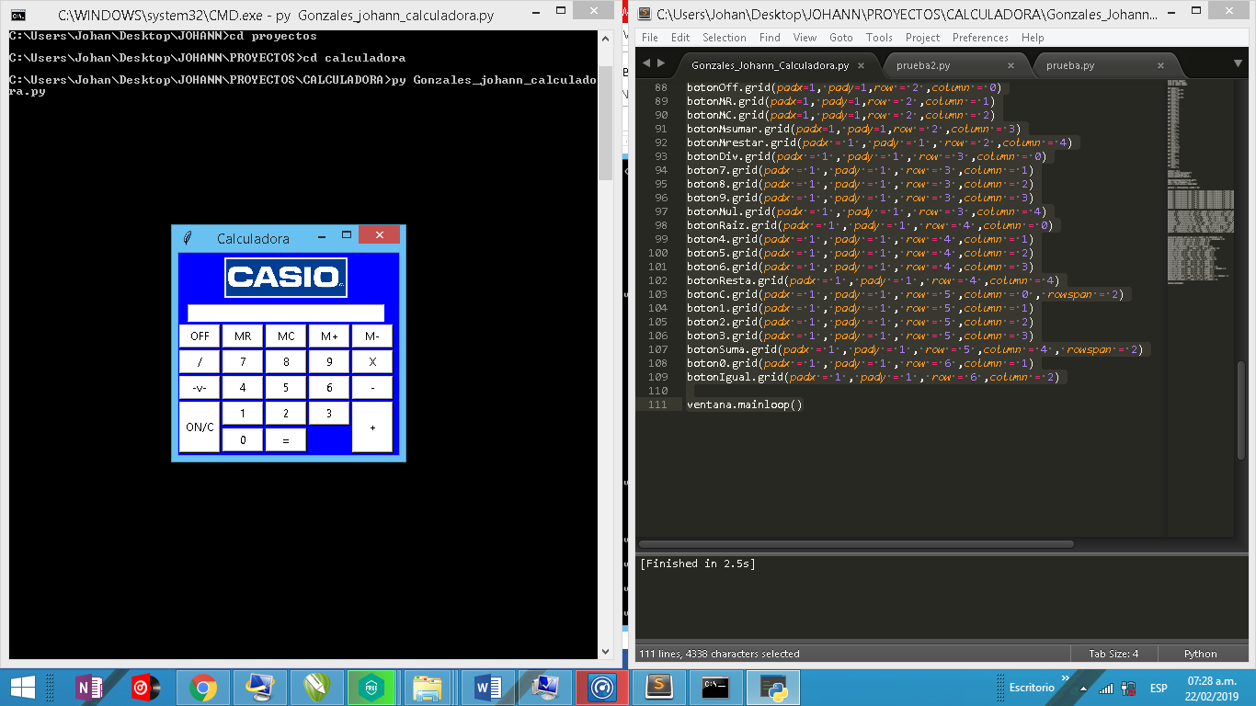**Resultado**

1. **Funciones para los botones de números**

**def Boton1():**

**pantalla.insert(END,"1")**

**pantalla.get()**

**def Boton2():**

**pantalla.insert(END,"2")**

**pantalla.get()**

**def Boton3():**

**pantalla.insert(END,"3")**

**pantalla.get()**

**def Boton4():**

**pantalla.insert(END,"4")**

**pantalla.get()**

**def Boton5():**

**pantalla.insert(END,"5")**

**pantalla.get()**

**def Boton6():**

**pantalla.insert(END,"6")**

**pantalla.get()**

**def Boton7():**

**pantalla.insert(END,"7")**

**pantalla.get()**

**def Boton8():**

**pantalla.insert(END,"8")**

**pantalla.get()**

**def Boton9():**

**pantalla.insert(END,"9")**

**pantalla.get()**

**def Boton0():**

**pantalla.insert(END,"0")**

**pantalla.get()**

**Resultado**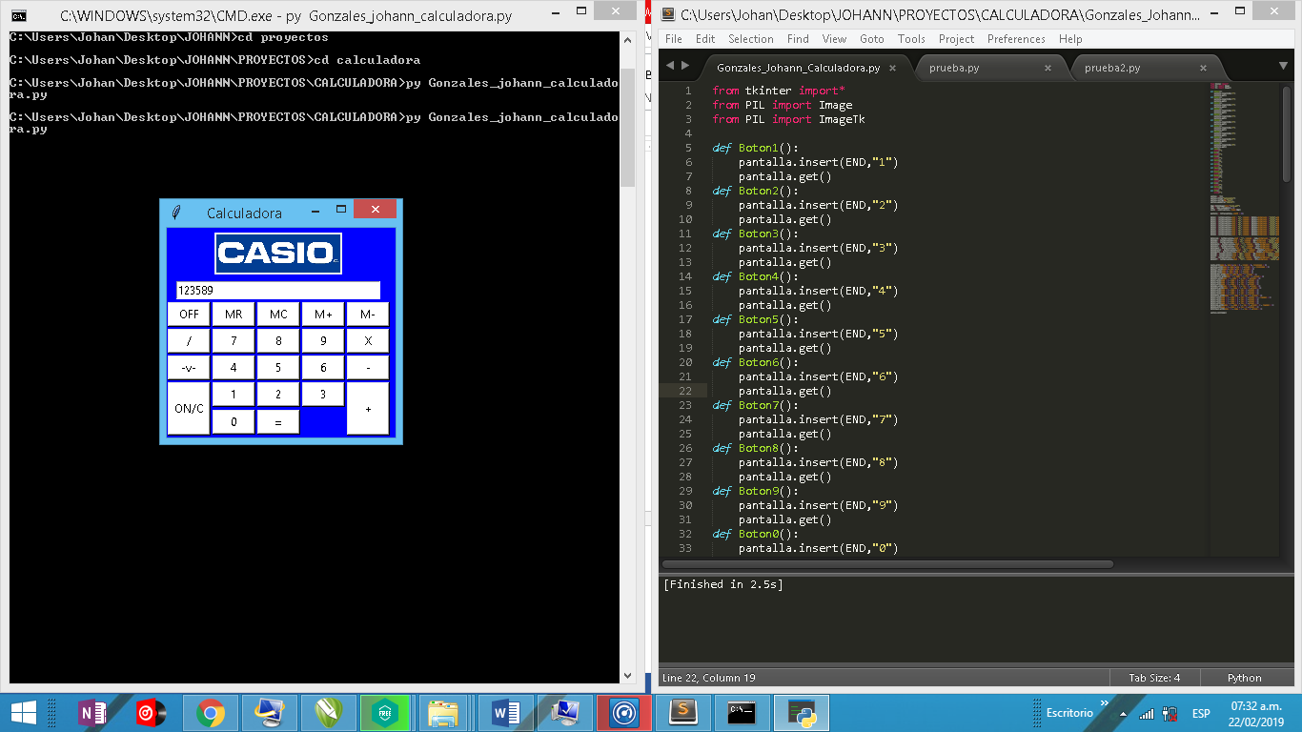

1. **Implementar la función del botón “ON/C”**

**def Borrar():**

**pantalla.delete(0,END)**

**pantalla.get()**

**RESULTADO**

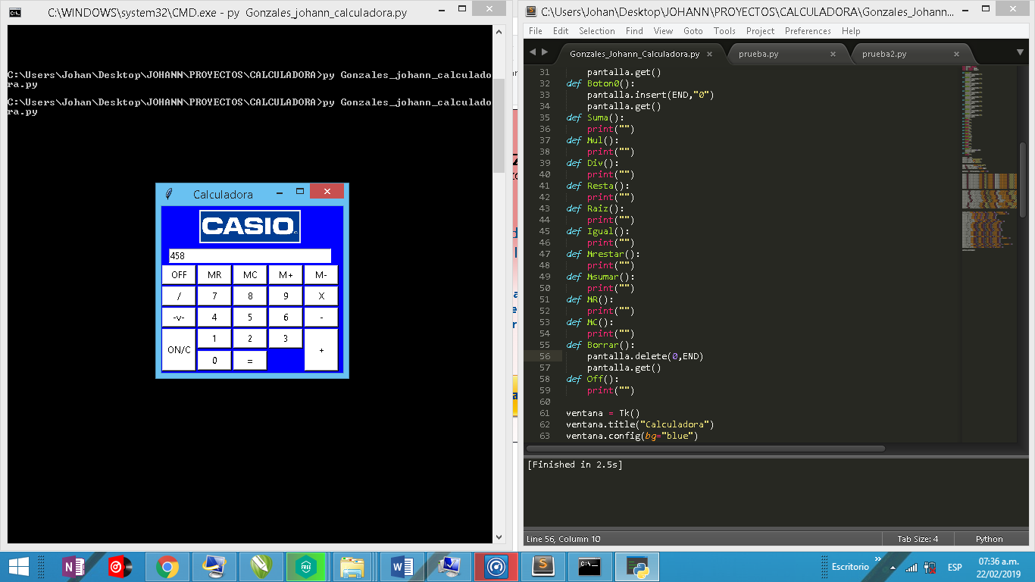

**Luego de presionar ON/C**

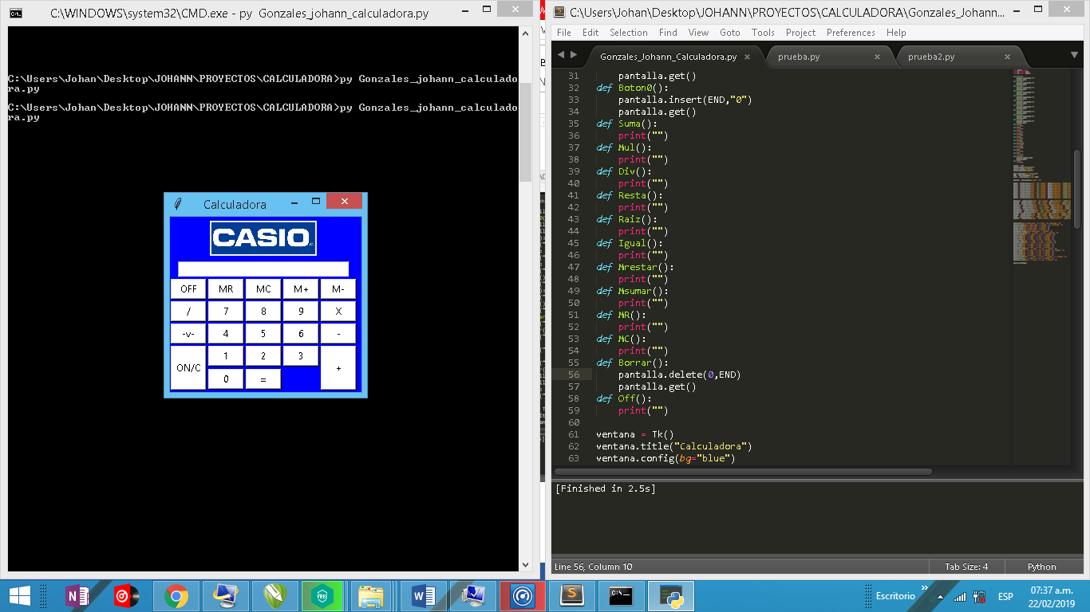

1. **Implementar la función del botón “Suma” e “Igual”**

**def Suma():**

**global suma**

**suma = suma + int(pantalla.get())**

**pantalla.delete(0,END)**

**def Mul():**

**print("")**

**def Div():**

**print("")**

**def Resta():**

**print("")**

**def Raiz():**

**print("")**

**def Igual():**

**global suma**

**suma = suma + int(pantalla.get())**

**pantalla.delete(0,END)**

**pantalla.insert(END,suma)**

**def Mrestar():**

**print("")**

**def Msumar():**

**print("")**

**def MR():**

**print("")**

**def MC():**

**print("")**

**def Borrar():**

**global suma**

**pantalla.delete(0,END)**

**pantalla.get()**

**suma = 0**

**RESULTADO**

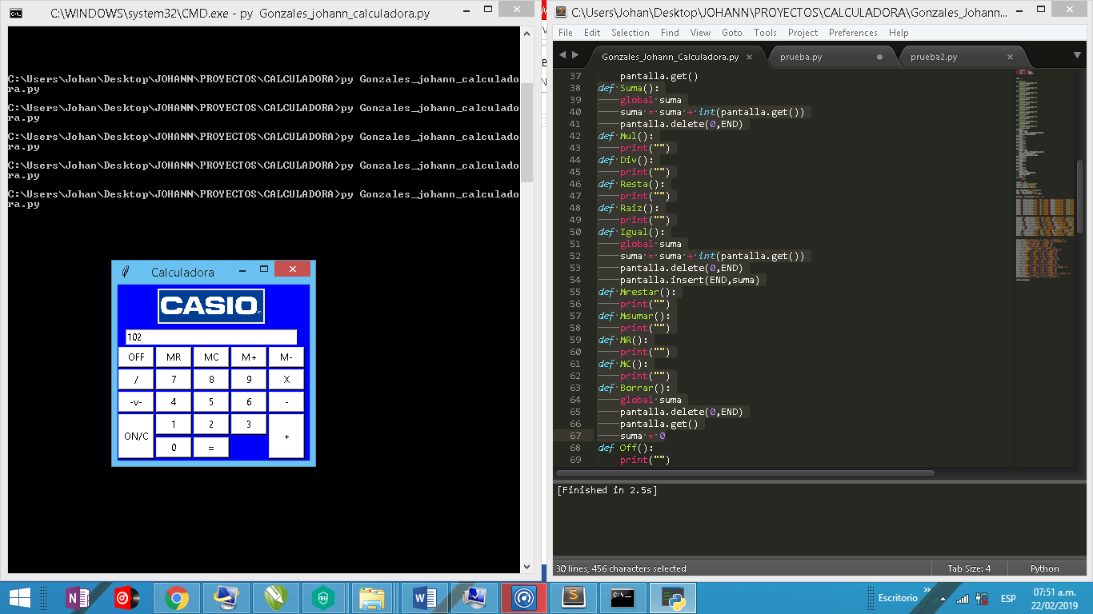

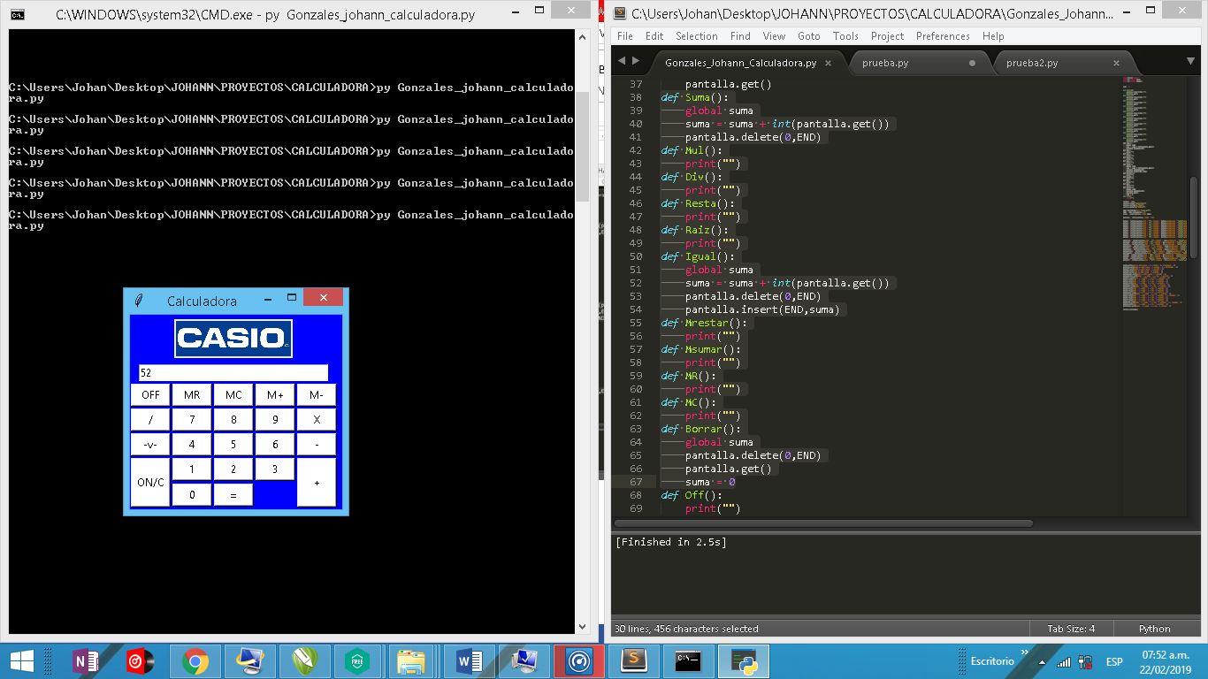

**Luego de sumar 102 + 52 = 154**

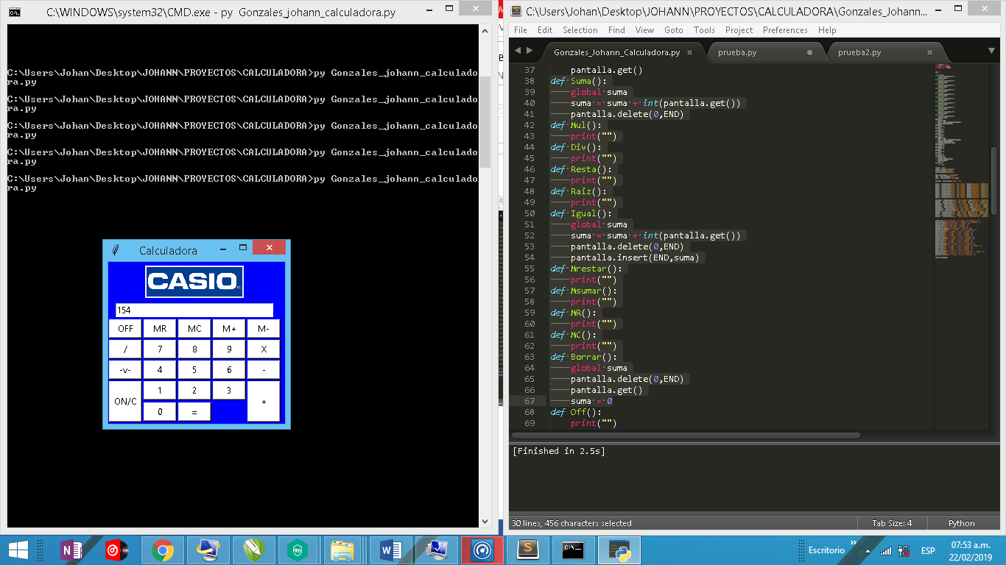

1. **Implementar los botones de operaciones**

**def Boton1():**

**pantalla.insert(END,"1")**

**pantalla.get()**

**def Boton2():**

**pantalla.insert(END,"2")**

**pantalla.get()**

**def Boton3():**

**pantalla.insert(END,"3")**

**pantalla.get()**

**def Boton4():**

**pantalla.insert(END,"4")**

**pantalla.get()**

**def Boton5():**

**pantalla.insert(END,"5")**

**pantalla.get()**

**def Boton6():**

**pantalla.insert(END,"6")**

**pantalla.get()**

**def Boton7():**

**pantalla.insert(END,"7")**

**pantalla.get()**

**def Boton8():**

**pantalla.insert(END,"8")**

**pantalla.get()**

**def Boton9():**

**pantalla.insert(END,"9")**

**pantalla.get()**

**def Boton0():**

**pantalla.insert(END,"0")**

**pantalla.get()**

**def Suma():**

**global suma, op , bsuma**

**if bsuma == 1:**

**suma = int(pantalla.get())**

**pantalla.delete(0,END)**

**bsuma = 0**

**else:**

**suma = suma + int(pantalla.get())**

**pantalla.delete(0,END)**

**op = 1**

**def Mul():**

**global mul , op , bmul**

**if bmul == 1:**

**mul = int(pantalla.get())**

**pantalla.delete(0,END)**

**bmul = 0**

**else:**

**mul = mul * int(pantalla.get())**

**pantalla.delete(0,END)**

**op = 2**

**def Div():**

**global div, op , bdiv**

**if bdiv == 1:**

**div = int(pantalla.get())**

**pantalla.delete(0,END)**

**bdiv = 0**

**else:**

**div = div / int(pantalla.get())**

**pantalla.delete(0,END)**

**op = 3**

**def Resta():**

**global resta, op , bresta**

**if bresta == 1:**

**resta = int(pantalla.get())**

**pantalla.delete(0,END)**

**bresta = 0**

**else:**

**resta = resta - int(pantalla.get())**

**pantalla.delete(0,END)**

**op = 4**

**def Raiz():**

**global raiz**

**raiz = int(pantalla.get())**(1/2)**

**pantalla.delete(0,END)**

**pantalla.insert(END,raiz)**

**def Igual():**

**global suma , mul , div, resta, op, bsuma , bmul , bdiv , bresta**

**if op == 1:**

**suma = suma + int(pantalla.get())**

**pantalla.delete(0,END)**

**pantalla.insert(END,suma)**

**bsuma = 1**

**if op == 2:**

**mul = mul * int(pantalla.get())**

**pantalla.delete(0,END)**

**pantalla.insert(END,mul)**

**bmul = 1**

**if op == 3:**

**div = div / int(pantalla.get())**

**pantalla.delete(0,END)**

**pantalla.insert(END,div)**

**bdiv = 1**

**if op == 4:**

**resta = resta - int(pantalla.get())**

**pantalla.delete(0,END)**

**pantalla.insert(END,resta)**

**bresta = 1**

**def Mrestar():**

**print("")**

**def Msumar():**

**print("")**

**def MR():**

**print("")**

**def MC():**

**print("")**

**def Borrar():**

**global suma , mul**

**pantalla.delete(0,END)**

**pantalla.get()**

**suma = 0**

**mul = 1**

**def Off():**

**print("")**

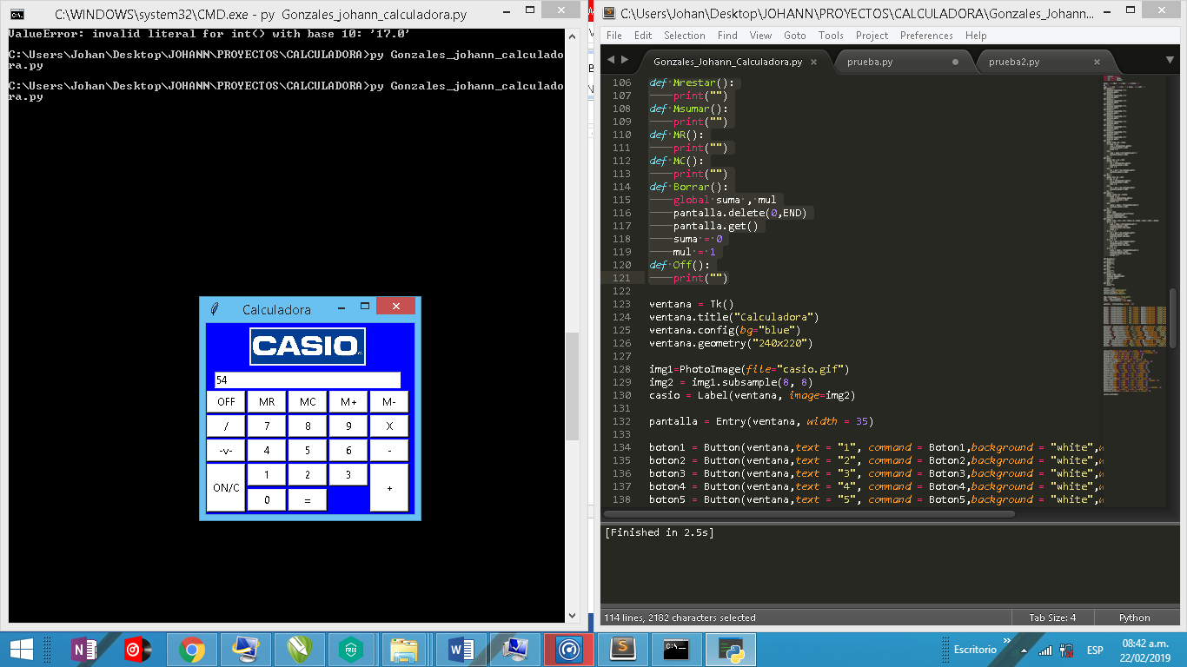**RESULTADO**

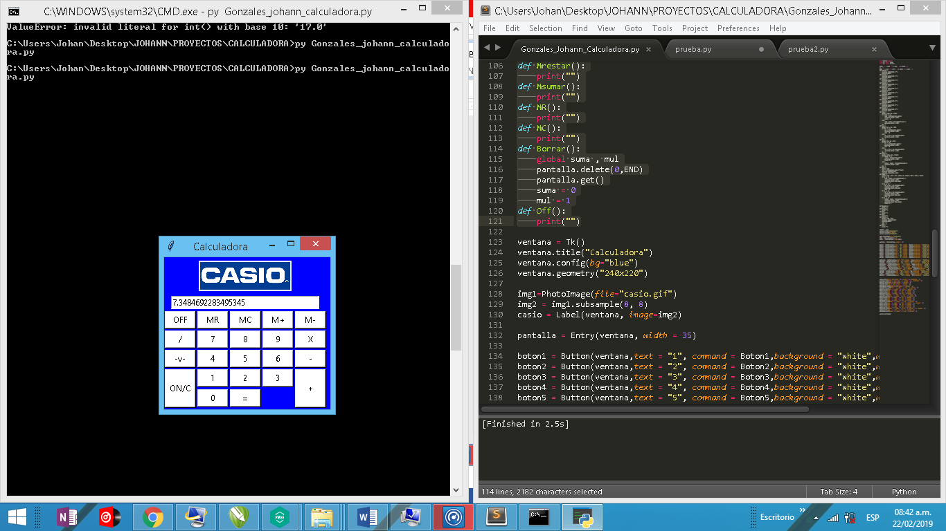**Luego de sacar raíz cuadrada a 54**

1. **Problema en el tipo de variable**

Como el resultado de dividir o realizar la raíz cuadrada daba un tipo float

**Corroboración:**

**raiz = int(pantalla.get())**(1/2)**

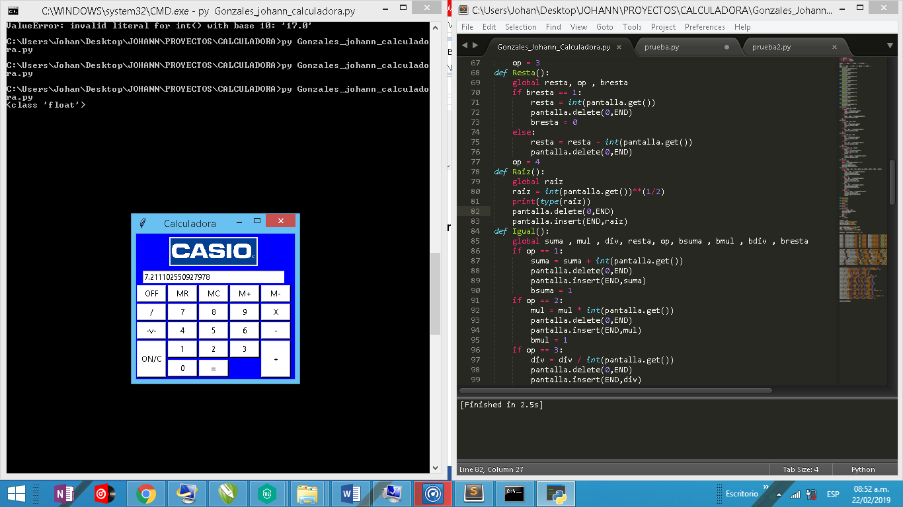 **print(type(raiz))**

En las bases no específica que usemos un botón del punto decimal, así que lo implementaremos como adicional y vamos a cambiar los tipos de datos que recibe el cuadro de texto a float.

**Código final:**

**from tkinter import\***

**from PIL import Image**

**from PIL import ImageTk**

**bsuma = 1 ; bmul = 1 ; bdiv = 1 ; bresta = 1**

**op = 0**

**suma = 0 ; mul = 1 ; div = 1 ; resta = 0 ; raiz = 1**

**def Boton1():**

**pantalla.insert(END,"1")**

**pantalla.get()**

**def Boton2():**

**pantalla.insert(END,"2")**

**pantalla.get()**

**def Boton3():**

**pantalla.insert(END,"3")**

**pantalla.get()**

**def Boton4():**

**pantalla.insert(END,"4")**

**pantalla.get()**

**def Boton5():**

**pantalla.insert(END,"5")**

**pantalla.get()**

**def Boton6():**

**pantalla.insert(END,"6")**

**pantalla.get()**

**def Boton7():**

**pantalla.insert(END,"7")**

**pantalla.get()**

**def Boton8():**

**pantalla.insert(END,"8")**

**pantalla.get()**

**def Boton9():**

**pantalla.insert(END,"9")**

**pantalla.get()**

**def Boton0():**

**pantalla.insert(END,"0")**

**pantalla.get()**

**def Punto():**

**pantalla.insert(END,".")**

**pantalla.get()**

**def Suma():**

**global suma, op , bsuma**

**if bsuma == 1:**

**suma = float(pantalla.get())**

**pantalla.delete(0,END)**

**bsuma = 0**

**else:**

**suma = suma + float(pantalla.get())**

**pantalla.delete(0,END)**

**op = 1**

**def Mul():**

**global mul , op , bmul**

**if bmul == 1:**

**mul = float(pantalla.get())**

**pantalla.delete(0,END)**

**bmul = 0**

**else:**

**mul = mul * float(pantalla.get())**

**pantalla.delete(0,END)**

**op = 2**

**def Div():**

**global div, op , bdiv**

**if bdiv == 1:**

**div = float(pantalla.get())**

**pantalla.delete(0,END)**

**bdiv = 0**

**else:**

**div = div / float(pantalla.get())**

**pantalla.delete(0,END)**

**op = 3**

**def Resta():**

**global resta, op , bresta**

**if bresta == 1:**

**resta = float(pantalla.get())**

**pantalla.delete(0,END)**

**bresta = 0**

**else:**

**resta = resta - float(pantalla.get())**

**pantalla.delete(0,END)**

**op = 4**

**def Raiz():**

**global raiz**

**raiz = float(pantalla.get())**(1/2)**

**pantalla.delete(0,END)**

**pantalla.insert(END,raiz)**

**def Igual():**

**global suma , mul , div, resta, op, bsuma , bmul , bdiv , bresta**

**if op == 1:**

**suma = suma + float(pantalla.get())**

**pantalla.delete(0,END)**

**pantalla.insert(END,suma)**

**bsuma = 1**

**if op == 2:**

**mul = mul * float(pantalla.get())**

**pantalla.delete(0,END)**

**pantalla.insert(END,mul)**

**bmul = 1**

**if op == 3:**

**div = div / float(pantalla.get())**

**pantalla.delete(0,END)**

**pantalla.insert(END,div)**

**bdiv = 1**

**if op == 4:**

**resta = resta - float(pantalla.get())**

**pantalla.delete(0,END)**

**pantalla.insert(END,resta)**

**bresta = 1**

**def Mrestar():**

**print("")**

**def Msumar():**

**print("")**

**def MR():**

**print("")**

**def MC():**

**print("")**

**def Borrar():**

**global suma , mul**

**pantalla.delete(0,END)**

**pantalla.get()**

**suma = 0**

**mul = 1**

**def Off():**

**print("")**

**ventana = Tk()**

**ventana.title("Calculadora")**

**ventana.config(bg="blue")**

**ventana.geometry("240x220")**

**img1=PhotoImage(file="casio.gif")**

**img2 = img1.subsample(8, 8)**

**casio = Label(ventana, image=img2)**

**pantalla = Entry(ventana, width = 35)**

**boton1 = Button(ventana,text = "1", command = Boton1,background = "white",width = 5 , height=1)**

**boton2 = Button(ventana,text = "2", command = Boton2,background = "white",width = 5,height=1)**

**boton3 = Button(ventana,text = "3", command = Boton3,background = "white",width = 5,height=1)**

**boton4 = Button(ventana,text = "4", command = Boton4,background = "white",width = 5,height=1)**

**boton5 = Button(ventana,text = "5", command = Boton5,background = "white",width = 5,height=1)**

**boton6 = Button(ventana,text = "6", command = Boton6,background = "white",width = 5,height=1)**

**boton7 = Button(ventana,text = "7", command = Boton7,background = "white",width = 5,height=1)**

**boton8 = Button(ventana,text = "8", command = Boton8,background = "white",width = 5,height=1)**

**boton9 = Button(ventana,text = "9", command = Boton9,background = "white",width = 5,height=1)**

**boton0 = Button(ventana,text = "0", command = Boton0,background = "white",width = 5,height=1)**

**botonSuma = Button(ventana,text = "+", command = Suma,background = "white",width = 5,height=3)**

**botonMul = Button(ventana,text = "X", command = Mul,background = "white",width = 5,height=1)**

**botonDiv = Button(ventana,text = "/", command = Div,background = "white",width = 5,height=1)**

**botonResta = Button(ventana,text = "-", command = Resta,background = "white",width = 5,height=1)**

**botonRaiz = Button(ventana,text = "-v-", command = Raiz,background = "white",width = 5,height=1)**

**botonIgual = Button(ventana,text = "=", command = Igual,background = "white",width = 5,height=1)**

**botonMrestar = Button(ventana,text = "M-", command = Mrestar,background = "white",width = 5,height=1)**

**botonMsumar = Button(ventana,text = "M+", command = Msumar,background = "white",width = 5,height=1)**

**botonMR = Button(ventana,text = "MR", command = MR,background = "white",width = 5,height=1)**

**botonMC = Button(ventana,text = "MC", command = MC,background = "white",width = 5,height=1)**

**botonC = Button(ventana,text = "ON/C", command = Borrar,background = "white",width = 5,height=3)**

**botonOff = Button(ventana,text = "OFF", command = Off,background = "white",width = 5 ,height=1)**

**botonPunto = Button(ventana,text = ".", command = Punto,background = "white",width = 5 ,height=1)**

**casio.grid(padx=5, pady=5,row = 0 , column = 0, columnspan = 5)**

**pantalla.grid(padx=2, pady=2,row = 1 ,column = 0 , columnspan = 5)**

**botonOff.grid(padx=1, pady=1,row = 2 ,column = 0)**

**botonMR.grid(padx=1, pady=1,row = 2 ,column = 1)**

**botonMC.grid(padx=1, pady=1,row = 2 ,column = 2)**

**botonMsumar.grid(padx=1, pady=1,row = 2 ,column = 3)**

**botonMrestar.grid(padx = 1 , pady = 1 , row = 2 ,column = 4)**

**botonDiv.grid(padx = 1 , pady = 1 , row = 3 ,column = 0)**

**boton7.grid(padx = 1 , pady = 1 , row = 3 ,column = 1)**

**boton8.grid(padx = 1 , pady = 1 , row = 3 ,column = 2)**

**boton9.grid(padx = 1 , pady = 1 , row = 3 ,column = 3)**

**botonMul.grid(padx = 1 , pady = 1 , row = 3 ,column = 4)**

**botonRaiz.grid(padx = 1 , pady = 1 , row = 4 ,column = 0)**

**boton4.grid(padx = 1 , pady = 1 , row = 4 ,column = 1)**

**boton5.grid(padx = 1 , pady = 1 , row = 4 ,column = 2)**

**boton6.grid(padx = 1 , pady = 1 , row = 4 ,column = 3)**

**botonResta.grid(padx = 1 , pady = 1 , row = 4 ,column = 4)**

**botonC.grid(padx = 1 , pady = 1 , row = 5 ,column = 0 , rowspan = 2)**

**boton1.grid(padx = 1 , pady = 1 , row = 5 ,column = 1)**

**boton2.grid(padx = 1 , pady = 1 , row = 5 ,column = 2)**

**boton3.grid(padx = 1 , pady = 1 , row = 5 ,column = 3)**

**botonSuma.grid(padx = 1 , pady = 1 , row = 5 ,column = 4 , rowspan = 2)**

**boton0.grid(padx = 1 , pady = 1 , row = 6 ,column = 1)**

**botonPunto.grid(padx = 1 , pady = 1 , row = 6 ,column = 2)**

**botonIgual.grid(padx = 1 , pady = 1 , row = 6 ,column = 3)**

**ventana.mainloop()**

**Resultado**

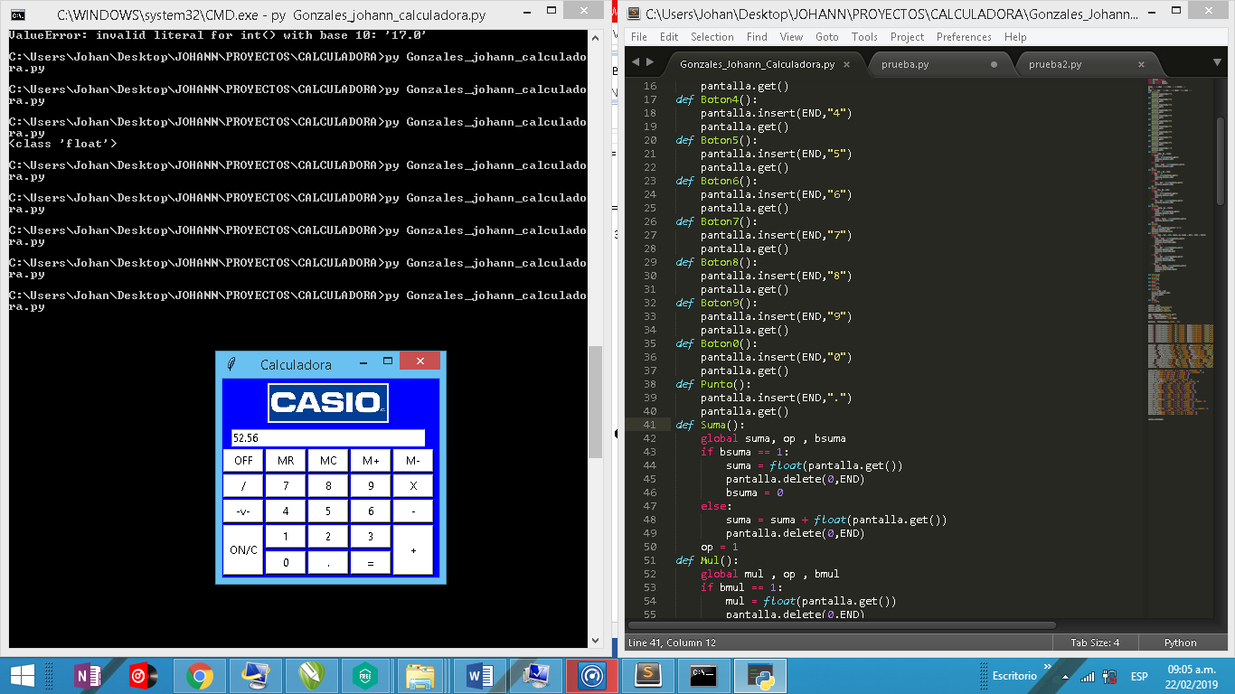

1. **Implementación de los botones de memoria y Off**

**def Mrestar():**

**global m**

**m = m - float(pantalla.get())**

**def Msumar():**

**global m**

**m = m + float(pantalla.get())**

**def MR():**

**global m**

**pantalla.delete(0,END)**

**pantalla.insert(END,m)**

**def MC():**

**global m**

**m = 0**

**def Borrar():**

**global suma , mul**

**pantalla.delete(0,END)**

**pantalla.get()**

**suma = 0**

**mul = 1**

**resta = 0**

**div = 1**

**def Off():**

**ventana.destroy()**

**RESULTADO**

**“54” guardado en memoria**

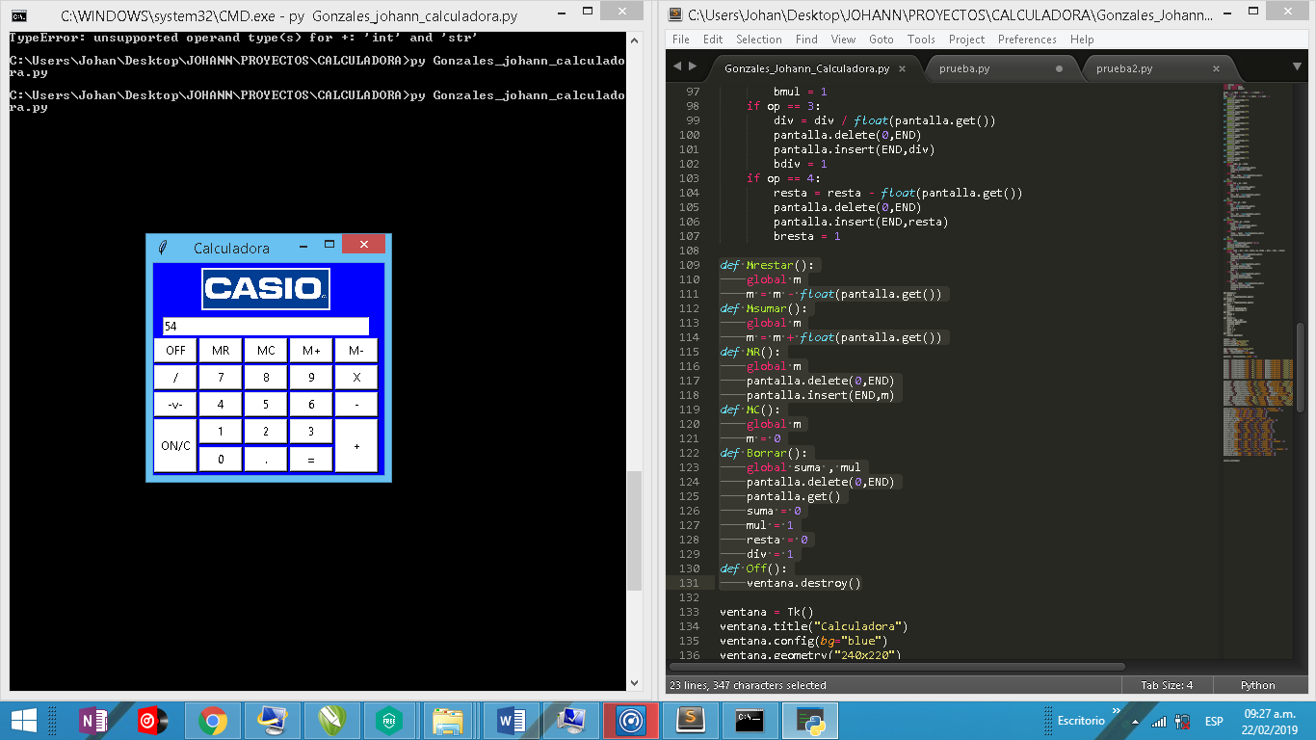

1. **Estética Final**

**Insertare otros colores y efectos a los botones, también se asimilara el color de fondo con el de CASIO. Agregare una firma en la parte de debajo de la calculadora**

**from tkinter import\***

**from PIL import Image**

**from PIL import ImageTk**

**from tkinter import font**

**bsuma = 1 ; bmul = 1 ; bdiv = 1 ; bresta = 1**

**op = 0 ; m = 0**

**suma = 0 ; mul = 1 ; div = 1 ; resta = 0 ; raiz = 1**

**def Boton1():**

**pantalla.insert(END,"1")**

**pantalla.get()**

**def Boton2():**

**pantalla.insert(END,"2")**

**pantalla.get()**

**def Boton3():**

**pantalla.insert(END,"3")**

**pantalla.get()**

**def Boton4():**

**pantalla.insert(END,"4")**

**pantalla.get()**

**def Boton5():**

**pantalla.insert(END,"5")**

**pantalla.get()**

**def Boton6():**

**pantalla.insert(END,"6")**

**pantalla.get()**

**def Boton7():**

**pantalla.insert(END,"7")**

**pantalla.get()**

**def Boton8():**

**pantalla.insert(END,"8")**

**pantalla.get()**

**def Boton9():**

**pantalla.insert(END,"9")**

**pantalla.get()**

**def Boton0():**

**pantalla.insert(END,"0")**

**pantalla.get()**

**def Punto():**

**pantalla.insert(END,".")**

**pantalla.get()**

**def Suma():**

**global suma, op , bsuma**

**if bsuma == 1:**

**suma = float(pantalla.get())**

**pantalla.delete(0,END)**

**bsuma = 0**

**else:**

**suma = suma + float(pantalla.get())**

**pantalla.delete(0,END)**

**op = 1**

**def Mul():**

**global mul , op , bmul**

**if bmul == 1:**

**mul = float(pantalla.get())**

**pantalla.delete(0,END)**

**bmul = 0**

**else:**

**mul = mul * float(pantalla.get())**

**pantalla.delete(0,END)**

**op = 2**

**def Div():**

**global div, op , bdiv**

**if bdiv == 1:**

**div = float(pantalla.get())**

**pantalla.delete(0,END)**

**bdiv = 0**

**else:**

**div = div / float(pantalla.get())**

**pantalla.delete(0,END)**

**op = 3**

**def Resta():**

**global resta, op , bresta**

**if bresta == 1:**

**resta = float(pantalla.get())**

**pantalla.delete(0,END)**

**bresta = 0**

**else:**

**resta = resta - float(pantalla.get())**

**pantalla.delete(0,END)**

**op = 4**

**def Raiz():**

**global raiz**

**raiz = float(pantalla.get())**(1/2)**

**pantalla.delete(0,END)**

**pantalla.insert(END,raiz)**

**def Igual():**

**global suma , mul , div, resta, op, bsuma , bmul , bdiv , bresta**

**if op == 1:**

**suma = suma + float(pantalla.get())**

**pantalla.delete(0,END)**

**pantalla.insert(END,suma)**

**bsuma = 1**

**if op == 2:**

**mul = mul * float(pantalla.get())**

**pantalla.delete(0,END)**

**pantalla.insert(END,mul)**

**bmul = 1**

**if op == 3:**

**div = div / float(pantalla.get())**

**pantalla.delete(0,END)**

**pantalla.insert(END,div)**

**bdiv = 1**

**if op == 4:**

**resta = resta - float(pantalla.get())**

**pantalla.delete(0,END)**

**pantalla.insert(END,resta)**

**bresta = 1**

**def Mrestar():**

**global m**

**m = m - float(pantalla.get())**

**def Msumar():**

**global m**

**m = m + float(pantalla.get())**

**def MR():**

**global m**

**pantalla.delete(0,END)**

**pantalla.insert(END,m)**

**def MC():**

**global m**

**m = 0**

**def Borrar():**

**global suma , mul**

**pantalla.delete(0,END)**

**pantalla.get()**

**suma = 0**

**mul = 1**

**resta = 0**

**div = 1**

**def Off():**

**ventana.destroy()**

**ventana = Tk()**

**ventana.title("Calculadora")**

**ventana.config(bg="#013D93")**

**ventana.geometry("235x260")**

**futura = font.Font(family = "Comic Sans MS", size = 8, weight="bold")**

**negrita = font.Font(size = 8 , weight="bold")**

**img1=PhotoImage(file="casio.gif")**

**img2 = img1.subsample(8, 8)**

**casio = Label(ventana, image=img2)**

**pantalla = Entry(ventana, width = 36)**

**boton1 = Button(ventana,text = "1", command = Boton1,background = "#99FFFF",width = 5 , height=1)**

**boton2 = Button(ventana,text = "2", command = Boton2,background = "#99FFFF",width = 5,height=1)**

**boton3 = Button(ventana,text = "3", command = Boton3,background = "#99FFFF",width = 5,height=1)**

**boton4 = Button(ventana,text = "4", command = Boton4,background = "#99FFFF",width = 5,height=1)**

**boton5 = Button(ventana,text = "5", command = Boton5,background = "#99FFFF",width = 5,height=1)**

**boton6 = Button(ventana,text = "6", command = Boton6,background = "#99FFFF",width = 5,height=1)**

**boton7 = Button(ventana,text = "7", command = Boton7,background = "#99FFFF",width = 5,height=1)**

**boton8 = Button(ventana,text = "8", command = Boton8,background = "#99FFFF",width = 5,height=1)**

**boton9 = Button(ventana,text = "9", command = Boton9,background = "#99FFFF",width = 5,height=1)**

**boton0 = Button(ventana,text = "0", command = Boton0,background = "#99FFFF",width = 5,height=1)**

**botonSuma = Button(ventana,text = "+", command = Suma,background = "#9900FF",width = 5,height=3)**

**botonMul = Button(ventana,text = "X", command = Mul,background = "#9900FF",width = 5,height=1)**

**botonDiv = Button(ventana,text = "/", command = Div,background = "#9900FF",width = 5,height=1)**

**botonResta = Button(ventana,text = "-", command = Resta,background = "#9900FF",width = 5,height=1)**

**botonRaiz = Button(ventana,text = "√", command = Raiz,background = "#9900FF",width = 5,height=1)**

**botonIgual = Button(ventana,text = "=", command = Igual,background = "#9900FF",width = 5,height=1)**

**botonMrestar = Button(ventana,text = "M-", command = Mrestar,background = "#C6C770",width = 5,height=1)**

**botonMsumar = Button(ventana,text = "M+", command = Msumar,background = "#C6C770",width = 5,height=1)**

**botonMR = Button(ventana,text = "MR", command = MR,background = "#C6C770",width = 5,height = 1)**

**botonMC = Button(ventana,text = "MC", command = MC,background = "#C6C770",width = 5,height = 1)**

**botonC = Button(ventana,text = "ON/C",font = negrita ,command = Borrar,background = "#FF6600",borderwidth = 4 , width = 5,height=3)**

**botonOff = Button(ventana,text = "OFF",font = negrita ,command = Off,background = "#FF6600",borderwidth = 4 , width = 5 ,height=1)**

**botonPunto = Button(ventana,text = ".", command = Punto,background = "#99FFFF",width = 5 , height=1)**

**etiqueta = Label(ventana,text = "Hecho por: Johguxo" , font = futura)**

**casio.grid(padx=5, pady=5,row = 0 , column = 0, columnspan = 5)**

**pantalla.grid(padx=2, pady=2,row = 1 ,column = 0 , columnspan = 5)**

**botonOff.grid(padx=1, pady=1,row = 2 ,column = 0)**

**botonMR.grid(padx=1, pady=1,row = 2 ,column = 1)**

**botonMC.grid(padx=1, pady=1,row = 2 ,column = 2)**

**botonMsumar.grid(padx=1, pady=1,row = 2 ,column = 3)**

**botonMrestar.grid(padx = 1 , pady = 1 , row = 2 ,column = 4)**

**botonDiv.grid(padx = 1 , pady = 1 , row = 3 ,column = 0)**

**boton7.grid(padx = 1 , pady = 1 , row = 3 ,column = 1)**

**boton8.grid(padx = 1 , pady = 1 , row = 3 ,column = 2)**

**boton9.grid(padx = 1 , pady = 1 , row = 3 ,column = 3)**

**botonMul.grid(padx = 1 , pady = 1 , row = 3 ,column = 4)**

**botonRaiz.grid(padx = 1 , pady = 1 , row = 4 ,column = 0)**

**boton4.grid(padx = 1 , pady = 1 , row = 4 ,column = 1)**

**boton5.grid(padx = 1 , pady = 1 , row = 4 ,column = 2)**

**boton6.grid(padx = 1 , pady = 1 , row = 4 ,column = 3)**

**botonResta.grid(padx = 1 , pady = 1 , row = 4 ,column = 4)**

**botonC.grid(padx = 1 , pady = 1 , row = 5 ,column = 0 , rowspan = 2)**

**boton1.grid(padx = 1 , pady = 1 , row = 5 ,column = 1)**

**boton2.grid(padx = 1 , pady = 1 , row = 5 ,column = 2)**

**boton3.grid(padx = 1 , pady = 1 , row = 5 ,column = 3)**

**botonSuma.grid(padx = 1 , pady = 1 , row = 5 ,column = 4 , rowspan = 2)**

**boton0.grid(padx = 1 , pady = 1 , row = 6 ,column = 1)**

**botonPunto.grid(padx = 1 , pady = 1 , row = 6 ,column = 2)**

**botonIgual.grid(padx = 1 , pady = 1 , row = 6 ,column = 3)**

**etiqueta.grid(padx = 1, pady = 2 , row = 7 ,column = 0,columnspan = 5)**

**ventana.mainloop()**

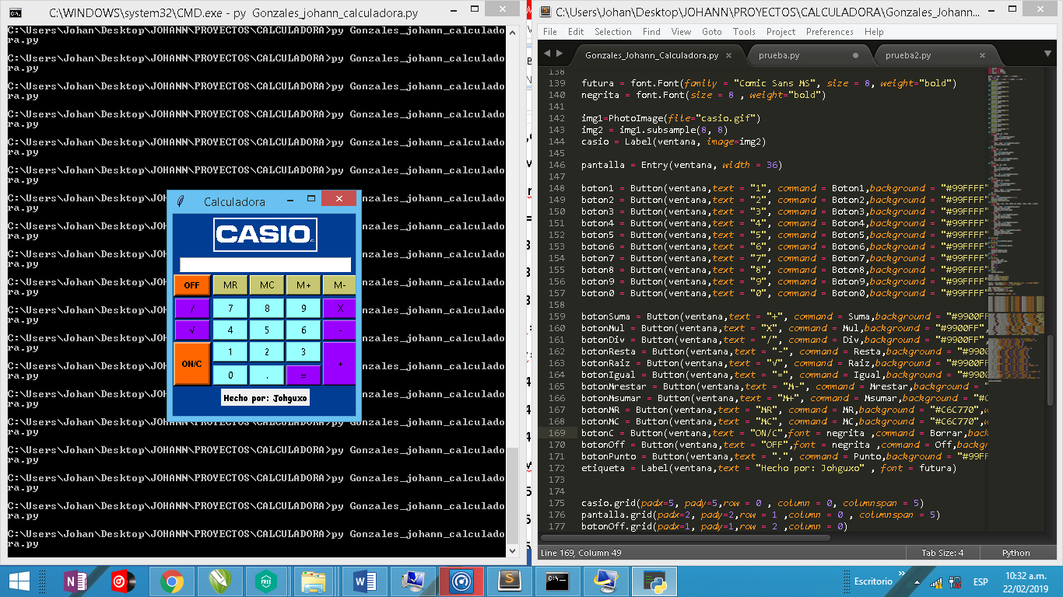**RESULTADO**

**RESULTADO FINAL**

