Solar Panel Assessment Tool

**CEG4912 : Computer Engineering Project**

Fall 2018

School of Information Technology and Engineering

University of Ottawa

Professor : Dan Ionescu

Teaching assistants :

Hamideh Ghanadian

Keerthimalikaa Mohan

Kushagra Mohan Kalra

Submitted : September 20 2018

Chieh Ko - 8477221

Maxime Laurin - 8032283

Johic Mes - 8182049

Kadiatou N’Diaye - 7939396

# Table Of Contents

**Project Description** **2**

**Project Rationale** **2**

**Project Architecture** **3**

Figure 1: High Level Architecture. 3

Figure 2: Low Level Architecture 3

**Project Requirements.** **4**

**Budget** **5**

**Project Breakdown and Timelines** **6**

Figure 3: Gantt chart of the Solar Panel Assessment Tool 6

**Work Breakdown Structure of the Project** **7**

Figure 4: WBS of the Project 7

# 

# Project Description

The proposed project is a solar panel assessment tool. With the help of light sensors, the main hardware will log the intensity of light hitting a roof over a long period of time. Also, a solar panel will be used to measure the voltage it produces. Our microcontroller will then use an algorithm to rotate the light sensor with the goal of maximizing the amount of energy captured. The angle that the motors will stop on will be logged in the hopes to understand the best position for potential solar panels. During winter, our microcontroller should be able to detect and then clean the snow off the solar panels. This data will be sent to a server via the wifi chip on the main microcontroller. This server will update in real time and allow data to be pulled from it anywhere. This data will be utilised by a web page to visualise all the data captured. This allows for any user to understand how much light solar panels could gather and turn into electricity in their home. This product should help determine the solar potential of a specific home and in turn verify if solar panels are a good renewable energy investment for a household.

# Project Rationale

The use of carbon based energies is having a detrimental impact on the planet and atmosphere we live in. Fossil fuels and other forms of non renewable energies contribute to a changing climate, rise in sea levels and many adverse effects on our wellbeing.[1] While the influence of mankind has been clear for years, progress to turn away from our ways of generating energy through fossil fuels has been slow. To see an impactful shift in the way we power our lives, it is crucial to make access, discover and transition to renewable energy as pain free and quick as possible. This is the challenge our product is geared to tackle.

Solar panels are a great source of renewable energy. Sadly, not every roof or area is suitable for the technology. Some are at a bad angle where there may exist an obstruction limiting sunlight while others might simply be facing the wrong direction. Unfortunately, it is hard to tell what surface has these defects without consulting with an expert and getting an assessment. Due to the versatility attribute of our product, it would be able to collect real time useful information in a short period while providing the flexibility for the customer to determine the economic and physical feasibility of installing solar panels on their homes. This is beneficial to the consumer since one of the major problems with solar panels is once installed they are permanently there unlike our product which is there to first test and provide useful information before things become permanent. It would enable more individuals to discover if this renewable energy is right for them and if the solar panels could become a potential investment in which the client could sell back the additional energy generated to the community. Our product would empower clients to make a more informed choice rather than deciding based upon the sheltered facts from sales pitches. Finally, it would simplify the transition and access to a technology that can often be daunting to understand.

# Research

By doing research on the web, we noticed that microcontroller using solar panels are already a common project. As such, parts and design are already on the internet and we could easily use them as inspiration. However, our project differs in the following aspects : we have as a goal the calculation of the optimal angle for the solar panel installation and the accumulation of data over a long period of time. We do not want to build a solar tracking solar panel as can be seen in most of those projects, we want to calculate the best fixed position for the installation of fixed solar panels.

We also plan on using sources to figure out the factors leading to an optimum position for our solar panels.[2] Our device will find the optimum spot empirically and we will be able to compare our result with our source.

We will also need to handle canadian winter. We will need to detect when snow is present on the solar panel, to do this we take inspiration from existing research ([3]) and we will try to improve upon it in our project. We will then need to remove the snow by rotating the solar panel. This is expected to work with light snow, however testing should done to see if it is good enough to deal with heavier snow.

# 

# Project Architecture

The following figure is the high level view of the project architecture.

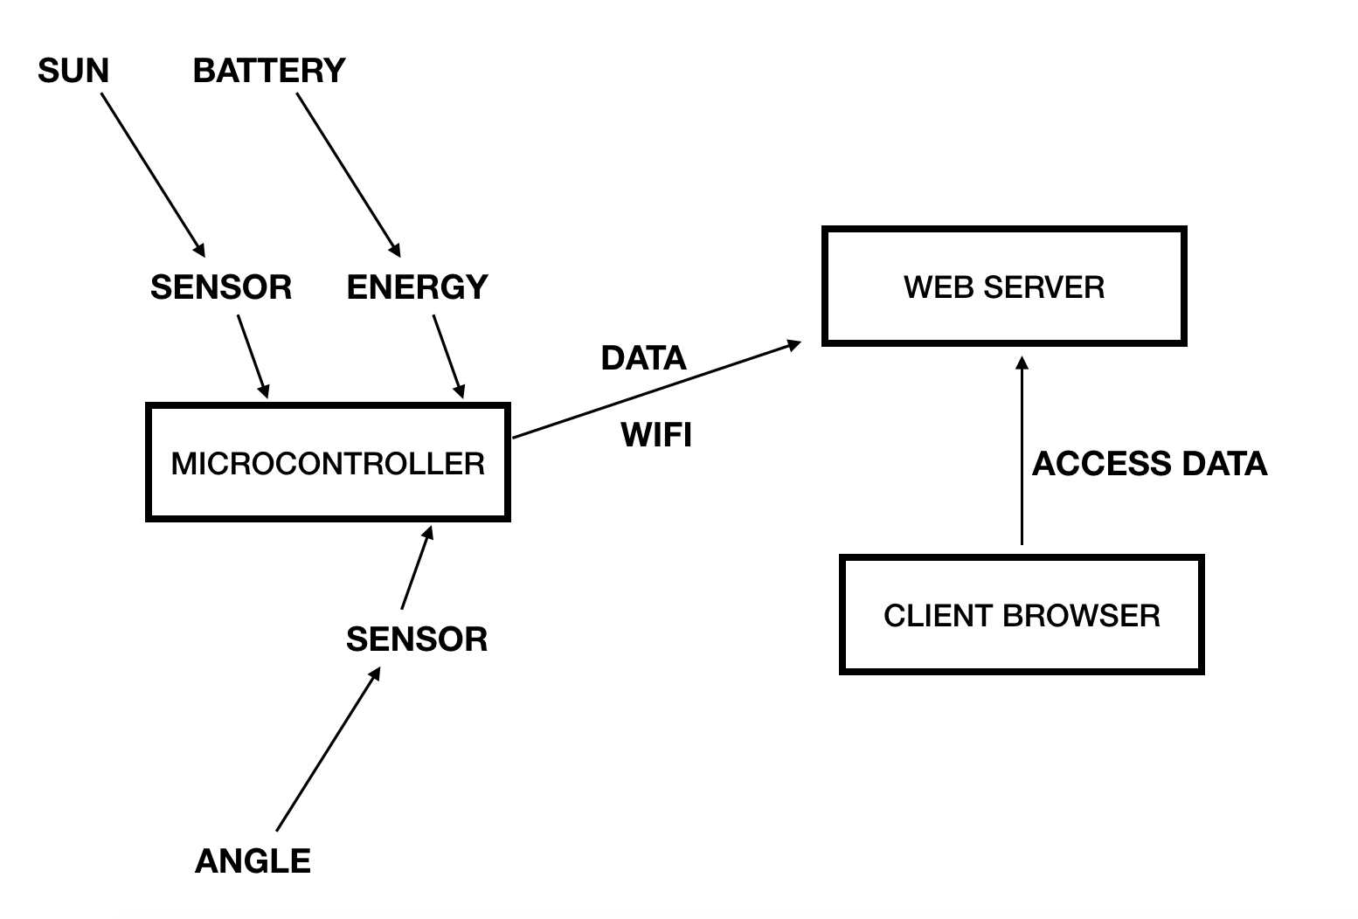

#### Figure 1: High Level Architecture.

The project also contains a low level view of the architecture.

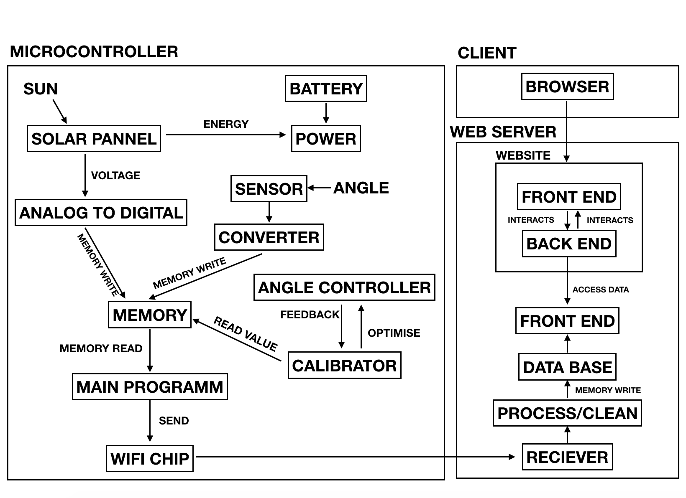

#### Figure 2: Low Level Architecture

# Project Requirements.

**Project Requirements:**

1. Non Functional Requirements:

* The solar panel assessment tool will be versatile and easy to use/install
* The solar panel assessment tool will be weather proof ie. waterproof, windproof
* The solar panel assessment tool will be able to efficiently collect and transmit data obtained from the sensors

1. Functional Requirements:

* The solar panel assessment tool will use the sensors to capture light intensity at all times and transmit the data to the servers for data processing
* The rotating motors on the solar panel assessment tool will be able to find the best angle for solar panels to be installed
* The snow will be detected and removed automatically by rotating the solar panel
* This tool would be able to display useful information regarding the amount of energy that is being generated and allow users to understand the solar potential for their household

1. Software Requirements:

* Our web page will be user-friendly and user oriented
* The data collected will be securely displayed for the user to visualize
* The information will be reliable in displayed in real-time

# 

# Budget

The cost associated with this project are purely hardware based. Here is a breakdown of the components needed and their cost.

|  |  |
| --- | --- |
| **Part** | **Cost** |
| ARDUINO MKR WIFI 1010 ………………………………………………………………... | 29.90 |
| GROVE - LIGHT SENSOR …………………………………………………………………  OR  GROVE - SUNLIGHT SENSOR …………………………………………………………… | 3.50  11.90 |
| 2X MOTORS ………………………………………………………………………………… | 7.50 |
| SOLAR PANEL ………..…………………………………………………………………….. | 13.90 |
| **TOTAL AFTER TAXES** | $79.89 |

|  |  |
| --- | --- |
| SHIPPING | 37.83 |
| **TOTAL + SHIPPING** | **$117.72** |

* The total was calculated with the most expensive sunlight sensor.

As seen above a budget of about 120 dollars is essential to acquire all the necessary components. An easy way to save a great deal of money would be finding a local retailer for arduino components. This would remove the 37.83 necessary for shipping costs. As with any project some unforeseen costs could always arise so setting aside a contingency fund would be a good idea.

# Project Breakdown and Timelines

The following gantt chart expresses the hopeful deadlines our team expects to meet. The deadlines are meant to culminate to the end of the winter semester in 2019.

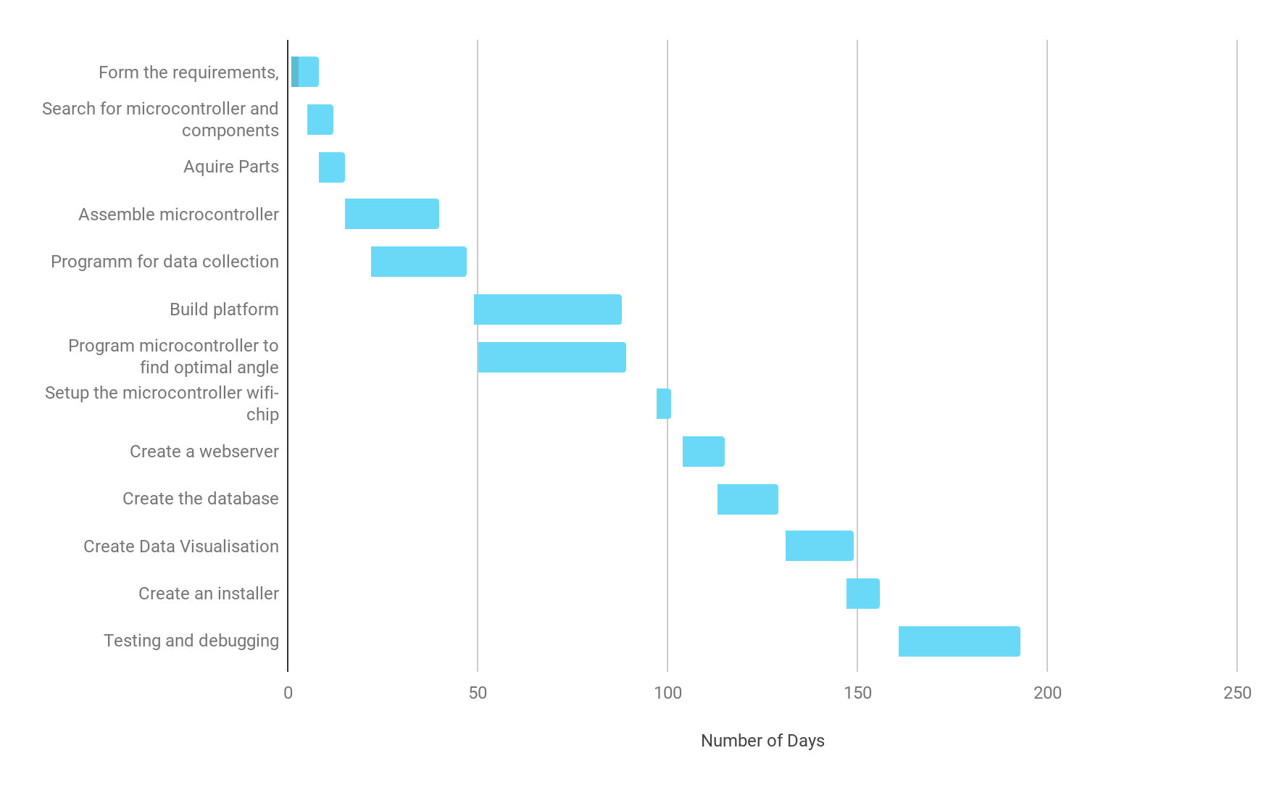

#### Figure 3: Gantt chart of the Solar Panel Assessment Tool

# 

# Work Breakdown Structure of the Project

The following figure presents the breakdown of task in the teams project.

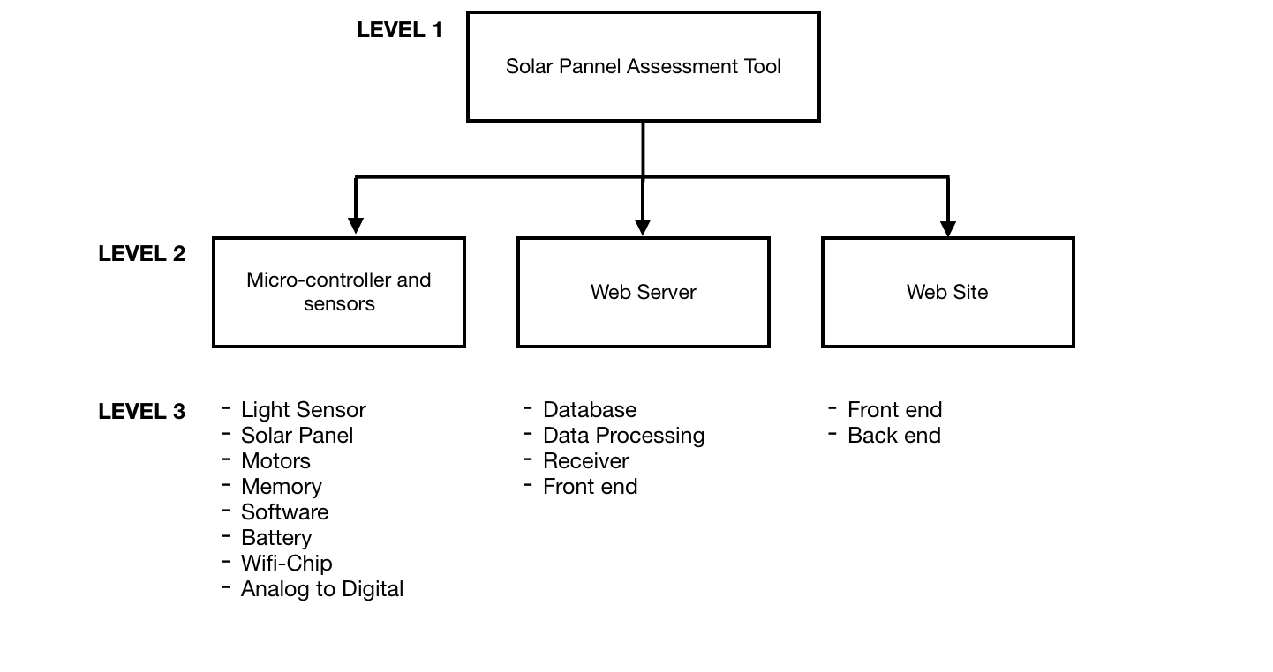

#### Figure 4: WBS of the Project

# Bibliography

[1]R. Jackson, "Global Climate Change: Effects", *Climate Change: Vital Signs of the Planet*, 2018. [Online]. Available: https://climate.nasa.gov/effects/. [Accessed: 26- Sep- 2018].

[2]”Optimum Tilt of Solar Panels”, *Solarpaneltilt.com*, 2018. [Online]. Available: <https://www.solarpaneltilt.com/>. [Accessed: 26- Sep- 2018].

[3]S. Meghdadi and T. Iqbal, “A Low Cost Method of Snow Detection on Solar Panels and Sending Alerts”, *Journal of Clean Energy Technologies,* vol.3 no. 5, pp. 393-397, 2015.