Exploratory Data Analysis and Visualization
Uncovering Patterns in the Titanic Passenger Dataset
Week 2 Task — EDA & Visualization Report
Prepared with Python (pandas, matplotlib, seaborn)
September 2026

Executive Summary
This report presents an exploratory data analysis (EDA) of the cleaned Titanic passenger dataset (891 passengers, 20 fields) produced in the prior data-cleaning phase of this project. The goal of this phase is not to clean the data further but to look at it closely: to summarize its basic statistical properties, visualize its distributions and relationships from multiple angles, and interpret the patterns that emerge in light of what is historically known about the disaster.
Thirteen visualizations were produced using Matplotlib and Seaborn, moving from univariate distributions, through bivariate relationships between individual features and survival, to multivariate views that combine three or more variables at once (class, sex, age, and fare together). Every chart is annotated with a title, axis labels, and a legend where relevant, and is followed by an interpretation of what the pattern shows and a plausible explanation for why it exists, grounded in the historical and social context of the 1912 voyage.
At a glance — headline findings
Overall survival rate: 38.4% · Female survival rate (74.2%) is nearly 4x the male rate (18.9%) · 1st class survival (63.0%) is more than double 3rd class (24.2%) · Passengers with 3–4 family members aboard survived at the highest rate (55–72%), while solo travelers and very large families survived least · Fare correlates with survival (r = 0.26) more strongly than age does (r = −0.06) · Whether a cabin/deck was recorded is the single strongest numeric correlate of survival (r = 0.32), acting as a proxy for wealth and deck location rather than a causal factor.

Table of Contents
1. Dataset Recap and EDA Approach
2. Initial Summary Statistics
3. Univariate Analysis
3.1 Target Variable: Survival
3.2 Numeric Feature Distributions
3.3 Categorical Feature Distributions
4. Bivariate Analysis
4.1 Survival by Sex
4.2 Survival by Passenger Class
4.3 Age, Sex, and Survival
5. Multivariate Analysis
5.1 Age Distribution Across Class and Survival
5.2 Fare, Age, Class, and Survival Together
5.3 Family Size and Survival
5.4 Correlation Structure
5.5 Embarkation Port, Class, and Survival
5.6 Explaining an Anomaly: The Deck-Recorded Proxy
5.7 Pairwise Relationships
6. Data Transformations and Aggregations Used
7. Critical Discussion and Limitations
8. Summary of Key Insights
9. Conclusion
Appendix A: Full Analysis and Visualization Code

1. Dataset Recap and EDA Approach
This analysis builds directly on the cleaned Titanic dataset delivered in the previous phase: 891 passengers and 20 columns, with zero missing values, engineered features such as family_size and fare_per_person, and a log-transformed fare column (fare_log) that reduces the raw fare's heavy right-skew. Because the cleaning work is already complete, this report focuses entirely on exploration — summarizing, visualizing, and interpreting rather than fixing.

Methodology
- Start narrow: examine each variable in isolation (univariate) before looking at relationships, so that any pattern found later in a two- or three-way view can be interpreted against a known baseline.
- Move to bivariate analysis focused on the target variable, survived, since the driving question behind this dataset is what distinguished passengers who survived from those who did not.
- Layer in a third and fourth variable (multivariate views) only once the two-way patterns are established, to check whether an apparent relationship holds up, strengthens, or disappears once class, sex, or family context is added.
- Interpret every chart against the historical record of the Titanic disaster (well-documented facts such as the “women and children first” evacuation protocol and the physical location of lifeboats relative to different class decks) rather than treating each pattern as a self-explanatory statistical artifact.
import pandas as pd
import seaborn as sns
import matplotlib.pyplot as plt
sns.set_theme(style="whitegrid", context="notebook")
df = pd.read_csv("titanic_cleaned.csv")
print(df.shape) # (891, 20)

2. Initial Summary Statistics
Basic descriptive statistics on the core numeric fields establish the scale and spread of the data before any visualization:
df[["age", "fare", "family_size", "fare_per_person"]].describe().T
Feature | Mean | Std Dev | Min | Median | Max
age | 29.60 | 13.20 | 0.42 | 27.00 | 80.00
fare | 32.20 | 49.69 | 0.00 | 14.45 | 512.33
family_size | 1.90 | 1.61 | 1 | 1 | 11
fare_per_person | 19.92 | 35.84 | 0.00 | 8.30 | 512.33
Two things stand out immediately. First, fare has a mean ($32.20) far above its median ($14.45), the signature of a right-skewed distribution with a small number of very high values pulling the average up — confirmed quantitatively by a skewness coefficient of 4.79 (compared to 0.39 after the log1p transform applied during cleaning). Second, family_size has a median of exactly 1 (i.e., most passengers traveled alone), yet a maximum of 11, indicating a small number of very large family groups that will need separate attention rather than being treated as the “typical” case.
The target variable itself, survived, has an overall mean of 0.384 — that is, 38.4% of passengers in this sample survived. This baseline rate is essential context for every subgroup comparison that follows: a subgroup surviving at, say, 60% is meaningfully above this baseline, while one surviving at 25% is meaningfully below it.

3. Univariate Analysis

3.1 Target Variable: Survival
df["survived"].value_counts(normalize=True)
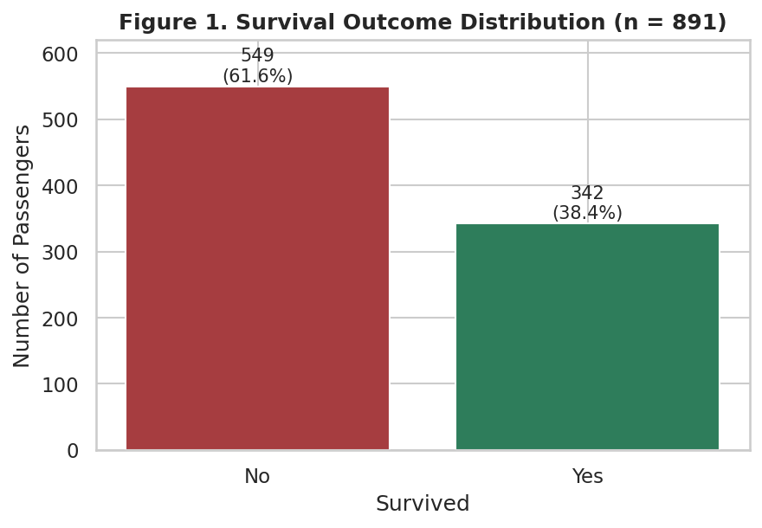
Figure 1. Survival outcome distribution. 549 passengers (61.6%) did not survive; 342 (38.4%) did.
Interpretation: the classes are imbalanced but not severely so (roughly 62/38). This is worth noting for any future modeling step — a naive model that always predicts “did not survive” would already be right 61.6% of the time, so any analysis or model built on this data should be judged against that baseline rather than against 50%.

3.2 Numeric Feature Distributions
fig, axes = plt.subplots(1, 2, figsize=(11, 4.3))
sns.histplot(df["age"], bins=30, kde=True, ax=axes[0])
sns.histplot(df["fare"], bins=40, kde=True, ax=axes[1])
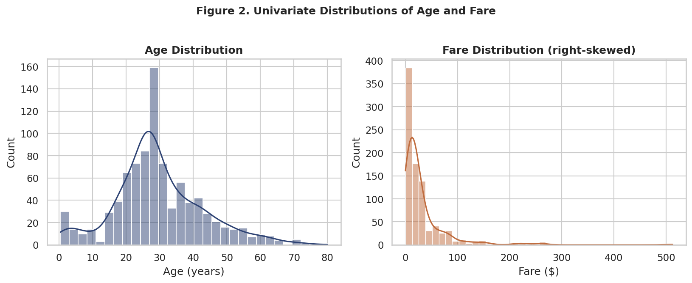
Figure 2. Age is roughly bell-shaped with a slight right skew and a small secondary bump under age 5 (infants traveling with family). Fare is heavily right-skewed, with the bulk of passengers paying under $30 and a long tail of high-value First-Class fares.
Interpretation: age behaves close to what a normal population distribution of ship passengers might look like, with young families and working-age adults as the two largest groups. Fare's shape is a direct reflection of the three-tier class system — a large low-cost Third-Class population, a smaller Second-Class band, and a long tail of First-Class luxury fares that pull the mean well above the median.

3.3 Categorical Feature Distributions
fig, axes = plt.subplots(1, 3, figsize=(12, 4))
sns.countplot(x="pclass", data=df, ax=axes[0])
sns.countplot(x="sex", data=df, ax=axes[1])
sns.countplot(x="embark_town", data=df, ax=axes[2])
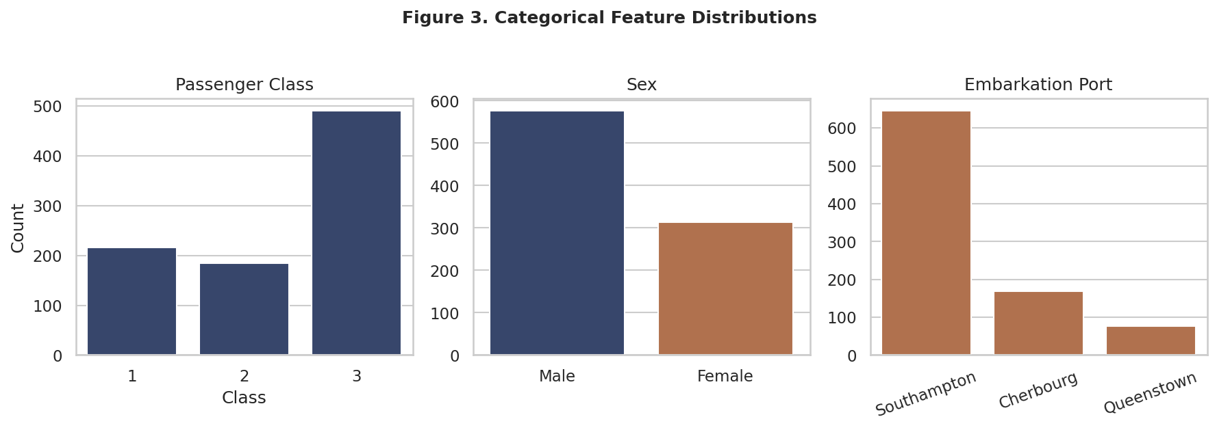
Figure 3. Third Class was the largest passenger group (491 of 891), men outnumbered women roughly 2:1 (577 vs 314), and the large majority of passengers embarked at Southampton (646 of 891).
Interpretation: this is consistent with the historical composition of the Titanic's passenger list, where Third Class carried the largest number of passengers (including many emigrant families), and Southampton was the ship's main departure port with Cherbourg and Queenstown as later boarding stops.

4. Bivariate Analysis

4.1 Survival by Sex
df.groupby("sex")["survived"].mean()
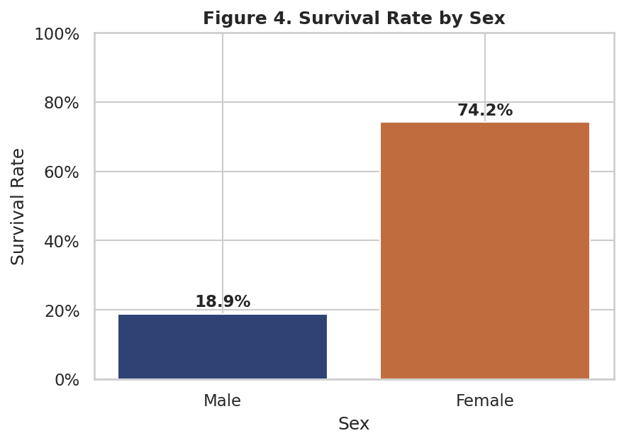
Figure 4. Female passengers survived at 74.2%, compared to 18.9% for male passengers — a gap of over 55 percentage points.
🔎 Why this pattern likely exists
This nearly 4x gap is the single strongest bivariate relationship in the dataset and matches the well-documented “women and children first” protocol followed during lifeboat loading. It is a strong candidate as the single most predictive feature for survival in this dataset, well beyond age, fare, or family size.

4.2 Survival by Passenger Class
df.groupby("pclass")["survived"].mean()
First Class: 63.0% · Second Class: 47.3% · Third Class: 24.2%. Survival decreases monotonically as class number increases (i.e., as class level decreases).
🔎 Why this pattern likely exists
Cabin location and lifeboat proximity were strongly correlated with ticket class — First-Class cabins and public rooms were located on the upper decks closer to the lifeboats, while Third-Class accommodation was lower in the ship and further from the boat deck, plausibly slowing evacuation. Fare (itself a proxy for class) shows the same directional relationship with survival (Section 5.4).

4.3 Age, Sex, and Survival
sns.violinplot(data=df, x="sex", y="age", hue="survived", split=True)
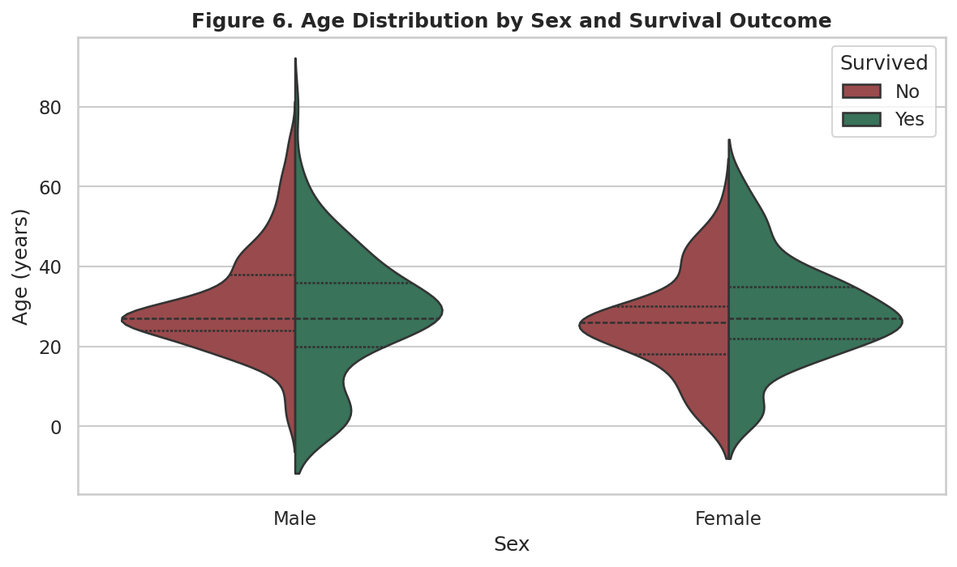
Figure 6. Split violin plot of age by sex and survival. The age distribution of surviving women is only slightly younger overall than non-surviving women, but among men, the youngest passengers (boys and young children) show visibly higher density on the “survived” side.
Interpretation: this is a first hint that the “women and children first” protocol operated somewhat differently by sex — age appears to matter more for male survival (children being prioritized alongside women) than for female survival (where sex alone was already a very strong predictor regardless of age). This is examined further with class added in Section 5.1.

5. Multivariate Analysis

5.1 Age Distribution Across Class and Survival
g = sns.FacetGrid(df, col="pclass", hue="survived")
g.map(sns.histplot, "age", bins=20, alpha=0.6)
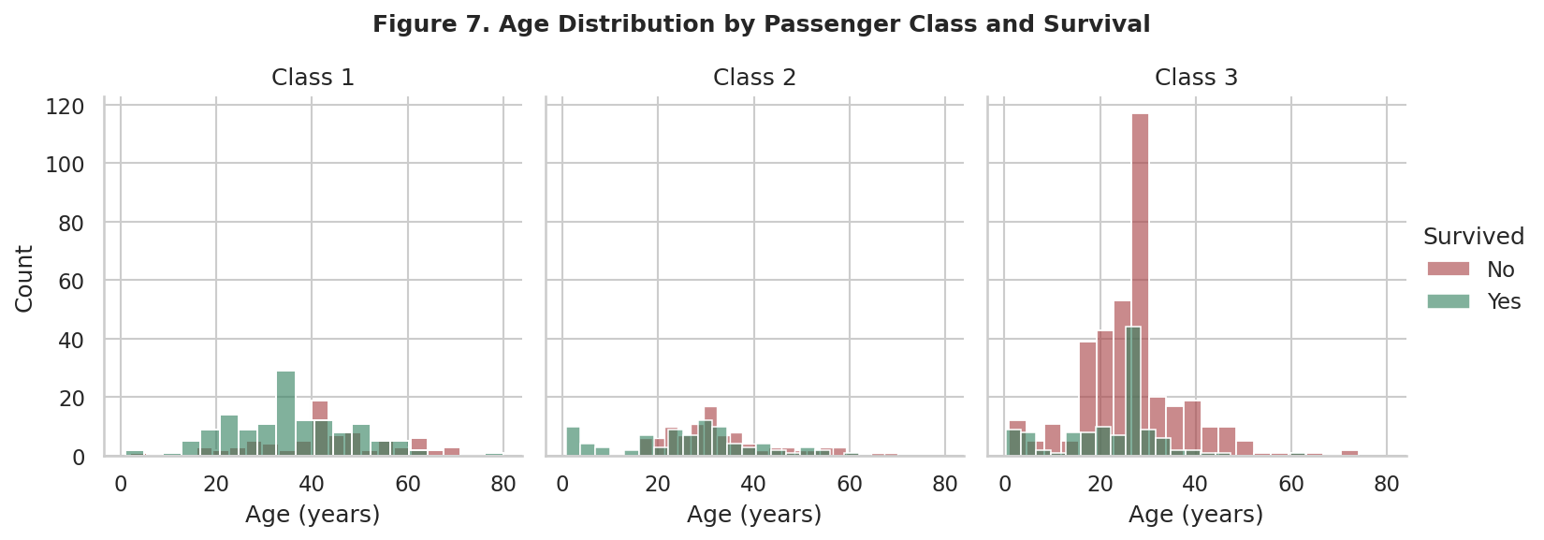
Figure 7. Age histograms faceted by class, colored by survival. In Third Class, the red (non-survived) bars dominate every age band, including young adults in their 20s. In First and Second Class, the green (survived) share is visibly larger across most age ranges.
Interpretation: adding class to the age/survival relationship clarifies the earlier violin plot — age's protective effect for children is visible mainly in First and Second Class; in Third Class, sheer number of passengers and possibly slower access to lifeboats meant many young adults and even children did not survive despite being nominally prioritized. This is a good example of why bivariate patterns can be incomplete without a third variable for context.

5.2 Fare, Age, Class, and Survival Together
plt.scatter(df["age"], df["fare"], c=df["survived"], s=df["pclass"].map({1:90,2:45,3:20}))
plt.yscale("symlog")
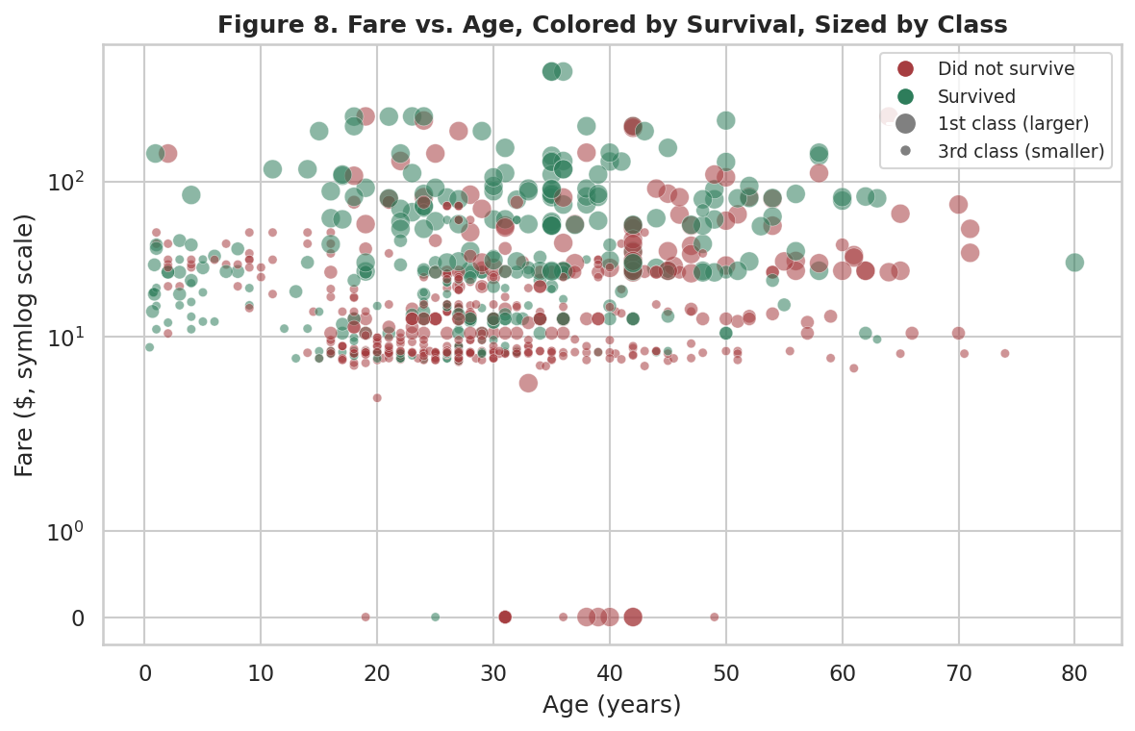
Figure 8. Fare (symlog scale) vs. age, colored by survival and sized by class (larger = First Class). Green (survived) points cluster toward the top of the chart (higher fares) and are visibly larger on average (more First-Class) than red points, which cluster in the lower-fare, smaller-marker (Third-Class) region.
Interpretation: combining four variables in one view confirms that survival is driven far more by fare/class (vertical position and marker size) than by age (horizontal position) — there is no clear vertical banding by age, but there is an obvious vertical banding by fare and marker size.

5.3 Family Size and Survival
df.groupby("family_size")["survived"].agg(["mean", "count"])
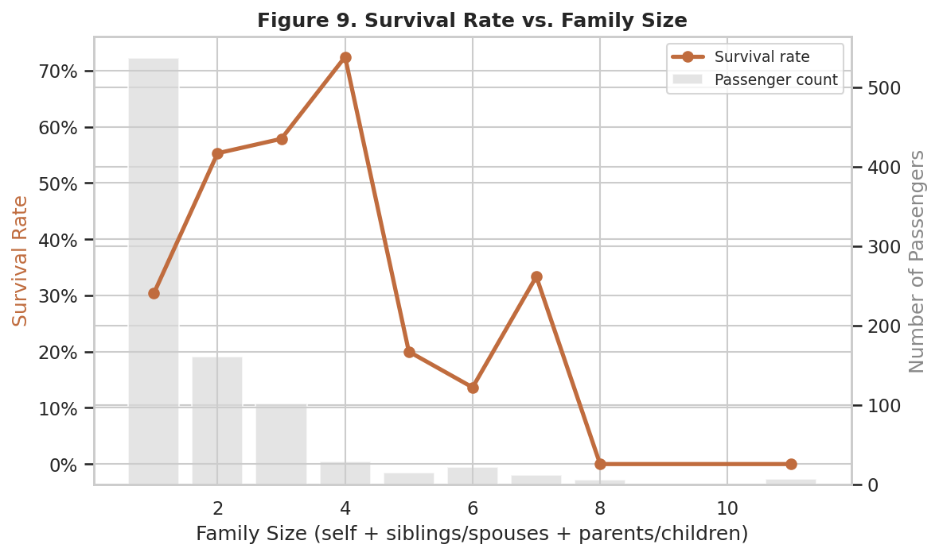
Figure 9. Survival rate (line, left axis) and passenger count (bars, right axis) by family size. Survival peaks at family sizes of 3–4 (57–72%), is lowest for solo travelers (30.4%) and for very large families of 5+ (0–33%).
🔎 Why this pattern likely exists
This is a classic “inverted-U” pattern: traveling completely alone may have meant less help coordinating an evacuation (particularly for children or the elderly), while small family groups (3–4) could assist each other without being so large that the group struggled to move or stay together through a crowded, chaotic ship. Very large families (5+) survived at the lowest rates of all, and the group sizes here are also small (6–22 passengers each), so these estimates should be read with the wider uncertainty that comes from a small sample.

5.4 Correlation Structure
num_cols = ["survived","pclass","age","sibsp","parch","fare",
"family_size","fare_per_person","deck_recorded","is_alone"]
sns.heatmap(df[num_cols].corr(), annot=True, cmap="RdBu_r")
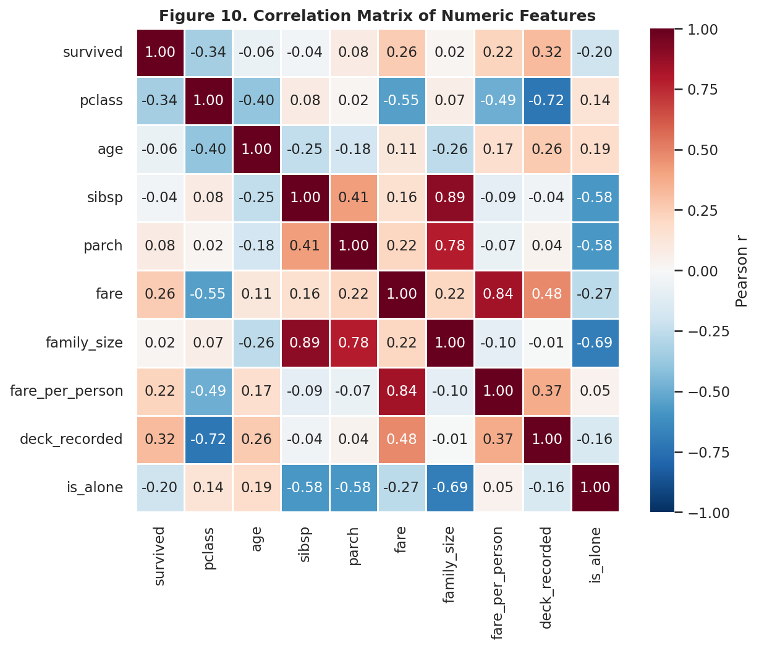
Figure 10. Correlation matrix of numeric features. deck_recorded (r = 0.32), fare (r = 0.26), and fare_per_person (r = 0.22) are the strongest positive correlates of survival; pclass (r = −0.34) and is_alone (r = −0.20) are the strongest negative correlates.
Interpretation: the strongest linear correlates of survival are all, directly or indirectly, proxies for wealth and cabin class rather than age or family composition — consistent with the class-driven pattern already observed. Notably, age's correlation with survival is close to zero (r = −0.06) as a simple linear relationship, even though Section 5.1 showed age does matter within specific class/sex subgroups; this is a useful reminder that a near-zero overall correlation can still hide a meaningful conditional relationship.

5.5 Embarkation Port, Class, and Survival
pivot = df.pivot_table(index="embark_town", columns="pclass", values="survived", aggfunc="mean")
sns.heatmap(pivot, annot=True, fmt=".0%", cmap="YlGnBu")
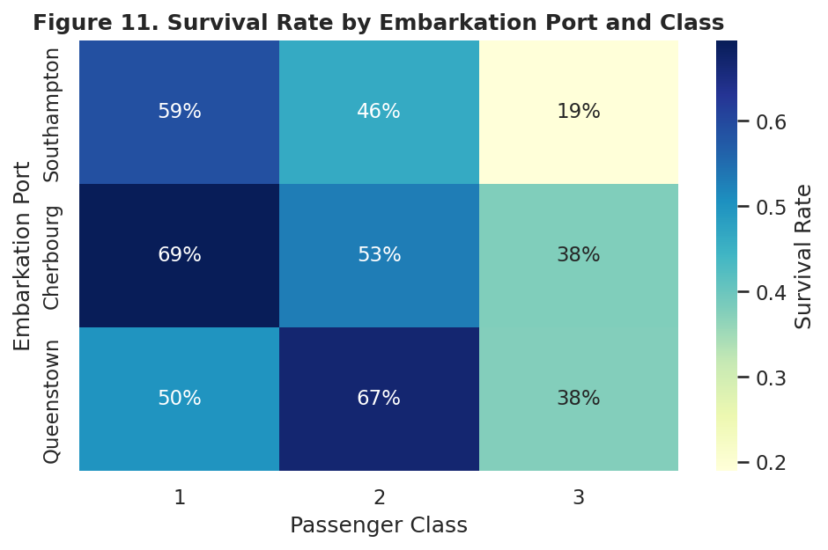
Figure 11. Survival rate by embarkation port and class. Cherbourg passengers survived at higher rates in every class than their Southampton counterparts, most notably in Third Class (Cherbourg 3rd: higher survival than Southampton 3rd).
Interpretation: a naive univariate look at embarkation port alone (Section 2) might suggest Cherbourg passengers were simply “luckier,” but this is very likely a confound: Cherbourg had a higher proportion of First-Class passengers than Southampton (see the crosstab in the accompanying code), so part of its higher overall survival rate is really a class effect showing through a correlated variable, not an effect of the port itself.

5.6 Explaining an Anomaly: The Deck-Recorded Proxy
Section 5.4 showed that deck_recorded (whether a cabin/deck letter was recorded for a passenger) is the single strongest numeric correlate of survival in the dataset, ahead of fare itself. This is worth investigating rather than taking at face value, since “whether a value was recorded” sounds more like a data-collection artifact than a real driver of survival.
sns.boxplot(data=df, x="deck_recorded", y="fare")
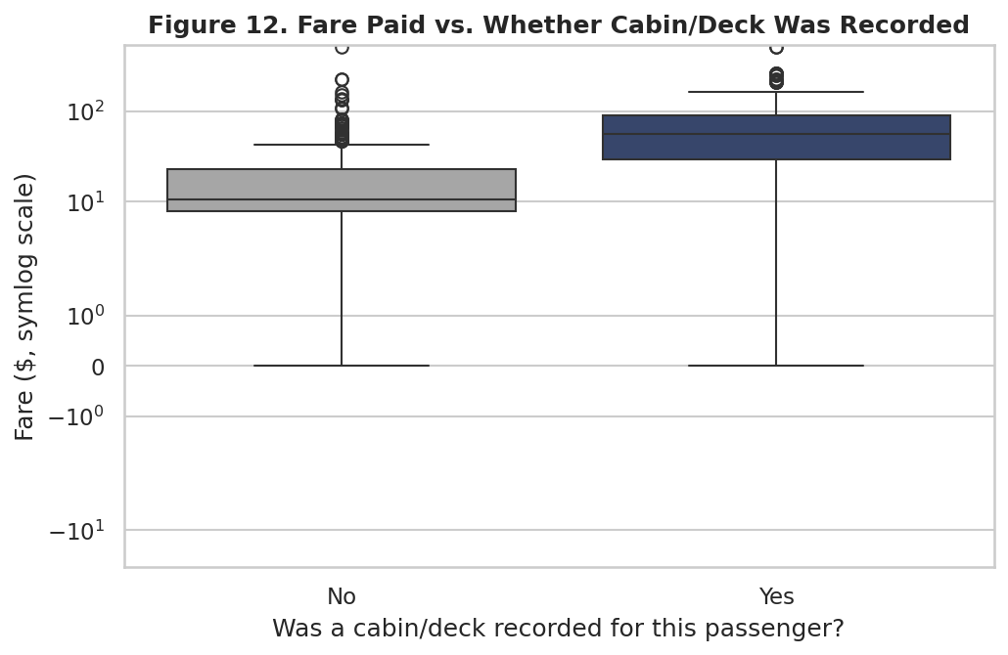
Figure 12. Fare paid (symlog scale) by whether a cabin/deck was recorded. Passengers with a recorded cabin paid substantially higher fares on average than those without.
🔎 Resolving the anomaly
deck_recorded is not an independent cause of survival; it is a near-proxy for First/Second Class and high fare. Cabin assignments were more completely documented for higher-fare passengers (whose cabins were individually booked and recorded), while Third-Class passengers were often assigned open berths that were not individually logged in the surviving records. This explains why deck_recorded correlates so strongly with survival: it is standing in for the same class/wealth effect seen throughout this analysis, not adding new independent information.

5.7 Pairwise Relationships
sns.pairplot(df, vars=["age","fare_log","family_size","pclass"], hue="survived")
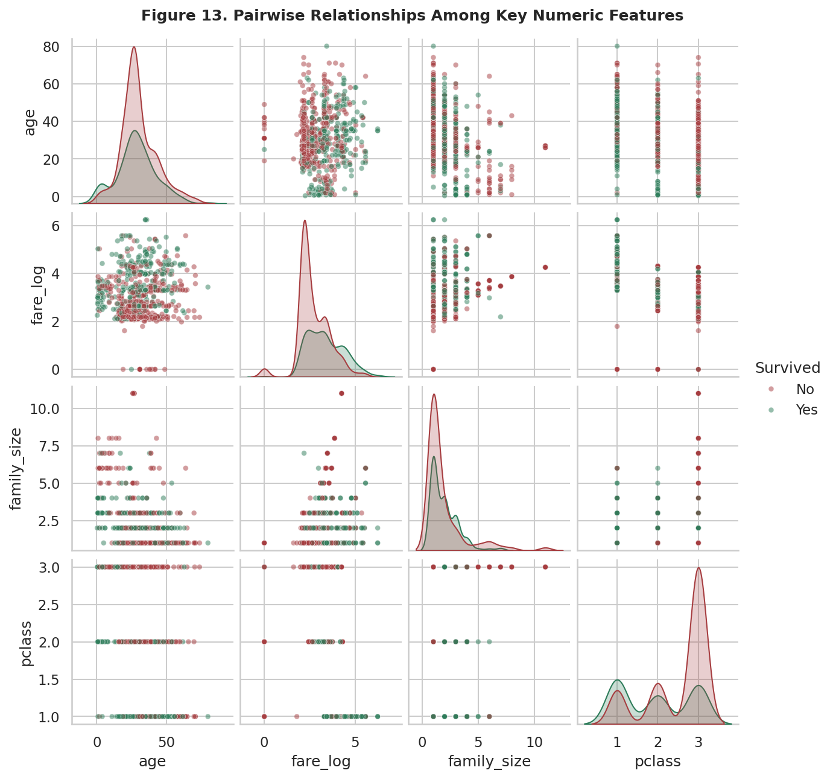
Figure 13. Pairwise scatter/KDE grid across age, log-fare, family size, and class, colored by survival. The clearest separation between the two survival groups appears along the fare_log and pclass axes; age and family_size show much more overlapping distributions.
Interpretation: this grid summarizes the whole analysis in one view — wherever fare_log or pclass appears on an axis, the green (survived) and red (did not survive) distributions separate visibly; wherever only age or family_size appears, the two distributions largely overlap. This visually confirms the correlation table's ranking of which features matter most.

6. Data Transformations and Aggregations Used
Several transformations and aggregations were applied purely for this analysis phase (in addition to the cleaning transformations carried over from Week 1), each chosen to make a pattern visible that would otherwise be obscured:
Transformation | Applied to | Purpose
Group-by mean aggregation | survived, grouped by sex / pclass / family_size / embark_town / who | Converts a raw 0/1 outcome into an interpretable survival rate per subgroup for direct comparison against the 38.4% baseline.
Pivot table (2-way) | survived by pclass × sex, and by embark_town × pclass | Reveals interaction effects that a single group-by would hide, e.g. whether the class effect on survival differs by sex or by port.
Symlog y-axis scaling | fare in scatter and box plots | Fare's heavy right-skew (skew = 4.79) compresses nearly all points near zero on a linear axis; symlog preserves the $0 values (which a log scale cannot show) while still spreading out the high end.
log1p transform (from Week 1, reused here) | fare → fare_log | Used in the pairplot and correlation table so that fare's distribution does not dominate variance-sensitive multivariate views.
Marker-size encoding | pclass in the fare/age scatterplot | Adds a third categorical dimension (class) to a two-axis scatterplot without needing a fourth panel.

7. Critical Discussion and Limitations
- Correlation vs. causation: every relationship reported here (sex, class, fare, family size) is an association within a specific, non-repeatable historical event, not a causal claim validated by controlled comparison. “Women and children first” and class-based deck access are historically documented explanations, but this dataset alone cannot prove them.
- Sample size at the margins: some subgroups are small (e.g., only 6 and 7 passengers in the family_size = 8 and 11 groups), so their 0% survival rates should be read as noisy estimates from a handful of individuals, not a robust statistical finding.
- Imputed values still present: roughly 1 in 5 age values were imputed during cleaning (Week 1). Patterns involving age (Sections 3.2, 4.3, 5.1, 5.2) are therefore slightly smoothed compared to what fully complete data would show, since imputed ages cluster at each subgroup's median.
- Confounded variables: Section 5.5 and 5.6 both illustrate that an apparently strong univariate pattern (embarkation port, deck_recorded) can be substantially explained by a lurking third variable (class/fare) rather than being an independent effect — a reminder to interpret every single-variable chart in this report with the multivariate sections' caveats in mind.

8. Summary of Key Insights
- Sex is the single strongest predictor of survival in this dataset (74.2% female vs. 18.9% male), consistent with a women-and-children-first evacuation protocol.
- Passenger class and fare are the second-strongest set of predictors, and they explain much of the apparent effect of other variables (embarkation port, deck_recorded) once examined multivariately.
- Family size has a non-linear (“inverted-U”) relationship with survival: small groups of 3–4 fared best; solo travelers and very large families fared worst.
- Age matters much less as a simple linear correlate (r = −0.06) than intuition might suggest, but it does matter conditionally — particularly for young boys within First and Second Class — which only becomes visible once class is added to the view.
- Several “strong” univariate patterns in this dataset (embarkation port, cabin/deck recorded) are proxies for wealth/class rather than independent effects, underscoring the value of multivariate analysis before drawing conclusions from a single chart.

9. Conclusion
This exploratory analysis moved systematically from single-variable summaries to increasingly multivariate views, using thirteen annotated Matplotlib/Seaborn visualizations to surface, test, and in some cases overturn or refine initial impressions of the Titanic dataset. The overarching finding is unsurprising in direction (sex and class dominate survival outcomes) but the value of this exercise lies in the supporting detail: quantifying the size of each effect, checking whether apparent patterns survive the addition of a third variable, and explicitly tracing an anomalous correlation (deck_recorded) back to its underlying cause rather than reporting it at face value. The resulting narrative, code, and all thirteen figures are fully reproducible from the two scripts listed in Appendix A.

Appendix A: Full Analysis and Visualization Code

A.1 Summary Statistics Script
"""
Week 2 - Step 1: Initial EDA summary statistics
"""
import pandas as pd
import numpy as np
pd.set_option("display.max_columns", None)
pd.set_option("display.width", 140)
df = pd.read_csv("titanic_cleaned.csv")
print("=" * 70)
print("SHAPE:", df.shape)
print("\n" + "=" * 70)
print("NUMERIC SUMMARY:")
print(df[["age", "fare", "family_size", "fare_per_person"]].describe().T)
print("\n" + "=" * 70)
print("OVERALL SURVIVAL RATE: {:.1f}%".format(df["survived"].mean() * 100))
print("\n" + "=" * 70)
print("SURVIVAL RATE BY SEX:")
print(df.groupby("sex")["survived"].agg(["mean", "count"]))
print("\n" + "=" * 70)
print("SURVIVAL RATE BY PCLASS:")
print(df.groupby("pclass")["survived"].agg(["mean", "count"]))
print("\n" + "=" * 70)
print("SURVIVAL RATE BY PCLASS x SEX:")
print(df.groupby(["pclass", "sex"])["survived"].agg(["mean", "count"]))
print("\n" + "=" * 70)
print("SURVIVAL RATE BY AGE GROUP:")
print(df.groupby("age_group", observed=True)["survived"].agg(["mean", "count"]))
print("\n" + "=" * 70)
print("SURVIVAL RATE BY FAMILY SIZE:")
print(df.groupby("family_size")["survived"].agg(["mean", "count"]))
print("\n" + "=" * 70)
print("SURVIVAL RATE BY EMBARKATION PORT:")
print(df.groupby("embark_town")["survived"].agg(["mean", "count"]))
print("\n" + "=" * 70)
print("SURVIVAL RATE BY DECK RECORDED (proxy for cabin class):")
print(df.groupby("deck_recorded")["survived"].agg(["mean", "count"]))
print("\n" + "=" * 70)
print("FARE STATS BY PCLASS:")
print(df.groupby("pclass")["fare"].describe())
print("\n" + "=" * 70)
print("SKEWNESS:")
print("fare skew:", df["fare"].skew())
print("fare_log skew:", df["fare_log"].skew())
print("age skew:", df["age"].skew())
print("\n" + "=" * 70)
print("CORRELATION WITH SURVIVED (numeric features):")
num_cols = ["survived", "pclass", "age", "sibsp", "parch", "fare",
"family_size", "fare_per_person", "deck_recorded", "is_alone"]
print(df[num_cols].corr()["survived"].sort_values(ascending=False))
print("\n" + "=" * 70)
print("WOMEN & CHILDREN FIRST CHECK (by 'who'):")
print(df.groupby("who")["survived"].agg(["mean", "count"]))
print("\n" + "=" * 70)
print("CROSSTAB: pclass x embark_town (counts):")
print(pd.crosstab(df["pclass"], df["embark_town"]))

A.2 Visualization Script
import pandas as pd
import numpy as np
import matplotlib
matplotlib.use("Agg")
import matplotlib.pyplot as plt
import matplotlib.ticker as mticker
import seaborn as sns
sns.set_theme(style="whitegrid", context="notebook")
plt.rcParams.update({"figure.dpi": 150, "font.size": 11})
PAL = {"survived_no": "#A63D40", "survived_yes": "#2E7D5B", "main": "#2E4374", "accent": "#C06C3E"}
SEX_PAL = {"male": "#2E4374", "female": "#C06C3E", "Male": "#2E4374", "Female": "#C06C3E"}
SURV_PAL = {0: "#A63D40", 1: "#2E7D5B"}
df = pd.read_csv("titanic_cleaned.csv")
df["Survived"] = df["survived"].map({0: "No", 1: "Yes"})
df["Sex"] = df["sex"].str.capitalize()
def savefig(name):
plt.tight_layout()
plt.savefig(f"figures/{name}", bbox_inches="tight")
plt.close()
# ---------------------------------------------------------------
# 1. Target variable distribution
# ---------------------------------------------------------------
fig, ax = plt.subplots(figsize=(6, 4.2))
counts = df["Survived"].value_counts().reindex(["No", "Yes"])
bars = ax.bar(counts.index, counts.values, color=[SURV_PAL[0], SURV_PAL[1]])
for b, v in zip(bars, counts.values):
ax.text(b.get_x() + b.get_width()/2, v + 8, f"{v}\n({v/len(df)*100:.1f}%)",
ha="center", fontsize=10)
ax.set_title("Figure 1. Survival Outcome Distribution (n = 891)", fontsize=12, fontweight="bold")
ax.set_xlabel("Survived")
ax.set_ylabel("Number of Passengers")
ax.set_ylim(0, 620)
savefig("01_target_distribution.png")
# ---------------------------------------------------------------
# 2. Age & Fare univariate distributions
# ---------------------------------------------------------------
fig, axes = plt.subplots(1, 2, figsize=(11, 4.3))
sns.histplot(df["age"], bins=30, kde=True, color=PAL["main"], ax=axes[0])
axes[0].set_title("Age Distribution", fontweight="bold")
axes[0].set_xlabel("Age (years)")
axes[0].set_ylabel("Count")
sns.histplot(df["fare"], bins=40, kde=True, color=PAL["accent"], ax=axes[1])
axes[1].set_title("Fare Distribution (right-skewed)", fontweight="bold")
axes[1].set_xlabel("Fare ($)")
axes[1].set_ylabel("Count")
fig.suptitle("Figure 2. Univariate Distributions of Age and Fare", fontsize=12, fontweight="bold", y=1.03)
savefig("02_age_fare_distributions.png")
# ---------------------------------------------------------------
# 3. Categorical feature counts: pclass, sex, embark_town
# ---------------------------------------------------------------
fig, axes = plt.subplots(1, 3, figsize=(12, 4))
sns.countplot(x="pclass", data=df, ax=axes[0], color=PAL["main"])
axes[0].set_title("Passenger Class")
axes[0].set_xlabel("Class")
axes[0].set_ylabel("Count")
sns.countplot(x="Sex", data=df, ax=axes[1], hue="Sex", palette=SEX_PAL, legend=False)
axes[1].set_title("Sex")
axes[1].set_xlabel("")
axes[1].set_ylabel("")
sns.countplot(x="embark_town", data=df, ax=axes[2], color=PAL["accent"], order=["Southampton", "Cherbourg", "Queenstown"])
axes[2].set_title("Embarkation Port")
axes[2].set_xlabel("")
axes[2].set_ylabel("")
axes[2].tick_params(axis="x", rotation=20)
fig.suptitle("Figure 3. Categorical Feature Distributions", fontsize=12, fontweight="bold", y=1.04)
savefig("03_categorical_counts.png")
# ---------------------------------------------------------------
# 4. Survival rate by Sex (annotated bar)
# ---------------------------------------------------------------
fig, ax = plt.subplots(figsize=(6, 4.3))
rates = df.groupby("Sex")["survived"].mean().reindex(["Male", "Female"])
bars = ax.bar(rates.index, rates.values, color=[SEX_PAL["male"], SEX_PAL["female"]])
for b, v in zip(bars, rates.values):
ax.text(b.get_x() + b.get_width()/2, v + 0.02, f"{v*100:.1f}%", ha="center", fontweight="bold")
ax.set_ylim(0, 1)
ax.yaxis.set_major_formatter(mticker.PercentFormatter(1.0))
ax.set_title("Figure 4. Survival Rate by Sex", fontsize=12, fontweight="bold")
ax.set_ylabel("Survival Rate")
ax.set_xlabel("Sex")
savefig("04_survival_by_sex.png")
# ---------------------------------------------------------------
# 5. Survival rate by class and sex (grouped bar)
# ---------------------------------------------------------------
fig, ax = plt.subplots(figsize=(7, 4.5))
pivot = df.pivot_table(index="pclass", columns="Sex", values="survived", aggfunc="mean")
pivot.plot(kind="bar", ax=ax, color=[SEX_PAL["female"], SEX_PAL["male"]])
ax.set_title("Figure 5. Survival Rate by Passenger Class and Sex", fontsize=12, fontweight="bold")
ax.set_xlabel("Passenger Class")
ax.set_ylabel("Survival Rate")
ax.yaxis.set_major_formatter(mticker.PercentFormatter(1.0))
ax.set_xticklabels(["1st", "2nd", "3rd"], rotation=0)
ax.legend(title="Sex")
for container in ax.containers:
ax.bar_label(container, fmt=lambda x: f"{x*100:.0f}%", fontsize=9)
savefig("05_survival_class_sex.png")
# ---------------------------------------------------------------
# 6. Age distribution by survival, split by sex (violin)
# ---------------------------------------------------------------
fig, ax = plt.subplots(figsize=(8, 4.8))
sns.violinplot(data=df, x="Sex", y="age", hue="Survived", split=True,
palette={"No": SURV_PAL[0], "Yes": SURV_PAL[1]}, ax=ax, inner="quartile")
ax.set_title("Figure 6. Age Distribution by Sex and Survival Outcome", fontsize=12, fontweight="bold")
ax.set_xlabel("Sex")
ax.set_ylabel("Age (years)")
ax.legend(title="Survived", loc="upper right")
savefig("06_age_violin_sex_survival.png")
# ---------------------------------------------------------------
# 7. FacetGrid: age histograms by class, colored by survival
# ---------------------------------------------------------------
g = sns.FacetGrid(df, col="pclass", hue="Survived", palette={"No": SURV_PAL[0], "Yes": SURV_PAL[1]},
height=3.6, aspect=0.95, col_order=[1, 2, 3])
g.map(sns.histplot, "age", bins=20, alpha=0.6, kde=False)
g.add_legend(title="Survived")
g.set_titles("Class {col_name}")
g.set_axis_labels("Age (years)", "Count")
g.figure.suptitle("Figure 7. Age Distribution by Passenger Class and Survival", fontsize=12, fontweight="bold", y=1.06)
g.figure.savefig("figures/07_facet_age_class_survival.png", bbox_inches="tight")
plt.close()
# ---------------------------------------------------------------
# 8. Fare vs Age scatter, colored by survival, sized by class
# ---------------------------------------------------------------
fig, ax = plt.subplots(figsize=(8, 5.2))
size_map = {1: 90, 2: 45, 3: 20}
sizes = df["pclass"].map(size_map)
scatter = ax.scatter(df["age"], df["fare"], c=df["survived"].map(SURV_PAL), s=sizes, alpha=0.55, edgecolor="white", linewidth=0.3)
ax.set_yscale("symlog")
ax.set_title("Figure 8. Fare vs. Age, Colored by Survival, Sized by Class", fontsize=12, fontweight="bold")
ax.set_xlabel("Age (years)")
ax.set_ylabel("Fare ($, symlog scale)")
from matplotlib.lines import Line2D
legend_elems = [
Line2D([0], [0], marker="o", color="w", markerfacecolor=SURV_PAL[0], markersize=9, label="Did not survive"),
Line2D([0], [0], marker="o", color="w", markerfacecolor=SURV_PAL[1], markersize=9, label="Survived"),
Line2D([0], [0], marker="o", color="w", markerfacecolor="gray", markersize=11, label="1st class (larger)"),
Line2D([0], [0], marker="o", color="w", markerfacecolor="gray", markersize=6, label="3rd class (smaller)"),
]
ax.legend(handles=legend_elems, loc="upper right", fontsize=9)
savefig("08_fare_age_scatter.png")
# ---------------------------------------------------------------
# 9. Survival rate by family size (line + bar hybrid)
# ---------------------------------------------------------------
fam = df.groupby("family_size")["survived"].agg(["mean", "count"]).reset_index()
fig, ax1 = plt.subplots(figsize=(8, 4.8))
ax2 = ax1.twinx()
ax2.bar(fam["family_size"], fam["count"], color="#D9D9D9", alpha=0.7, label="Passenger count")
ax1.plot(fam["family_size"], fam["mean"], color=PAL["accent"], marker="o", linewidth=2.5, label="Survival rate")
ax1.set_zorder(ax2.get_zorder() + 1)
ax1.patch.set_visible(False)
ax1.set_xlabel("Family Size (self + siblings/spouses + parents/children)")
ax1.set_ylabel("Survival Rate", color=PAL["accent"])
ax2.set_ylabel("Number of Passengers", color="#888888")
ax1.yaxis.set_major_formatter(mticker.PercentFormatter(1.0))
ax1.set_title("Figure 9. Survival Rate vs. Family Size", fontsize=12, fontweight="bold")
lines, labels = ax1.get_legend_handles_labels()
bars_, bar_labels = ax2.get_legend_handles_labels()
ax1.legend(lines + bars_, labels + bar_labels, loc="upper right", fontsize=9)
savefig("09_family_size_survival.png")
# ---------------------------------------------------------------
# 10. Correlation heatmap (seaborn)
# ---------------------------------------------------------------
num_cols = ["survived", "pclass", "age", "sibsp", "parch", "fare",
"family_size", "fare_per_person", "deck_recorded", "is_alone"]
corr = df[num_cols].corr()
fig, ax = plt.subplots(figsize=(8.5, 7))
sns.heatmap(corr, annot=True, fmt=".2f", cmap="RdBu_r", vmin=-1, vmax=1,
square=True, linewidths=0.5, cbar_kws={"label": "Pearson r"}, ax=ax)
ax.set_title("Figure 10. Correlation Matrix of Numeric Features", fontsize=12, fontweight="bold")
savefig("10_correlation_heatmap.png")
# ---------------------------------------------------------------
# 11. Embarkation port vs class vs survival (heatmap of survival rate)
# ---------------------------------------------------------------
pivot2 = df.pivot_table(index="embark_town", columns="pclass", values="survived", aggfunc="mean")
pivot2 = pivot2.reindex(["Southampton", "Cherbourg", "Queenstown"])
fig, ax = plt.subplots(figsize=(6.5, 4.3))
sns.heatmap(pivot2, annot=True, fmt=".0%", cmap="YlGnBu", cbar_kws={"label": "Survival Rate"}, ax=ax)
ax.set_title("Figure 11. Survival Rate by Embarkation Port and Class", fontsize=12, fontweight="bold")
ax.set_xlabel("Passenger Class")
ax.set_ylabel("Embarkation Port")
savefig("11_embark_class_heatmap.png")
# ---------------------------------------------------------------
# 12. Deck recorded proxy vs fare (boxplot) - anomaly/explanation chart
# ---------------------------------------------------------------
fig, ax = plt.subplots(figsize=(7, 4.6))
df["Cabin Recorded"] = df["deck_recorded"].map({0: "No", 1: "Yes"})
sns.boxplot(data=df, x="Cabin Recorded", y="fare", hue="Cabin Recorded",
palette={"No": "#A6A6A6", "Yes": PAL["main"]}, ax=ax, legend=False)
ax.set_yscale("symlog")
ax.set_title("Figure 12. Fare Paid vs. Whether Cabin/Deck Was Recorded", fontsize=12, fontweight="bold")
ax.set_xlabel("Was a cabin/deck recorded for this passenger?")
ax.set_ylabel("Fare ($, symlog scale)")
savefig("12_deck_recorded_fare_box.png")
# ---------------------------------------------------------------
# 13. Pairplot of key numeric variables colored by survival
# ---------------------------------------------------------------
pp_cols = ["age", "fare_log", "family_size", "pclass"]
g2 = sns.pairplot(df, vars=pp_cols, hue="Survived", palette={"No": SURV_PAL[0], "Yes": SURV_PAL[1]},
diag_kind="kde", plot_kws={"alpha": 0.5, "s": 18}, height=2.1)
g2.figure.suptitle("Figure 13. Pairwise Relationships Among Key Numeric Features", fontsize=12, fontweight="bold", y=1.02)
g2.figure.savefig("figures/13_pairplot.png", bbox_inches="tight")
plt.close()
print("All visualizations saved to figures/")

