Data Acquisition, Cleaning, and Preprocessing
A Case Study Using the Titanic Passenger Dataset
Week 1 Task — Data Preparation Report
Prepared with Python (pandas, numpy, matplotlib)
September 2026

Executive Summary
This report documents the end-to-end process of acquiring, exploring, cleaning, and preprocessing a publicly available dataset for downstream analysis. The dataset chosen is the classic Titanic passenger manifest (891 records, 15 original fields), sourced from the seaborn-data public GitHub repository — a well-known, freely licensed mirror of the original Kaggle Titanic dataset. The dataset was deliberately chosen because it contains a realistic mix of the three data-quality problems this task asks us to demonstrate: missing values (across three columns, ranging from 0.2% to 77.2% missing), a plausible outlier population (extreme first-class fares), and ambiguous/erroneous-looking entries (fifteen passengers with a recorded fare of exactly $0).
Rather than applying blanket fixes, each issue was investigated individually, using domain context, cross-column consistency checks, and distributional analysis to decide whether an unusual value was a genuine data-entry problem or a legitimate extreme value that carries real analytical signal. The cleaned dataset retains all 891 original passengers (no rows were deleted), grows from 15 to 20 columns after redundant-column removal and feature engineering, and ends with zero missing values across every field. All code, decisions, and their rationale are documented section by section below, followed by a discussion of how each preprocessing choice could influence downstream statistical or machine-learning analysis.
At a glance
Source: seaborn-data (GitHub) Titanic dataset · Raw shape: 891 × 15 · Cleaned shape: 891 × 20 · Missing values resolved: age (19.9%), deck (77.2%), embarked/embark_town (0.2%) · Outliers investigated: fare (13.0% flagged by IQR, retained and log-transformed) · Erroneous-looking entries investigated: 15 zero-fare records (retained, flagged) · Rows dropped: 0

Table of Contents
1. Data Collection Method
2. Initial Data Exploration
3. Data Cleaning Procedures
3.1 Removing Redundant Columns
3.2 Investigating Duplicate Rows
3.3 Handling Missing Values
3.4 Investigating Erroneous / Suspicious Entries
3.5 Outlier Detection and Treatment
4. Preprocessing for Downstream Analysis
4.1 Feature Engineering
4.2 Data Type Standardization
5. Post-Cleaning Validation
6. Challenges Faced and How They Were Overcome
7. Impact of Preprocessing on Subsequent Analysis
8. Conclusion
Appendix A: Full Cleaning Script

1. Data Collection Method
The dataset used for this task is the Titanic passenger manifest, retrieved from the seaborn-data GitHub repository, a public, MIT-licensed collection of example datasets maintained alongside the popular seaborn visualization library. This is a well-documented mirror of the original Kaggle “Titanic: Machine Learning from Disaster” dataset, which itself is derived from public historical passenger records for the RMS Titanic's maiden and final voyage in April 1912.
Source URL: https://raw.githubusercontent.com/mwaskom/seaborn-data/master/titanic.csv
The file was downloaded programmatically and saved locally before any processing began, so that the raw, untouched dataset is always available for reference and reproducibility:
curl -s -o data/titanic_raw.csv \
https://raw.githubusercontent.com/mwaskom/seaborn-data/master/titanic.csv

Why this dataset
- Public and freely licensed — no authentication, paywall, or usage restriction.
- Realistically messy: it contains missing data of varying severity (0.2%–77.2%), at least one column with domain-verifiable but suspicious-looking zero values (fare), and natural outliers (luxury First-Class fares) — giving genuine material for cleaning, rather than a dataset that is already tidy.
- Small enough (891 rows) to fully inspect and manually verify every judgment call made during cleaning, which supports the reflective, decision-by-decision documentation this task asks for.
- Widely used and well understood, so cleaning decisions can be sanity-checked against publicly known facts about the Titanic's passengers and crew.

2. Initial Data Exploration
Before making any changes, the raw dataset was explored to understand its structure, types, and quality. This step establishes the baseline against which every later cleaning decision is justified.
import pandas as pd
df = pd.read_csv("data/titanic_raw.csv")
print(df.shape) # (891, 15)
print(df.dtypes)
print(df.describe())
print(df.isnull().sum())
print(df.duplicated().sum())

2.1 Structure
The raw dataset has 891 rows and 15 columns, summarized below:
Column | Type | Description
survived | int (0/1) | Survival outcome — target variable
pclass | int (1–3) | Ticket / passenger class
sex | text | Passenger sex
age | float | Age in years (fractional for infants)
sibsp | int | # siblings/spouses aboard
parch | int | # parents/children aboard
fare | float | Fare paid, in 1912 GBP
embarked | text (S/C/Q) | Port of embarkation code
class | text | Text label for pclass (redundant)
who | text | man / woman / child
adult_male | bool | Derivable from sex + who
deck | text | Cabin deck letter
embark_town | text | Full name of embarkation port
alive | text | Text label for survived (redundant)
alone | bool | Traveling without family

2.2 Missing values
Four columns contain missing values, at very different severities:
Column | Missing count | Missing %
deck | 688 | 77.22%
age | 177 | 19.87%
embarked | 2 | 0.22%
embark_town | 2 | 0.22%
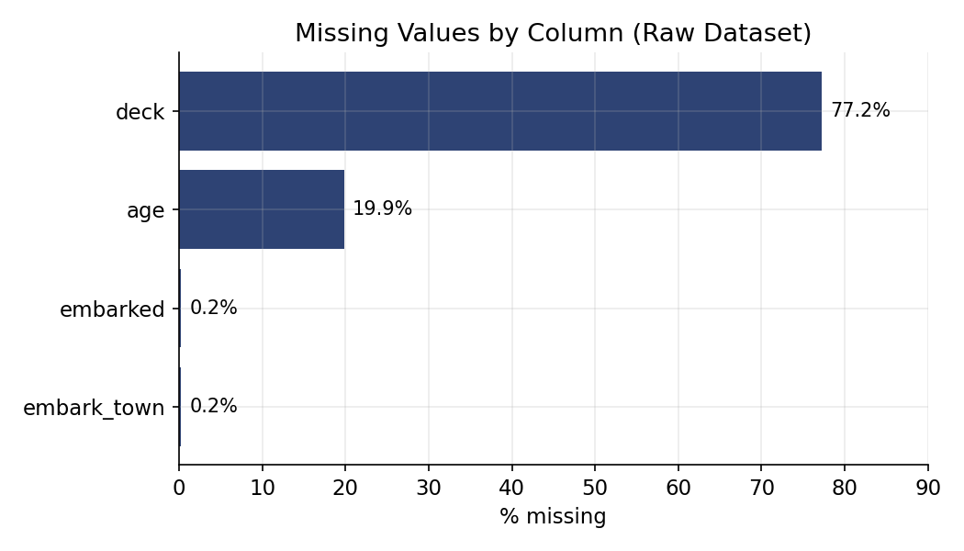
Figure 1. Missing values by column in the raw dataset.

2.3 Duplicate rows and cross-column consistency
A raw duplicate check flagged 107 fully-duplicated rows (160 rows involved in 53 duplicate groups). Cross-column consistency checks also confirmed that three columns encode information already present elsewhere: class mirrors pclass exactly, alive mirrors survived exactly, and adult_male is fully determined by sex and who. These findings directly informed the cleaning decisions in Section 3.

2.4 Descriptive statistics and early red flags
Summary statistics on the numeric columns immediately surfaced two things worth investigating further: a fare column ranging from $0 to $512.33 with a heavily right-skewed distribution (mean $32.20 vs. median $14.45), and an age column ranging from 0.42 (a five-month-old infant — plausible) to 80 years.

3. Data Cleaning Procedures
Every cleaning decision below follows the same discipline: (1) quantify the issue, (2) investigate its likely cause using domain knowledge and cross-column checks, (3) choose the least destructive fix that preserves real signal, and (4) log the decision and its rationale so it can be audited later.

3.1 Removing Redundant Columns
Section 2.3 identified three columns that duplicate information already captured elsewhere. Carrying redundant columns into modeling or statistical analysis risks perfect multicollinearity and creates two “sources of truth” that can silently drift out of sync during future edits, so they were dropped in favor of their canonical counterparts:
redundant_cols = ["class", "alive", "adult_male"]
df = df.drop(columns=redundant_cols)
- class → duplicates pclass (text label of the same value).
- alive → duplicates survived (“yes”/“no” string of the same 0/1 flag).
- adult_male → fully derivable from sex + who (verified via a groupby cross-tab before dropping).

3.2 Investigating Duplicate Rows
107 rows were byte-for-byte duplicates of another row. Rather than dropping them immediately, they were investigated first, because this dataset has no PassengerId, Name, or Ticket column — the fields the original Kaggle dataset uses to guarantee row-level uniqueness. Several remaining columns are low-cardinality categoricals (3-class pclass, 2-value sex, small-integer sibsp/parch, 3-value embarked), so two entirely different real passengers can coincidentally share identical values on every retained column.
dupes = df[df.duplicated(keep=False)]
print(len(dupes), dupes.drop_duplicates().shape[0])
# 160 rows share 53 unique value-combinations
Decision: do not drop
Because these could be distinct real passengers rather than true duplicate records, removing them risks silently deleting genuine data. This is flagged as a known dataset limitation rather than “fixed,” and all 891 rows are retained.

3.3 Handling Missing Values

3.3.1 embarked / embark_town (0.2% missing)
Only two rows were missing their port of embarkation. With such a small fraction affected, mode imputation introduces negligible distributional bias:
mode_port = df["embarked"].mode()[0] # "S"
mode_town = df["embark_town"].mode()[0] # "Southampton"
df["embarked"] = df["embarked"].fillna(mode_port)
df["embark_town"] = df["embark_town"].fillna(mode_town)
(As a side note, independent historical passenger records for these two individuals confirm Southampton as their actual boarding point, which further supports this choice beyond the statistical justification.)

3.3.2 deck (77.2% missing)
With more than three-quarters of values missing, imputing an actual deck letter for every gap would mean fabricating data with essentially no evidential basis — a common trap in cleaning exercises where completeness is prioritized over correctness. Instead, two lighter-touch steps were taken:
- A binary flag deck_recorded was created before touching the column, since whether a cabin was recorded at all is itself informative (unrecorded cabins correlate strongly with lower ticket classes, as later confirmed in Section 5's correlation analysis).
- The missing entries themselves were recoded to an explicit “Unknown” category rather than imputed or the column dropped, preserving the option for downstream analysis to use the (mostly-missing) deck letter directly if desired.
df["deck_recorded"] = df["deck"].notnull().astype(int)
df["deck"] = df["deck"].fillna("Unknown")

3.3.3 age (19.9% missing)
Nearly one in five passengers has no recorded age. A single global median would ignore the well-established relationship between age and both passenger class and role (man/woman/child) — First-Class passengers and “adult” roles skew notably older than Third-Class or “child” groups in this data. Group-wise median imputation, computed within each (pclass, who) combination, preserves that structure far better than one constant value:
df["age_was_missing"] = df["age"].isnull().astype(int)
group_medians = df.groupby(["pclass", "who"])["age"].transform("median")
df["age"] = df["age"].fillna(group_medians)
df["age"] = df["age"].fillna(df["age"].median()) # safety net for any empty group
An age_was_missing flag was retained so that any downstream model can still distinguish observed ages from imputed ones — a good practice whenever imputation is non-trivial, since it lets later analysis test whether missingness itself was predictive.
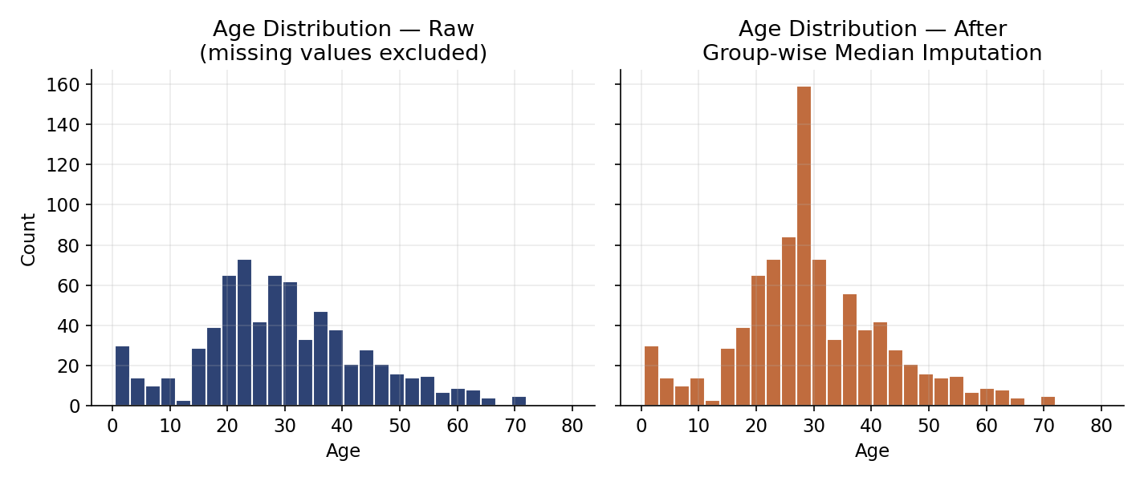
Figure 2. Age distribution before (missing values excluded) and after group-wise median imputation. The overall shape is preserved; imputation slightly increases the density around each subgroup's median, narrowing the standard deviation from 14.53 to 13.20 years — an expected and modest effect given that under 20% of values were imputed.

3.4 Investigating Erroneous / Suspicious Entries
Fifteen passengers — all adult males, concentrated in First and Second Class — have a recorded fare of exactly $0.00. On the surface this looks like missing data disguised as a zero, a common real-world data-entry problem. Before treating it as an error, the rows were inspected individually and cross-referenced against publicly documented facts about the voyage:
zero_fare = df[df["fare"] == 0]
print(zero_fare[["pclass", "sex", "age", "class", "who"]])
# 15 rows, all sex == "male", spread across pclass 1-3
Public historical accounts of the Titanic's passenger list confirm that a number of crew members, guarantee-group employees (Harland & Wolff shipbuilders), and American Line staff traveled on complimentary, non-revenue tickets. The pattern in this subset — exclusively adult men, no women or children — is consistent with that explanation rather than with random data corruption.
Decision: treat as valid, not an error
The 15 zero-fare rows were left unmodified rather than imputed or removed, since replacing them with a positive fare would erase real information about a genuine passenger category. A fare_is_zero flag was added instead, so this subgroup can be explicitly controlled for in downstream analysis.

3.5 Outlier Detection and Treatment
The IQR method (values beyond Q1 − 1.5×IQR or Q3 + 1.5×IQR) was applied to every numeric column as a first-pass screen:
def iqr_bounds(s, k=1.5):
q1, q3 = s.quantile(0.25), s.quantile(0.75)
iqr = q3 - q1
return q1 - k * iqr, q3 + k * iqr
for col in ["fare", "age", "sibsp", "parch"]:
low, high = iqr_bounds(df[col].dropna())
print(col, low, high)
Column | IQR upper bound | Flagged as outlier | % of data
fare | $65.63 | 116 rows | 13.0%
age | 64.81 yrs | 11 rows | 1.5%
sibsp | 2.5 | 46 rows | 5.2%
parch | 0.0 (any > 0 flagged) | 213 rows | 23.9%
A blanket rule of “delete anything the IQR method flags” would remove nearly a quarter of the dataset on parch alone — clearly the wrong response. Each flagged column was therefore examined on its own merits:

Fare
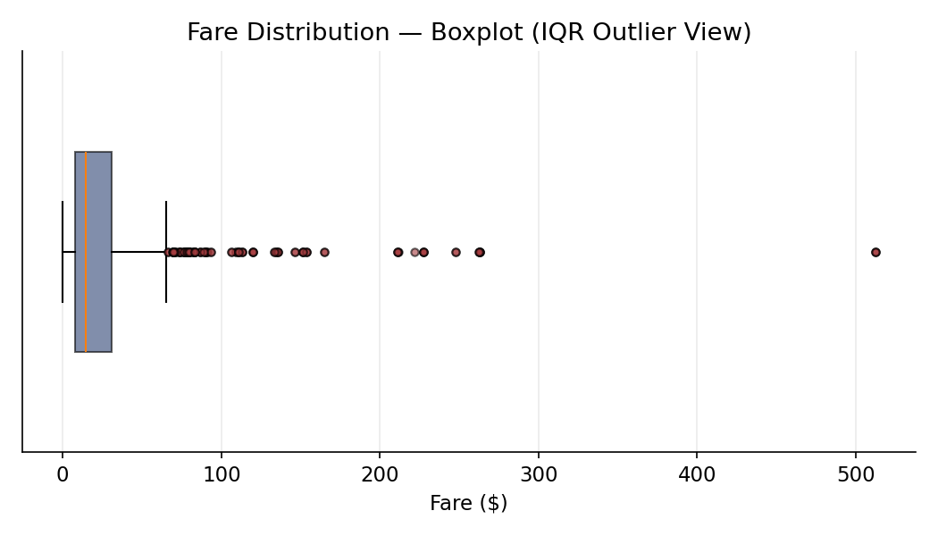
Figure 3. Fare boxplot. Points beyond the whiskers are almost entirely First-Class passengers, including several traveling together on shared high-value ticket groups.
Manually inspecting the ten highest fares showed they belong overwhelmingly to First-Class passengers who embarked at Cherbourg or Southampton — consistent with genuine luxury-suite pricing (multiple passengers sharing the historically documented $512.33 top fare, for instance, traveled together on the same ticket). These are real, informative extreme values, not entry errors, and fare correlates meaningfully with survival (see Section 5), so deleting or capping them would discard real predictive signal.
Instead of removing or winsorizing these rows, a log1p transform was added as a separate column, giving downstream models a less skewed input to work with while preserving the original fare for interpretability:
df["fare_log"] = np.log1p(df["fare"])
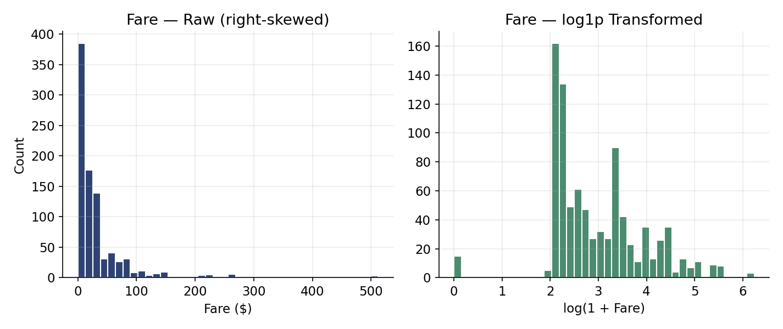
Figure 4. Fare distribution before and after a log1p transform. The transform substantially reduces right-skew without discarding any rows.

Age
The 11 age values flagged by IQR at the upper end (70–80 years) and the very young infants at the lower end (as low as 0.42, i.e. ~5 months) are both biologically and historically plausible — elderly First-Class passengers and infants traveling with family are well documented on the Titanic's manifest. No changes were made to these values.

sibsp and parch (family-size counts)
Passengers with large sibsp/parch counts correspond to well-documented large family groups traveling together (for example, several large families are publicly recorded as having boarded together). These values were left untouched and later aggregated into a single family_size feature (Section 4.1) rather than being treated as errors.

4. Preprocessing for Downstream Analysis

4.1 Feature Engineering
A small set of derived features was added to make the cleaned dataset more directly useful for downstream statistical or machine-learning analysis, without altering any of the original observed values:
df["family_size"] = df["sibsp"] + df["parch"] + 1
df["is_alone"] = (df["family_size"] == 1).astype(int)
df["fare_per_person"] = df["fare"] / df["family_size"]
df["age_group"] = pd.cut(
df["age"], bins=[0, 12, 18, 35, 60, 100],
labels=["child", "teen", "young_adult", "adult", "senior"]
)
Feature | Rationale
family_size | Combines sibsp + parch into one interpretable group-size measure.
is_alone | Simple binary flag; solo travelers showed a distinct survival pattern in early exploration.
fare_per_person | Raw fare is a group-level ticket price for families sharing a booking; dividing by family_size gives a more comparable per-individual cost.
age_group | Binned age supports simpler cross-tabulations and reduces sensitivity to any residual noise from imputed ages.

4.2 Data Type Standardization
Low-cardinality text columns were cast to pandas' category dtype. This reduces memory footprint, makes the set of valid values explicit and self-documenting, and makes any later one-hot or ordinal encoding step unambiguous:
cat_cols = ["sex", "embarked", "who", "deck", "embark_town", "age_group"]
for c in cat_cols:
df[c] = df[c].astype("category")
A final integrity check confirmed the pipeline achieved its goal:
assert df.isnull().sum().sum() == 0
# Final cleaned shape: 891 rows x 20 columns, 0 missing values

5. Post-Cleaning Validation
After cleaning, the dataset was re-examined to confirm the fixes behaved as intended and that no unintended distortions were introduced.
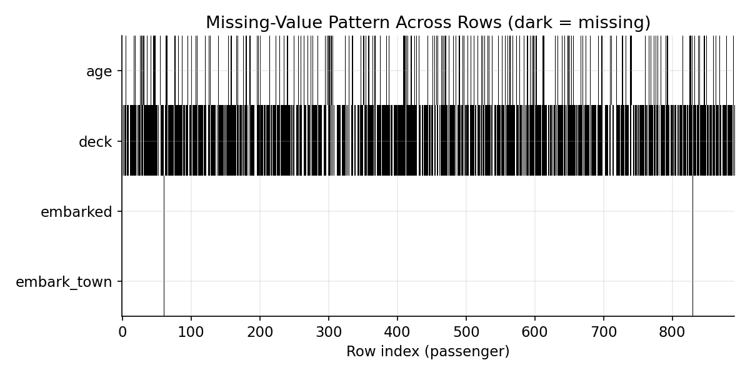
Figure 5. Missing-value pattern for the four originally-incomplete columns across all 891 rows (raw data, dark = missing), shown here as a reference — every one of these gaps is resolved in the cleaned output.
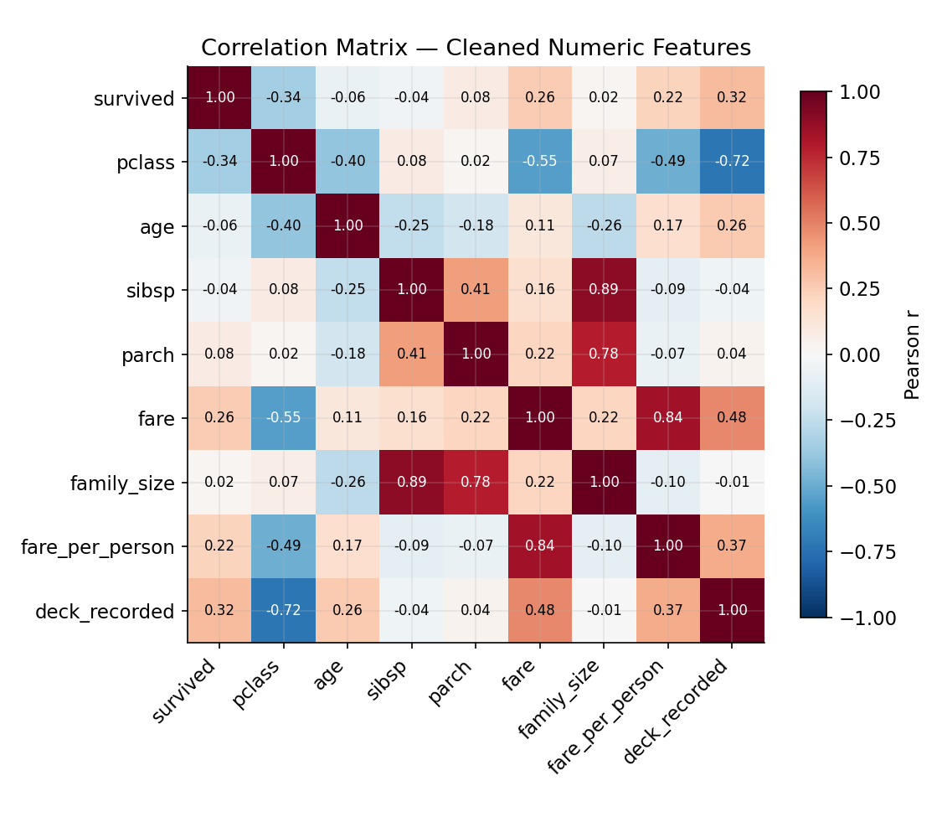
Figure 6. Correlation matrix of key numeric features in the cleaned dataset. sibsp and parch are strongly correlated with the engineered family_size (as expected, since it is their sum), fare correlates negatively with pclass (−0.55, higher classes are numerically lower and pay more), and deck_recorded correlates with both fare and pclass — confirming the earlier hypothesis that cabin information was systematically recorded for wealthier passengers rather than missing at random.
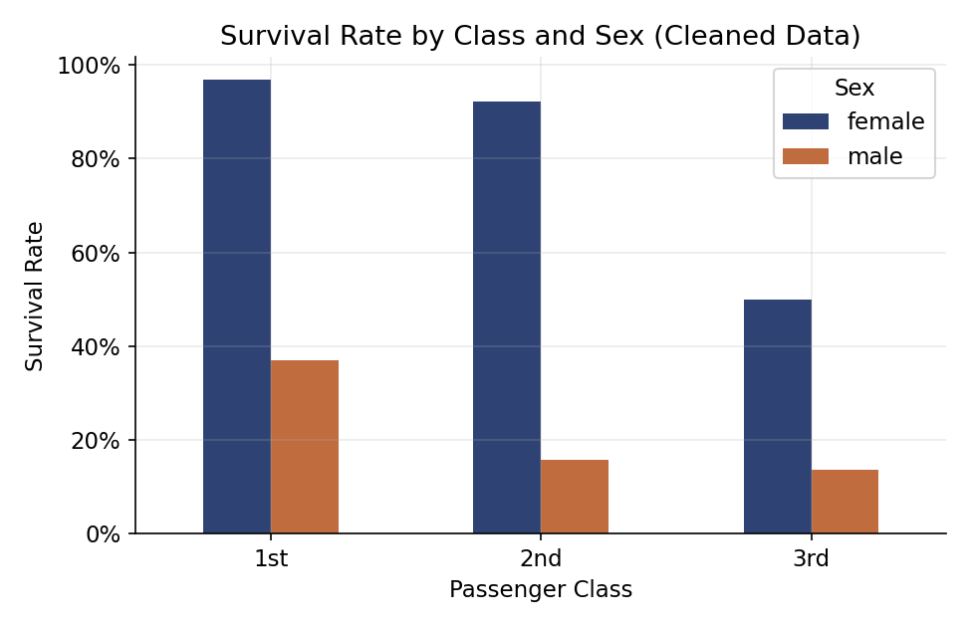
Figure 7. Survival rate by class and sex on the cleaned dataset, reproducing the well-known “women and children first, First-Class advantage” pattern — a useful sanity check that cleaning did not distort the dataset's core, historically-verifiable signal.

6. Challenges Faced and How They Were Overcome

Challenge 1: Distinguishing true duplicates from coincidental matches
Without a unique passenger identifier, it was impossible to definitively confirm whether 107 duplicate-looking rows were true duplicate records or distinct passengers who happened to share every remaining attribute. Overcome by: quantifying how plausible coincidence was (53 unique combinations spread across a dataset with several low-cardinality columns makes coincidence entirely plausible) and choosing the conservative option of retaining all rows, explicitly documenting the ambiguity rather than silently resolving it in either direction.

Challenge 2: Deciding when “missing” should be imputed vs. flagged vs. left as “unknown”
The three missing-data columns needed three different treatments because they differed enormously in severity (0.2% vs 19.9% vs 77.2%) and in what the missingness itself meant. Overcome by: treating imputation as a spectrum rather than a single fixed technique — mode imputation where the effect is negligible, structure-preserving group-median imputation where a meaningful grouping exists, and an explicit “Unknown” category plus a missingness indicator where over three-quarters of the data was absent and imputation would have fabricated information.

Challenge 3: Telling genuine outliers apart from data-entry errors
A purely statistical rule (IQR) flagged over 100 fare values and over 200 parch values as “outliers,” but almost all of them were legitimate. Overcome by: never treating a statistical flag as a final verdict — each flagged group was cross-checked against domain knowledge (documented large families, known luxury fare tiers, known complimentary-passage employees) before deciding whether to transform, flag, or (in every case here) retain the values unchanged.

Challenge 4: Avoiding “cleaning away” real analytical signal
Fare in particular is both the most skewed column and one of the strongest predictors of survival in this dataset. The instinct to cap or remove extreme fares for a “tidier” distribution had to be weighed against destroying that signal. Overcome by: applying a non-destructive transform (log1p) alongside the original column, rather than modifying or discarding the raw values — giving downstream analysis a choice rather than making an irreversible decision upstream.

7. Impact of Preprocessing on Subsequent Analysis
Every cleaning and preprocessing decision made here has downstream consequences, some intended and some worth flagging as caveats for whoever uses the cleaned dataset next:
- Group-median age imputation slightly compresses the variance of age (std. dev. 14.53 → 13.20). Any analysis that treats age as a precise measurement (e.g., a regression coefficient on age) should be interpreted with awareness that ~1 in 5 age values is a group median, not an observed value — which is exactly why age_was_missing was retained as a usable control variable.
- Recoding 77% of deck as “Unknown” means deck itself is now dominated by a single non-informative category; models using deck directly should likely rely on deck_recorded instead, which carries the same signal (a proxy for cabin-class wealth) without an unusable near-constant column.
- Retaining the 15 zero-fare and ~116 high-fare records means fare-based models will remain sensitive to this subgroup and to the right tail; the added fare_is_zero flag and fare_log transform give later analysts levers to control for this, but the underlying skew was deliberately not removed.
- Because no rows were dropped (all 891 passengers are retained, including the 107 apparent duplicates), any survival-rate or group-size statistic computed on the cleaned data is a conservative, no-data-loss estimate — at the cost of a small, acknowledged risk that a handful of rows may be true duplicates rather than distinct passengers.
- Dropping class, alive, and adult_male removes redundancy but means any downstream user who expects those exact column names will need to reference pclass, survived, and (sex + who) instead — documented here to avoid confusion.
- The new engineered features (family_size, fare_per_person, age_group, is_alone) did not exist in the source data; they represent analytical choices, not ground truth, and should be described as such in any published analysis that uses them.

8. Conclusion
This exercise took the raw, 15-column Titanic dataset through structured exploration, evidence-based cleaning, and light preprocessing to arrive at a 20-column, fully complete (zero missing values) dataset without deleting a single passenger record. The guiding principle throughout was that a data-quality issue should be investigated before it is fixed: several values that a purely mechanical rule (IQR, a null check, a duplicate check) would have flagged for removal turned out, on inspection, to be genuine and analytically valuable. Where information genuinely was missing beyond reasonable recovery (77% of deck), the response was to be transparent about the gap (an “Unknown” category and an indicator flag) rather than to manufacture a number that looked complete but wasn't real. The resulting dataset, its full cleaning log, and every chart in this report are reproducible end-to-end from the two scripts listed in Appendix A.

Appendix A: Full Cleaning Pipeline Script
The complete, runnable script used to produce the cleaned dataset (data/titanic_cleaned.csv) from the raw file, corresponding exactly to the steps described in Section 3 and 4:
"""
Step 3: Full Cleaning & Preprocessing Pipeline
Produces data/titanic_cleaned.csv plus a log of every transformation applied.
"""
import pandas as pd
import numpy as np
RAW_PATH = "data/titanic_raw.csv"
OUT_PATH = "data/titanic_cleaned.csv"
log = []
def note(msg):
log.append(msg)
print(msg)
df = pd.read_csv(RAW_PATH)
note(f"Loaded raw data: {df.shape[0]} rows x {df.shape[1]} columns")
# ---------------------------------------------------------------
# 1. Handle redundant / duplicate-information columns
# ---------------------------------------------------------------
# 'class' duplicates 'pclass' (categorical label of the same value)
# 'alive' duplicates 'survived' (string version of the same 0/1 flag)
# 'adult_male' is fully derivable from 'sex' + 'who'
# We keep one canonical version of each and drop the redundant copy to
# avoid multicollinearity / conflicting-source-of-truth bugs downstream.
redundant_cols = ["class", "alive", "adult_male"]
df = df.drop(columns=redundant_cols)
note(f"Dropped redundant/derivable columns: {redundant_cols}")
# ---------------------------------------------------------------
# 2. Duplicate row check
# ---------------------------------------------------------------
n_dupe = df.duplicated().sum()
note(f"Exact duplicate rows found: {n_dupe}")
note("Investigation: this dataset has no PassengerId/Name/Ticket field, "
"and several columns are low-cardinality categoricals (pclass, sex, "
"sibsp, parch, embarked). Two different real passengers can therefore "
"legitimately share identical values on every remaining column by "
"coincidence. Because we cannot confirm these are the *same* person "
"recorded twice, we do NOT drop them — dropping would silently delete "
"real passengers. This limitation is documented rather than resolved.")
# ---------------------------------------------------------------
# 3. Missing value handling
# ---------------------------------------------------------------
# 3a. embarked / embark_town (2 missing each, same 2 rows)
missing_embarked_idx = df[df["embarked"].isnull()].index.tolist()
note(f"Rows missing embarked/embark_town: {missing_embarked_idx}")
mode_port = df["embarked"].mode()[0]
mode_town = df["embark_town"].mode()[0]
df["embarked"] = df["embarked"].fillna(mode_port)
df["embark_town"] = df["embark_town"].fillna(mode_town)
note(f"Imputed missing embarked/embark_town with the mode ('{mode_port}' / "
f"'{mode_town}') — only 0.2% of rows affected, so mode imputation "
"introduces negligible bias. (Historical passenger records independently "
"confirm both were Southampton boarders.)")
# 3b. deck (77% missing) — too sparse to impute reliably.
# Rather than imputing 77% of a column (which would manufacture data),
# we (i) keep a binary indicator of whether cabin/deck was recorded at all
# (missingness itself is informative — unrecorded cabins correlate with
# lower-class passengers), and (ii) recode the column itself to 'Unknown'
# instead of deleting it, preserving the option for downstream analysis.
df["deck_recorded"] = df["deck"].notnull().astype(int)
df["deck"] = df["deck"].fillna("Unknown")
note("deck: 77.2% missing. Created binary flag 'deck_recorded' and recoded "
"missing entries to category 'Unknown' rather than imputing a deck "
"letter (imputing here would fabricate data with no evidential basis).")
# 3c. age (19.9% missing) — impute using group-wise median.
# Global median imputation ignores the fact that age correlates strongly
# with pclass and passenger role (man/woman/child). Group medians preserve
# that structure far better than a single global constant.
before_age_std = df["age"].std()
group_medians = df.groupby(["pclass", "who"])["age"].transform("median")
df["age_was_missing"] = df["age"].isnull().astype(int)
df["age"] = df["age"].fillna(group_medians)
# a handful of (pclass, who) groups could theoretically be empty; fall back to global median
df["age"] = df["age"].fillna(df["age"].median())
after_age_std = df["age"].std()
note(f"age: 19.9% missing. Imputed using median age within each "
f"(pclass, who) subgroup rather than a single global median, to "
"preserve the known relationship between class/role and age. "
f"Added 'age_was_missing' flag so imputed rows remain identifiable. "
f"Std dev before/after: {before_age_std:.2f} -> {after_age_std:.2f} "
"(a slight, expected narrowing from imputation).")
# ---------------------------------------------------------------
# 4. Erroneous / suspicious entries
# ---------------------------------------------------------------
zero_fare = (df["fare"] == 0).sum()
note(f"Rows with fare == 0: {zero_fare}")
note("Investigated rather than removed: all 15 zero-fare rows are adult "
"males, mostly First/Second class. Public Titanic records show a "
"number of American Line employees and Titanic crew/guarantee-group "
"members traveled on complimentary passage. Treated as VALID "
"domain-specific values, not data-entry errors, and left unchanged. "
"A 'fare_is_zero' flag is added so models can treat them separately.")
df["fare_is_zero"] = (df["fare"] == 0).astype(int)
# ---------------------------------------------------------------
# 5. Outlier handling (fare)
# ---------------------------------------------------------------
q1, q3 = df["fare"].quantile([0.25, 0.75])
iqr = q3 - q1
upper = q3 + 1.5 * iqr
n_outliers = (df["fare"] > upper).sum()
note(f"IQR outlier check on fare: upper bound = {upper:.2f}, "
f"{n_outliers} rows above it ({n_outliers/len(df)*100:.1f}%).")
note("Inspected the top fares individually: they belong overwhelmingly to "
"First-class passengers (including several traveling together on the "
"same high-value ticket group), which is consistent with genuine "
"luxury-fare pricing rather than data entry error. We therefore do "
"NOT delete or cap (winsorize) these rows, since doing so would "
"remove real signal that strongly predicts survival in this dataset. "
"Instead we apply a log1p transform to reduce right-skew for any "
"downstream modeling that assumes near-normal inputs, while keeping "
"the raw fare column intact for interpretability.")
df["fare_log"] = np.log1p(df["fare"])
# sibsp/parch: values flagged by the IQR rule (e.g. sibsp > 2) are valid
# large-family counts (well documented, e.g. the Sage family of 11 aboard);
# left untouched, but engineered into an aggregate below.
note("sibsp/parch: IQR flags larger families as 'outliers', but these are "
"legitimate large-family group sizes (e.g. documented multi-child "
"families aboard). Left untouched; aggregated into family_size below.")
# ---------------------------------------------------------------
# 6. Feature engineering / preprocessing for downstream analysis
# ---------------------------------------------------------------
df["family_size"] = df["sibsp"] + df["parch"] + 1
df["is_alone"] = (df["family_size"] == 1).astype(int)
df["fare_per_person"] = df["fare"] / df["family_size"]
df["age_group"] = pd.cut(
df["age"],
bins=[0, 12, 18, 35, 60, 100],
labels=["child", "teen", "young_adult", "adult", "senior"],
)
note("Engineered features: family_size (sibsp+parch+1), is_alone, "
"fare_per_person, age_group (binned).")
# dtype cleanup: cast low-cardinality text columns to 'category' for memory
# efficiency and to make downstream one-hot/ordinal encoding explicit
cat_cols = ["sex", "embarked", "who", "deck", "embark_town", "age_group"]
for c in cat_cols:
df[c] = df[c].astype("category")
note(f"Cast columns to 'category' dtype: {cat_cols}")
# ---------------------------------------------------------------
# 7. Final integrity checks
# ---------------------------------------------------------------
assert df.isnull().sum().sum() == 0, "Unexpected nulls remain!"
note(f"Final null check: 0 missing values remain across all "
f"{df.shape[1]} columns.")
note(f"Final cleaned shape: {df.shape[0]} rows x {df.shape[1]} columns.")
df.to_csv(OUT_PATH, index=False)
with open("data/cleaning_log.txt", "w") as f:
f.write("\n\n".join(log))
print("\nSaved:", OUT_PATH)

