Week 3 Task
Unsupervised Learning and Clustering Analysis
Segmenting 20,640 California census block groups with K-Means, with Ward hierarchical clustering and Gaussian mixtures as comparators
Dataset: California Housing (1990 U.S. Census), publicly available
Tools: Python 3, pandas, NumPy, scikit-learn 1.8, SciPy, matplotlib, seaborn
Date: October 19, 2026

1. Executive Summary
This report applies unsupervised learning to segment 20,640 California census block groups (small neighbourhood-sized districts) into groups with similar housing and demographic structure. The aim is to find segments that are statistically sound, interpretable, and useful for decisions in real estate, lending, urban planning and public policy.
Six housing and demographic features were engineered, cleaned and standardised. K-Means was selected as the primary algorithm and compared with Ward agglomerative clustering and Gaussian mixture models. The number of clusters was chosen using four internal validity indices plus a bootstrap stability analysis, which led to k = 5.
Key findings:
- Five distinct neighbourhood types emerge: crowded modest-income family districts, newer suburban growth areas, established mature neighbourhoods, dense small-household urban districts, and affluent spacious districts.
- The segments validate against variables that were deliberately withheld. House value and location were not used for clustering, yet median house value rises from $136,900 to $321,900 across clusters (Kruskal–Wallis p < 0.001), and the clusters have distinct geographic footprints.
- One cluster reveals something income alone would miss. Dense urban districts (C3) have below-average income but the highest value-to-income ratio (about 7.4×), a signal of location-driven price premiums and affordability stress.
- The structure is a continuum rather than isolated islands. The overall silhouette score is modest (0.19), and the different algorithms agree only partially (Adjusted Rand Index 0.28–0.31). The segments are best read as useful archetypes, not hard natural boundaries.

2. Dataset and Problem Framing

2.1 Why this dataset
The California Housing dataset is derived from the 1990 U.S. Census and is freely available (it is distributed with several textbooks and public repositories). It was chosen because it satisfies the requirements of a good clustering exercise:
- It has a large sample (20,640 rows), so cluster structure is estimated reliably.
- It contains several continuous numeric features with different scales and skewness, which makes preprocessing a real and visible part of the workflow.
- It includes variables that can be held out for external validation (house value, location, distance to ocean), allowing the clusters to be checked against something they never saw.
- It supports a clear business framing: customer-style segmentation of markets (districts) rather than of individuals.

2.2 Variables
Table 1. Original variables
Variable | Description
median_income | Median household income of the block group (tens of thousands of 1990 USD)
housing_median_age | Median age of buildings, in years
total_rooms / total_bedrooms | Total rooms and bedrooms across all housing units in the block group
population / households | Residents and occupied households in the block group
median_house_value | Median house value (USD). Capped at $500,001 by the census. Held out of clustering
longitude / latitude | Location of the block group. Held out of clustering
ocean_proximity | Categorical: <1H OCEAN, INLAND, NEAR OCEAN, NEAR BAY, ISLAND. Held out of clustering

2.3 Design choice: separating "what we cluster on" from "what we explain with"
A key methodological decision was to cluster only on structural and demographic characteristics (income, building age, housing size, crowding, block size) and to keep house value, location and ocean proximity out of the clustering. These withheld variables are then used afterwards as an independent test. If clusters built purely from structure also separate by price and geography, the segmentation captures something real rather than an artefact of the algorithm. If house value had been included in the features, this check would be circular.

3. Preprocessing
Distance-based algorithms such as K-Means are sensitive to feature scale, skewness and outliers, so preprocessing has a large effect on the result. The steps below were applied in order.

3.1 Missing values
Only total_bedrooms had missing values (207 rows, 1.0%). Dropping them would discard otherwise valid districts, so they were imputed with the median of total_bedrooms within the same ocean_proximity group. This keeps the imputation local to similar districts rather than using a single global median.

3.2 Feature engineering
Raw totals such as total_rooms scale with how large a block group is, so they mostly measure size and not character. Ratios describe the housing stock and household composition independent of size:
- rooms_per_hh = total_rooms / households (spaciousness)
- bedroom_ratio = total_bedrooms / total_rooms (share of rooms that are bedrooms, a proxy for smaller units and apartment-style housing)
- occupancy = population / households (average household size or crowding)
- log_households = log of households (scale of the block group, logged because of its right tail)
Together with median_income and housing_median_age this gives six clustering features.
df["total_bedrooms"] = df.total_bedrooms.fillna(
df.groupby("ocean_proximity").total_bedrooms.transform("median"))
df["rooms_per_hh"] = df.total_rooms / df.households
df["bedroom_ratio"] = df.total_bedrooms / df.total_rooms
df["occupancy"] = df.population / df.households
df["log_households"] = np.log(df.households)
feats = ["median_income", "housing_median_age", "rooms_per_hh",
"bedroom_ratio", "occupancy", "log_households"]

3.3 Outliers and skewness
The engineered ratios contain extreme values (for example an occupancy skewness of 97.6 caused by a few block groups with tens of residents per household, typically institutional housing). Such points would drag K-Means centroids and distort distances. Two corrections were applied: (1) winsorising each feature at its 1st and 99th percentiles, which affects roughly 2% of rows per feature but removes no data, and (2) a log transform of rooms_per_hh and occupancy. Skewness fell from 20.7 to −0.11 for rooms per household and from 97.6 to 0.08 for occupancy.
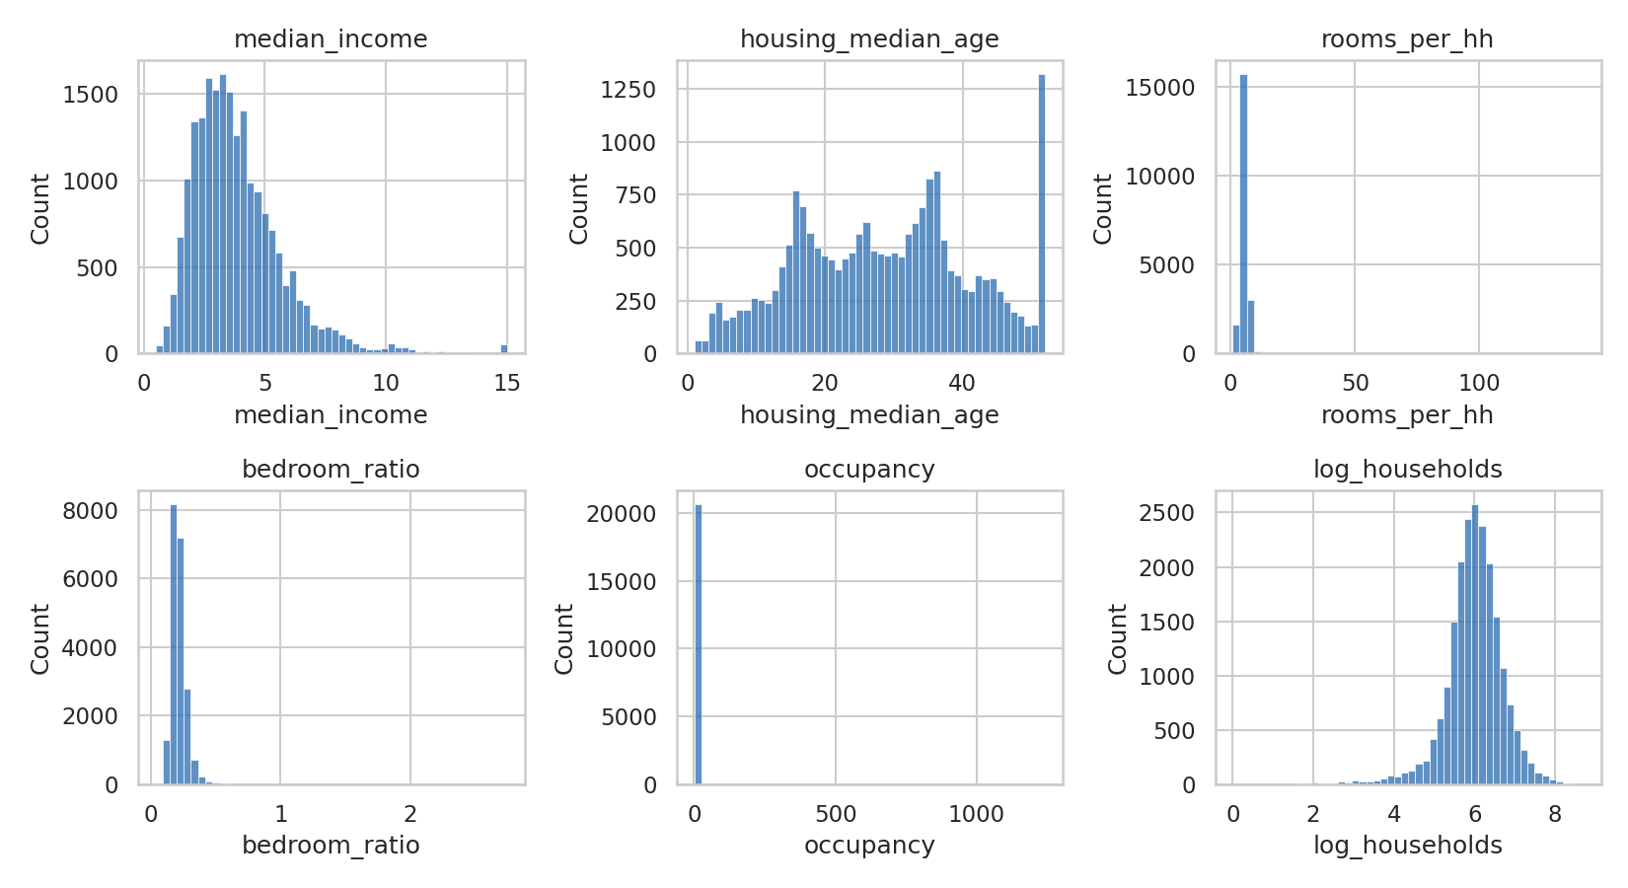
Figure 1. Distributions of the six features before cleaning. Long right tails are visible in the ratio features.
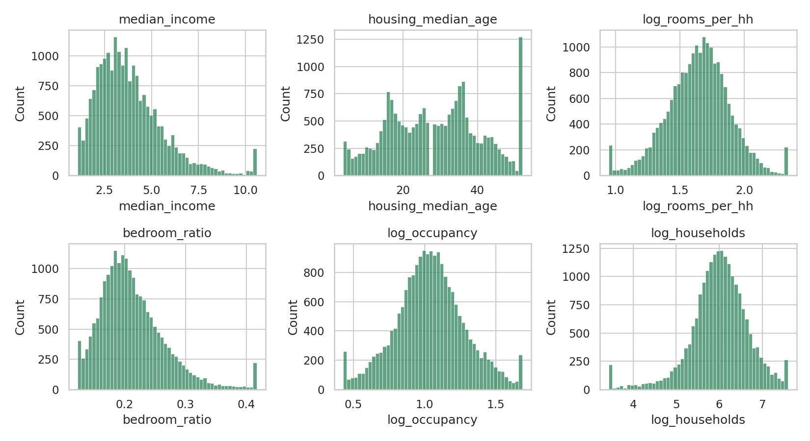
Figure 2. Distributions after winsorising and log transformation. The features are far more symmetric.
lo, hi = X.quantile(.01), X.quantile(.99)
Xw = X.clip(lo, hi, axis=1) # winsorise
Xw["occupancy"] = np.log(Xw.occupancy) # reduce skew
Xw["rooms_per_hh"] = np.log(Xw.rooms_per_hh)
Z = StandardScaler().fit_transform(Xw) # mean 0, std 1

3.4 Scaling and correlation check
All features were standardised (zero mean, unit variance) so that no variable dominates the Euclidean distance because of its units. The correlation matrix shows two strongly related pairs: median_income is positively related to rooms_per_hh, and bedroom_ratio is negatively related to both. This is expected, because wealthier districts have larger units with proportionally fewer bedrooms, and it means these three features jointly describe a single "affluence and spaciousness" dimension. This is acceptable for K-Means but is worth remembering when interpreting results.
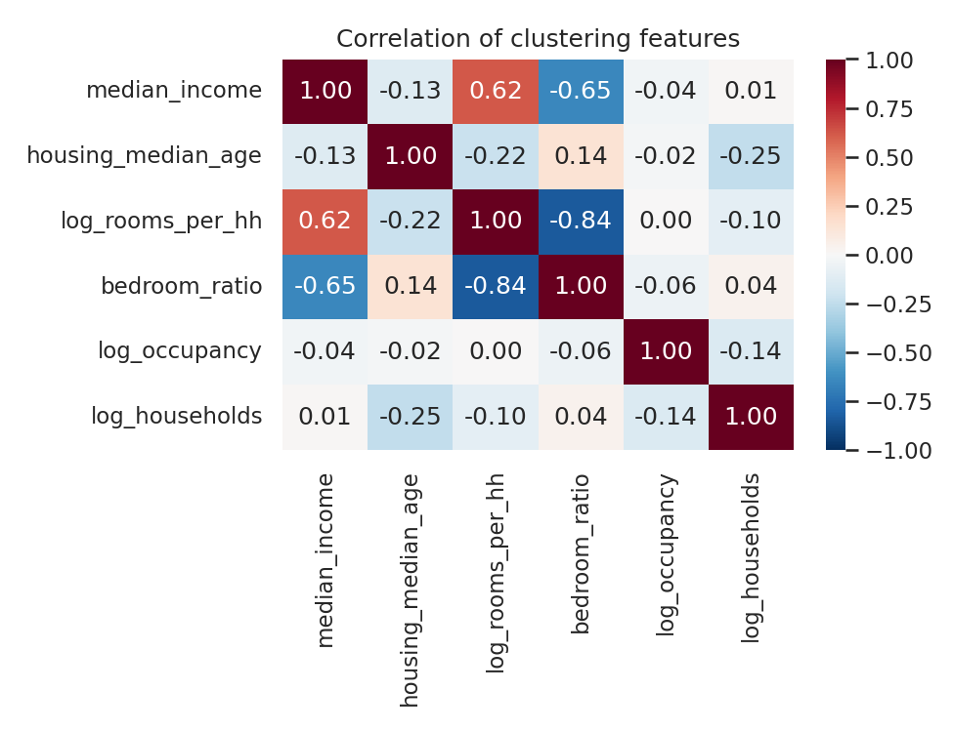
Figure 3. Correlation matrix of the standardised clustering features.

3.5 Dimensionality reduction for diagnostics
PCA was fit on the standardised features. The first two components explain 41.2% and 21.2% of the variance (62.4% together). PC1 is an "affluence and spaciousness" axis (loadings: rooms per household +0.59, income +0.52, bedroom ratio −0.59). PC2 is a "newness and block size" axis (log households +0.74, median age −0.56). PCA is used here only for visualisation. Clustering is performed in the full six-dimensional space so that no information is lost.

4. Methodology and Rationale

4.1 Primary algorithm: K-Means
K-Means partitions the data into k groups by minimising the within-cluster sum of squared distances to the centroids. It was chosen as the primary method for four reasons:
- Scale: it is fast and memory-efficient on 20,000+ rows, whereas full hierarchical clustering is quadratic in memory.
- Interpretability: every cluster has a centroid that is directly a profile (mean feature values), which maps neatly onto business-style personas.
- Fit with the preprocessing: after standardisation and de-skewing, the features are roughly symmetric and compact, which is the setting in which spherical, equal-variance clusters are a reasonable approximation.
- Reproducibility: with n_init = 50 random restarts and a fixed seed, the result is stable and repeatable.

4.2 Comparison algorithms
- Ward agglomerative clustering. Bottom-up merging that minimises the increase in within-cluster variance. It does not require a pre-set k to build the tree, and the dendrogram shows how clusters nest. Because it needs a full distance matrix, it was run on a random sample of 5,000 districts.
- Gaussian Mixture Model (GMM). A probabilistic model that allows elliptical clusters of different shapes and gives soft assignments. It tests whether the spherical assumption of K-Means is limiting.

4.3 Evaluation toolkit
Because there are no true labels, clustering quality is judged with internal measures and stability:
Table 2. Evaluation measures used
Measure | What it captures | Direction
Inertia (elbow) | Within-cluster compactness | Look for the bend, where gains slow
Silhouette | Cohesion vs separation per point (−1 to 1); computed on a 6,000-point sample | Higher is better
Calinski–Harabasz | Ratio of between- to within-cluster dispersion | Higher is better
Davies–Bouldin | Average similarity of each cluster to its closest neighbour | Lower is better
Bootstrap stability (ARI) | Agreement between the full-data solution and solutions fit on random 80% subsamples (15 repeats) | Closer to 1 is more reproducible

5. Choosing the Number of Clusters
K-Means was run for k = 2 to 10 with 20 restarts each, and every validity measure was recorded.
rows = []
for k in range(2, 11):
km = KMeans(k, n_init=20, random_state=42).fit(Z)
rows.append(dict(k=k, inertia=km.inertia_,
silhouette=silhouette_score(Z[sidx], km.labels_[sidx]),
ch=calinski_harabasz_score(Z, km.labels_),
db=davies_bouldin_score(Z, km.labels_)))
# bootstrap stability: refit on 80% subsamples, compare with ARI
base = KMeans(k, n_init=10, random_state=42).fit(Z)
ari = adjusted_rand_score(base.predict(Z[i]), KMeans(k, n_init=5).fit(Z[i]).labels_)

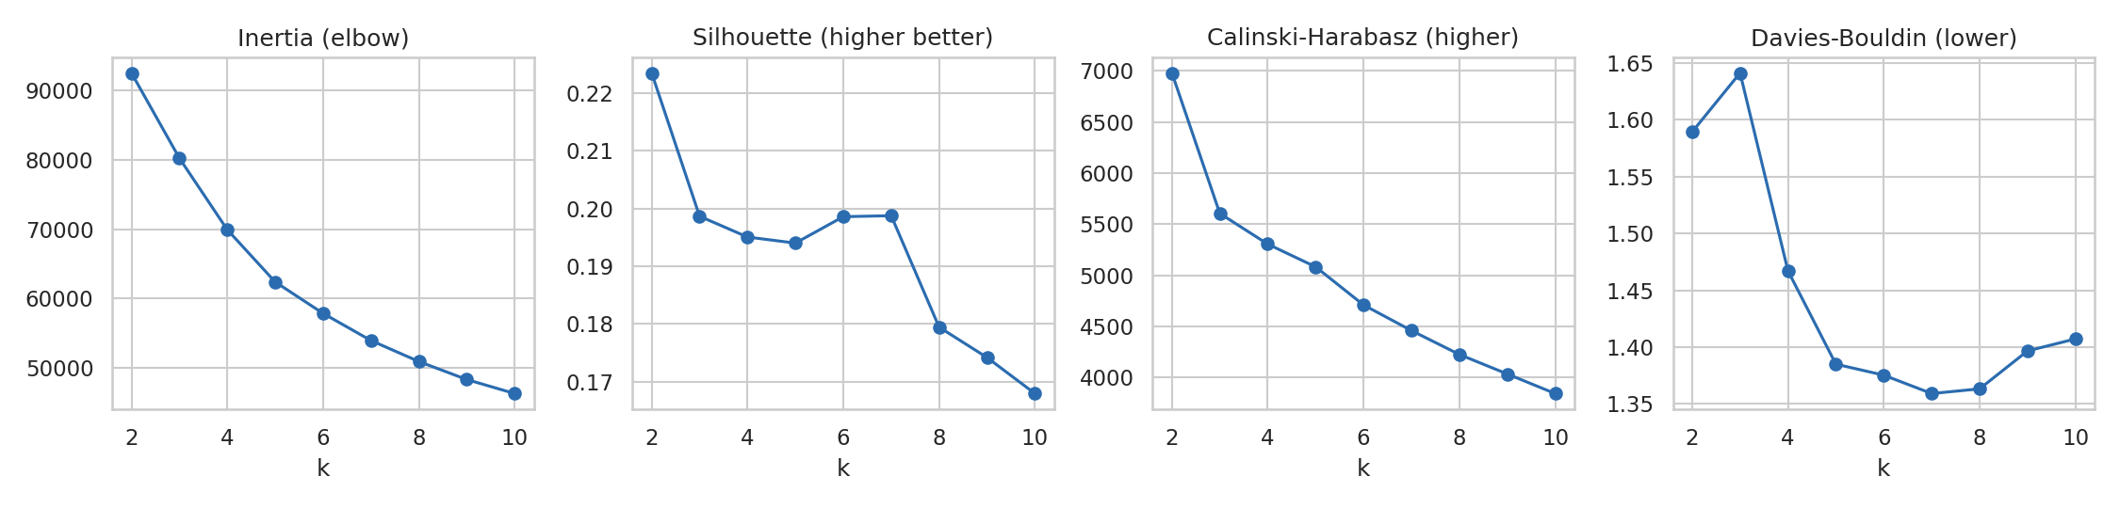
Figure 4. Model selection diagnostics for k = 2 to 10.
Table 3. Validity measures by number of clusters
k | Inertia | Silhouette | Calinski–Harabasz | Davies–Bouldin | Stability (ARI)
2 | 92,548 | 0.223 | 6,978 | 1.589 | 0.982
3 | 80,250 | 0.199 | 5,605 | 1.641 | 0.887
4 | 69,918 | 0.195 | 5,305 | 1.467 | 0.971
5 | 62,381 | 0.194 | 5,083 | 1.385 | 0.973
6 | 57,833 | 0.199 | 4,710 | 1.375 | 0.920
7 | 53,916 | 0.199 | 4,460 | 1.359 | 0.950
8 | 50,882 | 0.179 | 4,226 | 1.363 | 0.936
9 | 48,283 | 0.174 | 4,036 | 1.397 | 0.894
10 | 46,259 | 0.168 | 3,844 | 1.407 | 0.940

5.1 Reading the evidence honestly
No single k wins on every measure, which is normal for data without well-separated groups. Silhouette and Calinski–Harabasz are highest at k = 2, but a two-way split (roughly "higher" vs "lower" affluence) is too coarse to inform decisions. Beyond k = 2 silhouette is essentially flat at 0.17–0.20, so it does not discriminate between candidate values. The elbow in inertia is gradual with no sharp bend.
The decisive criteria were therefore Davies–Bouldin and stability. Davies–Bouldin improves markedly from k = 3 (1.64) to k = 5 (1.39) and then plateaus. Stability at k = 5 is 0.973, one of the highest among the candidates that provide more than 3 groups, whereas k = 3 (0.887) and k = 6 (0.920) are noticeably less reproducible. k = 5 is therefore the smallest solution that is both reproducible and meaningfully granular, and it was adopted. As shown in Section 7, each of the five clusters also has a distinct and interpretable profile, which is a final practical test that statistics alone cannot provide.

6. Clustering Results

6.1 Final K-Means model
km = KMeans(n_clusters=5, n_init=50, random_state=42).fit(Z)
df["cluster"] = km.labels_
# relabel clusters 0..4 in ascending order of median house value
order = df.groupby("cluster").median_house_value.median().sort_values().index
df["cluster"] = df.cluster.map({old: new for new, old in enumerate(order)})

Clusters are relabelled C0 to C4 in increasing order of median house value (a label-only change that does not affect the partition), which makes the results easier to read. The final model has a silhouette score of 0.195 and a Davies–Bouldin index of 1.385.

6.2 Visualising the clusters
Figure 5 shows the clusters projected into two dimensions with PCA (left) and t-SNE (right). In PCA space, the clusters form an ordered fan-like structure along the affluence axis (PC1) with overlap at the edges. In t-SNE, which emphasises local neighbourhoods, the groups are more locally coherent but still touch. This confirms the quantitative message: the data form a continuum with density concentrations, not isolated blobs.
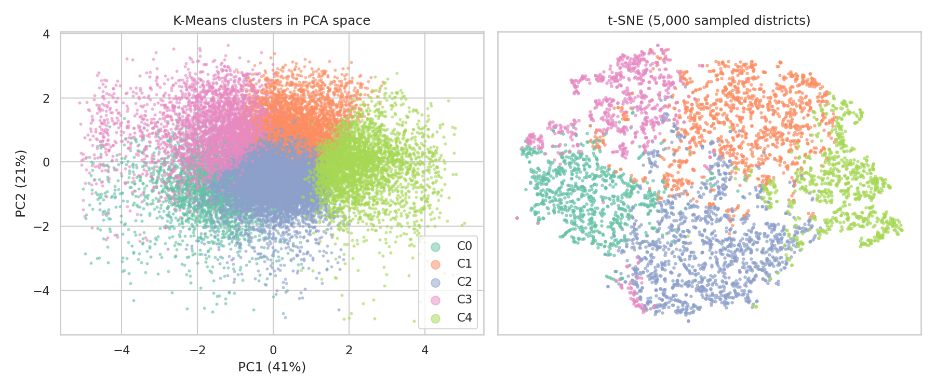
Figure 5. K-Means clusters visualised with PCA (left) and t-SNE (right).

6.3 Comparison with other algorithms
Table 4. Algorithm comparison at k = 5
Metric | K-Means | Ward (n=5,000) | GMM
Silhouette | 0.195 | 0.139 | 0.093
Davies–Bouldin (lower is better) | 1.385 | 1.739 | 2.445
ARI vs K-Means | 1.00 | 0.311 | 0.275

K-Means achieves the best internal scores. The moderate ARI values (about 0.3) show that the algorithms carve the continuum in different places, so the exact boundaries are method-dependent. This is an honest limitation (see Section 9) and a reason to treat clusters as archetypes. The GMM scores poorly because its flexible ellipses overlap heavily, which suggests that there is no extra elliptical structure to exploit beyond what K-Means already captures.
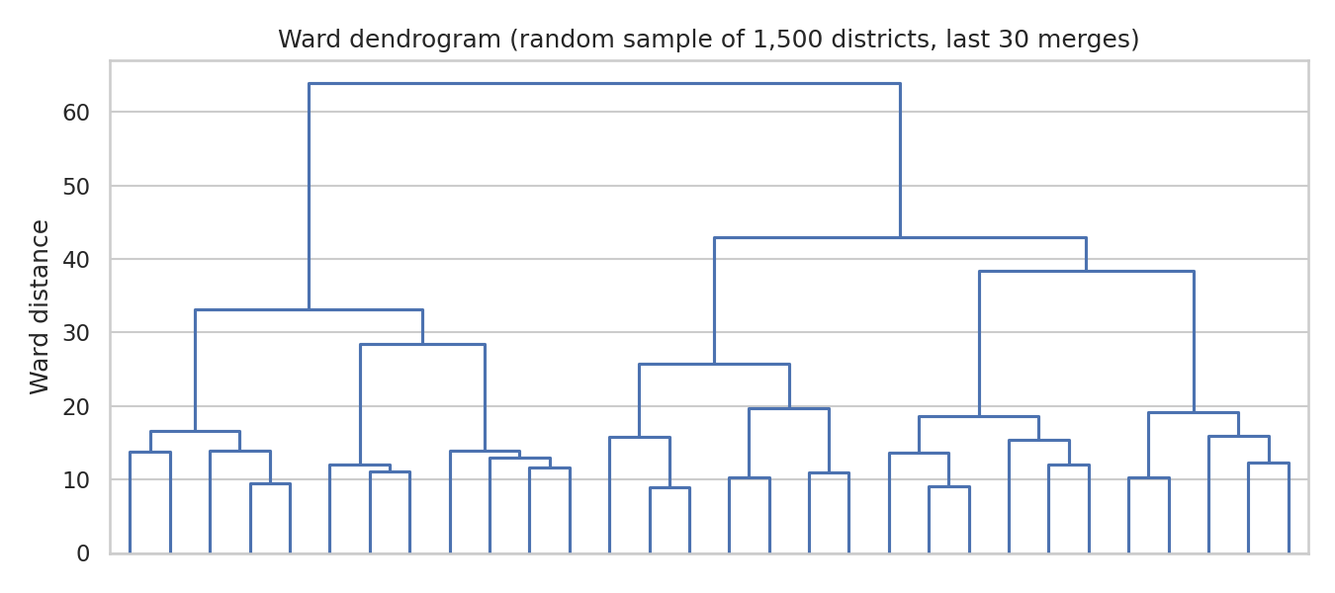
Figure 6. Ward dendrogram (truncated to the last 30 merges) on a random sample of 1,500 districts. The tall merges at the top show the broadest groupings in the data.

7. Cluster Analysis and Interpretation

7.1 Cluster profiles
Table 5. Cluster medians (income in $10,000s; value is median house value, not used in clustering)
 | Segment (my label) | Size | Income | Age | Rooms/hh | Bedr. ratio | Occup. | Hshlds | Value
C0 | Crowded modest-income family districts | 3,505 (17.0%) | 2.34 | 34 | 4.21 | 0.252 | 3.86 | 345 | $136.9k
C1 | Newer suburban growth areas | 5,130 (24.9%) | 3.75 | 17 | 5.55 | 0.193 | 2.81 | 588 | $157.6k
C2 | Established mature neighbourhoods | 5,831 (28.3%) | 3.68 | 37 | 5.35 | 0.196 | 2.66 | 315 | $187.0k
C3 | Dense small-household urban districts | 2,930 (14.2%) | 2.67 | 26 | 3.99 | 0.271 | 2.14 | 592 | $197.9k
C4 | Affluent spacious districts | 3,244 (15.7%) | 6.47 | 23 | 6.93 | 0.150 | 2.92 | 365 | $321.9k

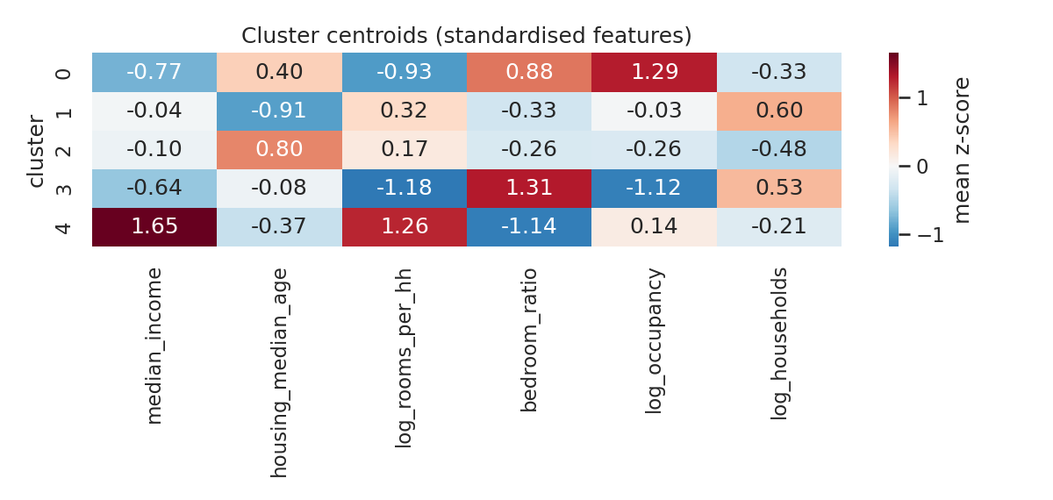
Figure 7. Cluster centroids in standardised units. Red means above the dataset average and blue means below.
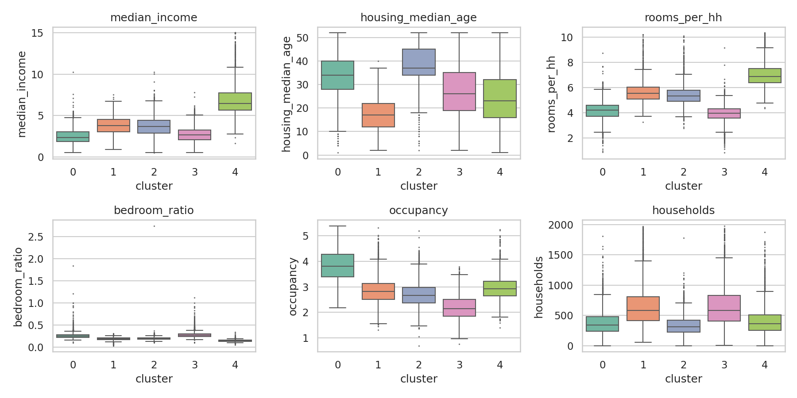
Figure 8. Distribution of the original features within each cluster (top 1% trimmed for ratio features for readability).

7.2 Segment descriptions
C0 – Crowded modest-income family districts (17.0%)
These districts have the lowest income (z = −0.77), the highest household size (median 3.86 people, z = +1.29) and small housing (4.2 rooms per household) with a high bedroom share. The housing is older than average (median 34 years). House values are the lowest of all clusters at a median of $136,900. Two thirds of these districts (68.5%) lie in Southern California, and many are in the Central Valley and the Los Angeles basin on the map.
Interpretation: lower-income, multi-person households living in older, smaller homes. This is the segment where crowding and affordability pressures are most acute, and where public investment is likely to have the highest marginal impact.
C1 – Newer suburban growth areas (24.9%)
The defining characteristic is youth: median building age is 17 years (z = −0.91), the lowest of all clusters. These are large block groups (median 588 households) with comfortably sized homes (5.5 rooms), average household size and about-average income. Half of the districts (50.9%) are classed INLAND, the highest share, and the map shows them spreading across the inland valleys and metropolitan fringes. Values are moderate at $157,600.
Interpretation: recently built, middle-income suburban development on the metropolitan edge, where land was cheaper. This is a growth segment for infrastructure planning, schools and retail.
C2 – Established mature neighbourhoods (28.3%)
The largest cluster and the oldest housing stock (median 37 years, z = +0.80). Block groups are small (median 315 households), household size is low (2.66), and incomes are roughly average. It is over-represented NEAR BAY (17.6%, versus 5–14% in the other clusters) and has the broadest geographic reach, with a strong Bay Area and coastal presence. Median value is $187,000, with a wide spread (standard deviation about $111,000), reflecting a mix of ordinary and highly desirable older neighbourhoods.
Interpretation: stable, built-out, mature communities. Value differences within this group are driven more by location than by structure, so it is the segment where neighbourhood-level pricing models are most needed.
C3 – Dense small-household urban districts (14.2%)
The most distinctive structure: the smallest housing (4.0 rooms per household, z = −1.18), the highest bedroom share (0.271, z = +1.31, characteristic of studios and small apartments) and the smallest households (2.1 people). Block groups are large (median 592 households). Income is low at 2.67 (z = −0.64) but median house value is $197,900, the second highest. It has the highest NEAR OCEAN share (20.5%) and 59.5% of districts are in Southern California, clustered in the dense urban cores.
Interpretation: small apartment-style homes with singles, couples and small households in high-demand locations. Dividing the median house value by ten times the median income gives a value-to-income ratio of about 7.4 for this cluster, versus 4.2 to 5.8 for the others. Prices here are carried by location, not by local earnings, which is a marker of affordability stress and a likely renter market.
C4 – Affluent spacious districts (15.7%)
The highest-income segment by a wide margin (6.47, z = +1.65), with the largest homes (6.9 rooms per household) and the lowest bedroom share (0.15), meaning more non-bedroom living space. Median value is $321,900, and 19.2% of districts hit the census cap of $500,001 (compared with 0.2% to 4% elsewhere). Most are concentrated in the Bay Area (31%) and the coastal parts of Southern California.
Interpretation: high-income, high-value family housing. This is the premium segment for luxury lending, high-value insurance and specialised retail. Its house values are the most truncated by the data cap, so the true gap to other clusters is larger than the figures suggest.

7.3 External validation with withheld variables
Because house value, location and ocean proximity were excluded from clustering, they act as an independent check. House value increases steadily from C0 to C4 and the differences are highly significant (Kruskal–Wallis H = 4,999.8, p < 0.001). The overall correlation between income and value is 0.69, which explains the general ordering, but the clusters add information beyond income. For example, C3 and C1 have similar or lower incomes than C2, yet C3 is priced higher, which a single-variable income split would miss. Ocean proximity and geography also differ in the expected directions (C1 is the most inland, C3 the most near-ocean, C2 the most Bay-adjacent).
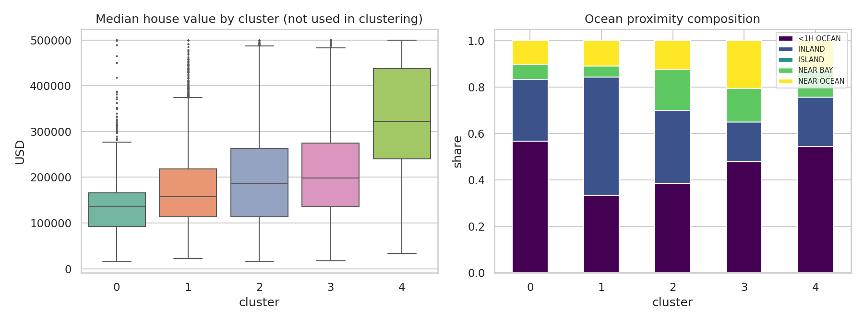
Figure 9. Left: house value by cluster. Right: ocean-proximity composition of each cluster.
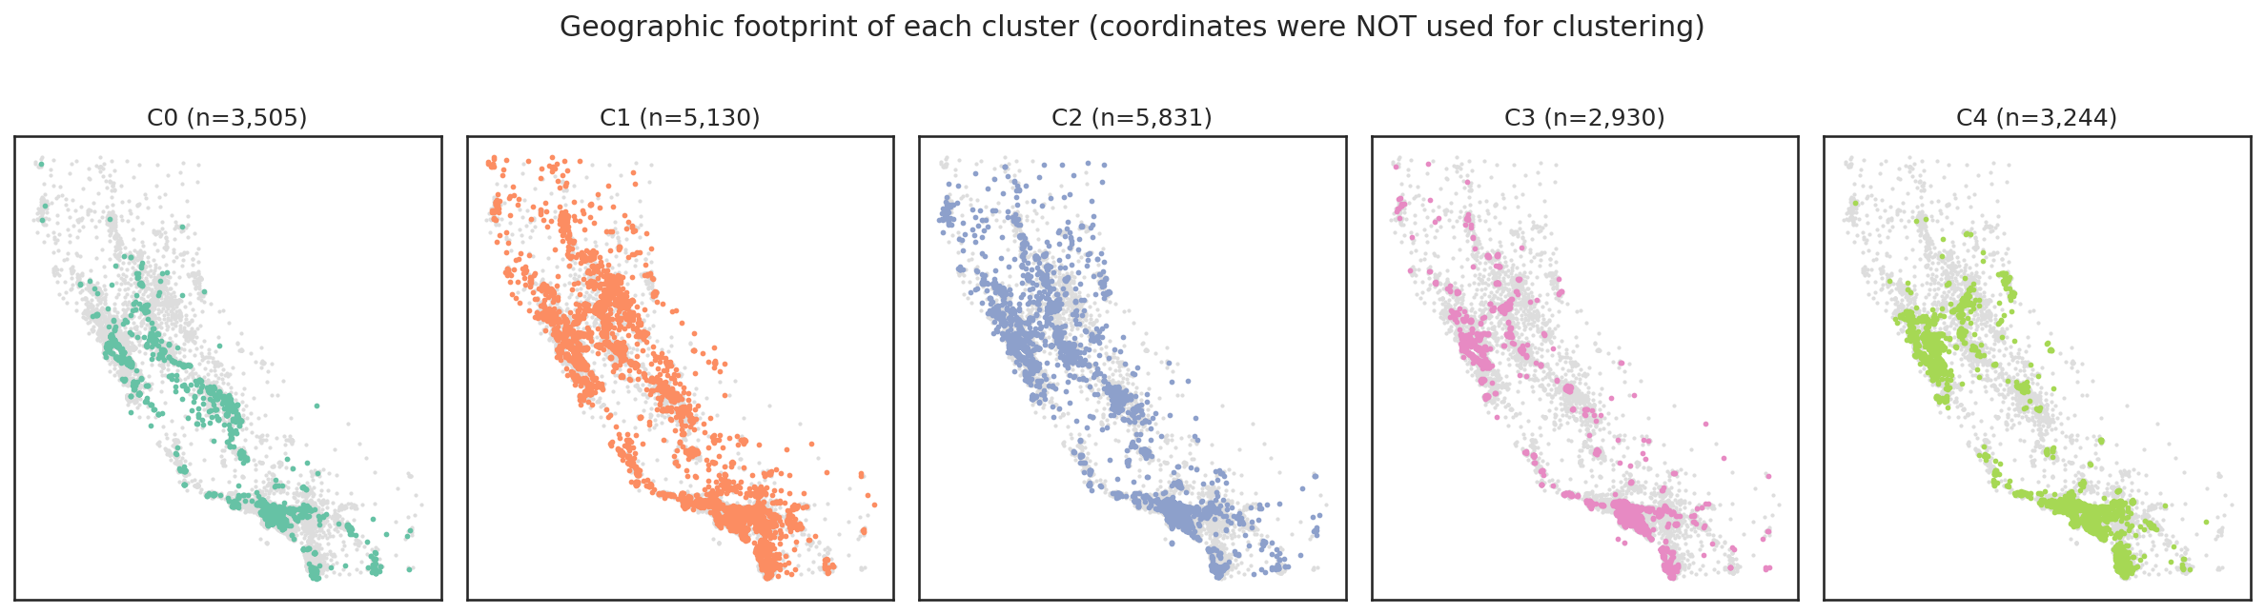
Figure 10. Geographic footprint of each cluster. Grey dots show all other districts.
Per-cluster cohesion. Mean silhouette by cluster is 0.181 (C0), 0.220 (C1), 0.217 (C2), 0.131 (C3) and 0.187 (C4). C3 is the least cohesive, which is plausible because dense urban districts sit between the older family districts and the affluent segment in feature space. The practical implication is that C3 membership is the most uncertain and should be treated with soft boundaries.

8. Business and Research Implications
Table 6. Suggested uses by segment
Segment | Business application | Research / policy application
C0 Crowded modest-income | Affordable-housing finance, community lending, low-cost retail and services | Target for housing-assistance and overcrowding studies; evaluate rehabilitation programmes
C1 Newer suburban growth | Infrastructure, schools, new retail and mortgage products for first-time buyers | Study of urban sprawl, commuting patterns and school capacity planning
C2 Established mature | Renovation, home-improvement and insurance (older stock), local pricing models | Ageing infrastructure and retrofitting; location-specific price modelling
C3 Dense urban | Rental products, small-unit developers, transit-oriented investment | Affordability and displacement research; high price-to-income ratio analysis
C4 Affluent spacious | Premium and jumbo lending, luxury and high-value insurance | Wealth concentration and the effect of price caps on census data

More generally, a lender or insurer could use the segment as a compact feature in a downstream model (for example price prediction), and a planning agency could use the segments to compare like with like when evaluating programmes. The key advantage over single-variable thresholds is that each segment bundles several correlated characteristics into one interpretable label.

9. Limitations and Further Work
- Weak separation. A silhouette near 0.19 and an ARI of about 0.3 between algorithms indicate overlapping groups. Conclusions should be about typical profiles, and individual boundary districts may reasonably belong to a neighbouring cluster.
- Spherical-cluster assumption. K-Means favours roughly equal-sized, round clusters. The GMM did not improve on it here, but density-based methods such as HDBSCAN could be tried to identify genuine outlier districts.
- Data age and truncation. The data describe 1990, and house values are capped at $500,001 (19.2% of C4 is at the cap). The segments illustrate the method and should not be used to describe California today.
- Ecological caution. The clusters describe districts, not individuals. Inferences about people inside a district are subject to the ecological fallacy.
- Preprocessing sensitivity. Winsorising at 1%/99% and the choice of log transforms are judgement calls. A natural extension is to repeat the analysis with different thresholds, a robust scaler, or a different feature set to test the robustness of the segments.

10. Conclusion
A careful preprocessing pipeline, a deliberately withheld validation set, and a model-selection process that combined four validity indices with bootstrap stability led to a five-segment K-Means solution. The segments are interpretable, externally validated against house value and geography, and each suggests a different business or policy action. The most informative finding was the dense urban segment, whose prices are far out of line with local income, a result that only emerged because clustering combined multiple housing and demographic features. The report also shows the limits of the technique: the data form a continuum, so cluster boundaries depend on the algorithm, and the results should be used as archetypes and decision aids rather than as sharp categories.

Appendix A. Reproducibility Notes
- Data source: California Housing CSV (housing.csv, 20,640 rows), 1990 U.S. Census block groups.
- All random operations use seed 42. K-Means uses n_init = 50 for the final model.
- Silhouette values are computed on a fixed random sample of 6,000 points (5,000 for the algorithm comparison); the other indices use all points.
- Ward clustering and the dendrogram use random samples (5,000 and 1,500 points) because they require a full pairwise distance matrix.
- t-SNE uses 5,000 sampled points, perplexity 40, PCA initialisation.

Core pipeline in one block
import numpy as np, pandas as pd
from sklearn.preprocessing import StandardScaler
from sklearn.cluster import KMeans, AgglomerativeClustering
from sklearn.mixture import GaussianMixture
from sklearn.metrics import silhouette_score

df = pd.read_csv("housing.csv")
# 1. impute + engineer features
df["total_bedrooms"] = df.total_bedrooms.fillna(
df.groupby("ocean_proximity").total_bedrooms.transform("median"))
df["rooms_per_hh"] = df.total_rooms / df.households
df["bedroom_ratio"] = df.total_bedrooms / df.total_rooms
df["occupancy"] = df.population / df.households
df["log_households"] = np.log(df.households)
feats = ["median_income","housing_median_age","rooms_per_hh",
"bedroom_ratio","occupancy","log_households"]
# 2. winsorise, log-transform, scale
X = df[feats]; X = X.clip(X.quantile(.01), X.quantile(.99), axis=1)
X["occupancy"] = np.log(X.occupancy); X["rooms_per_hh"] = np.log(X.rooms_per_hh)
Z = StandardScaler().fit_transform(X)
# 3. cluster
km = KMeans(5, n_init=50, random_state=42).fit(Z)
df["cluster"] = km.labels_
# 4. compare
ward = AgglomerativeClustering(5, linkage="ward").fit(Z[:5000])
gmm = GaussianMixture(5, n_init=5, random_state=42).fit(Z)
# 5. profile
print(df.groupby("cluster")[feats + ["median_house_value"]].median())

