Week 4 Task
Supervised Learning Model Implementation
Predicting customer churn for a telecom provider with scikit-learn and XGBoost
Problem type: Binary classification (churn vs. stay)
Dataset: IBM Telco Customer Churn (7,043 customers, publicly available)
Tools: Python 3, pandas, scikit-learn 1.8, XGBoost 3.4, matplotlib, seaborn
Date: October 19, 2026

1. Executive Summary
This report builds and evaluates a supervised classification model that predicts whether a telecom customer will churn. Starting from 7,043 customers and 20 raw attributes, I cleaned the data, engineered 12 additional features, compared five model families using stratified 5-fold cross-validation, tuned the strongest candidates with randomised search, and evaluated the final model once on a held-out test set.
Key results:
- Predictive performance: the final tuned XGBoost model reaches a test ROC-AUC of 0.847 (95% bootstrap CI 0.826–0.869) and a PR-AUC of 0.664, against a no-skill baseline of 0.500 and 0.265 respectively.
- Model choice is close: a tuned logistic regression is statistically indistinguishable (test AUC 0.845) and far easier to explain. Gradient boosting adds little here because the signal is dominated by a few simple variables.
- Feature engineering had no measurable accuracy benefit. An ablation test shows that adding 12 engineered features changed cross-validated AUC by less than ±0.003, which is within noise. The report documents this negative result honestly and explains why.
- Business value comes from the threshold, not the algorithm. Using illustrative costs ($500 for a lost customer, $50 for a retention offer), choosing the decision threshold by cost lowers expected cost on the test set from $51,100 (default 0.5 threshold) to $36,300, and from $187,000 when no action is taken.
- Main drivers: contract type and tenure dominate, followed by internet service type, online security and payment method.

2. Problem Definition

2.1 Business problem
Acquiring a new telecom customer costs several times more than retaining an existing one. If a provider can identify customers who are likely to leave, it can target them with retention offers such as discounts, contract upgrades or support calls. The task is therefore to produce, for each customer, a probability of churn that can be used to rank customers and trigger an action.

2.2 Machine learning formulation
- Task: binary classification. Target Churn = 1 if the customer left within the last month, otherwise 0.
- Class balance: 26.5% of customers churned, so the problem is moderately imbalanced (about 1 churner for every 2.8 stayers).
- Why classification and not regression: the retention team makes a yes/no decision about whom to contact, so a calibrated probability and a threshold map directly onto the action.

2.3 Success metrics
Accuracy alone is misleading with imbalanced classes: a model that predicts "no churn" for everyone would score 73.5% accuracy while catching zero churners. The following metrics were therefore used:
Table 1. Evaluation metrics
Metric | Why it is used
ROC-AUC | Threshold-independent measure of ranking quality; primary metric for model selection
PR-AUC (average precision) | More informative than ROC-AUC when the positive class is the minority
Recall and precision | Recall measures how many churners are caught; precision measures how many offers reach real churners
F1-score | Balance between precision and recall at a chosen threshold
Expected cost | Business metric: $500 per missed churner (false negative) and $50 per wasted offer (false positive). These are illustrative assumptions, not company figures
Brier score and calibration | Whether predicted probabilities can be trusted as probabilities

3. Data
The IBM Telco Customer Churn dataset is publicly available and contains one row per customer with demographic information, the services subscribed to, account information and the churn label.
Table 2. Dataset overview (7,043 rows, 21 columns including customerID)
Group | Variables
Demographics | gender, SeniorCitizen, Partner, Dependents
Phone and internet services | PhoneService, MultipleLines, InternetService (DSL / Fiber optic / No)
Add-on services | OnlineSecurity, OnlineBackup, DeviceProtection, TechSupport, StreamingTV, StreamingMovies
Account | tenure (months), Contract (Month-to-month / One year / Two year), PaperlessBilling, PaymentMethod
Charges | MonthlyCharges, TotalCharges
Target | Churn (Yes / No)

4. Data Preparation

4.1 Data quality checks
- Duplicates: 0 duplicated customer IDs.
- TotalCharges was stored as text because 11 rows contain a blank string. All 11 belong to customers with tenure = 0 (brand-new customers who have not yet been billed), so the blanks are structurally zero rather than random missing values. They were converted to 0.
- Several columns contain the value "No internet service" or "No phone service". These are informative (they mean the service is unavailable) and were kept as a separate category rather than merged into "No".
df = pd.read_csv("telco.csv")
df["TotalCharges"] = pd.to_numeric(df.TotalCharges.str.strip(), errors="coerce")
df["TotalCharges"] = df.TotalCharges.fillna(0) # tenure == 0 customers
df["y"] = (df.Churn == "Yes").astype(int)

4.2 Train/test split
The data were split 80/20 with stratification on the target (5,634 training rows, 1,409 test rows). Churn rates are 26.5% in training and 26.5% in the test set. The test set was locked away and used exactly once, at the end. All model selection, tuning and threshold choice used only the training data.
Xtr, Xte, ytr, yte = train_test_split(X, y, test_size=0.2,
stratify=y, random_state=42)

5. Exploratory Data Analysis
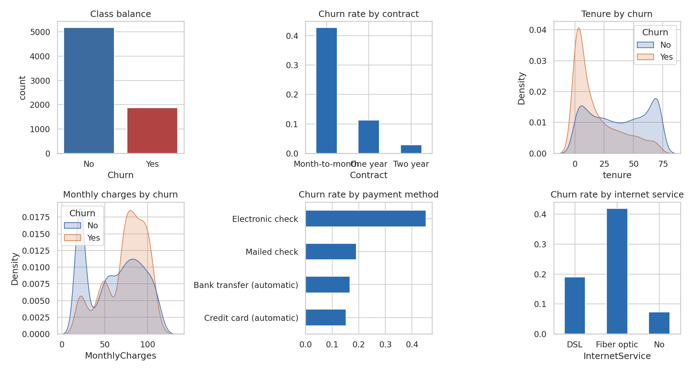
Figure 1. Class balance and the strongest univariate relationships with churn.
The exploratory analysis shows consistent, interpretable patterns:
- Contract type is the strongest signal. Churn is 42.7% for month-to-month contracts, 11.3% for one-year and 2.8% for two-year contracts.
- Tenure: churners leave early. Median tenure is 10 months for churners versus 38 months for stayers.
- Price: churners pay more, with a median monthly charge of $79.6 versus $64.4.
- Service and payment: fibre-optic customers churn at 41.9% versus 19.0% for DSL, and customers paying by electronic check churn at 45.3%, about three times the rate of automatic payers (15.2%–16.7%).
- Senior citizens churn at 41.7% versus 23.6% for non-seniors.
These are associations, not causes. For example, electronic-check payers may differ in other ways (age, income, tenure) that drive churn.

6. Feature Engineering
Features were designed from business reasoning about why customers leave. Each one is a deterministic function of columns in the same row, so no information from other customers or from the target leaks into them.
Table 3. Engineered features
Feature | Definition | Rationale
n_addons | Count of the six add-on services subscribed | Customers with more services are more embedded
n_protect | Count of security, backup, protection, tech support | Protection services may reduce churn through support contact
has_internet | 1 if any internet service | Separates phone-only customers
auto_pay / e_check | Automatic payment flag; electronic-check flag | Payment friction and engagement
avg_monthly_paid | TotalCharges / tenure | Realised average price per month
price_drift | MonthlyCharges − avg_monthly_paid | Positive when the current price is above what the customer historically paid
charge_per_service | MonthlyCharges / (1 + number of services) | Perceived value for money
new_customer | 1 if tenure ≤ 6 months | Early-life churn risk
tenure_group | Binned tenure (0–12, 13–24, 25–48, 49–72) | Allows non-linear tenure effects in linear models
family | 1 if partner or dependents | Household stability
mtm_fiber | Month-to-month AND fibre optic | Interaction of the two highest-risk attributes

svc = ["OnlineSecurity","OnlineBackup","DeviceProtection",
"TechSupport","StreamingTV","StreamingMovies"]
d["n_addons"] = (d[svc] == "Yes").sum(axis=1)
d["auto_pay"] = d.PaymentMethod.str.contains("automatic").astype(int)
d["avg_monthly_paid"] = np.where(d.tenure > 0,
d.TotalCharges / d.tenure.clip(lower=1), d.MonthlyCharges)
d["price_drift"] = d.MonthlyCharges - d.avg_monthly_paid
d["new_customer"] = (d.tenure <= 6).astype(int)
d["mtm_fiber"] = ((d.Contract == "Month-to-month") &
(d.InternetService == "Fiber optic")).astype(int)

6.1 Encoding and scaling
Categorical variables were one-hot encoded (binary variables with a single column) and numeric variables were standardised. Both steps live inside a scikit-learn ColumnTransformer that is part of the model Pipeline, so they are re-fitted within each cross-validation training fold. This prevents data leakage, because the scaling statistics of a validation fold never influence training.
prep = ColumnTransformer([
("c", OneHotEncoder(handle_unknown="ignore", drop="if_binary"), cat_cols),
("n", StandardScaler(), num_cols)])
pipe = Pipeline([("p", prep), ("m", model)])

7. Model Selection and Rationale
Five candidates were chosen to span a range of bias and variance, plus a naive baseline that gives the reference level any real model must beat.
Table 4. Candidate models
Model | Why included | Imbalance handling
Dummy (majority class) | Floor: shows what accuracy means with no skill | None
Logistic Regression (L2) | Interpretable, well-calibrated, strong baseline for tabular business data | class_weight = balanced
Random Forest | Captures non-linearities and interactions; robust to noise | balanced_subsample
HistGradientBoosting | Fast sequential trees, native in scikit-learn | Threshold tuning later
XGBoost | Regularised gradient boosting; typically top performer on tabular data | scale_pos_weight = 2.77

Rather than resampling methods such as SMOTE, class weights were used. They avoid creating synthetic customers, work inside cross-validation without leakage risk, and the decision threshold is tuned separately afterwards, which gives the main benefit of rebalancing.

8. Validation

8.1 Cross-validation
Models were compared with stratified 5-fold cross-validation on the training set (the same folds for every model). Stratification keeps the churn rate near 26.5% in every fold.
cv = StratifiedKFold(5, shuffle=True, random_state=42)
scoring = ["roc_auc","average_precision","f1","recall","precision","accuracy"]
res = cross_validate(Pipeline([("p", prep), ("m", model)]),
Xtr, ytr, cv=cv, scoring=scoring)

Table 5. 5-fold cross-validation results (threshold 0.5, default hyperparameters)
Model | ROC-AUC (mean ± sd) | PR-AUC | F1 | Recall | Precision | Accuracy
Dummy (majority) | 0.500 ± 0.000 | 0.265 | 0.000 | 0.000 | 0.000 | 0.735
Logistic Regression | 0.846 ± 0.012 | 0.660 | 0.628 | 0.793 | 0.520 | 0.751
Random Forest | 0.843 ± 0.009 | 0.653 | 0.632 | 0.712 | 0.568 | 0.780
HistGradientBoosting | 0.842 ± 0.009 | 0.651 | 0.577 | 0.514 | 0.658 | 0.800
XGBoost | 0.845 ± 0.011 | 0.661 | 0.626 | 0.777 | 0.525 | 0.754

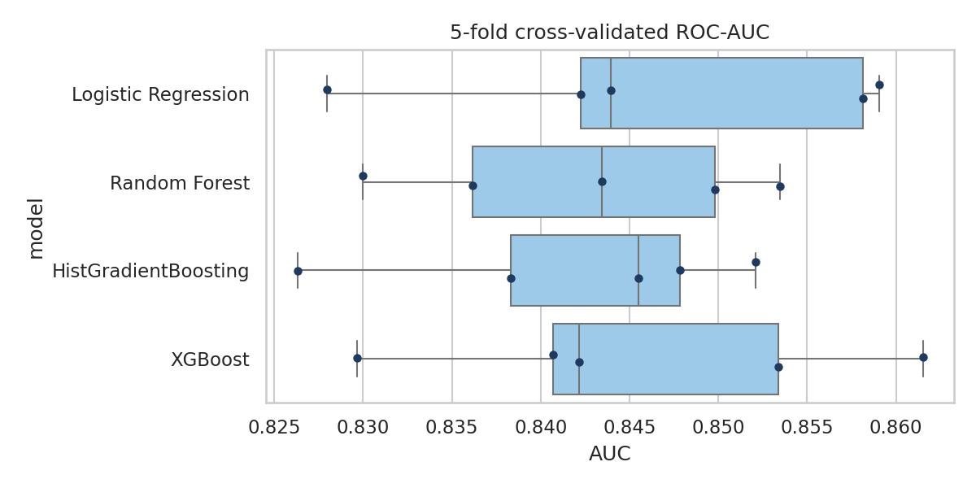
Figure 2. Cross-validated ROC-AUC across the five folds for each model.
All four real models land at an AUC of about 0.84–0.85, far above the dummy baseline of 0.50. Differences between them (≤ 0.004) are smaller than the fold-to-fold standard deviation (about 0.01), so they cannot be reliably ranked at this stage. The F1, recall and precision columns differ more, mostly because class weighting moves the operating point rather than because the models rank customers differently. For this reason, AUC and PR-AUC were used for model comparison and the threshold was optimised separately.

8.2 Does feature engineering help? An ablation study
To test the effectiveness of the engineered features directly, three models were cross-validated twice: once on the original columns only and once with the engineered features added.
Table 6. Feature engineering ablation (5-fold CV)
Model | Feature set | ROC-AUC | PR-AUC | F1
Logistic Regression | Original features | 0.8459 | 0.6600 | 0.6281
Logistic Regression | + Engineered features | 0.8463 | 0.6601 | 0.6279
HistGradientBoosting | Original features | 0.8452 | 0.6573 | 0.5840
HistGradientBoosting | + Engineered features | 0.8420 | 0.6510 | 0.5769
XGBoost | Original features | 0.8477 | 0.6695 | 0.6319
XGBoost | + Engineered features | 0.8455 | 0.6608 | 0.6262

The engineered features did not improve performance. The change in AUC ranges from +0.0004 (logistic regression) to −0.0032 (HistGradientBoosting), all inside the noise of cross-validation. There are three plausible reasons. First, the dominant signals (contract, tenure, internet service) are already present in the raw data. Second, tree models can discover simple interactions such as month-to-month plus fibre on their own, so an explicit interaction feature is redundant. Third, most engineered features are combinations of existing columns, so they add correlation, not new information. This is a useful finding in its own right: further feature work should focus on new information sources (for example support-call history or usage trends) and not on re-arranging the existing columns. The engineered set was kept for the final model because it costs nothing in performance, supports interpretability (for example new_customer is easier to act on than a continuous tenure), and the permutation analysis below shows two of the new features in the top six.

9. Hyperparameter Tuning
The three strongest families (logistic regression, HistGradientBoosting and XGBoost) were tuned with randomised search (15 to 20 samples each) optimising cross-validated ROC-AUC on the training set. Randomised search covers wide ranges more efficiently than a grid when only a few hyperparameters really matter.
search = RandomizedSearchCV(
Pipeline([("p", prep), ("m", XGBClassifier(scale_pos_weight=spw))]),
{"m__n_estimators": randint(100, 400), "m__learning_rate": loguniform(.01, .15),
"m__max_depth": randint(2, 5), "m__subsample": uniform(.6, .4),
"m__colsample_bytree": uniform(.5, .5), "m__min_child_weight": randint(1, 10),
"m__reg_lambda": loguniform(.1, 20)},
n_iter=20, scoring="roc_auc", cv=cv, random_state=42).fit(Xtr, ytr)

Table 7. Tuning results
Model | Best CV AUC | Selected hyperparameters
Logistic Regression | 0.8467 | C=0.0315, penalty=l2
HistGradientBoosting | 0.8477 | l2_regularization=4.57, learning_rate=0.128, max_iter=367, max_leaf_nodes=5, min_samples_leaf=42
XGBoost | 0.8494 | colsample_bytree=0.550, learning_rate=0.0347, max_depth=2, min_child_weight=4, n_estimators=251, reg_lambda=3.15, subsample=0.623

XGBoost had the highest cross-validated AUC (0.8494) and was selected. The margin over logistic regression (0.8467) is only 0.003, much smaller than the fold standard deviation, so the choice is a mild preference and not a decisive victory. The tuned XGBoost is deliberately shallow (max_depth = 2) with strong regularisation, which agrees with the learning-curve evidence in Section 11 that the problem favours simple models. The tuned logistic regression uses a strong L2 penalty (C ≈ 0.03).

10. Final Evaluation on the Held-Out Test Set
The selected XGBoost pipeline was refit on the full training set and evaluated once on the 1,409 test customers.
Table 8. Test-set metrics (threshold-free)
Metric | Value | Comment
ROC-AUC | 0.847 | 95% bootstrap CI 0.826–0.869 (500 resamples)
PR-AUC (average precision) | 0.664 | Baseline (churn rate) = 0.265
Brier score | 0.163 | Lower is better; see calibration note
Log loss | 0.485 | Inflated by class weighting
Tuned logistic regression AUC | 0.845 | Practically identical

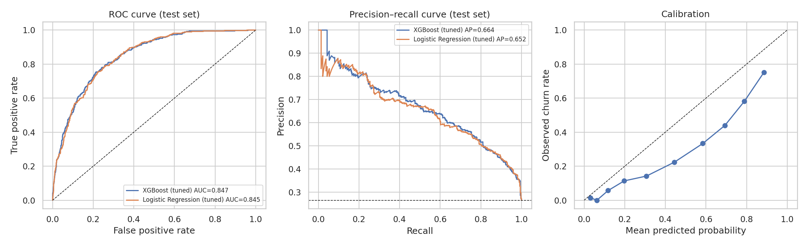
Figure 3. ROC curve, precision–recall curve and calibration plot on the test set.
The ROC and precision–recall curves of the tuned XGBoost and tuned logistic regression almost overlap, confirming that both learn essentially the same ranking. The calibration plot shows that the XGBoost probabilities are systematically too high: customers predicted at 0.8 churn at about 0.6. This is a known side effect of scale_pos_weight, which shifts the model towards predicting the minority class. The ranking quality is unaffected, but if the probabilities are used directly (for example to estimate expected revenue at risk), they should first be recalibrated with Platt scaling or isotonic regression on a separate validation set.

10.1 Choosing the decision threshold
The default threshold of 0.5 is arbitrary. Because a missed churner costs ten times more than a wasted offer in the assumed cost structure, the threshold was chosen by minimising expected cost on out-of-fold predictions from the training set. The test set was not used for this choice.
oof = cross_val_predict(best, Xtr, ytr, cv=cv, method="predict_proba")[:, 1]
cost = lambda y, p, t: ((p >= t) & (y == 0)).sum()*50 + ((p < t) & (y == 1)).sum()*500
thresholds = np.linspace(.05, .95, 91)
best_t = thresholds[np.argmin([cost(ytr.values, oof, t) for t in thresholds])] # 0.19

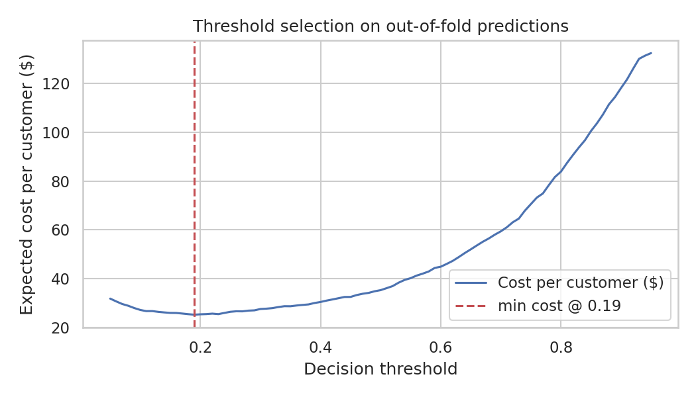
Figure 4. Expected cost per customer across decision thresholds (out-of-fold training predictions).
Table 9. Business comparison on the test set (cost assumptions: $500 per missed churner, $50 per offer)
Strategy | Precision | Recall | F1 | Offers sent | Total cost
No model (do nothing) | – | 0% | – | 0 | $187,000
Offer to everyone | 26.5% | 100% | 0.419 | 1409 | $51,750
Default threshold 0.50 | 51.5% | 80.2% | 0.628 | 582 | $51,100
F1-optimal threshold 0.60 | 56.7% | 72.2% | 0.635 | 476 | $62,300
Cost-optimal threshold 0.19 | 38.7% | 95.7% | 0.552 | 924 | $36,300

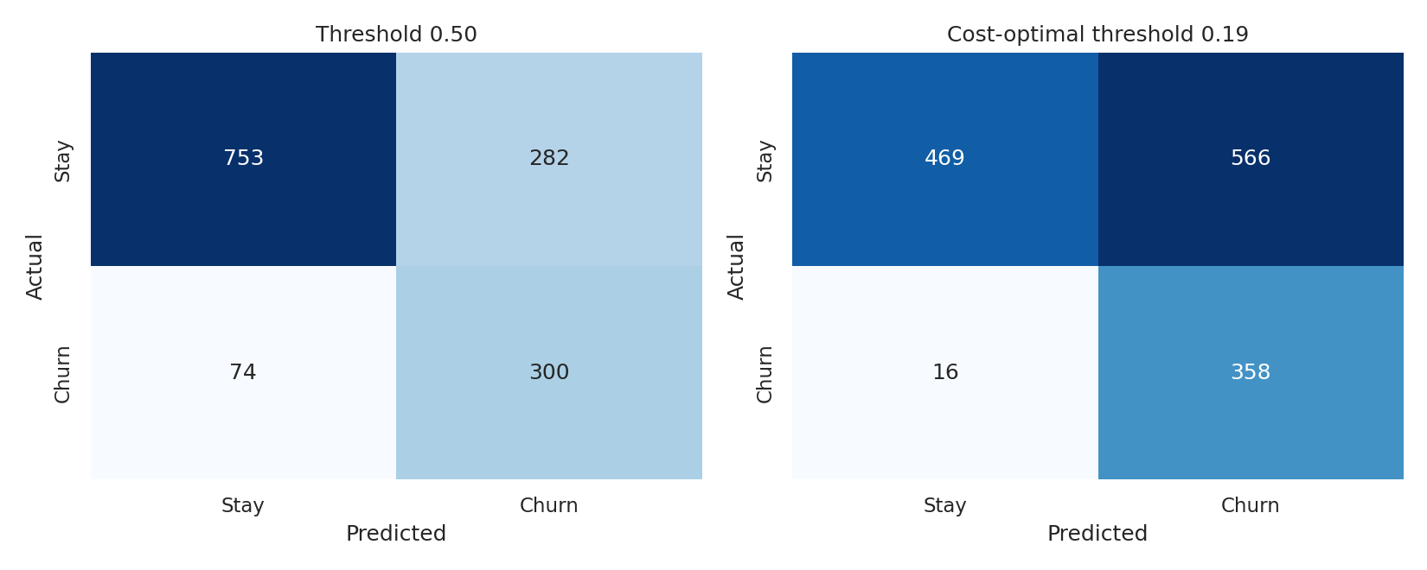
Figure 5. Confusion matrices on the test set at the default and cost-optimal thresholds.
At the cost-optimal threshold of 0.19 the model catches 96% of churners (358 of 374) at the price of lower precision (39%), and the total cost falls to $36,300. That is 30% cheaper than offering a discount to everyone and 29% cheaper than using the default 0.5 threshold. Under these specific costs the optimal policy is broad targeting. If retention offers were more expensive (for example $150), the optimal threshold would rise and the programme would be more selective, so the cost inputs should be replaced with the company's real figures before deployment.

11. Performance Analysis

11.1 What drives the predictions?
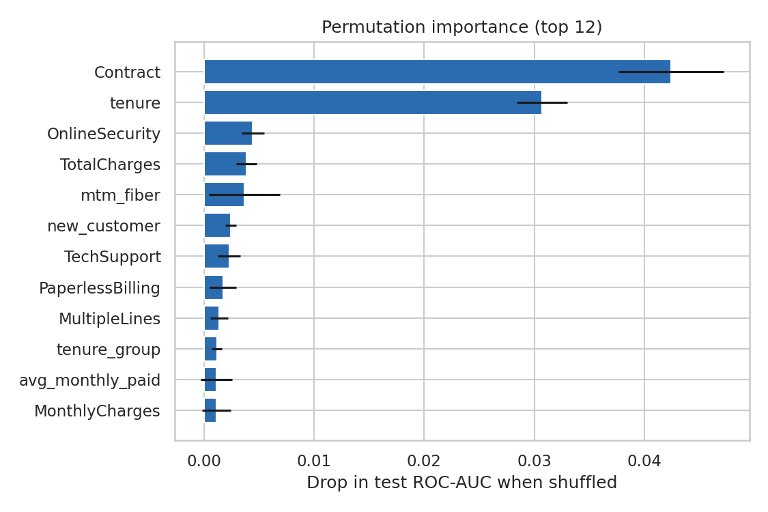
Figure 6. Permutation importance on the test set: drop in ROC-AUC when a feature is randomly shuffled.
Contract (drop of 0.042 in AUC when shuffled) and tenure (0.031) are by far the most important features, about ten times more than anything else. Online security, total charges and the engineered mtm_fiber and new_customer flags follow, but each contributes less than 0.005 AUC. Permutation importance understates the importance of correlated features because a shuffled feature can be partly replaced by its correlated neighbours (for example tenure and TotalCharges), so these rankings should be read as approximate.
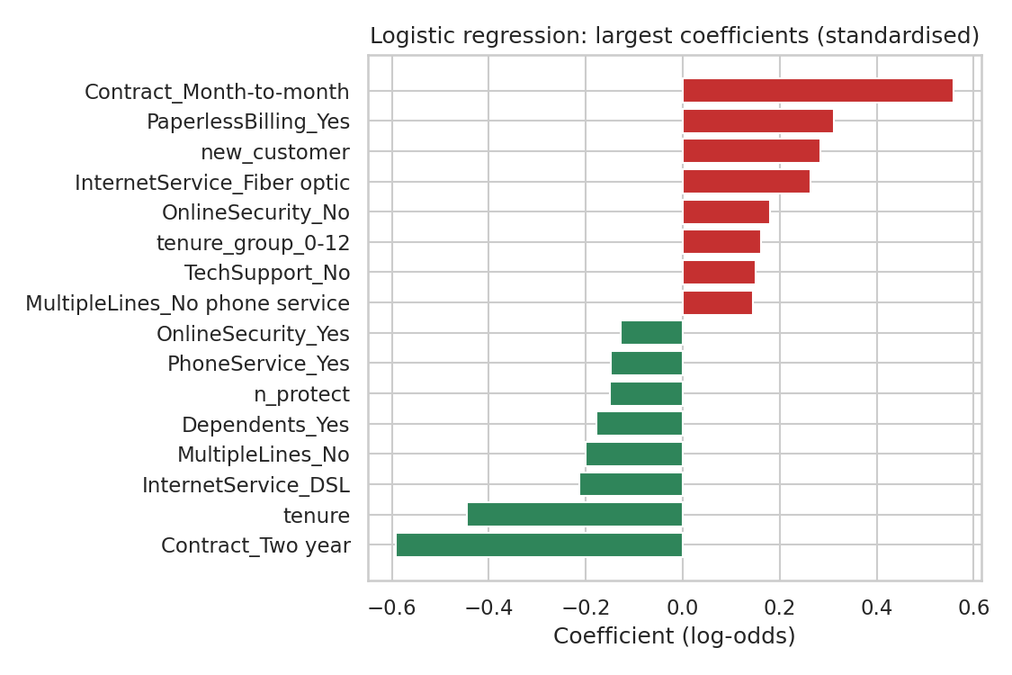
Figure 7. Largest standardised coefficients of the tuned logistic regression.
The logistic regression gives directional information that matches the exploratory analysis. Churn risk increases with month-to-month contracts, paperless billing, short tenure, fibre-optic service and no online security. It decreases with two-year contracts, longer tenure, DSL service, having dependents and holding protection services. Interpretable evidence of this kind is valuable for retention strategy and is one reason to prefer logistic regression when the accuracy gap is negligible.

11.2 Bias-variance diagnosis
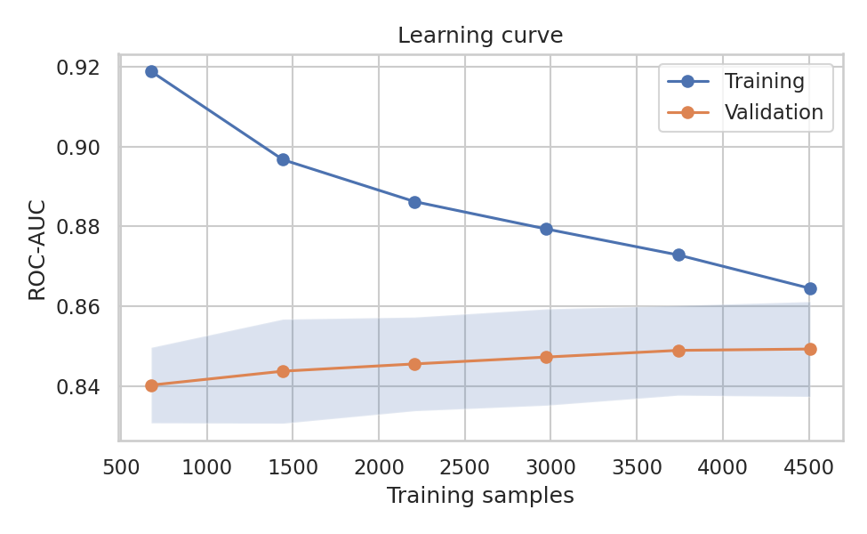
Figure 8. Learning curve of the final model: training and validation ROC-AUC against training-set size.
Validation AUC rises from 0.84 to 0.849 and flattens after about 3,000 samples, while training AUC falls from 0.92 to 0.865. The gap at full size is only about 0.016, so the model is not seriously overfitting, and the plateau shows that collecting more rows of the same kind is unlikely to help much. The remaining error comes from information that the current features do not contain.

11.3 Ranking quality for targeting
If customers are ranked by predicted risk and the retention team contacts only the top decile (141 customers), 75.2% of them actually churn, which is a lift of 2.8 over the base rate. The top 20% of customers contain 50% of all churners and the top 30% contain 67%. A capacity-limited team can therefore use the ranking directly even without a probability threshold.

11.4 Performance across subgroups
Table 10. Test-set AUC by subgroup
Subgroup | Customers (test) | Observed churn | ROC-AUC within subgroup
Contract=Month-to-month | 773 | 42.6% | 0.756
Contract=One year | 300 | 12.0% | 0.756
Contract=Two year | 336 | 2.7% | 0.733
Not senior | 1187 | 23.3% | 0.849
Senior citizen | 222 | 44.1% | 0.784

The overall AUC is flattered by the large, easy gap between contract types. Within a single contract type the model separates churners from stayers less well (AUC 0.73–0.76), and performance is lower for senior citizens (0.78) than for non-seniors (0.85). Subgroup sizes are small (222 to 773 customers), so these figures are noisy, but they warn that the headline AUC should not be assumed to hold equally for every segment. Fairness concerns also apply, because age-related variables should be handled with care in any retention policy.

12. Strengths and Limitations

Strengths
- Leak-free design: all preprocessing sits inside the cross-validated pipeline and the test set was touched once.
- Consistent evidence: cross-validation, a held-out test set, bootstrap intervals and a learning curve all agree that the model achieves an AUC of about 0.85.
- Decision-focused evaluation: the threshold is optimised against an explicit cost structure instead of defaulting to 0.5.
- Transparent comparison: a strong linear baseline and an ablation of the engineered features keep the conclusions honest.
- Actionable interpretation: the drivers (contract, tenure, payment method, service type) translate into specific retention actions.

Limitations
- Cross-sectional data: each customer appears once, with no history of usage, complaints or price changes. The model predicts who looks like past churners, not when a customer will leave.
- Probability calibration: class weighting inflates predicted probabilities. Rankings are reliable, absolute probabilities are not.
- Correlation, not causation: the model cannot say whether a discount would actually retain a customer. Estimating that requires uplift modelling or a randomised trial.
- Assumed costs: the $500 and $50 figures are illustrative, and the optimal threshold depends strongly on them.
- Single dataset and time window: performance on other markets or periods is unknown, and concept drift is likely in production.
- No gain from engineered features: the feature set may be near the information ceiling of this dataset, so accuracy improvements will need new data.

13. Possible Improvements
- Add behavioural and temporal data: monthly usage trends, support tickets, billing disputes, and recent price changes. This is the most likely source of real gains, as the learning curve indicates the current information is saturated.
- Calibrate probabilities with isotonic regression or Platt scaling, and report reliability diagrams on a fresh validation split.
- Model time-to-churn: survival analysis (Cox model or gradient-boosted survival) would predict when churn occurs and handle customers who have not yet left (censoring).
- Uplift modelling: target customers whose behaviour is most likely to change because of an offer, instead of those most likely to churn.
- Model explanation and monitoring: SHAP values for local explanations, and drift monitoring of the input distribution and AUC after deployment.
- Ensembling and stacking of logistic regression and boosted trees may yield small gains, though given the plateau they are unlikely to be large.
- Nested cross-validation to give an unbiased estimate of the whole tuning procedure.

14. Implications and Recommendations
- Prioritise contract migration. Month-to-month customers churn at 15 times the rate of two-year customers. Incentives to move them to annual plans address the single strongest driver.
- Focus on the first year. Churners have a median tenure of 10 months, so onboarding and early-life engagement are the best place to intervene.
- Review fibre and electronic-check cohorts. Both show unusually high churn and may reflect service quality or billing friction. Promoting automatic payment is a low-cost experiment.
- Bundle protection services. Online security and tech support are associated with lower churn, although causality is unproven and should be tested.
- Deploy with a ranking policy. Score customers monthly, contact the highest-risk segment first within campaign capacity, and measure the real retention effect with a control group.

15. Conclusion
The project delivered a complete supervised-learning workflow: problem framing, leak-free preprocessing, feature engineering with an honest ablation, five-model cross-validated comparison, tuning, a locked-box test evaluation, threshold optimisation, interpretation and diagnostics. The final model ranks churners well (test AUC 0.847), and a cost-aware threshold turns that ranking into a measurable saving. The most important lessons are methodological: simple models can match complex ones on this kind of tabular data, feature engineering is not guaranteed to help, and the choice of threshold and evaluation metric can matter more than the choice of algorithm.

Appendix A. Reproducibility
- Random seed 42 for the split, cross-validation folds, search and models.
- Library versions: scikit-learn 1.8, XGBoost 3.4, pandas, NumPy, SciPy, matplotlib, seaborn (Python 3).
- Data: https://raw.githubusercontent.com/IBM/telco-customer-churn-on-icp4d/master/data/Telco-Customer-Churn.csv

Condensed end-to-end pipeline
import numpy as np, pandas as pd
from sklearn.model_selection import train_test_split, StratifiedKFold, RandomizedSearchCV
from sklearn.compose import ColumnTransformer
from sklearn.pipeline import Pipeline
from sklearn.preprocessing import OneHotEncoder, StandardScaler
from sklearn.metrics import roc_auc_score, average_precision_score
from xgboost import XGBClassifier

df = pd.read_csv("telco.csv")
df["TotalCharges"] = pd.to_numeric(df.TotalCharges.str.strip(), errors="coerce").fillna(0)
df["y"] = (df.Churn == "Yes").astype(int)
df = add_features(df) # engineered features (Section 6)
X, y = df[cat_cols + num_cols], df.y
Xtr, Xte, ytr, yte = train_test_split(X, y, test_size=.2, stratify=y, random_state=42)

prep = ColumnTransformer([
("c", OneHotEncoder(handle_unknown="ignore", drop="if_binary"), cat_cols),
("n", StandardScaler(), num_cols)])
spw = (ytr == 0).sum() / (ytr == 1).sum()
pipe = Pipeline([("p", prep), ("m", XGBClassifier(scale_pos_weight=spw,
eval_metric="logloss", random_state=42))])
cv = StratifiedKFold(5, shuffle=True, random_state=42)
search = RandomizedSearchCV(pipe, param_distributions, n_iter=20,
scoring="roc_auc", cv=cv, random_state=42).fit(Xtr, ytr)
best = search.best_estimator_
p = best.predict_proba(Xte)[:, 1]
print(roc_auc_score(yte, p), average_precision_score(yte, p))

