1. Install WSL2 + Ubuntu.
2. Inside Ubuntu:
sudo apt update
sudo apt install -y mininet openvswitch-switch iperf python3-pip python3-venv build-essential curl git

3. Install pyenv:
curl https://pyenv.run | bash

4. Add pyenv to ~/.bashrc and run:
source ~/.bashrc

5. Install Python:
pyenv install 3.10.16
pyenv global 3.10.16

6. Create venv:
python -m venv ~/ryu-env
source ~/ryu-env/bin/activate

7. Install Ryu:
python -m pip install "setuptools==58.2.0" wheel
python -m pip install "ryu==4.34" --no-build-isolation
python -m pip install "eventlet==0.33.3"
python -m pip install "dnspython==2.2.1"
python -m pip install "oslo.config==10.4.0"

8. Put reservation.py, topology.py and client.py in the same folder.

9. Terminal 1:
source ~/ryu-env/bin/activate
ryu-manager reservation.py

10. Terminal 2:
sudo mn -c
sudo python3 topology.py

11. Terminal 3:
source ~/ryu-env/bin/activate
python client.py STATUS

Terminal 3:
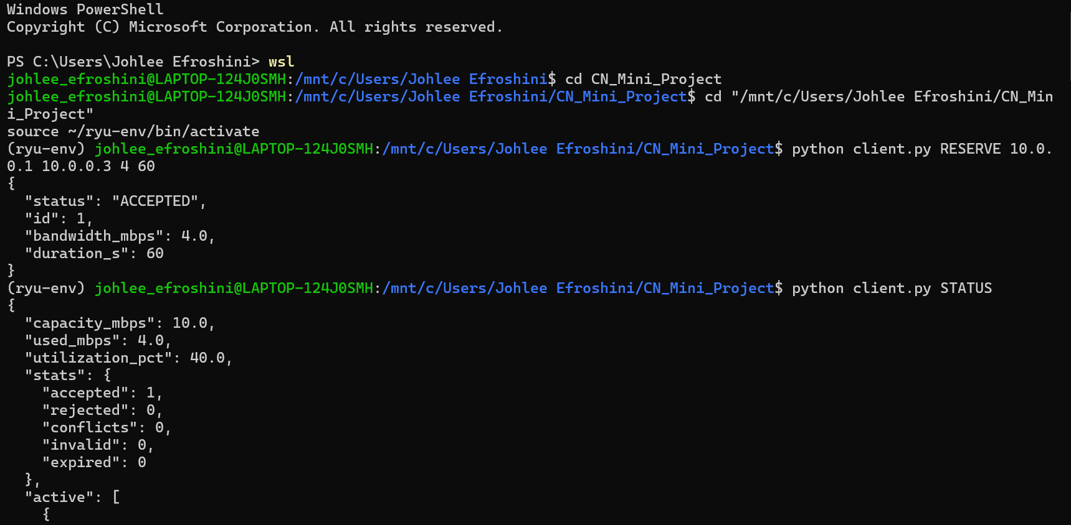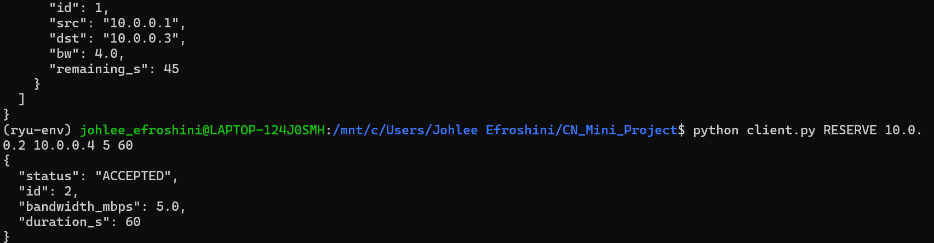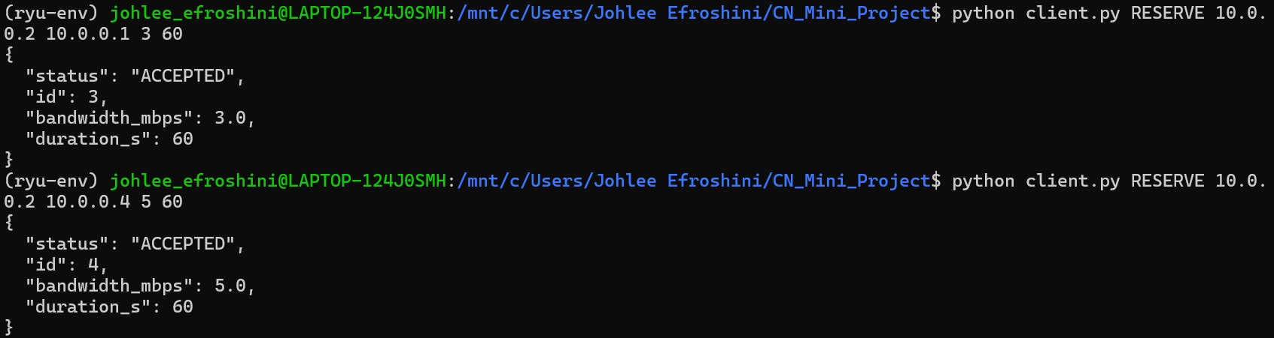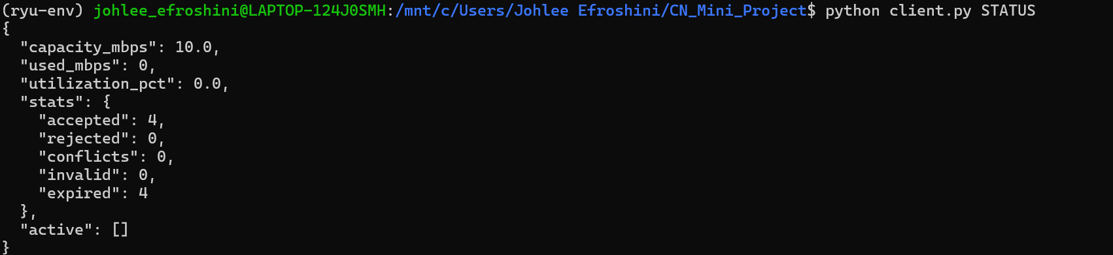
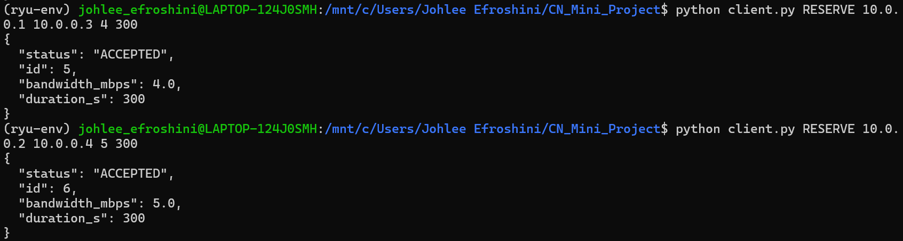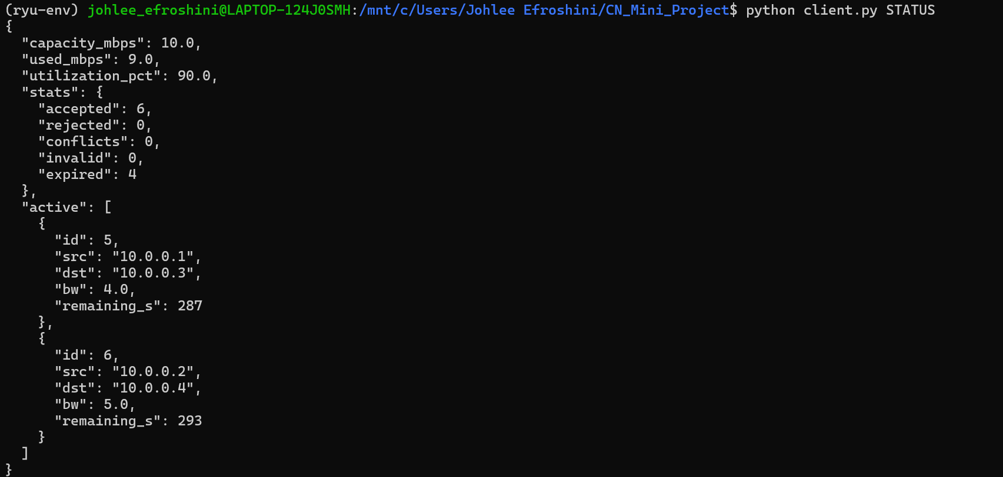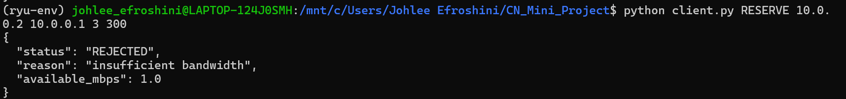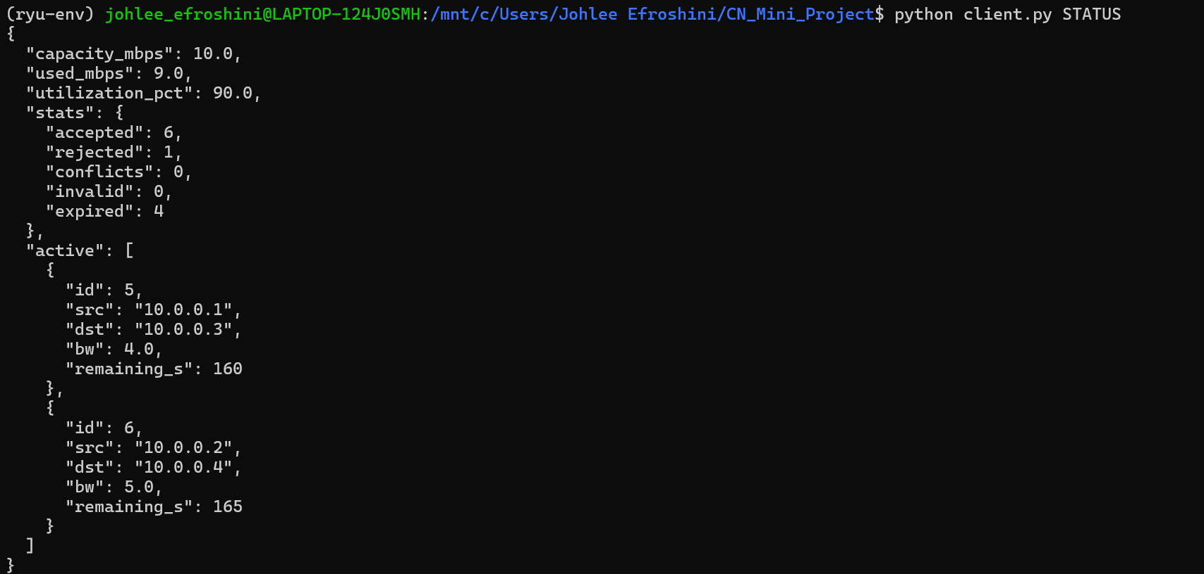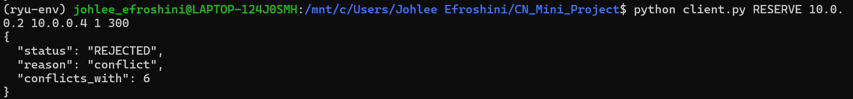
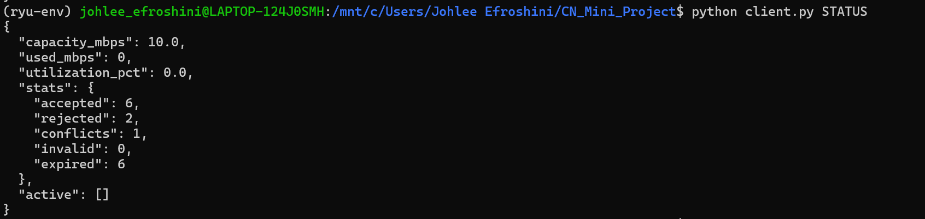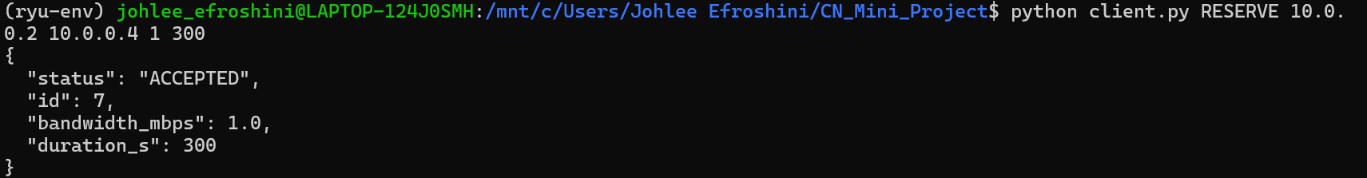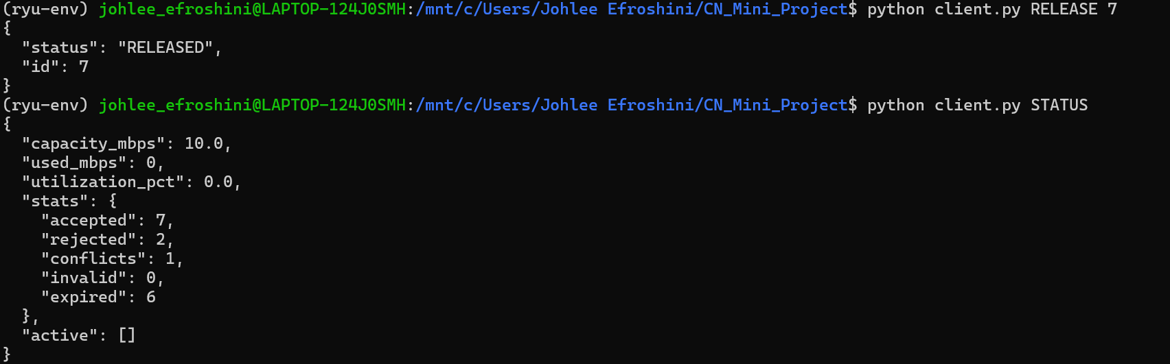

Terminal 1:

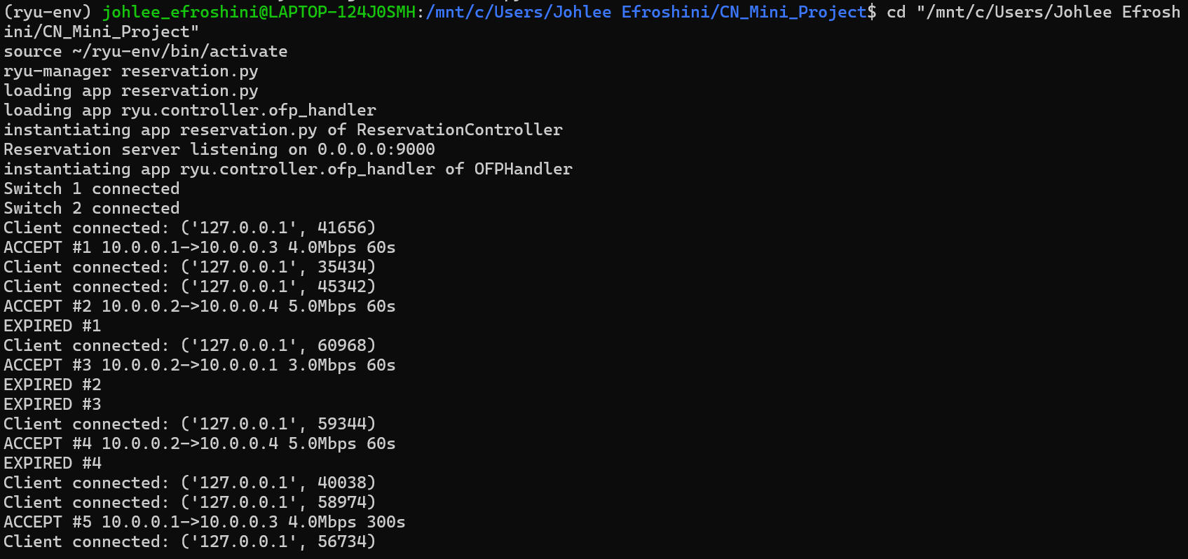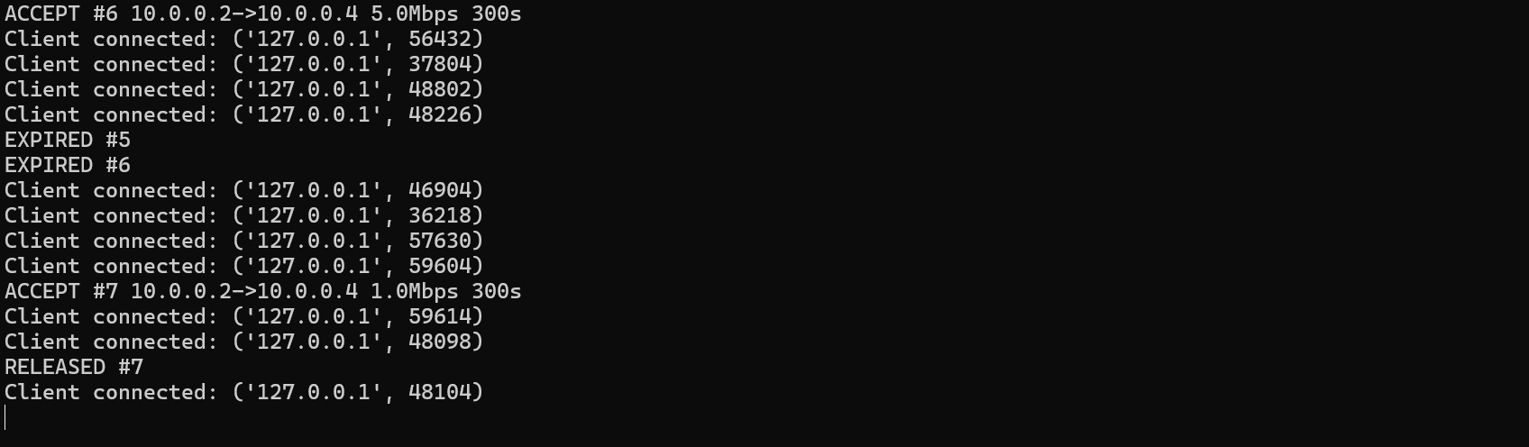
1. Open WSL
Open your Ubuntu/WSL terminal.
Go to your project:
cd "/mnt/c/Users/Johlee Efroshini/CN_Mini_Project"
Then activate your Ryu virtual environment:
source ~/ryu-env/bin/activate
Check:
python --version
which python
ryu-manager --version
You should see approximately:
Python 3.10.16
/home/johlee_efroshini/ryu-env/bin/python
ryu-manager 4.34
You do NOT need to reinstall Python, Ryu, Eventlet, Oslo, etc. tomorrow.

2. Start Terminal 1 — Ryu
Open a second WSL terminal.
Again:
cd "/mnt/c/Users/Johlee Efroshini/CN_Mini_Project"
source ~/ryu-env/bin/activate
Then:
ryu-manager reservation.py
You want to see:
loading app reservation.py
loading app ryu.controller.ofp_handler
instantiating app reservation.py of ReservationController
Reservation server listening on 0.0.0.0:9000
instantiating app ryu.controller.ofp_handler of OFPHandler
Leave this terminal running.
Do not press Ctrl+C.

3. Start Terminal 2 — Mininet
Open another WSL terminal.
Go to your project:
cd "/mnt/c/Users/Johlee Efroshini/CN_Mini_Project"
You don't need to activate the Ryu venv for Mininet.
Run:
sudo mn -c
Then:
sudo python3 topology.py
You should eventually get:
*** Starting CLI:
mininet>
Then you can verify:
mininet> pingall
and ideally:
*** Results: 0% dropped (12/12 received)
Leave this terminal running too.

4. Start Terminal 3 — client
Open a third WSL terminal.
Go to the project:
cd "/mnt/c/Users/Johlee Efroshini/CN_Mini_Project"
source ~/ryu-env/bin/activate
Then you can make reservations:
python client.py RESERVE 10.0.0.1 10.0.0.3 4 60
Check:
python client.py STATUS
Release one:
python client.py RELEASE 1
And later, if you want to perform the load test:
python client.py LOADTEST 30

So tomorrow your checklist is
WSL
│
├── Terminal 1
│ cd project
│ source ~/ryu-env/bin/activate
│ ryu-manager reservation.py
│
├── Terminal 2
│ cd project
│ sudo mn -c
│ sudo python3 topology.py
│ mininet> pingall
│
└── Terminal 3
cd project
source ~/ryu-env/bin/activate
python client.py STATUS
python client.py RESERVE ...

To stop Execution:-
Terminal 2:- mininet> exit
Then, if you want to clean up(optional): sudo mn -c
Terminal 1:- ctrl + c

Linking of the 3 files:-
WSL
│
├── Terminal 1
│ cd project
│ source ~/ryu-env/bin/activate
│ ryu-manager reservation.py
│ │
│ ├── Ryu controller starts
│ └── TCP reservation server starts :9000
│
├── Terminal 2
│ cd project
│ sudo mn -c
│ sudo python3 topology.py
│ │
│ ├── Mininet creates h1-h4, s1-s2
│ └── switches connect to Ryu :6653
│
└── Terminal 3
cd project
source ~/ryu-env/bin/activate
python client.py STATUS
python client.py RESERVE ...
│
└──── TCP :9000 ────► reservation.py
│
└──► OpenFlow ──► switches

