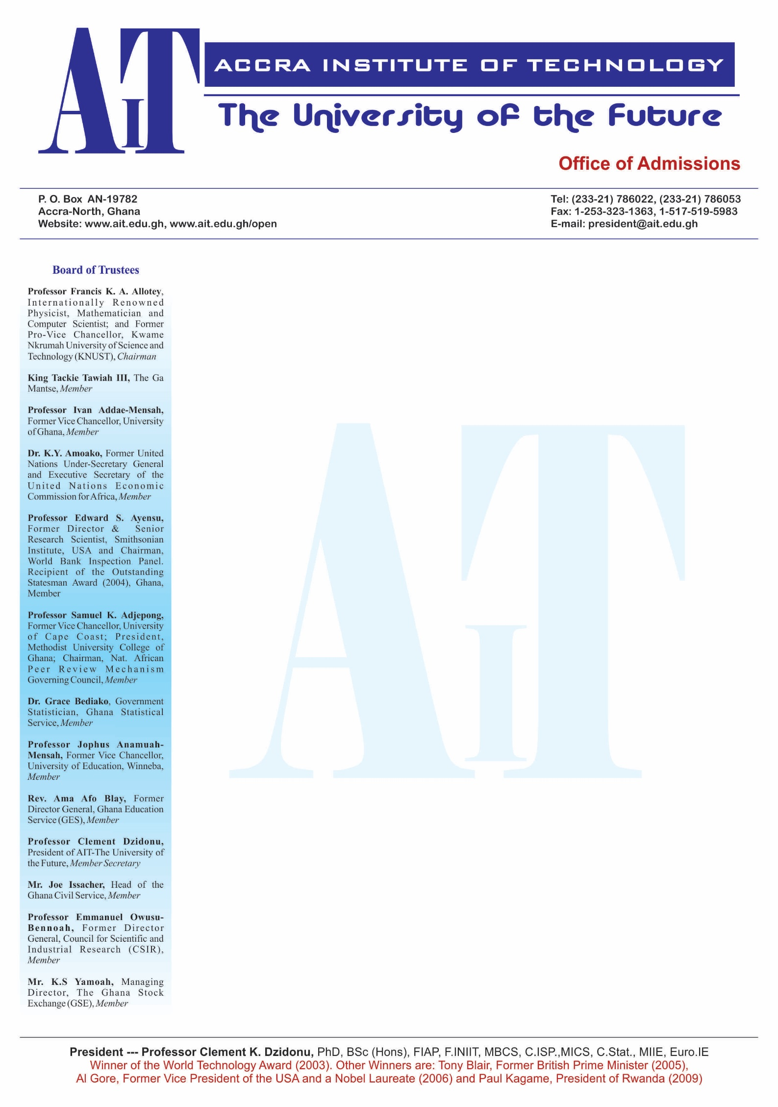 ADVANCED BUSINESS SCHOOL (ABS)

**PROJECT TOPIC:**

ASSESSING THE EFFECT OF PRODUCT PACKAGING AND SALES VOLUME

(A CASE STUDY OF SHOPRITE, GHANA)

**PRESENTED BY**

ANTHONY THANKGOD EKPO

ID NUMBER: ABS14B00164Y

AUGUST, 2016

**DECLARATION**

I hereby declare that this research work is my own piece of work, done as part of the requirement for the award of a Bachelor’s of Science Degree in Marketing and IT. This work does not contain any material published by any person which has been accepted for the award of any other degree of the university, except where due acknowledgement has been made in text.

**ANTHONY THANKGOD EKPO** …………………………… …………………….. (STUDENT) (SIGNATURE) (DATE)

**MRS. OWUSUAA ESHIA** ……………………….……… …………………….

(SUPERVISOR) (SIGNATURE) (DATE)

**MR. ELEAZER FIANKO OFEI** ………………………………… …………………

(COORDINATOR) (SIGNATURE) (DATE)

**ACKNOWLEDGEMENT**

In a credible way am honored to say that my supervisor MRS. OWUSUAA ESHIA deserves credit for her outstanding sense and her avid interest in my work which helped me in keeping up on the right trail. Undeniably, her guidance has made my work a reality.

To my cherished mother, and to my lovely father I say thank you from my innermost part. I am greatly sorry for the exhaustion I would transfer to you after hectic lectures and field work. I believe in that scenario that you’re in one way or the other playing a role model for my educational career.

Finally, I must express my sincere gratitude to my respondents the manager of Shoprite Company, Ghana and consumers for the vital information given to me freely without any form of suspicious activities and for accepting me into your company. I also thank my colleagues and true friends whom we shared a vision of undertaking studies. I particularly thank my friend and course mates who helped me in this struggle.

**DEDICATION**

I dedicate this research to my entire family for their moral and financial support towards the success of my education.

**ABSTRACT**

The study is conceded basically on the role of product packaging towards the sales volume of Shoprite Company. The study was guided by the following objectives; to identify the forms of product packaging used by Shoprite in promoting their sales, to examine the role played by product packaging towards the sales volume of Rites Brand, to identify the challenges faced by Shoprite in packaging their brand products uniquely towards improving the success of their business and to find the relationships between product packaging and the sales volume of Shoprite brand products. The researcher used descriptive, cross-sectional and explanatory research designs. Data was collected using questionnaires, interview guide. Data was collected from two sources; primary and secondary source using a sample size of 50 respondents. It was found that Shoprite Company widely used various forms of packages with 100% respondent of made on the type of package that is plastics, plastic paunches, plastics bottles, Automatic pouch making, Shoprite filling & pouch sealing machines with a printing provision. The study concluded that the findings also indicated that not only Packages that affect sale volume but there are other factors such as research and development, good customer care, price reduction, good after sale service and wide coverage which influenced consumption behavior of the customers in the market. The researcher recommended that Shoprite need to understand the significance of product packaging towards the sales volume and which media to communicate to consumers. It should put a lot of emphasize in planning promotional programs and set promotional goals and strategies and should ensure to carryout evaluations and control of packaging and make adjustments were possible.

**TABLE OF CONTENTS**

DECLARATION…………………………………………………………………………… i

ACKNOWLEDGEMENT…………………………………………………………………. ii

DEDICATION……………………………………………………...……………………… iii

ABSTRACT…………………………………………………………………………….….. iv

TABLE OF CONTENTS……………………………………………………………………v

**CHAPTER ONE: GENERAL INTRODUCTION AND SUMMARY**

1.0 INTRODUCTION……………………………………………………………….………1 1.1 KEY TERMINOLOGIES……………………………………………….……….1 1.2 FIELD OF STUDY AND SUBJECT OF STUDY………………………………….……2 1.2.1 OBJECTIVES OF STUDY……………………………………………………….…….3 1.2.2 GENERAL OBJECTIVES..……………………………………………............3 1.2.3 SPECIFIC OBJECTIVES…………………………………………..……….…3

1.3 PROBLEM STATEMENT...……………………………………….…………………….3

1.4 RESEARCH QUESTIONS………………………………………………………....……3

1.5 BACKGROUND OF STUDY……………………………………………………………4

1.6 JUSTIFICATION OF STUDY…………………………………………………………...8

1.7 EXPECTED RESULTS AND POSSIBLE USAGE………………………………….….9

1.7 LAYOUT OF THESIS…………………………………………………………………..10

**CHAPTER TWO: LITERATURE REVIEW**

1.0 INTRODUCTION………………………………………………………………………11

2.1HOW DOES PRODUCT PACKAGING INFLUENCES BRAND SELECTIONS….....11

2.2 THE CHALLENGES FACED IN PACKAGING THEIR BRAND PRODUCTS UNIQUELY TOWARDS IMPROVING SUCCESS OF THEIR BUSINESS……………...23

2.3 RELATIONSHIP BETWEEN PRODUCT PACKAGING AND SALES VOLUME ….24

2.4 HOW CONSUMER COMPREHEND TO PRODUCT MESSAGES........................…...25

2.5 CRITICISM OF PACKAGING………………………………………………………….26

**CHAPTER THREE: RESEARCH METHODOLOGY**

3.0 INTRODUCTION………………………………………………………………………27

# 3.1 RESEARCH DESIGN………………………………………………………………….27

# 3.2 STUDY POPULATION……………………………………………………………......27

# 3.3 SAMPLE SIZE.........................................................................................................…...28

# 3.3.1 SAMPLING TECHNIQUES………………………………..……………………….28

3.4 SOURCES OF DATA………………………………………………………….………29

# 3.4.1 PRIMARY SOURCE OF DATA………………………………………….…………29

# 3.4.2 SECONDARY SOURCE OF DATA……………………………………….……….29

# 3.5 RESEARCH INSTRUMENTS……………………………….……………………….29

# 3.5.1 QUESTIONNAIRES………………………………………………………………..29

# 3.5.2 INTERVIEW GUIDE……………………………………………………………….29

# 3.6 DATA COLLECTION METHODS…………………………………………………..30

# 3.6.1 OBSERVATIONS…………………………………………………………………..30

3.6.2 SURVEY…………………………………………………………………………….30

3.7 VALIDITY AND RELIABILITY………………………………………………….…30

# 3.8 RESEARCH PROCEDURES………………………………………………………...30

# 3.9 DATA PROCESSING, PRESENTATION AND ANALYSIS………………………31

3.9.1 DATA ANALYSIS AND MANAGEMENT……………………...…………..……31

# 3.9.2 DATA PROCESSING……………………………………………………...…........31

# 3.10 ETHICAL CONSIDERATION……………………………………………...……..,31

# 3.11 LIMITATATION OF STUDY……………………………………………………...32

REFERENCE……………………………………………………………….……………34