THUNDERCARS API SPECS

ENDPOINTS

Screenshots δίνονται στα endpoints που συνδυάζουν δεδομένα από τουλάχιστον δύο οντότητες.

Σε όλα τα endpoints, εκτός των healthcheck και sessionsupd, γίνεται διαπίστευση των χρηστών με τα credentials να στέλνονται σε custom http header με το όνομα “X-OBSERVATORY-AUTH”.

1. AC CHARGERS

GET {baseurl}/evcharge/api/acchargers

GET {baseurl}/evcharge/api/acchargers/{id}

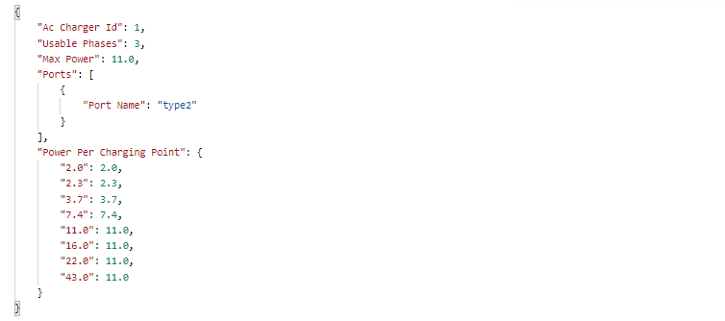

POST {baseurl}/evcharge/api/acchargersmod

PUT {baseUrl}/evcharge/api/acchargersmod/{id}

DEL {baseUrl}/evcharge/api/acchargersmod/{id}

1. AC CHARGERS PORTS

GET {baseUrl}/evcharge/api/acchargerports

POST {baseUrl}/evcharge/api/acchargerportsmod

GET {baseUrl}/evcharge/api/acchargerports/{id}

PUT {baseUrl}/evcharge/api/acchargerportsmod/{id}

DEL {baseUrl}/evcharge/api/acchargerportsmod/{id}

1. ADDRESSES (of stations)

GET {baseUrl}/evcharge/api/addresses

POST {baseUrl}/evcharge/api/addressesmod

GET {baseUrl}/evcharge/api/addresses/{id}

PUT {baseUrl}/evcharge/api/addressesmod/{id}

DEL {baseUrl}/evcharge/api/addressesmod/{id}

1. CHARGING PROCESSES

GET {baseUrl}/evcharge/api/SessionsPerPoint

/:{stationSpotId}/:{startDate}/:{endDate}?format={format}

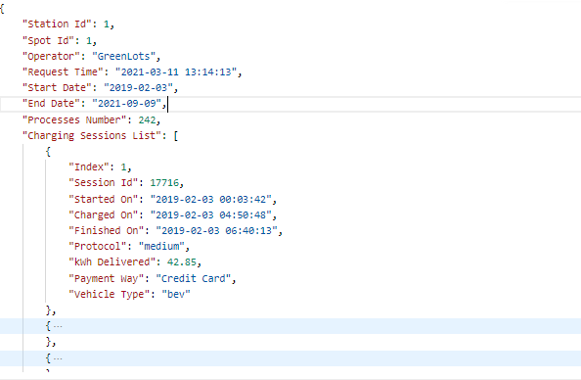

GET {baseUrl}/evcharge/api/SessionsPerStation

/:{stationSpotId}/:{startDate}/:{endDate}?format={format}

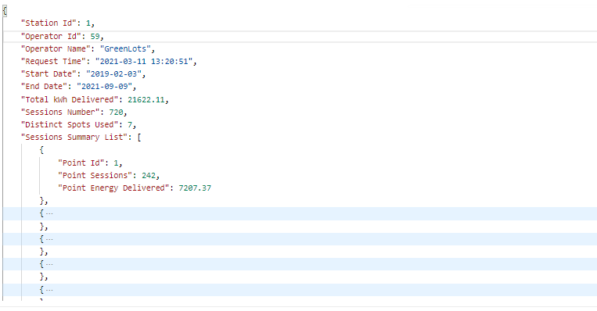

GET {baseUrl}/evcharge/api/SessionsPerEV

/:{stationSpotId}/:{startDate}/:{endDate}?format={format}

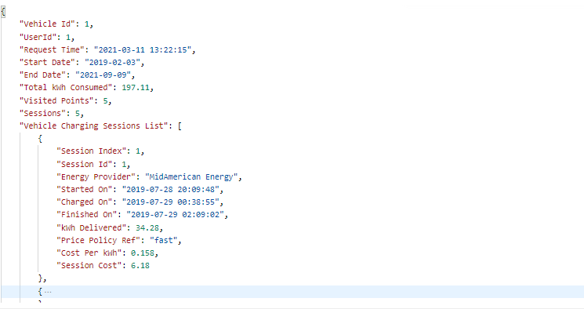

GET {baseUrl}/evcharge/api/SessionsPerProvider

/:{stationSpotId}/:{startDate}/:{endDate}?format={format}

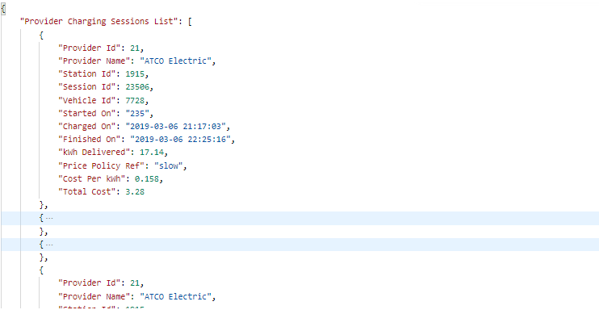

GET {baseUrl}/evcharge/api/chargingprocesses

GET {baseUrl}/evcharge/api/chargingprocesses/{id}

POST {baseUrl}/evcharge/api/chargingprocessesmod

PUT {baseUrl}/evcharge/api/chargingprocessesmod/{id}

DEL {baseUrl}/evcharge/api/chargingprocessesmod/{id}

POST {baseUrl}/evcharge/api/admin/system/sessionsupd

1. CHARGING SPOTS

GET {baseUrl}/evcharge/api/chargingspots

GET {baseUrl}/evcharge/api/chargingspots/{id}

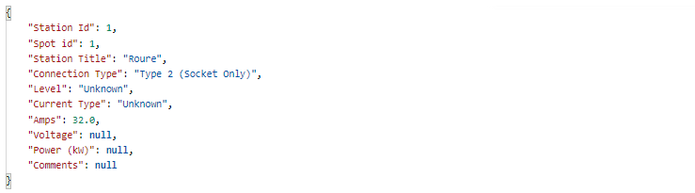

GET {baseUrl}/evcharge/api/chargingspotsdb

GET {baseUrl}/evcharge/api/chargingspotsdb/{id}

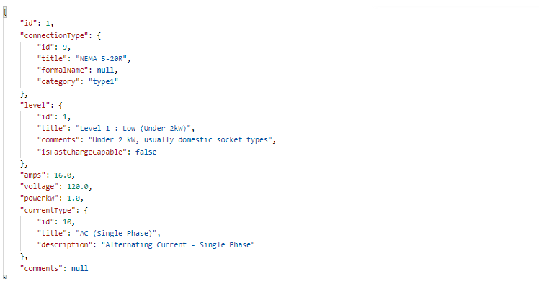

POST {baseUrl}/evcharge/api/chargingspotsmod

PUT {baseUrl}/evcharge/api/chargingspotsmod/{id}

DEL {baseUrl}/evcharge/api/chargingspotsmod/{id}

1. CHARGING STATIONS

GET {baseUrl}/evcharge/api/chargingstationsdb

GET {baseUrl}/evcharge/api/chargingstationsdb/{id}

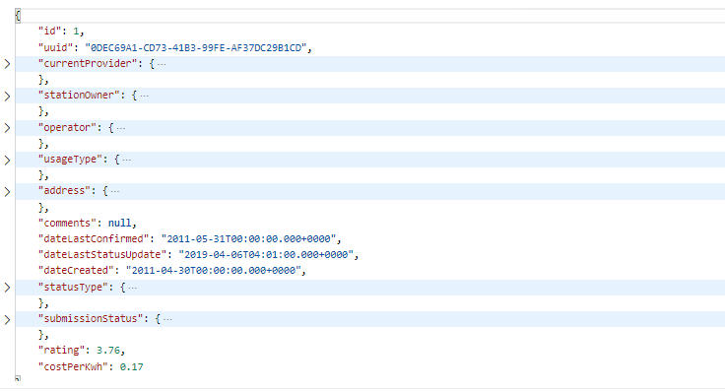

GET {baseUrl}/evcharge/api/chargingstations

GET {baseUrl}/evcharge/api/chargingstations/{id}

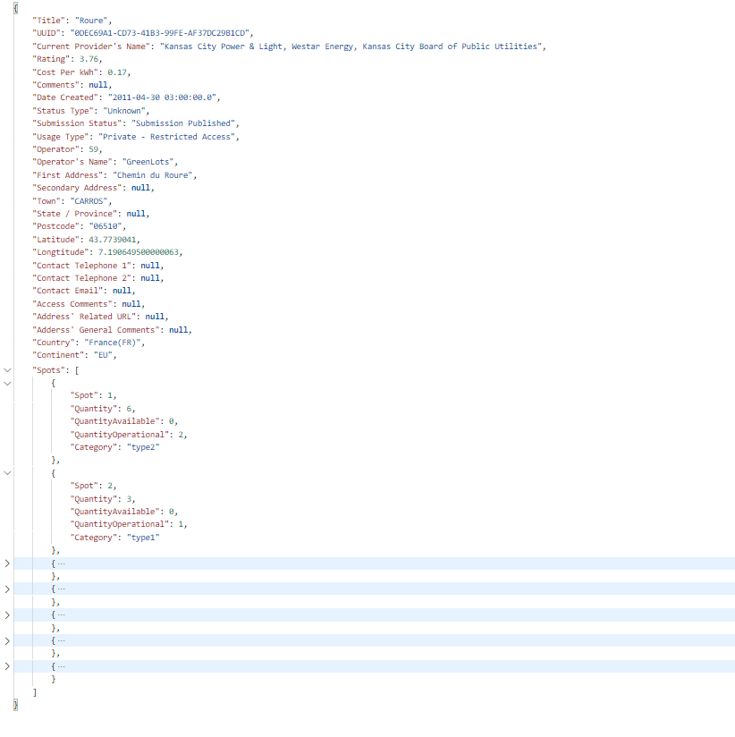

POST {baseUrl}/evcharge/api/chargingstationsmod

PUT {baseUrl}/evcharge/api/chargingstationsmod/{id}

DEL {baseUrl}/evcharge/api/chargingstationsmod/{id}

1. CHARGING STATION SPOTS

GET {baseUrl}/evcharge/api/chargingstationspots

POST {baseUrl}/evcharge/api/chargingstationspotsmod

GET {baseUrl}/evcharge/api/chargingstationspots/{id}

PUT {baseUrl}/evcharge/api/chargingstationspotsmod/{id}

DEL {baseUrl}/evcharge/api/chargingstationspotsmod/{id}

1. CONNECTION TYPES

GET {baseUrl}/evcharge/api/connectiontypes

POST {baseUrl}/evcharge/api/connectiontypesmod

GET {baseUrl}/evcharge/api/connectiontypes/{id}

PUT {baseUrl}/evcharge/api/connectiontypesmod/{id}

DEL {baseUrl}/evcharge/api/connectiontypesmod/{id}

1. COUNTRIES

GET {baseUrl}/evcharge/api/countries

POST {baseUrl}/evcharge/api/countriesmod

GET {baseUrl}/evcharge/api/countries/{id}

PUT {baseUrl}/evcharge/api/countriesmod/{id}

DEL {baseUrl}/evcharge/api/countriesmod/{id}

1. CURRENT PROVIDERS

GET {baseUrl}/evcharge/api/currentproviders

POST {baseUrl}/evcharge/api/currentprovidersmod

GET {baseUrl}/evcharge/api/currentproviders/{id}

PUT {baseUrl}/evcharge/api/currentprovidersmod/{id}

DEL {baseUrl}/evcharge/api/currentprovidersmod/{id}

1. CURRENT TYPES

GET {baseUrl}/evcharge/api/currenttypes

POST {baseUrl}/evcharge/api/currenttypesmod

GET {baseUrl}/evcharge/api/currenttypes/{id}

PUT {baseUrl}/evcharge/api/currenttypesmod/{id}

DEL {baseUrl}/evcharge/api/currenttypesmod/{id}

1. DC CHARGERS

GET {baseUrl}/evcharge/api/dcchargersdb

GET {baseUrl}/evcharge/api/dcchargersdb/{id}

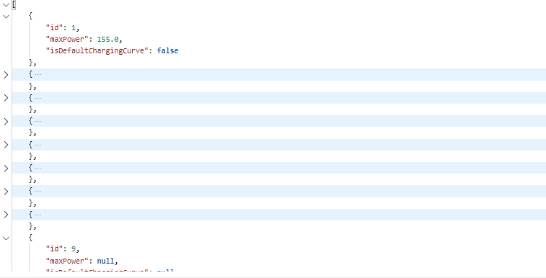

GET {baseUrl}/evcharge/api/dcchargers

GET {baseUrl}/evcharge/api/dcchargers/{id}

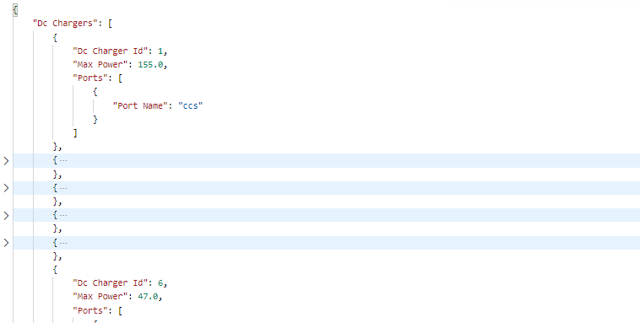

POST {baseUrl}/evcharge/api/dcchargersmod

PUT {baseUrl}/evcharge/api/dcchargersmod/{id}

DEL {baseUrl}/evcharge/api/dcchargersmod/{id}

1. DC CHARGERS PORTS

GET {baseUrl}/evcharge/api/dcchargerports

POST {baseUrl}/evcharge/api/dcchargerportsmod

GET {baseUrl}/evcharge/api/dcchargerports/{id}

PUT {baseUrl}/evcharge/api/dcchargerportsmod/{id}

DEL {baseUrl}/evcharge/api/dcchargerportsmod/{id}

1. LEVELS

GET {baseUrl}/evcharge/api/levels

POST {baseUrl}/evcharge/api/levelsmod

GET {baseUrl}/evcharge/api/levels/{id}

PUT {baseUrl}/evcharge/api/levelsmod/{id}

DEL {baseUrl}/evcharge/api/levelsmod/{id}

1. OPERATORS

GET {baseUrl}/evcharge/api/operators

POST {baseUrl}/evcharge/api/operatorsmod

GET {baseUrl}/evcharge/api/operators/{id}

PUT {baseUrl}/evcharge/api/operatorsmod/{id}

DEL {baseUrl}/evcharge/api/operatorsmod/{id}

1. POWER PER CHARGING POINT

GET {baseUrl}/evcharge/api/powerperchargingpoint

POST {baseUrl}/evcharge/api/powerperchargingpointmod

GET {baseUrl}/evcharge/api/powerperchargingpoint/{id}

PUT {baseUrl}/evcharge/api/powerperchargingpointmod/{id}

DEL {baseUrl}/evcharge/api/powerperchargingpointmod/{id}

1. STATUS TYPES

GET {baseUrl}/evcharge/api/statustypes

POST {baseUrl}/evcharge/api/statustypesmod

GET {baseUrl}/evcharge/api/statustypes/{id}

PUT {baseUrl}/evcharge/api/statustypesmod/{id}

DEL {baseUrl}/evcharge/api/statustypesmod/{id}

1. SUBMISSION STATUS

GET {baseUrl}/evcharge/api/submissionstatus

POST {baseUrl}/evcharge/api/submissionstatusmod

GET {baseUrl}/evcharge/api/submissionstatus/{id}

PUT {baseUrl}/evcharge/api/submissionstatusmod/{id}

DEL {baseUrl}/evcharge/api/submissionstatusmod/{id}

1. USAGE TYPES

GET {baseUrl}/evcharge/api/usagetypes

POST {baseUrl}/evcharge/api/usagetypesmod

GET {baseUrl}/evcharge/api/usagetypes/{id}

PUT {baseUrl}/evcharge/api/usagetypesmod/{id}

DEL {baseUrl}/evcharge/api/usagetypesmod/{id}

1. USER ADDRESSES

GET {baseUrl}/evcharge/api/useraddresses

POST {baseUrl}/evcharge/api/useraddressesmod

GET {baseUrl}/evcharge/api/useraddresses/{id}

PUT {baseUrl}/evcharge/api/useraddressesmod/{id}

DEL {baseUrl}/evcharge/api/useraddressesmod/{id}

1. USER HAS VEHICLES

GET {baseUrl}/evcharge/api/userhasvehicles

POST {baseUrl}/evcharge/api/userhasvehiclesmod

GET {baseUrl}/evcharge/api/userhasvehicles/{id}

PUT {baseUrl}/evcharge/api/userhasvehiclesmod/{id}

DEL {baseUrl}/evcharge/api/userhasvehiclesmod/{id}

1. VEHICLES

GET {baseUrl}/evcharge/api/vehicles

POST {baseUrl}/evcharge/api/vehiclesmod

GET {baseUrl}/evcharge/api/vehicles/{id}

PUT {baseUrl}/evcharge/api/vehiclesmod/{id}

DEL {baseUrl}/evcharge/api/vehiclesmod/{id}

1. VEHICLE OWNERS

GET {baseUrl}/evcharge/api/users

GET {baseUrl}/evcharge/api/admin/users/{username}

GET {baseUrl}/evcharge/api/users/{id}

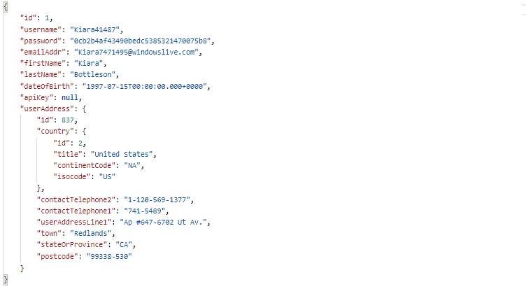

GET {baseUrl}/evcharge/api/user/{id}/profile



GET {baseUrl}/evcharge/api/user/{id}/myvehicles/{id}

GET {baseUrl}/evcharge/api/user/{id}/myvehicles

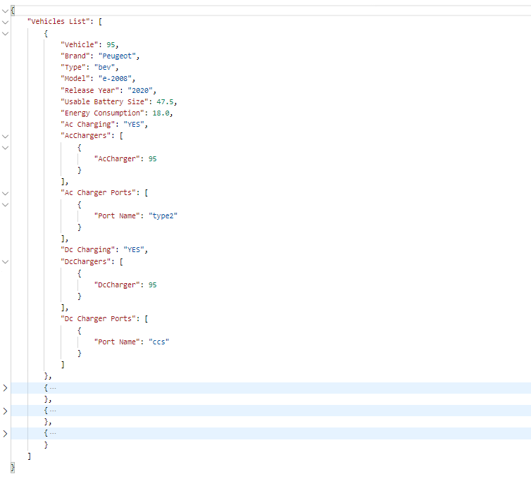

GET {baseUrl}/evcharge/api/user/{id}/statistics

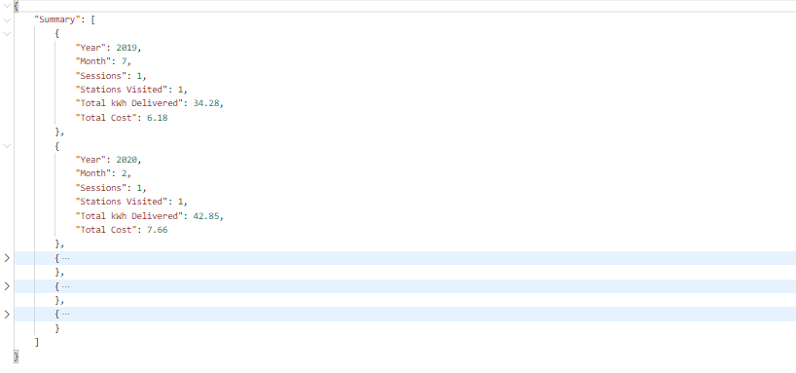

POST {baseUrl}/evcharge/api/usersmod

POST {baseUrl}/evcharge/api/admin/usersmod/{username}/

{password}

PUT {baseUrl}/evcharge/api/usersmod/{id} //update username only

PUT {baseUrl}/evcharge/api/usersmodandpass/{id}

//update everything

PUT {baseUrl}/evcharge/api/usersmodnopass/{id}

//update everything except for password

DEL {baseUrl}/evcharge/api/usersmod/{id}

1. STATION OWNERS

GET {baseUrl}/evcharge/api/stationowners

GET {baseUrl}/evcharge/api/admin/stationowners/{username}

GET {baseUrl}/evcharge/api/stationowners/{id}

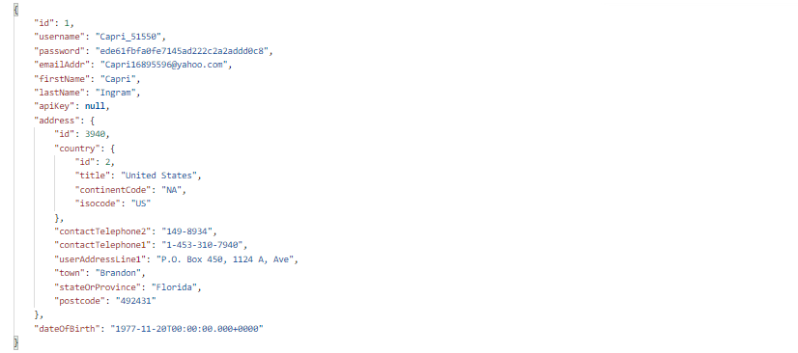

GET {baseUrl}/evcharge/api/stationowners/{id}/profile

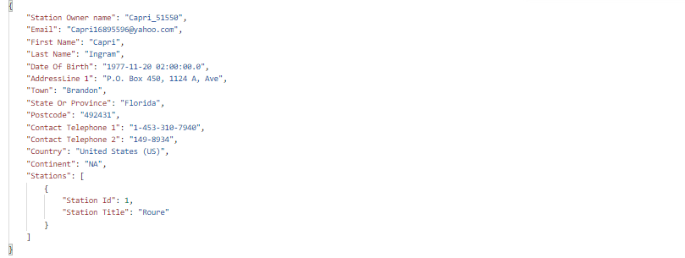

GET {baseUrl}/evcharge/api/stationowners/{id}/mystations

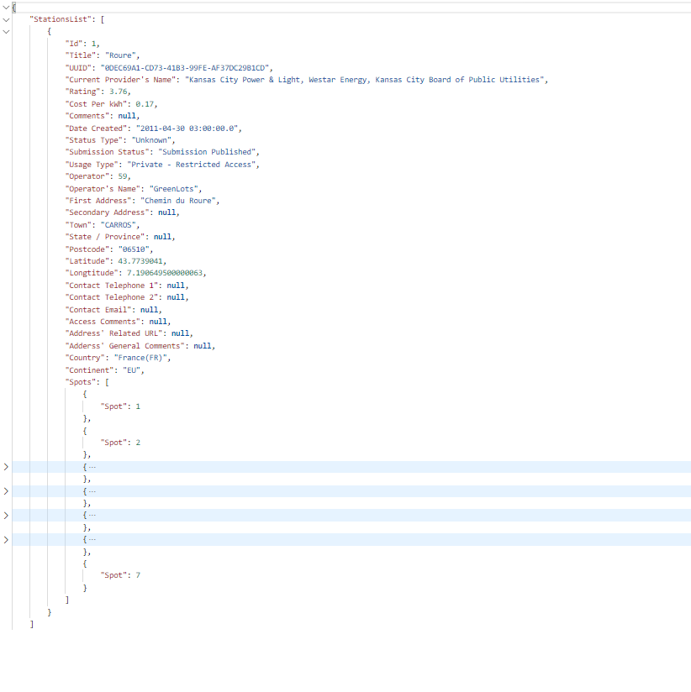

GET {baseUrl}/evcharge/api/stationowners/{id}/mystatistics

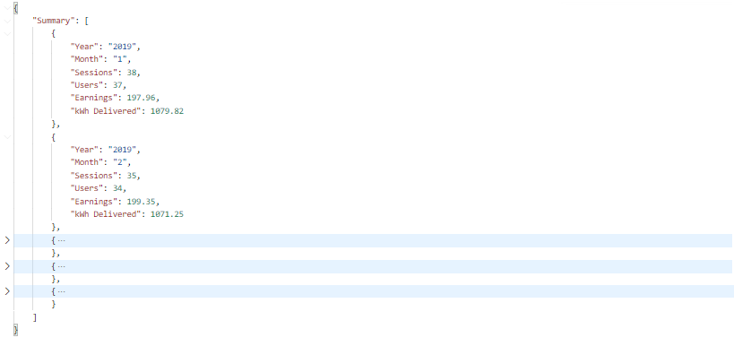

POST {baseUrl}/evcharge/api/stationownersmod

POST {baseUrl}/evcharge/api/admin/stationownersmod/

{username}/{password}

PUT {baseUrl}/evcharge/api/stationownersmod/{id}

// updates everything

PUT {baseUrl}/evcharge/api/stationownersmod/{id}

// updates everything except for password

DEL {baseUrl}/evcharge/api/stationownersmod/{id}

1. LOGIN

POST {baseUrl}/evcharge/api/login

1. HELPING ENDPOINTS

GET {baseUrl}/evcharge/api/admin/healthcheck

GET {baseUrl}/evcharge/api/admin/resetsessions

1. LOGOUT

POST {baseUrl}/evcharge/api/logout