|  |  |
| --- | --- |
| 506 Herzog Byway Apt 99 |  |
| Barre | 123 Street |
| Massachusetts | W1 456 |
| 01005 | 0123456789 |

**Dear Ms. Beatty,**

An appointment has been made for you to see Dr. Backwell on:

**The 1st of January 2020 at 12:00 at the Gastro Clinic**

It would be helpful if a family member or friend could attend this appointment with

you. It would also be helpful if you could have with you a list of all your current

medication (prescribed and over the counter)

**Yours sincerely,**

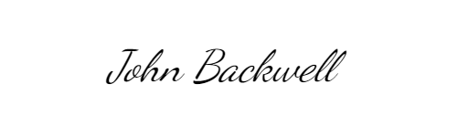

Doctor Backwell