JohnBaker.Law | 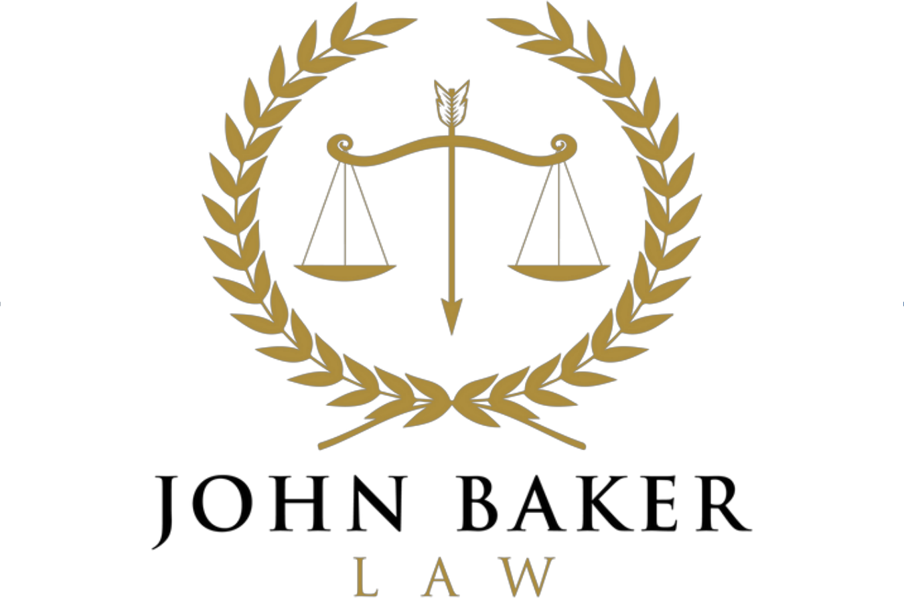 | AV Preeminent Rating

November 12, 2026
VIA E-MAIL (jeff@ehdhlaw.com)
Jeffrey W. DeLoach, Esq.
Epps, Holloway, DeLoach & Hoipkemier, LLC
1220 Langford Drive, Building 200, Suite 101
Watkinsville, Georgia 30677
Re: Stevens Brothers, Inc. v. Five Points Bottle Stop of Athens, Inc., et al., State Court of Athens-Clarke County, Civil Action File No. ST26CV0570 — today’s supplemental discovery responses, service of productions, and coordination
Dear Jeff:
Today I am serving supplemental and amended discovery responses for Mr. Patel, Five Points Clarke, and Mind the Gap, and a supplemental response for non-party Nu Age Horizon. Copies are enclosed. I am also serving on you our productions FP20260924-000001 through -000324 and FP20261008-000001 through -000410. Our records show that the September 24 production was not sent to you and that the October 8 e-mail carrying the second production was returned to us as too large, so you may never have received either. I apologize for that. Both are available at the enclosed link.
Because the tenant side is better served by describing the record the same way, I want to flag, before you hear it from Plaintiff, several points on which our served responses describe the documents differently from Bottle Stop’s papers. I offer these only for your consideration. Whether any of them warrants a supplement or a different description in Bottle Stop’s answer to the First Amended Complaint is, of course, your call.
1. Harford/1842 Policy BP114482810. Bottle Stop’s Verified Answer (Second Defense) and interrogatory answers 5(d) and 9(a) describe Stevens as a loss payee and additional insured. The policy documents we have show Stevens added as loss payee by a BP 12 03 endorsement issued April 21, 2026, with a stated effective date of November 21, 2025. They show a 30-day notice-of-cancellation endorsement (issued December 10, 2025) naming Stevens and Bottle Stop. We have located no additional-insured endorsement naming either Stevens or Bottle Stop; that status appears on certificates. Bottle Stop is not named as a loss payee. Our responses say so.
2. How the evidence of insurance reached Stevens. Interrogatory answers 1, 5(c) and 9(c) say Mr. Cass generally provided evidence of insurance directly to Plaintiff. The documents we have show it reaching Stevens through Mr. Lumpkin in November 2025 (Plaintiff’s interrogatory answer 7) and through Mr. Costantino’s February 24, 2026 letter, which Plaintiff says it received March 3, 2026.
3. Agency history and course of dealing. Interrogatory answer 5(b) describes the coverage as placed through the same agency throughout. Mr. Cass wrote on June 16, 2026 that he could not provide five years of certificates “as that was done through another agency since 2018.” We are producing amended declarations for Citizens Insurance Company of America Policy OBA-A911690 (2018 and 2020), placed through Norton Metro. They schedule the Harry Stevens Estate, and then Stevens Brothers, as loss payee by endorsement, which may bear on the wording of interrogatory answer 5(c) and the Fourth Defense.
4. Rent history. Interrogatory answer 5(g) says Plaintiff accepted $2,334.38 per month throughout the Applicable Period. The Lease’s renewal escalator (110% per five-year term) puts $2,334.38 in the term beginning March 1, 2024; earlier payments were lower.
5. Five Points Clarke at 1655. Bottle Stop’s Answer ¶ 11 denies knowledge of Five Points Clarke’s status. Bottle Stop produced the February 28, 2022 Sputnik-to-Five Points Clarke assignments from its own file (BS-0288–0295), and our responses describe Five Points Clarke’s occupancy under those instruments. Please let me know whether Bottle Stop intends to address this in its answer to the First Amended Complaint.
6. Jury demand. Bottle Stop’s prayer (e) reads “Plaintiff have a trial by jury.” You may wish to conform it in Bottle Stop’s next pleading.
I also have four requests:
1. Registry. Could you send the receipts for Bottle Stop’s October 1 and November 1 deposits under the September 16 Order? We will not describe the deposits in any paper until we have them.
2. Documents. Could you send, from Bottle Stop’s file, the January 29, 2020 Assignment of Rights Under Lease recited at BS-0291, and any written renewal election under the July 1, 1996 Sub-Lease for the term that began in 2024?
3. Insurance renewal. The Harford policy expires November 21, 2026. Because the Lease places the insurance covenant on Bottle Stop as Lessee, I suggest that the renewal be endorsed, by policy endorsement rather than certificate, to make loss payable jointly to Stevens Brothers and Bottle Stop, and that we coordinate with Legacy this week so that no gap arises. I would welcome your views.
4. Mediation. Mr. Manoll proposed on November 6 a joint motion to extend the mediation deadline by at least 60 days. A draft is enclosed. If Bottle Stop consents, please confirm in writing; I will not sign or file anything on Bottle Stop’s behalf without that confirmation.
Please call me if it would be easier to talk any of this through.
Sincerely,
/s/ John Baker
John H. Baker
Enclosures: Supplemental and Amended Objections and Responses of Balubhai P. Patel, Five Points Clarke LLC, and Mind the Gap, Inc.; Supplemental and Amended Response of Non-Party Nu Age Horizon, LLC; productions FP20260924-000001 through -000324, FP20261008-000001 through -000410, and FP2026____ (by file-transfer link); draft Joint Motion to Extend the Mediation Deadline

