JohnBaker.Law | 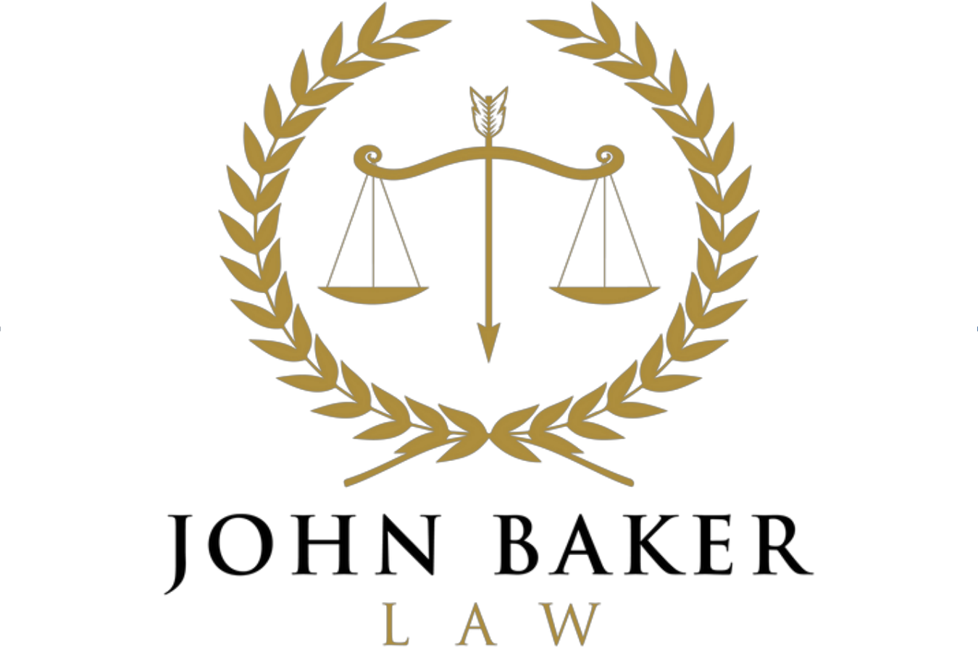 | AV Preeminent Rating

November 12, 2026
VIA E-MAIL (rob@gabusinessdisputes.com)
Robert S. Huestis, Esq.
Huestis Law, LLC
160 Tracy Street, Unit 2
Athens, Georgia 30601
Re: Stevens Brothers, Inc. v. Five Points Bottle Stop of Athens, Inc., et al., State Court of Athens-Clarke County, Civil Action File No. ST26CV0570 — today’s supplemental discovery responses, service of productions, and coordination
Dear Rob:
Today I am serving supplemental and amended discovery responses for Mr. Patel, Five Points Clarke, and Mind the Gap, and a supplemental response for non-party Nu Age Horizon. Copies are enclosed. I am also serving on you our productions FP20260924-000001 through -000324 and FP20261008-000001 through -000410. Our records show that the September 24 production was not sent to you and that the October 8 e-mail carrying the second production was returned to us as too large. I apologize for that. Both are available at the enclosed link.
So that the tenant side describes the record consistently, I want to flag two points on which our served responses describe Graymad’s documents. I offer them only for your consideration.
1. The March 13, 2026 Sublease. Our responses describe it as demising “Tract 2, 0.005 Acre” and “Tract 3, 0.003 Acre” shown on the plat of survey for Five & Ten Restaurant recorded in Plat Book 37, page 251, together with the exclusive use of six parking spaces along the northerly boundary and non-exclusive use of the remainder of the lot. Graymad’s July 8 Verified Answer ¶¶ 8 and 13 admit the Affidavit’s descriptions of the sublease as one for the exclusive use of six parking spaces and of Graymad as a “purported sublessee.” You may wish to consider whether Graymad’s answer to the First Amended Complaint should address those descriptions.
2. Keystone Policy CP00070683. Our responses describe the amended declarations effective February 25, 2026 as adding Stevens Brothers as loss payee on Location 1, Building 2, during the July 1, 2025 to July 1, 2026 term. If we have misdescribed that endorsement, or if the policy has been renewed since July 1, I would be grateful to know.
Our papers also reflect Graymad’s verified statement that it does not do business as “Slater’s Steakhouse.” Consistent with your November 3 e-mail, no paper of ours in the Fulton County action will name Graymad as a party without its written consent.
Two requests. First, our file shows no Graymad answer to the October 9 First Amended Complaint; if one was filed, please send me a copy. Second, Mr. Manoll proposed on November 6 a joint motion to extend the mediation deadline by at least 60 days. A draft is enclosed. If Graymad consents, please confirm in writing; I will not sign or file anything on Graymad’s behalf without that confirmation.
Please call me if it would be easier to discuss.
Sincerely,
/s/ John Baker
John H. Baker
Enclosures: Supplemental and Amended Objections and Responses of Balubhai P. Patel, Five Points Clarke LLC, and Mind the Gap, Inc.; Supplemental and Amended Response of Non-Party Nu Age Horizon, LLC; productions FP20260924-000001 through -000324, FP20261008-000001 through -000410, and FP2026____ (by file-transfer link); draft Joint Motion to Extend the Mediation Deadline

