ECE301 2nd Project Update: 11/02/18

Alex Topping, John Clapham

We currently have the first signal completed without using the Goertzel Algorithm. This method was done by manually splitting up the dialed digits and running them through a series of filters. The signal is passed through using a for loop that generates a matrix of data for each digit. The frequencies are then found using the findpeaks function.

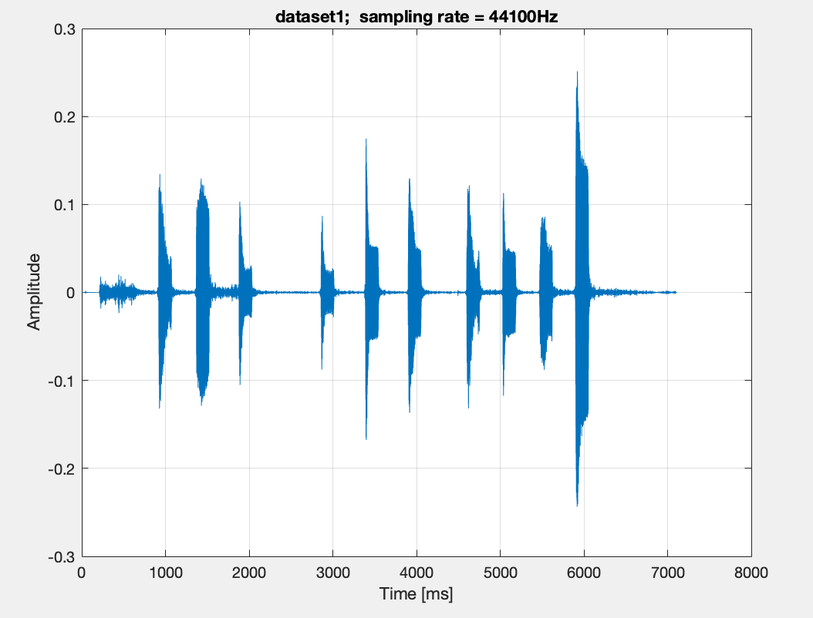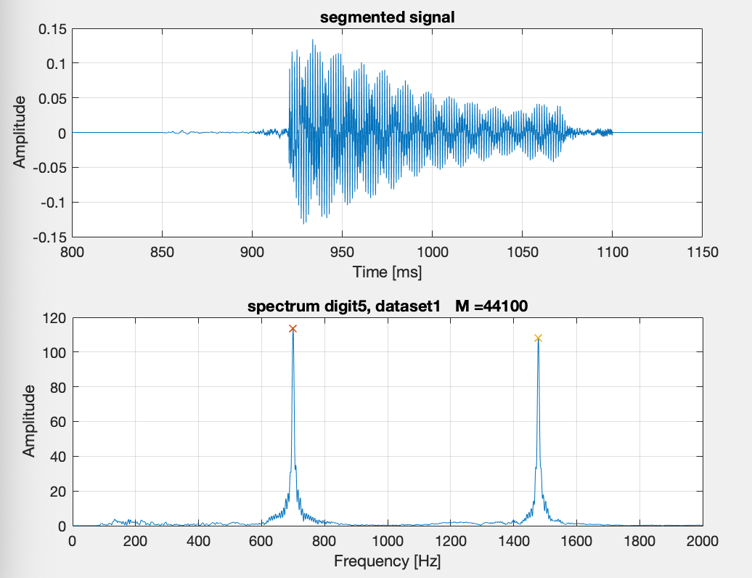

Figure 1: Signal 1 Figure 2: First Digit

Figure 1 shows the entire first signal. Each digit is shown by the spikes in amplitude at different times. Figure 2 shows the first digit being passed through the filters to obtain the two frequency peaks.

After each frequency peak was found, a couple if else statements were written to determine the number that was dialed. The following is the output obtained:

number =

3 0 9 6 7 7 2 7 3 4

See folder labeled first_signal for code.

At this stage of the project we are now focusing on completing the extra credit portion. This is to obtain the hi and low frequencies of each digit by using the Goertzel Algorithm. We are currently having trouble with detecting the numbers dialed using this method and the first signal (see Figure 1).

We are using the reference document provided by Professor Lu to develop the code. The following is our current output:

number =

3 0 9 3 42 7 2 100 3 4

The energy levels being detected are acting a little strange and it seems that the output is very dependent on the value of N that is used. The digit ’42’ I believe is the ASCII for * but this isn’t correct, this was added in as a test to determine a quick solution to a problem. The 100 is a value that I added in the if else statements that says there were weird values for the energy levels calculated and there was an error.

We are continuing to work and the Goertzel Algorithm and plan on implementing it in finding the number of the second two signals.