Peggy Adams Shelter Flow Viz Analysis
VCAP
2024-10-9

Title 1
Figure 1. SVI Quintile distribution at the Census Tract level 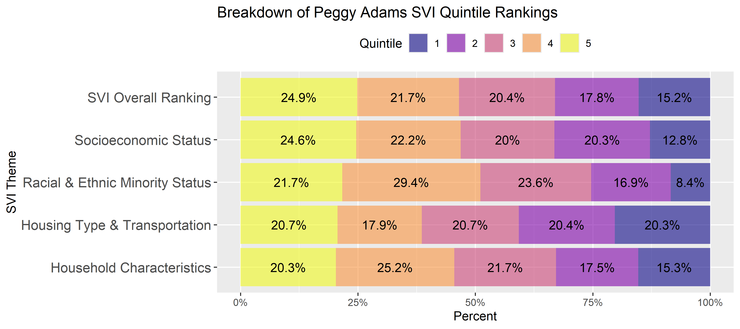

Title 2
Figure 2. Flow of animals from intake to adoption by SVI quintile. 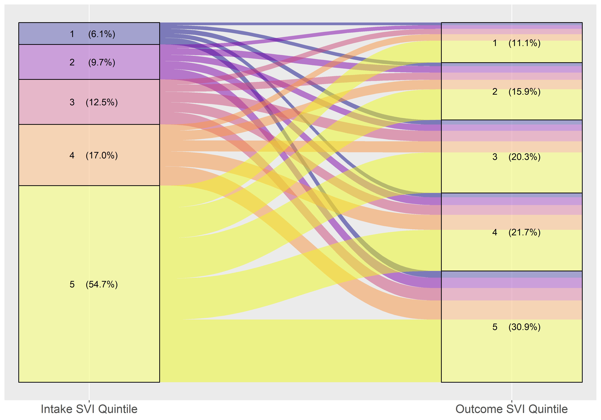

Title 3
91.5% of “Transfer In” intakes came from SVI quintile 5. Of the 1,881 animals transferred in, 1,689 came from 1 location.
Figure 3. Flow of animals from intake to adoption by SVI quintile, divided by intake type 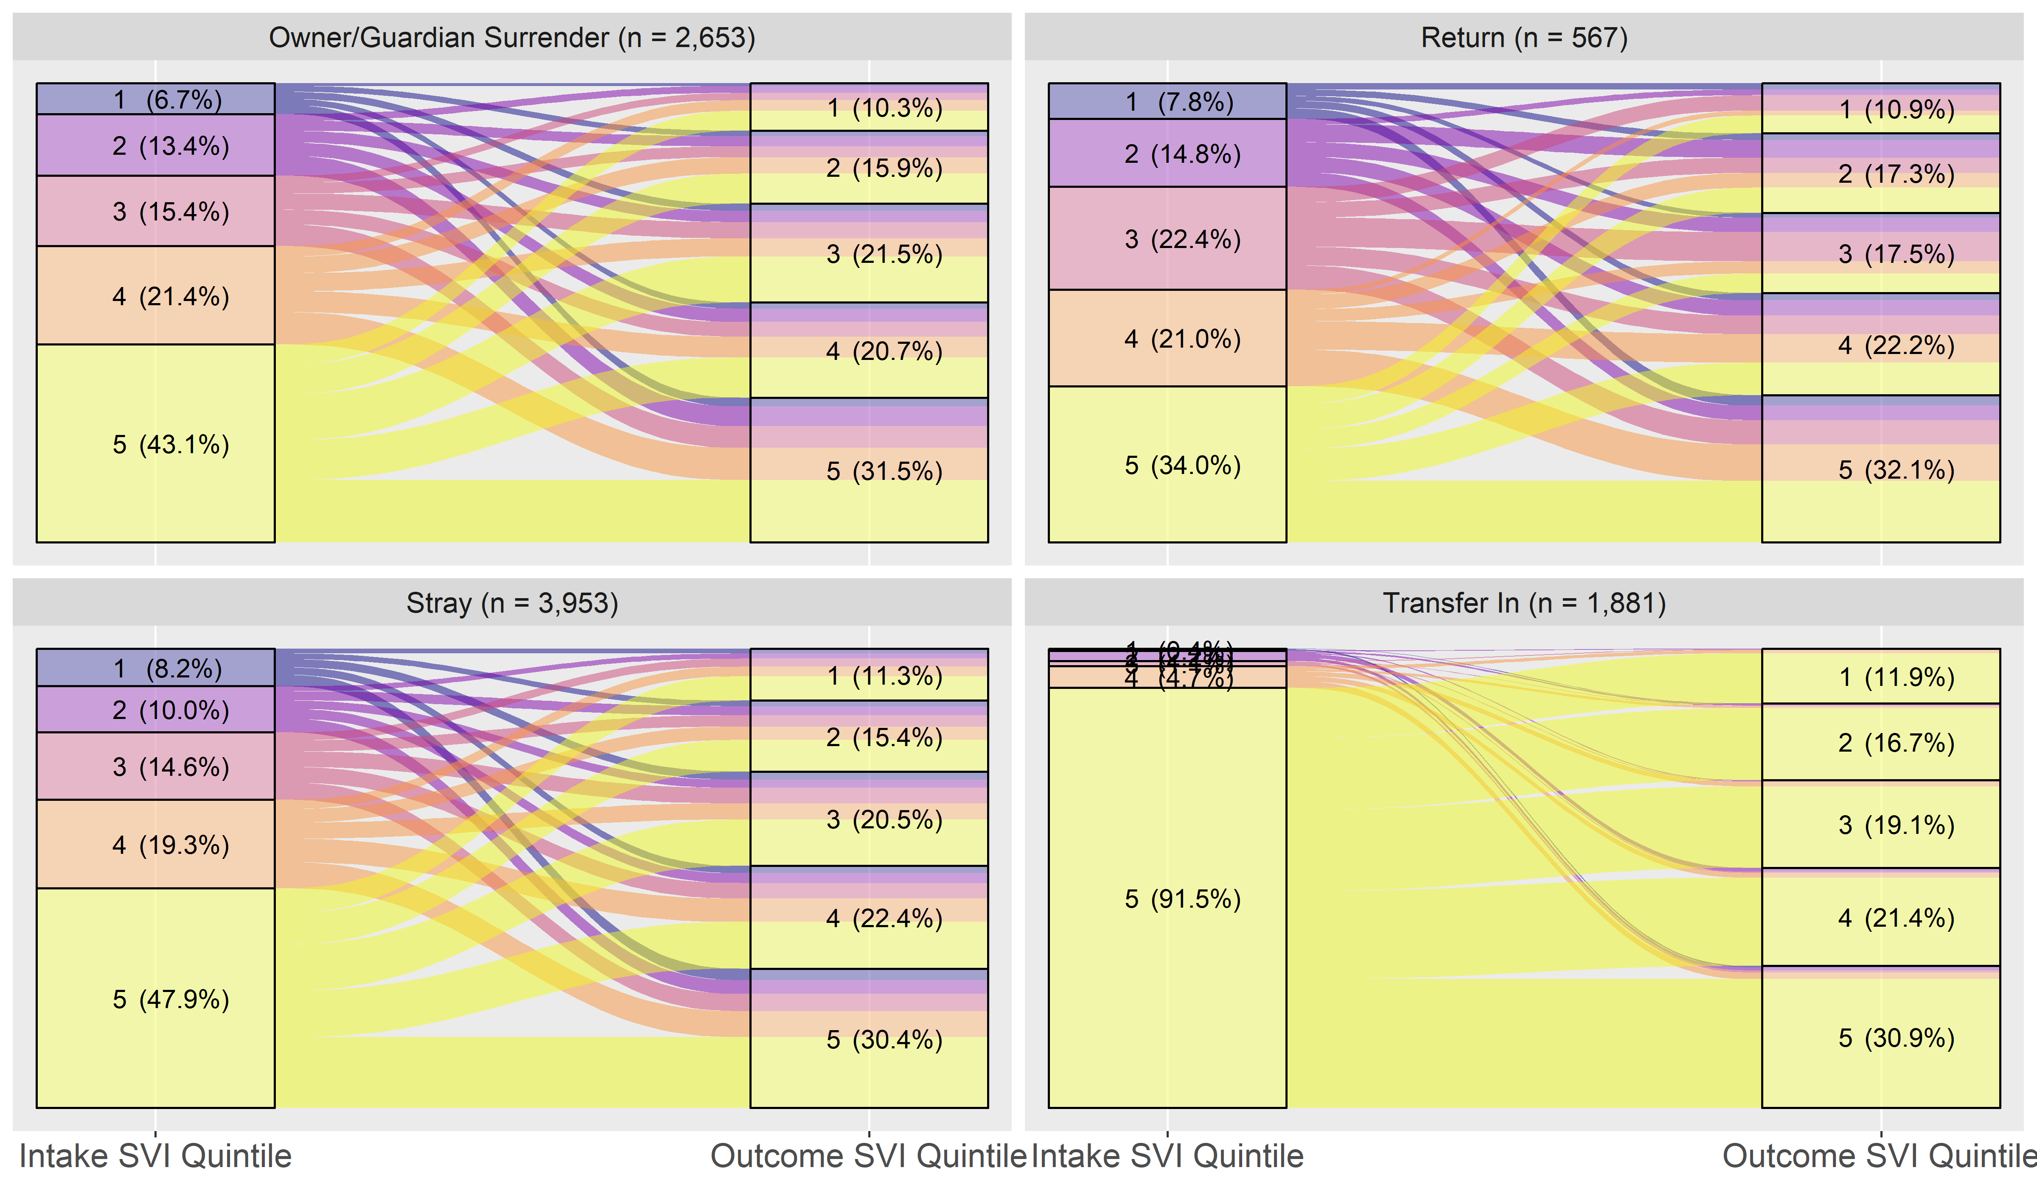

Title 4
Figure 4. Flow of animals from intake to adoption by SVI quintile, rotating SVI themes
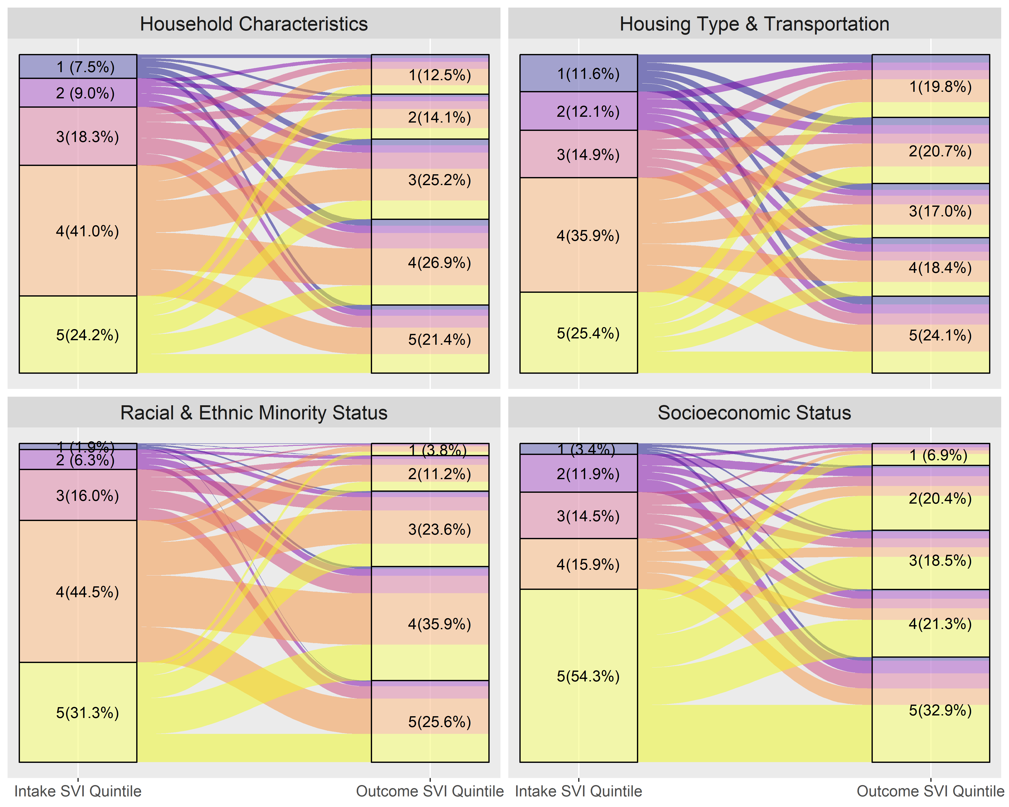

Title 5
Figure 5. Flow of animals from intake to adoption by SVI quintile, divided by age and species
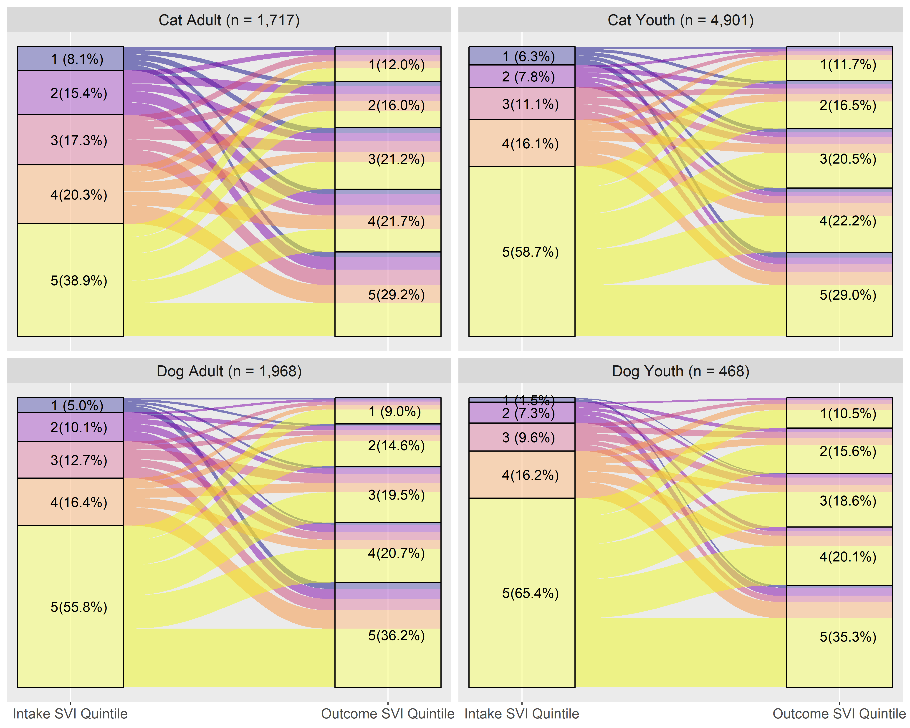

Title 6
Figure 6. Intakes and adoptions per 100 households within SVI quintiles.
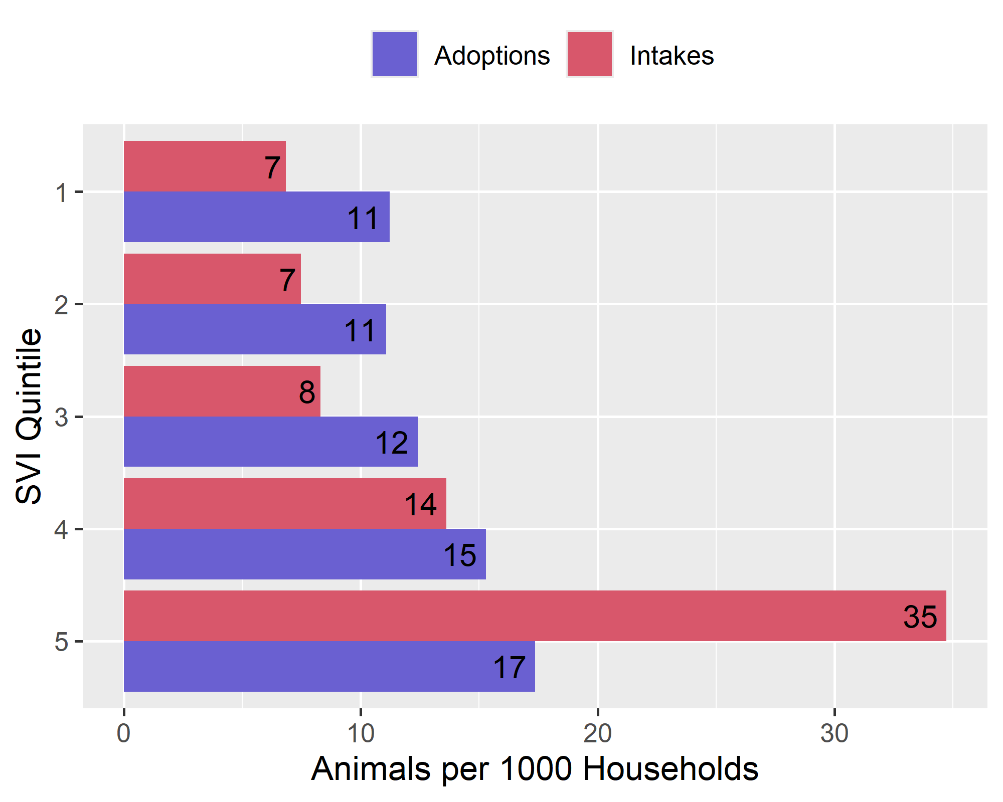

Title 7
Figure 7. Intakes and adoptions per 1000 households within SVI quintiles, divided by intake type.
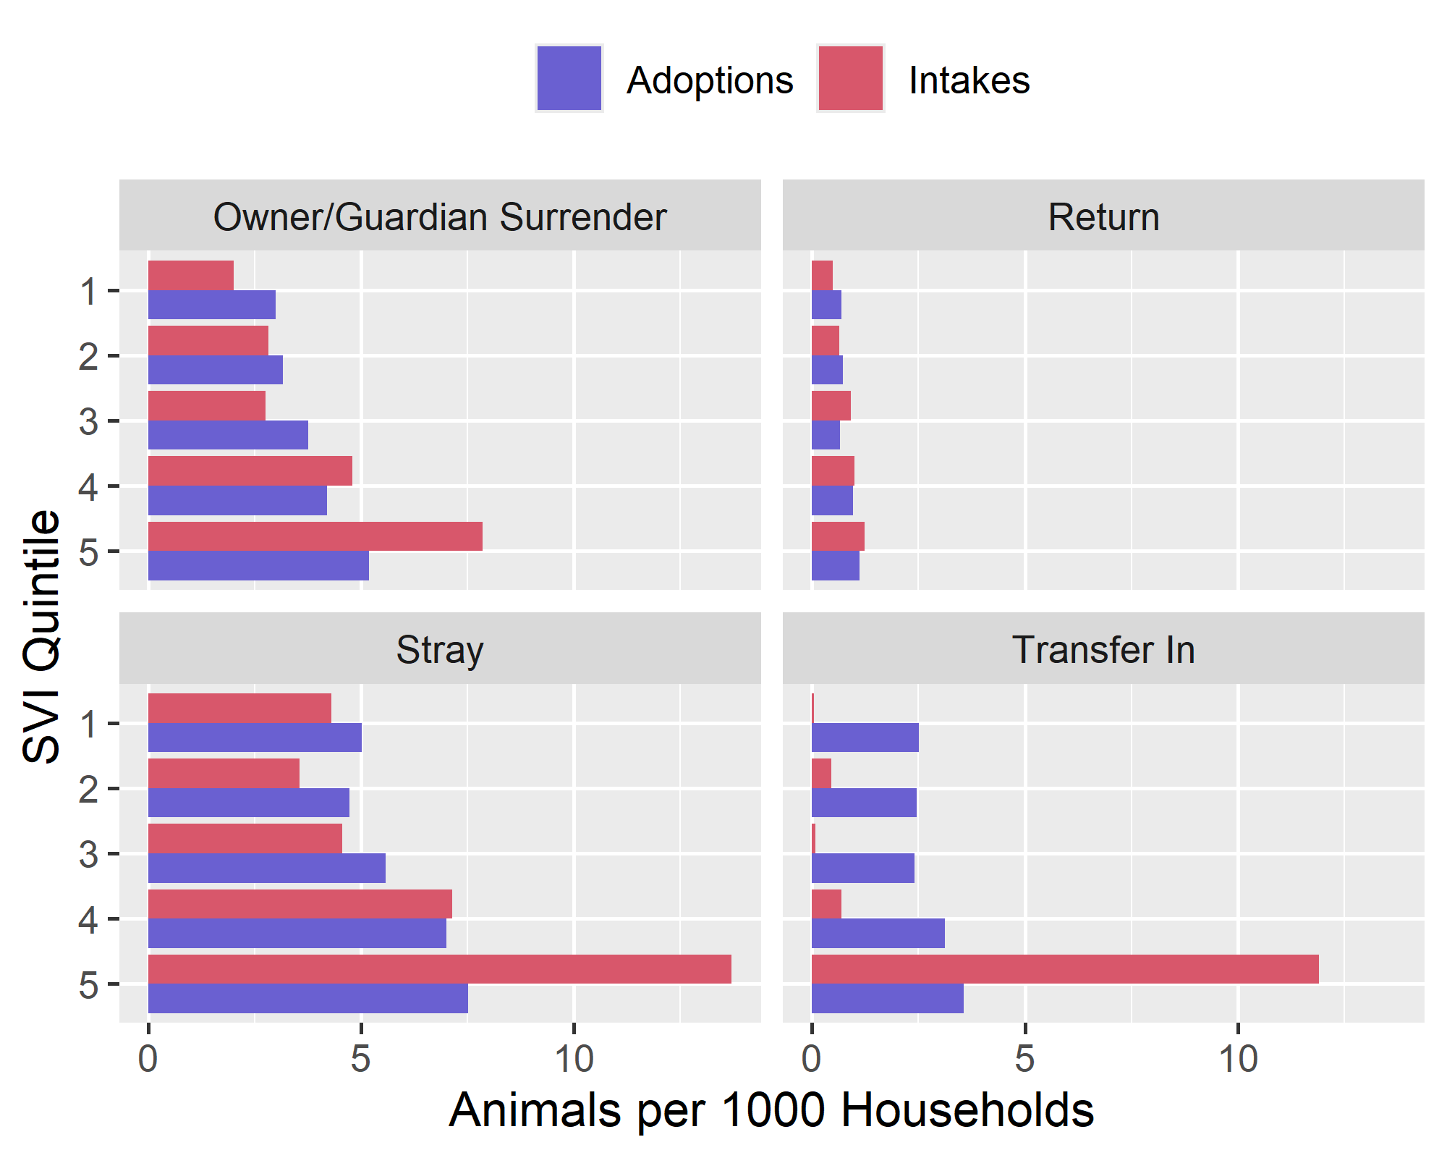

Title 8
There were 7 outcomes types listed, Adoption, Euthanasia, Feral/Wildlife, Return to Owner/Guardian, Transfer Out, Died, and Stolen/Lost. The last two were removed because they made up less than 1% of all outcomes.
Figure 8. Distribution of outcomes within intake SVI quintiles
