Audio file conversion

Add noise in the ocean – standard ocean noise of 80db – Professor has a way to convert into volts that he found working with a sound engineer trying to test the range of the sensors for the hardware team 1600m range

Send out a simple signal

Arbitrary magnitude (1) sine wave at 30kHz, for 30 cycles,

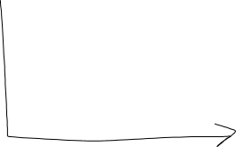

Convolve this data with a matching filter – real time

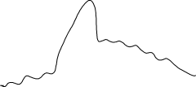

Multiply original signal by relative amplitude and add to original signal (if you’re using sound pressure – you can add it, if we’re in dB we cannot add)

If we multiply by the numbers Bellhop gives us, we need to find the units – what does Bellhop want out of this ‘

dB references are difficult – divided by what to get dB?

Kilo Pascals unit for pressure

May use a *chirp* for better results

.wav files – incorporate all the information self contained within the wav file, more transportable

Paper:

Prof. vastly prefers Google Docs to Latex – not a source document, unless we have a compelling reason

A chance for the prof. to give us feedback for the final paper

Talking about the paper, making plans

Main goal: helping Vaishakhi

Important references: reference any tools you use, like MATLAB or bellhop, reference everything we use to think about the problems, lots of references to valid sources is important, citing links in Google Drive pages to make sure links don’t break

Pick cool images to put in the document

Competing this fall